# **Proposed improvements for the current version of Recruitment Module**

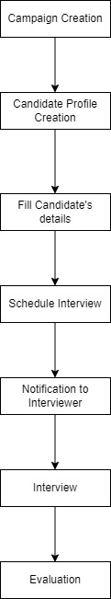

* **Task 1**

1. **Automatic generation of candidate codes (Candidate Profile section)**

[**https://t2gworkroom.com/admin/recruitment/candidate_profile**](https://t2gworkroom.com/admin/recruitment/candidate_profile)

In Recruitment Module under Candidate Profile Section, candidate code should be generated automatically. This candidate code should start from T2G-1001.

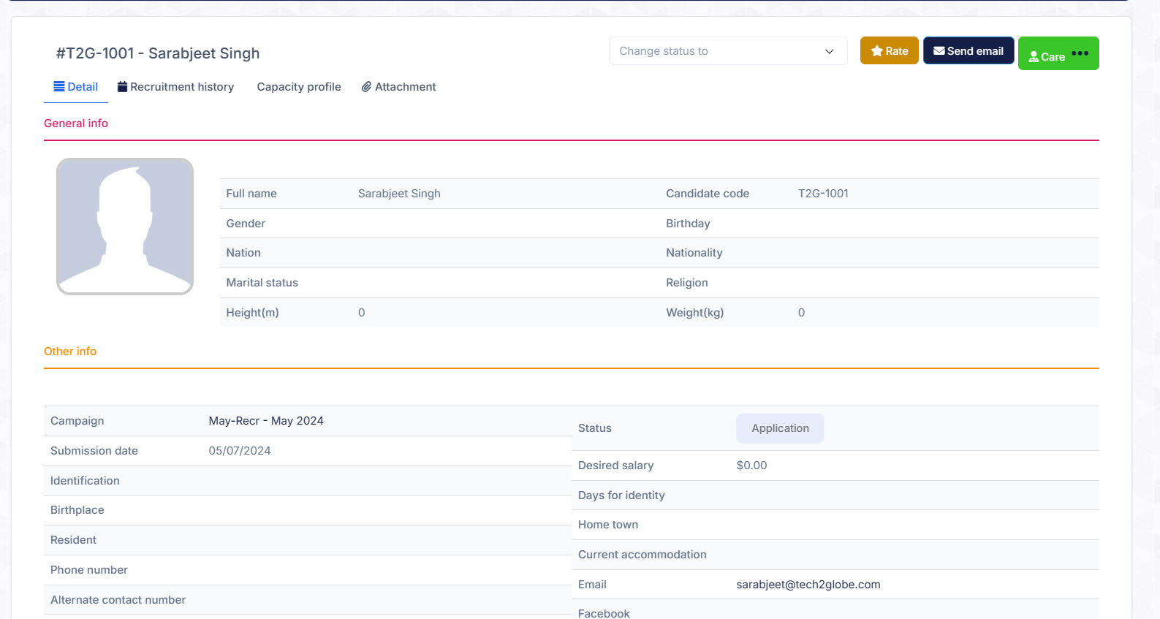

**Fig I. Candidate Profile**

1. **Tab format for candidate profile fields (mandatory /other) (Candidate Profile section)**

[**https://t2gworkroom.com/admin/recruitment/candidate_profile**](https://t2gworkroom.com/admin/recruitment/candidate_profile)

This section should be made in a tab format manner.

Under Mandatory Tab, details like

* Candidate cv link
* Name
* Phone number
* Email address
* Phone number
* Current Location
* Gender (Male/Female/Others)
* Graduate/Diploma: Yes/No
* Post Grad.: Yes/No
* Total Experience: 0-30 DDL
* Remarks

Under Other Tab, details like

* Post Grad.: Yes/No
* LinkedIn Profile
* Work Experience Details – Company Name, Job Position, Salary, work duration
* Introduce yourself
* Marital status
* Nationality
* Identification mark
* Birthplace

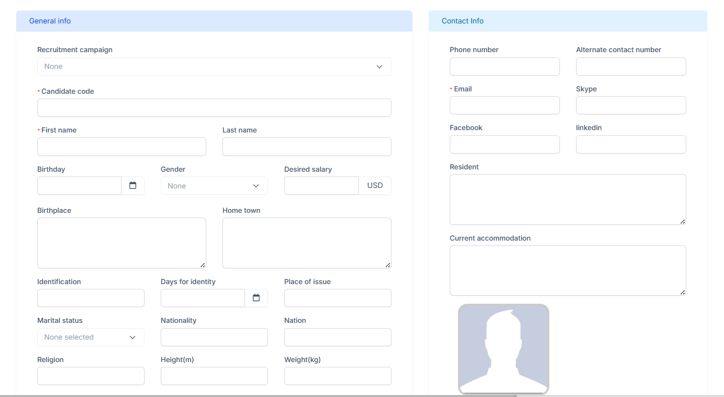

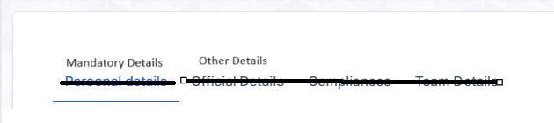

**Fig II. Candidate Details – Tab Format View**

1. **Memory reduction by CV link upload. (Candidate Profile Section)**

[**https://t2gworkroom.com/admin/recruitment/candidate_profile**](https://t2gworkroom.com/admin/recruitment/candidate_profile)

Instead of uploading candidate CV in document format, we can just put a link for candidate’s CV. This will help in reducing memory consumption.

* **Task 2**

1. **Notification for interviewers about interview scheduled (Interview Schedule section)**

[**https://t2gworkroom.com/admin/recruitment/interview_schedule**](https://t2gworkroom.com/admin/recruitment/interview_schedule)

When HR schedules an interview of a candidate with an interviewer, interviewer should receive notification on email as well as a notification on their notification section in CRM. On email all important details should be mentioned such as candidate name, duration, date of interview.

1. **Visibility of remarks editing history**

[**https://t2gworkroom.com/admin/recruitment/candidate/1**](https://t2gworkroom.com/admin/recruitment/candidate/1)

HR can put interviewer’s evaluation of candidate here. This evaluation should appear under comments/remarks. Whenever someone edits these remarks **history of editing** should be visible like in Google Forms. Admin should see complete journey of remarks given by different interviewers at different stages of interview.

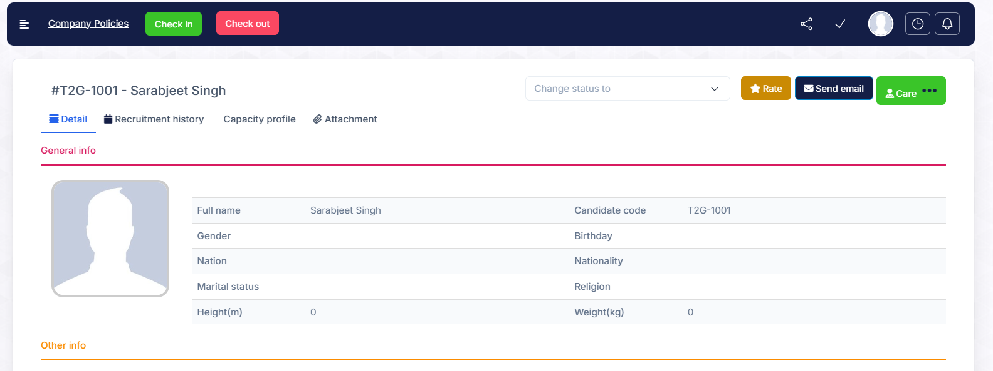

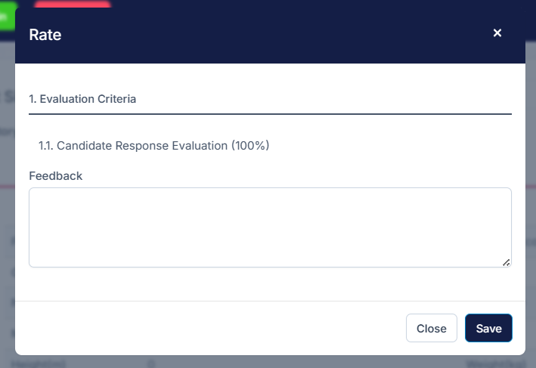

**Fig III. Candidate Evaluation**

1. **Fields should appear on top while adding candidate while scheduling an interview. (Interview Schedule section)**

[**https://t2gworkroom.com/admin/recruitment/interview_schedule**](https://t2gworkroom.com/admin/recruitment/interview_schedule)

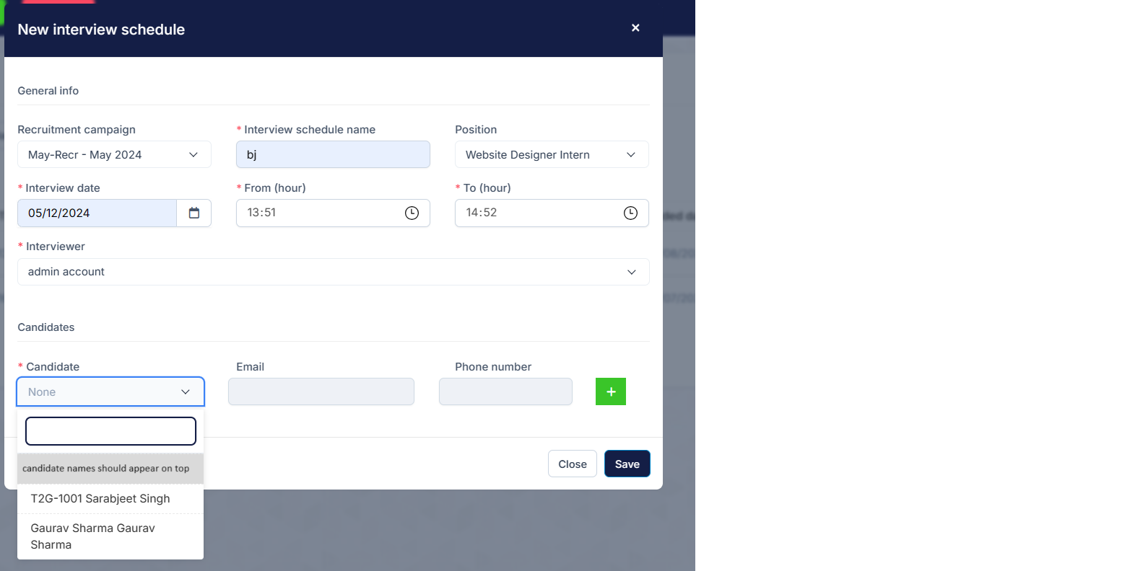

**Fig IV. Interview Schedule**