OOPS PROJECT REPORT

Group Information: Group 47

Raj Tripathi - 2019B4A70869H

Pranjal Jasani - 2019B4A70831H

Kanishk Yadav - 2019B2A71452H

Bhavya Tibrewala - 2019B2A71404H

Class Diagram:

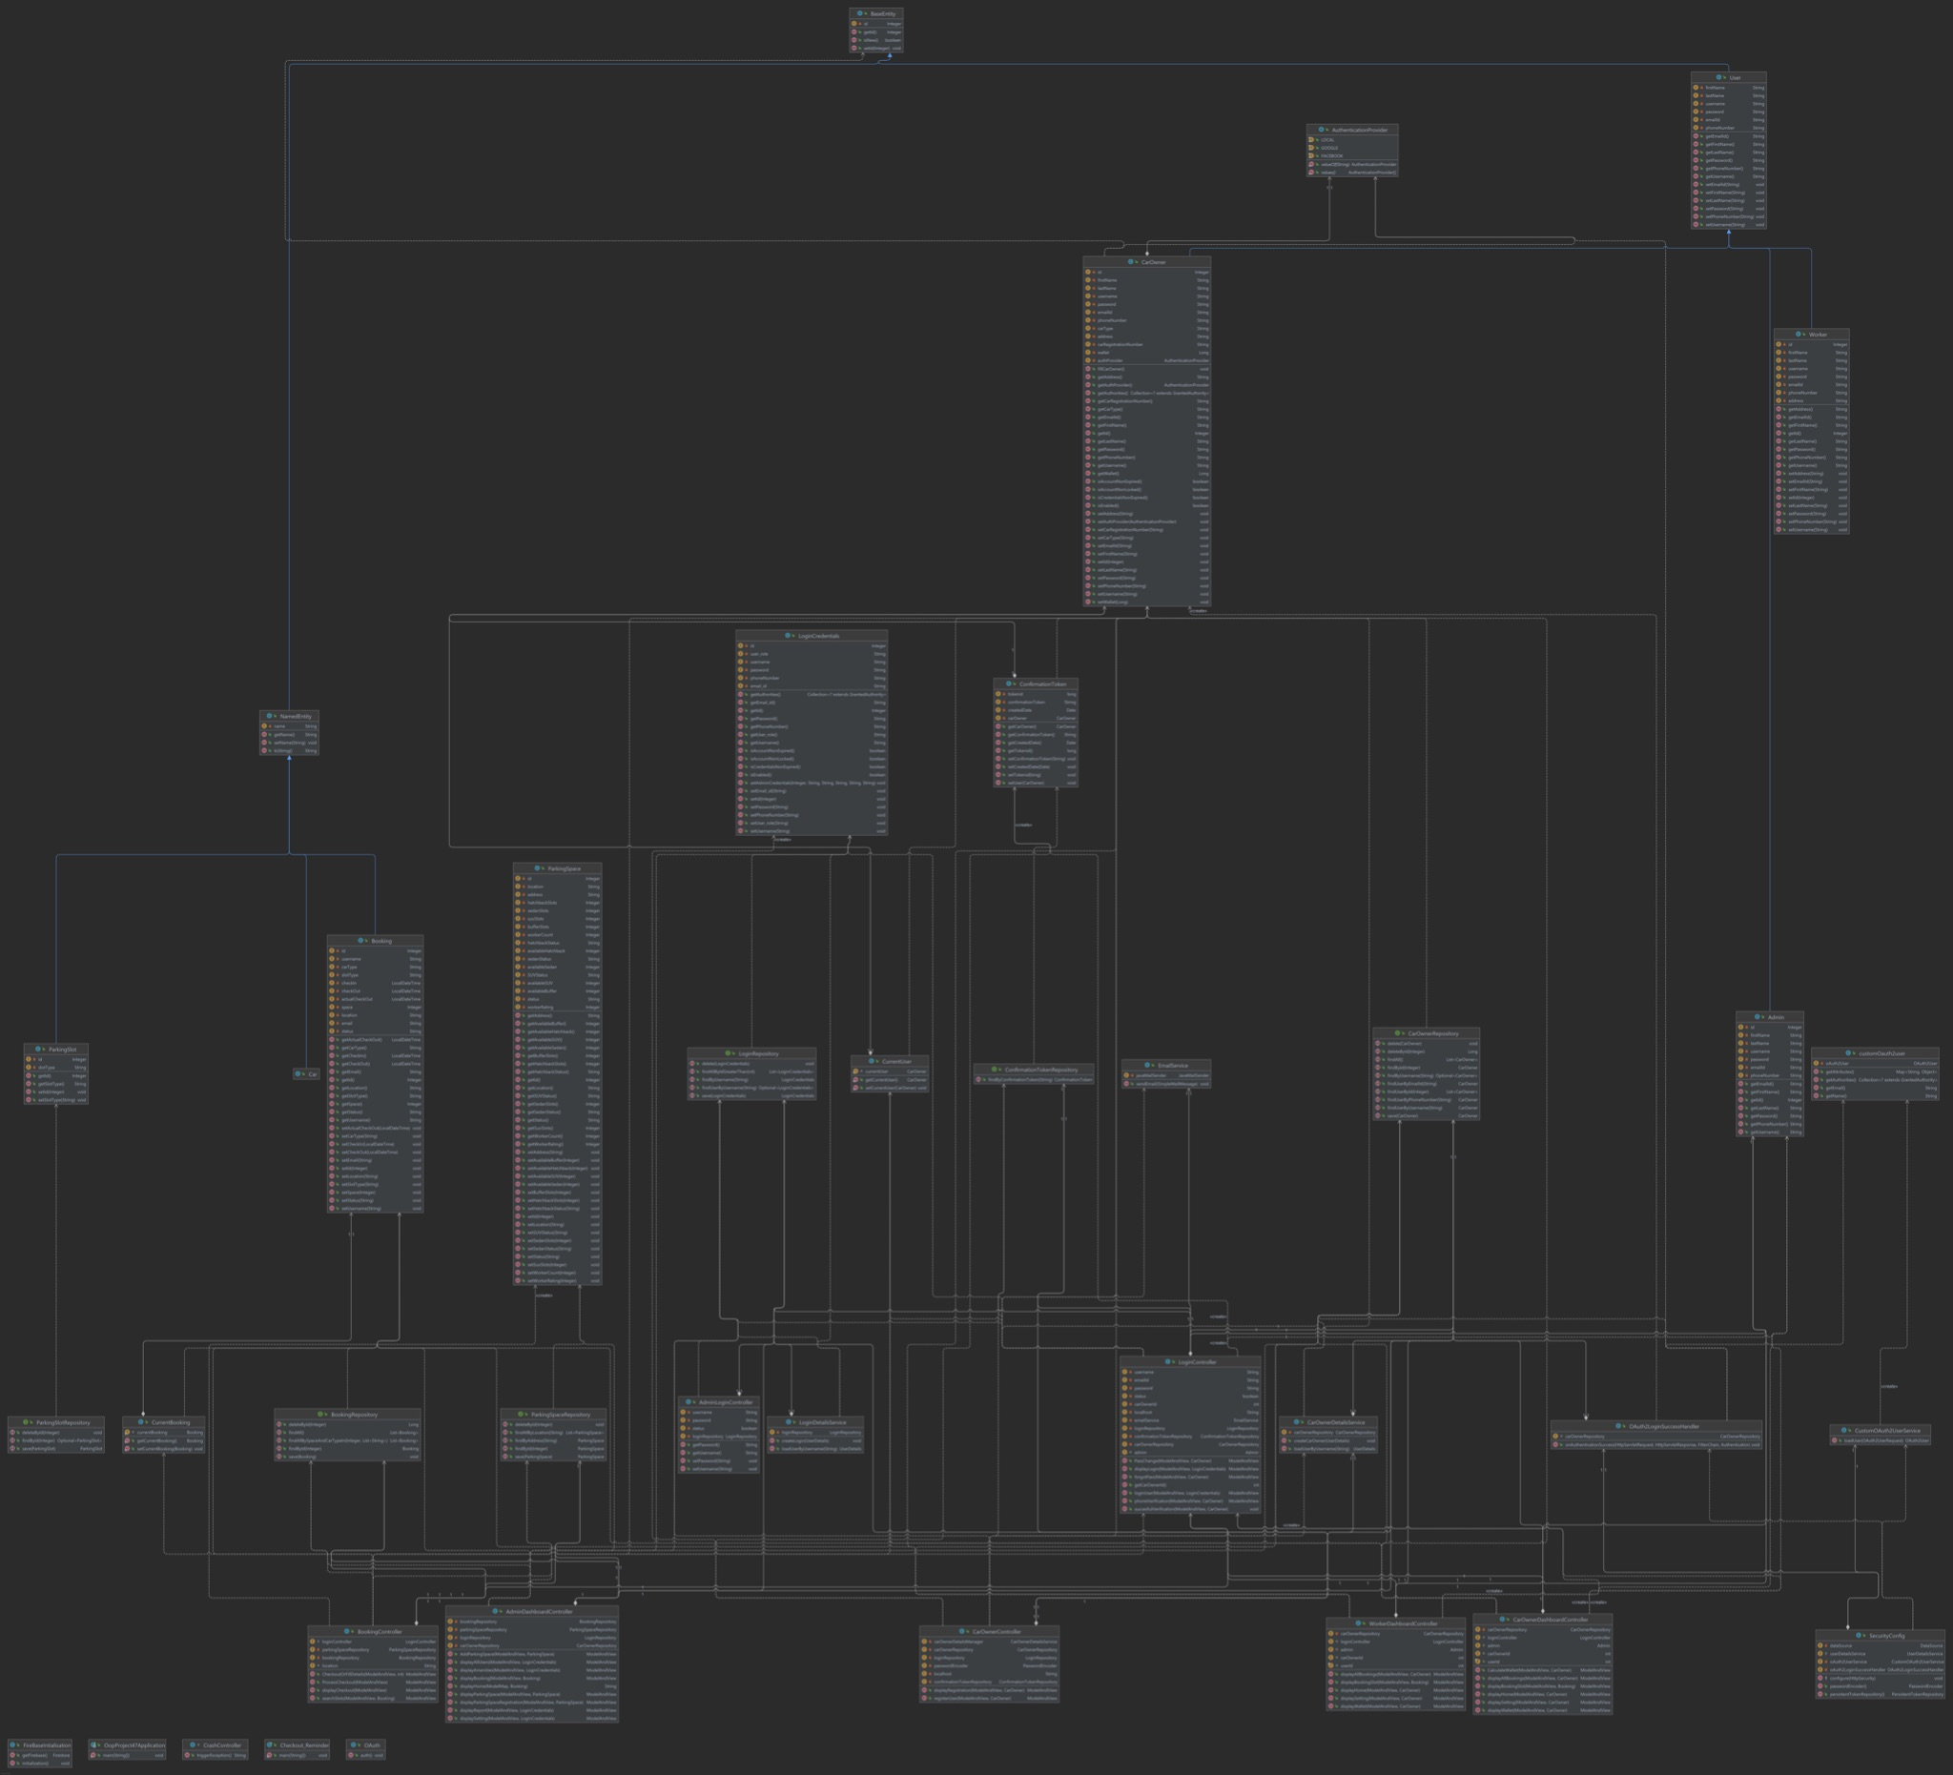

Implementation Details:

1. User Interface Implementation

* Programming Languages: HTML, CSS, JS
* Framework:

1. Server-Side Business Logic

* Programming Languages: Java
* Framework: Springboot
* Build Automation Tool: Maven
* Server: Apache Tomcat

Screenshots of the Project Modules:

**LOGIN MODULE:**

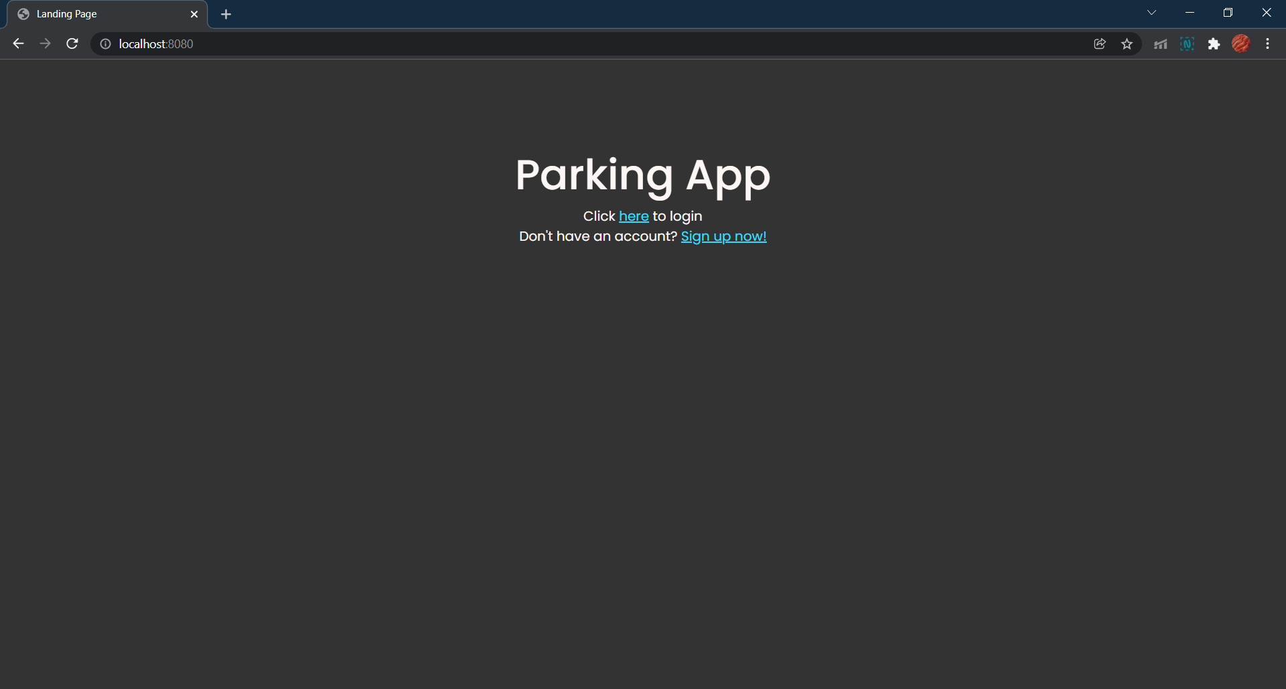

This is the landing page, all users must login or sign up from here.

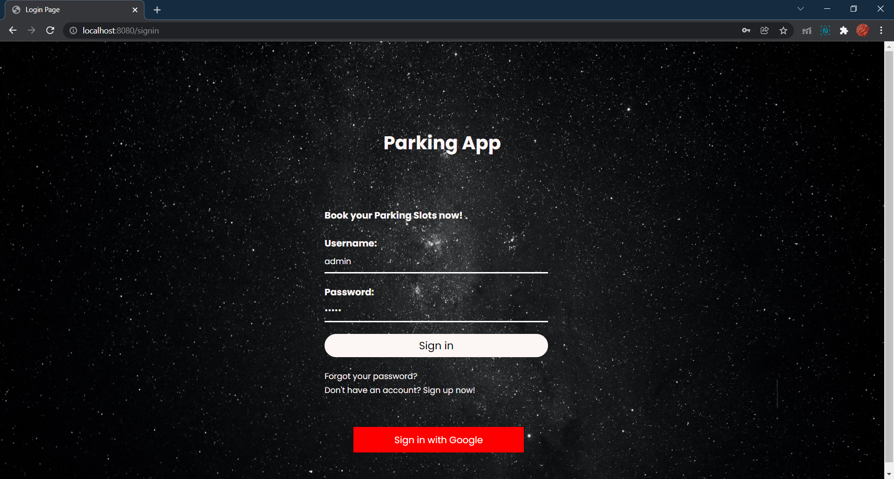

The admin credentials are hardcoded, the user credentials are made by signing up and the worker credentials are made from the admin dashboard.

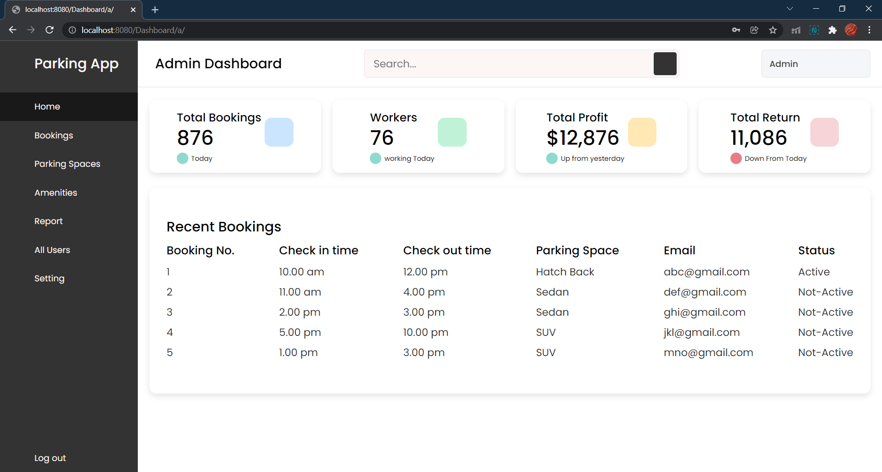

This is the admin dashboard. All the features in the left pane are available to him - seeing/modifying all bookings; adding/deleting parking spaces; adding/deleting amenities, adding/deleting workers and viewing reports for each; adding/deleting/viewing all users etc.

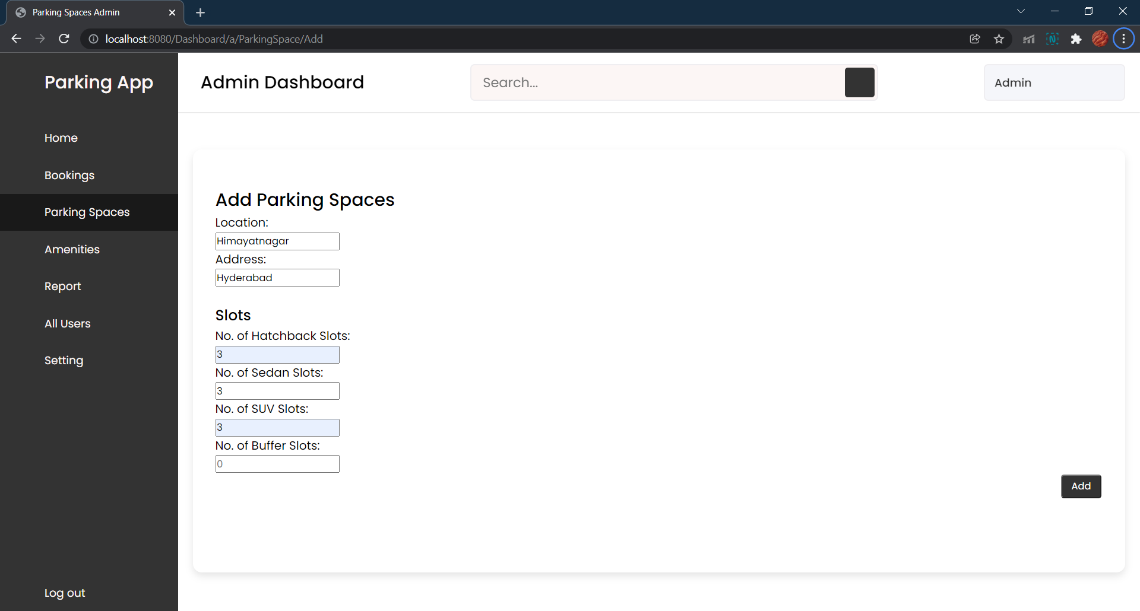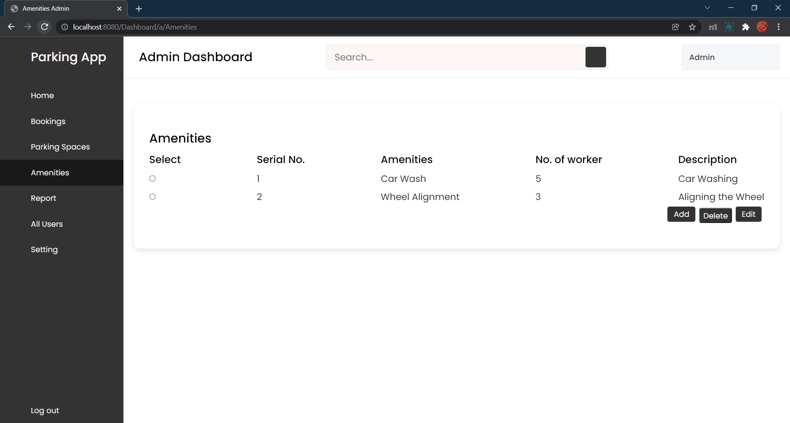

Admin can update parking spaces, amenities etc.

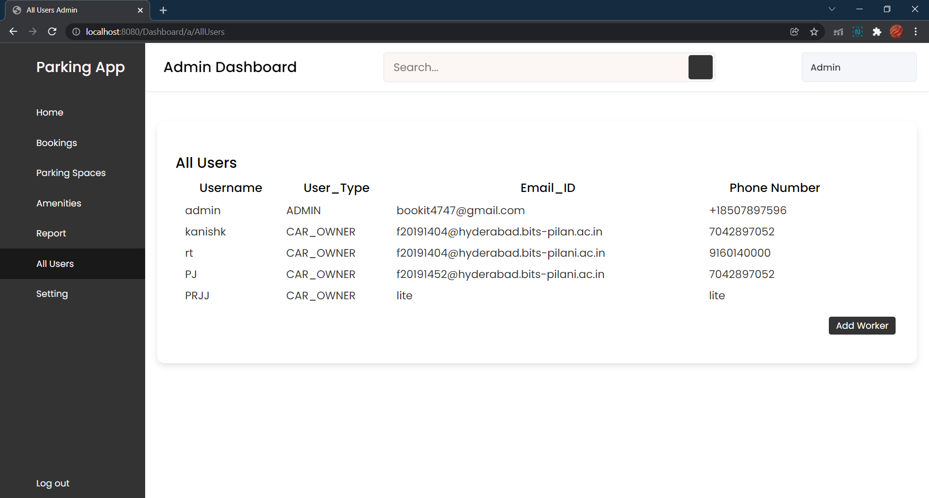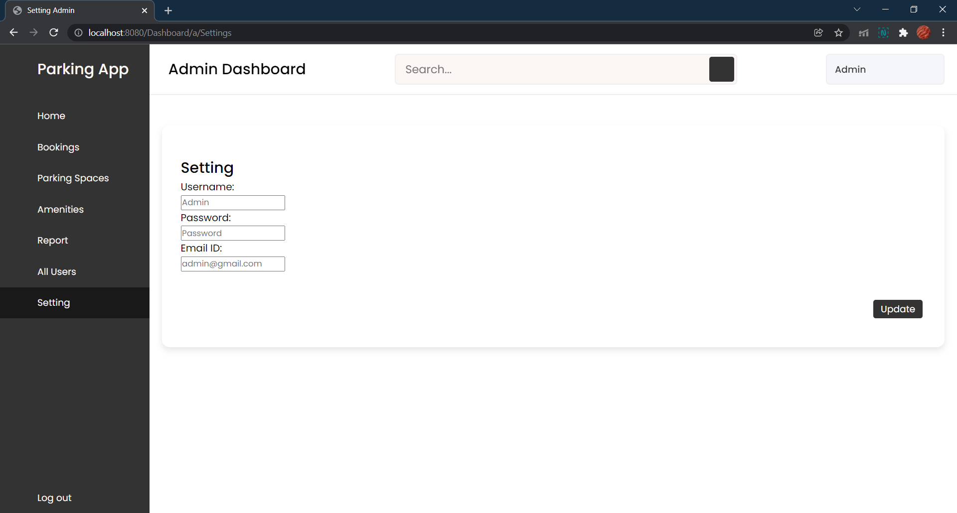

Admin has access to all users, and has settings of his own - username, password, email.

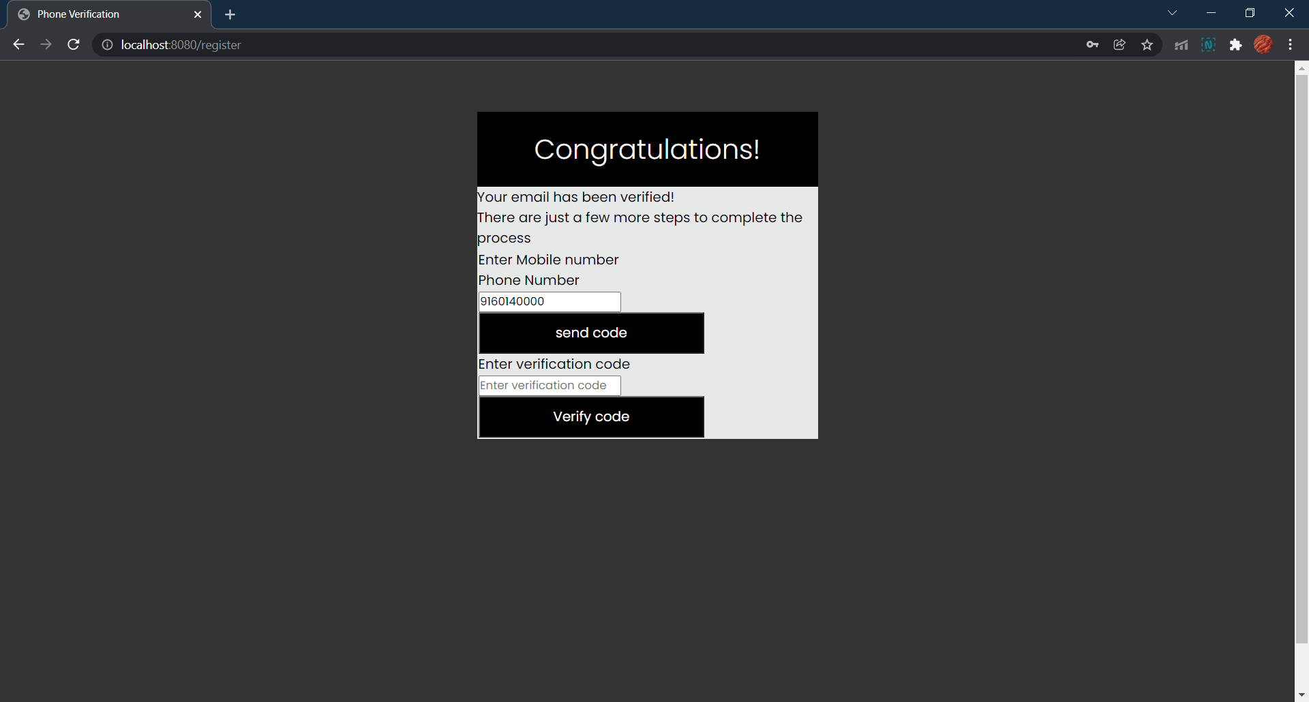

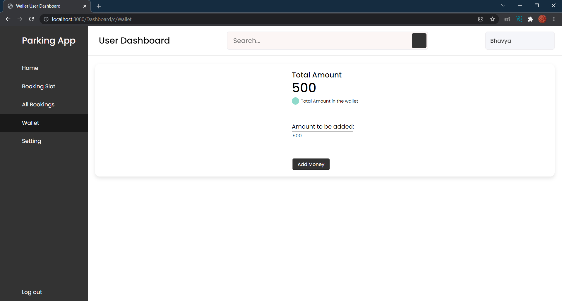

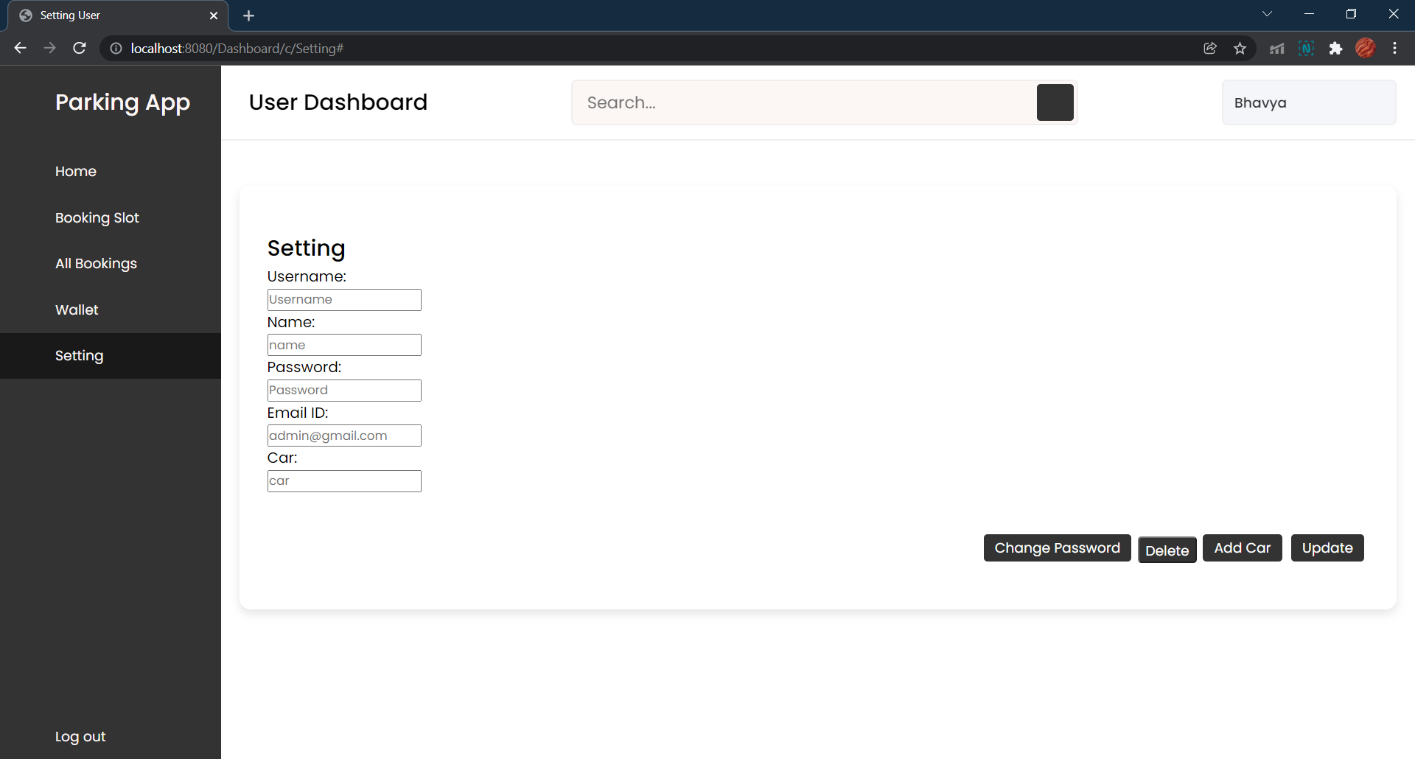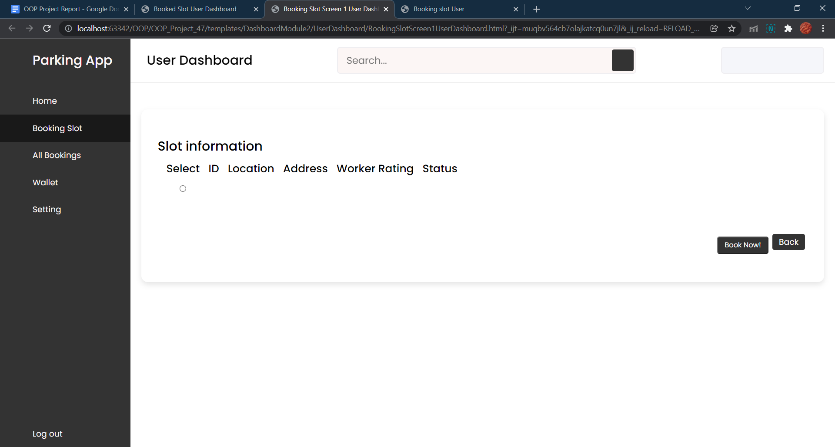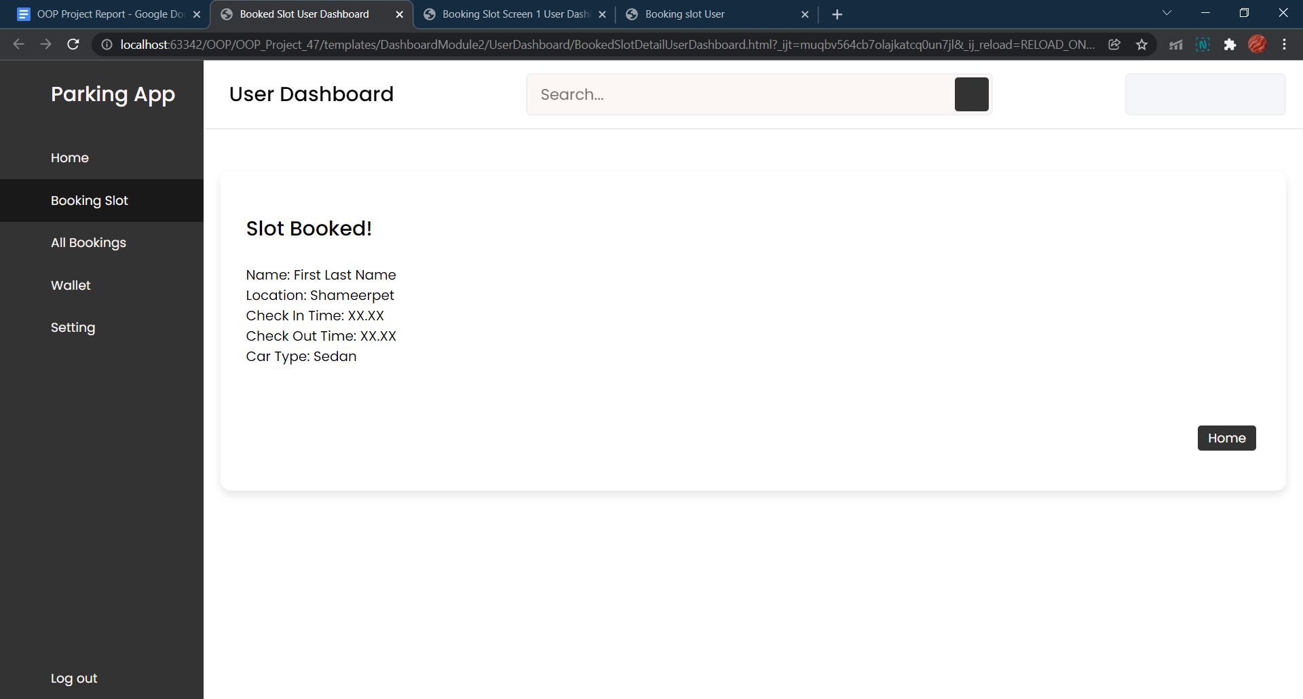

The above pics are the user dashboard, slot booking, wallet of user and user settings.

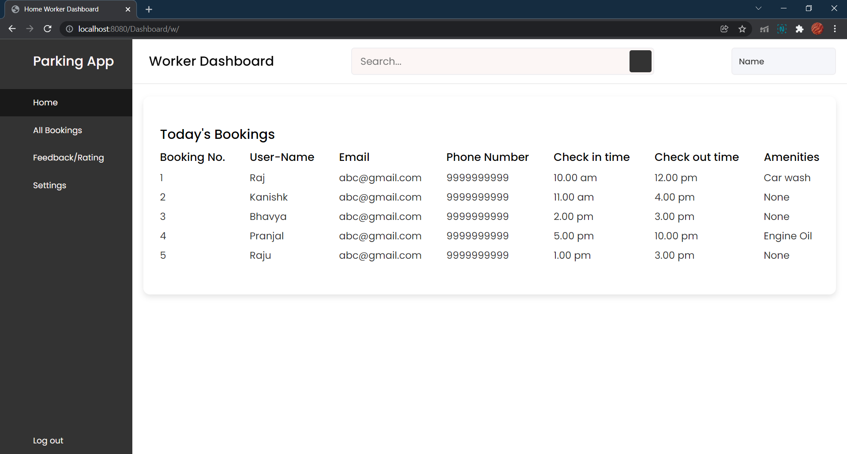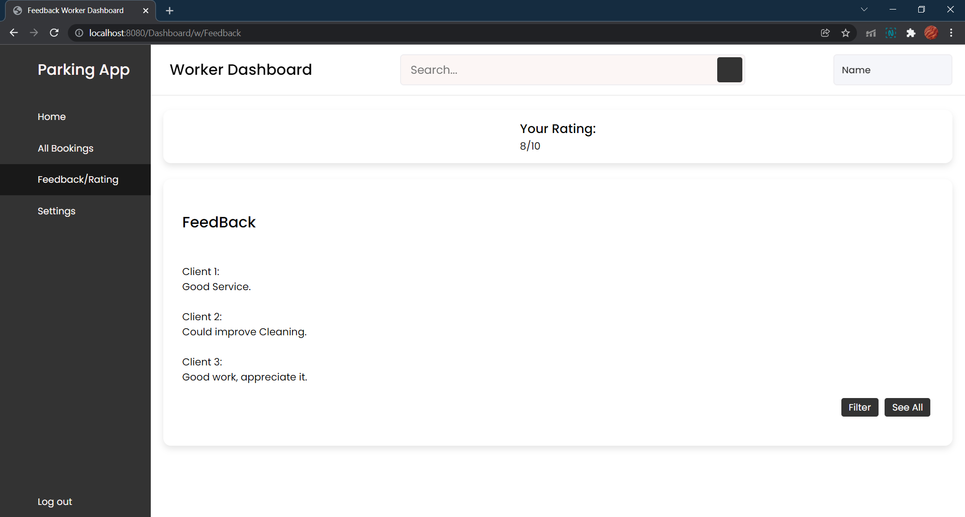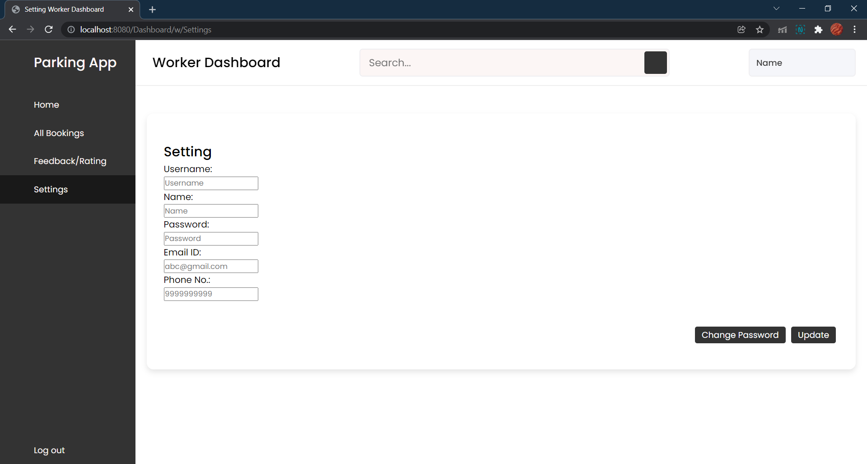

The above pics are worker dashboard, their reviews, reports, and current bookings.

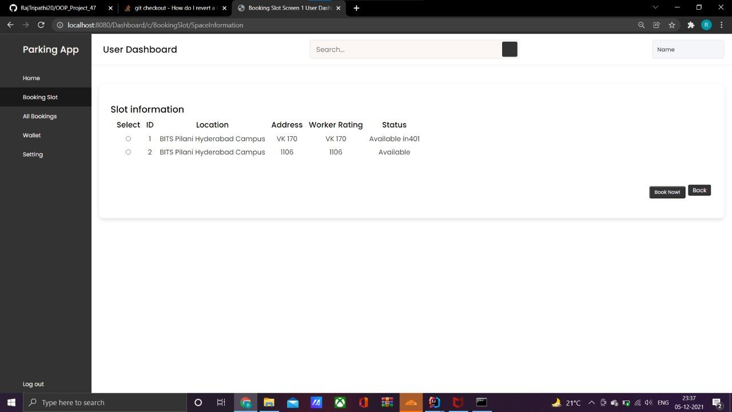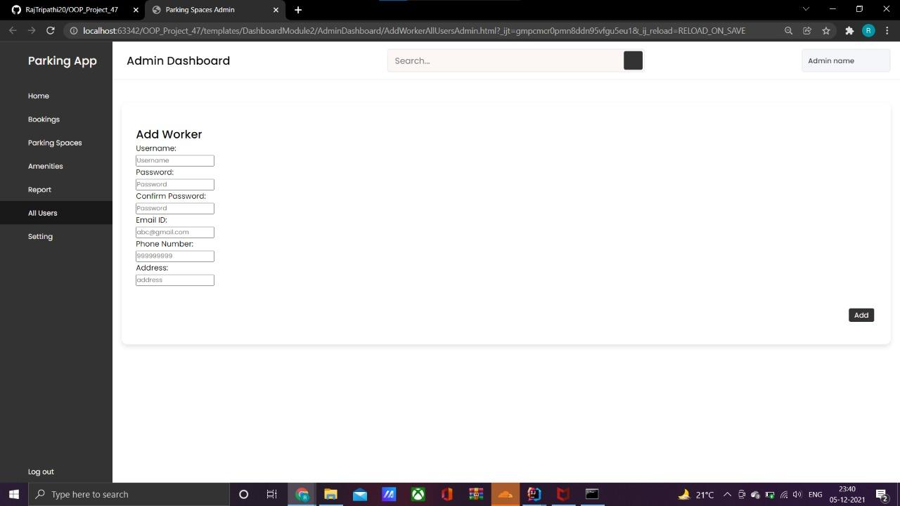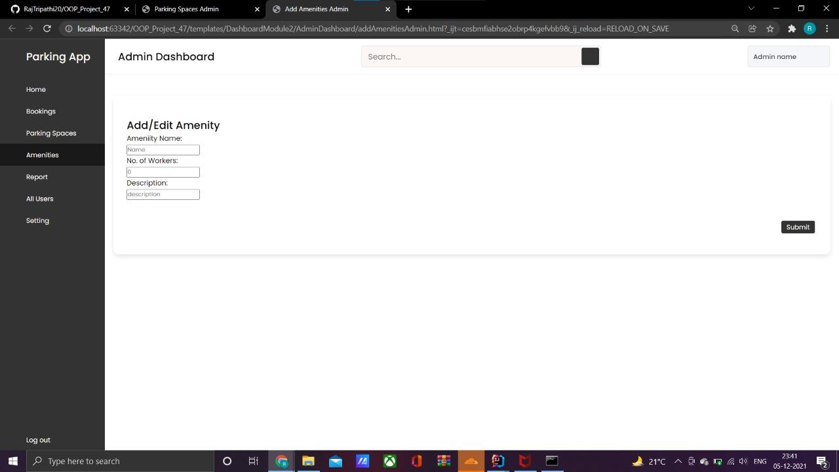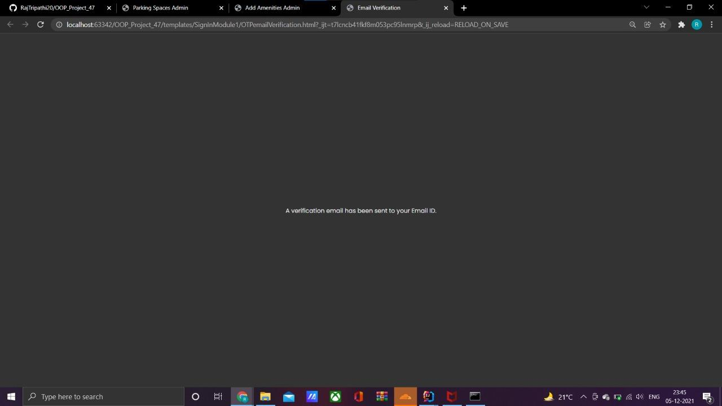

This is mail verification during signup.