**CHAPTER 1**

**INTRODUCTION**

This project gives the values of the resistivity values of the retina through the blood vessels present in the retina.the values are measured using the phenomenon of soil resistivity which is used to measure the resisitivty of the soil.by calculating the retina values the person health can be calculated

**CHAPTER 2**

**Parts of the eye**

The basic parts of the eye are described below:

**Sclera**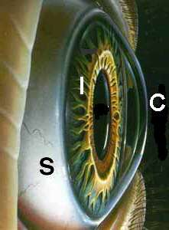

The sclera is the white of the eye. "Don't shoot until you see their scleras."

* Exterior is smooth and white
* Interior is brown and grooved
* Extremely durable
* Flexibility adds strength
* Continuous with sheath of optic nerve
* Tendons attached to it

**The Cornea**

The cornea is the clear bulging surface in front of the eye. It is the main refractive surface of the eye.

* Primary refractive surface of the eye
* Index of refraction: n = 1.37
* Normally transparent and uniformly thick
* Nearly avascular
* Richly supplied with nerve fibers
* Sensitive to foreign bodies, cold air, chemical irritation
* Nutrition from aqueous humor and
* Tears maintain oxygen exchange and water content
* Tears prevent scattering and improve optical quality

**Anterior & Posterior Chambers**

* The anterior chamber is between the cornea and the iris
* The posterior chamber is between the iris and the lens
* Contains the aqueous humor
* Index of refraction: n = 1.33
* Specific viscosity of the aqueous just over 1.0 (like water, hence the name)
* Pressure of 15-18 mm of mercury maintains shape of eye and spacing of the elements
* Aqueous humor generated from blood plasma
* Renewal requires about an hour
* Glaucoma is a result of the increased fluid pressure in the eye due to the reduction or blockage of aqueous from the anterior to posterior chambers.

**Iris/Pupil**

* Iris is heavily pigmented
* Sphincter muscle to constrict or dilate the pupil
* Pupil is the hole through which light passes
* Pupil diameter ranges from about 3-7 mm
* Area of 7-38 square mm (factor of 5)
* Eye color (brown, green, blue, etc.) dependent on amount and distribution of the pigment melanin

**Lens**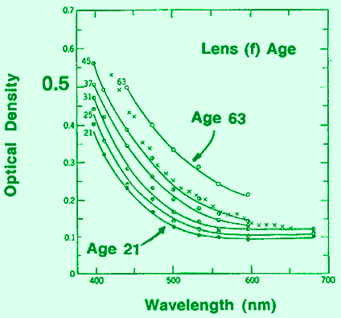

* Transparent body enclosed in an elastic capsule
* Made up of proteins and water
* Consists of layers, like an onion, with firm nucleus, soft cortex
* Gradient refractive index (1.38 - 1.40)
* Young person can change shape of the lens via ciliary muscles
* Contraction of muscle causes lens to bulge
* At roughly age 50, the lens can no longer change shape
* Becomes more yellow with age: Cataracts

The graph on the right shows the optical density (-log transmittance) of the lens as a function of wavelength. The curves show the change in density with age. More short wavelength light is blocked at increases ages.

**Vitreous Humor**

* Fills the space between lens and retina
* Transparent gelatinous body
* Specific viscosity of 1.8 - 2.0 (jelly-like consistency)
* Index of refraction, n=1.33
* Nutrition from retinal vessels, ciliary body, aqueous
* Floaters, shadows of sloughed off material/debris in the vitreous
* Also maintains eye shape

**Retina**

|  |  |
| --- | --- |
| https://www.cis.rit.edu/people/faculty/montag/vandplite/images/chapter_8/retina1.jpg | Notice the orientation of the retina in the eye. The center of the eyeball is towards the bottom of this figure and the back of the eyeball is towards the top. Light enters from the bottom in this figure.The light has to pass through many layers of cells before finally reaching the photoreceptors. The photoreceptors are where the light is absorbed and and transformed into the electrochemical signals used by the nervous system. This change is transduction |

This next picture shows a schematic of the cells in the retina:

|  |  |
| --- | --- |
| Again the light in entering from the bottom passing through all these layers before being absorbed in the receptors.  You can see the two types of receptors: the rod-shaped rods and the cone-shaped cones. The signal, after transduction, is passed to the horizontal cells (H) and the bipolar cells via a layer of connections. Lateral processing takes place in this layer via the horizontal cells. The throughput is transferred to another layer of connections with the amacrine cells (A) and the ganglion cells.The amacrine cells also exhibit lateral connections in this inner plexiform layer. The signals pass out of the eye via the ganglion cell axons which are bundled together to form the optic nerve. | https://www.cis.rit.edu/people/faculty/montag/vandplite/images/chapter_8/retina2.gif |

**Function**

An image is produced by the patterned excitation of the cones and rods in the retina. The excitation is processed by the neuronal system and various parts of the brain working in parallel to form a representation of the external environment in the brain.

The cones respond to bright light and mediate high-resolution colour vision during daylight illumination (also called photopic vision). The rods are saturated at daylight levels and don't contribute to pattern vision. However, rods do respond to dim light and mediate lower-resolution, monochromatic vision under very low levels of illumination (called scotopic vision). The illumination in most office settings falls between these two levels and is called mesopic vision. At these light levels, both the rods and cones are actively contributing pattern information to that exiting the eye. What contribution the rod information makes to pattern vision under these circumstances is unclear.

The response of cones to various wavelengths of light is called their spectral sensitivity. In normal human vision, the spectral sensitivity of a cone falls into one of three subgroups. These are often called blue, green, and red cones but more accurately are short, medium, and long wavelength sensitive cone subgroups. It is a lack of one or more of the cone subtypes that causes individuals to have deficiencies in colour vision or various kinds ofcolour blindness. These individuals are not blind to objects of a particular colour but experience the inability to distinguish between two groups of colours that *can* be distinguished by people with normal vision. Humans have three different types of cones (trichromatic vision) while most other mammals lack cones with red sensitive pigment and therefore have poorer (dichromatic) colour vision. However, some animals have four spectral subgroups, e.g. the trout adds an ultraviolet subgroup to short, medium and long subgroups that are similar to humans. Some fish are sensitive to the polarization of light as well.

When light falls on a receptor it sends a proportional response synaptically to bipolar cells which in turn signal the retinal ganglion cells. The receptors are also 'cross-linked' by horizontal cells and amacrine cells, which modify the synaptic signal before the ganglion cells. Rod and cone signals are intermixed and combine, although rods are mostly active in very poorly lit conditions and saturate in broad daylight, while cones function in brighter lighting because they are not sensitive enough to work at very low light levels.

Although all are nerve cells, only the retinal ganglion cells and few amacrine cells create action potentials. In the photoreceptors, exposure to light hyperpolarizes the membrane in a series of graded shifts. The outer cell segment contains a photopigment. Inside the cell the normal levels of [cyclic guanosine monophosphate](https://en.wikipedia.org/wiki/Cyclic_guanosine_monophosphate)(cGMP) keep the Na+ channel open and thus in the resting state the cell is depolarised. The [photon](https://en.wikipedia.org/wiki/Photon) causes the retinal bound to the receptor protein to [isomerise](https://en.wikipedia.org/wiki/Isomerism) to [trans-retinal](https://en.wikipedia.org/wiki/Retinal). This causes receptor to activate multiple [G-proteins](https://en.wikipedia.org/wiki/G-protein). This in turn causes

the Ga-subunit of the protein to activate a phosphodiesterase (PDE6), which degrades cGMP, resulting in the closing of Na+ [cyclic nucleotide-gated ion channels](https://en.wikipedia.org/wiki/Cyclic_nucleotide-gated_ion_channel) (CNGs). Thus the cell is hyperpolarised. The amount of neurotransmitter released is reduced in bright light and increases as light levels fall. The actual photopigment is bleached away in bright light and only replaced as a chemical process, so in a transition from bright light to darkness the eye can take up to thirty minutes to reach full sensitivity (see [Adaptation (eye)](https://en.wikipedia.org/wiki/Adaptation_(eye))).

In the retinal ganglion cells there are two types of response, depending on the [receptive field](https://en.wikipedia.org/wiki/Receptive_field) of the cell. The receptive fields of retinal ganglion cells comprise a central approximately circular area, where light has one effect on the firing of the cell, and an annular surround, where light has the opposite effect on the firing of the cell. In ON cells, an increment in light intensity in the centre of the receptive field causes the firing rate to increase. In OFF cells, it makes it decrease. In a linear model, this response profile is well described by a [difference of Gaussians](https://en.wikipedia.org/wiki/Difference_of_Gaussians) and is the basis for [edge detection](https://en.wikipedia.org/wiki/Edge_detection) algorithms. Beyond this simple difference ganglion cells are also differentiated by chromatic sensitivity and the type of spatial summation. Cells showing linear spatial summation are termed X cells (also called parvocellular, P, or midget ganglion cells), and those showing non-linear summation are Y cells (also called magnocellular, M, or parasol retinal ganglion cells), although the correspondence between X and Y cells (in the cat retina) and P and M cells (in the primate retina) is not as simple as it once seemed.

In the transfer of visual signals to the brain, the [visual pathway](https://en.wikipedia.org/wiki/Visual_pathway), the retina is vertically divided in two, a temporal (nearer to the temple) half and a nasal (nearer to the nose) half. The axons from the nasal half cross the brain at the [optic chiasma](https://en.wikipedia.org/wiki/Optic_chiasma) to join with axons from the temporal half of the other eye before passing into the [lateral geniculate body](https://en.wikipedia.org/wiki/Lateral_geniculate_body).

Although there are more than 130 million retinal receptors, there are only approximately 1.2 million fibres (axons) in the optic nerve; a large amount of pre-processing is performed within the retina. The [fovea](https://en.wikipedia.org/wiki/Fovea_centralis) produces the most accurate information. Despite occupying about 0.01% of the visual field (less than 2° of [visual angle](https://en.wikipedia.org/wiki/Visual_angle)), about 10% of axons in the optic nerve are devoted to the fovea. The resolution limit of the fovea has been determined at around 10,000 points.[[*clarification needed*](https://en.wikipedia.org/wiki/Wikipedia:Please_clarify)] See [visual acuity](https://en.wikipedia.org/wiki/Visual_acuity). The information capacity is estimated at 500,000 bits per second (for more information on bits, see [information theory](https://en.wikipedia.org/wiki/Information_theory)) without colour or around 600,000 bits per second including colour.

**Importance of retina**

Most people have heard of the retina, but do they really know what this part of the eye is and what it does? The retina is a tissue that lines the inside of the eye. This tissue is light sensitive, which is vital for sight. The retina itself is made of multiple layers of neurons. The photoreceptor cells, which are commonly referred to as rods and cones, are the only neurons that are light sensitive. The rods and cones act as receptors that send information to the other neurons to process light.

**How the Retina Sees**

Other parts of the eye take in light, which forms an image projected on the retina. In a way, it could be viewed like a projector and a movie screen. The world projects images and the retina captures them for the eye and brain to process. The optic nerve serves as a link between the eye and the brain, so the images get to the right places.

**Retina Health and Risks**

Just like any other part of the body, the retina is susceptible to certain diseases and conditions. Since the retina plays an integral role in the sense of sight, a problem can hinder the patient’s ability to see and process images. Some conditions are inherited. For example, Retinitis pigmentosa develops as a result of genetics. This term refers to an entire group of diseases that impact the retina and lead to a loss of peripheral and night vision. Retinoblastoma refers to cancer that develops in the retina while macular degeneration causes central vision blindness.

**Treating Retina Conditions**

Retina conditions are caused by many different things. In order to treat a retina problem, the individual condition must be evaluated. If you suspect a problem with your eyes, make an appointment with a physician right away. Only a trained medical professional can accurately diagnose the problem and provide a safe treatment plan.

Your retina is a very important part of your eyes. Without the retina, the entire process of seeing would be hindered. Have problems checked out as soon as you notice a change in your eyes. You may be able to correct the problem or find a way to live with it.

**CHAPTER 3**

**Connection from eye to brain**

# The Optic Nerve And Its Visual Link To The Brain:

The optic nerve, a cable–like grouping of nerve fibers, connects and transmits visual information from the eye to the brain. The optic nerve is mainly composed of retinal ganglion cell (RGC) axons. In the human eye, the optic nerve receives light signals from about 125 million photoreceptor cells (known as rods and cones) via two intermediate neuron types, bipolar and amacrine cells. In the brain, the optic nerve transmits vision signals to the lateral geniculate nucleus (LGN), where visual information is relayed to the visual cortex of the brain that converts the image impulses into objects that we see.  
[](https://i2.wp.com/discoveryeye.org/wp-content/uploads/Optic-nerve.jpg)

In the retinal tissues of the eye, more than 23 types of RGCs vary significantly in terms of their morphology, connections, and responses to visual stimulation. Those visual transmitting RGCs are the neuronal cells. They all share the defining properties of:

1. possessing a cell body (soma) at the inner surface of the retina
2. having a long axon that extends into the brain via the optic chiasm and the optic tract
3. synapsing with the LGN. The RGCs form multiple functional pathways within the optic nerve to mediate the visual signal

Human beings can see three primary colors: red, green, and blue. This is due to our having three different kinds of color sensitive cone cells: red cones, green cones, and blue cones.

The RGCs connecting to the red and green cones are midget RGCs. They are mainly located at the center of the retina (known as fovea). A single midget RGC communicates with as few as five photoreceptors. They transmit red-green color signals to the parvocellular layer in the LGN (see Figure). The midget-parvocellular pathway responds to color changes, but has little or no response to contrast change. This pathway has center-surround receptive fields, and slow conduction velocities. Because of this pathway, we can see objects precisely in detail and in full color.  
[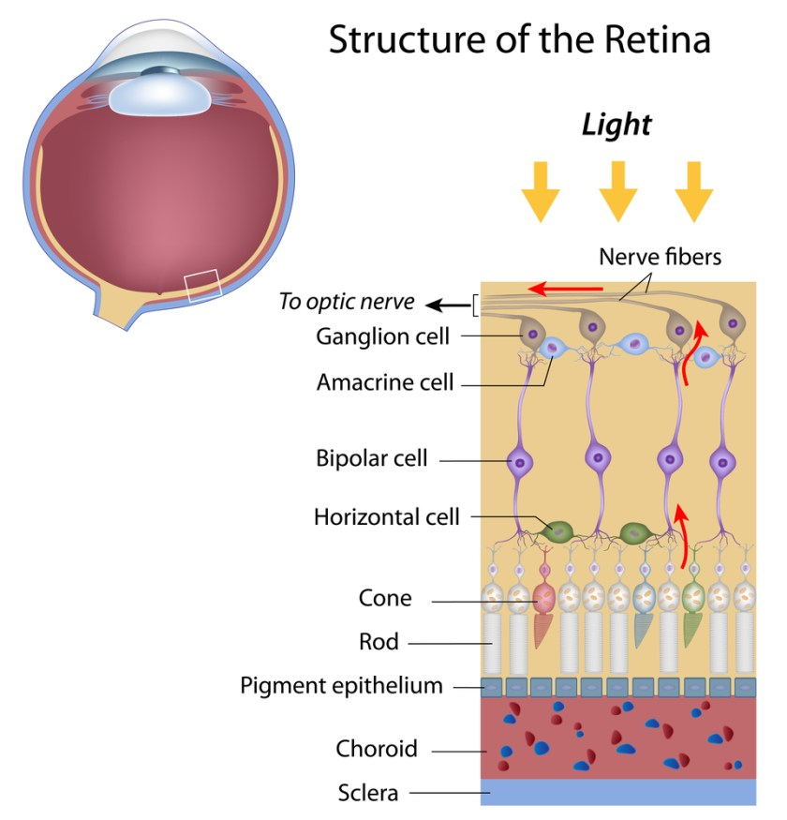](https://i0.wp.com/discoveryeye.org/wp-content/uploads/Retina-and-light.jpg)

The bistratified RGCs are likely involved in blue color vision. Bistratified cells receive visual information input originally from an intermediate numbers of cones and rods. The bistratified RGCs connect to the koniocellular layers in the LGN (see Figure). The koniocellular neurons form robust layers throughout the visual hemifield and have moderate spatial resolution, moderate conduction velocities, and can respond to moderate-contrast stimuli. They have very large receptive fields that only possess on-center regions (no off-surround regions).

Objects can be seen in the dark with motion and coarse outlines accentuated due to the parasol RGCs. At the periphery of the retina, a single parasol RGC connects to many thousands of photoreceptors (many rods and few cones).

The parasol RGCs project their axons to the magnocellular layers of the LGN (see Figure) and are primarily concerned with visual perception. They have fast conduction velocities, can respond to low-contrast stimuli, but are not very sensitive to changes in color.

Finally, humans can see objects in three-dimension courtesy of the crossing over of optic nerve fibers at the optic chiasm. This anatomic structure allows for the human visual cortex to receive the same hemispheric visual field from both eyes (see Figure), thus making it possible for the visual cortex to generate binocular and stereoscopic vision.

Recently, a new type of RGC, called photosensitive RGCs, was discovered. The photosensitive RGCs contribute minimally to our vision, but play a key role in vision regulation. Photosensitive RGCs axons do not have connections to the LGN, but form the retino-hypothalamic tract, and synapse to three other locations in the brain for specific vision regulation functions:

1. Pretectal nucleus: involved in reflexive eye movements, thereby helping to target what we want to see
2. Midbrain nuclei: involved in controlling the size of the pupil, thus helping to adjust the brightness of objects; and coordinating movement of the eye for focusing
3. Suprachiasmatic nucleus: involved in regulating the sleep-wake cycle

A fully functional optic nerve is essential for vision. Obviously, any damage of the optic nerve will sever the precise transmission of visual information between the retina and brain, directly leading to vision distortion and/or vision loss. Damage to the optic nerve can result from:

1. Direct/indirect physical damage (e.g. ocular trauma)
2. Acute/sub-acute physiological lesion (e.g. infection or inflammation, or malignancy (cancer))
3. Chronic neuronal degeneration (e.g. glaucoma, a most common cause of optic nerve damage)

Moreover, the optic nerve is also a very important vivo model for studying central nervous protection and regeneration. At the cell biology level, the RGC axons are covered with myelin produced by oligodendrocytes (rather than Schwann cells of the peripheral nervous system) after exiting the eye on their way to the LGN and thus part of the central nervous system.

Scientists have recently acquired more and more evidence that certain types of damage to the optic nerve may be reversible in the future. Therefore, the optic nerve provides a potential window to explore more complicated neuronal degenerative diseases, such as Alzheimer’s disease and Huntington disease.

**CHAPTER 4**

**Resistivity**

**Introduction**

Resistivity is a measure of the resistance of a given size of a specific material to electrical conduction.

Although materials resist the flow of electrical current, some are better at conducting it than others. The resistivity is a figure that enables comparisons of the way in which different materials allow or resist current flow.

To enable resistivity figures to be meaningful, specific units are used for resistivity, and there are formulas for calculating it and relating it to the resistance in Ohms for a given size of material.

Materials that conduct electrical current easily are called conductors and have a low resistivity. Those that do not conduct electricity easily are called insulators and these materials have a high resistivity.

**Resistivity definition and units**

The electrical resistivity of a specimen of a material may also be known as its specific electrical resistance. It is a measure of how strongly a material opposes the flow of electric current.

**Resistivity definition:**

The resistivity of a substance is the resistance of a cube of that substance having edges of unit length, with the understanding that the current flows normal to opposite faces and is distributed uniformly over them.

The electrical resistivity is the electrical resistance per unit length and per unit of cross-sectional area at a specified temperature.

The SI unit of electrical resistivity is the ohm⋅metre (Ω⋅m). It is commonly represented by the Greek letter ρ, rho.

Although the SI resistivity unit, the ohms metre is generally used, sometimes figures will be seen described in terms of ohms centimetres, Ω⋅cm.

**Resistivity formula / equation**

The resistivity of a material is defined in terms of the magnitude of the electric field across it that gives a certain current density. It is possible to devise an electrical resistivity formula.

Ρ = EJρ = EJ

Where,  
    ρ is the resistivity of the material in ohm metres, (Ω⋅m)  
    E is the magnitude of the electric field in volts per metre, (V⋅m^-1)  
    J is the magnitude of the current density in amperes per square metre, (A⋅m^-2)

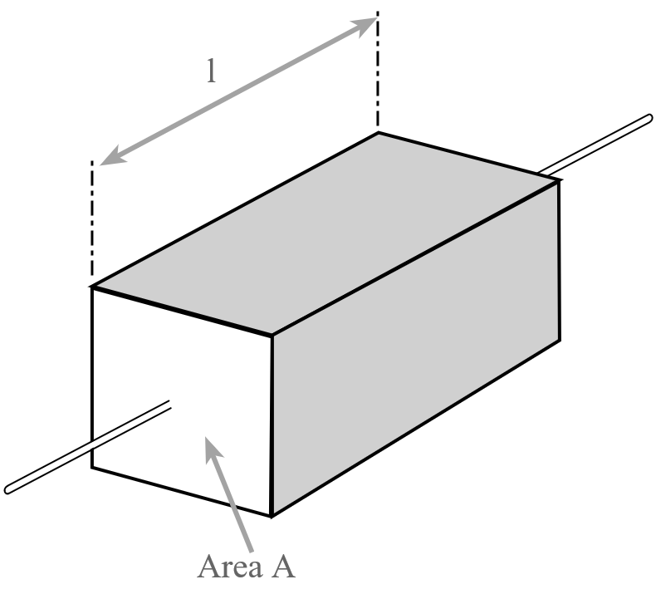

**Resistivity of a material**

Many resistors and conductors have a uniform cross section with a uniform flow of electric current. It is therefore possible to create the more specific, but more widely used electrical resistivity formula or equation:

Ρ = RAlρ = RAl

Where,  
    R is the electrical resistance of a uniform specimen of the material measured in ohms  
  l is the length of the piece of material measured in metres, m  
    A is the cross-sectional area of the specimen measured in square metres, m^2

**Material resistivity levels**

Materials are put into different categories according to their level or resistivity. A summary is given in the table below.

| **RESISTIVITY REGIONS FOR DIFFERENT CATEGORIES OF MATERIALS** | | |
| --- | --- | --- |
| **MATERIAL TYPE** | **RESISTIVITY REGION** |  |
| Electrolytes | Variable**\*** |  |
| Insulators | ~10^16 |  |
| Metals | ~10^-8 |  |
| Semiconductors | Variable**\*** |  |
| Superconductors | 0 |  |

**\***The level of conductivity of semiconductors is dependent upon the level of doping. With no doping they appear almost like an insulator, but with doping charge carriers are available and the resistivity falls dramatically. Similarly for electrolytes, the level of resistivity varies widely.

Electrical resistivity is a key parameter for material that are to be used with electrical and electronic systems. Those substances with a high electrical resistivity are termed insulators and can be used for this purpose. This with a low level of electrical resistivity are good conductors and can be used in a host of applications from wire, to electrical connections and much more.

**Difference Between Resistance & Resistivity**

One of the major difference between the resistance and the resistivity of the material is that the resistance opposes the flow of free electrons whereas the resistivity is the property of the material which defines the resistance of the material having specific dimension. The other differences between them are explained below in the comparison chart.

Comparison Chart

| **Basis For Comparison** | **Resistance** | **Resistivity** |
| --- | --- | --- |
| Definition | Property of substance due to which it opposes the flow of electrons. | It is defined as the resistance of material having specific dimensions. |
| Formula | [equation-1](https://circuitglobe.com/wp-content/uploads/2017/02/equaiton-1.jpg) | [equation-2](https://circuitglobe.com/wp-content/uploads/2017/02/equation-2.jpg) |
| SI Unit | Ohms | Ohms-meter |
| Symbol | R | Ρ |
| Dependence | Length, cross-section area of conductor and temperature. | Temperature |

While comparing,

**Definition of Resistance**

The resistance is the property of the material which creates an obstruction in the flow of the current. When the voltage is applied across the conductor, the free electrons starts moving in a particular direction. While moving these electrons collapse with atoms or molecules and hence produce heat. These atoms or molecules oppose the movement of free electrons in a material.

[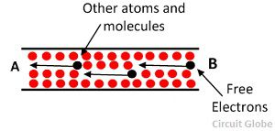](https://circuitglobe.com/wp-content/uploads/2017/02/resistance.jpg)

This opposition is known as the resistance. It is represented by the formula

[equation-1](https://circuitglobe.com/wp-content/uploads/2017/02/equaiton-1.jpg)

Where,

l – length of the conductor  
a – cross section area of the conductor  
ρ – resistivity of the material.

The SI unit of the material is ohms, and it is denoted by Ω at kΩ.

**Factors Affecting Resistance**

The resistance of the wire depends on the following factors.

1. The resistance of the wire increases with the length of the conductor.
2. It is inversely proportional to the cross section area of the conductor.
3. It depends on the material of the wire.
4. The resistance of the material depends on their temperature.

## Definition of Resistivity

The resistivity is also known as specific resistance. The resistivity represents the resistance of the material which has specific dimensions, i.e., the material has 1-meter length and 1 square meter area of cross section.

[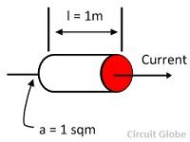](https://circuitglobe.com/wp-content/uploads/2017/02/specific-resistance.jpg)

The formula represents the resistivity of the material

[equation-2](https://circuitglobe.com/wp-content/uploads/2017/02/equation-2.jpg)

Where l – length of the conductor  
a – cross-section area of conductor  
R – Resistance of the material

The SI unit of resistivity is ohm meter. The resistivity is directly proportional to the temperature of the material.The resistivity of the cube having one-meter side is defined as the resistance offered between the opposite two phases of the one-meter cube. 

**Main Differences between Resistance and Resistivity**

1. The resistance is the property of the material which obstructs the flow of current, whereas the resistivity gives the resistance of the material which has fixed dimension.
2. The resistance is the ratio of the length and cross-section area of the conductor, whereas the resistivity of the material is the ratio of the product of the resistance and area to the length of the conductor.
3. The resistance is represented by the symbol R whereas the resistivity is represented by the symbol ρ.
4. The SI unit of the resistance is ohm, and the SI unit of resistivity is ohm-meter.
5. The resistance of the material depends on the length, cross-section and area of conductor whereas the resistivity depends on the nature and temperature of the material.
6. The inverse of the resistivity is known as the conductivity of the material.

**CHAPTER 5**

**Methods of resistivity**

**Four probe resistivity method**

At a constant temperature, the resistance, R of a conductor is proportional to its length L and inversely proportional to its area of cross section A.

http://vlab.amrita.edu/userfiles/1/image/four%20probe/four1.JPG  (1)

Where ρ is the resistivity of the conductor and its unit is ohmmeter.

A semiconductor has electrical conductivity intermediate in magnitude between that of a conductor and insulator. Semiconductor differs from metals in their characteristic property of decreasing electrical resistivity with increasing temperature.

According to band theory, the energy levels of semiconductors can be grouped into two bands, valence band and the conduction band. In the presence of an external electric field it is electrons in the valence band that can move freely, thereby responsible for the electrical conductivity of semiconductors.

In case of intrinsic semiconductors, the Fermi level lies in between the conduction band minimum and valence band maximum. Since conduction band lies above the Fermi level at 0K, when no thermal excitations are available, the conduction band remains unoccupied. So conduction is not possible at 0K, and resistance is infinite. As temperature increases, the occupancy of conduction band goes up, thereby resulting in decrease of electrical resistivity of semiconductor.

**Resistivity of semiconductor by four probe method**

1. The resistivity of material is uniform in the area of measurement.  
2. If there is a minority carrier injection into the semiconductor by the current- carrying electrodes most of the carriers recombine near electrodes so that their effect on conductivity is negligible.   
3. The surface on which the probes rest is flat with no surface leakage.  
4. The four probes used for resistivity measurement contact surface at points that lie in a straight line.  
5. The diameter of the contact between metallic probes and the semiconductor should be small compared to the distance between the probes.  
6. The boundary between the current carrying electrodes and the bulk material is hemispherical and small in diameter.   
7. The surface of semiconductor material may be either conducting and non-conducting. A

conducting boundary is one on which material of much lower resistivity than semiconductor has been plated. A non-conducting boundary is produced when the surface of the semiconductor is in contact with insulator.

Fig: 2 show the resistivity probes on a die of material. If the side boundaries are adequately far from the probes, the die may be considered to be identical to a slice. For this case of a slice of thickness w and the resistivity is computed as

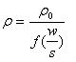   (2)

The function, f(w/S) is a divisor for computing resistivity which depends on the value of w and S

We assume that the size of the metal tip is infinitesimal and sample thickness is greater than the distance between the probes,

http://vlab.amrita.edu/userfiles/1/image/four%20probe/four3.JPG      (3)

Where

V – the potential difference between inner probes in volts.  
 I – Current through the outer pair of probes in ampere.  
 S – Spacing between the probes in meter.

**Temperature dependence of resistivity of semiconductor**

Total electrical conductivity of a semiconductor is the sum of the conductivities of the valence band and conduction band carriers. Resistivity is the reciprocal of conductivity and its temperature dependence is given by

http://vlab.amrita.edu/userfiles/1/image/four%20probe/four5.JPG     (4)

Where

Eg – band gap of the material  
T – Temperature in kelvin  
K – Boltzmann constant, K – 8.6x10-5 eV/K  
The resistivity of a semiconductor rises exponentially on decreasing the temperature.   
  