DBMS LAB



Name: BHAWANA

Registration ID: 2021PGCACA011

Course: MCA 3rd Semester

Date: 19-08-2022

# Instructor- D.A. KHAN SIR

***Assignment***

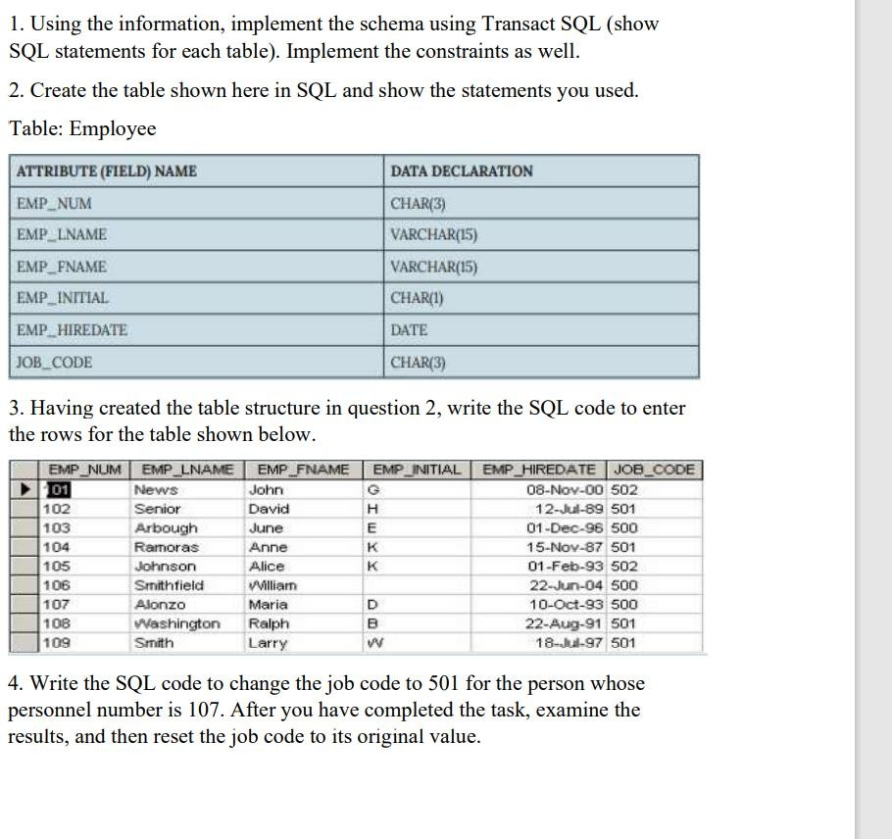

# Question :-

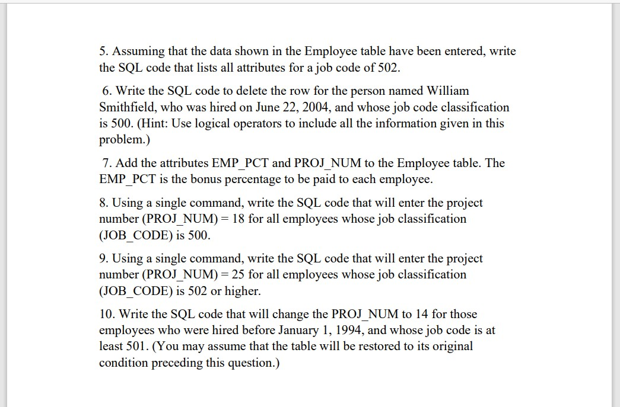

ANSWER 2: CREATE INTO TABLE.

create table Employee( EMP_NUM CHAR(3), EMP_LNAME VARCHAR(15), EMP_FNAME VARCHAR(15), EMP_INITIAL CHAR(1), EMP_HIREDATE DATE, JOB_CODE CHAR(3)

);

ANSWER 3: INSERT INTO TABLE .

INSERT INTO Employee VALUES( 102,'Senior','David','H','89-07-12',501

);

INSERT INTO Employee VALUES( 103,'Arbough','june','E','96-12-01',500

);

INSERT INTO Employee VALUES( 104,'Ramoras','Anne','K','87-11-15',501

);

INSERT INTO Employee VALUES( 105,'Johnson','Alice','k','93-02-01',502

);

INSERT INTO Employee VALUES(

106,'Smithfield','William',' ','04-11-08',500

);

INSERT INTO Employee VALUES( 107,'Alonzo','Maria','D','93-11-10',500

);

INSERT INTO Employee VALUES(

108,'Washington','Ralph','B','91-07-22',501

);

INSERT INTO Employee VALUES( 109,'Smith','Larry','W','97-07-18',501

);

.TABLE:-

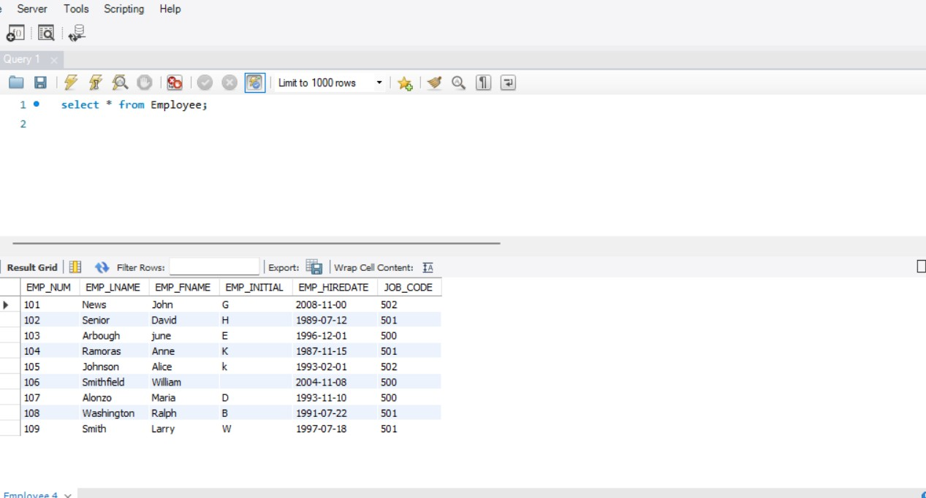

ANSWER 4:

UPDATE Employee SET JOB_CODE=501 where EMP_NUM=107;

ANSWER 5:

SELECT * FROM Employee WHERE JOB_CODE=502;

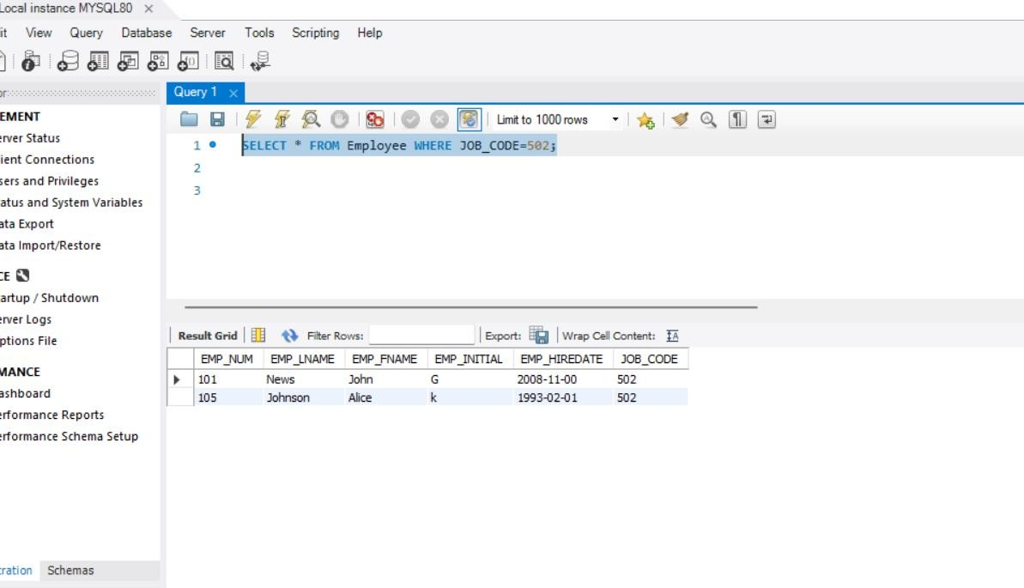

ANSWER : 6

ELETE FROM Employee WHERE EMP_LNAME='William' || EMP_HIREDATE='04-11-08' || JOB_CODE=500;

ANSWER :7

* ALTER TABLE Employee ADD EMP_PCT INT;
* ALTER TABLE Employee ADD PROJ_NUM INT;

OUTPUT:-

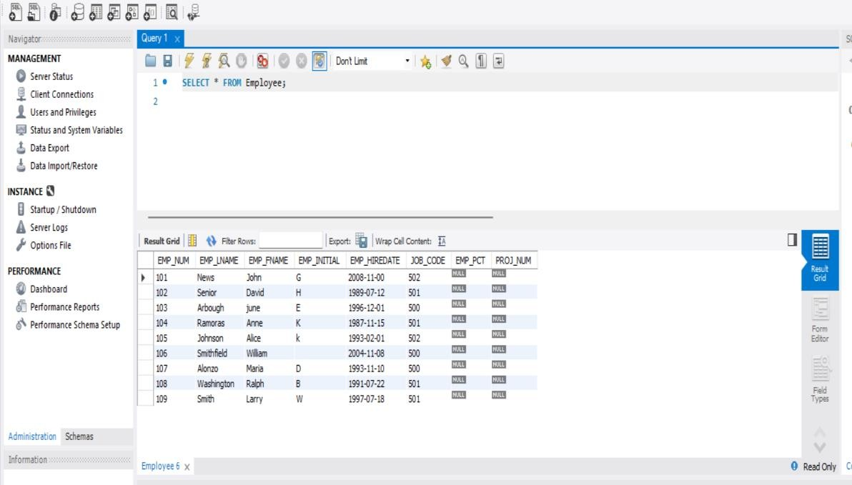

ANSWER 8:

UPDATE Employee SET PROJ_NUM = 18 where JOB_CODE = '500';

SELECT * FROM Employee;

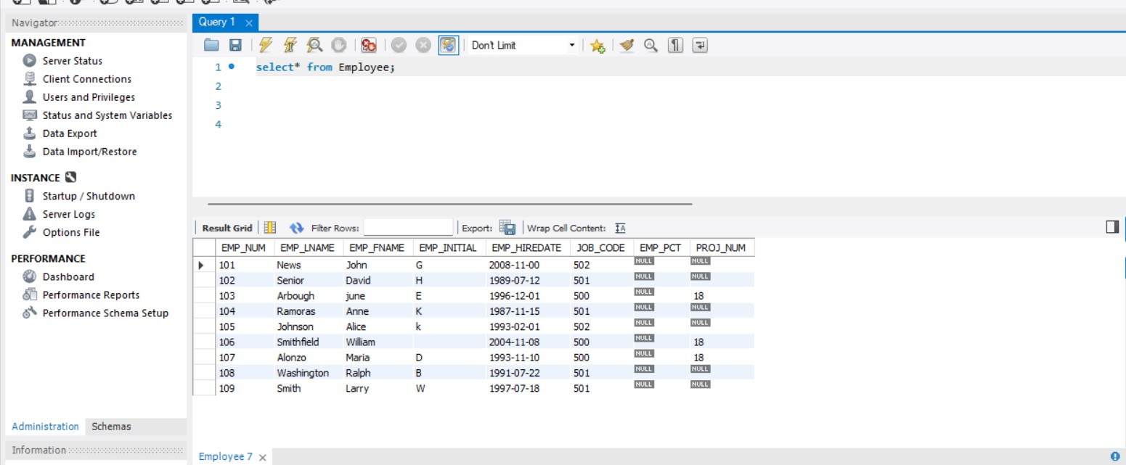

ANSWER 9:

UPDATE Employee SET PROJ_NUM = 25 where JOB_CODE >= '502';

SELECT * FROM Employee;

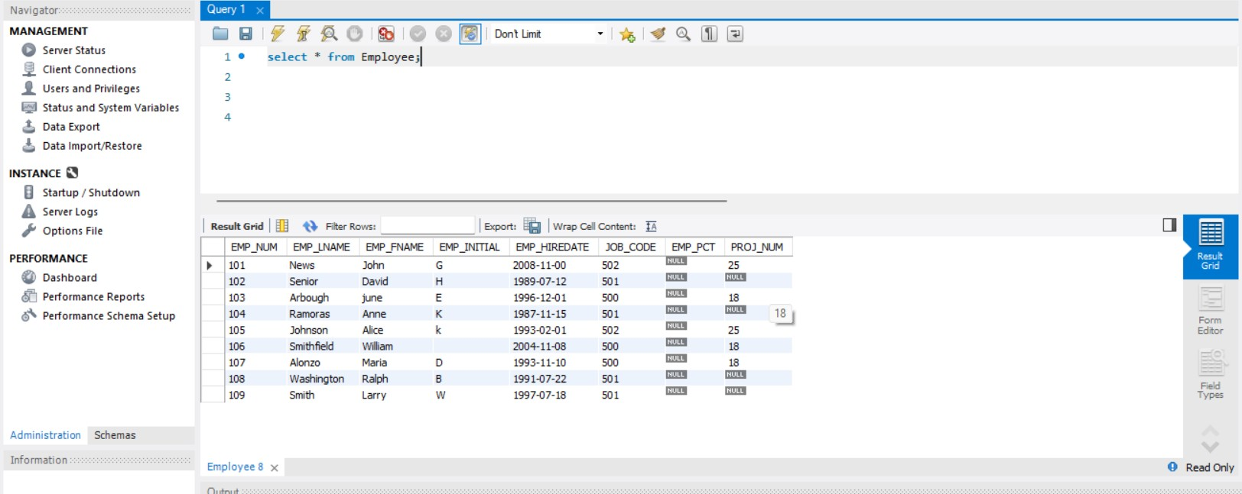

ANSWER 10:

UPDATE Employee SET PROJ_NUM = 14 where EMP_HIREDATE

< '1994-01-01' AND JOB_CODE >= '501';

SELECT * FROM Employee;

