**Study of different cloud initiatives**

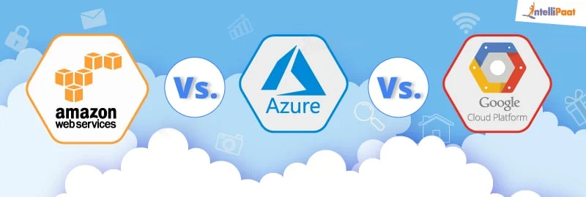

**INTRODUCTION**

Cloud computing is the delivery of on-demand computing services -- from applications to storage and processing power -- typically over the internet .

**What is meant by cloud platform?**

The hardware and operating environment of a server in an Internet-based datacenter. The system software components (OS, virtual machine monitor, etc.)The software infrastructure for a cloud computing service, which includes applications that let users create and manage their own accounts.

**What are the different types of cloud computing services?**

Cloud computing types are service deployment models that let you choose the level of control over your information and types of services you need to provide. There are three main types of cloud computing services, sometimes called the cloud computing stack because they build on top of one another.

The first cloud computing type is infrastructure-as-a-service (IaaS), which is used for Internet-based access to storage and computing power. The most basic category of cloud computing types, IaaS lets you rent IT infrastructure - servers and virtual machines, storage, networks, and operating systems - from a cloud provider on a pay-as-you-go basis.

The second cloud computing type is platform-as-a-service (PaaS) that gives developers the tools to build and host web applications. PaaS is designed to give users access to the components they require to quickly develop and operate web or mobile applications over the Internet, without worrying about setting up or managing the underlying infrastructure of servers, storage, networks, and databases.

The third cloud computing type is software-as-a-service (SaaS) which is used for web-based applications. SaaS is a method for delivering software applications over the Internet where cloud providers host and manage the software applications making it easier to have the same application on all of your devices at once by accessing it in the cloud.

**AWS Vs Azure Vs Google Cloud: Establishment**



Amazon Web Services

Amazon Web Services is a subsidiary of amazon.com, which provides an on-demand Cloud Computing platform to individuals, companies, and governments on a paid-subscription basis.

Amazon Web Services is the oldest and the most experienced player in the cloud market. As one of the oldest cloud providers, it has established a bigger user base, as well as bigger trust and reliability factors.

AWS was publicly launched in 2006 with service offerings such as Elastic Compute Cloud (EC2), Simple Storage Service (Amazon S3), etc. By 2009, Elastic Block Store (EBS) was made public and services such as Amazon CloudFront, Content delivery network (CDN), and more formally joined the AWS Cloud Computing Service offerings.

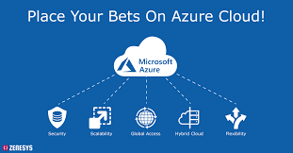

Microsoft Azure

Microsoft Azure, initially called Azure, was launched in 2010 with the intent to provide a competent Cloud Computing platform for businesses. Azure was renamed as ‘Microsoft Azure’ in 2014, though the name ‘Azure’ is still commonly used. Since its inception, Microsoft Azure has shown a great progress among its competitors.



Google Cloud Platform

Google Cloud Platform (GCP), which is offered by Google, is a suite of Cloud Computing services that runs on the same infrastructure that Google uses internally for its end-user products such as Google Search engine, YouTube, and more.

Google Cloud Platform began its journey in 2011, and in less than a decade it has managed to create a good presence in the cloud industry. The initial intent of Google Cloud was to strengthen Google’s own products such as Google Search engine and YouTube. But now, they have also introduced their enterprise services so that anyone can use Google Cloud Platform which shares the same infrastructure as that of Google Search or YouTube.

**AWS Vs Azure Vs Google Cloud: Availability Zones**

It has been already established that AWS was the earliest in the cloud domain which means that they have had more time to establish and expand their network.

AWS has 66 availability zones with 12 more on the way.

Azure has 54 regions worldwide and is available in 140 countries all around the world.

Google Cloud Platform has been made available in 20 regions around the world with 3 more on their way.

Moving on with this Azure vs AWS vs Google Cloud blog, let’s look into the market shares and growth rate of each of these cloud providers.

AWS Vs Azure Vs Google Cloud: Market Shares and Growth Rate

In terms of cloud market, AWS has been on the top for as long as anyone can remember.

⦁ AWS is leading with around 30 percent of public cloud share in its name.

⦁ Microsoft Azure is in the second place, owning around 16 percent of the worldwide market share.

⦁ Google, on the third place, owns up to 10 percent of the market share worldwide.

**AWS Vs Azure Vs Google Cloud: Key Takeaways!**

Now, lets wrap up this Azure vs AWS vs Google Cloud blog and take a look at the most significant pros and cons of these three cloud giants.

So which cloud provider would be claimed the winner for all the factors that have been discussed above?

⦁ Establishment: With a head start of 5 years, the winner here is AWS.

⦁ Availability zones: With a greater number of regions and availability zones, the winner here is AWS.

⦁ Market shares: With around one-third of market shares in its name, the winner here is AWS.

⦁ Growth rate: Having a growth rate of almost 100 percent, the winner is GCP.

⦁ Who uses them: With various high-end customers using all the three cloud platforms, it's a tie!

⦁ Services:

When it comes to the number of services, the winner is AWS.

Regarding the integration with open-source and on-premise systems,such as MS tools, that are mostly used in almost all organizations, the winner is Azure.

⦁ Pricing Models: With more customer-friendly pricing models and discount models, the winner here is Google Cloud.