Professor As a Service

Digital Platform

Simran Nagpurkar - 002922747

Bhakti Ukey - 002922939

Bhawana Agrawal - 002938098

Table of Contents

Introduction 3

Architectural diagram 4

Sequence Diagram 4

Class diagram of the application 5

UI of the Professor as a Service model 7

Conclusion 11

# Introduction

Over the years, our world and daily lives have been revolutionized by technological advancements. As we are in the digital era, everything is evolving and becoming virtual, which has paved the path for multifunctional devices, making resources more accessible. Education is one of them. No physical presence of the professor and students is required to get a better education. We have designed the Professor-As-a-Service model, keeping this in mind and making the quality of education accessible to a broader part of society.

In this model, the professor is responsible for everything a university does, say managing students, fees, courses, schedules, and even degrees. Each professor offers the lessons as per their expertise and sets the price depending on the number of students enrolled, making it affordable. Furthermore, we have maintained the professor's reputation index and their course. The "Reputation Index" is a parameter representing the course's quality, making it easier for the students to decide which course/professor is the best fit.

We have conditioned the reputation index as an average of three things:

1. Professors' expertise and experience in the field,

2. Feedback from previous students, and

3. Course affordability

Each of the parameters is then averaged and considered out of 10.

The price parameter is decided based on the number of students enrolled. The number of students per lecture and the fee for the same would be within the set limit, avoiding any exploitation of the resources and quality.

We have also kept track of student performance via our dashboard, where a professor can access students' profiles and compare their relative performance to other students and subjects.

Below are the UML diagrams and performance metrics to get the gist of this model.

# Architectural diagram

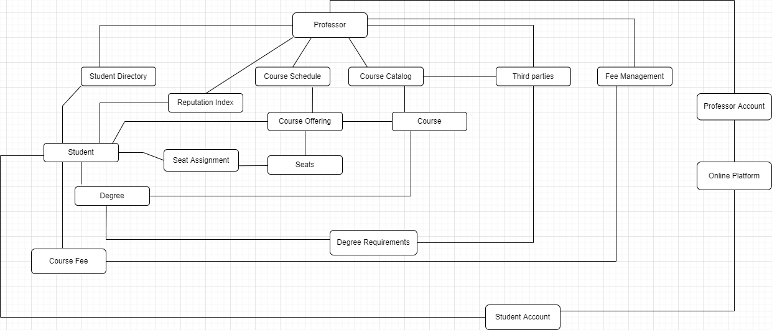

In addition to the details mentioned above, the degree to the student is approved by a third party based on the minimum requirements set by the professor and based on the industry standards.

# Sequence Diagram

The below diagram explains how the professor and other resources (students and third parties) work together.

# Class diagram of the application

The above class diagram comprises class attributes – variables and methods, representing the plan and approach towards building this application. (Note* - As this is the first draft of the application design and model, these attributes are subjected to change on actual implementation.)

# UI of the Professor as a Service model

Steps on how the application works:

1. As soon as the application loads, the user will be redirected to the login screen to access the respective account.

Students must click on the “Student Login” button, and Professors must click on the “Professor Login” button. After clicking on login, the user will be redirected to their respective landing screen.

1. Professor login:
   1. Professor can add a new course

* 1. They can search for student records, view their details, and check the performance records.

1. Student login:
   1. Students can view the available courses, respective professors, and professor details.

* 1. They can enroll in the selected courses they aspire for.
  2. Analytics for course vs. fee is provided to the students to maintain transparency to make it easier for them to choose the desired course.

1. Apart from the functionalities mentioned above, we have also kept track of the course popularity based on students’ feedback. The below screen will allow students to fill up the feedback form for each course.

1. All students can view the course recommendation to make the right choice.

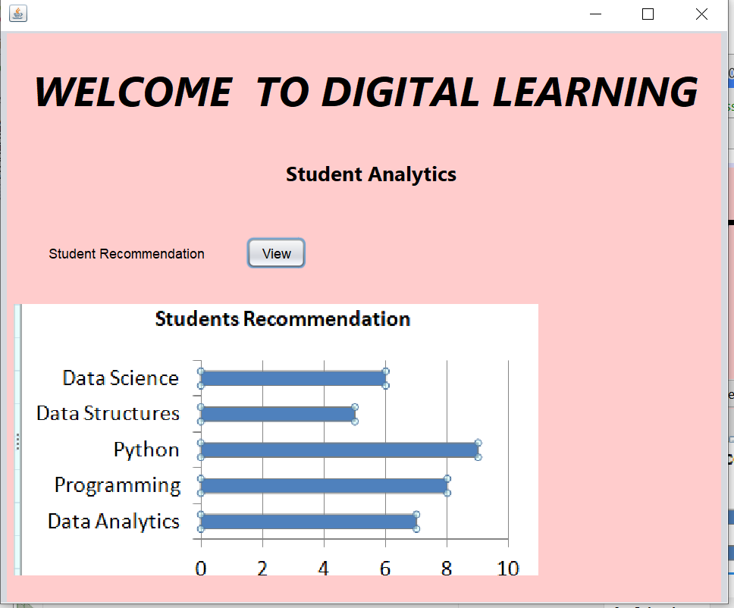

# Conclusion

This system encourages the quality of education by allowing students to choose courses according to their convenience and professor's experience, which can be analyzed via provided statistics, as compared to a regular university, which allows a specific number of professor choices and does not have metrics transparency enabling students to make right choices.

In addition to this, students can also choose the courses based on their financial ability. It also allows students to opt for affordable courses that add value to their career, which is not the case in the regular educational system where the cost in the university is fixed irrespective of the financial status of the students. This sometimes becomes taxing for both students and parents.

To sum up, the online courses are flexible and affordable to the students and the professors and worth it when the transparency is maintained.