Coding Challenge: PhoneBuzz

# Building the application:

1) **Set Up**: We need the proper versions of Java and Maven. I used Java 7 & Apache Maven 3.1.

**Downloading Java**:

* Download and install the JDK. (<http://www.oracle.com/technetwork/java/javase/downloads/index.html>)
* Set your JAVA_HOME environment variable. This can be done by opening up the system properties (WinKey + Pause), selecting the “Advanced” tab, and the “Environment Variables” button, then adding or selecting the PATH variable in the user variables with the value C:\Program Files\apache-maven-3.3.9\bin. The same dialog can be used to set JAVA_HOME to the location of your JDK, e.g. C:\Program Files\Java\jdk1.7.0_51

**Downloading Maven:**

* Download Maven 3.1 or greater from the Maven website. (<http://maven.apache.org/download.cgi>)
* Install Maven 3.1 or greater on your local machine. (<http://maven.apache.org/install.html>)

**Check the set up:**

* echo %JAVA_HOME%
* Confirm maven installation with **mvn –v** command from any folder in command prompt

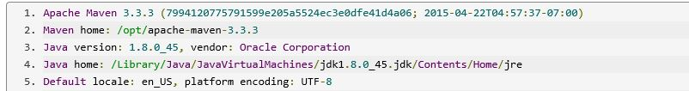

**2) Creating the Project & adding the code**

Copy the code (guestbook folder) into your local folder say D:\twilio\

Code URL:

**3) Storing the data:**

The database I used is Google Cloud Datastore (<https://cloud.google.com/appengine/docs/java/datastore/>). This way the phonebuzz logs are stored in cloud datastore & can be accessed from anywhere.

4) **Running the application:** Navigate to your guest book folder & type the following two commands

* mvn clean install
* mvn appengine:update

## Phase 1: Simple TwiML PhoneBuzz

* Call my registered twilio account at (334) 422-8836 to play phone buzz.
* If you want to use your account add the url <https://red-bruin-123409.appspot.com/phase1> to your twilio account’s phone number

## Phase 2: Dialing PhoneBuzz

You can play phone buzz at https://red-bruin-123409.appspot.com/phase2.jsp

. The input textbox is validate for number of digits in the phone number & for the presence of special charters.

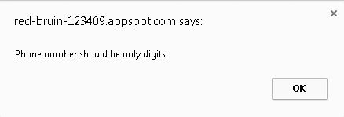

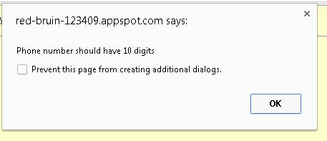

## Phase 3: Delayed PhoneBuzz

Phonebuzz with delay is available at <https://red-bruin-123409.appspot.com/>

Here the phone call will be made after the enter delay (in seconds) has elapsed. Each time you enter a number it will be stored in the datastore, so that the logs can later be retrieved in phase 4. The phone number, delay and the Phonebuzz play number is stored in the datastore

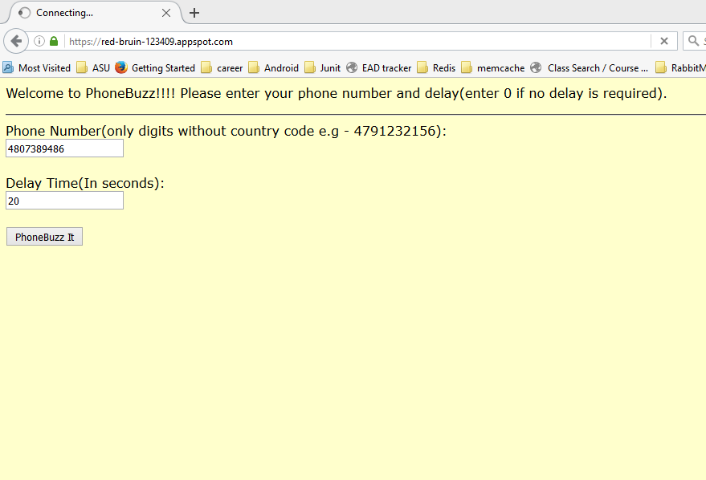

& as per the input validation the maximum delay can be 999 seconds.

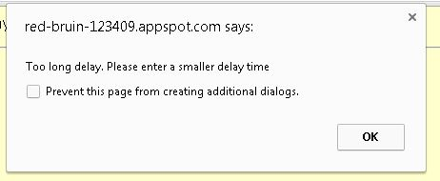

## Phase 4: Tracking PhoneBuzz

The phone number entered here is checked & retrieved from the datastore & the matching logs are displayed to the user. The logs are in the form of hyperlink & a click will initiate the call.

**URL**: <https://red-bruin-123409.appspot.com/retrieve.jsp>

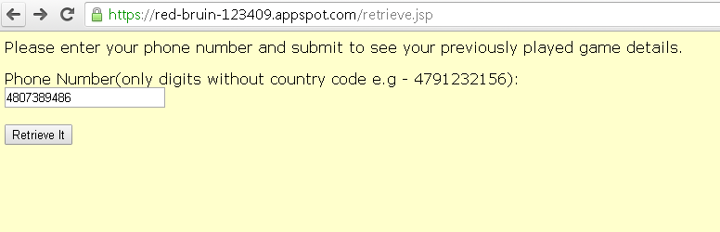

**Datastore:**

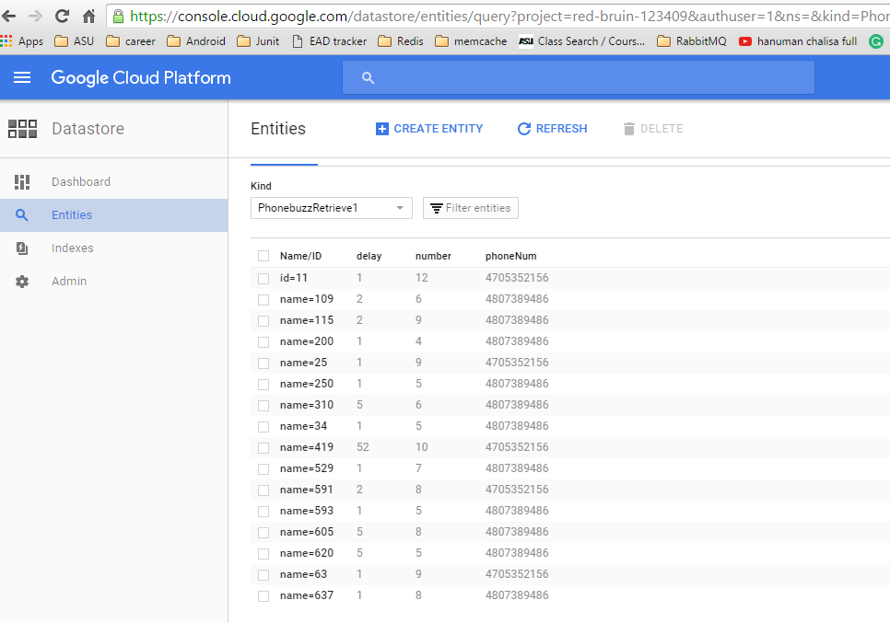

The retrieved call logs are

