*PROJECT REPORT*

# INT301: OPEN-SOURCE TECHNOLOGY

Submitted in partial fulfilment of the requirements for the award of degree of

**Bachelor of Technology**

Computer Science and Engineering

Submitted to Professor- Dr. Manjot Kaur

LOVELY PROFESSIONAL UNIVERSITY PHAGWARA, PUNJAB



Submitted By- Bhawani Pratap Singh

*Section-* KE016

*Registration Number-*11906195

*Roll number-* A17

# Introduction

In this project, we will investigate Network Miner's features and demonstrate how to utilize it to examine network data. We'll also look at installing and setting up Network Miner on different operating systems. Finally, we will show how Network Miner may be used to examine actual network traffic circumstances.

## Objective of the project

The objective of this project is to implement a network miner tool to detect operating system , sessions and open ports through packet sniffing and investigate the network traffic.

## Description of the project

This project involves the installation and working of network miner (a network miner tool.at first we need to install the software then through a trace file we can star sniffing and get out information like os , open ports, traffic etc.

## Scope of the project

The integrity of packet sniffing will be the project's main priority.The trace file's contents and their applicability for any given purpose won't be examined as part of the project.

# System Description

## Target system description

A network miner tool's target system is the kind of network architecture or environment from which it is intended to analyze and extract data. In general, network miner tools are used to gather and examine data traffic passing through a network in order to spot security threats, keep an eye on network performance, and resolve network problems.

## Assumptions and Dependencies

The project makes the assumption that neither the downloaded files nor their origin were tampered with prior to the project's launch. The project depends on the expected checksum values being correct.

## Functional/Non-Functional Dependencies

The project is dependent on the functionality of network protocol support, To enable thorough network traffic analysis, the tool should handle a variety of network protocols, such as TCP/IP, UDP, HTTP, FTP, and others.

* 1. Data set used in support of your project.

We will be using a total of different files for this project, which can be any kind of file, including photographs, papers, audio files, and video files. As long as they are available and undamaged, these files can be obtained from any site.

# Analysis Report:

## Full analysis report

The network mine tool was downloaded from the internet and saved to a folder on the Windows-based system. The capturing was then used to sniff out the packets. The expected checksum values were obtained from the source website where the files were downloaded.

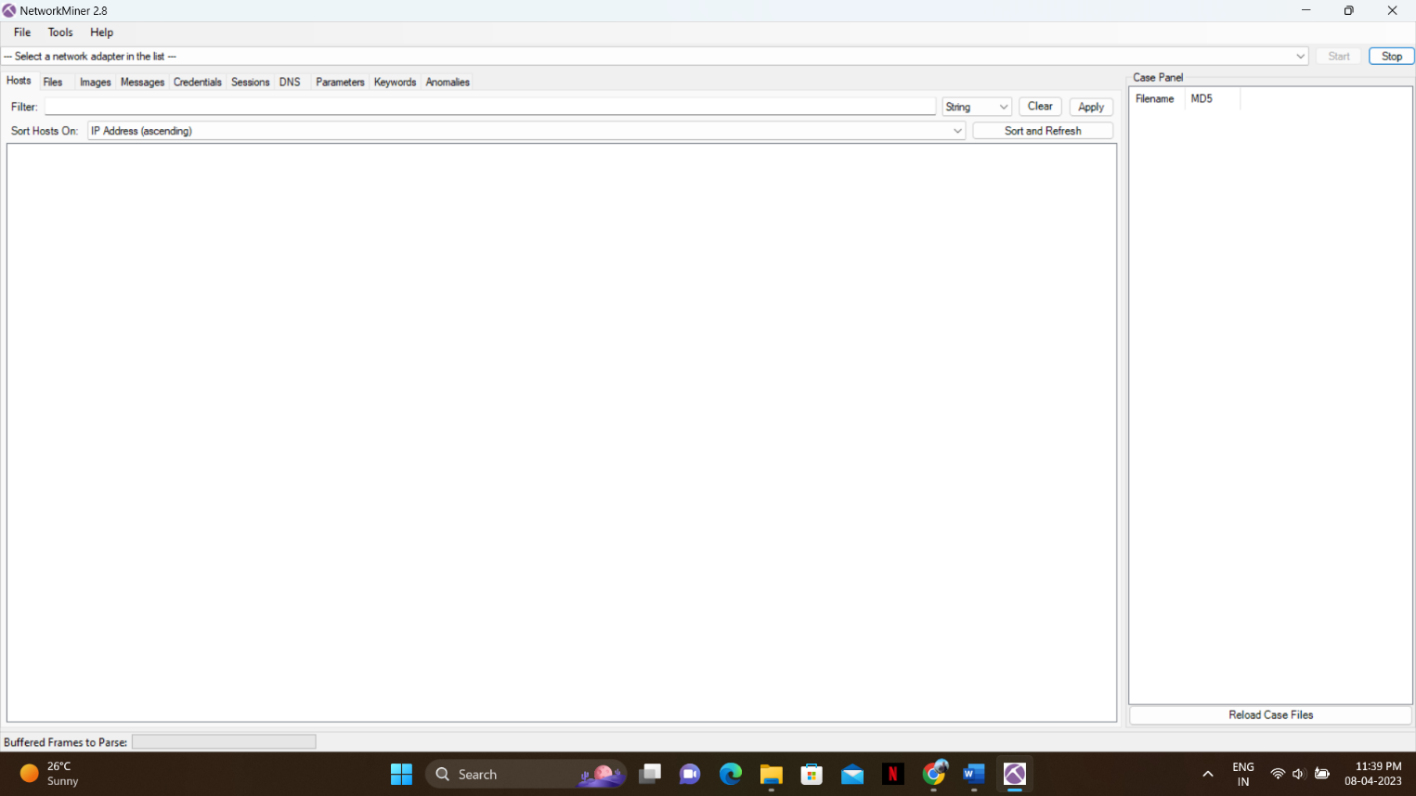

## System Snapshots and working:

1.) We are using network miner tool for doing packet sniffing to detect os and for our project. We can download it from https://www.netresec.com/?page=NetworkMiner

2.) We need to install it and run it.

