Student Details
Name: Brittania Hawes
ID#: 2408218
Module: CIT2011- Web Programming
Assignment: Internal Assessment 2
Tutor: Sirisha Badhika
Date/ Time of Class: Thursdays, 6pm – 8pm
Hosting Link: https://bhawes-2408218.github.io/IA2/

Wireframes
Desktop Layout
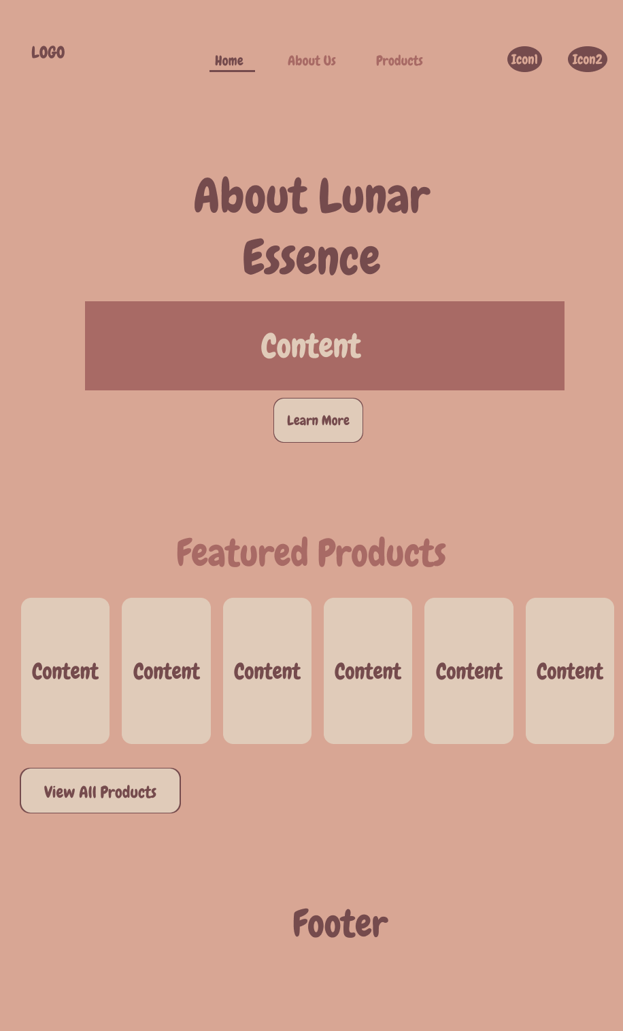
Home Page
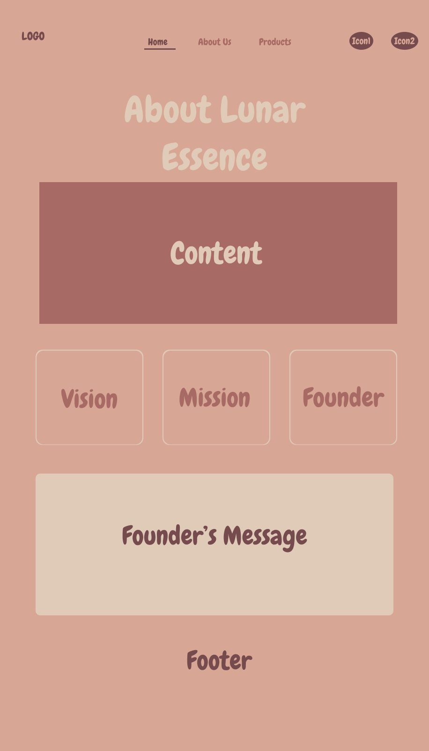
About Us Page
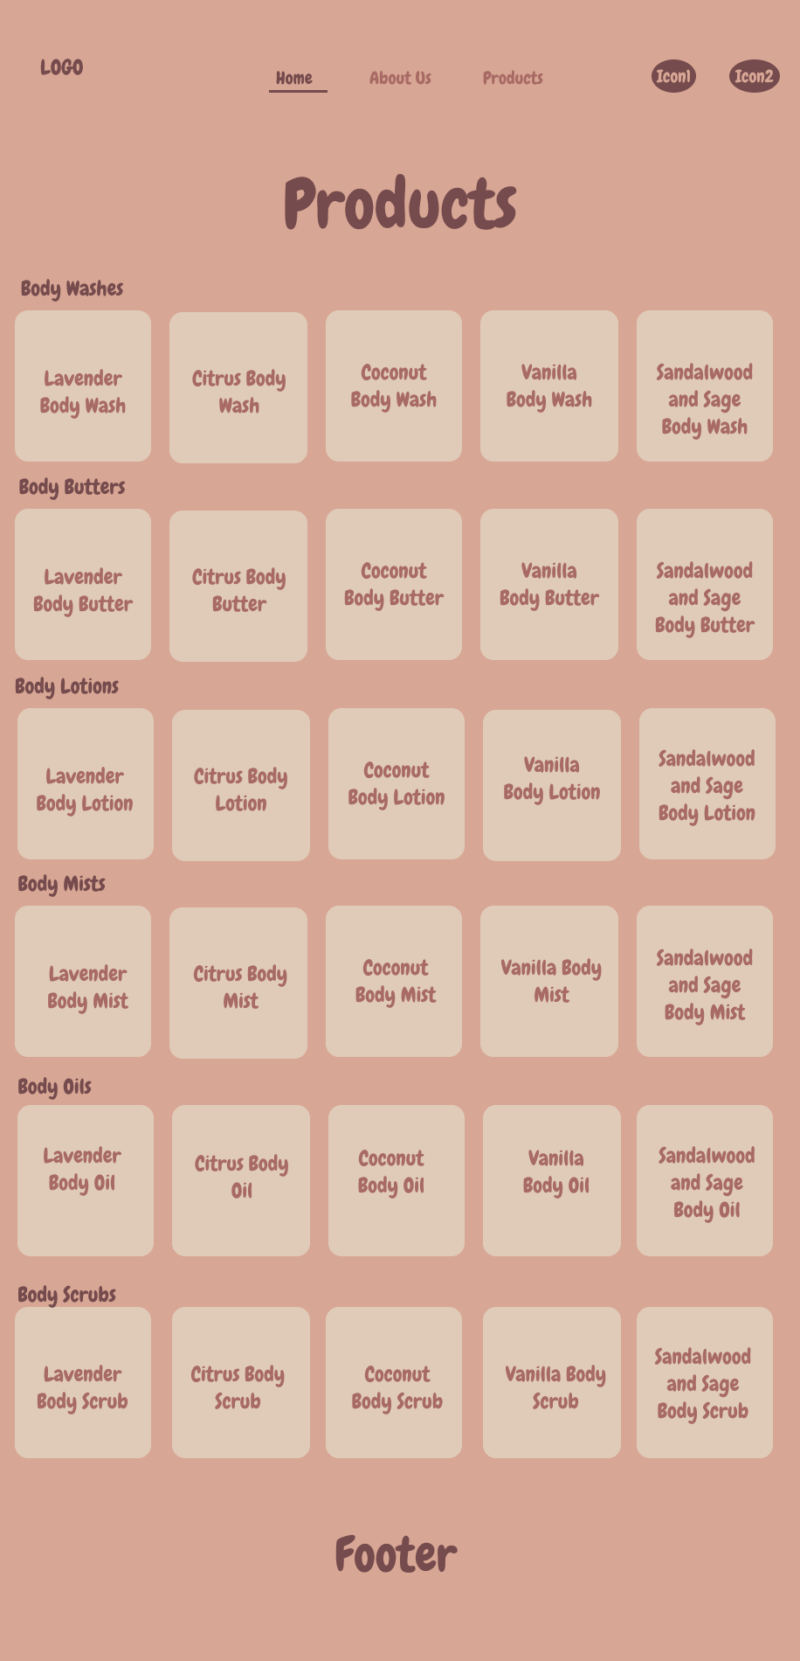
Products Page

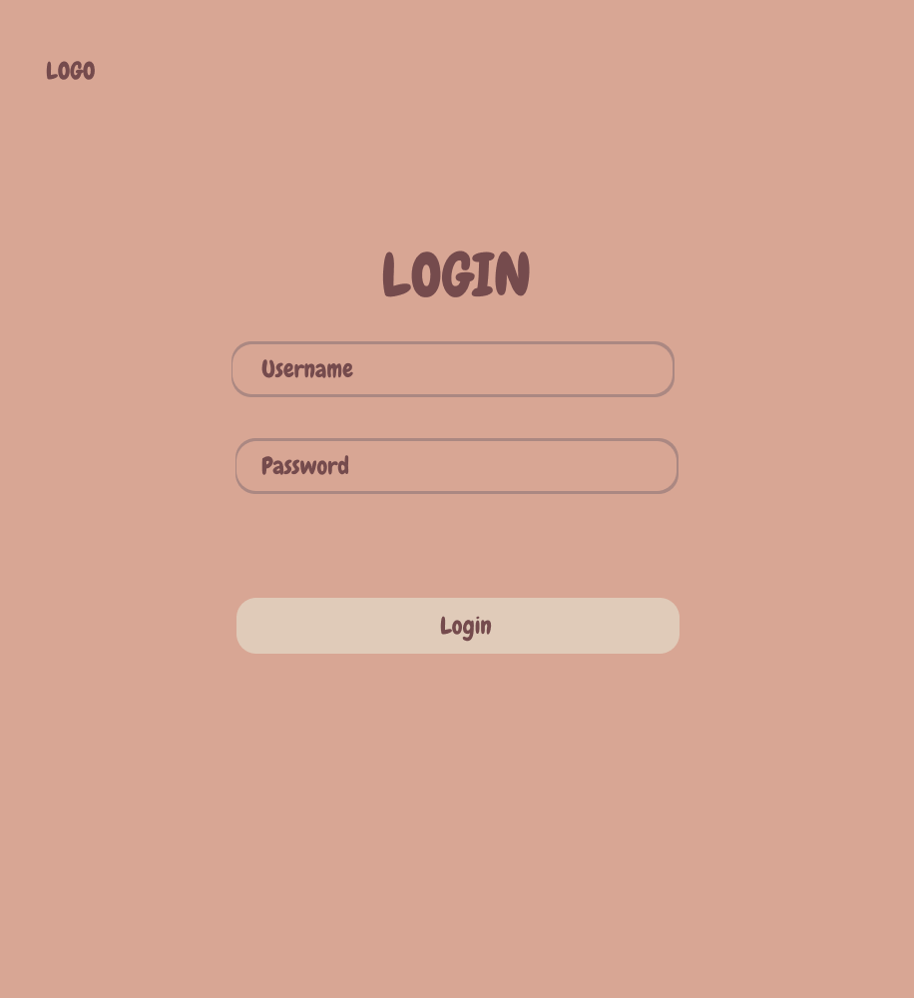
Login Page

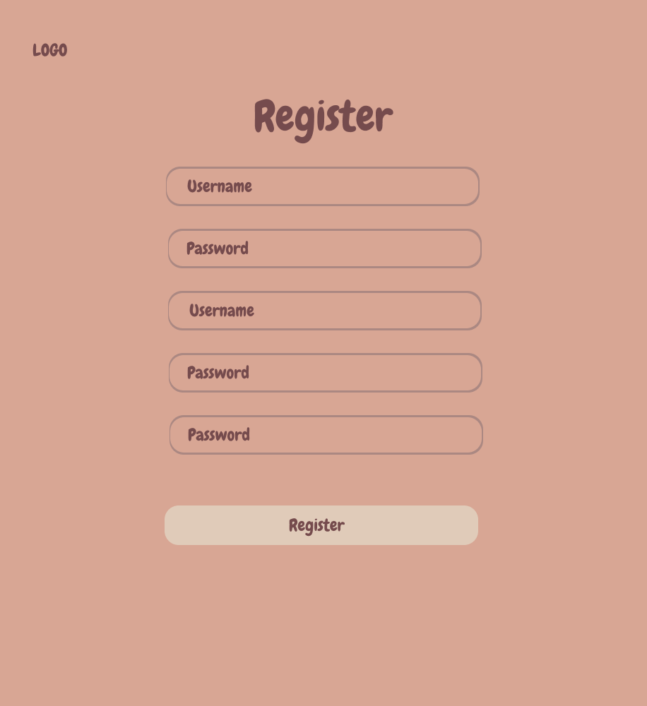
Registration Page

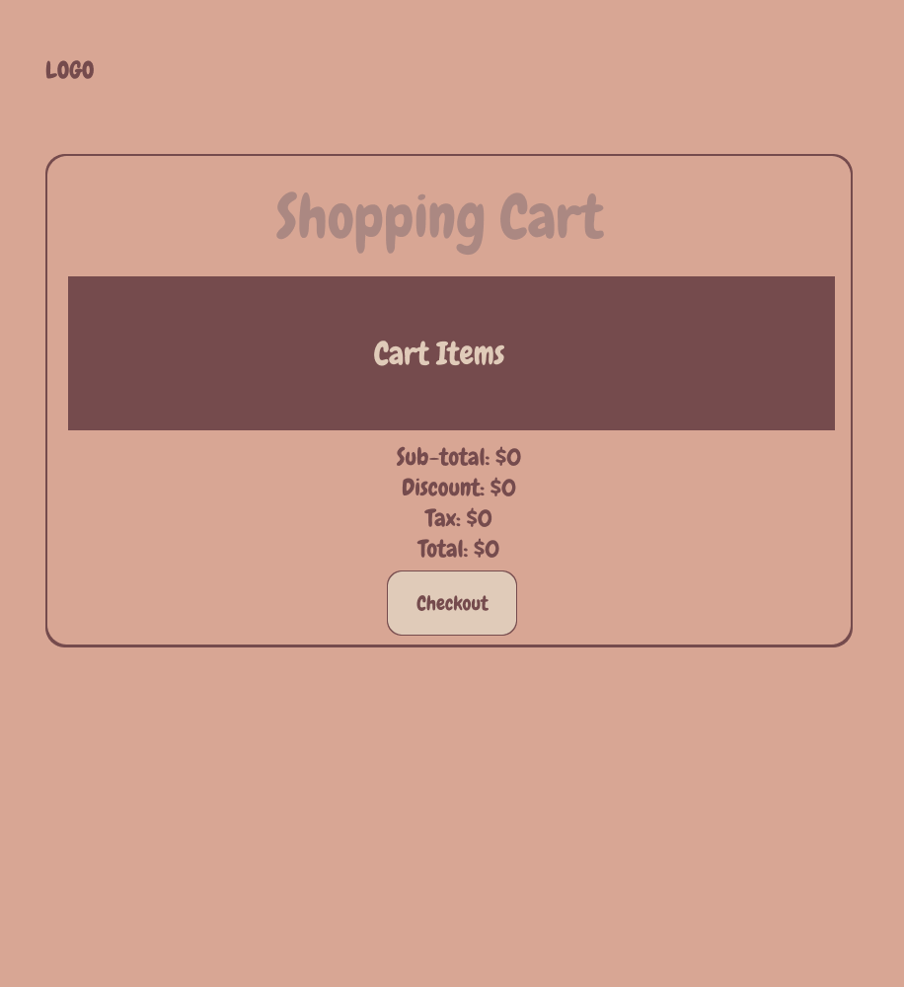
Shopping Cart Page

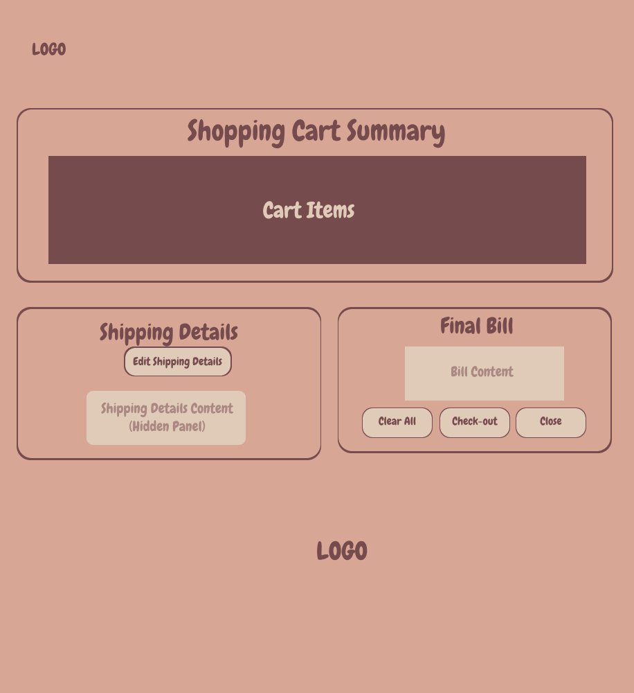
Checkout Page
Mobile Layout
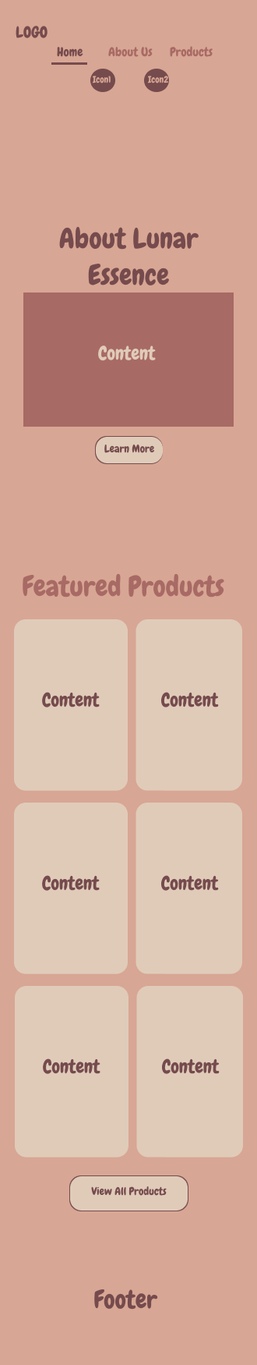
Home Page

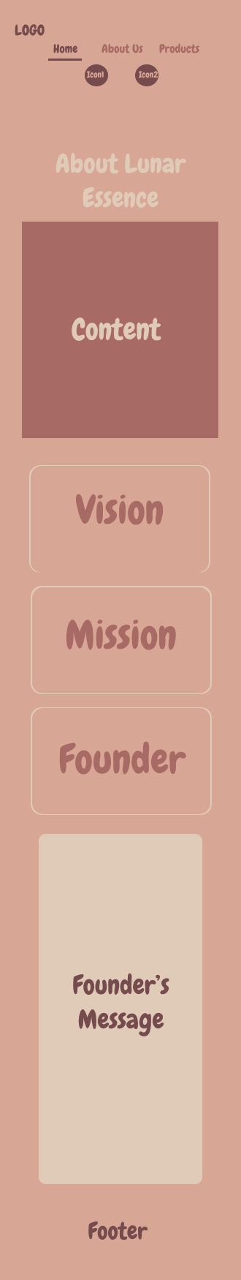
About Us
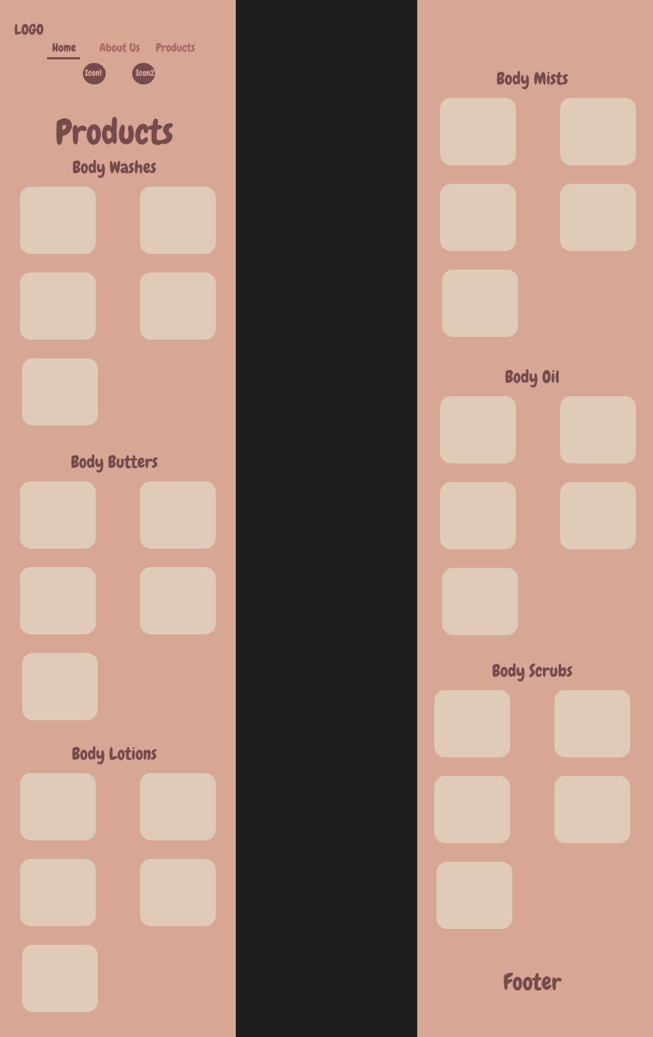
Products Page

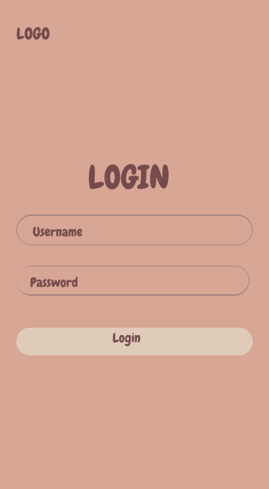
Login Page
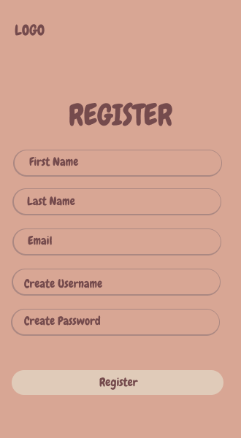
Registration Page
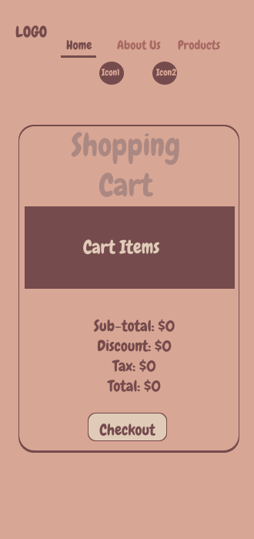
Shopping Cart Page
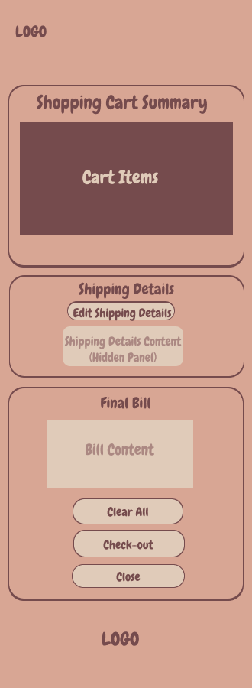
Checkout Page

Site Map
Home Page

Cart Page
Login Page
About Us Page
Products Page

Register Page
Checkout Page

Description

Lunar Essence is a body-care brand where design meets intention and nature inspires transformation. Each product is thoughtfully crafted with natural ingredients and captivating scents that cleanse, nourish, and elevate everyday rituals into radiant moments of self-care.

Logo
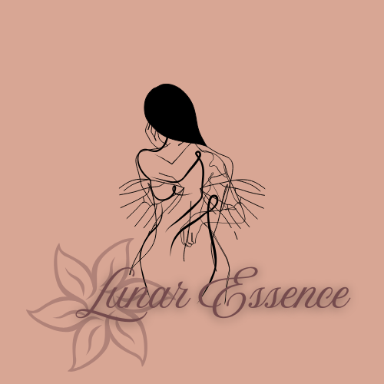

Slogan
From Cleanse to Caress—Awaken Your Glow with Beauty in Every Intention

Mission Statement
To create luxurious, handcrafted body products using natural ingredients that nourish the skin and uplift the spirit. We are committed to sustainability, ethical sourcing, and fostering a community that values self-care and holistic well-being.

Vision Statement
To be a leading brand in the self-care industry, inspiring individuals to embrace their inner radiance through high-quality, natural body products that promote wellness and confidence.

Colour Palette
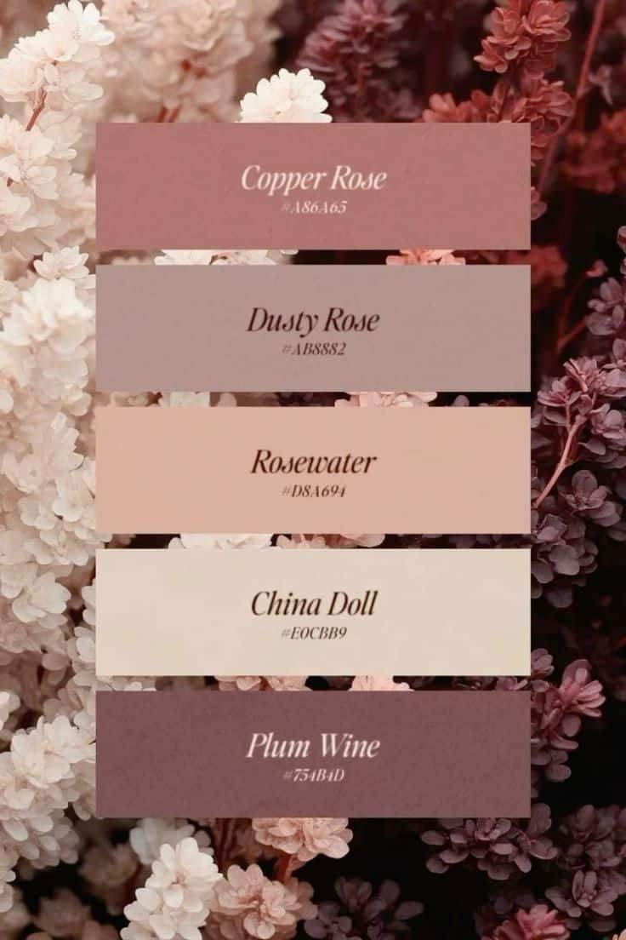

Targeted Audience
The General Public
References
W3Schools. (n.d.). HTML tutorial. W3Schools. https://www.w3schools.com/html/default.asp
W3Schools. (n.d.). CSS tutorial. W3Schools. https://www.w3schools.com/css/default.asp
W3Schools. (n.d.). JavaScript tutorial. W3Schools. https://www.w3schools.com/js/default.asp
user5616242. (2015, December 15). JavaScript: Login/Register with localStorage [Online forum post]. Stack Overflow. https://stackoverflow.com/questions/34299555/javascript-login-register-with-localstorage
Code Explained. (2018, February 15). Login and registration form with JavaScript [Video]. YouTube. https://youtu.be/AkK2VclgfgQ
Code Explained. (2018, February 15). Login and registration form with localStorage [Video]. YouTube. https://youtu.be/zi3tKRp0fIY
Code Explained. (2018, February 15). Login form validation with JavaScript [Video]. YouTube. https://youtu.be/p1GmFCGuVjw
Code Explained. (2018, February 15). JavaScript login system tutorial [Video]. YouTube. https://youtu.be/X7U2M9f2n5U
CP Beleza e Estética. (2025). Color palettes for copper rose, pink wine, and plum wine [Image]. Pinterest. https://www.pinterest.com/pin/140806234221770/

