DS LAB FILE MAIN
1. Array and sum and average
Bhawna (24/SCA/BCA/004)
2. Trasversing in array
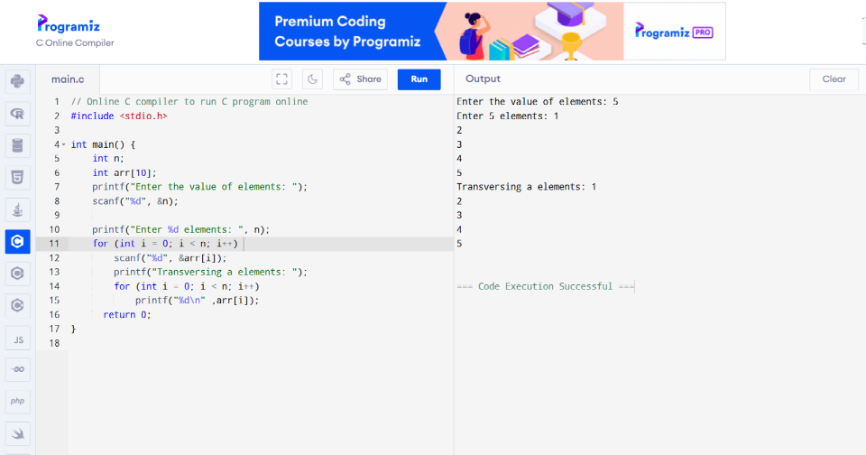
Bhawna (24/SCA/BCA/004)
3. Insertion in Array
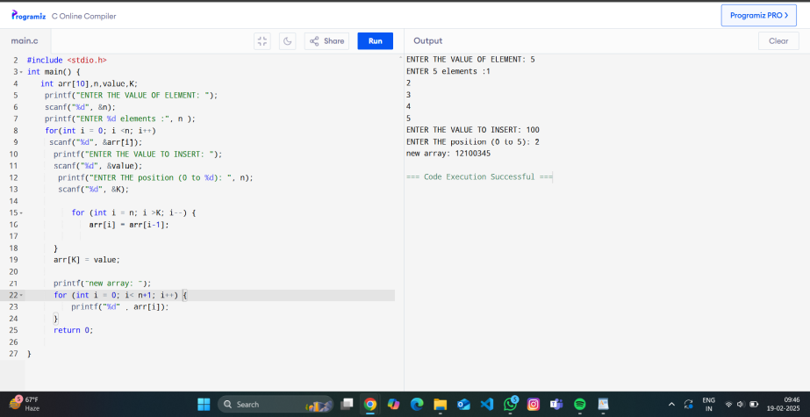
Bhawna (24/SCA/BCA/004)
4. Deletion in array
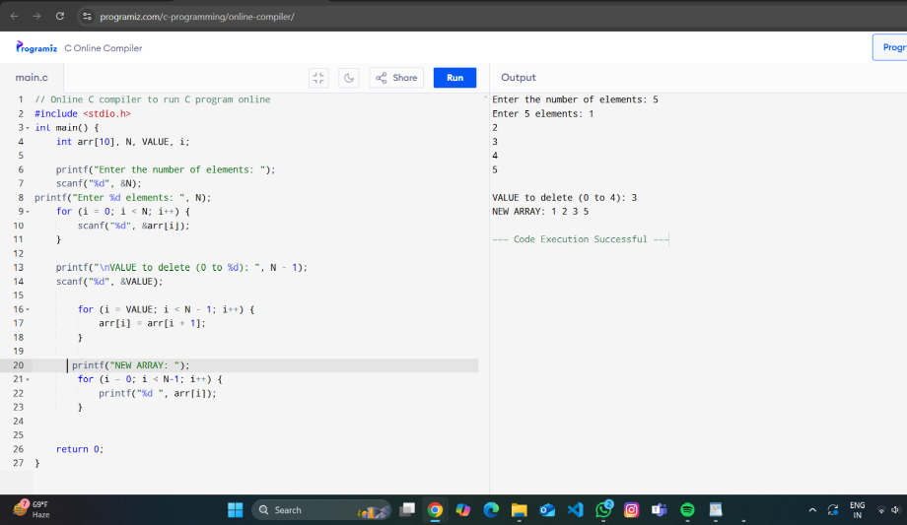
Bhawna (24/SCA/BCA/004)
5.Decimal to Binary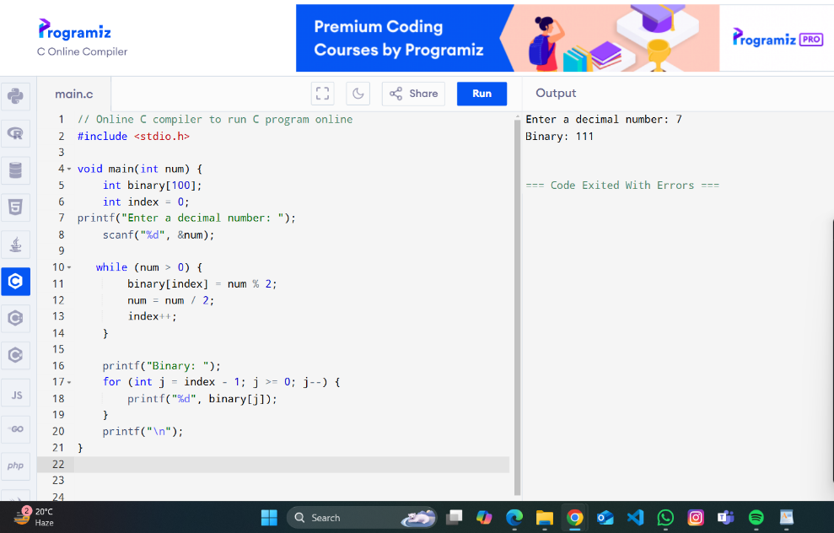
Bhawna (24/SCA/BCA/004)
6. 2D MULTIPLICATION in array
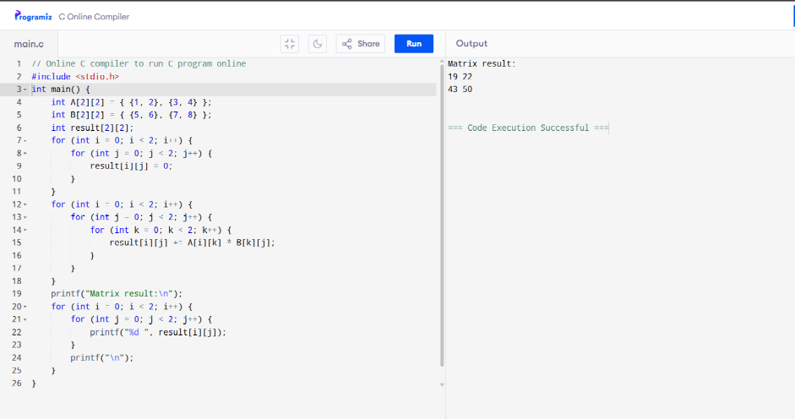
Bhawna (24/SCA/BCA/004)
7. Transposing in Array
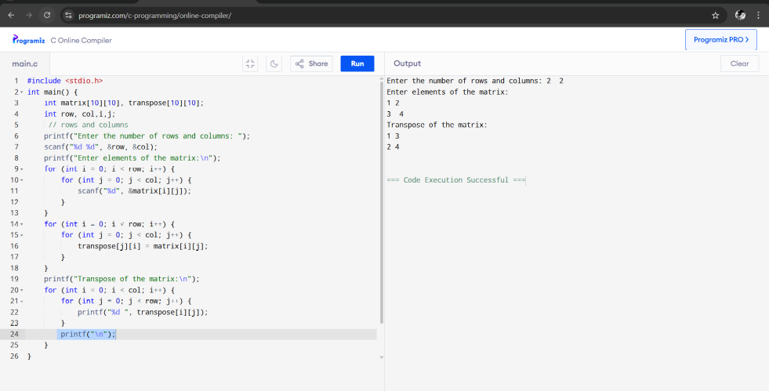
Bhawna(24/SCA/BCA/004)
8.Stack operation- push and pop
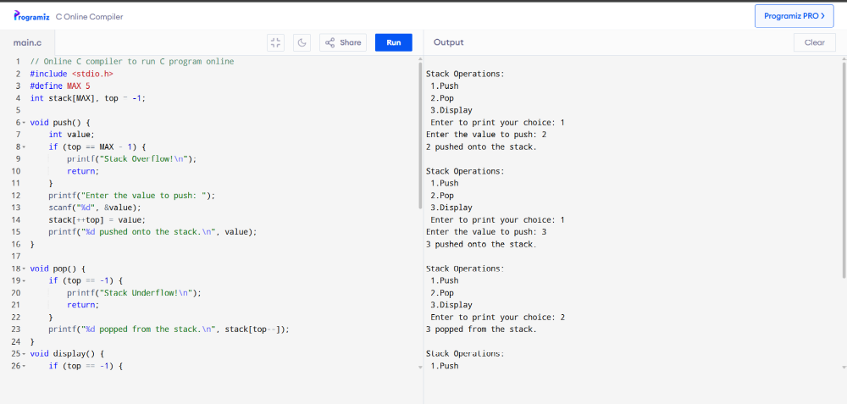
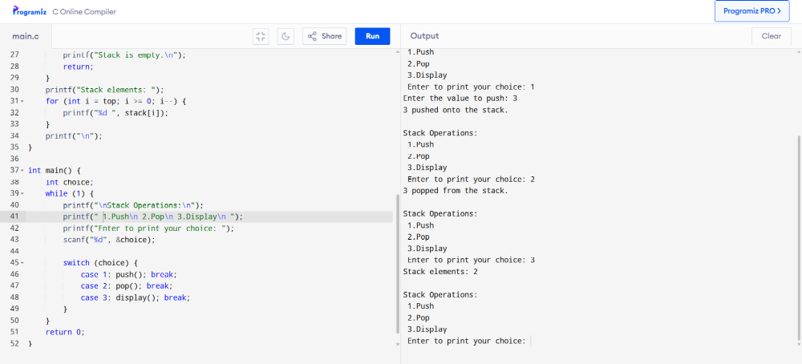
Bhawna (24/SCA/BCA/004)
9. Queue operation - insertion, deletion, display
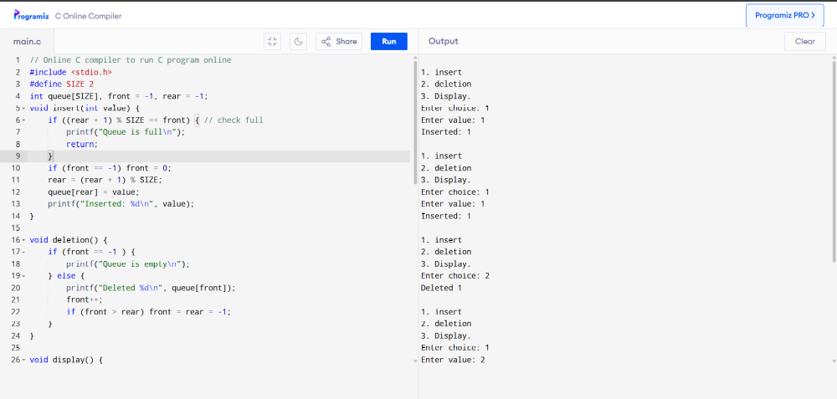
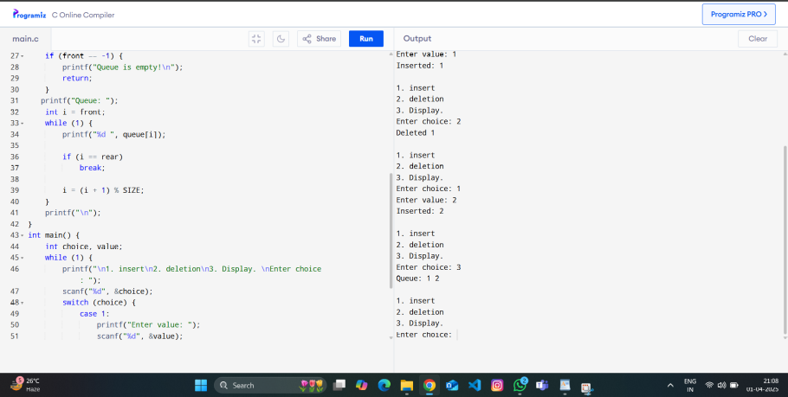
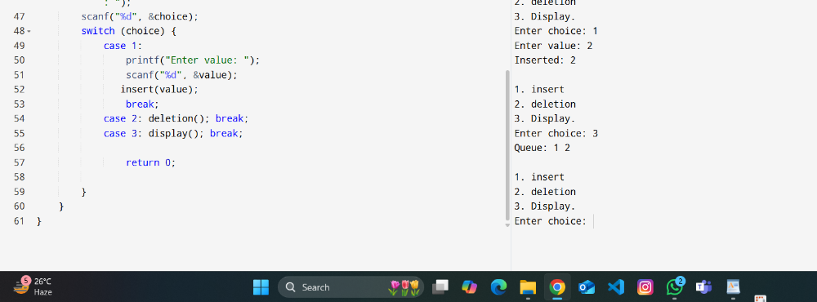
Bhawna (24/SCA/BCA/004)
10. Linked list operation - insertion, deletion, display
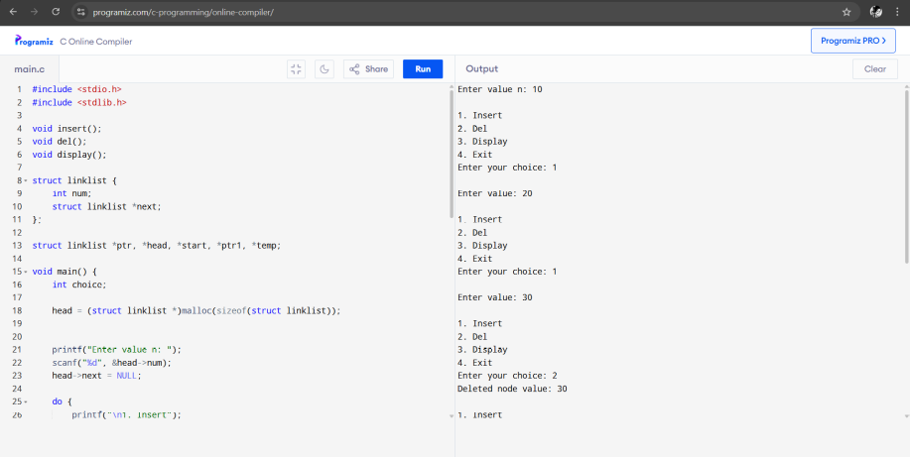
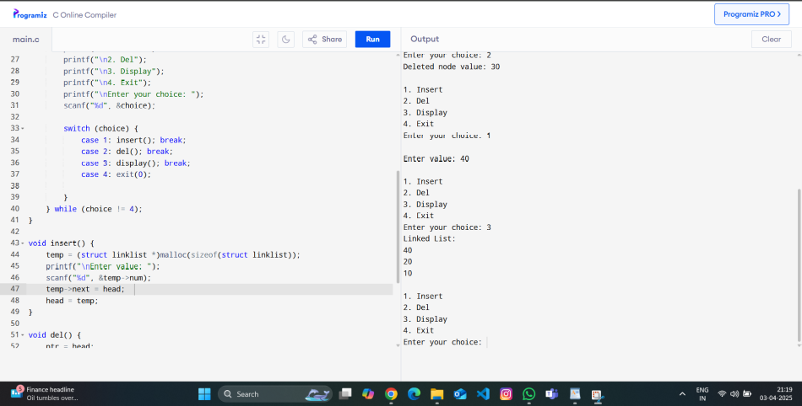
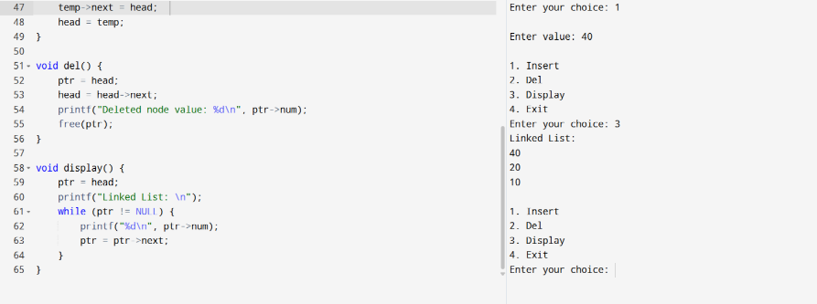
Bhawna (24/SCA/BCA/004)
11. Stack through linked list
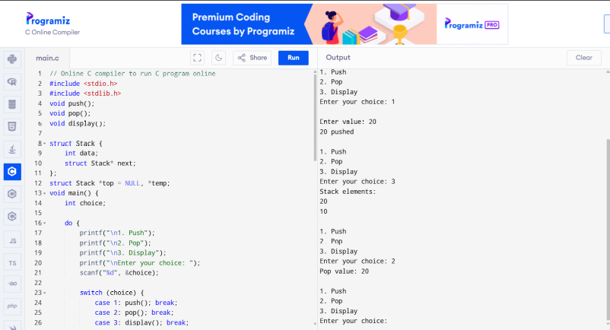
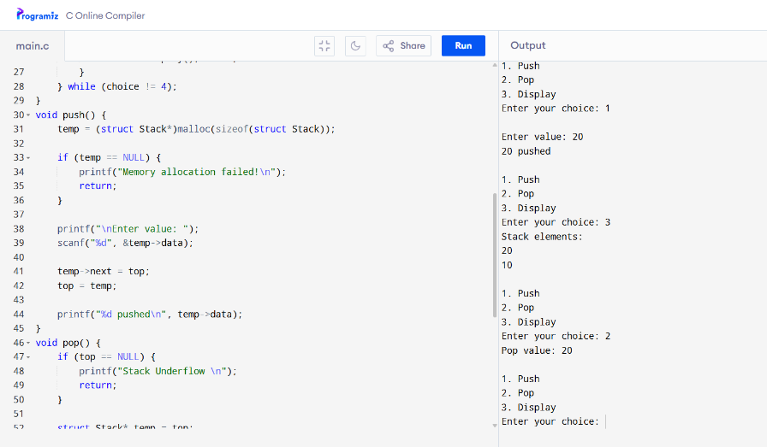
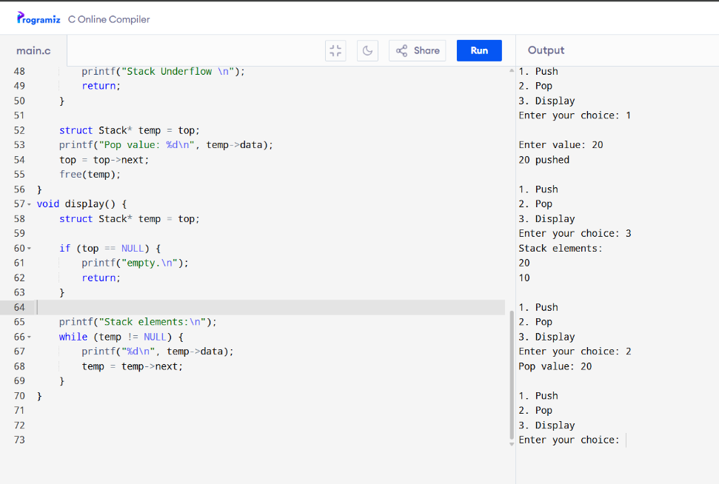
Bhawna (24/SCA/BCA/004)
12. Queue through link list
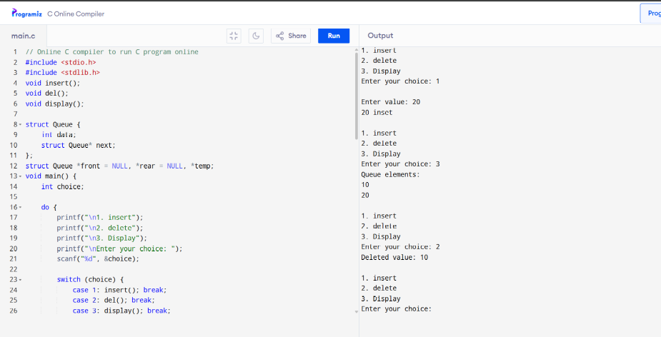
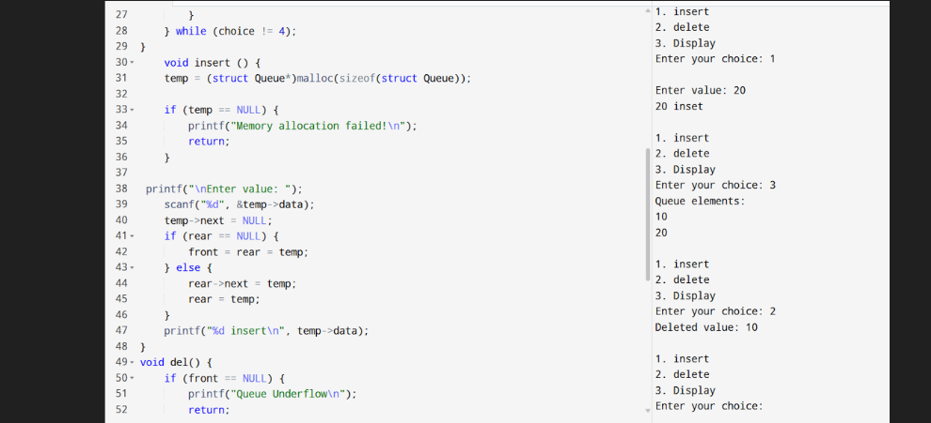
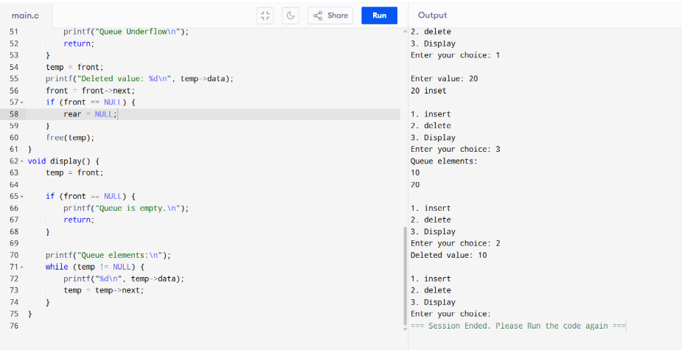
13. Tree traversal (inorder, preorder, postorder)
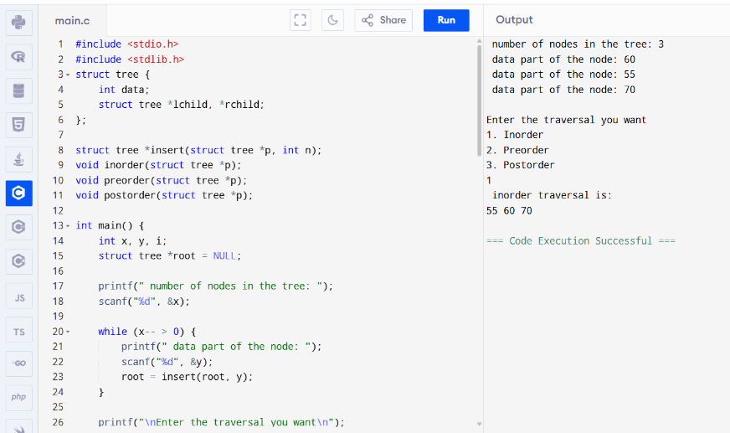
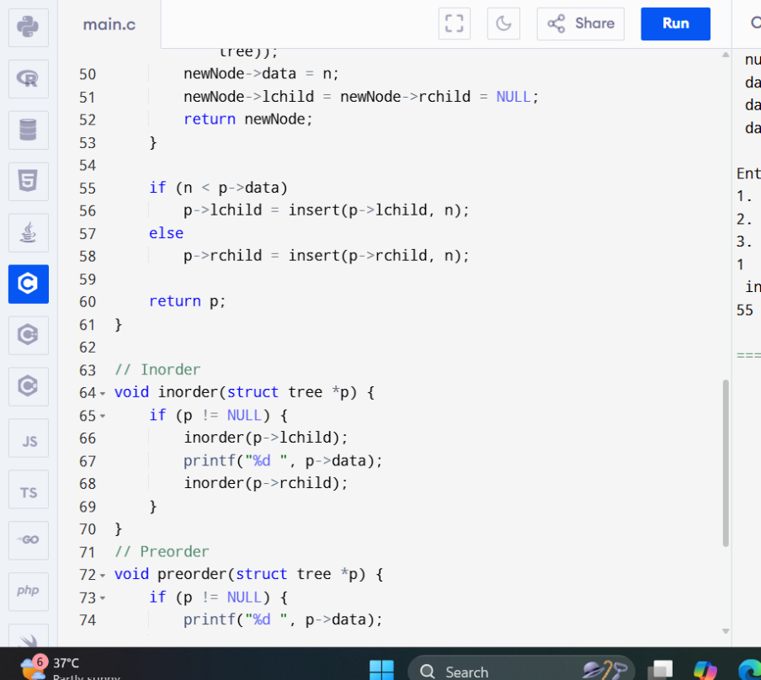
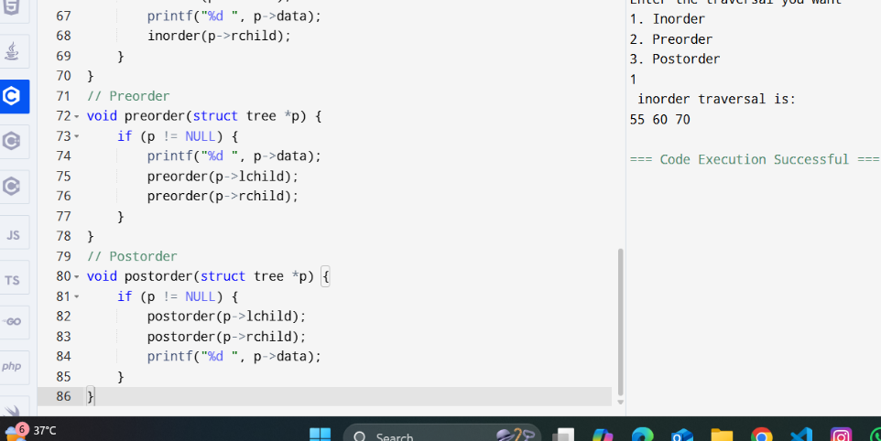
Bhawna (24/SCA/BCA/004)
14. Tree searching (sorted)
Bhawna (24/SCA/BCA/004)
15. Binary search
Bhawna (24/SCA/BCA/004)
16. Sorting using quick sort
Bhawna (24/SCA/BCA/004)
17. Linear search method
Bhawna (24/SCA/BCA/004)
18. Concatenation of two linklist
Bhawna (24/SCA/BCA/004)
19. Reverse of a linklist
Bhawna(24/SCA/BCA/004)
20. Sorting using merege sort
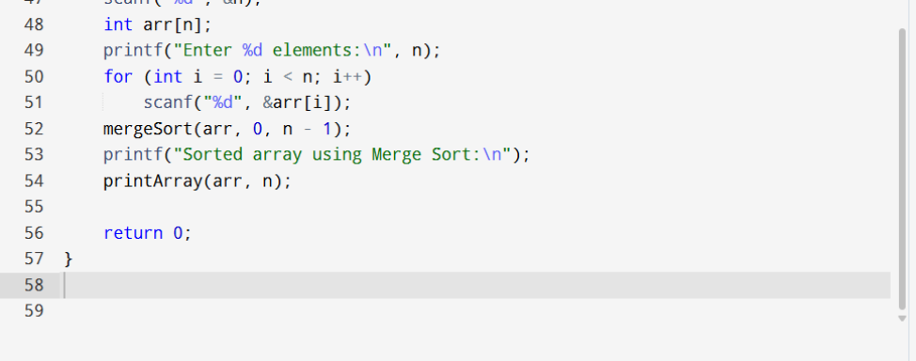
Bhawna (24/SCA/BCA/004)

