A

select input- user choose which sector to plot(its FILENAME column)

input-usecr choose date range

Date to date

select inputUser choose which Channel to plot(All, channel 1,2,3,4)

select input-interactive dataset input-user choose which dataset to plot (speed, length, weight)

Aggregation of data-how to aggregate data- "mins", "hours", "days","weeks","months","quarters","years"

checkboxGroupInput- which trace to plot(which bin)

Tab1

|  |
| --- |
| SC1_MEJA k. Mengusovce - k. PP Západ |
| SC2_MEJA k. PP Západ - k. Vysoké Tatry |
| SC3_MEJA k. Vysoké Tatry - k. PP Východ |
| SC4_MEJA k. PP Východ - k. Spišský Štvrtok |
| SC5_JAJA k. Spišský Štvrtok - k. Levoča |

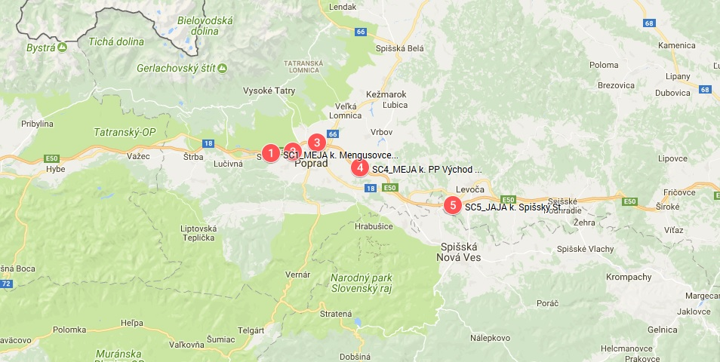

Plot of time series data(plotly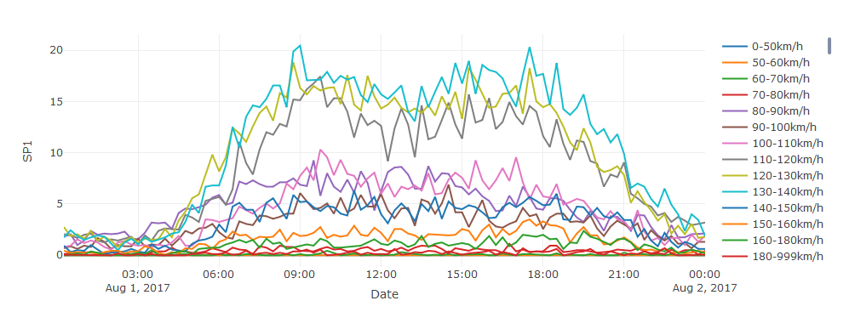

Tab2 Boxplots

plot_ly(pac,y = ~SP1, name = '0-50km/h',type = 'box')%>%

add_trace(y = ~SP2, name = '50-60km/h', mode = 'lines') %>%

add_trace(y = ~SP3, name = '60-70km/h', mode = 'lines') %>%

add_trace(y = ~SP4, name = '70-80km/h', mode = 'lines') %>%

add_trace(y = ~SP5, name = '80-90km/h', mode = 'lines') %>%

add_trace(y = ~SP6, name = '90-100km/h', mode = 'lines') %>%

add_trace(y = ~SP7, name = '100-110km/h', mode = 'lines') %>%

add_trace(y = ~SP8, name = '110-120km/h', mode = 'lines') %>%

add_trace(y = ~SP9, name = '120-130km/h', mode = 'lines') %>%

add_trace(y = ~SP10, name = '130-140km/h', mode = 'lines') %>%

add_trace(y = ~SP11, name = '140-150km/h', mode = 'lines') %>%

add_trace(y = ~SP12, name = '150-160km/h', mode = 'lines') %>%

add_trace(y = ~SP13, name = '160-180km/h', mode = 'lines')%>%

add_trace(y = ~SP14, name = '180-999km/h', mode = 'lines')%>%

layout(title = "Boxplot by day of week")

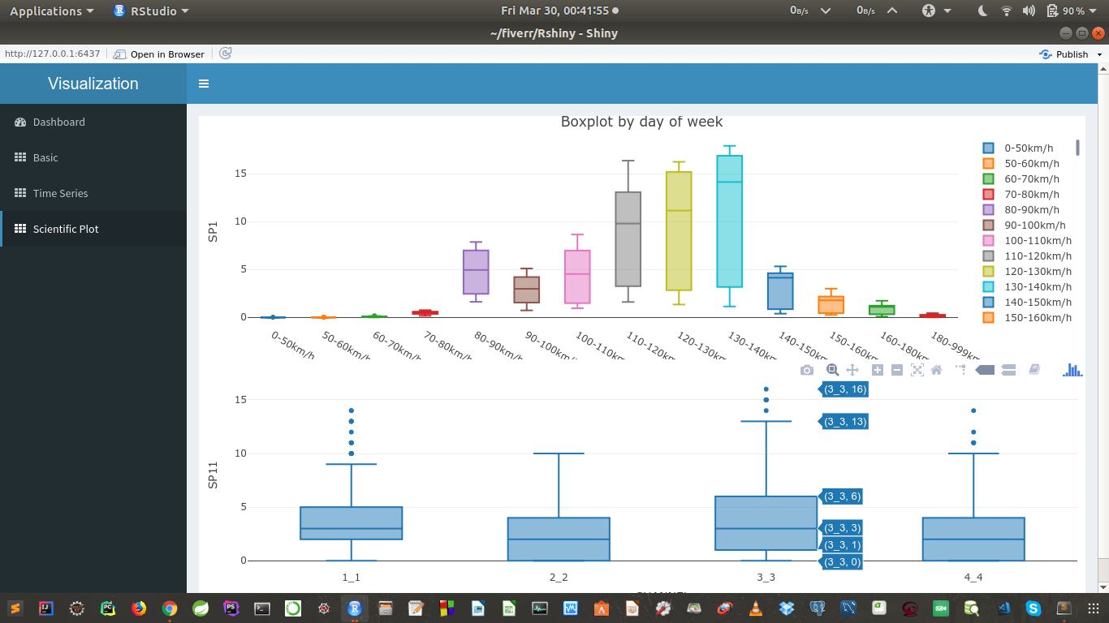

**This one is GOOD**

Boxplots with atribudes ()

Select input- wday.lbl,year.iso,half quarter,month,am.pm

plot_ly(pac, y = ~SUM,SP1-SP14,etc.., color = ~wday.lbl,year.iso,half quarter,month,am.pm, type = "box")

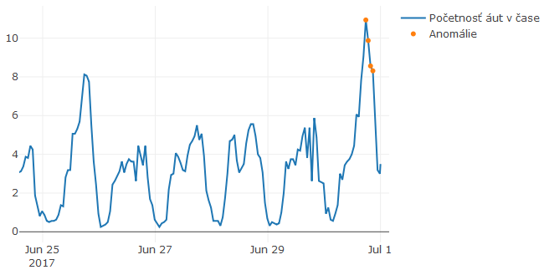

Choose which tracks to detect

Choose period of anomaly to detect and if user want detect only last period or all periods.

res=AnomalyDetectionVec(SUM_DATA[,2], max_anoms=0.01, period=2, direction='both',only_last=FALSE, plot=TRUE)

Tab3 Anomaly detection

**PLOT**

Just choose which track to discover on motifs

Any select input

Tab4 Motif discovery detection

**Error table**

**PLOT**

Just choose which track to discover on ML

Any select input

Tab5 Machine learning timetk + h2o:

**Error table**

**PLOT**

Just choose which track to discover on ML

Any select input

Tab6 timetk + linear regression:

**Error table**

**PLOT**

Just choose which track to discover on ML

Any select input

Tab7 ARIMA + sweep: