Dylan Oszust

CEN 2024

Team Composition Gas Locator:

Angela: GasStation, helped on BusinessRule and GasLocatorGUI

Bruno: BusinessRuleEngine (Business layer) and help with GasLocatorGUI

Desiree: Location, helped on BusinessRule and GasLocatorGUI

Kevin: Exceptions, helped on BusinessRule and GasLocatorGUI

Dylan: GasLocatorGUI (Presentation layer) and help with BusinessRuleEngine

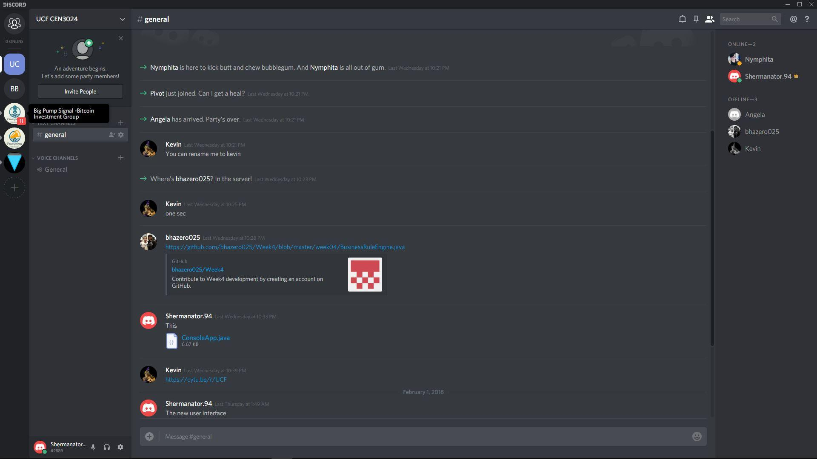

Meeting Minutes

We met on discord on January 31st to talk about task designation. The smaller classes were split up between Angela, Desiree, and Kevin. The Business Layer was started by Bruno, and the GUI was started by Dylan. On Friday, we had another team meeting for code clean up, and completion of the BusinessRuleEngine and the GUI which everyone took part in. After compiling the project during the meeting to make sure it ran successfully, it was decided that the project would be submitted upon completion of the UML and the Documentation.

List Of Functions:

BusinessRuleEngine:

* BusinessRuleEngine():
* addGasStation(GasStation):
* findNearestGasStation(Location):GasStation
* calculateDistanceBetweenLocations(Location, Location): integer

GasLocatorGUI:

* main(String[]):
* GasLocatorGUI():
* getNearestGas():
* addFirstGasStation():
* addSecondGasStation():
* currentLocation():Location
* locate(String, String):Location
* showInfo(GasStation, Location):

GasStation:

* GasStation(String, Location):
* getName():String
* setName(String):
* getLocation():Location
* setLocation(Location):
* toString():String

Location

* Location(int, int):
* getStreet():int
* setStreet(int):
* getAvenue():int
* setAve(int):

InvalidLocationException

* InvalidLocationException():
* InvalidLocationException(Location):
* getInvalidLocation():Location

UML

