**FETpulser**

**Operations manual**

**GAA Custom Electronics**

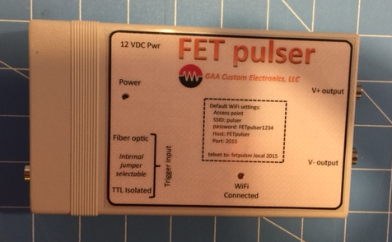

**Introduction:**

The FET pulser is designed to produce two complementary output pulse, one positive and one negative. Below are the features of the pulser:

* Programmable positive and negative pulse voltages
* Isolated TTL level input
* Fiber optic input
* WiFi interface to allow host control
* 12VDC at 0.25A supply.
* Cab be run from batteries

**Warnings:**

* Never exceed 12 VDC on the pulser power input.
* Do initial testing using the provided 12 VDC supply.
* The TTL trigger input and the fiber transmitter are low impedance, about 75 ohms. You will need a low impedance driver. Its important to drive the input to 5 volts and you should test this before you power up the pulser.
* Pulser current consumption is a function of load capacitance, voltage, and frequency. It is possible to burn up the pulser so use caution and monitor the input current if possible.
* The output pulse rise and fall times are very fast, less than 10 nS. This will cause reflections on long transmission lines. You can stop these reflections with series resistance that matches the transmission lines impedance. Do not terminate with resistance to ground. Try to keep the leads as short as possible.

**Communicating with the pulser:**

The default configuration of the pulser is to act as a WiFi access point. The cover of the pulser defines how to connect. You can use telnet to open a connection to the pulser and control its settings. Use caution setting the communication parameters because you could render the pulser in a state that will not allow you to communicate.

**Below is a list of all the pulser commands:**

General commands

GVER Return the current firmware version number.

GERR Returns the error code for the last bad message.

MUTE,value Stops all serial communications but still processes commands. Value = ON or OFF

ECHO,value If value is TRUE this command will cause the command to be send prior to the reply, if FALSE only the relpy is sent.

DELAY,value Delays for the number of milliseconds defined by value.

GCMDS Returns a list of all commands.

RESET Reboots the pulser.

SAVE Saves all the current settings.

FET pulser commands

CAL This command is used to calibrate internal voltages in the pulser and is used for setup in the factory.

SVP,value Sets the positive output pulse voltage to the value defined by value, 5 to 200 volts.

GVP Returns the positive pulse voltage settings.

SVN,value Sets the negative output pulse voltage to the value defined by value, -5 to -200 volts.

GVN Returns the positive pulse voltage settings.

GINV Returns the output logic invert state, TRUE or FALSE.

SINV,value Sets the output logic invert state, value equals TRUE or FALSE.

GP This commands return the pulse output state, HIGH or LOW.

SP,value This command allows you to set the pulser output state where value defines the state, value equals HIGH, LOW or PULSE. Pulse will define a 1 mS output pulse.

WiFi commands

LIST Displays a list of all detected networks.

SHOST,value Sets host name to value.

GHOST Displays current host name.

SSSID,value Sets SSID name to value.

GSSID Returns the current SSID name.

SPSWD,value Sets network password to value.

GPSWD Returns the current network password value.

CONNECT This command will attempt to connect to an existing WiFi network. This will require the WiFi setting to be properly set.

AP Causes the system to enter WiFi access point mode.

DISCONNECT Disconnects for the current network.

STATUS Return the WiFi status.

IP Returns the WiFi IP address.

GSM Returns the current WiFi startup mode.

SSM,value This command sets the WiFi startup mode when the pulser boots up. Value is; IDLE to start with no WiFi, AP to start as an access point, and CONNECT to startup and connect to an existing WiFi network.

Restoring default pulser settings:

If you are not careful you can set the communications settings in a way that will not allow you to communicate with the pulser. There is a way to start the pulser and load its default parameters. The figure below shows how to start in default mode.

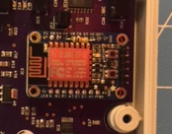

Short this end of the resistor to ground and then apply power. You can ground this with a clip lead connected to the output BNC shield. After the system starts you can remove the ground jumper.

