PyCOMPARE

1. Start

The Start page of the PyCOMPARE GUI (Figure 1) allows users to either define a new project or load previous project. All project files for PyCOMPARE have the extension *\*.cmprj*.

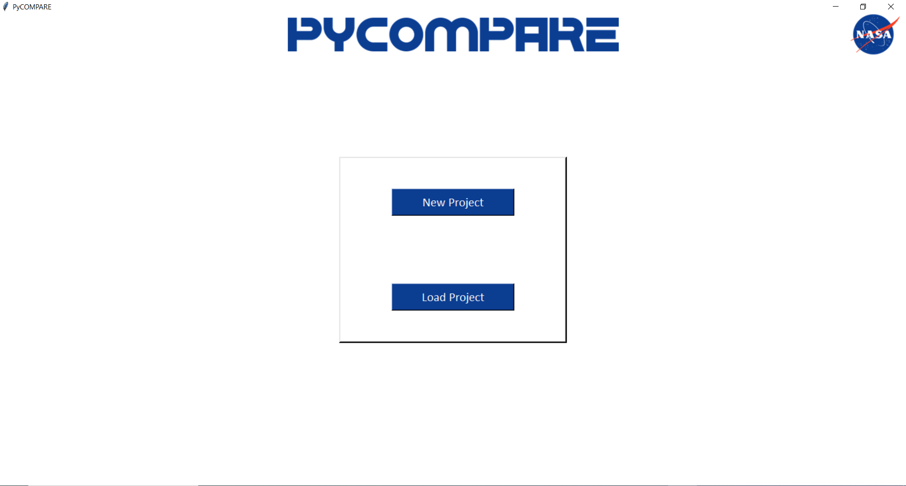

Figure 1. Start Page

Once a project is selected or defined, the Main Navigation page (Figure 2) is displayed for the user. The Main Navigation page offers various options for the user to define the test data used for model characterization, the ability to either optimize or run a model, visualize model performance, export results, and define general application settings. It also contains a “Save” button that allows users to save the project file.

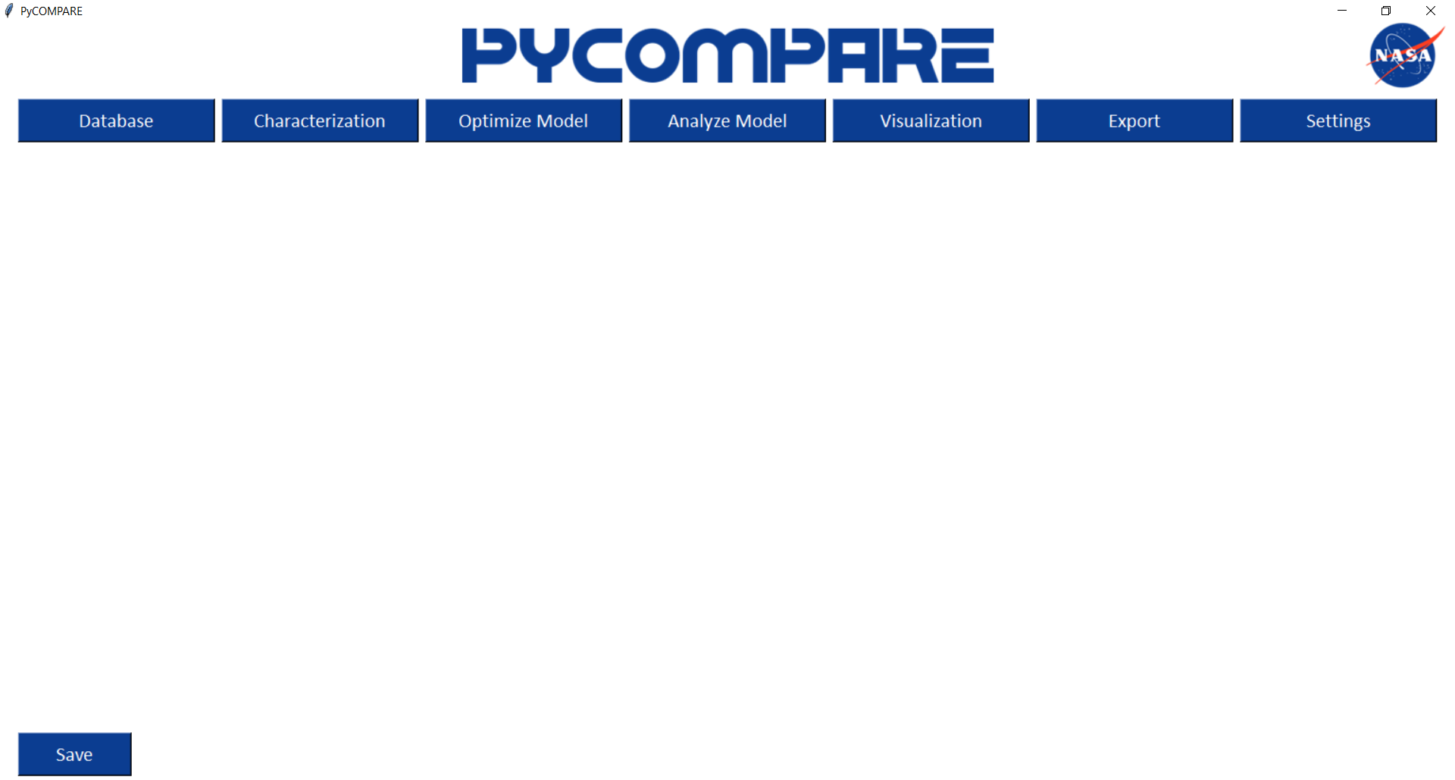

Figure 2. Main Navigation Page

1. Database

Selecting the “Database” button creates the Database page (Figure 3), which offers two buttons for the user to select.

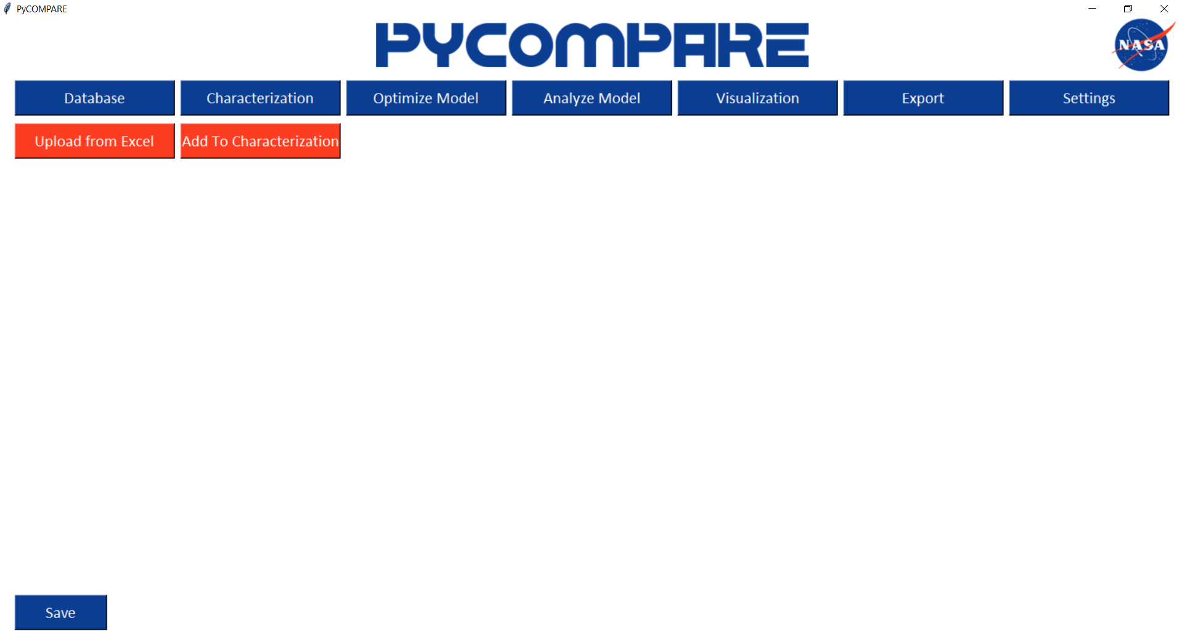

Figure 3. Database Page

* 1. Importing Data

The “Upload from Excel” button allows users to import material test data to the project database using the provided Excel Import Template (ImportTemplate.xlsx) (Figure 4). The Excel Import Template has three sections: one to define general test information, one to define control turn points during the test, and one to define the control and response curves.   
 For the general information section, Test Name, Test Type, Test Temperature, and Anisotropy Angle must be populated. For isotropic materials, enter 0 for the Anisotropy Angle. The Control Mode option in the general information section defines to the COMPARE engine which full curve (stress or strain) will be used for control and which will be used for response. Therefore, for a test with multiple control modes, users should define the control mode relevant to the test type. For example, in a classic creep test with strain controlled loading followed by stress controlled creep, the Control Mode in the general information section should be labeled as Stress. Note that only one of the three directions are required to be defined to import data.  
 The control turn points section allows users to define the various stages that are present in a test. Each row should correspond to one stage, where the user defines the start time for the stage, the loading direction, the control mode, the load rate (in units that correspond to the selected control mode), the target type (i.e., strain, stress, or time) and the target value for the end of the stage (in units that correspond to the selected target type).  
 The control and response curves section allows users to enter the measured time, stress, and strain arrays in each direction for a test. It is required that all columns have the same number of points (or 0 points if that quantity was not measured). Entering zero stress for stress-free directions is not necessary.

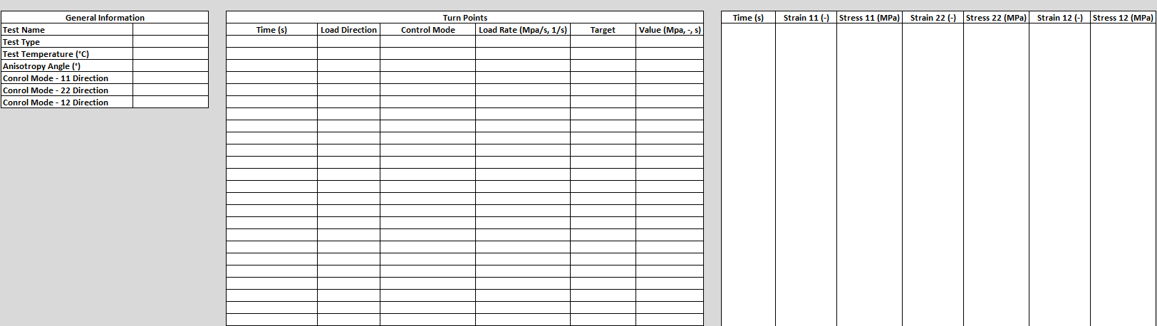

Figure 4. Import Template

* 1. Viewing the Database

Once data has been uploaded to the project database, it can be viewed on the Database page (Figure 5). For each test uploaded, a row is added to the database table that displays the test name, type, temperature, loading direction, control mode, control rate, and anisotropy angle, as well as a checkbox used to add data to the characterization set. Right clicking on any individual row in the database presents the user with four options: 1) Select/Unselect All, 2) View Data, 3) View All Selected Data, and 4) Delete Test.

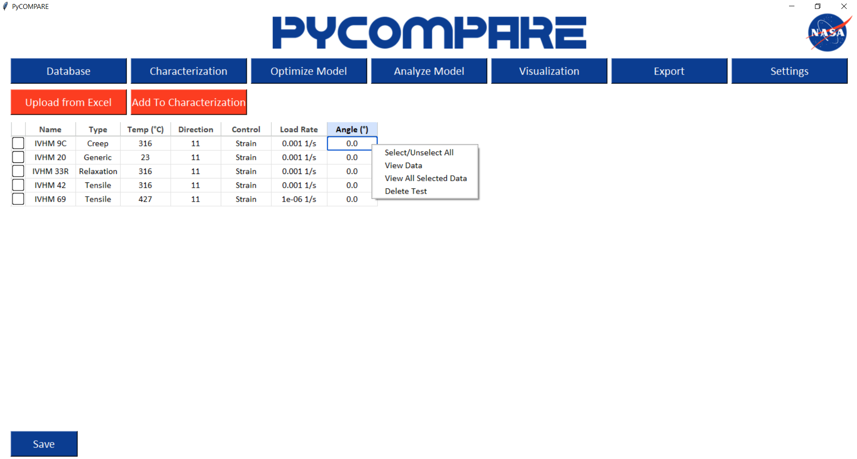

Figure 5. Viewing the Project Database

The Select/Unselect All option checks or unchecks the first column for all tests in the database table. The View Data option displays the response curves for the test and the defined stage table for the test (Figure 6). The response curve plot automatically segments the test based on the information defined in the import file and colorizes each segment. It also gives users drop down menus to select the dependent and independent variables for plotting different response curves. Plots are generated by selecting the two desired arrays and pressing the “Plot” button.

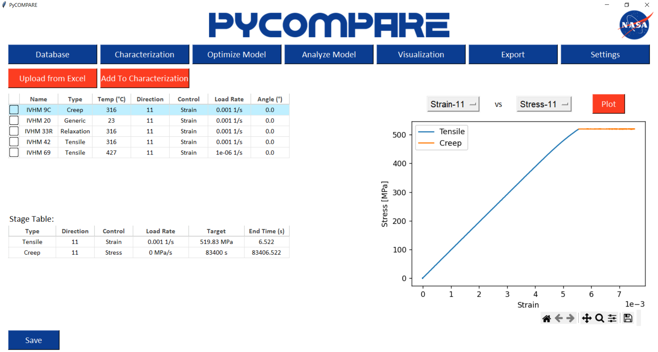

Figure 6. Viewing an Individual Test

The View All Data option co-plots the stress vs strain curve in each selected test’s loading direction (Figure 7). Users have the option to look at all test types or filter results by individual test type to ensure all data for characterization is consistent.

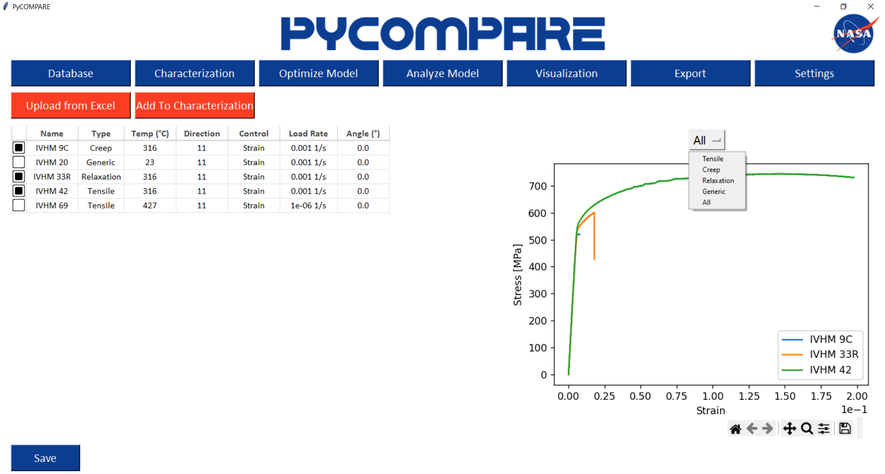

Figure 7. Viewing All Selected Tests

The Delete Test option removes a test from the project database.

* 1. Adding Data to the Characterization Set

Using the checkboxes next to each test in the database table, users can define which tests in their project database they want to use for model characterization. PyCOMPARE performs model characterization for a material *at each temperature*; therefore, all tests in the characterization set must be performed at the same temperature for accurate results. If there are currently no tests in the characterization set, the user must only select tests that are at the same temperature. If there are already tests in the characterization set, users can only add additional tests at the same temperature. Tests are added to the characterization set by pressing the “Add to Characterization” button.

1. Characterization

The characterization set of data is the set of tests used by the COMPARE engine to optimize constitutive model parameters. The data set can be viewed by selecting the “Characterization” button on the Main Page (Figure 8). On the displayed characterization set table, users can edit the relative weights of each test during the optimization process. All weights are normalized to sum to 1 prior to running the COMPARE engine. Right clicking on any individual row in the characterization set table gives the users three options: 1) View Data, 2) View All Data, and 3) Delete from Set.

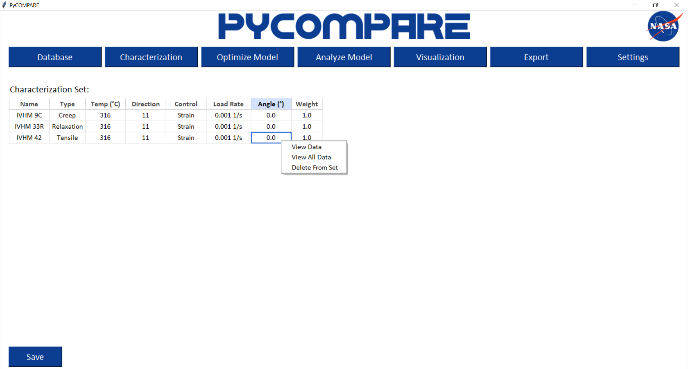

Figure 8. Viewing All Characterization Set

Similar to the View Data option on the Database page, the View Data option on the Characterization page displays a plot of the response curves for a given test, which can be changed via drop down menus by the user, as well as the stage table for the test (Figure 9). The plot also displays the data reduction used by the COMPARE engine. For each *stage* in a test, PyCOMPARE defaults to 10 points that capture the response. Tensile, compressive, and shear loading/unloading stages have points that are equidistant in normalized stress vs strain, creep stages (i.e., constant stress) have points that are equidistant in normalized strain vs time, and relaxation stages (i.e., constant strain) have points that are equidistant in normalized stress vs time.

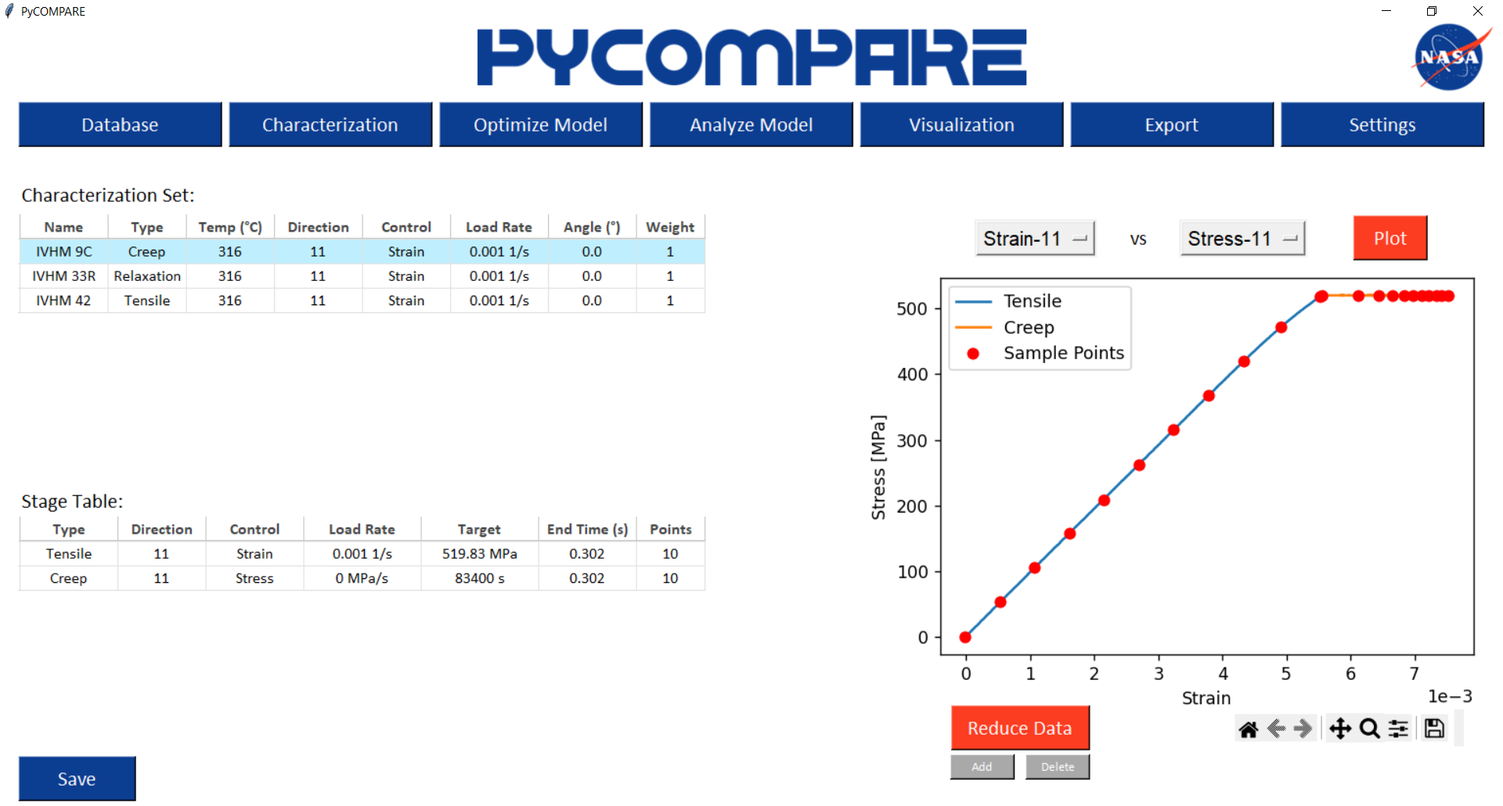

Figure 9. Viewing an Individual Test in the Characterization Set

The number of points in each segment is controlled by selecting the “Reduce Data” button, which creates the segmentation control panel (Figure 10a). When selecting the “Get Data Points” button, each stage is individually re-analyzed using the stage-specific response curves for equidistant points. The resultant points are then displayed back on the Characterization page (Figure 10b).

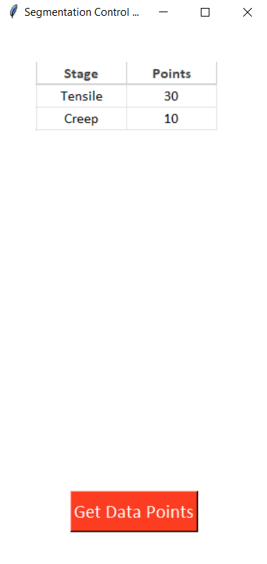 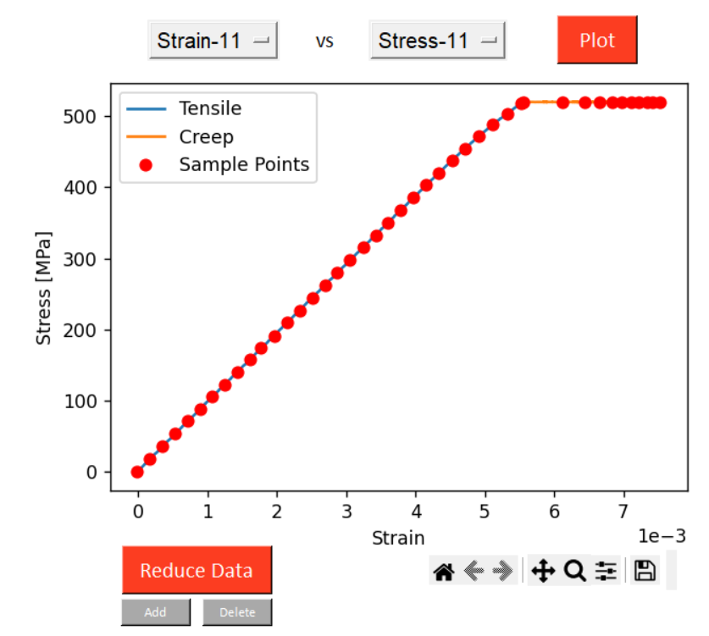

1. (b)

Figure 10. Setting the test data segmentation: (a) Defining the number of points for each segment and (b) Viewing the results

Users can also add and delete points to further refine the reduced data’s characterization of the full response using the “Add” and “Delete” buttons below the plot. Pressing the “Add” button and selecting a point on the response curve generates a potential new point for user, displayed in green (Figure 11a). The user can use the left and right arrow keys to move the point, selecting data points along the full response curves. When the user presses “Enter”, the point is confirmed, indicated by turning red (Figure 11b).

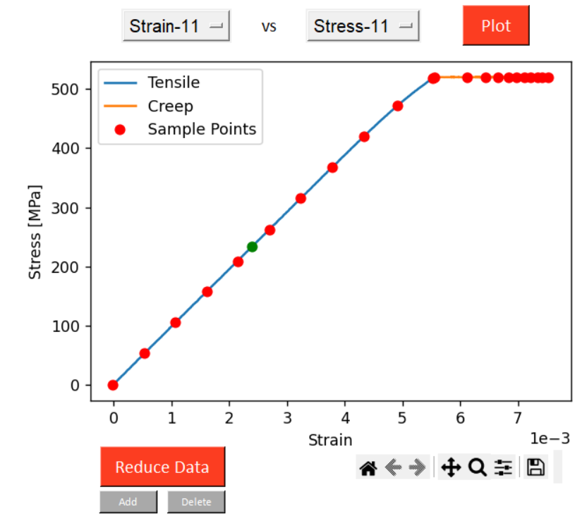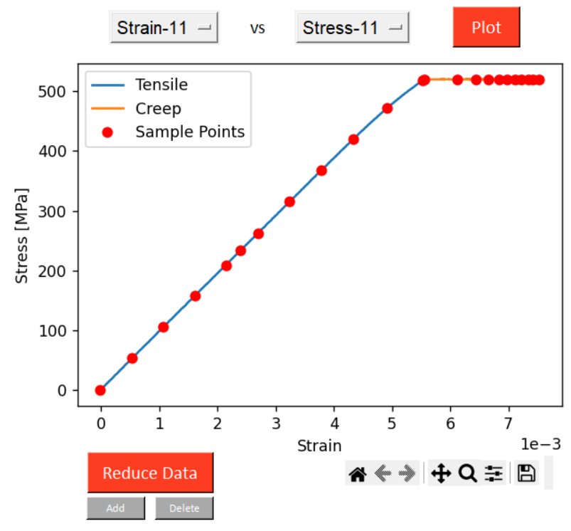

Figure 11. Adding a data reduction point: (a) Adding a new point and (b) Confirming the point

Pressing the “Delete” button and selecting a point on the curve will highlight a potential data reduction point to remove for user, displayed in green (Figure 12a). The user can use the left and right arrow keys to move the point, selecting existing data reduction points. When the user presses “Enter”, the user is prompted to confirm before deleting the point (Figure 12b).

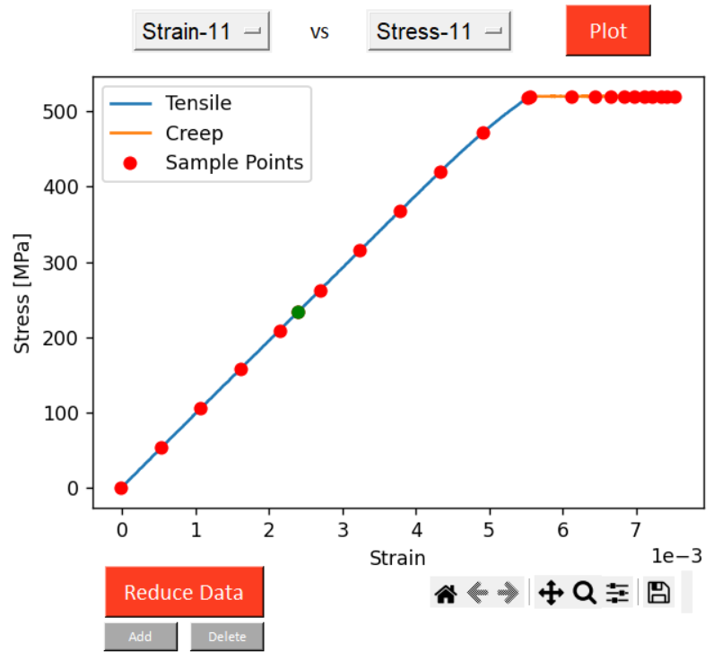 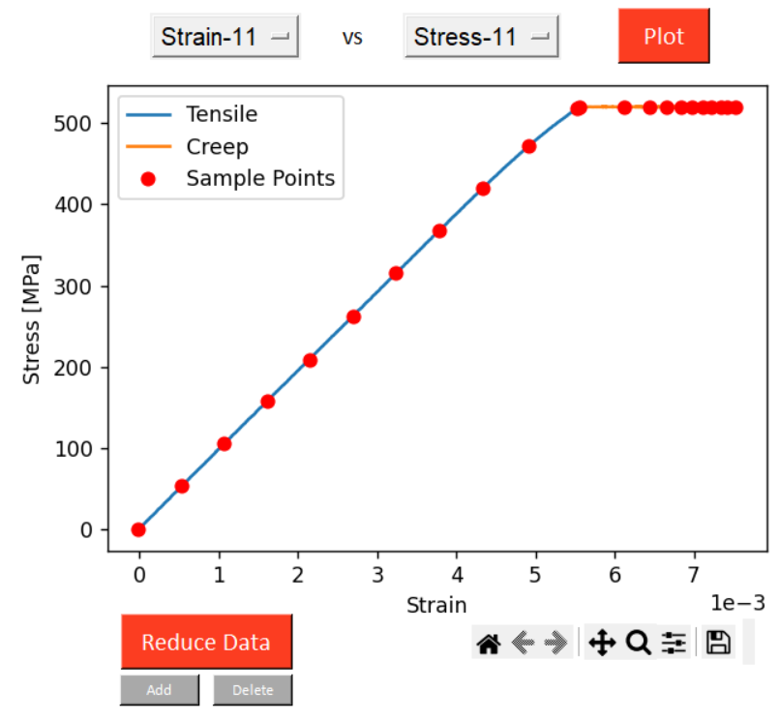

Figure 12. Adding a data reduction point: (a) Adding a new point and (b) Confirming the point

1. Optimization
   1. Defining a New Model

The Optimization page allows users to define a constitutive model and the parameters desired for optimization (Figure 13). The top of the Optimization page allows users to define a constitutive model and the associated reversible and irreversible models for the material. The user also has the option to set the number of reversible and irreversible mechanisms. The available model types and associated parameters are defined in the provided file “AvailableModels.xlsx”. The reversible and irreversible parameter tables, presented on the left and right of the page, respectively, are then automatically generated. For each parameter, users must set the initial guess, the upper and lower bounds, and indication of active or passive (active indicates that the COMPARE engine will try to optimize the parameter). Upper and lower bounds can be automatically generated using the slider bar on the far right of the page, right clicking on either parameter table, and selecting “Auto-Generate Bounds”. Notes for a defined model can be added by selecting the “Model Notes” button. All user selections and entries for a model can be saved to the project file by selecting the “Save Model” button.

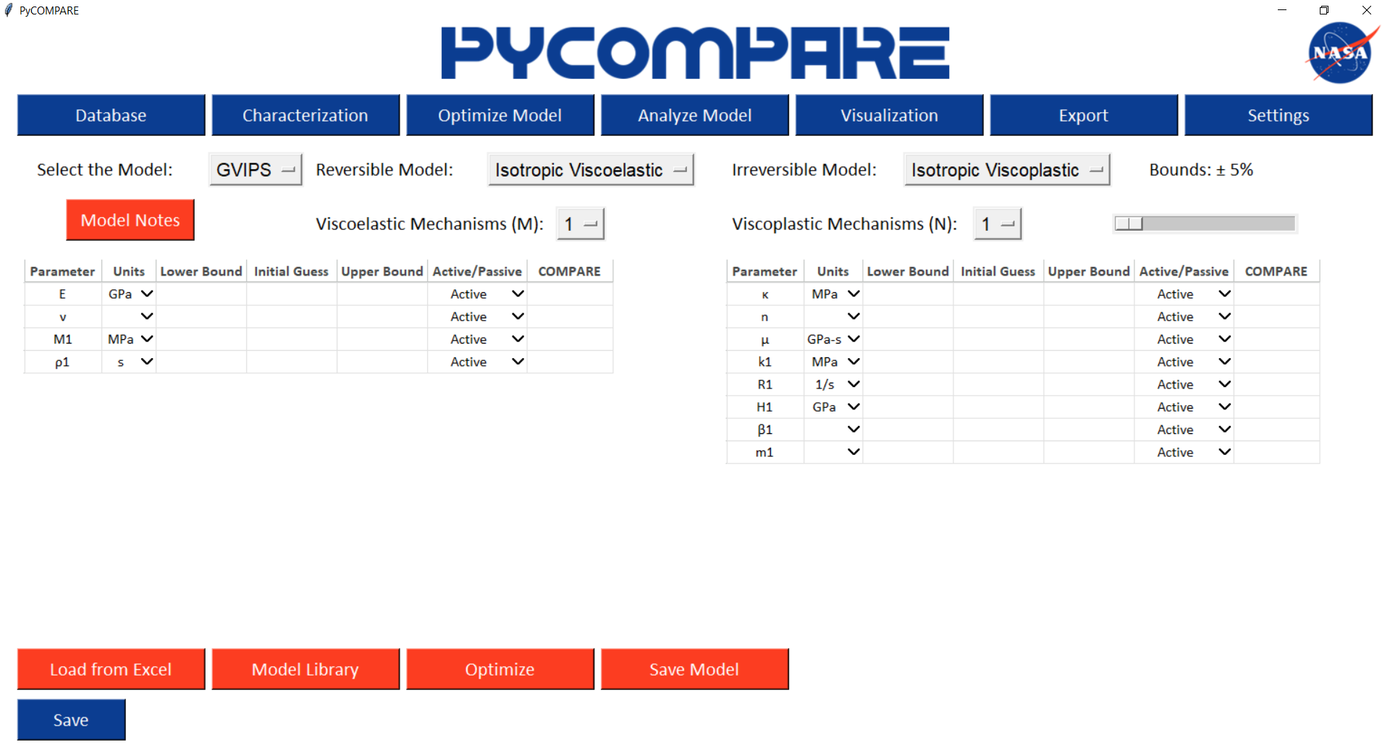

Figure 13. Defining a Model Optimization

* 1. Loading a Model from Excel

Models can be loaded from Excel using the “Load From Excel” button. Excel files must follow the format of the “ExportTemplate.xlsx” file (Figure 14). To ensure no errors occur, the “Load from Excel” button should only be used to load models that have been exported by the PyCOMPARE tool.

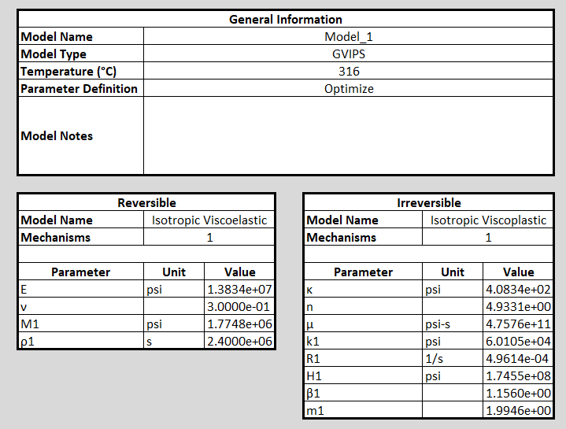

Figure 14. Excel Format for Loading a Model

* 1. Loading a Model from the Model Library

Models can be loaded from the project library by selecting the “Model Library” button, which presents the user with all models that have been saved to the current project. Right clicking on any row presents the user with the options to rename the model, delete the model from the library, load the model parameters to the parameter tables, or view any associated notes for the model (Figure 15).

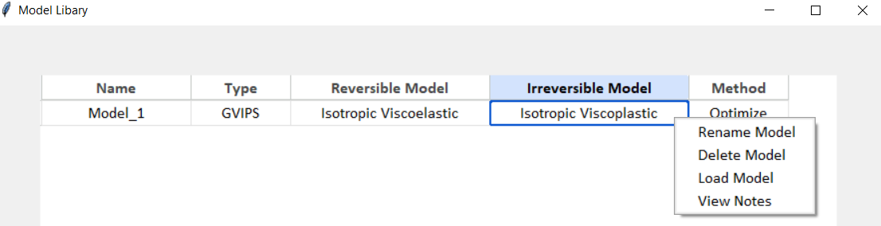

Figure 15. Model Library Options

* 1. Running the Optimization

Selecting the “Optimize” button runs the COMPARE engine to produce optimized parameters given the test data defined in the characterization set. If the optimization is successful, the optimized parameters will appear in the Compare column for each parameter table (Figure 16). If the optimized parameter text is green, COMPARE found a viable solution for that parameter within the specified bounds. If the value is red, the COMPARE result for that parameter hit one of the upper or lower bounds. For accurate material models, the bounds for that parameter should be increased and the optimization should be repeated.

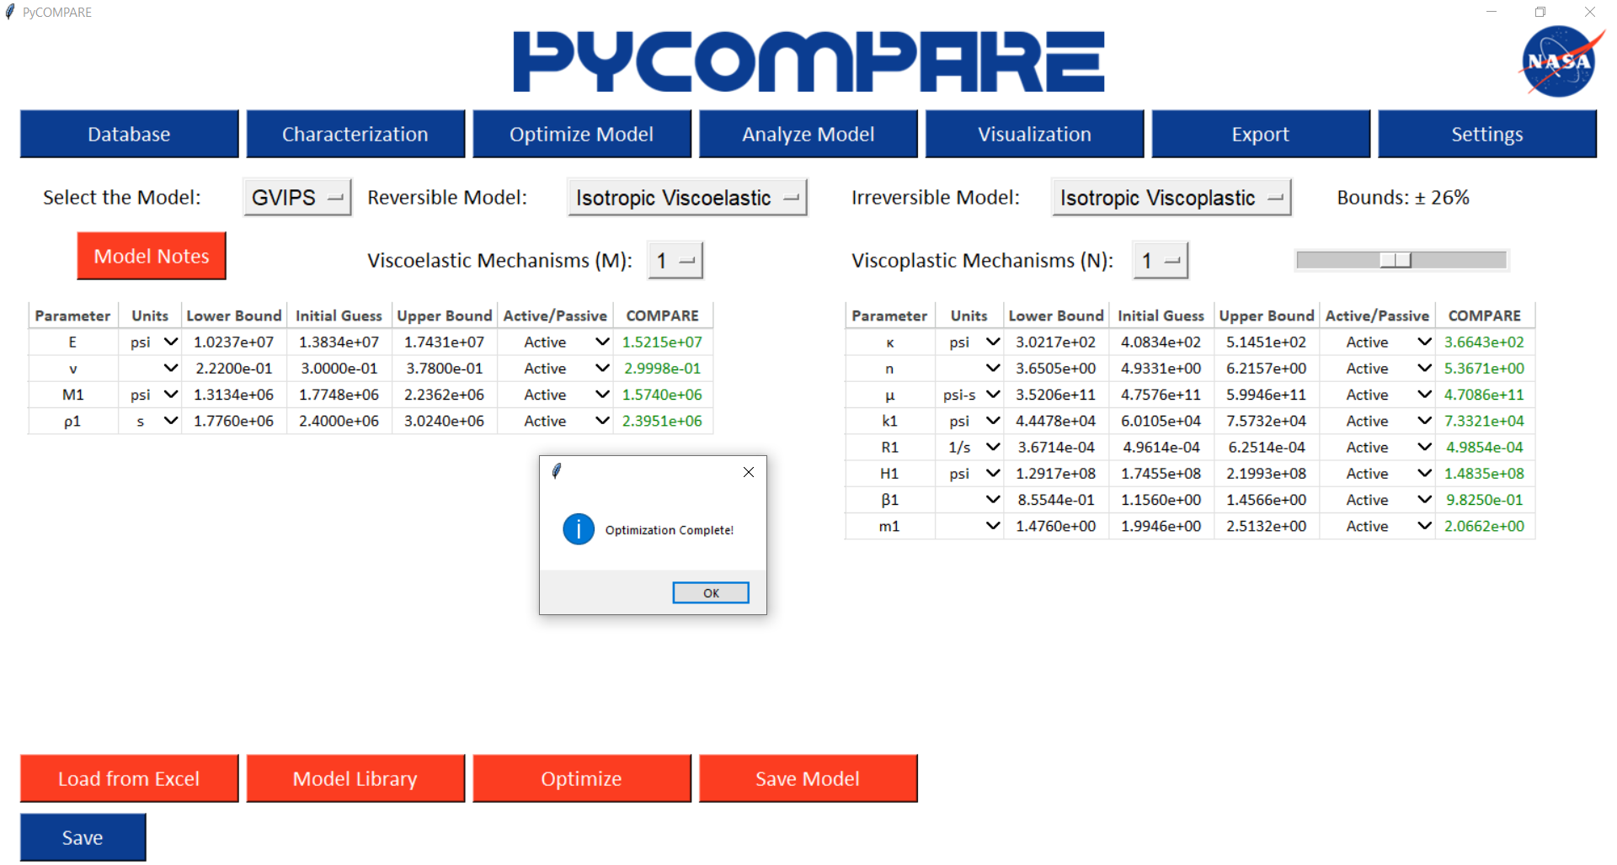

Figure 16. Optimization Results

1. Analysis
   1. Defining a New Model

The Analysis page allows users to define the constitute model parameters for a material and run simulations without running the COMPARE engine (Figure 17). The top of the Analysis page allows users to define a constitutive model and the associated reversible and irreversible models for the material. The user also has the option to set the number of reversible and irreversible mechanisms. The available model types and associated parameters are defined in the provided file “AvailableModels.xlsx”. The reversible and irreversible parameter tables, presented on the left and right of the page, respectively, are then automatically generated. Notes for a defined model can be added by selecting the “Model Notes” button. All user selections and entries for a model can be saved to the project file by selecting the “Save Model” button.

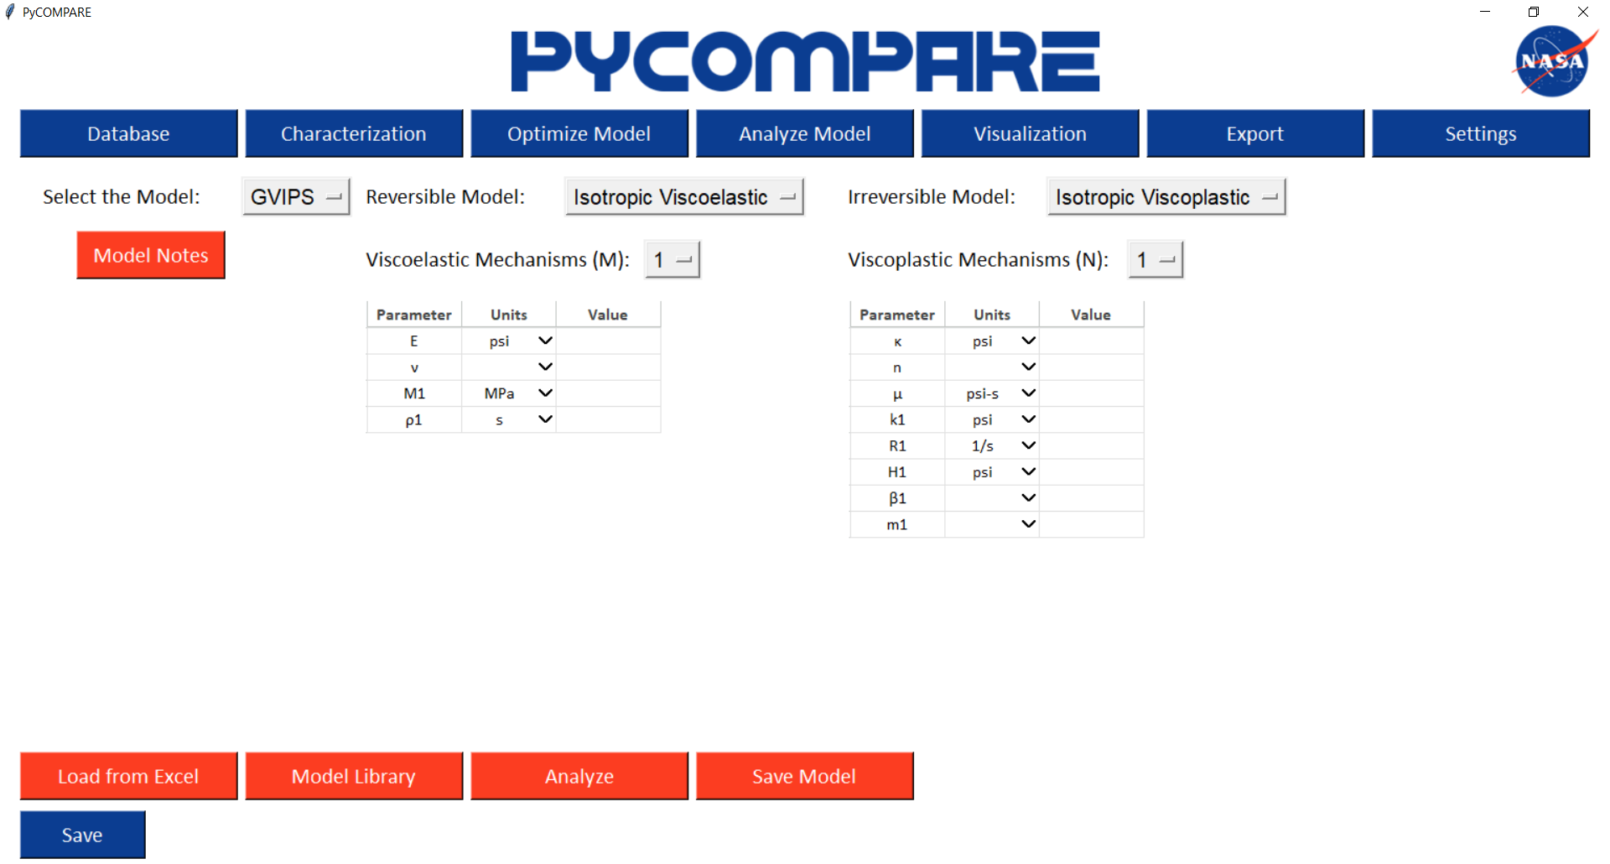

Figure 17. Defining a Model for Analysis Only

* 1. Loading a Model from Excel

Models can be loaded from Excel using the “Load From Excel” button. Excel files must follow the format of the “ExportTemplate.xlsx” file (Figure 14). To ensure no errors occur, the “Load from Excel” button should only be used to load models that have been exported by the PyCOMPARE tool.

* 1. Loading a Model from the Model Library

Models can be loaded from the project library by selecting the “Model Library” button, which presents the user with all models that have been saved to the current project. Right clicking on any row presents the user with the options to rename the model, delete the model from the library, load the model parameters to the parameter tables, or view any associated notes for the model (Figure 15).

* 1. Running the Analysis

Selecting the “Analyze” button runs the COMPARE engine without optimizing the material parameters, solely producing the simulated response curves for the tests in the characterization set.

1. Visualization

The Visualization page allows users to view predictions made by COMPARE to assess the determine model parameters accuracy. For each test in the Characterization set, the test name, information, weight, and error are presented on the left-hand side of the page. The error is the objective value score for the test during the optimization process. Note that for cases where the “Analyze Model” tab is used, although no parameter optimization is performed, the COMPARE engine still produces an objective function score for each test. Right clicking on any individual test and selecting “View Data” produces the response curves for the raw test data, reduced test data, and the simulated predictions. Users have the option to change the dependent and independent variables using the drop down menus and selecting the “Plot” button.

Similarly, users can view data in the Verification set by repeating the above process. The Verification set is automatically populated by finding all tests in the project database that were performed at the same temperature as the tests in the Characterization set. By default, tests in the Verification set are not automatically analyzed. If no score is present in the Error column, selecting “View Data” will first run the analysis for the selected test, populate the error score in the table, and present the response curves for the user.

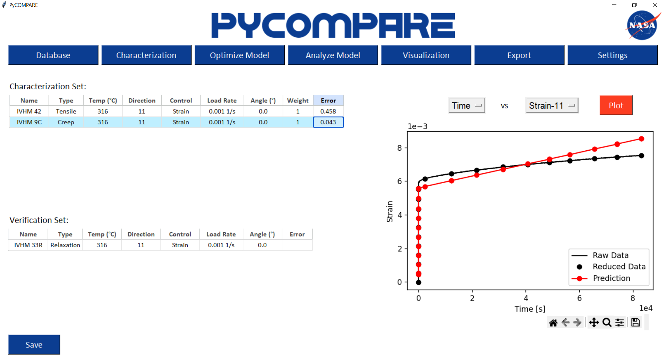

Figure 18. Viewing Results on the Visualization Tab

1. Export

The Export button on the main page produces an Excel file containing all model and simulation data for the project. The Excel file contains three sheets: Model Information, Test Information, and Response Curves. The Model Information sheet contains the selected model type, reversible and irreversible parameters, number of mechanisms chosen, and the optimized parameter values determined for the model. The Test Information sheet lists all tests that have associated simulation data, including their test temperature, test type, loading direction, control mode and rate, and anisotropy angle. It also defines if the test belongs to the Characterization or Verification set and displays the associated error score for the test. The Response Curves sheet displays predicted time, strain, and stress curves for each test in the available directions.

1. Settings

The Settings tab on the Main Page allows the user to define the required path dependencies for the COMPARE GUI to function properly and download Excel templates for importing and exporting. Pressing the “Setting” button opens a separate window that displays to the user the current paths for the COMPARE Executable, the Available Models, the Import Template, and the Export Template (Figure 18). Users can edit each path location by selecting the corresponding “Edit” button, and can download the two Excel templates by selecting the “Download” button.

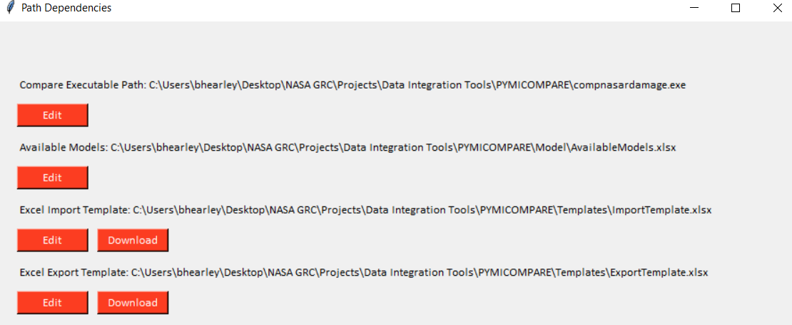

Figure 18. Settings Tab