PyCOMPARE User’s Manual
Brandon L. Hearley, Steven M. Arnold
National Aeronautics and Space Administration
Glenn Research Center
Cleveland, Ohio 44135

Abstract

Table of Contents
1. Overview 4
2. Error! Reference source not found. Error! Bookmark not defined.
3. Error! Reference source not found. Error! Bookmark not defined.
4. Error! Reference source not found. Error! Bookmark not defined.
5. Error! Reference source not found. Error! Bookmark not defined.
6. Error! Reference source not found. Error! Bookmark not defined.
7. Error! Reference source not found. Error! Bookmark not defined.
Error! Reference source not found.. Error! Reference source not found. Error! Bookmark not defined.
Error! Reference source not found.. Error! Reference source not found. Error! Bookmark not defined.
Error! Reference source not found.. Error! Reference source not found. Error! Bookmark not defined.
Error! Reference source not found.. Error! Reference source not found. Error! Bookmark not defined.
Error! Reference source not found.. Error! Reference source not found. Error! Bookmark not defined.
Error! Reference source not found. Error! Bookmark not defined.
Appendix Error! Bookmark not defined.
Error! Reference source not found. Error! Bookmark not defined.
Error! Reference source not found. Error! Bookmark not defined.

Overview

Navigating the UI
The PyCOMPARE UI features a toolbar for PyCOMPARE project management and a series of tabs for defining experimental data, optimizing or analyzing a GVIPS model, visualizing predictions, exporting data, and changing project settings (Figure 1). The toolbar at the top left of the screen contains two menus:
File
The file menu is used for overall project management. PyCOMPARE projects are saved with a *.cmprj file extension. Five options are available within the file menu:
New
Create a new PyCOMPARE project. The user is prompted to enter the name of the new project. All data in the workspace will be cleared. If data is currently loaded into the UI and associated with a project, the user will be prompted to save to original project.
Open
Open an existing PyCOMPARE project. If data is currently loaded into the UI and associated with a project, the user will be prompted to save to original project.
Save
Save a PyCOMPARE project. If the project file name is not already defined, the user will be prompted to name the project.
Save As
Save a PyCOMPARE project to a new name. The user is prompted to enter the name of the new project. All future saves will be written to the new project name.
Exit
Exit the program. The user will be prompted to save any data.

Help
The help menu is used to display the user manual. One option is available within the help menu:
About
Display the user manual.

Figure 1. PyCOMPARE Toolbar and Tabs

Database Tab
The Database tab allows users to upload experimental test data to their PyCOMPARE project (Figure 2). Data is uploaded to the project using the “Upload from Excel” button. The required import excel template can be downloaded from the Settings tab.
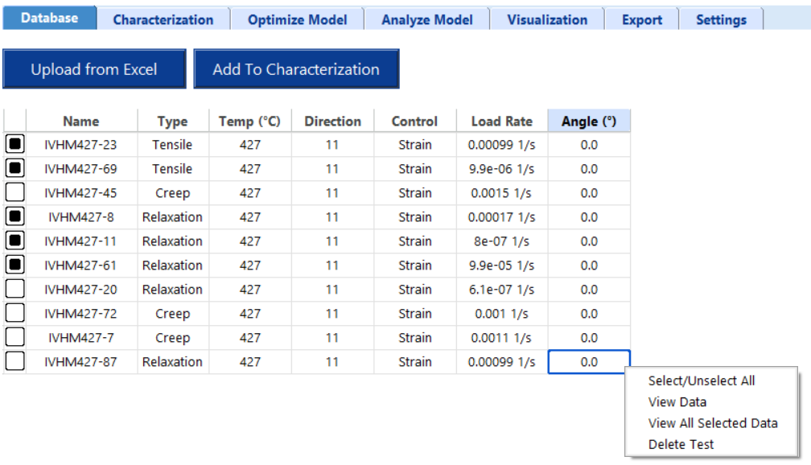
Figure 2. Database Tab: Uploading Test Data
For each test uploaded to the project, a row is added to the database table. Selecting the checkbox in the first column allows a test to be added to the characterization data set, which is used to optimize the GVIPS parameters. All tests added to the characterization set must be at the same temperature. If multiple temperatures are selected, the user will be prompted to only select one. Tests are only added to the characterization set after pressing the “Add to Characterization” button. Right clicking on any individual row of the database table gives the user four options:
Select/Unselect All
Select or unselect all checkboxes.
View Data
View the time, strain, and stress curves for a selected test (Figure 3). The x and y axes quantities can be changed using the drop down menus and “Plot” button above the curve. The stage information for each stage during the test is displayed under the database table.
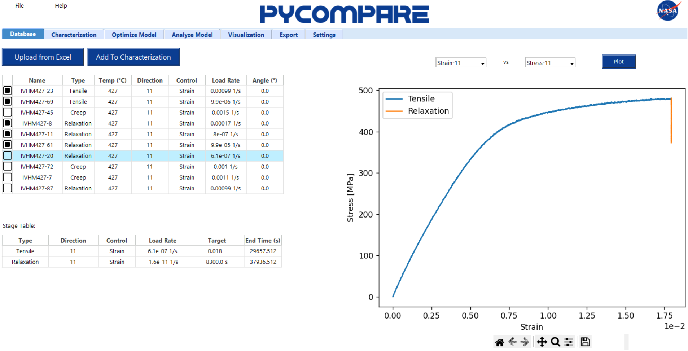
Figure 3. Database Tab: View Data
View All Selected Data
View the stress vs strain curve for all selected tests (Figure 4). Users can view selected tests together by test type, or view all test types, using the drop down menu and “Plot” button above the curve.
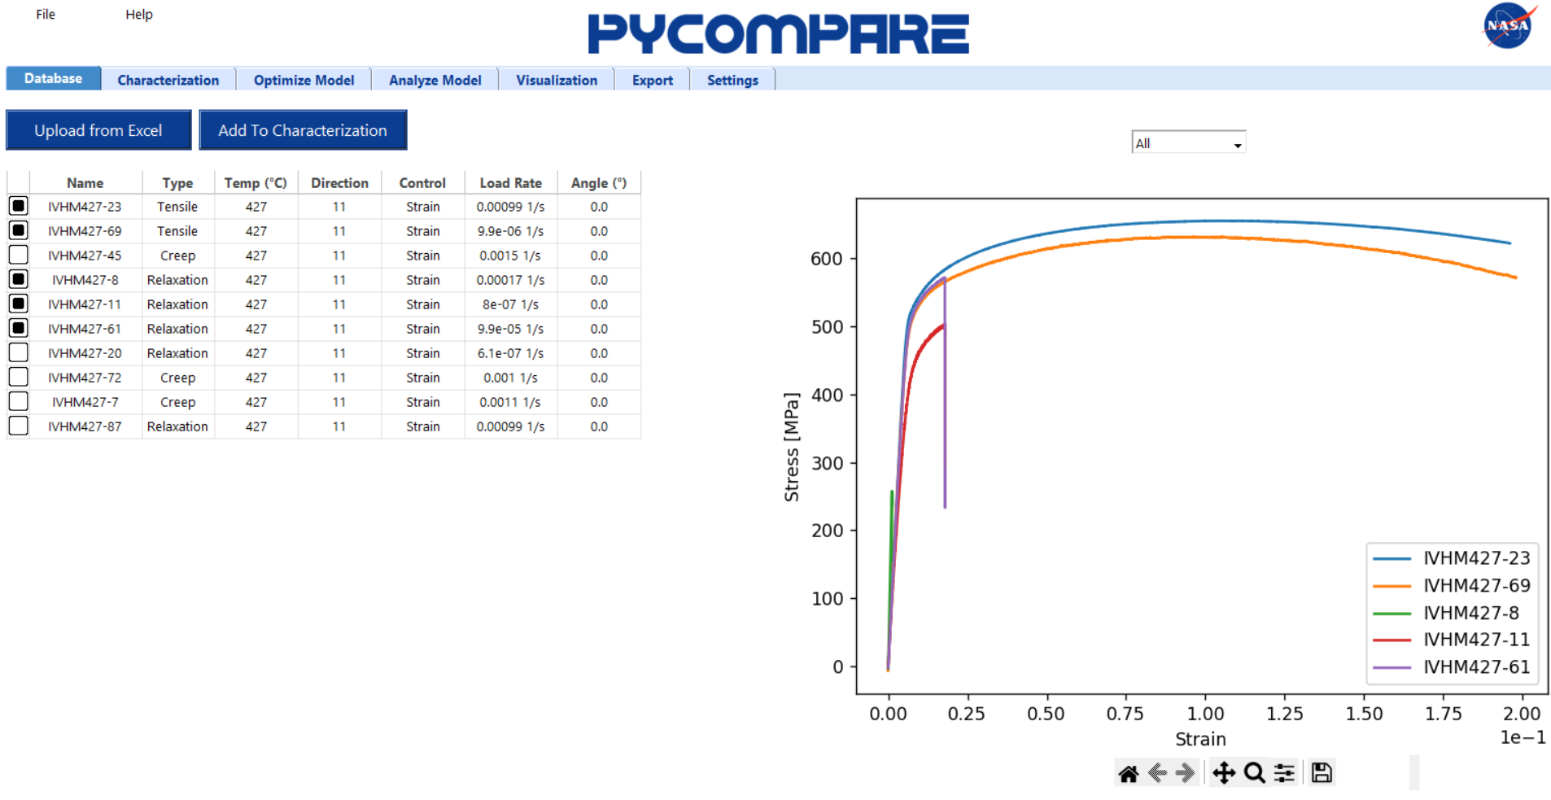
Figure 4. Database Tab: View All Selected Data
Delete Test
Delete a test from the database. This will permanently delete the test from the project.

Characterization Tab
The Characterization tab allows users to view the experimental test data in their PyCOMPARE project used for characterizing the model, reducing data, and assigning weights to each test (Figure 5).
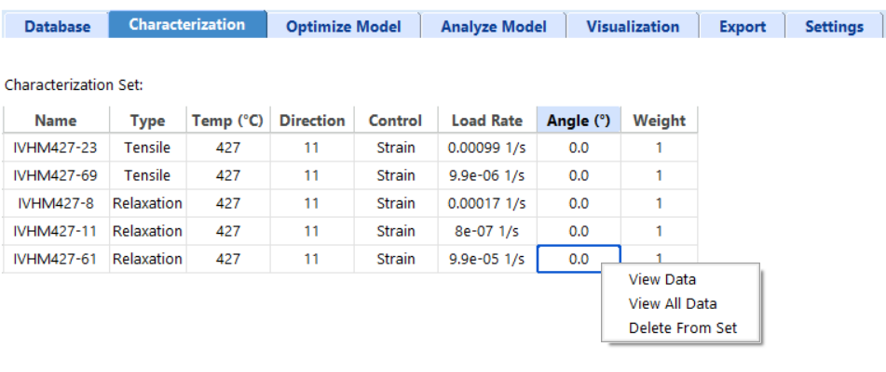
Figure 5. Characterization Tab: Viewing the Characterization Test Set
Each test in the characterization set is added to the characterization set table. Only the “Weight” column can be changed. Weights are assigned relatively (i.e., 2 is twice as important as 1). Right clicking on any individual row of the characterization set table gives the user three options:
View Data
View the time, strain, and stress curves for a selected test (Figure 6). The x and y axes quantities can be changed using the drop down menus and “Plot” button above the curve. The stage information for each stage during the test is displayed under the database table.
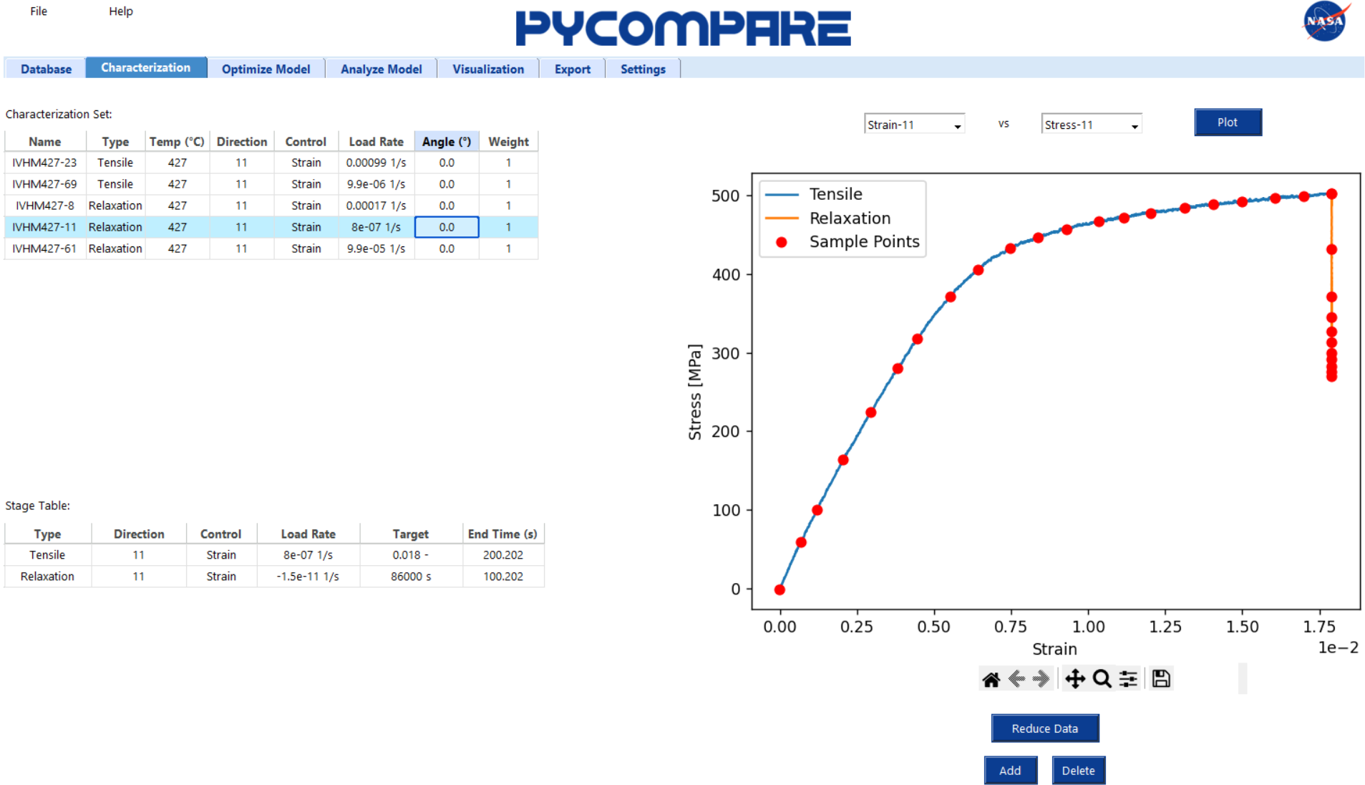
Figure 6. Characterization Tab: View Data

Selecting View Data also enables the user to set the data reduction points, displayed with red markers. Users can automatically set equally spaced data reductions points by pressing the “Reduce Data” button, which launches the Segmentation Control Panel (Figure 7a). For each stage user enters the number of desired data reduction points. Pressing the “Get Data Points” button automatically generates the data reduction points. Tensile stage points are equally spaced in normalized stress vs strain space, Creep stage points are equally spaced in normalized strain vs time space, and Relaxation stage points are equally spaced in normalized stress vs time space. Data reduction points can be manually added or deleted using the “Add” and “Delete” buttons, respectively. After the “Add” button is pressed, clicking on the plot will create a green marker at the nearest real data point that exists (Figure 7b). Similarly, after the “Delete” button is pressed, clicking on the plot will create a green marker at the nearest existing data reduction point The point can be adjusted right and left using the arrow keys. After the user hits “Enter” on the keyboard, the point will either be added or removed from the data reduction set of points.
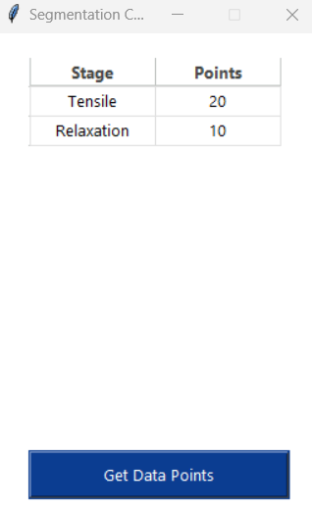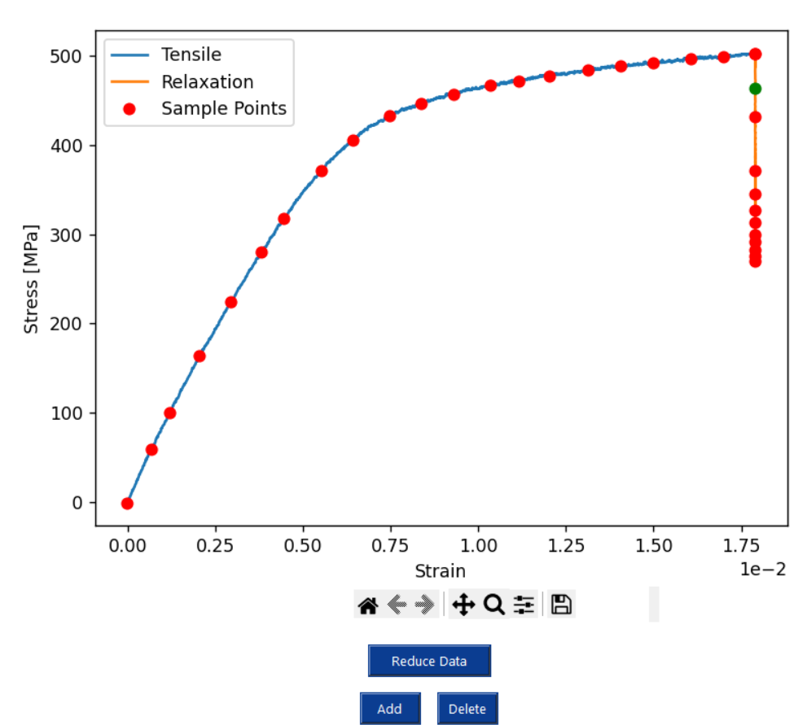
(a) (b)
Figure 7. Characterization Tab: (a) Segmentation Control Panel for Automatic Reduction and (b) Adding Data Points for Manual Reduction

View All Selected Data
View the stress vs strain curve for all selected tests (Figure 8). Users can view selected tests together by test type, or view all test types, using the drop down menu and “Plot” button above the curve.
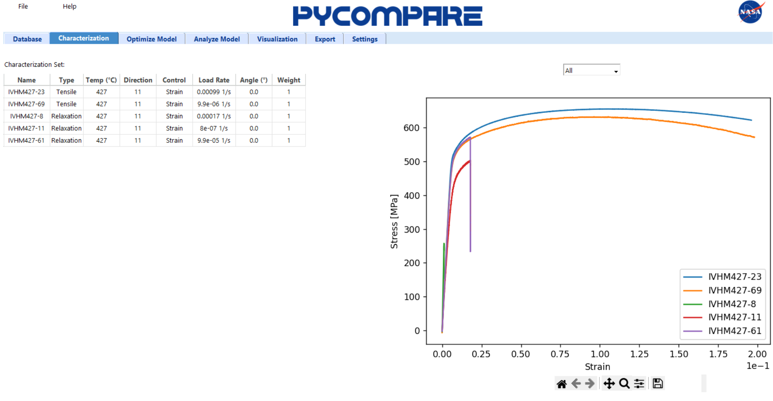
Figure 8. Characterization Tab: View All Data

Delete From Set
Delete a test from the characterization set. This will not delete the test from the project database.

Optimize Model Tab
The Optimize Model tab allows users to optimize a model for the material. For a given model type, the user may be able to select the individual reversible (viscoelastic) and irreversible (viscoplastic) model, as well as the number of viscoelastic and viscoplastic mechanisms. Table 1 gives a summary of the available models in PyCOMPARE.
Table 1. Available Model Types in PyCOMPARE
Model | Reversible Models | Viscoelastic Mechanisms | Irreversible Models | Viscoplastic Mechanisms
GVIPS | Isotropic  Anisotropic | E  $ν$  $M_{i}$  $ρ_{i}$ | Isotropic  Anisotropic
GVIPS w/ Damage | Isotropic  Anisotropic |  | Isotropic  Anisotropic

Based on the selection by the user for each field using the available drop down menus, two tables will automatically appear for defining the initial parameters needed by compare (Figure 9a). Both the viscoelastic (left) and viscoplastic (right) parameter tables contain seven columns:
Parameter
The viscoelastic or viscoplastic parameter.
Units
The units for all values in the row. User can edit via drop down menu.
Lower Bound
The lower bound for the parameter optimization.
Initial Guess
The initial guess for the parameter optimization.
Upper Bound
The upper bound for the parameter optimization.
Active/Passive
Indicator for whether the parameter is active (allowed to change during optimization) or passive (remains fixed during optimization). User can edit via drop down menu.
COMPARE
The COMPARE optimized parameters.

Users can directly edit the lower bound, initial guess, and upper bound cells in the table. Bounds can also be generated automatically by using the Bounds slider bar (Figure 9a), right clicking on the table, and selection “Auto-generate bounds” (Figure 9b). If a bound is invalid (i.e., the lower bound is greater than the initial guess or the upper bound is less than the initial guess) it will appear in red. Right clicking on a table also provides options to change all parameters to active or passive, or to sort alphabetically.

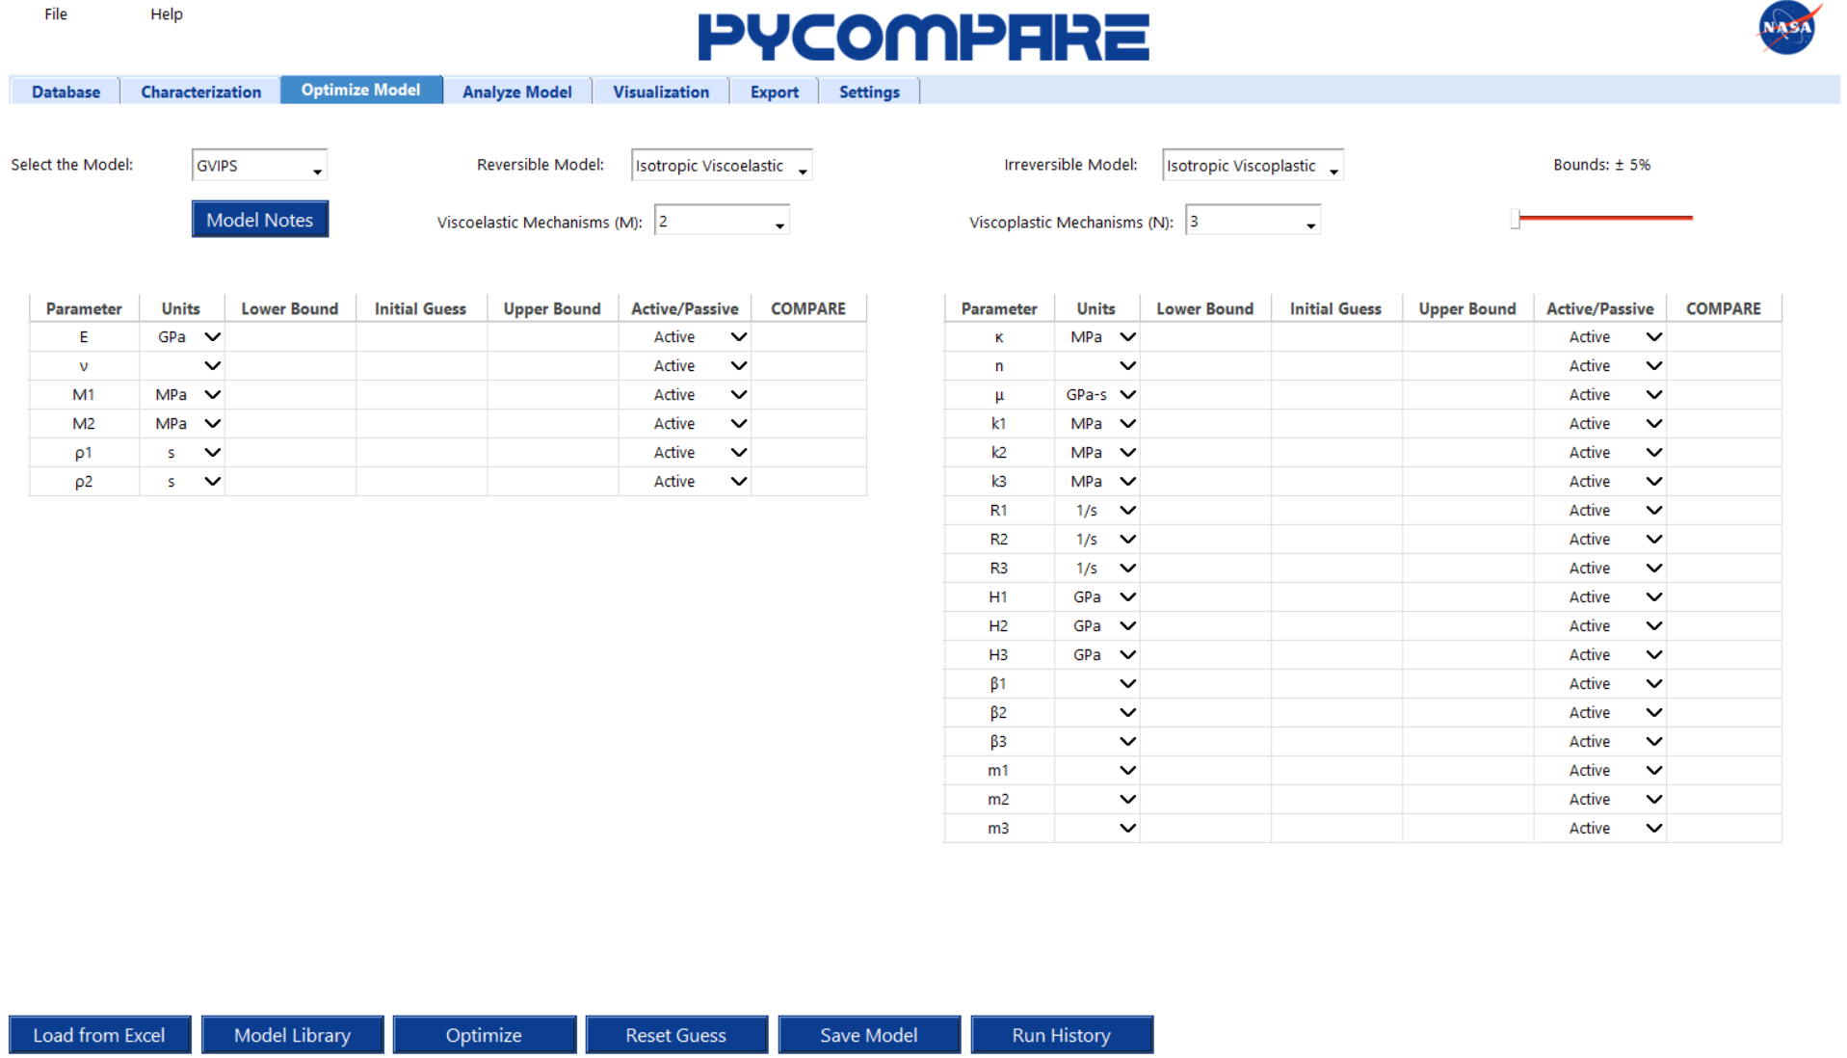
(a)
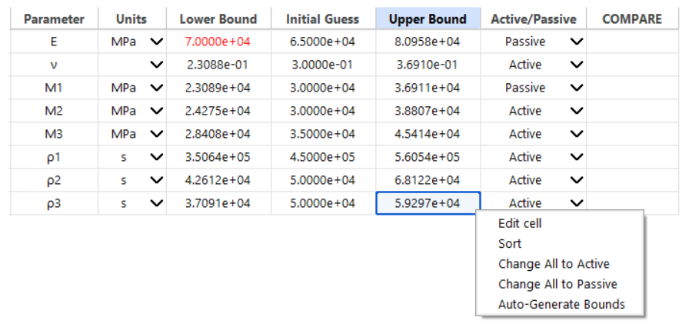
(b)
Figure 9. Optimize Model Tab: (a) Defining the model and (b) Populating the initial conditions

Once the parameters for a model have been initialized, they can be optimized by pressing the “Optimize” button. The results from COMPARE will appear in the COMPARE column. If the optimal value is at or near a bound (within 1%), the value will appear in red; otherwise, it will appear in green (Figure 10). Initial guesses and bounds should be adjusted and re-optimized until all values are green. To use the latest COMPARE result as the initial guess, press the “Reset Guess” button. The Initial Guess column will populate with the COMPARE column values, and bounds will be automatically calculated from the current Bounds slider value.
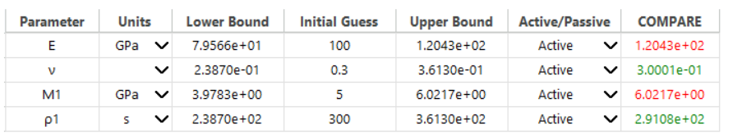
Figure 10. Optimize Model Tab: Example COMPARE results

Individual models can be saved to the project model library using the “Save Model” button. Notes can be added to a model by pressing the “Model Notes” button. Models can be loaded into COMPARE three ways:
- Load from Excel
Pressing the “Load from Excel” button will prompt the user to select an Excel file. The user must supply a PyCOMPARE export file with the model information tab populated.
- Model Library
Pressing the “Model Library” button will load the model library window (Figure 11). Right clicking on any row allows the user to rename the model, delete the model from the library, load the model into PyCOMPARE, or view the model notes.
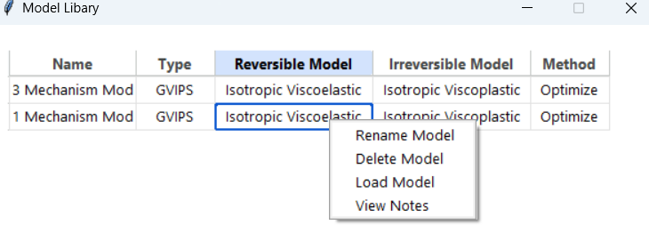
Figure 11. Optimize Model Tab: Model Library

- Run History
Pressing the “Run History” button will load the run history window (Figure 11). The run history table displays all runs of COMPARE stored in the automatically generated log files. Right clicking on any individual row allows users to either view the model information or load the model into PyCOMPARE. Pressing “View Data” generates the parameter table (top right) and characterization set table (bottom right)
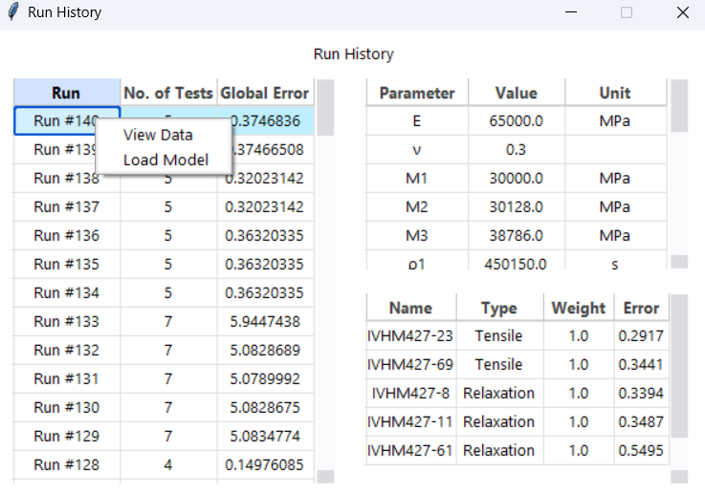
Figure 12. Optimize Model Tab: Run History

Analyze Model Tab
The Analyze Model tab allows users to define a model for the material without optimization (Figure 13). It contains the same options for defining the model and number of mechanisms as the Optimize Model tab, and similarly contains two tables for viscoelastic and viscoplastic mechanisms. However, only three columns exist in each:
Parameter
The viscoelastic or viscoplastic parameter
Units
The units for all values in the row. User can edit via drop down menu.
Value
The initial guess for the parameter optimization.

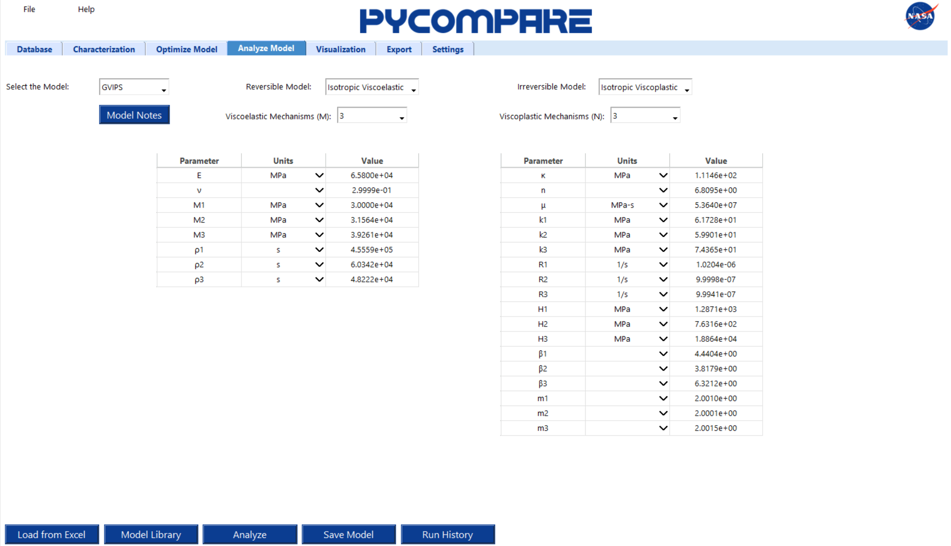
Figure 13. Analyze Model Tab: Defining the model
Pressing the “Analyze” button evaluates all tests in the characterization and verification set with the prescribed parameters without any optimization performed by COMPARE. Models can be saved using the “Save Model” button, and can be loaded into the Analyze Model tab using the same methods prescribed in the Optimize Model tab section.

Visualization Tab
The Visualization tab allows users to visualize the predictions made by COMPARE. Tests available for predictions are separated into the characterization set (used to optimize the model) and the verification set (used for blind predictions). Right clicking on any individual row of either the characterization or verification tables gives four options:
View Data
View the experimental and predicted curves for the individual test (Figure 14a). Two plots are generated to allow side by side comparison of control and response curves for the same test.
Select All
Select all tests in the table.
Select All of Same Type
Select all of the tests in a table that have the same type as the row selected.
View Selected Data
View the selected experimental and predicted curves (Figure 14b). Experimental curves are displayed on the left and predicted curves are displayed on the right.

The verification table has an additional option to “Evaluate All”, which evaluates all tests in the verification set with the prescribed parameters.
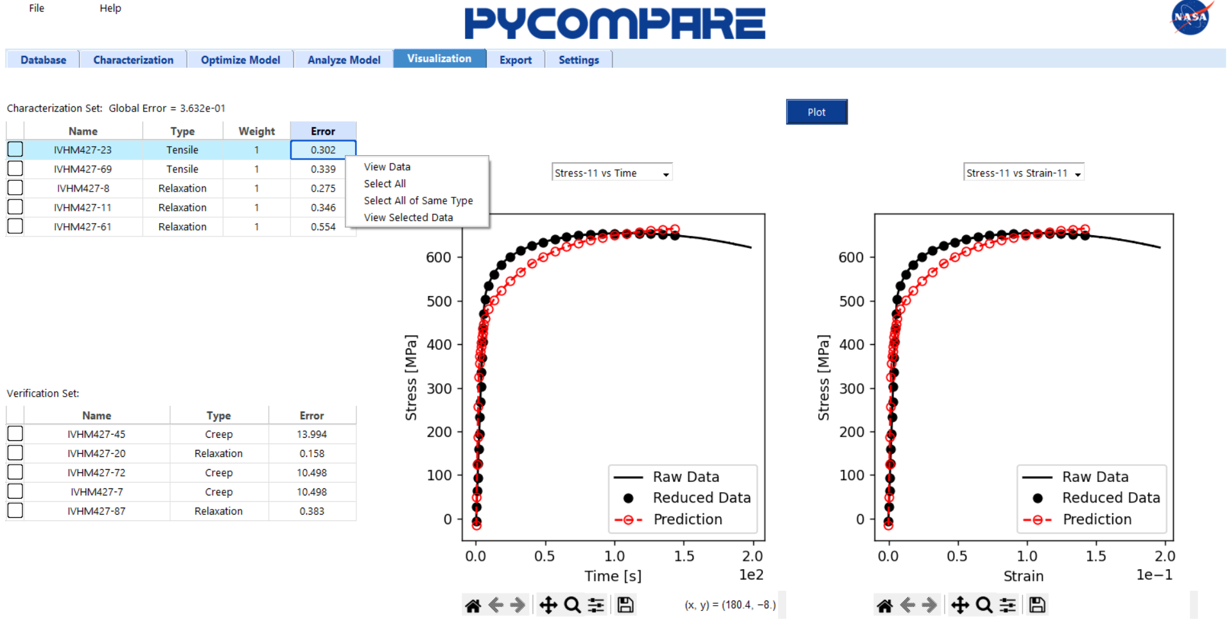
(a)
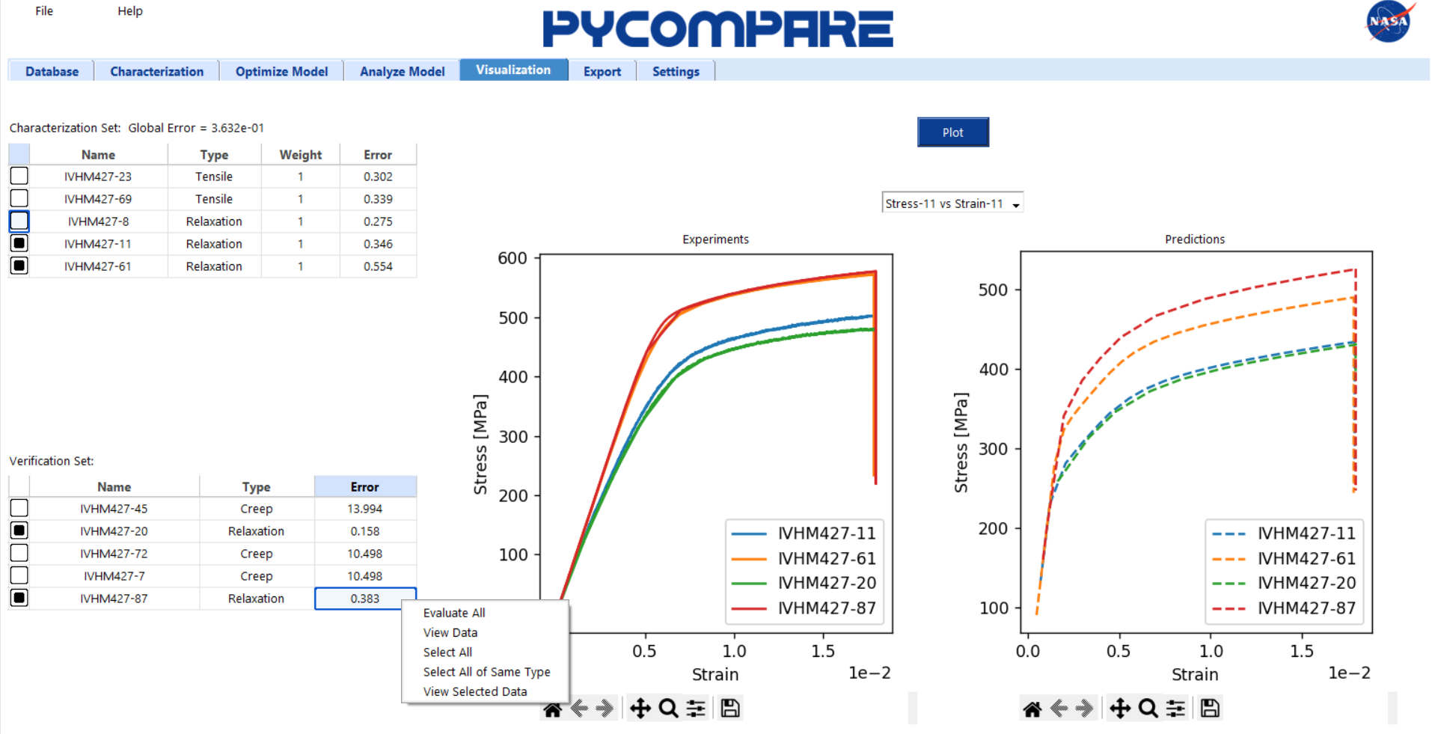
(b)
Figure 14. Visualization Tab: (a) Viewing Individual Predictions and (b) Viewing Multiple Predictions

Export Tab
The Export tab allows users to export all project results to an Excel file (Figure 15). The export template contains five pages:
Model Information
The Model Information page contains all information defining the model, including the model name, type, temperature, notes, and parameter values.
Test Information
The Test Information page contains a table of all tests in the characterization and verification data sets. For each test, the name, type, control mode, loading rate, anisotropy angle, data set (characterization or verification), weight, and error are given.
Full Experimental Curves
The Full Experimental Curves page contains the full experimental data for all tests in the characterization and verification data sets.
Reduced Experimental Curves
The Reduced Experimental Curves page contains the reduced experimental data for all tests in the characterization and verification data sets.
Predicted Curves
The Full Experimental Curves page contains the predicted simulation data for all tests in the characterization and verification data sets.

Users can check or uncheck each of the pages from the export file on the Export tab.
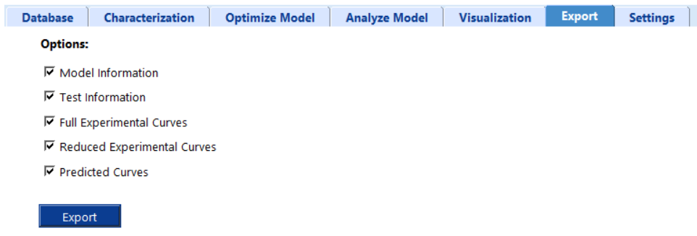
Figure 15. Export Tab: Options for Exporting Project Results

Settings Tab
The Settings tab allows users to set all directories necessary to run PyCOMPARE and download the template import and export files (Figure 16). When PyCOMPARE is installed, all directories should be automatically set. If an error occurs, users can reset a directory using an “Edit” button. For the import and export templates, users can also download a copy using the “Download” button.
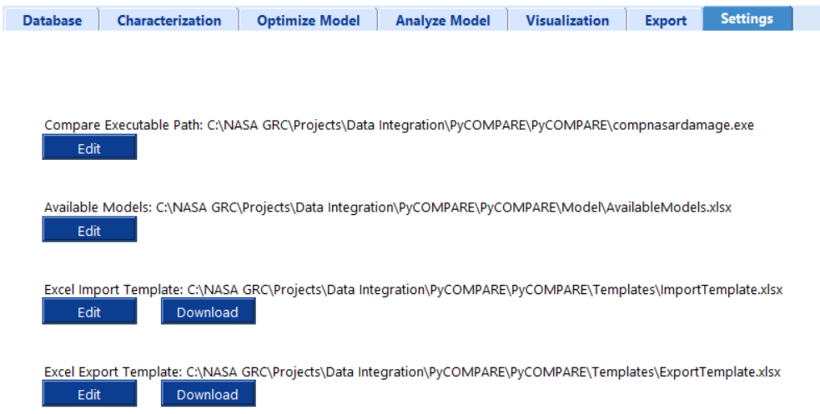
Figure 16. Settings Tab: Setting Project Directories

