CSE 574

Learning to Rank using Linear Regression
Project 2

Vivek Kantilal Bheda
UBIT: vivekkan
UB Person#: 50206966

Implementation

Data Partitioning
Implementing the project, partitioning the data was done by first seperating the data into 3 sets, depening on the discrete values of the relevance labels of 0,1,2. These 3 sets were shuffled and then the data vectors were distributed between the training, validation and testing set. Data was added to the three sets, training, validation and testing such that training set has 80% of the total data, training and validation each have 10% of the data. None of the sets overlap.
Using this method, I was able to maintain the same ratio of 0,1 and 2 relevance level data in all the tree sets, thus maintaining their proportions.
I would like to point out, since the Learning to Rank data set has many more number of 0 relevance level data items, the learning algorithm skews towards identifying unknown data that have 0 relevance level rather than 1 or 2. A data set with more number of samples with relevance level 1 and 2 would have probably generated much better results.

Hyper-parameter Tuning

Selecting Lamda
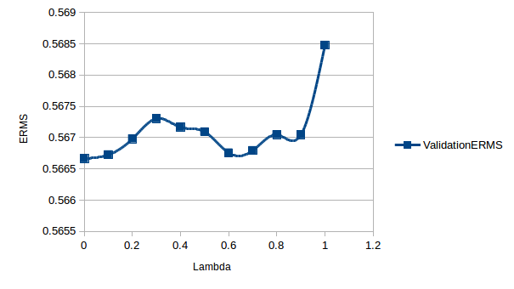
Illustration 1: LeToR Dataset: Performance for various values of Lambda

As suggested by the graph, the Learning to Rank dataset was giving the best performance in the closed form solution for lambda equal to 0 and 0.6, thus lambda equal to 0 was chosen for the learning to rank dataset.
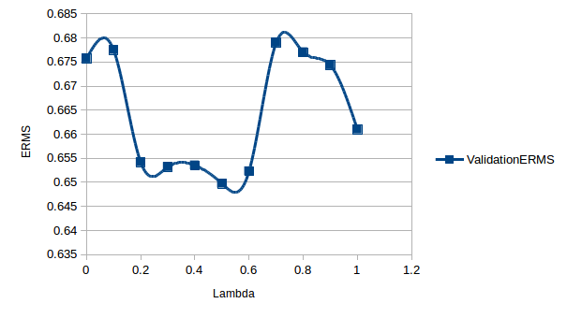
Illustration 2: Synthetic Dataset: Performance for various values of Lambda
For the synthetic dataset the learning algorithm would perform well at various range of values, thus their mean on 0.5 also where the ERMS was minimum was chosen.

Selecting M
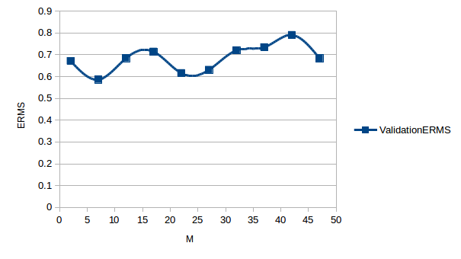
Illustration 3: LeToR Dataset: SGD Performance for various values of M

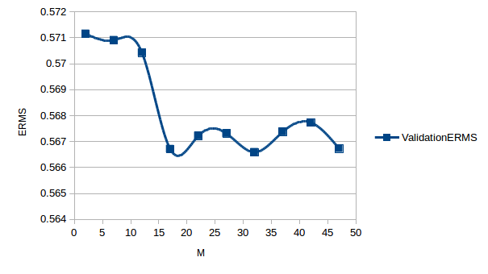
Illustration 4: LeToR Dataset: Closed Form Performance for various values of M
Looking at Illustrations 3 & 4, for the Learning to Rank dataset, the learning algorithm provided good results for 17 radial basis functions. For 17 basis functions the time to train and test the algorithm wasn’t too large neither was the performance gain for an M greater than 17.
LeToR dataset consistently provided decent results at M=17, throughout various runs where the dataset was shuffled randomly each time.All the values illustrated here are for lambda equal to 0 and eta equal to 0.1.
The Synthetic dataset provides good performance for many values of M. Rather the performance for the synthetic dataset keeps getting better for even larger values of M, when M is greater than number of features of the dataset. Here we chose M equal to 8 for the synthetic dataset as the time required to train is not large and the performance is decent enough.
I would like to point out though, the synthetic dataset provides a much better performance, when the training set has the same number of samples with relevance 2. In such a scenario where the training set has same number of 0s,1s and 2s, the learning algorithm is able to predict better.
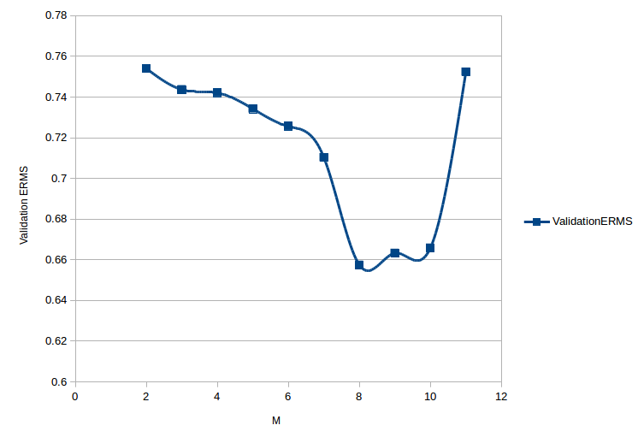
Illustration 5: Synthetic Dataset: SGD Performance for various values of M
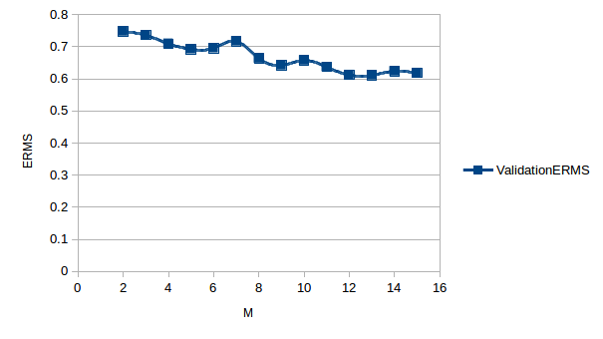
Illustration 6: Synthetic Dataset: Closed Form Performance for various values of M

Choosing μj and Σj
Choosing Mu and Sigma matrices was straight forward. The training dataset was divided into M-1 clusters using the K-Means algorithm, where the cluster centers acted as values for Mu[0]....Mu[m-1].
Sigma matrices were calculating the variance of the dataset using each value of Mu, thus forming M-1 sigma vectors which were converted into sigma matrix according to the method suggested in the documentation, ie converting the variance vector into a square (46x46) matrix. The function written in implementation directly returns the inverse of the sigma matrix to avoid further computation in the future. The values of the sigma matrix were scaled by a factor of 2, so as to increase the spread of the radial basis function to form some overlap.
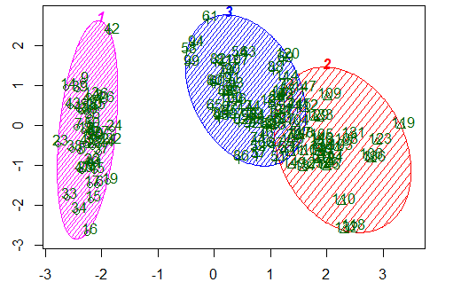
Illustration 7: Sample Illustration of K Means

Choosing η
For the project I have implemented a constant Eta value for the Stocastic Gradient Learning Algorithm.
The Learning to Rank dataset was giving best performance when the value of Eta was between 0.01 and 0.0001. Thus I chose a value of 0.1 for Eta so the learning rate would be faster and since a larger Eta value didn’t hinder performance. SGD Algorithm was performing close to the Closed Form solution. Had there been more information more readily available regarding how to adapt the learning rate, I think the algorithm would be able to match the closed form solution’s performance.
For the Synthetic dataset, an eta value of 1 with lambda equal to 0 was producing the best results. Thus I chose eta equal to 1 for the synthetic dataset.
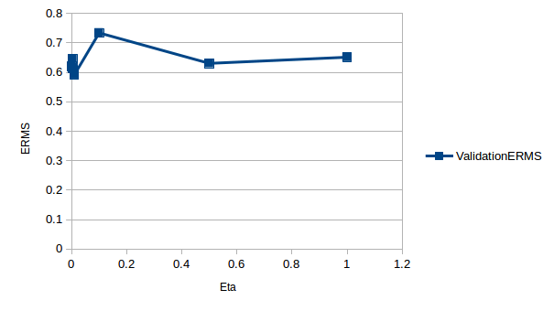
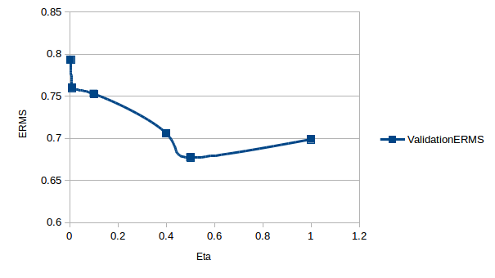

Results

The above table shows the results obtained after training for the selected values of M, Lambda and Eta. The Learning to Rank data set provides good performance with ERMS values dropping as close 0.5. Since we are comparing the continous value produced by our learning algorithm with the discrete relevance level, no output would produce an exact error of 0. Also since the data set has more samples with relevance level zero, the algorithms output skews towards producing 0s, thus documents with relevance 2 would probably have high Error values.
The SGDs performance comes close to the closed form solution, but this is highly dependent on how the Input dataset is shuffled, if shuffled in the wrong way, the SGD’s performance becomes very poor with ERMS values from 0.8 and above. These values are when the SGD’s performance was at its best.
I have not produced the mean vectors and the sigma matrix in the report or printed them during execution, as those matrices are very large and would make understanding the output very difficult and confusing. If you wish to see the Mu and sigma inverse matrices, they can be accessed from the following variables :
- Final Weight Vector – newTrainResult[0]
- Mu Matrices – newTrainResult[1]
- Inverse Sigma Matrices - newTrainResult[2]

References
Sample Kmeans Illustration Image : http://i.stack.imgur.com/OQlbA.png

