“MediVault – Digital Prescription and Medication Tracker”
A Project Report Submitted in the partial fulfillment of the requirements for the award of the degree of

BACHELOR OF TECHNOLOGY
In

DEPARTMENT OF COMPUTER SCIENCE ENGINNERING
By

SAI SURENDRANATH PENDYALA 2520030157

SHAIK SABIYA THABASSUM 2520030502
SINGAMSETTY BHEESHMA 2520030528

Under the Esteemed Guidance of

Dr Yerragudipadu Subbarayudu Assistant Professor
Department of Computer Science and Engineering




K L (Deemed to be) University DEPARTMENT OF COMPUTER SCIENCE ENGINEERING
&

DEPARTMENT OF COMPUTER SCIENCE AND INFORMATION TECHNOL

Declaration

The Project Report entitled “MediVault: Digital Prescription and Medication Tracker” is a record of Bonafide work of SAI SURENDRANATH PENDYALA - 2520030157 , SHAIK SABIYA THABASSUM- 2520030502, SINGAMSETTY BHEESHMA- 2520030528submitted in
partial fulfillment for the award of B. Tech in Computer Science and Engineering (or) Computer Science and Information Technology to the K L University. The results embodied in this report have not been copied from any other departments/University/Institute.

SAI SURENDRANATH PENDYALA – 25200300157

SHAIK SABIYA THABASSUM– 2520030502

SINGAMSETTY BHEESHMA– 2520030528

K L (Deemed to be) University

DEPARTMENT OF COMPUTER SCIENCE ENGINEERING

&

DEPARTMENT OF COMPUTER SCIENCE AND INFORMATION TECHNOLOGY

CERTIFICATE

This is certify that the mini project based report entitled“Design and Development of an Integrated Tourism Platform for Flights, Trains, Hotels, and Hidden Destinations” is a bonafide work done and submitted by SAI SURENDRANATH PENDYALA - 2520030157 , SHAIK SABIYA THABASSUM-2520030502, SINGAMSETTY BHEESHMA – 2520030528 in partial fulfillment of the requirements for the award of the degree of BACHELOR OF TECHNOLOGY in Department of Computer Science Engineering, K L (Deemed to be University), during the academic year 2026-2027.

Signature of the Guide

Signature of the Course Coordinator Signature of the HOD

ACKNOWLEDGEMENT
The success in this project would not have been possible but for the timely help and guidance rendered by many people. Our wish to express my sincere thanks to all those who has assisted us in one way or the other for the completion of my project.

Our greatest appreciation to my Course Coordinator Dr Yerragudipadu Subbarayudu, and my guide Dr Yerragudipadu Subbarayudu, Department of Computer Science which cannot be expressed in words for his/her tremendous support, encouragement and guidance for this project.

We express our gratitude to Dr. P Venkateshwara Roa (CSE) Head of the Department for Computer Science Engineering for providing us with adequate facilities, ways and means by which we are able to complete this project-based Lab.

We thank all the members of teaching and non-teaching staff members, and also who have assisted me directly or indirectly for successful completion of this project. Finally, I sincerely thank my parents, friends and classmates for their kind help and cooperation during my work.

SAI SURENDRANATH PENDYALA – 25200300157

SHAIK SABIYA THABASSUM– 2520030502

SINGAMSETTY BHEESHMA– 2520030528

Abstract

MediVault is a web-based Digital Prescription and Medication Tracker developed to simplify the process of managing prescriptions and medicines digitally. Managing physical prescriptions and multiple medicines manually can be difficult because prescriptions may be lost or damaged, medicine names and dosages may be forgotten, and medication timings can be missed. Existing basic reminder applications generally focus only on notifications and do not provide complete prescription and medication management in a single platform.
MediVault provides a centralized platform where users can register and log in, maintain their profile, store prescription details, manage medicine information, specify dosage, frequency, and duration, schedule medication timings, and receive reminders for scheduled medicines. The system also maintains prescription and medication history, allowing users to access previously stored information whenever required. A dashboard provides an overview of active prescriptions, medicines, and upcoming medication schedules, while search functionality helps users quickly locate stored records.
The system is developed using modern web technologies. React.js, HTML5, CSS3, and JavaScript are used for developing the front-end interface, while Node.js and Express.js are used for backend development. MySQL is used as the database for storing user, prescription, medicine, schedule, and history information. Visual Studio Code is used as the primary development environment, while Git and GitHub can be used for version control and collaboration.
MediVault aims to reduce dependence on physical prescription documents and manual medication tracking by providing an organized, accessible, and user-friendly digital solution. The system can be further enhanced with OCR-based prescription scanning, AI-assisted medicine extraction, automatic refill reminders, pharmacy integration, doctor connectivity, cloud synchronization, caregiver access, voice-based reminders, wearable-device integration, multilingual support, and medication adherence reports.

Index

S.  No. | Chapters | Topics | Page.no
 |  | Acknowledgement
 |  | Abstract
1 | Introduction | - Background of the project  - Problem statement  - Scope of the project  - Objective(s)  - Importance of the application  - Target users/audience | 5-15
2 | System Requirements | - Hardware requirements  - Software requirements  - Development tools and frameworks | 16-21
3 | Technology Stack | - Front-end (e.g., React.js, Angular, HTML/CSS)  - Back-end (e.g., Node.js, Django, Spring Boot)  - Database (e.g., MongoDB, MySQL, PostgreSQL)  - Version Control (e.g., Git, GitHub)  - APIs or External services (e.g., Firebase, Stripe) | 22-32
4 | System Architecture | - High-level architecture diagram  - Description of each layer (frontend, backend, database)  - Deployment architecture (e.g., cloud, local, CI/CD  pipelines) | 33-36
5 | Design | 5.2 ER Diagram / Database schema | 37
6 | Implementation | - Module-wise implementation  - Front-end logic (UI rendering, state management)  - API integration  - Authentication & Authorization | 38-47
7 | Features | - List of main features  - How each feature works (user perspective + technical description) | 48-55
8 | Testing | - Postman testing (frontend/backend)  - Integration testing  - Tools used for testing  - Test cases and results | 56-64
9 | Deployment | - Steps to deploy  - Environment configuration  - Hosting of frontend and backend | 65-73
10 | Challenges & Limitations | - Issues faced during development  - Solutions applied  - Current limitations or known bugs | 74-82
11 | Future Enhancements | - Planned features  - Possible integrations or optimizations | 83-88
12 | Conclusion | - Summary of the project  - What was achieved  - Skills learned during development | 89-97
13 | References | - Books, tutorials, APIs, documentation sites used | 98-99

14 | Appendices | - Screenshots of the app  - Sample code snippets  - Installation/setup instructions  - User manual or guide  -Geo Tag photos with guide  -Review forms with guide signatures | 100-105

CHAPTER -1 INTRODUCTION

Background of the Project

Healthcare is one of the most important sectors where the effective use of information technology can significantly improve the way information is stored, accessed, and managed. With the continuous advancement of digital technologies, healthcare services are increasingly moving from traditional paper-based processes toward digital platforms. Prescription records, medicine information, dosage instructions, and medication schedules are among the important details that need to be maintained accurately for effective medication management. Traditionally, patients have depended on physical prescriptions, handwritten notes, paper records, or verbal instructions to remember their medicines and medication timings. As the number of prescribed medicines increases, manually managing these details can become difficult and may result in forgotten doses, misplaced prescriptions, or difficulty in accessing previous medication information.
The growth of web technologies and digital healthcare applications has changed the way patients can manage their medical information. Today, digital platforms can provide users with convenient methods to store, organize, and retrieve healthcare-related records. However, many existing applications focus on only one particular activity, such as medicine reminders, prescription storage, or appointment management. These separate solutions may require users to maintain their information across different applications, making medication management less convenient. A user may need one application to store prescription details, another to set medicine reminders, and another to maintain medication history. This fragmented approach can make it difficult to maintain a centralized and organized record of medicines.
The idea for this project emerged from observing these difficulties and identifying the need for a unified digital platform for prescription and medication management. The proposed system, “MediVault – Digital Prescription and Medication Tracker,” aims to provide a centralized platform where users can digitally manage their prescriptions and medicines in an organized manner. The system allows users to register and log in, maintain their profile, store prescription information, add medicine details, specify dosage, frequency, and duration, and manage medication schedules. By bringing these functionalities together in a single platform, MediVault aims to simplify the process of maintaining medication-related information.
The development of modern web technologies has made it possible to create such centralized healthcare management systems. Technologies such as React.js, HTML5, CSS3, and JavaScript can be used to create an interactive and responsive user interface, while Node.js and Express.js can provide the backend services required to process user requests and manage application logic. MySQL can be used as the database for storing user information, prescription records, medicine details, schedules, and medication history. The communication between the front end, backend, and database allows information to be stored and retrieved efficiently whenever required.
Beyond storing information, the project focuses on making medication management more organized and accessible. The system provides users with a structured method to maintain prescription records and associated medicine information. Users can enter details such as medicine name, dosage, frequency, and duration, allowing medication information to be maintained in a consistent format. A medication reminder module can help users keep track of scheduled medicines, while the medication history allows previously stored information to be accessed when required. The dashboard provides an overview of relevant medication information and helps users navigate between different functionalities of the system.
From a user perspective, MediVault reduces the dependence on physical prescription documents for maintaining personal medication information. Physical prescriptions can be misplaced, damaged, or become difficult to access when required. By maintaining the information digitally, users can organize their records within a centralized system. Search functionality further improves accessibility by allowing users to locate stored prescription or medicine information without manually searching through multiple physical documents.
From a healthcare management perspective, the system provides a structured approach to maintaining prescription and medication-related information. Instead of maintaining separate handwritten records, users can maintain their information digitally in an organized database. This makes it easier to manage multiple medicines and prescriptions and provides a clear history of previously stored information. The system is designed primarily as a digital management and tracking platform and does not replace professional medical advice or diagnosis.
From an academic and engineering perspective, the background of the project lies in combining several core areas of computer science:
- Web Technology: development of an interactive and responsive user interface using React.js, HTML5, CSS3, and JavaScript.
- Database Management: efficient storage, organization, and retrieval of user profiles, prescriptions, medicines, schedules, and medication history using MySQL.
- Backend Development: implementation of server-side application logic and communication between the user interface and database using Node.js and Express.js.
- Software Engineering Principles: modular development, structured architecture, maintainability, scalability, and systematic implementation of different application modules.
- User Experience Design: designing an intuitive interface that allows users to navigate through registration, prescriptions, medicines, reminders, history, dashboard, and search functionalities easily.
This technological foundation ensures that MediVault is not simply a collection of static web pages but a structured, database-driven application capable of managing medication-related information through interconnected modules. The interface is designed to provide clear navigation and organized information so that users can easily access the features required for prescription and medicine management.
In a broader context, the project reflects the growing adoption of digital solutions in healthcare and the increasing importance of accessible electronic information management. As users increasingly depend on digital platforms for storing and accessing important information, medication management can also benefit from centralized digital systems. A platform such as MediVault can provide a convenient method for organizing prescription and medicine records while reducing dependence on physical documents and manual tracking.
The project can also be extended in the future with additional intelligent and connected healthcare features. Possible enhancements include OCR-based prescription scanning, AI-assisted medicine information extraction, automatic refill reminders, pharmacy integration, doctor connectivity, cloud synchronization, caregiver access, voice-based reminders, wearable-device integration, multilingual support, and medication adherence reports. These extensions can further improve the usefulness of the platform while keeping the core objective focused on organized digital prescription and medication management.
To summarize, the background of this project rests on three fundamental observations:
Existing prescription and medication management methods can be fragmented and heavily dependent on physical records and manual tracking.
Rapid technological progress in web development, backend systems, and database management makes centralized digital medication management practical and accessible.
Healthcare information management can benefit from a unified platform that allows users to organize prescriptions, medicines, schedules, reminders, and medication history in one place.
By addressing these points, MediVault establishes itself as a digital prescription and medication management platform designed to simplify the way users store, organize, and access their medication-related information while providing a foundation for future improvements in technology-enabled healthcare management.
.

Problem Statement

In today’s digital healthcare environment, users have access to numerous applications and online services for managing different aspects of their health, yet prescription and medication management often remains fragmented and inefficient. Despite the rapid growth of healthcare technology, many digital solutions focus on individual functions such as medicine reminders, prescription storage, appointment scheduling, or health record management. Users may therefore need to depend on multiple applications or continue using physical prescriptions and handwritten notes to manage their medication information. This fragmented approach makes it difficult to maintain a complete and organized record of prescriptions, medicines, dosage information, schedules, and medication history in one place.
The core problem addressed by this project is the lack of a centralized, user-friendly system that combines major prescription and medication management functions into one digital environment. Traditional methods of managing prescriptions depend heavily on physical documents, which can be misplaced, damaged, or difficult to access when required. Similarly, manually remembering medicine names, dosages, frequencies, and timings becomes increasingly difficult when a user has multiple medications. Existing applications may provide reminders or individual tracking features, but they may not provide an integrated environment for maintaining prescriptions, medicines, schedules, history, and related information together.
Another major issue lies in the difficulty of maintaining medication information in a structured manner. A prescription generally contains several types of information, including medicine names, dosage instructions, frequency, duration, and additional instructions. When this information is maintained manually, users may have difficulty remembering or locating specific details at the right time. Repeatedly checking physical prescriptions or handwritten notes can make medication management inconvenient. The absence of a centralized digital record creates a gap between the need for easily accessible medication information and the traditional methods used to maintain it.
Medication scheduling represents another important challenge. Different medicines may need to be taken at different times and frequencies. A user taking multiple medicines may have to remember several schedules throughout the day. Missing or forgetting a scheduled medication can occur when the user relies entirely on memory or manual notes. Although separate reminder applications are available, they may not be directly connected with the user’s prescription and medicine records. As a result, users may need to enter the same medicine information multiple times across different applications, creating unnecessary effort and increasing the possibility of incorrect or incomplete information.
From a technical standpoint, there is also a persistent integration challenge between prescription information, medicine records, schedules, and medication history. These components are often maintained separately, making it difficult to establish a clear relationship between a prescription and the medicines associated with it. A centralized database-driven system can address this issue by connecting users with their prescriptions, medicines, schedules, and historical records. Instead of storing information in disconnected locations, the system can organize related data through a structured database and provide it to the user whenever required.
User experience is another important concern in existing medication management processes. Healthcare-related information can sometimes be complex, and poorly organized interfaces may make it difficult for users to locate important information. Users should not have to navigate through complicated screens to find their current medicines, prescription details, or upcoming medication schedules. The absence of a simple and organized interface can reduce usability, particularly for users who may not have extensive technical knowledge. Therefore, an effective medication management system should provide clear navigation, understandable information, and easy access to frequently required functions.
Accessibility of medication records also represents a significant challenge. Physical prescriptions cannot always be accessed conveniently when a user is away from home or when an old prescription is required for reference. Maintaining digital records can provide a more organized method of accessing previously stored information. A centralized system can allow users to view prescription and medication information through a single interface instead of manually searching through physical documents or multiple applications.
Security and privacy represent additional challenges because prescription and medication information is personal and should be handled carefully. A digital medication management platform needs appropriate authentication and access-control mechanisms so that user-specific information is not unnecessarily exposed to unauthorized users. Users need confidence that their stored information is associated with their own account and can be accessed through appropriate authentication mechanisms. Therefore, secure user registration, login, and controlled access form important parts of a centralized medication management system.
The problem, therefore, extends beyond simply storing medicine information; it involves efficiency, organization, accessibility, usability, and secure management of medication-related records. A user's medication journey should ideally follow a simple digital pathway—from storing a prescription and adding medicines to managing dosage and schedules, receiving reminders, and reviewing medication history. Instead, users may currently experience interruptions caused by physical records, separate applications, manual data entry, and disconnected reminder systems. For a digital solution to be effective, these related activities need to be organized within a unified environment.
In this context, our project seeks to solve these interrelated challenges by developing a web-based digital prescription and medication management platform called “MediVault – Digital Prescription and Medication Tracker.” The system’s central objective is to provide a single-window environment where users can register, manage their profiles, store prescription information, add and manage medicines, specify dosage and frequency, maintain medication schedules, access medication history, and use search and notification-related functionalities. By connecting these components through a common database and backend architecture, the system aims to reduce the effort involved in manually maintaining medication information.
By addressing these fundamental issues, the project aims to achieve the following problem resolutions:
- Eliminate fragmentation by integrating prescription, medicine, scheduling, history, search, and notification-related functionalities into one unified platform.
- Improve accessibility by allowing users to digitally store and retrieve prescription and medication information whenever required.
- Simplify medication management by providing structured fields for medicine names, dosage, frequency, duration, and schedules.
- Reduce dependence on physical records by providing a centralized digital repository for prescription and medication information.
- Improve medication tracking by maintaining medication schedules, reminders, and historical records in an organized manner.
- Enhance usability through a simple, responsive, and user-friendly interface that allows users to access important functions easily.
- Improve data organization by using a relational database to establish connections between users, prescriptions, medicines, schedules, and history.
- Support secure access through user authentication and appropriate authorization mechanisms for user-specific information.
In summary, the problem statement identifies a clear gap between the user's need for a centralized, organized, and accessible medication management system and the fragmented methods commonly used for maintaining prescriptions and medicine information. Physical prescriptions, manual tracking, separate reminder applications, and disconnected records can make medication management unnecessarily difficult. The proposed MediVault system aims to address this gap by providing a unified, database-driven, and user-centered platform that brings prescription management, medicine tracking, scheduling, reminders, history, search, and related functions together. Through this integrated approach, the project aims to transform medication management from a fragmented manual process into a more organized and accessible digital experience.

Scope of the Project

The scope of this project, “MediVault – Digital Prescription and Medication Tracker,” extends across multiple dimensions of digital healthcare management — technological, functional, organizational, and user-oriented. The main objective is to establish a comprehensive, web-based solution that consolidates the essential functions required for managing prescriptions and medications into a single digital platform. By integrating prescription storage, medicine management, medication scheduling, reminders, history, search, and dashboard functionalities, the project aims to simplify how users organize and access their medication-related information in the digital age.
The technical scope involves building a responsive, database-driven web application that can function efficiently across commonly used devices and modern web browsers. The platform is developed using modern web technologies such as React.js, HTML5, CSS3, and JavaScript for the front end, while Node.js and Express.js are used for backend development. MySQL is used as the relational database for storing and retrieving user, prescription, medicine, schedule, and history information. The system architecture follows a modular approach, allowing individual features to be developed and maintained separately. This structure also provides the possibility of adding additional healthcare-related features in future versions without requiring a complete redesign of the existing system.
In addition, the project encompasses the implementation of communication between the front-end interface, backend services, and database. The backend provides APIs through which the application can perform operations such as user registration, authentication, prescription management, medicine management, schedule management, and retrieval of stored records. This allows information entered by the user to be processed and stored systematically rather than being maintained only within the interface. The database provides persistent storage so that users can access their previously stored prescription and medication information whenever required.
The project also falls within the scope of user experience and interface design, with emphasis on simplicity, clarity, accessibility, and ease of navigation. Medication-related information can contain several details such as medicine names, dosage, frequency, duration, and timing. Therefore, the interface is designed to organize these details in a clear and understandable manner. Users should be able to navigate between registration, login, dashboard, prescription management, medicine management, reminders, history, and search functionalities without unnecessary complexity. The responsive nature of the interface also allows the platform to adapt to different screen sizes and devices.
The functional scope of the system includes several interconnected modules. The User Registration and Login module provides account creation and authentication. The User Profile module allows users to maintain their personal information. The Prescription Management module enables users to digitally store and manage prescription-related information. The Medicine Management module allows users to record medicine names, dosage, frequency, duration, and other relevant information. The Medication Reminder module supports the management of scheduled medication timings, while the Medication History module provides access to previously stored medication-related records.
The Dashboard forms an important part of the scope by providing users with a centralized overview of their medication-related information. Instead of accessing each module separately to understand their current records, users can use the dashboard as a central navigation point. The Search module further improves accessibility by allowing users to locate specific prescriptions or medicines more efficiently. Notification-related functionality can also be associated with scheduled medication activities to help users remain aware of relevant medication timings.
From a database management perspective, the scope includes the structured storage and retrieval of information using MySQL. The database can maintain separate but related records for users, profiles, prescriptions, medicines, schedules, medication history, and notifications. Relationships between these entities allow the system to associate medication information with the appropriate user and prescription. This database-driven approach improves organization and provides a foundation for retrieving information efficiently.
From a security perspective, the project includes user authentication and controlled access to user-specific information. Since prescription and medication records are personal in nature, the system needs to ensure that users access information through their respective accounts. Authentication provides the basic mechanism for verifying users before allowing access to protected sections of the application. Security considerations can also be extended in future versions through stronger authentication mechanisms, improved authorization, encryption, and other security measures.
From a usability perspective, the scope of the project is not limited to technically storing information. The system aims to make medication management easier for users by reducing dependence on physical prescriptions and handwritten notes. Users can maintain their medication information in a structured digital format and access it whenever required. This can be particularly useful for individuals managing multiple medicines or maintaining several prescription records.
From a research and development perspective, the scope provides opportunities for future improvements in intelligent healthcare management. The current platform focuses on digital storage, organization, tracking, and management of prescription and medication information. However, the architecture can be extended in the future with technologies such as Optical Character Recognition (OCR) for extracting information from prescription images, AI-assisted medicine information extraction, intelligent medication recommendations, and automated analysis of medication adherence. These features can improve automation while extending the functionality of the existing platform.
The project also has an administrative and operational scope. In future versions, administrative functionality can be introduced to manage system users, monitor application data, maintain medicine-related information, and control system-level configurations. Additional roles such as doctors, pharmacies, caregivers, or healthcare organizations may also be integrated in future versions. Such extensions can transform the platform from a personal medication management system into a broader healthcare information ecosystem.
The scope also extends to potential integration with external healthcare services. Future versions can include pharmacy integration for refill-related services, doctor connectivity for sharing appropriate prescription information, cloud synchronization for accessing records across devices, and caregiver access for users who require assistance with medication management. Voice-based reminders, wearable-device integration, and multilingual support can also be considered as future enhancements to improve accessibility and convenience.
In terms of limitations and exclusions, the current version of the project primarily focuses on digital prescription and medication management. It does not replace doctors, pharmacists, or other healthcare professionals and is not intended to provide medical diagnosis or prescribe medicines. Advanced features such as OCR-based prescription scanning, AI-assisted medicine extraction, automatic pharmacy ordering, doctor connectivity, wearable integration, and cloud-based synchronization are considered future enhancements rather than core functionalities of the current system.
To summarize, the scope of the project can be defined through the following key points:
- Development of a unified, web-based platform for digital prescription and medication management.
- Implementation of user registration, authentication, profile management, prescription management, medicine management, medication scheduling, reminders, history, search, dashboard, and notification-related functionalities.
- Use of React.js, HTML5, CSS3, JavaScript, Node.js, Express.js, and MySQL for developing the application.
- Implementation of a structured database for storing and retrieving user, prescription, medicine, schedule, and history information.
- Emphasis on usability, accessibility, responsive design, and organized presentation of medication information.
- Implementation of authentication and controlled access for protecting user-specific records.
- Scalable architecture supporting future integration with OCR, AI-assisted features, pharmacy services, doctor connectivity, cloud synchronization, caregiver access, and wearable technologies.
- Potential expansion toward a broader digital healthcare ecosystem through additional integrations and intelligent features.
In conclusion, the scope of MediVault extends far beyond a simple medicine reminder application. It represents a structured approach toward building a centralized digital prescription and medication management ecosystem that brings together prescription storage, medicine tracking, scheduling, reminders, history, search, and user management under one platform. By combining modern web technologies with database-driven information management and a user-centered interface, the project provides a foundation for more organized, accessible, and technology-enabled medication management while leaving room for future intelligent and connected healthcare enhancements.

Objectives of the Project

The main objective of this project is to design and develop an integrated digital prescription and medication management system that simplifies the process of storing prescriptions, managing medicines, scheduling medication routines, and maintaining medication history through one centralized and user-friendly web-based platform. The system, named MediVault – Digital Prescription and Medication Tracker, aims to reduce the difficulties associated with managing medication information manually and provide users with an organized, accessible, and efficient solution for their day-to-day medication management needs.
In the traditional medication management process, users often depend on physical prescriptions, handwritten notes, medicine strips, separate reminder applications, or manually maintained records to keep track of their medications. As the number of prescribed medicines increases, maintaining accurate information regarding medicine names, dosage, frequency, duration, and schedules becomes increasingly difficult. This project aims to reduce such fragmentation by providing a centralized system where prescription information, medicine details, medication schedules, reminders, and history can be maintained within a single application.
The primary technical objective is to develop a database-driven web application using modern web development technologies and a structured software architecture. The system is designed using React.js, HTML5, CSS3, and JavaScript for the front-end interface, Node.js and Express.js for backend development, and MySQL for database management. The system should allow the front-end and backend components to communicate efficiently through APIs while maintaining structured and consistent data within the database. Each functional module should operate independently while interacting with other modules to provide a cohesive medication management experience.
Another important objective is to create a user-centric interface that makes medication management simple and convenient. The system should provide clear navigation and organized screens so that users can easily register, log in, manage their profile, store prescriptions, add medicines, view medication details, and monitor their medication history. The interface should minimize unnecessary complexity and allow users to access important information without having to search through multiple physical records or disconnected applications.
The project also aims to provide effective medication scheduling and reminder functionality. Users may need to take different medicines at different times, frequencies, and durations. Therefore, the system is designed to organize medication schedules in a structured manner and provide reminder-related functionality that helps users keep track of their medication routines. By maintaining medicine schedules together with prescription and history information, the system provides a more systematic approach to medication tracking.
The Prescription Management Module has a specific role within the objectives of the project. Its purpose is to allow users to digitally maintain prescription-related information rather than depending completely on physical documents. The prescription information can be associated with the medicines prescribed to the user, allowing medication details to be organized in a structured manner. This improves accessibility to important prescription information and reduces the inconvenience of repeatedly searching for or carrying physical prescription records.
The Medicine Management Module is another major component of the system. Its objective is to provide users with an organized method of maintaining information about medicines, including details such as medicine name, dosage, frequency, duration, and schedule. Instead of keeping these details in different locations, the system brings them together in a structured database. This improves data organization and makes it easier for users to review their medication requirements.
From a database perspective, an important objective is to maintain accurate, structured, and consistent medication information. The MySQL database is used to store relevant information related to users, profiles, prescriptions, medicines, medication schedules, history, and notifications. Proper database organization allows the system to retrieve and manage information efficiently while maintaining relationships between different entities. This provides a strong foundation for reliable medication tracking and future system expansion.
From a security and reliability perspective, the project aims to provide controlled access to user information through authentication mechanisms. Since prescription and medication records contain personal information, the system should prevent unauthorized access and ensure that users can access their own information through the appropriate authentication process. Secure communication between the front end, backend, and database is an important consideration in developing a reliable healthcare-related application.
The project additionally aims to provide a modular and extendable architecture that can support future improvements. The current system focuses on essential prescription and medication management functionality, while the architecture can be extended with advanced features in the future. Possible enhancements include OCR-based prescription scanning, AI-assisted medicine extraction, automatic refill reminders, pharmacy integration, doctor connectivity, cloud synchronization, caregiver access, voice reminders, wearable integration, multilingual support, and medication adherence reports. These features are considered future enhancements rather than core functionality of the current implementation.
From a user and social perspective, the project aims to improve convenience for individuals who need to maintain regular medication information. By providing centralized access to prescriptions, medicine details, schedules, reminders, and history, MediVault can reduce dependence on scattered physical records and manual tracking methods. The system is particularly designed around the idea of making medication information easier to organize and access through a digital platform.
In educational and technical terms, the objective is also to demonstrate the practical application of concepts learned in Web Technology, Database Management Systems, Backend Development, Software Engineering, API Communication, and User Interface Design. The project provides a practical example of how front-end technologies, backend services, databases, and modular software design can be integrated to solve a real-world information management problem.
To summarize, the major objectives of the project are as follows:
- To design and develop a centralized digital platform for prescription and medication management.
- To provide secure user registration and authentication for controlled access to personal medication information.
- To digitally store and manage prescription information in an organized and easily accessible manner.
- To manage medicine details such as medicine name, dosage, frequency, duration, and medication schedule.
- To provide medication reminder functionality that helps users organize and follow their medication routines.
- To maintain medication history so that users can review previously recorded medication information.
- To implement a structured MySQL database for storing and managing users, prescriptions, medicines, schedules, history, and notification-related information.
- To develop a responsive and user-friendly interface using React.js, HTML5, CSS3, and JavaScript.
- To establish efficient communication between the front end, backend, and database through Node.js, Express.js, and API-based architecture.
- To provide search and dashboard functionality for easier access to important medication information.
- To ensure maintainability and scalability through a modular system architecture.
- To demonstrate the practical application of modern web development and database management concepts in solving a real-world healthcare information management problem.
- To provide a foundation for future enhancements such as OCR-based prescription scanning, AI-assisted medicine extraction, automatic refill reminders, pharmacy integration, caregiver access, multilingual support, and medication adherence analysis.
In essence, the objective of MediVault goes beyond simply creating a medicine-recording website. It is intended to provide a comprehensive digital environment where prescription information, medicine details, medication schedules, reminders, and history can be organized within one centralized system. By combining modern web technologies, database management, user-focused design, and modular architecture, the project aims to make medication information management more organized, accessible, and convenient while providing a strong foundation for future digital healthcare enhancements.

Healthcare has become increasingly dependent on digital technologies for storing, managing, and accessing important information. As healthcare systems continue to move from traditional paper-based processes toward digital platforms, medication management has also become an important area where technology can improve organization and accessibility. Patients often have to manage prescriptions, medicine details, dosage instructions, medication schedules, and previous medication records using physical prescriptions, handwritten notes, or separate applications. This creates difficulties in maintaining accurate and easily accessible information. Hence, the importance of MediVault lies in its ability to bring essential prescription and medication management functions together within one centralized digital platform.
The proposed system is not simply a digital medicine-recording application; it is an integrated medication management solution designed to provide users with a structured environment for managing their prescription and medication-related information. By combining prescription management, medicine management, medication scheduling, reminders, history, dashboard, search, and notification-related functionality, the application provides a single access point for important medication information. This reduces the need for users to depend on multiple disconnected methods and makes the overall process more organized and convenient.
One of the most significant aspects of the project’s importance lies in its ability to improve the organization and accessibility of prescription information. Physical prescriptions can be misplaced, damaged, or difficult to access when required. By maintaining prescription-related information digitally, MediVault provides users with a more systematic way to organize their records. Users can associate prescription information with the medicines prescribed to them, making it easier to understand and review their medication details whenever required.
Another major factor that highlights the importance of the system is its medication management functionality. Users may have to take multiple medicines with different dosages, frequencies, and durations. Remembering these details manually can become difficult, particularly when medication schedules are complex. MediVault provides a structured approach for maintaining medicine names, dosage information, frequency, duration, and schedules. This organization helps users keep their medication-related information in one place rather than depending on scattered notes or memory.
The medication reminder functionality further increases the practical importance of the application. Medication schedules may involve different timings throughout the day and may continue for specific durations. By incorporating reminder-related functionality, the system helps users organize their medication routines and keep track of scheduled medicines. The purpose of this feature is to support better organization and consistency in medication management rather than replacing professional medical advice.
The application is also important from a data management perspective. Medication information consists of multiple interconnected entities, including users, profiles, prescriptions, medicines, medication schedules, medication history, and notifications. Managing these entities through a structured MySQL database provides a systematic method for storing and retrieving information. The database-driven approach helps maintain relationships between different types of records and provides a foundation for reliable information management.
From a technological standpoint, the project demonstrates the practical application of modern web development technologies. The front end is developed using React.js, HTML5, CSS3, and JavaScript, while the backend uses Node.js and Express.js. MySQL is used for database management, allowing the application to follow a structured client-server-database architecture. The integration of these technologies demonstrates how different software components can work together to create a complete database-driven web application.
The importance of the application is also connected to usability and accessibility. A medication management system should present information in a clear and understandable manner because users may need to access important medication details quickly. MediVault therefore focuses on organized navigation, structured information presentation, dashboard-based access, search functionality, and a user-friendly interface. A well-organized interface reduces unnecessary effort and allows users to locate relevant information more efficiently.
From a security perspective, the application is important because prescription and medication information is associated with personal user data. A centralized authentication mechanism helps restrict access to authorized users and provides a controlled environment for managing personal records. The use of a backend layer between the user interface and database also provides a structured architecture for handling requests, validating information, and managing database operations.
The project also has importance in terms of reducing dependence on physical records. Traditional medication management may involve maintaining printed prescriptions, handwritten medicine lists, or separate notes. Digital storage provides an alternative method for organizing such information. By maintaining records electronically, the system can make important information easier to access and manage while reducing the need to repeatedly maintain physical copies.
From a social and practical perspective, MediVault can be useful for individuals who regularly manage prescription and medication information. Users who have multiple medicines or recurring medication schedules can benefit from having their information organized in a single system. The application can also provide a foundation for future healthcare-related integrations that could improve coordination between users and other healthcare services.
The project also holds significant academic and educational importance. It demonstrates the practical application of concepts from Database Management Systems, Web Development, Software Engineering, Backend Development, API Communication, and User Interface Design. The project provides a real-world case study of how requirements can be analyzed and transformed into a modular software system consisting of a front end, backend services, database, authentication mechanisms, and multiple functional modules.
Furthermore, the modular architecture of MediVault makes the system suitable for future development and research. Advanced features such as OCR-based prescription scanning, AI-assisted medicine extraction, automatic refill reminders, pharmacy integration, doctor connectivity, cloud synchronization, caregiver access, voice reminders, wearable integration, multilingual support, and medication adherence reports can be considered for future versions of the system. These possibilities demonstrate how the current system can serve as a foundation for more advanced digital healthcare applications.
The project also contributes to the broader digital transformation of healthcare by demonstrating how routine medication-related activities can be organized through a web-based platform. Instead of depending entirely on manual record maintenance, users can interact with a centralized digital system that stores and presents their information in a structured manner. This supports the broader movement toward digital healthcare management while keeping the current application focused on medication information management rather than medical diagnosis or prescription.
To summarize, the importance of this application can be understood through the following key points:
- It centralizes prescription and medication information within a single digital platform.
- It improves convenience and reduces manual effort by organizing medicine details, schedules, reminders, and history.
- It provides structured prescription and medicine management through a database-driven system.
- It supports medication schedule organization and reminders, helping users manage their medication routines more systematically.
- It improves accessibility to medication records by reducing dependence on physical prescriptions and handwritten notes.
- It demonstrates the practical application of modern web technologies such as React.js, Node.js, Express.js, and MySQL.
- It provides controlled access to personal information through authentication and structured backend processing.
- It demonstrates effective database management by maintaining relationships among users, prescriptions, medicines, schedules, history, and notifications.
- It provides a modular foundation for future healthcare enhancements such as OCR, AI-assisted extraction, refill reminders, pharmacy integration, and caregiver support.
- It serves as an academic and technical case study demonstrating software engineering, database management, web development, and user interface design principles.
In conclusion, the importance of MediVault extends beyond simply storing medicine information. Its significance lies in providing a centralized, organized, and user-focused approach to prescription and medication management. By combining structured database management, modern web technologies, medication scheduling, reminders, history, and secure user access, the application provides a strong foundation for improving the way medication information is digitally managed. At the same time, its modular design creates opportunities for future expansion into more advanced digital healthcare services while maintaining the current system’s primary focus on organized medication management

Target Users / Audience

The target users of the MediVault – Digital Prescription and Medication Tracker include a diverse range of individuals who need to store, organize, and manage prescription and medication-related information digitally. The application is primarily designed for users who want a convenient and centralized method of maintaining medicine details, prescription records, medication schedules, reminders, and medication history. By providing these functions through a single web-based platform, MediVault aims to make medication information management more organized, accessible, and convenient.
The primary users of the application are individuals who are required to manage one or more medicines as part of their regular medication routine. These users may need to remember different medicine names, dosages, frequencies, durations, and schedules. Instead of depending completely on physical prescriptions, handwritten notes, or memory, they can use the application to maintain their medication-related information in a structured digital format.
Another important group of users includes individuals who manage multiple medications with different schedules. Such users may find it difficult to remember which medicine needs to be taken at a particular time or for how long it should be continued. The medication management and reminder-related features of MediVault provide a centralized environment where these details can be organized and reviewed when required.
The application can also be useful for users who want to maintain their prescription information digitally. Physical prescriptions may become difficult to locate or maintain over time. By recording prescription-related information in the system, users can keep their medication records organized and access the information through their account. This provides a more convenient alternative to maintaining multiple physical documents.
Users who regularly monitor their previous medication information can also benefit from the Medication History functionality. Maintaining historical information allows users to review previously recorded medicines and prescription-related details in an organized manner. This can be particularly useful when users need to refer back to information that was entered previously instead of searching through separate physical records or handwritten notes.
The secondary users of the system can include individuals who assist family members with medication management. For example, family members or caregivers may need to help organize medication-related information for individuals who take multiple medicines. Although the current system primarily focuses on individual user management, its modular architecture provides a foundation for future caregiver-oriented functionality and controlled access mechanisms.
Another potential audience includes students, researchers, and developers who are interested in digital healthcare applications, database management, web development, and medication tracking systems. MediVault can serve as an academic case study demonstrating how front-end technologies, backend services, databases, APIs, authentication, and modular system design can be combined to develop a real-world healthcare information management application.
Healthcare-related service providers and organizations may also represent potential future users or integration partners. The current system does not attempt to replace doctors, pharmacists, or other healthcare professionals, nor does it provide medical diagnosis or independent prescription decisions. However, future versions could potentially support integrations with healthcare services, pharmacies, doctors, or other authorized systems to improve information connectivity.
The target audience can therefore be broadly categorized as follows:
- Individual Users seeking a centralized and convenient way to manage prescriptions and medication information.
- Users Managing Multiple Medicines who require organized information about medicine names, dosage, frequency, duration, and schedules.
- Users Maintaining Prescription Records who want to digitally organize and access prescription-related information.
- Users Requiring Medication Reminders who need support in organizing their medication routines and scheduled medicines.
- Family Members and Caregivers who may assist individuals with medication organization and management, particularly as a potential future extension of the system.
- Students and Researchers interested in healthcare technology, database systems, web applications, and digital medication management.
- Developers and Academic Institutions who can use the project as a reference or case study for understanding full-stack web application development.
- Healthcare and Pharmacy Service Providers who may become potential integration partners in future versions of the system.
Overall, the target audience of MediVault represents users who value organization, accessibility, convenience, and digital management of medication information. The application bridges the gap between traditional manual medication record-keeping and a centralized digital approach by providing users with a structured environment for managing prescriptions, medicines, schedules, reminders, and history.
In essence, MediVault is primarily designed around the needs of individual users while maintaining an architecture that can support a broader healthcare ecosystem in the future. By focusing on usability, organized information management, secure access, and modular development, the system provides a practical foundation for users who want a simpler and more systematic approach to managing their medication-related information.
the modern travel industry.

CHAPTER -2 SYSTEM REQUIREMENTS

Hardware Requirements

Hardware requirements form the physical foundation for developing, testing, and operating any software application. They define the computational resources necessary for the successful implementation of the system and directly influence development performance, application execution, database operations, and overall user experience. Since MediVault – Digital Prescription and Medication Tracker is a database-driven web application consisting of a React.js front end, Node.js and Express.js backend, and MySQL database, the hardware environment should be capable of supporting simultaneous development tools, local servers, database services, web browsers, and testing utilities.
The hardware requirements for MediVault can be broadly considered from two perspectives: the development environment required by developers during system design, coding, testing, and debugging, and the client-side environment required by users to access the application through a web browser. The development system requires comparatively higher resources because multiple software components may need to operate simultaneously, whereas the end-user requirements remain relatively minimal because most of the processing is handled by the web application and backend system.
The development environment should ideally use a modern multi-core processor such as an Intel Core i5 or equivalent AMD Ryzen 5 processor or higher. A multi-core processor provides sufficient processing capability for simultaneously running Visual Studio Code, Node.js services, MySQL, web browsers, API testing tools, and other development utilities. Since the project involves front-end compilation, backend execution, database communication, and browser-based testing, adequate processor performance helps reduce delays during development and testing activities.
A minimum of 8 GB RAM is recommended for the development system, while 16 GB RAM provides a more comfortable development environment. Web application development frequently requires several applications to remain open simultaneously. For example, the developer may need to run the React development server, Node.js backend server, MySQL database service, Visual Studio Code, Chrome, and Postman at the same time. Sufficient memory allows these applications to operate smoothly and reduces performance issues caused by excessive memory usage.
For storage, a minimum of 256 GB of available storage is recommended for the development machine. The project requires storage for the source code, Node.js packages, React dependencies, database-related files, development tools, testing resources, and project documentation. An SSD (Solid-State Drive) is preferred because it provides faster read and write operations compared with traditional hard disk drives. Faster storage can reduce application startup time, dependency installation time, project loading time, and database access delays during development.
A stable internet connection is also an important hardware-related requirement for the development environment because MediVault is a web-based application. Internet connectivity may be required for downloading project dependencies and development packages, accessing documentation, synchronizing code through Git and GitHub, installing updates, and performing web-based testing. A stable broadband connection is therefore recommended for uninterrupted development and testing activities.
The development machine should also have a suitable display with a recommended resolution of 1920 × 1080 pixels or higher. A Full HD display provides sufficient screen space for simultaneously viewing source code, browser output, terminal windows, database tools, and API testing interfaces. Since MediVault includes multiple user-interface screens such as registration, login, dashboard, prescription management, medicine management, reminders, and history, an adequate display resolution is useful for designing and testing responsive interfaces.
Additional peripherals such as a keyboard and mouse are required for normal development activities. The keyboard is used extensively for programming, database queries, configuration, and documentation, while the mouse supports interface navigation, debugging, browser testing, and design activities. External storage or cloud-based storage may also be used for maintaining backups of source code, project documentation, and other development resources.
The server-side hardware requirements depend on the deployment environment and expected number of users. During development and internal testing, the Node.js and Express.js backend and MySQL database can operate on the same development machine. A system with a modern multi-core processor, 8 GB or more RAM, and SSD storage is generally suitable for running the backend server and database along with the front-end development environment. For larger-scale deployment in the future, server or cloud infrastructure can be increased according to application traffic, database size, and concurrent user requirements.
From the end-user perspective, the hardware requirements are comparatively minimal because MediVault is accessed through a web browser. Users can access the system using a desktop computer, laptop, tablet, or smartphone with a modern processor, sufficient RAM, a functional display, and a stable internet connection. The user does not need to install the complete development environment or database because the application is accessed through the web interface.
A device with approximately 4 GB RAM or higher and a modern web browser should be sufficient for normal interaction with the application. The system should support JavaScript-enabled browsers such as Google Chrome, Microsoft Edge, or Mozilla Firefox. Since the application is designed as a web-based system, client-side storage requirements are expected to be minimal and primarily related to normal browser operations such as caching and session-related data.
The application should also be accessible across different screen sizes. Responsive design allows users to interact with MediVault from laptops, desktop computers, tablets, and mobile devices without requiring a separate application for each device type. This improves accessibility and allows users to access their prescription, medicine, schedule, reminder, and history information from different devices according to their requirements.
The hardware environment also needs to support the testing requirements of the project. During development, the system may require simultaneous execution of the front-end development server, backend server, MySQL database, browser, and Postman for API testing. Therefore, adequate processor performance, RAM, and storage are important for maintaining a smooth development workflow. These resources help developers identify errors, test database operations, verify API communication, and evaluate the behavior of different modules.
In summary, the hardware requirements of MediVault are designed to provide a reliable environment for software development, database management, application testing, and end-user access. Developers require moderately capable systems that can efficiently handle multiple development and testing tools simultaneously, while end users can access the application using standard computers or mobile devices with a modern web browser. The relatively low hardware dependency on the client side makes the web-based system convenient and accessible across different types of devices.
The major hardware requirements can be summarized as follows:
- Processor: Intel Core i5 / AMD Ryzen 5 or equivalent and above for development.
- RAM: Minimum 8 GB, with 16 GB recommended for smoother development and testing.
- Storage: Minimum 256 GB, preferably SSD-based for faster application and development operations.
- Display: Full HD display with 1920 × 1080 resolution or higher recommended for development.
- Internet: Stable broadband internet connection for package installation, Git/GitHub synchronization, documentation, and web-based testing.
- Development Peripherals: Keyboard, mouse, and optional external storage or backup facilities.
- Client Device: Desktop, laptop, tablet, or smartphone capable of running a modern web browser.
- Browser: Google Chrome, Microsoft Edge, Mozilla Firefox, or another modern JavaScript-enabled browser.
- Server Environment: A multi-core system with adequate RAM and SSD storage for running Node.js, Express.js, and MySQL during development and testing.
Overall, the hardware configuration provides the necessary foundation for developing and operating MediVault efficiently while keeping end-user hardware requirements relatively low. The combination of adequate development resources and browser-based accessibility supports the project’s goal of providing a practical, responsive, and accessible digital medication management system.

Software Requirements

Software requirements define the digital environment necessary to design, develop, test, and deploy the MediVault – Digital Prescription and Medication Tracker efficiently. Since the proposed system is a database-driven web application, it depends on a combination of front-end technologies, backend frameworks, database management systems, development tools, browsers, version-control systems, and testing utilities. A clearly defined software environment ensures that all components of the application can communicate effectively and that the system remains maintainable, reliable, and scalable.
The operating system forms the basic software environment required for development and testing. MediVault can be developed and executed on commonly used operating systems such as Windows 10 or Windows 11, Linux distributions such as Ubuntu, or macOS. A modern operating system provides the required environment for installing Node.js, MySQL, Visual Studio Code, web browsers, Git, and other development utilities. The operating system should also support command-line tools required for installing project dependencies and running the application servers.
The front-end of MediVault is developed using React.js, supported by HTML5, CSS3, and JavaScript. HTML5 provides the basic structure of the web pages and application components, while CSS3 is used to control the visual presentation, layout, spacing, typography, and responsive behavior of the interface. JavaScript provides the programming logic and interactive behavior required for user interaction. React.js provides a component-based architecture that allows the interface to be divided into reusable components and functional modules.
The React.js environment also provides an efficient approach for developing the different screens and modules of MediVault. Components can be created for functions such as user registration, login, profile management, dashboard, prescription management, medicine management, medication schedules, history, search, and notification-related interfaces. This modular approach improves code organization and makes individual components easier to develop, test, maintain, and modify.
At the backend level, Node.js is used as the server-side runtime environment, while Express.js is used as the backend framework. Node.js provides the environment required to execute JavaScript outside the browser and handle server-side operations. Express.js provides the framework for creating backend routes, processing HTTP requests, implementing application logic, and communicating with the MySQL database.
The backend layer acts as an intermediary between the React.js front end and the MySQL database. When a user performs an operation such as registering an account, adding a prescription, storing medicine details, viewing medication history, or searching for information, the front end sends a request to the backend through an API. Express.js processes the request, performs the required operation, communicates with the database when necessary, and sends the appropriate response back to the front end.
The MySQL Database Management System (DBMS) forms an important part of the software environment because MediVault needs to store structured information related to users and medication management. The database can maintain information related to user accounts, user profiles, prescriptions, medicines, medication schedules, medication history, and notification-related records. MySQL provides a relational structure that allows these entities to be stored systematically and connected through appropriate relationships.
Database operations are handled through SQL queries executed by the backend application. The system can perform common database operations such as INSERT, SELECT, UPDATE, and DELETE depending on the functionality being performed. For example, when a user adds a new medicine, the backend receives the information from the front end and stores the corresponding record in the MySQL database. When the user later views the medicine or history section, the backend retrieves the required information from the database and returns it to the interface.
For database development and management, MySQL Workbench can be used as a graphical database management environment. It provides facilities for creating databases and tables, executing SQL queries, inspecting records, and managing database structures. It is useful during development for verifying whether data is being stored and retrieved correctly and for examining relationships between different database entities.
The communication between the front end and backend is implemented using API-based communication. The React.js application sends HTTP requests to the Express.js backend, and the backend processes these requests before interacting with MySQL where database operations are required. The response is then returned to the front end and displayed to the user. This separation between presentation, application logic, and data storage helps maintain a modular architecture.
The application primarily follows a REST-style API approach for communication between the front end and backend. Data exchanged between different application components can be represented using structured formats such as JSON. This provides a lightweight method of transferring information between the React.js interface and the Node.js/Express.js backend. API-based communication also allows different modules to remain logically separated while continuing to operate as part of the same application.
For application development and coding, Visual Studio Code (VS Code) is used as the primary Integrated Development Environment (IDE). VS Code provides features such as syntax highlighting, code completion, debugging support, terminal integration, project navigation, and extensions for JavaScript and web development. It also allows the front-end and backend components to be developed and managed efficiently within the same development environment.
The project uses Node Package Manager (npm) for managing the dependencies required by the Node.js and React.js environments. Project libraries and packages can be installed and maintained through package configuration files. Dependency management ensures that the required frameworks and supporting libraries are available when the application is developed, executed, or deployed.
For version control and collaborative development, Git and GitHub are used. Git allows developers to track modifications made to the project source code, maintain different versions of files, and recover earlier versions when required. GitHub provides a remote repository where the project can be stored and managed. Version control is particularly useful for maintaining the development history of the MediVault application and organizing changes made to different modules.
Web browsers are essential for executing and testing the front-end portion of the application. Google Chrome can be used as the primary browser for development and testing, while other modern browsers such as Microsoft Edge or Mozilla Firefox can also be used for compatibility testing. Browser developer tools can assist in inspecting HTML elements, checking CSS behavior, monitoring network requests, identifying JavaScript errors, and evaluating the responsive behavior of the application.
Testing forms an important part of the software development process. Postman can be used to test the backend APIs independently from the front-end interface. Developers can send requests to API endpoints and inspect the returned responses to verify whether operations such as user registration, login, data insertion, retrieval, updating, and deletion are functioning correctly. API testing helps identify backend issues before integrating the functionality completely with the user interface.
The software environment also supports authentication and controlled access to the application. User registration and login functionality can be implemented through the backend, where user credentials are processed and verified before allowing access to protected application features. The authentication layer works together with the front-end and database components to provide controlled access to user-specific information.
In terms of software architecture, MediVault follows a modular and layered approach. The front-end layer is responsible for presentation and user interaction, the backend layer handles application logic and API requests, and the database layer manages persistent data storage. Individual functional modules such as User Registration and Login, User Profile, Prescription Management, Medicine Management, Medication Reminder, Medication History, Dashboard, Search, and Notification operate within this overall architecture.
The development environment also supports future expansion of the system. Since the application is designed using modular web technologies, additional functionality can be incorporated without completely redesigning the existing system. Possible future software enhancements include OCR-based prescription scanning, AI-assisted medicine extraction, automatic refill reminders, pharmacy integration, doctor connectivity, cloud synchronization, caregiver access, voice reminders, wearable integration, multilingual support, and medication adherence reports. These features represent future possibilities and are not considered core functionality of the current implementation.
The software requirements can therefore be summarized as follows:
- Operating System: Windows 10/11, Linux, or macOS.
- Front-End Technologies: React.js, HTML5, CSS3, and JavaScript.
- Backend Technologies: Node.js and Express.js.
- Database Management System: MySQL for structured storage of application data.
- Database Management Tool: MySQL Workbench for database creation, SQL queries, and database administration.
- API Communication: REST-style API communication between React.js and the Node.js/Express.js backend.
- Development Environment: Visual Studio Code for coding, debugging, project management, and terminal operations.
- Package Management: npm for installing and managing project dependencies.
- Version Control: Git and GitHub for source-code management and version tracking.
- Web Browser: Google Chrome and other modern browsers for application execution and testing.
- API Testing: Postman for testing backend endpoints and verifying request-response operations.
- Database Operations: SQL-based INSERT, SELECT, UPDATE, and DELETE operations for managing application records.
- Application Architecture: Modular separation of front-end, backend, API, and database components.
In conclusion, the software requirements of MediVault provide the complete digital foundation required for developing and operating a modern database-driven medication management system. The combination of React.js, HTML5, CSS3, JavaScript, Node.js, Express.js, and MySQL enables the development of a structured full-stack web application, while VS Code, npm, Git/GitHub, Chrome, MySQL Workbench, and Postman support coding, dependency management, version control, database administration, browser testing, and API verification. Together, these technologies provide a maintainable and extensible environment for implementing the current MediVault system and supporting its future development.

Development Tools and Frameworks

Developing MediVault – Digital Prescription and Medication Tracker requires a combination of programming technologies, frameworks, development environments, database tools, testing utilities, and version-control systems. Each tool is selected according to its role in the development lifecycle, including interface development, server-side processing, database management, API development, testing, and source-code management. The combination of these technologies provides a structured environment for implementing and maintaining the application.
At the front-end level, HTML5, CSS3, JavaScript, and React.js are used to develop the user interface. HTML5 provides the basic structure of application pages and forms, including input fields, buttons, navigation elements, and content sections. CSS3 controls the visual appearance, layout, spacing, typography, and responsive behavior of the interface. JavaScript provides client-side programming and interactive functionality.
React.js is used to organize the interface into reusable components. This component-based approach is suitable for MediVault because the application contains several functional screens, including registration, login, profile, dashboard, prescription management, medicine management, medication reminders, medication history, search, and notifications. Individual interface components can therefore be developed and maintained independently.
For server-side development, Node.js and Express.js are used. Node.js provides the runtime environment for executing JavaScript on the server, while Express.js provides the framework for creating routes and handling HTTP requests and responses. The backend contains the application logic required to process requests received from the front end and perform the required operations.
Express.js is also used to develop the application's API layer. Different endpoints can be created for operations such as user registration, authentication, profile management, prescription records, medicine records, medication schedules, history, and notifications. JSON is used as the primary data format for transferring structured information between the front end and backend.
MySQL is used as the relational database management system for storing persistent application data. The database can contain information related to users, profiles, prescriptions, medicines, medication schedules, medication history, and notifications. SQL operations such as INSERT, SELECT, UPDATE, and DELETE are used to manage these records according to the requirements of different modules.
MySQL Workbench is used as a supporting database development and administration tool. It provides an interface for creating databases and tables, executing SQL queries, inspecting records, and managing the database structure. It is particularly useful during development for checking whether information is being stored and retrieved correctly.
Visual Studio Code is used as the primary Integrated Development Environment (IDE). It provides features such as syntax highlighting, code completion, integrated terminal access, debugging support, project navigation, and extensions for web development. It allows the front-end and backend source files to be managed within a common development environment.
Node Package Manager (npm) is used to install and manage the packages required by the React.js and Node.js environments. Project dependencies can be defined and maintained through the project's package configuration, making it easier to install the required libraries and maintain a consistent development environment.
Git is used for version control throughout the development process. It records changes made to source-code files and allows different versions of the project to be maintained. This provides a systematic way to track modifications and recover earlier versions when required.
GitHub is used as the remote repository for storing the project source code. It provides online backup and supports development activities such as repository management, branching, commits, and collaboration. Using Git and GitHub also helps maintain an organized history of project development.
Postman is used for testing the backend APIs. Developers can send HTTP requests to individual API endpoints and examine the responses returned by the server. This allows operations such as registration, login, data insertion, retrieval, updating, and deletion to be tested independently from the front-end interface.
Google Chrome is used for executing and testing the web application. Its developer tools provide facilities for inspecting page elements, analyzing CSS, identifying JavaScript errors, monitoring network requests, and checking application behavior. Other modern browsers such as Microsoft Edge or Mozilla Firefox can also be used for compatibility testing.
The overall development environment follows a modular approach in which each technology has a defined responsibility. React.js manages the user interface, Node.js and Express.js provide server-side functionality and APIs, MySQL manages persistent data, VS Code supports development, npm manages dependencies, Git and GitHub handle version control, and Postman supports API testing. This separation helps organize the project without unnecessarily coupling different components.
The selected tools also provide a foundation for future development. The existing architecture can be extended with additional functionality such as OCR-based prescription scanning, AI-assisted medicine extraction, automatic refill reminders, pharmacy integration, doctor connectivity, cloud synchronization, caregiver access, voice reminders, wearable integration, multilingual support, and medication adherence reports. These features can be considered as future enhancements to the current system.
The major development tools and frameworks used in the project are:
- HTML5 – Used for structuring web pages and application elements.
- CSS3 – Used for styling, layouts, and responsive interface design.
- JavaScript – Used for client-side programming and interactive functionality.
- React.js – Used for developing reusable front-end components.
- Node.js – Used as the server-side JavaScript runtime.
- Express.js – Used for backend routing, API development, and request handling.
- MySQL – Used for relational database management and persistent data storage.
- MySQL Workbench – Used for database creation, SQL queries, and database administration.
- Visual Studio Code – Used as the primary development environment.
- npm – Used for managing project dependencies and packages.
- Git – Used for source-code version control.
- GitHub – Used for remote repository management and source-code backup.
- Google Chrome – Used for application execution, debugging, and browser testing.
- Postman – Used for backend API testing and request-response verification.
In conclusion, the development tools and frameworks selected for MediVault provide the necessary environment for implementing the application's interface, backend, database, API, testing, and version-control requirements. The defined responsibilities of each technology reduce unnecessary dependency between components and support a structured development process. The resulting technology stack is suitable for the current implementation while providing a foundation for future expansion of the system.
strong and operationally efficient.

CHAPTER-3 TECHNOLOGY STACK

Front-End Design

The front-end of MediVault – Digital Prescription and Medication Tracker represents the user interface layer through which users interact with the application. It provides the visual environment for accessing important functions such as user registration, login, profile management, prescription management, medicine management, medication reminders, medication history, dashboard, search, and notifications. The front-end is designed to provide a simple, responsive, and organized experience so that users can manage their prescription and medication information without unnecessary technical complexity.
The front-end architecture of MediVault is developed using HTML5, CSS3, JavaScript, and React.js. These technologies work together to provide the structural, visual, interactive, and component-based features required by the application. Each technology has a specific responsibility within the interface, which helps maintain a clear separation between structure, presentation, and functionality.
HTML5 forms the structural foundation of the MediVault interface. It is used to define the basic elements of the application's web pages, including headings, forms, input fields, buttons, navigation elements, tables, cards, and content sections. HTML5 forms are particularly important for features such as user registration, login, profile information, prescription details, and medicine information, where users need to enter and view structured data.
Semantic HTML elements can also be used to organize different sections of the interface in a meaningful manner. Elements such as header, section, article, form, and footer improve the organization of the page structure and make the interface easier to understand and maintain. Proper HTML structure also provides a foundation for accessibility and consistent browser rendering.
CSS3 is responsible for the visual appearance and layout of the MediVault application. It is used to control properties such as colors, fonts, spacing, borders, alignment, sizing, backgrounds, buttons, forms, cards, and navigation elements. The styling is designed to maintain a professional healthcare-oriented appearance while keeping the interface simple enough for users to navigate easily.
CSS3 also supports responsive design, allowing the interface to adapt to different screen sizes. Techniques such as Flexbox, CSS Grid, relative sizing, and media queries can be used to organize interface elements according to the available screen space. This allows MediVault pages to remain usable across desktops, laptops, tablets, and smartphones.
JavaScript provides the programming logic required for interactive behavior within the front end. It enables the application to respond to user actions, perform client-side validation, update interface elements, process input information, and communicate with backend services. For example, when a user submits a registration form or adds medicine information, JavaScript helps handle the interaction and prepare the required information for further processing.
JavaScript also supports dynamic data handling within the application. Information retrieved from backend services can be displayed in appropriate interface components without requiring the entire page to be recreated. This is useful for displaying prescription records, medicine lists, medication history, search results, and other user-specific information.
React.js is used as the primary front-end framework for developing MediVault. React.js follows a component-based architecture in which the user interface is divided into smaller reusable components. Instead of developing every page as a completely independent structure, common elements can be created as components and reused wherever required.
The component-based approach is useful for MediVault because several parts of the application follow similar interface patterns. Components can be created for elements such as navigation bars, forms, buttons, medicine cards, prescription sections, dashboard elements, search interfaces, and notification displays. Reusing these components helps maintain consistency across different screens.
React.js also supports dynamic updates to the user interface. When application data changes, the relevant interface components can be updated according to the new state. For example, when a medicine is added or an existing record is modified, the corresponding medicine information displayed on the page can be updated without requiring unnecessary complete-page reloads.
The front-end can be organized into separate screens corresponding to the major functional modules of MediVault. The registration and login interfaces allow users to access the application, while the profile section provides access to personal information. The dashboard provides an overview of relevant medication information, and separate interfaces are provided for prescriptions, medicines, reminders, history, search, and notifications.
Form handling is an important part of the front-end implementation. Forms are used for collecting information such as user details, prescription information, medicine names, dosage, frequency, duration, and medication schedules. HTML5 validation attributes and JavaScript-based validation can be used to identify missing or invalid information before the data is submitted to the backend.
The search functionality provides a convenient way for users to locate relevant information within the application. Search interfaces can accept user input and display matching prescription or medicine-related information retrieved from the system. This reduces the need to manually examine large amounts of stored information.
The dashboard provides a centralized interface for presenting important information to the user. Instead of requiring users to navigate through every module separately, the dashboard can provide an overview of relevant records and available functions. This improves navigation and provides a clear starting point after the user logs into the system.
The front end also communicates with the backend through API requests. When an operation requires data processing or database access, the React.js interface sends the appropriate request to the backend. The response received from the backend is then used to update the corresponding interface component. This allows the user interface to work with dynamically stored application data.
JSON can be used as the data format for communication between the front end and backend. Its structured format makes it suitable for transferring information such as user details, prescription records, medicine information, schedules, and history between the application layers.
User experience is another important consideration in the front-end design. Since medication information can contain multiple fields and records, the interface should present information in an organized manner. Clear labels, understandable navigation, consistent buttons, readable content, and logically arranged forms help users complete common operations more easily.
Accessibility can also be supported through appropriate HTML structure, descriptive labels, readable text, meaningful form controls, and suitable interface contrast. These practices help make the application easier to use for a wider range of users.
The front-end is designed using a modular structure so that changes to one part of the interface can be made without unnecessarily affecting other modules. For example, modifications to the medicine-management interface can be handled independently from the prescription or history interfaces. This improves maintainability and supports future expansion of the application.
The front-end development is carried out using Visual Studio Code as the primary development environment. Browser developer tools, particularly those available in Google Chrome, can be used to inspect HTML elements, debug JavaScript, examine CSS behavior, monitor network requests, and identify interface-related issues during development and testing.
The current front-end provides the interface required for the implemented MediVault functionality. Advanced features such as OCR-based prescription scanning, AI-assisted medicine extraction, multilingual interfaces, voice reminders, wearable integration, and intelligent adherence analysis are considered future enhancements and are not part of the current front-end implementation.
The major front-end technologies used in MediVault are:
- HTML5 – Used to define the structure of web pages, forms, and interface elements.

- CSS3 – Used for styling, layouts, responsive design, and visual presentation.

- JavaScript – Used for client-side logic, validation, interaction, and dynamic behavior.

- React.js – Used for component-based development and dynamic user-interface rendering.

- JSON – Used for structured data exchange between the front end and backend.

- Browser Developer Tools – Used for debugging, interface inspection, and monitoring application behavior.

In conclusion, the front end of MediVault combines HTML5, CSS3, JavaScript, and React.js to provide a structured, interactive, and responsive user interface. The component-based approach of React.js supports modular development, while HTML5 and CSS3 provide the structural and visual foundation of the application. JavaScript enables interactive functionality and communication with backend services. Together, these technologies provide the required interface for managing prescriptions, medicines, reminders, history, and other core functions of the MediVault system.

Back-End Design

The back-end of MediVault – Digital Prescription and Medication Tracker serves as the application layer responsible for processing user requests, managing application logic, communicating with the database, and providing the required information to the front-end. It acts as the connecting layer between the React.js user interface and the MySQL database, ensuring that information submitted through the application is processed and stored appropriately.
The back-end of MediVault is developed using Node.js and Express.js. Node.js provides the runtime environment for executing JavaScript on the server side, while Express.js provides the framework required to create server routes, handle HTTP requests, process responses, and organize backend functionality. The combination provides a lightweight environment for developing the server-side portion of the application.
Node.js is used to execute the backend JavaScript code and manage requests received from the front-end application. When a user performs an operation such as registering an account, logging in, adding a prescription, entering medicine details, or viewing medication history, the corresponding request is sent to the backend. Node.js processes the request and determines the appropriate operation that needs to be performed.
One of the useful characteristics of Node.js is its event-driven approach to handling requests. This allows the server to manage multiple operations efficiently without requiring a separate execution environment for every request. For a database-driven application such as MediVault, this is useful when several users perform operations involving data retrieval, insertion, or modification.
Express.js is used to organize the server-side functionality of MediVault. It provides routing mechanisms through which different application operations can be assigned to specific API endpoints. Separate routes can be created for functionalities such as user registration, login, profile management, prescription management, medicine management, medication schedules, medication history, search, and notifications.
The Express.js routing structure helps maintain a modular backend. Instead of placing all application operations into a single section of code, different functionalities can be separated according to their purpose. This makes the backend easier to understand, test, debug, and modify when changes are required.
The back-end also performs application-level validation before information is stored in the database. When the front end sends user information, prescription details, or medicine information, the server can check whether the received data follows the expected structure and contains the required values. This provides an additional level of validation beyond the checks performed at the front-end level.
Database communication is an important responsibility of the MediVault backend. The Express.js server communicates with the MySQL database whenever an operation requires persistent data storage or retrieval. For example, when a user adds a new prescription, the backend receives the submitted information and performs the required database operation. Similarly, when the user requests previously stored prescription or medicine information, the backend retrieves the relevant records and sends them to the front end.
SQL operations are used for managing the stored information. INSERT operations can be used to add new records, SELECT operations can retrieve existing records, UPDATE operations can modify information, and DELETE operations can remove records when required. These operations allow the backend to provide the functionality required by the different MediVault modules.
The backend manages information belonging to several application entities. These include user information, user profiles, prescriptions, medicines, medication schedules, medication history, and notifications. Relationships between these records allow information belonging to the same user and their medication activities to be organized systematically.
The communication between the React.js front end and the backend is handled through APIs. When a user performs an action through the interface, the front end sends an appropriate HTTP request to the corresponding backend endpoint. Express.js receives the request, processes the required logic, performs database operations when necessary, and returns a response to the front end.
JSON is used for exchanging structured information between the front end and backend. Its lightweight structure is suitable for transferring user information, prescription records, medicine details, schedules, and other application data. The use of a consistent data format also makes the API communication easier to manage and test.
The backend also handles responses generated after different operations. For example, after successful registration, the server can return a response indicating that the operation was completed. Similarly, when prescription or medicine information is requested, the backend can return the corresponding records so that they can be displayed by the React.js interface.
Error handling is an important part of the backend implementation. Operations such as database access, API requests, and user input processing may encounter errors. The backend can identify these conditions and return appropriate responses instead of allowing unexpected failures to interrupt the entire application. Proper error handling also helps during development and debugging.
User authentication is supported through the backend because access to personal prescription and medication information should be controlled. Login information submitted through the front end is processed by the server, which verifies the provided credentials against the stored user information. After successful authentication, the user can access the appropriate application functionality.
The backend architecture also supports separation between application logic and data storage. The React.js interface is responsible for presenting information and collecting user input, while Express.js handles server-side processing and MySQL maintains persistent records. This separation reduces unnecessary dependency between the different parts of the system and makes future maintenance easier.
The backend can also be organized according to functional modules. User-related operations can be separated from prescription-related operations, while medicine, reminder, history, search, and notification functionality can be maintained as individual logical sections. This modular organization supports clearer development and makes it easier to identify problems within a particular feature.
API testing is performed using Postman during development. Individual backend endpoints can be tested by sending HTTP requests and examining the responses returned by the Express.js server. This makes it possible to verify backend operations independently from the React.js interface and identify problems in request processing or database communication.
The backend development is supported by Visual Studio Code, which provides an integrated environment for writing and managing Node.js and Express.js source code. The integrated terminal can be used to install dependencies, start the backend server, execute development commands, and monitor server output.
npm is used to manage the packages and dependencies required by the backend environment. Required Node.js and Express.js packages can be installed and maintained through the project's package configuration. This simplifies dependency management and provides a consistent environment for backend development.
The current backend is designed around the implemented requirements of MediVault. It focuses on user management, prescription and medicine information, medication-related records, API communication, and database operations. Advanced capabilities such as AI-based prescription interpretation, OCR processing, pharmacy integration, cloud synchronization, and external healthcare-service integration are considered future enhancements and are not treated as current backend functionality.
The major backend technologies and functions used in MediVault are:
- Node.js – Provides the server-side JavaScript runtime environment.
- Express.js – Provides backend routing, request handling, response handling, and API development.
- REST-style APIs – Provide structured communication between the front end and backend.
- JSON – Provides the data format used for exchanging structured information between application layers.
- MySQL Connectivity – Allows the backend to store, retrieve, update, and delete application records.
- SQL – Provides database operations for managing users, prescriptions, medicines, schedules, history, and notifications.
- API Validation – Helps verify that incoming requests contain the required information before processing.
- Error Handling – Manages invalid requests, database-related problems, and unexpected backend conditions.
- Postman – Supports independent testing of backend API endpoints.
- npm – Manages backend packages and project dependencies.
In conclusion, the back-end of MediVault provides the processing and data-management layer required to operate the application. Node.js supplies the server-side runtime, while Express.js organizes the API routes and request-processing logic. The backend communicates with MySQL to manage persistent application data and exchanges structured information with the React.js front end through APIs and JSON. This architecture provides a modular foundation for the current MediVault implementation while allowing additional functionality to be introduced in future versions.

Database Design

The database of MediVault – Digital Prescription and Medication Tracker forms the central data-management layer of the application. It is responsible for storing, organizing, retrieving, and maintaining the information generated through different modules of the system. Since MediVault deals with user profiles, prescriptions, medicines, medication schedules, history, and notifications, a structured database is required to maintain these records accurately and establish meaningful relationships between them.
MySQL is used as the primary relational database management system for MediVault. A relational database is suitable for the application because most of the information handled by the system follows a structured format and has defined relationships. For example, a user can have multiple prescriptions, a prescription can contain multiple medicines, and medication-related records can be associated with the corresponding user and medicine.
The relational structure of MySQL allows the application to organize information into separate tables rather than maintaining all records in a single storage structure. This reduces unnecessary duplication and makes the data easier to manage. Primary keys are used to uniquely identify records, while foreign keys can be used to establish relationships between related tables.
The main database entities of MediVault include Users, User Profiles, Prescriptions, Medicines, Medication Schedules, Medication History, and Notifications. Each entity represents a specific category of information required by the application. Separating these entities into appropriate tables provides a structured representation of the system's data.
The Users table is responsible for storing information required for user identification and authentication. Typical attributes can include a unique user ID, name, email address, and password-related information. The user ID acts as a unique identifier that can be referenced by other tables when storing user-specific records.
The User Profiles section maintains additional information associated with a user. Separating profile information from basic authentication information allows the application to manage user details independently while maintaining a relationship with the corresponding user account.
The Prescriptions table stores information related to prescriptions entered into the system. A prescription can be associated with a particular user and can contain information such as prescription identification, prescription details, date, and related medication information. This allows users to maintain their prescription records digitally rather than depending entirely on physical documents.
The Medicines table stores information about medicines associated with the user's prescription records. Relevant information may include medicine name, dosage, frequency, duration, and other required medication details. The stored information can subsequently be used by other modules such as medication scheduling and history.
Medication Schedules are maintained to represent the timing and duration associated with medicines. This information allows the system to organize medication-related schedules and provide the information required by the reminder functionality. By maintaining schedule information separately, the system can handle multiple medication timings without mixing scheduling information with basic medicine details.
The Medication History section maintains records related to previous medication activities. This allows users to review information about their medication usage and maintain a historical record within the application. Maintaining a separate history structure also prevents current medicine information from becoming mixed with previous records.
The Notifications section is used to maintain information related to medication reminders and notification-related activities. Notification records can be associated with the relevant user and medication schedule so that the application can identify which user and medication activity the notification belongs to.
Relationships between these entities are important for maintaining data consistency. For example, a single user may have multiple prescriptions, while a prescription may contain multiple medicines. Similarly, a medicine may have associated scheduling information and medication history. These relationships allow the backend to retrieve related information when required by the front-end application.
Primary keys are used to uniquely identify records within the database. For example, UserID can uniquely identify a user, PrescriptionID can identify a prescription, and MedicineID can identify a medicine. Foreign keys can then be used to connect records between tables. This relational structure helps ensure that records remain associated with the correct user and corresponding application data.
Database normalization principles can be applied to reduce unnecessary data duplication. Instead of repeatedly storing the same user information with every prescription or medicine record, the user information can be maintained in the Users table and referenced through an appropriate relationship. This improves consistency and makes updating information easier.
SQL provides the main mechanism for interacting with the MySQL database. INSERT operations are used when new information needs to be stored, such as when a user creates an account or adds a prescription. SELECT operations are used to retrieve information, such as displaying medicines or medication history. UPDATE operations allow existing records to be modified, while DELETE operations can be used when records need to be removed.
The database is accessed through the backend rather than directly through the user interface. When the user performs an operation through the React.js application, the request is sent to the Node.js and Express.js backend. The backend processes the request and performs the appropriate database operation. The resulting information is then returned to the front end for display.
Indexes can be used on frequently searched or referenced fields to improve data retrieval efficiency. For example, fields such as user email or user identifiers can be indexed where appropriate. Indexing allows the database to locate relevant records more efficiently, particularly as the amount of stored information increases.
Data integrity is an important consideration because MediVault stores information that belongs to individual users. Primary keys, foreign keys, constraints, and appropriate data types help ensure that stored records follow the expected database structure. Validation at both the application and database levels can reduce the possibility of incorrect or incomplete records.
Database security is also considered as part of the system design. User authentication information should not be exposed through the front-end interface, and database access is handled through the backend layer. Appropriate access controls and secure configuration practices should be followed so that unauthorized users cannot directly access or modify stored records.
MySQL Workbench provides a graphical environment for managing the MediVault database. It can be used to create tables, examine database structures, execute SQL queries, inspect stored records, and verify relationships between entities. During development, it is useful for checking whether information submitted through the application is correctly inserted and retrieved.
The database design also supports the different operations required by the MediVault modules. Registration and login require user-related records, profile management requires profile information, prescription management requires prescription records, medicine management requires medicine records, reminder functionality uses schedule information, and history functionality retrieves previous medication-related records.
The database can also support search functionality by allowing the backend to retrieve relevant prescription or medicine records according to user-provided search criteria. The results can then be returned to the React.js interface and displayed in an organized format.
For development and testing purposes, database queries can be executed directly through MySQL Workbench, while application-level database operations are tested through the backend APIs. This provides two levels of verification: direct database testing and complete application-flow testing.
The current database design focuses on the implemented requirements of MediVault and uses MySQL as the primary database technology. Advanced database capabilities that may be required for future features, such as cloud synchronization, large-scale analytics, external healthcare integration, or advanced medication adherence analysis, can be considered during future versions of the system.
The major database components of MediVault are:
- MySQL – Used as the primary relational database management system.
- SQL – Used for inserting, retrieving, updating, and deleting records.
- Users – Stores user account and authentication-related information.
- User Profiles – Stores additional information associated with users.
- Prescriptions – Stores digital prescription records.
- Medicines – Stores medicine names, dosage, frequency, duration, and related information.
- Medication Schedules – Stores medication timing and schedule-related information.
- Medication History – Maintains historical medication-related records.
- Notifications – Stores information associated with medication reminders and notifications.
- Primary and Foreign Keys – Used to uniquely identify records and establish relationships between related entities.
- MySQL Workbench – Used for database development, administration, query execution, and testing.
In conclusion, the database of MediVault provides a structured and centralized mechanism for managing the information required by the application. MySQL provides the relational foundation for connecting users, prescriptions, medicines, schedules, history, and notifications while maintaining data consistency and organization. Through appropriate tables, relationships, keys, SQL operations, and validation mechanisms, the database supports the major functions of MediVault and provides a foundation for maintaining and extending the application in future versions.
.

Version Control

Version control is an important part of the development and maintenance of MediVault – Digital Prescription and Medication Tracker. It provides a systematic method for managing changes made to the project's source code and helps maintain different stages of development. Since MediVault contains multiple components, including the React.js front end, Node.js and Express.js backend, and MySQL database-related files, maintaining an organized development history is useful for tracking modifications and recovering previous versions when required.
Git is used as the version-control system for the MediVault project, while GitHub can be used as the remote repository for storing and managing the project source code. Git provides local version management, whereas GitHub provides remote storage and access to the repository. Together, they provide a structured environment for maintaining the development history of the application.
The version-control process begins by initializing or creating a Git repository for the project. The project files are then added to the repository and recorded through commits. Each commit represents a specific set of changes made to the project at a particular stage of development. This creates a history that can be reviewed whenever it is necessary to understand how the project has changed over time.
Git also allows developers to work with different versions of the source code. When modifications are made to the front end, backend, or supporting project files, the changes can be tracked independently through Git. If a newly introduced modification causes an issue, previous versions can be examined and, when necessary, restored.
The MediVault project can be organized into separate front-end and backend sections while maintaining them within the overall project repository. This makes it easier to identify changes related to the user interface and server-side functionality. Database-related scripts and documentation can also be maintained alongside the application source code where appropriate.
GitHub provides remote repository hosting for the project. Storing the source code remotely provides an additional copy of the project and makes the repository accessible from different development environments. It also provides a convenient interface for viewing project files, commit history, branches, and other repository information.
Commits are an important part of the Git workflow. Each meaningful change can be recorded using a commit message that describes what was modified. For example, changes to the medicine-management interface can be recorded separately from changes made to backend API functionality. Clear commit messages make the development history easier to understand.
Git also supports branching, which allows different versions or features of the project to be developed separately. A feature can be developed in a separate branch and tested before being incorporated into the main project branch. This approach can reduce the risk of directly affecting a stable version of the application while new changes are being developed.
Branching is particularly useful for a modular project such as MediVault because different functional areas may require changes at different stages. For example, changes related to the dashboard, medicine management, or backend APIs can be developed and tested independently when required. After verification, the completed changes can be merged into the appropriate project branch.
The version-control system also provides a method for identifying and managing development errors. If an update introduces unexpected behavior, Git's commit history allows developers to identify the point at which the change was introduced. Previous versions can then be examined to determine the cause of the problem and restore a stable implementation when necessary.
GitHub also supports collaboration when multiple contributors are involved in the development process. Developers can work on different parts of the project, commit their changes, and synchronize their work through the shared repository. This helps reduce the need to manually exchange complete project folders whenever changes are made.
Another important advantage of version control is project backup. Maintaining the project in a remote GitHub repository provides an additional copy of the source code apart from the local development environment. In case of accidental deletion or local system problems, the repository can be used to recover the stored project files and development history.
Sensitive information should not be committed directly to the repository. Configuration files containing database credentials, passwords, API keys, or other private information should be handled carefully. A .gitignore file can be used to prevent selected files and folders from being included in Git commits. This reduces the possibility of accidentally exposing confidential configuration information.
Version control can also be used for maintaining project documentation. Important documentation such as installation instructions, project descriptions, database scripts, and development notes can be maintained along with the source code when required. This allows changes to the documentation to be tracked in a similar manner to changes in the application.
The Git and GitHub workflow also supports project evaluation and maintenance. The commit history provides evidence of development progress and shows how the application evolved from its initial implementation to its later versions. This can be useful in an academic project for demonstrating continuous development and organized source-code management.
From a software engineering perspective, the use of Git and GitHub encourages disciplined development practices. Instead of making changes without maintaining a record, developers can create identifiable versions of the project and review modifications when necessary. This improves traceability and makes the overall development process more organized.
The major version-control practices used for MediVault are:
- Git – Used for tracking changes and maintaining the project's source-code history.
- GitHub – Used for remote repository hosting and source-code storage.
- Commits – Used to record specific changes made during development.
- Branches – Used to develop and test changes separately when required.
- Merging – Used to incorporate verified changes into the appropriate project branch.
- Repository Management – Used to organize the front-end, backend, documentation, and supporting project files.
- .gitignore – Used to prevent selected sensitive or unnecessary files from being included in the repository.
- Remote Backup – GitHub provides an additional remote copy of the project source code.
- Version History – Git maintains a record of previous project states for tracking and recovery.
In conclusion, Git and GitHub provide MediVault with a structured method for managing source-code changes, maintaining development history, and storing the project remotely. Git supports commits, branches, version tracking, and recovery, while GitHub provides remote repository management and backup. The use of version control improves the organization, maintainability, and traceability of the MediVault development process and provides a reliable foundation for managing future modifications to the application.

APIs or External Services

APIs (Application Programming Interfaces) form an important part of the MediVault – Digital Prescription and Medication Tracker, enabling communication between the front-end interface, back-end application, and database system. APIs act as bridges that allow different software components to exchange data in a structured and controlled manner. In MediVault, the API layer connects the React.js front-end with the Node.js and Express.js back-end, allowing users to perform operations such as registration, login, profile management, prescription management, medicine management, medication scheduling, history tracking, search, and notification-related activities. Without API-based communication, the front-end and back-end would remain separate components and could not exchange application data efficiently.
The core of MediVault relies on back-end APIs developed using Node.js and Express.js. These APIs expose endpoints corresponding to the major functional modules of the application. For example, endpoints can be organized for user registration and login, profile management, prescription records, medicine information, medication schedules, history, search, and notifications. The APIs receive requests from the React.js front-end, process the requested operation through the application logic, communicate with the MySQL database whenever persistent data is required, and return the appropriate response to the front-end.
The API architecture follows a structured REST-style approach. HTTP methods are used according to the type of operation being performed. GET requests are used for retrieving information such as medicine records, prescription details, medication history, or profile information. POST requests are used for submitting new information such as registration details, prescriptions, medicines, or schedules. PUT requests can be used for updating existing records such as profile information, medicine details, or medication schedules. DELETE requests can be used when a user removes a record that is permitted to be deleted. This organization provides a clear and consistent communication mechanism between the different modules of MediVault.
JSON (JavaScript Object Notation) is used as the primary data interchange format between the front-end and back-end. JSON is lightweight, readable, and naturally compatible with JavaScript and React.js applications. When the user submits information through a form, the React.js front-end can organize the data into a JSON request and send it to the appropriate Express.js endpoint. The back-end processes the request and communicates with MySQL when necessary. After completing the operation, the back-end returns a structured JSON response containing the requested information, success status, or an appropriate error message. This approach provides a consistent method of data exchange throughout the application.
The API layer supports the user registration and authentication process. When a user enters registration or login information, the front-end sends the required data to the corresponding back-end endpoint. The Express.js server receives the request, validates the submitted information, and performs the required database operation. During login, the submitted credentials are checked against the stored user information before access to the application is provided. This separation ensures that database operations and authentication-related processing are handled by the back-end rather than directly by the client-side interface.
APIs also support prescription management within MediVault. When a user adds a prescription, the prescription information is submitted from the React.js interface to the back-end through an API request. The back-end processes the information and stores the corresponding record in the MySQL database. When the user wants to view previously stored prescriptions, the front-end sends a request to the appropriate API endpoint, and the back-end retrieves the relevant information from the database. Similarly, updating or removing prescription information can be handled through corresponding API operations.
Medicine management is another major area supported by the API layer. Medicine-related information such as medicine name, dosage, frequency, duration, and other required details can be submitted through the front-end and processed by the Express.js back-end. The API layer ensures that medicine information is transferred between the interface and database in a structured manner. When users access their medicine records, the application retrieves the required information through API requests instead of allowing the front-end to communicate directly with MySQL.
Medication scheduling and reminder-related operations also depend on API communication. When a user creates or modifies a medication schedule, the schedule information is transferred to the back-end through an API request. The back-end processes the information and stores the relevant schedule in the database. The application can then retrieve the stored schedule whenever the user accesses the reminder or medication-management section. This provides a centralized mechanism for maintaining medication timing, frequency, and duration information.
The medication history module also uses API-based communication. Information related to completed, missed, or recorded medication activities can be stored and retrieved through the back-end. When a user requests their medication history, the React.js interface communicates with the appropriate API endpoint. The Express.js server retrieves the required records from MySQL and returns them to the front-end in JSON format. This allows the history section of MediVault to present previously stored medication information in an organized manner.
Search functionality is also supported through APIs. When a user searches for a medicine, prescription, or related record, the search information can be sent from the React.js interface to the Express.js server. The back-end processes the search request and performs the required query on the MySQL database. The matching records are then returned to the front-end and displayed to the user. This approach keeps database-query processing within the back-end layer and provides controlled access to stored information.
The API integration follows a modular structure so that different functional areas can be maintained independently. User-related operations, prescription operations, medicine operations, scheduling operations, history operations, and notification-related operations can be organized into separate route and logic sections. This modular design makes the application easier to understand, maintain, test, and extend. Changes made to one module can be managed without unnecessarily affecting unrelated modules.
Error handling is an important part of API communication. The back-end validates incoming requests before processing them and can return suitable responses when required information is missing, invalid, or unavailable. For example, if a required registration field is empty, if an invalid record is requested, or if a database operation cannot be completed, the API can return an appropriate error response. The front-end can then interpret the response and display a suitable message to the user. This prevents unexpected application behavior and improves the reliability of the system.
Security is also considered in API communication. The front-end does not directly connect to the MySQL database. Instead, all database-related operations are handled through the Node.js and Express.js back-end. This creates a controlled communication layer between the user interface and stored information. User input is validated before database operations are performed, and access to user-specific information is handled through the application’s authentication and authorization mechanisms. Sensitive configuration information can be maintained separately from the main source code when required.
API testing is supported using Postman. Postman allows developers to send requests to different API endpoints and examine the responses returned by the Express.js server. Different HTTP methods and request data can be tested independently before connecting the APIs completely with the React.js interface. This helps identify problems in request handling, validation, database communication, and response generation. API testing therefore contributes to the reliability of the back-end services used by MediVault.
The development environment also provides tools for monitoring API behavior. Visual Studio Code is used for writing and maintaining the Node.js and Express.js source code, while browser developer tools can be used to inspect requests made by the React.js application. Network-related information can be examined to determine whether requests are reaching the correct endpoint and whether the expected responses are being returned. MySQL Workbench can additionally be used to verify whether API operations are correctly creating, updating, retrieving, or deleting database records.
API communication also contributes to the separation of responsibilities within MediVault. The React.js front-end is responsible primarily for presentation and user interaction, while the Node.js and Express.js back-end manages application logic, request processing, validation, and communication with MySQL. The database is responsible for persistent storage and retrieval of structured information. This separation makes the overall system easier to develop and maintain because each layer has a clearly defined responsibility.
The architecture also provides a foundation for future external-service integration. The current MediVault implementation focuses on its internal React.js, Node.js, Express.js, and MySQL communication rather than depending on external healthcare APIs. However, the API-based structure allows future versions of the system to integrate additional services if required. Possible future integrations include OCR services for extracting medicine information from prescription images, notification services for advanced reminders, pharmacy services for refill information, doctor or healthcare-provider systems, cloud synchronization, and other healthcare-related services. These are considered future enhancements and are not treated as currently implemented features.
From an academic and practical perspective, the API architecture demonstrates how different software layers communicate within a modern web application. It shows the practical use of REST-style communication, HTTP methods, JSON data exchange, server-side processing, database interaction, validation, and API testing. Rather than allowing the front-end to directly manipulate stored information, MediVault uses the back-end API layer as an intermediary, providing a structured and maintainable approach to application development.
The major API-related components of MediVault can be summarized as follows:
- REST-style APIs – Provide structured communication between the React.js front-end and Express.js back-end.
- HTTP Methods – GET, POST, PUT, and DELETE are used according to the type of operation being performed.
- JSON – Provides the primary data exchange format between front-end and back-end components.
- User APIs – Handle registration, login, profile information, and user-related operations.
- Prescription APIs – Support creation, retrieval, updating, and management of prescription records.
- Medicine APIs – Manage medicine information including dosage, frequency, and duration.
- Medication Schedule APIs – Support the creation and retrieval of medication schedules.
- History APIs – Provide access to stored medication history and related records.
- Search APIs – Process user searches and retrieve matching information from the database.
- Notification APIs – Support notification-related application operations.
- MySQL Integration – Allows APIs to store and retrieve persistent application data.
- Error Handling – Provides appropriate responses when invalid requests, missing information, or processing problems occur.
- Postman – Supports testing and validation of API endpoints during development.
- Browser Developer Tools – Help inspect API requests, responses, and communication between the front-end and back-end.
- Future External Integrations – Provide a foundation for possible OCR, pharmacy, healthcare, cloud, and advanced notification services.
In conclusion, APIs form an essential communication layer within MediVault, connecting the React.js front-end with the Node.js and Express.js back-end and enabling controlled interaction with the MySQL database. Through REST-style API communication, HTTP methods, JSON data exchange, validation, error handling, and systematic testing, the system provides a structured mechanism for managing prescriptions, medicines, schedules, history, search operations, and user information. The modular API architecture improves maintainability and provides a foundation for future expansion without requiring major changes to the existing application structure. Thus, API integration plays a central role in transforming MediVault into a connected, interactive, and maintainable digital medication-management platform.

CHAPTER -4 SYSTEM ARCHITECTURE

High-level architecture diagram
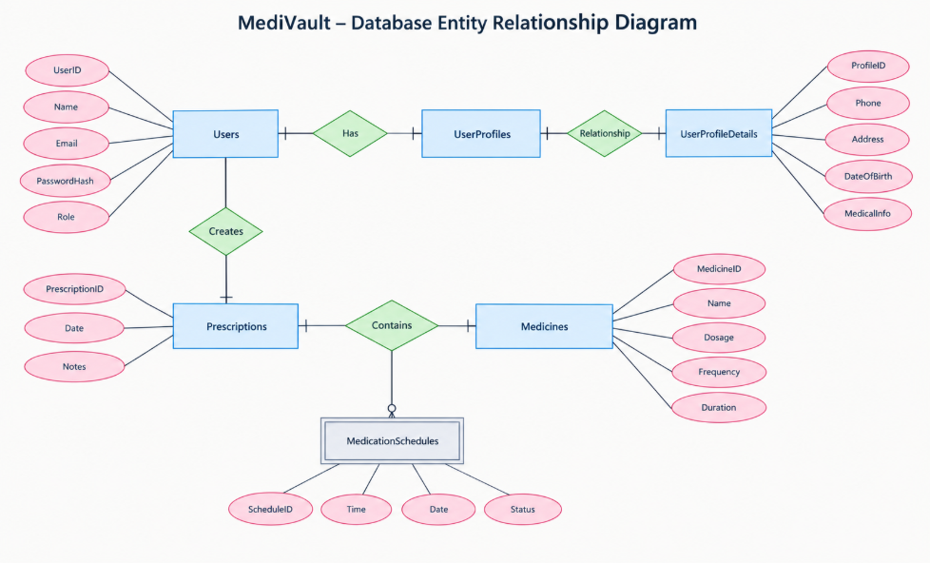

Description of Each Layer (Frontend, Backend, Database)

The architecture of the MediVault – Digital Prescription and Medication Tracker follows a well-defined layered approach that separates the user interface, application processing, and data management responsibilities. This structure improves modularity, maintainability, and scalability by assigning specific responsibilities to each layer while allowing them to communicate through defined interfaces. The system consists of three primary layers: the Frontend layer, the Backend layer, and the Database layer. Together, these layers support the management of user accounts, prescriptions, medicines, medication schedules, medication history, search operations, and notifications.
The Frontend layer provides the user-facing interface of MediVault and is developed using React.js, HTML5, CSS3, and JavaScript. It provides the screens and components required for registration, login, profile management, dashboard access, prescription management, medicine management, medication reminders, history, search, and notifications. React.js provides a component-based structure that supports reusable interface elements, while HTML5, CSS3, and JavaScript provide page structure, styling, responsiveness, validation, and interactive behavior. The frontend is designed to present medication-related information in an organized manner and allow users to perform system operations through forms, navigation elements, and interactive components.
The Backend layer provides the application-processing functionality of MediVault and is developed using Node.js and Express.js. It acts as the intermediary between the user interface and the database by receiving API requests, processing application operations, validating submitted information, and performing the required database actions. The backend provides endpoints for the major modules of the system, including user management, prescriptions, medicines, medication schedules, history, search, and notifications. This layer ensures that application logic and database operations are handled separately from the presentation layer.
The Database layer provides persistent storage for the information required by MediVault. MySQL is used as the relational database management system, with structured tables for users, user profiles, prescriptions, medicines, medication schedules, medication history, and notifications. Primary keys and foreign keys are used to establish relationships between related records. The relational structure helps maintain data consistency and supports organized storage and retrieval of information. For example, user records can be associated with their prescriptions, while prescription and medicine records can be connected with corresponding medication schedules.
The communication between these layers follows a systematic request-response process. When a user performs an operation through the React.js interface, the required information is sent to the appropriate Express.js API endpoint. The backend processes the request and communicates with MySQL when database access is required. The resulting data or operation status is then returned to the frontend, generally in JSON format, and the relevant interface is updated. The frontend does not directly access the MySQL database, maintaining a clear separation between presentation, application processing, and data storage.
This separation of responsibilities allows the different parts of MediVault to be developed and maintained independently. Changes to the user interface can be made without directly modifying the database, while backend operations can be updated without redesigning the entire frontend. Similarly, database structures can be maintained through the backend without exposing database operations to the client. This modular organization also makes testing and debugging more manageable because each layer can be examined according to its specific responsibility.
Security and performance are considered across the architecture. The frontend provides initial input validation, while the backend performs validation before processing requests and storing information. Database operations are accessed through the backend rather than directly from the client. The structured API approach also allows requests and responses to be tested independently using tools such as Postman, while MySQL Workbench can be used to verify database operations during development.
The architecture provides a foundation for future expansion of MediVault without requiring a complete redesign of the existing system. Possible future enhancements include OCR-based prescription scanning, AI-assisted medicine extraction, automatic refill reminders, pharmacy integration, doctor connectivity, cloud synchronization, caregiver access, voice reminders, wearable integration, multilingual support, and medication adherence reports. These features are considered future enhancements and are not part of the current implementation.
In conclusion, the Frontend, Backend, and Database layers together provide the core architectural structure of MediVault. React.js and related frontend technologies provide user interaction, Node.js and Express.js manage application processing and API communication, and MySQL provides structured and persistent data storage. The clear separation between these responsibilities improves maintainability, organization, and controlled communication within the system while providing a suitable foundation for future development.

Deployment Architecture (Cloud, Local, CI/CD Pipelines)

The deployment architecture of the MediVault – Digital Prescription and Medication Tracker is designed to provide a simple and organized environment for developing, testing, and running the application. The current implementation primarily follows a local deployment approach in which the React.js frontend, Node.js and Express.js backend, and MySQL database are configured within the development environment. This approach is suitable for the academic development and testing of the system because it allows each application component to be developed, tested, and modified independently while maintaining communication between the different layers.
The development environment contains the main components required to run MediVault. The frontend is developed using React.js and is executed through the Node.js-based development environment. The backend is developed using Node.js and Express.js and runs as a separate server responsible for handling API requests and communicating with the database. MySQL is used as the database management system for storing user information, prescriptions, medicines, medication schedules, history, and notification-related data. These components operate together within the local development environment to provide the complete application workflow.
The frontend and backend operate as separate application processes during development. When the user opens the MediVault application through a web browser, the React.js frontend provides the user interface and handles user interactions. When an operation requires server-side processing, the frontend sends the appropriate request to the Express.js backend through the configured API endpoints. The backend processes the request and communicates with the MySQL database whenever persistent information is required. The processed response is then returned to the frontend and displayed to the user.
The local deployment structure provides a convenient environment for development and testing because changes can be made directly to the source code and immediately tested in the browser. Visual Studio Code is used as the primary development environment for maintaining the frontend and backend source files. npm is used for managing the required project packages and running the development commands. The browser is used to access and test the frontend, while MySQL Workbench can be used to manage and verify the database. Postman can also be used to test backend API endpoints independently from the frontend.
Git and GitHub are used as part of the project development and source-code management process. Git maintains the version history of the project, allowing changes to frontend, backend, and supporting files to be recorded through commits. GitHub provides a remote repository for maintaining the project source code and provides an additional backup of the development work. This also supports collaboration and makes it possible to track changes made during different stages of development.
The current project does not depend on a cloud infrastructure for its academic deployment. The application can be executed within the local development environment by starting the required frontend and backend processes and ensuring that the MySQL database is available. This approach reduces deployment complexity during development and allows the complete application to be tested without depending on external hosting infrastructure.
Continuous Integration and Continuous Deployment (CI/CD) pipelines are not considered part of the current MediVault implementation. The current development process focuses on manually running, testing, and validating the application within the development environment. However, the use of Git and GitHub provides a suitable foundation for introducing automated CI/CD workflows in a future version of the project. Such a pipeline could automatically perform application testing and deployment whenever approved changes are pushed to the repository.
Cloud deployment is also considered a possible future enhancement. A future version of MediVault could deploy the React.js frontend, Node.js and Express.js backend, and MySQL database using suitable cloud-hosting services. Cloud deployment could make the application accessible to users through the internet and provide additional capabilities such as centralized hosting, automated backups, monitoring, and easier access from different devices. These capabilities are not part of the current implementation.
The deployment process can be divided into several stages. During development, source code is created and modified using Visual Studio Code. The frontend and backend are executed locally for functional testing. API requests are tested to verify communication between the frontend and backend, while database operations are verified using MySQL. Once individual modules function correctly, the complete workflow is tested by performing operations through the user interface and verifying that the expected information is stored and retrieved correctly.
Testing is an important part of the deployment process. Frontend functionality can be checked through the browser, while browser developer tools can be used to inspect interface behavior, console messages, and network requests. Backend APIs can be tested using Postman to verify request and response behavior. MySQL Workbench can be used to verify whether records are correctly inserted, retrieved, updated, or deleted. Testing these components separately helps identify whether a problem originates in the interface, API communication, backend processing, or database operation.
The local deployment architecture also makes troubleshooting easier. If the frontend does not display the expected information, the browser developer tools can be used to inspect the relevant component or network request. If an API request fails, the backend and Postman can be used to determine whether the problem is related to routing or request processing. If the backend cannot retrieve or store information, MySQL and the database configuration can be checked. This layered troubleshooting approach reduces the difficulty of identifying problems during development.
The major components of the MediVault deployment architecture can be summarized as follows:
- Local Development Environment – Provides the primary environment for developing, running, and testing the MediVault application.
- React.js Frontend – Provides the user interface and runs within a web browser during development.
- Node.js and Express.js Backend – Runs as the application server and processes API requests.
- MySQL Database – Provides persistent storage for the application's structured data.
- Visual Studio Code – Used for developing and maintaining frontend and backend source code.
- npm – Used for managing project dependencies and running development commands.
- Browser and Developer Tools – Used for accessing the application and inspecting frontend behavior and network communication.
- Postman – Used for testing backend API endpoints and validating request-response behavior.
- MySQL Workbench – Used for managing and verifying database operations during development.
- Git and GitHub – Used for source-code version control, change tracking, and remote repository management.
- CI/CD – Not part of the current implementation, but can be introduced as a future development enhancement.
- Cloud Deployment – Not part of the current deployment; future versions may use cloud hosting for wider accessibility and centralized infrastructure.
In conclusion, the current deployment architecture of MediVault is centered on a local development environment consisting of the React.js frontend, Node.js and Express.js backend, and MySQL database. Supporting tools such as Visual Studio Code, npm, Git, GitHub, Postman, MySQL Workbench, and browser developer tools assist in development, testing, debugging, and source-code management. The architecture is intentionally kept simple for the current academic implementation while providing a foundation for future cloud deployment and automated CI/CD processes.

CHAPTER -5 DESIGN

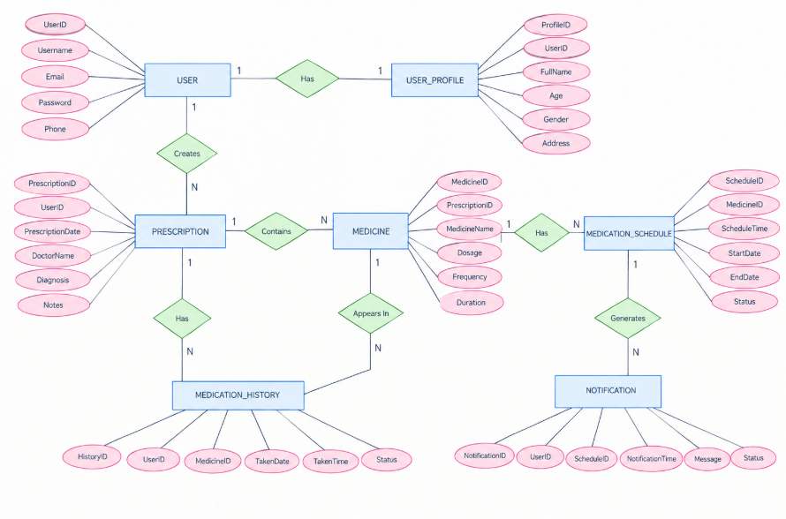

CHAPTER -6 IMPLEMENTATION

Section 6.1 – Module-Wise Implementation

The implementation of the MediVault – Digital Prescription and Medication Tracker was systematically organized into a set of interconnected modules that collectively provide a centralized platform for prescription and medication management. Each module was designed with a specific functional responsibility while maintaining proper interaction with the other components through the application backend and centralized MySQL database. This modular structure improves maintainability, supports organized development, and allows individual functionalities to be modified without affecting the complete system. The implementation focuses on simplifying the process of storing prescription information, managing medicines, maintaining medication schedules, tracking medication history, and providing timely reminders through a unified web interface. The overall design follows a user-centered approach in which frequently required medication-management operations are organized into clearly accessible modules.
The User Registration and Login Module forms the entry point of the MediVault system and is responsible for managing user access to the application. The registration functionality collects the required user information and stores the corresponding account details in the database. The login functionality validates the submitted credentials through the backend before providing access to the application. This module establishes the user identity required by other modules such as prescription management, medicine management, medication history, and the dashboard. Input validation is applied to ensure that required information is properly entered before it is processed. The module is implemented using React.js on the frontend and Node.js with Express.js on the backend, while MySQL is used for persistent storage. By separating the user interface from backend processing and database operations, the module maintains a structured and controlled authentication workflow.
The User Profile Module is implemented to maintain personal information associated with each registered user. It provides functionality for viewing and managing profile-related information such as name, age, gender, phone number, and address, according to the information supported by the application. The profile information is associated with the corresponding user account through the database relationship between the user and profile records. This module allows personal information to be maintained separately from prescription and medication records while still remaining connected to the user's account. The React.js interface provides the forms and views required for profile management, while the Express.js backend processes profile-related requests and communicates with MySQL for storing and retrieving the information. The separation of profile data also contributes to a more organized database structure and makes the information easier to manage.
The Prescription Management Module is one of the central components of MediVault and is responsible for storing and managing prescription-related information. Users can maintain prescription records containing information such as prescription date, doctor name, diagnosis, and notes. The module provides operations for adding and viewing prescription information and maintains the relationship between a prescription and the user who created it. Prescription records are stored in MySQL and can subsequently be associated with medicine records. The implementation ensures that prescription information remains organized instead of being maintained only through physical documents or disconnected records. The frontend provides structured forms for entering prescription information, while the backend validates the received data and performs the required database operations. This module therefore acts as an important foundation for the medicine-management functionality of the system.
The Medicine Management Module is responsible for maintaining detailed information about medicines associated with stored prescriptions. Each medicine record contains relevant information such as medicine name, dosage, frequency, and duration. The module allows users to organize multiple medicines under their corresponding prescription records, making it easier to understand which medicines belong to a particular prescription. The database maintains relationships between prescriptions and medicines using appropriate identifiers and relational constraints. The frontend provides an organized interface for entering and viewing medicine information, while the backend handles the corresponding CRUD operations through Express.js and SQL queries. This module plays an important role in transforming prescription information into structured medication data that can subsequently be used for scheduling and history tracking.
The Medication Schedule Module is implemented to manage the timing and duration associated with medicine consumption. It stores schedule-related information such as medicine reference, scheduled time, start date, end date, and status. The module enables users to maintain structured medication schedules rather than relying entirely on memory or manually maintained notes. Schedule information is connected to the corresponding medicine through the relational database structure. The React.js interface provides the required controls for entering and viewing schedules, while the backend processes schedule-related requests and stores the information in MySQL. The scheduling structure also provides the data required by the notification functionality, allowing reminders to be associated with specific medication schedules.
The Medication Reminder and Notification Module is responsible for supporting timely medication-related communication. It uses the stored medication schedule information to organize reminder-related information such as notification time, message, and status. The module is designed to help users remember scheduled medication activities and provides a structured record of notification information. Notification-related data is maintained in the database and associated with the appropriate user and medication schedule. The implementation separates reminder information from the medicine records themselves, allowing scheduling and notification-related operations to be managed independently. This modular approach also provides a foundation for future improvements such as voice reminders, automated refill notifications, or integration with external notification services.
The Medication History Module provides functionality for maintaining records of medication consumption. It records information such as the user, medicine, date, time, and status associated with a medication activity. This allows users to review previously recorded medication activities and provides a historical view of medication usage. The module is connected with both user and medicine records through foreign-key relationships in the MySQL database. The frontend presents the stored history in an organized manner, while the backend retrieves the required records using SQL queries. Maintaining medication history as a separate module prevents historical information from being mixed with current medicine or schedule information and provides a structured foundation for future adherence-related analysis.
The Dashboard Module provides a centralized view of the user's medication-management activities. Instead of requiring users to navigate through every individual module to understand their current information, the dashboard organizes important information into a single interface. It can present relevant prescription, medicine, schedule, reminder, and history information according to the data available to the user. The dashboard is implemented using React.js components so that individual information sections can be organized and updated independently. Backend APIs provide the required data from the MySQL database. The module therefore acts as an overview layer that improves navigation and provides users with a convenient starting point for accessing the major functionalities of MediVault.
The Search Module is implemented to improve access to stored medication-related information. As the number of prescriptions and medicines increases, manually locating a particular record can become inconvenient. The search functionality allows users to locate relevant information using supported search fields such as medicine-related or prescription-related information. Search requests are processed through the backend and translated into appropriate SQL queries for retrieving matching records from MySQL. The results are then returned to the React.js frontend and displayed in an organized manner. This module improves usability by reducing the time required to locate specific information and demonstrates the practical use of database querying within the application.
The system also includes a structured database management layer that supports all the application modules. MySQL stores user information, profile information, prescriptions, medicines, medication schedules, medication history, and notification records in separate but related tables. Primary keys uniquely identify records, while foreign keys maintain relationships between related entities. This relational structure reduces unnecessary duplication and helps maintain data consistency across modules. The Node.js and Express.js backend acts as the controlled communication layer between the frontend and database, ensuring that database operations are performed through defined application requests rather than allowing the frontend to access MySQL directly.
The Backend API Module provides the communication mechanism through which the React.js frontend interacts with the application logic and database. Express.js routes are used to process requests related to users, profiles, prescriptions, medicines, schedules, history, search operations, and notifications. Depending on the operation, the backend performs validation, retrieves information, inserts new records, updates existing records, or deletes records when supported by the corresponding functionality. Data is exchanged between the frontend and backend using JSON-based requests and responses. This separation allows the user interface and database operations to remain independent, making the application easier to maintain and extend.
The overall implementation of MediVault follows a modular architecture in which each component performs a clearly defined responsibility while remaining connected to the rest of the system. User registration and profile management establish the user context; prescription and medicine modules organize medical information; medication schedules and notifications support timely medication management; medication history maintains past records; and the dashboard and search modules improve accessibility and usability. The Node.js and Express.js backend coordinates these operations, while MySQL provides structured and persistent data storage. This division of responsibilities improves maintainability, reduces unnecessary coupling, and makes individual modules easier to test and modify.
Collectively, the module-wise implementation of MediVault transforms prescription and medication information into a structured digital management system. The modular approach allows the current implementation to address core requirements while providing a foundation for future extensions such as OCR-based prescription scanning, AI-assisted medicine extraction, automatic refill reminders, pharmacy integration, doctor connectivity, cloud synchronization, caregiver access, voice reminders, wearable integration, multilingual support, and medication adherence reports. These enhancements are considered future scope rather than part of the current implementation. Through the integration of its individual modules, MediVault provides an organized, accessible, and maintainable platform for digital prescription storage and medication management.

Section 6.2 – Front-End Logic (UI Rendering and State Management)

The front-end of the MediVault – Digital Prescription and Medication Tracker plays an important role in providing users with a simple, organized, and accessible interface for managing prescription and medication information. Since the system deals with multiple activities such as user registration, profile management, prescription storage, medicine management, medication scheduling, reminders, medication history, and search, the front-end is designed to present these functions in a clear and understandable manner. The main objective of the front-end logic is to translate the underlying application functionality into an interactive interface through which users can easily enter, view, update, and manage their medication-related information. The implementation therefore focuses on usability, responsive interaction, structured navigation, form validation, and efficient communication with the backend.
The foundation of the MediVault front-end is built using HTML5, CSS3, JavaScript, and React.js. HTML5 provides the basic structure of the application screens, while CSS3 is used to control layout, spacing, typography, visual appearance, and responsive behavior. JavaScript provides the interactive functionality required for user actions and dynamic updates. React.js is used to organize the interface into reusable components, allowing different sections of the application to be developed and maintained independently. This combination provides a structured environment for implementing the various screens of MediVault while maintaining consistency throughout the application.
The component-based architecture of React.js forms an important part of the front-end implementation. The user interface is divided into reusable components such as navigation elements, forms, buttons, input fields, prescription sections, medicine cards, schedule displays, dashboard sections, search components, and history views. Each component is responsible for a specific part of the interface and can be reused wherever the same functionality is required. This approach reduces unnecessary duplication of interface code and makes modifications easier. When changes are required in a particular component, they can be implemented without restructuring the complete application. The component-based structure therefore contributes to maintainability and organized development.
The registration and login interfaces provide the initial interaction between the user and the system. The registration form collects the required user information, while the login form accepts the credentials required to access the application. Form fields are designed to provide clear labels and appropriate input areas so that users can enter information without confusion. Front-end validation is applied to identify missing or incorrectly entered information before the request is sent to the backend. Appropriate messages are displayed when an input does not satisfy the required conditions. This reduces unnecessary requests and provides immediate feedback to the user.
The user profile interface provides a structured method for viewing and managing personal information. Profile fields are displayed in an organized form so that users can easily understand and update their details. React components are used to manage the profile interface and respond to user interactions. When profile information is submitted, the front-end sends the required data to the backend through the appropriate API request. The response received from the backend is then used to update the interface and provide feedback regarding the operation. This interaction keeps the profile information synchronized with the stored database records.
The prescription management interface is designed to make the storage and retrieval of prescription information convenient. The user can enter information such as prescription date, doctor name, diagnosis, and notes through structured form fields. The interface separates different types of information into understandable sections so that users can enter prescription details systematically. Once the information is submitted, the front-end communicates with the backend API, which processes the request and stores the information in MySQL. The resulting prescription information can then be displayed through the appropriate React components.
The medicine management interface provides users with a structured way to maintain medicine information associated with prescriptions. Fields such as medicine name, dosage, frequency, and duration are presented through suitable input controls. The interface allows users to view the medicines associated with their prescription records and manage the available information. React.js components are used to dynamically display medicine-related records obtained from the backend. This organization allows users to understand medication information more easily and reduces the possibility of confusion when multiple medicines are associated with the same prescription.
The medication schedule interface focuses on presenting medicine timing and duration in an organized manner. Users can enter scheduling information such as scheduled time, start date, end date, and status. The front-end provides appropriate fields and controls for entering these values and communicates the information to the backend for storage. Once schedule information is retrieved, the interface displays it in a clear format so that users can identify when a particular medicine needs to be taken. The scheduling interface therefore connects the medicine-management functionality with the reminder and notification functionality of the system.
State management is an important part of the React.js front-end because the interface must respond to changes in user actions and backend responses. State is used to maintain information required by different components, such as form values, retrieved records, search input, selected medicines, schedules, and notification-related information. When a user performs an action, the corresponding state can be updated and the affected component is re-rendered. This allows the interface to reflect the latest information without requiring unnecessary page operations. State management therefore helps maintain consistency between user actions and the information displayed on the screen.
The dashboard provides a centralized interface for presenting important medication-related information. Instead of requiring users to access every module individually, the dashboard brings relevant information together in a single view. React components can display prescription details, medicine information, upcoming schedules, reminders, and medication history according to the information retrieved from the backend. The dashboard is therefore designed as an overview of the user's activities and provides convenient navigation to the major modules of the application. Its component-based structure also allows individual sections to be updated independently.
The search functionality is integrated into the front-end to make stored information easier to locate. Users can enter search terms through the search interface, after which the required request is sent to the backend. The retrieved results are displayed dynamically in the appropriate section of the interface. Search results can be organized according to the type of medication-related information being searched. This functionality reduces the effort required to locate specific prescriptions or medicines, particularly when a user has accumulated multiple records.
The front-end also implements dynamic rendering to display information according to the current application state. For example, prescription records, medicine lists, schedules, notifications, and history records can be displayed based on the data received from the backend. When the underlying state changes, React.js updates the relevant components so that the user can see the latest information. This avoids unnecessary reloading of the complete interface and contributes to a smoother interaction. Dynamic rendering is particularly useful for dashboard information and lists where the displayed records may change after user operations.
Navigation is another important part of the front-end logic. The application provides access to the major modules through an organized navigation structure so that users can move between the dashboard, profile, prescriptions, medicines, schedules, history, search, and notification-related sections. Consistent navigation reduces confusion and allows users to understand the overall structure of the application. The interface is designed so that frequently required functions remain accessible without requiring unnecessary steps. This improves the overall usability of the system and supports a smooth user journey.
The front-end also includes input validation and error-handling mechanisms. Required fields are checked before information is submitted, helping to prevent incomplete or invalid data from being sent to the backend. When an operation fails or the backend returns an error, the interface can provide appropriate feedback to the user instead of leaving the user uncertain about the result. These mechanisms are particularly important for registration, login, prescription entry, medicine entry, and schedule creation. Validation and error handling therefore contribute to reliability and improve the overall interaction between the user and the application.
Responsive design is incorporated to ensure that the MediVault interface can adapt to different screen sizes. CSS3 techniques are used to organize layouts, forms, cards, navigation elements, and information sections so that they remain readable and usable across supported devices. Proper spacing, alignment, typography, and component organization are maintained to prevent the interface from becoming difficult to use on smaller screens. Responsive design improves accessibility and allows users to interact with the medication-management system through different screen sizes.
The front-end communicates with the backend through defined API endpoints. When a user performs an operation such as registering an account, adding a prescription, viewing medicines, creating a schedule, searching for a record, or viewing medication history, the React.js interface sends the required request to the Node.js and Express.js backend. The backend processes the request and returns the required response in JSON format. The front-end then uses the response to update the relevant component or display appropriate information. This separation ensures that the React.js interface does not directly access the MySQL database and that database operations remain controlled through the backend.
Performance and usability are also considered during front-end implementation. Components are organized so that only the required sections need to update when information changes. Reusable components reduce unnecessary duplication and make the application easier to maintain. Forms and information displays are structured to avoid unnecessary complexity, while clear navigation helps users reach required functions quickly. These design considerations support a responsive and efficient user experience without introducing unnecessary complexity into the interface.
The front-end implementation also considers basic security and controlled data handling. User-entered information is validated before being submitted, while sensitive database operations are handled through the backend rather than directly from the browser. The front-end does not communicate directly with MySQL; instead, all required data operations are performed through the Node.js and Express.js API layer. This separation provides better control over how application data is accessed and processed. Additional advanced security mechanisms can be incorporated as part of future improvements to the system.
Overall, the front-end logic of MediVault combines React.js component-based development, HTML5 structure, CSS3 styling, JavaScript-based interaction, state management, form validation, dynamic rendering, responsive design, navigation, and API communication. These elements work together to provide a clear and organized interface for managing prescriptions, medicines, schedules, reminders, and medication history. The implementation keeps the user interface separate from backend and database operations, improving maintainability and allowing individual components to be modified independently. The front-end therefore serves as the primary interaction layer of MediVault and provides the foundation for an accessible and organized digital medication-management experience.

6.3 API Integration

The API Integration stage forms the communication layer of the MediVault – Digital Prescription and Medication Tracker, connecting the React.js front-end with the Node.js and Express.js backend and MySQL database. The APIs allow the front-end to send requests, retrieve information, create records, update existing data, and perform other application operations through the backend. This structure maintains a clear separation between the user interface, application logic, and database.
The MediVault system uses internal APIs to manage major functions such as user registration, login, profile management, prescription management, medicine management, medication schedules, medication history, search, and notifications. These APIs are developed using Node.js and Express.js, with separate routes handling different functional areas. This modular structure makes the API implementation easier to maintain and allows each module to communicate with the backend through defined endpoints.
The communication between the React.js front-end and Express.js backend is performed using HTTP requests and JSON-based responses. When a user performs an operation, the front-end sends the required request to the appropriate API endpoint. The backend processes the request, performs the required operation, and returns the result to the front-end. The React.js interface then uses the response to update the corresponding component.
Different HTTP methods are used according to the required operation. GET requests are used to retrieve records such as prescriptions, medicines, schedules, history, and profile information. POST requests are used to create new records such as user accounts, prescriptions, medicines, schedules, and notifications. PUT requests are used for supported update operations, while DELETE requests are used for supported record removal operations.
The API layer manages communication with the MySQL database. The React.js front-end does not directly access the database. Instead, requests are sent to the Express.js backend, which performs the required SQL operations and returns the results to the front-end. This approach provides controlled database access and maintains separation between the application layers.
Input validation is performed at the backend before information is stored or processed. Required fields and received values are checked to reduce invalid or incomplete database entries. Validation is applied to important operations such as user registration, login, prescription entry, medicine information, and medication scheduling.
The API layer supports CRUD operations across the major modules of MediVault. Create operations add new records, read operations retrieve existing records, update operations modify available information, and delete operations remove records when supported. These operations are implemented through Express.js routes and SQL queries executed against the MySQL database.
JSON is used as the main data format for communication between the front-end and backend. Prescription details, medicine information, medication schedules, history records, and other application data can be transferred as structured JSON objects. This allows React.js components to process and display the information returned by the backend.
Error handling is implemented to manage invalid requests, missing records, and database-related errors. The backend returns appropriate responses when an operation cannot be completed, and the front-end displays suitable feedback to the user. This helps maintain reliable communication between the application layers.
Postman is used for testing the APIs during development. Individual endpoints can be tested with different request methods and input values to verify whether the backend correctly handles valid and invalid requests. The returned responses are examined to confirm that the expected data is being created, retrieved, updated, or deleted.
The API layer also supports the Dashboard and Search modules. Dashboard APIs retrieve relevant prescription, medicine, schedule, notification, and history information for display. Search APIs receive search parameters from the front-end and use SQL queries to retrieve matching records from MySQL.
The current MediVault implementation primarily uses internal APIs connecting React.js, Node.js, Express.js, and MySQL. External healthcare APIs, payment gateways, mapping services, and other third-party services are not required for the current implementation. Future versions may integrate services for OCR-based prescription scanning, AI-assisted medicine extraction, automatic refill reminders, pharmacy connectivity, doctor connectivity, cloud synchronization, and other advanced features.
In summary, the API integration provides the communication backbone of MediVault by connecting the React.js front-end, Node.js and Express.js backend, and MySQL database. It supports CRUD operations, JSON-based communication, validation, error handling, search, dashboard data retrieval, and module-level communication. The use of defined API routes and Postman testing provides a structured and maintainable approach for implementing the application's backend communication

6.4 Authentication and Authorisation

The Authentication and Authorisation module is responsible for protecting user accounts and controlling access to the MediVault – Digital Prescription and Medication Tracker. Authentication verifies the identity of the user, while authorisation controls access to the functions available within the system. Since MediVault stores personal profiles, prescriptions, medicine information, medication schedules, and history records, controlled access is required to protect user data.
MediVault provides user registration and login functionality through the React.js front-end and Node.js with Express.js backend. During registration, the user provides the required account information, which is validated by the backend before being stored in the MySQL database. During login, the submitted credentials are checked against the stored user information. Successful authentication allows the user to access the application and its available modules.
The authentication process is handled through the backend rather than allowing the React.js front-end to directly access the MySQL database. Login requests are sent from the front-end to the appropriate Express.js API endpoint. The backend validates the received information and communicates with MySQL to verify the user account. The result is then returned to the front-end as a JSON response.
Authorisation is applied to control access to user-specific information and application operations. After successful login, the system provides access to modules such as the user profile, prescriptions, medicines, medication schedules, medication history, dashboard, search, and notifications. Operations involving these records are processed through the backend APIs so that database access remains controlled.
Input validation is performed during registration and login to reduce invalid or incomplete data. Required fields are checked before account information is processed. The backend also validates received requests before performing database operations, helping prevent incorrect information from being stored.
The authentication module is connected with the User Profile module so that users can manage their own profile information after logging in. Similarly, prescription, medicine, schedule, and history operations are handled through backend APIs associated with the authenticated user's account. This allows the system to keep user-related information separated and prevents direct database access from the front-end.
Error handling is included for authentication-related operations. Invalid login details, missing information, invalid requests, or unavailable records result in appropriate responses from the backend. The React.js front-end uses these responses to display suitable messages to the user.
The security of the application is also supported through the separation of the three application layers. The React.js front-end communicates with the Express.js backend, while the backend communicates with MySQL. Database credentials and SQL operations are therefore not exposed directly to the client-side interface.
Postman is used during development to test authentication-related API endpoints with different request inputs. The testing process verifies registration, login, validation, response handling, and error conditions. Browser developer tools can also be used to examine front-end requests and responses during testing.
The current MediVault implementation focuses on basic user registration, login, validation, and controlled access to application modules. Advanced mechanisms such as two-factor authentication, biometric authentication, OAuth, external identity providers, and advanced session management are not part of the current implementation. These can be considered for future versions if required.
Overall, the Authentication and Authorisation module provides controlled user access to MediVault and protects communication between the front-end, backend, and database. By combining login, validation, backend-controlled access, and structured API communication, the module supports secure management of prescriptions, medicines, schedules, history, and other user-related information.

CHAPTER 7- FEATURES

7.1 List of main features

MediVault is designed as a centralized digital prescription and medication tracking application. Its main features are organized around the activities a user normally performs when maintaining medication information: creating an account, signing in, maintaining a profile, storing prescription details, recording medicines, defining schedules, reviewing history, searching stored information, and receiving reminder or notification-related information. Bringing these functions into one application reduces the need to maintain separate notes, paper records, and disconnected reminder methods.

User registration and login form the entry point to the application. A new user can provide the required registration information and create an account, while an existing user can authenticate using the login interface. Authentication is important because prescription and medication records are user-specific information. The application therefore separates the account-access process from the medication-management functions and uses the backend to process authentication requests rather than relying only on client-side controls.

The user profile feature provides a place for account-related information to be maintained. Profile information can be viewed and updated when necessary so that the application has a consistent identity for the person using the system. The dashboard then gives the user a summarized view of important medication information. Instead of opening several screens to understand the current state of the account, the dashboard can present active prescriptions, medicines, upcoming schedules, and other frequently required information in an organized form.

Prescription management is one of the central features of MediVault. It allows prescription-related information to be stored digitally so that it can be retrieved later. The system can maintain prescription details as structured records instead of treating every prescription as an isolated note. This organization is useful when a user needs to review an earlier prescription, connect medicines with prescription information, or maintain a history of medication-related records over time.

Medicine management extends prescription storage by allowing individual medicines to be recorded with relevant information such as medicine name, dosage, frequency, duration, and related schedule details. The feature is intended to make medication information easier to understand and update. Users can maintain more than one medicine record and can review the stored information without repeatedly referring to a physical prescription for routine tracking purposes.

Medication scheduling and reminders support the routine side of medication management. A user can associate a medicine with a schedule so that the expected time and frequency are represented digitally. Reminder or notification-related functionality can then help the user notice upcoming medication activities. The purpose is organizational: the application records and presents the schedule so that medication-related tasks are easier to track within the same system.

Medication history and search provide access to information that may no longer be part of the immediate schedule but remains useful for reference. History allows earlier medication-related activity to be reviewed, while search helps users locate records without manually checking every screen. Authentication, authorization, responsive interface design, and MySQL-based storage support these features by providing controlled access, browser-friendly interaction, and persistent storage. Together, the features form a connected workflow from account creation to prescription storage, medicine tracking, scheduling, reminders, history, and retrieval.

A further consideration for 7.1 list of main features is consistency across the complete MediVault workflow. The application is not made up of isolated screens; each operation produces information that can be used by another module. The feature organization, user account management, prescriptions, medicines, schedules, reminders, history,

search, security, dashboard, responsive access, and database storage therefore needs to be considered as part of the same system. A change in one area should be checked against the records and interface behavior that depend on it. This approach helps maintain predictable behavior as the application grows and makes later maintenance easier.
The project also benefits from keeping the responsibility of each layer clear while working on 7.1 list of main features. The React interface should concentrate on collecting and presenting information, the Express and Node.js layer should process requests and enforce application rules, and MySQL should provide persistent storage. When these responsibilities remain clear, problems can be traced more easily and new functionality can be added without placing unrelated logic in a single component.

From a user perspective, 7.1 list of main features should remain understandable even though the underlying implementation contains several technical steps. A useful workflow gives the user clear feedback after an action, presents stored information in a readable form, and avoids requiring unnecessary repetition. Validation messages, successful-operation feedback, and consistent navigation all contribute to this experience. The technical design should therefore support the user's task rather than becoming visible as unnecessary complexity.

Verification is also important when considering 7.1 list of main features. A result should ideally be checked at more than one level when the operation affects persistent information. The interface can show the immediate result, the API response can confirm the server operation, and the database can confirm persistence. Using these checks together provides stronger evidence than relying on only one visible outcome and can shorten debugging when a discrepancy occurs.

The current project structure also provides a useful foundation for maintenance related to 7.1 list of main features. Source files can be organized by functional responsibility, configuration can be separated from application logic, and version control can preserve working states. When a future change is introduced, the developer can compare the modified behavior with the previously verified workflow. This reduces the risk that an enhancement unintentionally breaks an existing module.

Another important point is that 7.1 list of main features should be documented in a way that can be followed by another developer. The selected technologies, expected inputs, API behavior, database relationships, and testing approach should be understandable without relying entirely on the original developer's memory. Clear documentation also makes future deployment, troubleshooting, and academic review easier because the reasoning behind the implementation can be followed from requirements to working behavior.

In summary, the treatment of 7.1 list of main features in MediVault is connected to the broader objective of building a structured, maintainable digital medication-management application. The project emphasizes organized records, controlled access, clear communication between application layers, and repeatable testing. These principles provide a stable base for future improvements while keeping the current implementation focused on the project's defined scope.

7.2How Each Feature Works

From the user's perspective, MediVault begins with account registration and login. During registration, the user enters the information requested by the application and submits the form to the backend. The backend validates the request and stores the account information in the database when the required conditions are satisfied. During login, the submitted credentials are sent to the authentication endpoint, checked against the stored account information, and used to establish access to protected application functions. This process gives the application a clear boundary between public account access and private medication records.

After authentication, the user can access the profile and dashboard. The profile screen is intended for viewing and updating account information, while the dashboard acts as a summary screen. When dashboard information is requested, the frontend communicates with the backend through API calls. The backend retrieves the relevant records from MySQL and returns the required information to the frontend. React components then render the returned data. This separation keeps presentation logic in the frontend while data processing and database interaction remain on the server side.

Prescription management follows a create, retrieve, update, and delete pattern. When the user adds a prescription, the frontend collects the entered information and sends it to the appropriate backend endpoint. The server validates the request and performs the database operation. When the user opens the prescription area, a retrieval request obtains the stored records and displays them in the interface. Update and delete operations follow the same general path, with the frontend identifying the selected record and the backend applying the requested database change.

Medicine management works in a similar manner but focuses on individual medication records. The user can enter a medicine name and associated details such as dosage, frequency, duration, and other schedule information supported by the application. The frontend sends the structured values through the API, and the backend stores them in MySQL. When medicine records are requested later, the backend retrieves the records associated with the authenticated user. This creates a consistent relationship between the information shown in the interface and the information persisted in the database.

Scheduling connects medicine information with time-related tracking. A user selects or enters the schedule information supported by the interface and submits it. The backend processes the request and stores the schedule so it can be retrieved with the relevant medication information. Reminder or notification-related behavior can then use the stored schedule to present upcoming medication activities. The workflow does not require the user to maintain a separate list because schedule information is kept with the application records and can be reviewed through the appropriate screens.

History and search operate as retrieval features. History allows the user to inspect previously stored medication-related information, which is useful when an earlier record needs to be reviewed. Search reduces the amount of manual navigation required when several records exist. A search request is sent from the frontend to the backend, where the relevant records are identified and returned. The frontend then displays the matching information. The result is a more direct path from the user's question—such as finding a particular medicine—to the stored record.

Technically, the complete workflow follows the application's layered architecture. React.js manages the user interface and state needed for interaction; Node.js and Express.js handle API requests and application logic; and MySQL provides persistent storage. Authentication and authorization are applied to protect user-specific operations. A typical workflow is therefore: register or log in, open the dashboard, maintain profile information, add a prescription, record medicines, create schedules, review reminders, and consult history or search when required. Each feature remains a separate functional module while participating in the same overall MediVault system.

A further consideration for 7.2 how each feature works is consistency across the complete MediVault workflow. The application is not made up of isolated screens; each operation produces information that can be used by another module. The the user workflow, frontend interaction, API request flow, validation, database persistence, authentication, retrieval, updates, deletion, scheduling, reminders, history, and search therefore needs to be considered as part of the same system. A change in one area should be checked against the records and interface behavior that depend on it. This approach helps maintain predictable behavior as the application grows and makes later maintenance easier.

The project also benefits from keeping the responsibility of each layer clear while working on 7.2 how each feature works. The React interface should concentrate on collecting and presenting information, the Express and Node.js layer should process requests and enforce application rules, and MySQL should provide persistent storage. When these responsibilities remain clear, problems can be traced more easily and new functionality can be added without placing unrelated logic in a single component.

From a user perspective, 7.2 how each feature works should remain understandable even though the underlying implementation contains several technical steps. A useful workflow gives the user clear feedback after an action, presents stored information in a readable form, and avoids requiring unnecessary repetition. Validation messages, successful-operation feedback, and consistent navigation all contribute to this experience. The technical design should therefore support the user's task rather than becoming visible as unnecessary complexity.

Verification is also important when considering 7.2 how each feature works. A result should ideally be checked at more than one level when the operation affects persistent information. The interface can show the immediate result, the API response can confirm the server operation, and the database can confirm persistence. Using these checks together provides stronger evidence than relying on only one visible outcome and can shorten debugging when a discrepancy occurs.
The current project structure also provides a useful foundation for maintenance related to 7.2 how each feature works. Source files can be organized by functional responsibility, configuration can be separated from application logic, and version control can preserve working states. When a future change is introduced, the developer can compare the modified behavior with the previously verified workflow. This reduces the risk that an enhancement unintentionally breaks an existing module.

Another important point is that 7.2 how each feature works should be documented in a way that can be followed by another developer. The selected technologies, expected inputs, API behavior, database relationships, and testing approach should be understandable without relying entirely on the original developer's memory. Clear documentation also makes future deployment, troubleshooting, and academic review easier because the reasoning behind the implementation can be followed from requirements to working behavior.

In summary, the treatment of 7.2 how each feature works in MediVault is connected to the broader objective of building a structured, maintainable digital medication-management application. The project emphasizes organized records, controlled access, clear communication between application layers, and repeatable testing. These principles provide a stable base for future improvements while keeping the current implementation focused on the project's defined scope.

CHAPTER -8 TESTING

8.1Postman Testing(Frontend/Bcakend)

Postman testing was used to examine the backend API independently of the visual interface. This approach is useful because a web application contains several layers, and an error visible in the frontend may actually originate from request construction, server-side validation, routing, database interaction, or the response returned by the backend. By sending API requests directly through Postman, the development process can inspect the backend behavior before relying on the complete frontend workflow.

The registration endpoint can be tested by sending the same fields that the registration form submits. A successful request should return an appropriate response indicating that the account operation has been processed. The test also checks how the server responds when required fields are missing, when an invalid value is supplied, or when an account condition prevents registration. These checks help verify that validation is handled by the backend and that the API does not depend entirely on browser-side validation.

Login testing verifies the authentication endpoint. A valid account should be accepted when the correct credentials are provided, while incorrect credentials should not provide normal access to protected functionality. Testing both successful and unsuccessful requests is important because authentication has two responsibilities: allowing legitimate users to continue and preventing incorrect credentials from being treated as a successful login. The response status and returned data can be examined directly in Postman.

CRUD-related endpoints can also be tested separately. Prescription, medicine, schedule, history, and profile operations can be represented by POST, GET, PUT or PATCH, and DELETE requests as implemented by the project. Each request is checked for the expected parameters, response structure, and database effect. For example, after creating a medicine record, a subsequent retrieval request can be used to confirm that the newly stored information is returned. An update request can then verify that the changed value is reflected in later retrievals.

Postman also helps test protected routes. A request made without the required authentication information should not behave like an authenticated request. This test is important because the database contains information associated with individual users. The backend must therefore distinguish between requests that have valid access context and requests that do not. Testing unauthorized access separately provides evidence that route protection is being applied at the API level rather than only by hiding buttons in the frontend.

Response validation is another part of the testing process. The developer can inspect status codes, JSON response bodies, error messages, and returned record structures. Unexpected server errors, missing fields, incorrect identifiers, and malformed requests can be observed without the additional complexity of the browser interface. Repeating the same request after correcting the input also helps verify whether the endpoint behaves consistently under normal and invalid conditions.

Overall, Postman provides a controlled environment for validating the communication contract between the frontend and backend. The project uses it to check registration, login, profile operations, prescription operations, medicine operations, schedules, history, search, and protected access. The documented API tests were used to identify request and response issues during development and to confirm that the backend endpoints were functioning before and alongside frontend integration.

A further consideration for 8.1 postman testing (frontend/backend) is consistency across the complete MediVault workflow. The application is not made up of isolated screens; each operation produces information that can be used by another module. The API request construction, valid and invalid inputs, authentication, CRUD endpoints, response inspection, protected routes, and repeatable backend verification therefore needs to be considered as part of the same system. A change in one area should be checked against the records and interface behavior that depend on it. This approach helps maintain predictable behavior as the application grows and makes later maintenance easier.

The project also benefits from keeping the responsibility of each layer clear while working on 8.1 postman testing (frontend/backend). The React interface should concentrate on collecting and presenting information, the Express and Node.js layer should process requests and enforce application rules, and MySQL should provide persistent storage. When these responsibilities remain clear, problems can be traced more easily and new functionality can be added without placing unrelated logic in a single component.

From a user perspective, 8.1 postman testing (frontend/backend) should remain understandable even though the underlying implementation contains several technical steps. A useful workflow gives the user clear feedback after an action, presents stored information in a readable form, and avoids requiring unnecessary repetition. Validation messages, successful-operation feedback, and consistent navigation all contribute to this experience. The technical design should therefore support the user's task rather than becoming visible as unnecessary complexity.

Verification is also important when considering 8.1 postman testing (frontend/backend). A result should ideally be checked at more than one level when the operation affects persistent information. The interface can show the immediate result, the API response can confirm the server operation, and the database can confirm persistence. Using these checks together provides stronger evidence than relying on only one visible outcome and can shorten debugging when a discrepancy occurs.

The current project structure also provides a useful foundation for maintenance related to 8.1 postman testing (frontend/backend). Source files can be organized by functional responsibility, configuration can be separated from application logic, and version control can preserve working states. When a future change is introduced, the developer can compare the modified behavior with the previously verified workflow. This reduces the risk that an enhancement unintentionally breaks an existing module.

Another important point is that 8.1 postman testing (frontend/backend) should be documented in a way that can be followed by another developer. The selected technologies, expected inputs, API behavior, database relationships, and testing approach should be understandable without relying entirely on the original developer's memory. Clear documentation also makes future deployment, troubleshooting, and academic review easier because the reasoning behind the implementation can be followed from requirements to working behavior.

In summary, the treatment of 8.1 postman testing (frontend/backend) in MediVault is connected to the broader objective of building a structured, maintainable digital medication-management application. The project emphasizes organized records, controlled access, clear communication between application layers, and repeatable testing. These principles provide a stable base for future improvements while keeping the current implementation focused on the project's defined scope.

8.2Integration Testing

Integration testing in MediVault focuses on whether the separate parts of the application work correctly when they are connected. Unit-level behavior can appear correct while the complete feature still fails because a frontend field does not match the backend parameter, an API route is incorrect, a database column is mapped incorrectly, or the returned data is not handled as expected. Integration testing therefore connects the user interface, API layer, server logic, authentication mechanism, and MySQL database in one workflow.

The registration and login flow provides a clear example of integration testing. A user enters information in the React interface, submits the form, and expects the request to reach the Express route. The backend processes the request and interacts with MySQL. The resulting response is then returned to the browser, where the frontend updates its state and navigation. Testing the entire sequence verifies that the individual components agree on field names, response structures, validation rules, and authentication behavior.

Profile integration testing checks whether information entered or changed in the frontend is correctly persisted and retrieved. A profile update is submitted through the interface, processed by the API, and stored in the database. The profile screen is then refreshed or reopened so that the retrieval path can be checked. If the updated value is displayed, the complete path from browser input to database storage and back to browser output has worked as expected.

Prescription and medicine integration tests follow the same principle. A user creates a prescription or medicine record through the application, after which the frontend calls the corresponding endpoint. The server validates the request, performs the database operation, and returns a response. The application then displays the record. Additional update and delete operations can be tested to ensure that the interface remains synchronized with the database after each change rather than only after initial creation.

Scheduling and history require additional attention because they depend on relationships between records. When a schedule is created for a medicine, the system must preserve the connection between the schedule and the correct medication or user context. When history is requested later, the backend must return the appropriate records rather than unrelated data. Integration testing checks these relationships by performing realistic sequences of operations instead of testing each endpoint in isolation.

Search and dashboard integration testing verifies data retrieval and presentation. Search begins with a user-entered term and ends with a displayed result set. The dashboard begins with a request for summarized or current information and ends with a collection of values presented through React components. Testing these paths can reveal issues such as incorrect API URLs, missing response fields, stale state, or database queries that do not return the expected records.
Authentication and authorization are tested across the complete application because they affect several modules at once. A user should be able to access the records associated with the authenticated session while protected operations should not be treated as public operations. Integration testing therefore considers not only whether an endpoint responds, but whether the correct user context travels through the application. The overall result is a connected verification of frontend behavior, backend processing, database persistence, and controlled access.

A further consideration for 8.2 integration testing is consistency across the complete MediVault workflow. The application is not made up of isolated screens; each operation produces information that can be used by another module. The connected frontend, backend, authentication, database, record relationships, dashboard, search, scheduling, and end-to-end workflows therefore needs to be considered as part of the same system. A change in one area should be checked against the records and interface behavior that depend on it. This approach helps maintain predictable behavior as the application grows and makes later maintenance easier.

The project also benefits from keeping the responsibility of each layer clear while working on 8.2 integration testing. The React interface should concentrate on collecting and presenting information, the Express and Node.js layer should process requests and enforce application rules, and MySQL should provide persistent storage. When these responsibilities remain clear, problems can be traced more easily and new functionality can be added without placing unrelated logic in a single component.

From a user perspective, 8.2 integration testing should remain understandable even though the underlying implementation contains several technical steps. A useful workflow gives the user clear feedback after an action, presents stored information in a readable form, and avoids requiring unnecessary repetition. Validation messages, successful-operation feedback, and consistent navigation all contribute to this experience. The technical design should therefore support the user's task rather than becoming visible as unnecessary complexity.

Verification is also important when considering 8.2 integration testing. A result should ideally be checked at more than one level when the operation affects persistent information. The interface can show the immediate result, the API response can confirm the server operation, and the database can confirm persistence. Using these checks together provides stronger evidence than relying on only one visible outcome and can shorten debugging when a discrepancy occurs.

The current project structure also provides a useful foundation for maintenance related to 8.2 integration testing. Source files can be organized by functional responsibility, configuration can be separated from application logic, and version control can preserve working states. When a future change is introduced, the developer can compare the modified behavior with the previously verified workflow. This reduces the risk that an enhancement unintentionally breaks an existing module.

Another important point is that 8.2 integration testing should be documented in a way that can be followed by another developer. The selected technologies, expected inputs, API behavior, database relationships, and testing approach should be understandable without relying entirely on the original developer's memory. Clear documentation also makes future deployment, troubleshooting, and academic review easier because the reasoning behind the implementation can be followed from requirements to working behavior.

In summary, the treatment of 8.2 integration testing in MediVault is connected to the broader objective of building a structured, maintainable digital medication-management application. The project emphasizes organized records, controlled access, clear communication between application layers, and repeatable testing. These principles provide a stable base for future improvements while keeping the current implementation focused on the project's defined scope.

8.3 Tools Used For Testing

Testing MediVault requires more than a single tool because the application contains a browser interface, backend APIs, database operations, and authentication behavior. The tools used during development provide different forms of verification. Browser developer tools help inspect the frontend, Postman provides direct API testing, MySQL tools help verify stored records, and the development environment supports debugging and repeated execution. Using several tools makes it possible to identify whether an issue belongs to presentation, communication, server logic, or data storage.

Postman is particularly useful for backend testing. It allows HTTP requests to be created manually and sent to the Express server without opening the React interface. Requests can be prepared for registration, login, profile operations, prescriptions, medicines, schedules, history, and search. The response can then be inspected for status information, returned fields, error messages, and data structures. This makes Postman useful both during initial API development and when checking a feature after changes have been made.
Browser developer tools provide a complementary view from the frontend. The Console can reveal JavaScript errors and warnings, while the Network panel can show requests made by the React application. Developers can inspect the request URL, method, payload, response, and timing. This is useful when an API works correctly in Postman but fails from the browser because the frontend may be sending a different field name, using an incorrect route, or handling the response differently.

MySQL and MySQL Workbench support database-level verification. After a create, update, or delete operation is performed through the application, the corresponding table can be checked to determine whether the expected row was inserted or changed. Database inspection is important because a successful browser response does not automatically prove that the correct data was persisted. SQL queries can be used to retrieve records, inspect relationships, and verify that user-specific information is associated with the expected account.

Visual Studio Code is the main development environment and also contributes to debugging. Source files can be inspected while the application is running, terminal output can be monitored, and backend errors can be traced to the relevant route or service. The editor is therefore not a testing tool in isolation, but it provides the working environment in which fixes are made after failures are observed through the browser, API client, or database.

Web browsers such as Google Chrome provide the final execution environment for the frontend. Browser testing checks whether pages render correctly, forms accept the intended input, navigation behaves as expected, and the responsive interface remains usable. Testing in a browser also verifies that the frontend can communicate with the running backend under the same conditions a user will encounter. Other modern browsers can be considered for compatibility checks when required.

Git and GitHub support testing indirectly by maintaining versions of the source code. When a change causes a previously working feature to fail, version history can help identify what changed. Together, these tools create a layered testing workflow: Postman checks APIs, browser tools check frontend communication, MySQL checks persistence, the browser checks user interaction, and the development environment supports debugging and correction.

The application is not made up of isolated screens; each operation produces information that can be used by another module. The Postman, browser developer tools, MySQL Workbench, Visual Studio Code, browsers, npm, Git, logs, and how each tool contributes evidence therefore needs to be considered as part of the same system. A change in one area should be checked against the records and interface behavior that depend on it. This approach helps maintain predictable behavior as the application grows and makes later maintenance easier.

The project also benefits from keeping the responsibility of each layer clear while working on 8.3 tools used for testing. The React interface should concentrate on collecting and presenting information, the Express and Node.js layer should process requests and enforce application rules, and MySQL should provide persistent storage. When these responsibilities remain clear, problems can be traced more easily and new functionality can be added without placing unrelated logic in a single component.

From a user perspective, 8.3 tools used for testing should remain understandable even though the underlying implementation contains several technical steps. A useful workflow gives the user clear feedback after an action, presents stored information in a readable form, and avoids requiring unnecessary repetition. Validation messages, successful-operation feedback, and consistent navigation all contribute to this experience. The technical design should therefore support the user's task rather than becoming visible as unnecessary complexity.

Verification is also important when considering 8.3 tools used for testing. A result should ideally be checked at more than one level when the operation affects persistent information. The interface can show the immediate result, the API response can confirm the server operation, and the database can confirm persistence. Using these checks together provides stronger evidence than relying on only one visible outcome and can shorten debugging when a discrepancy occurs.

The current project structure also provides a useful foundation for maintenance related to 8.3 tools used for testing. Source files can be organized by functional responsibility, configuration can be separated from application logic, and version control can preserve working states. When a future change is introduced, the developer can compare the modified behavior with the previously verified workflow. This reduces the risk that an enhancement unintentionally breaks an existing module.

Another important point is that 8.3 tools used for testing should be documented in a way that can be followed by another developer. The selected technologies, expected inputs, API behavior, database relationships, and testing approach should be understandable without relying entirely on the original developer's memory. Clear documentation also makes future deployment, troubleshooting, and academic review easier because the reasoning behind the implementation can be followed from requirements to working behavior.

In summary, the treatment of 8.3 tools used for testing in MediVault is connected to the broader objective of building a structured, maintainable digital medication-management application. The project emphasizes organized records, controlled access, clear communication between application layers, and repeatable testing. These principles provide a stable base for future improvements while keeping the current implementation focused on the project's defined scope.

8.4Test Case And Result

The test cases for MediVault are organized around the application's principal user journeys. Each case identifies an input or action, the expected behavior, and the observed result. The purpose is not only to demonstrate that individual buttons work, but to confirm that important records can be created, retrieved, updated, deleted, and protected through the complete application workflow. The documented project testing records show the core functional cases as passed after the corresponding development issues were addressed.

A registration test checks whether a new user can enter valid information and create an account. The expected result is that the request is accepted and the account information becomes available for later authentication. An invalid registration case checks missing or unsuitable input and verifies that the system does not silently create an incorrect record. These cases cover both normal operation and validation behavior at the beginning of the user journey.

Login testing includes a valid credential case and an invalid credential case. With correct credentials, the user should be authenticated and allowed to continue to protected parts of the application. With incorrect credentials, authentication should fail and protected information should not be exposed. These tests are followed by an authorization case in which an unauthenticated request attempts to reach protected functionality. The expected result is that access is controlled by the backend rather than simply by frontend navigation.

Profile testing checks viewing and updating account information. Prescription testing covers creating a prescription, retrieving it, changing its information, and deleting it where supported. Medicine testing follows the same CRUD pattern and also checks fields such as name, dosage, frequency, and duration. The expected result in each case is that the user sees a response consistent with the operation and that the database contains the corresponding change.

Schedule testing verifies that a medication schedule can be created and retrieved correctly. History testing checks that previously stored medication-related records can be viewed later. Search testing verifies that an appropriate query returns matching records and that unrelated information is not incorrectly presented. These cases are important because they validate the retrieval side of the application rather than only data-entry functions.

Database verification is used after selected functional cases. When a record is created or changed through the application, the corresponding MySQL data can be checked directly. API verification through Postman provides another independent confirmation that the relevant endpoints respond as intended. The combination of application-level observation and backend/database checks helps distinguish a successful visual operation from a genuinely successful end-to-end operation.

The documented test results for the core MediVault functions were recorded as passed after development testing. The main cases include registration, login, invalid login, profile operations, prescription operations, medicine operations, schedule operations, history, search, unauthorized access, database verification, and API verification. The test results provide evidence that the implemented workflow was exercised across the major modules. They also establish a baseline for regression testing when future changes are introduced.

A further consideration for 8.4 test cases and results is consistency across the complete MediVault workflow. The application is not made up of isolated screens; each operation produces information that can be used by another module. The registration, login, invalid login, profile, prescriptions, medicines, schedules, history, search, authorization, API verification, database verification, and regression testing therefore needs to be considered as part of the same system. A change in one area should be checked against the records and interface behavior that depend on it. This approach helps maintain predictable behavior as the application grows and makes later maintenance easier.
The project also benefits from keeping the responsibility of each layer clear while working on 8.4 test cases and results. The React interface should concentrate on collecting and presenting information, the Express and Node.js layer should process requests and enforce application rules, and MySQL should provide persistent storage. When these responsibilities remain clear, problems can be traced more easily and new functionality can be added without placing unrelated logic in a single component.

From a user perspective, 8.4 test cases and results should remain understandable even though the underlying implementation contains several technical steps. A useful workflow gives the user clear feedback after an action, presents stored information in a readable form, and avoids requiring unnecessary repetition. Validation messages, successful-operation feedback, and consistent navigation all contribute to this experience. The technical design should therefore support the user's task rather than becoming visible as unnecessary complexity.

Verification is also important when considering 8.4 test cases and results. A result should ideally be checked at more than one level when the operation affects persistent information. The interface can show the immediate result, the API response can confirm the server operation, and the database can confirm persistence. Using these checks together provides stronger evidence than relying on only one visible outcome and can shorten debugging when a discrepancy occurs.

The current project structure also provides a useful foundation for maintenance related to 8.4 test cases and results. Source files can be organized by functional responsibility, configuration can be separated from application logic, and version control can preserve working states. When a future change is introduced, the developer can compare the modified behavior with the previously verified workflow. This reduces the risk that an enhancement unintentionally breaks an existing module.

Another important point is that 8.4 test cases and results should be documented in a way that can be followed by another developer. The selected technologies, expected inputs, API behavior, database relationships, and testing approach should be understandable without relying entirely on the original developer's memory. Clear documentation also makes future deployment, troubleshooting, and academic review easier because the reasoning behind the implementation can be followed from requirements to working behavior.

In summary, the treatment of 8.4 test cases and results in MediVault is connected to the broader objective of building a structured, maintainable digital medication-management application.

CHAPTER -9 DEPLOYMENT

9.1 Steps To Depoly

Deployment of MediVault involves preparing the frontend, backend, database, configuration values, and hosting environment so that the application can operate outside the local development machine. The project uses React.js for the frontend, Node.js and Express.js for backend services, and MySQL for persistent storage. Deployment should therefore be treated as a sequence of related steps rather than as a single upload operation. Each layer must be configured so that it can communicate with the next layer using the correct addresses and environment settings.

The first step is to prepare the project source code. The frontend and backend dependencies should be installed from their package definitions using npm. The source should be checked to ensure that development-only addresses, temporary credentials, local database names, and test values are not being used in the production configuration. Version control through Git can be used to identify the intended version of the project before deployment. A clean and known project version reduces confusion when a deployment problem appears later.

The database environment is prepared next. A MySQL database must exist in the target environment, and the required tables and relationships must be created using the project's schema or SQL setup. Connection information should be recorded through environment variables rather than hard-coded into application source files. After creating the database, a basic connection test should be performed so that the backend can confirm that the configured database host, user, password, and database name are valid.

The backend is then prepared as a server application. Node.js and Express.js must be available in the hosting environment, and the backend dependencies must be installed. The server should listen on the port provided by the hosting platform when such a value is supplied. Environment variables should define the database connection and other configuration values required by the application. Before exposing the backend, API routes can be tested to confirm that authentication and the main data operations are responding correctly.

The frontend is prepared by configuring its API base address so that browser requests do not continue pointing to the local development server. A production build can then be generated using the project's frontend build process. The resulting static assets can be hosted through a suitable web-hosting service. If the frontend and backend are hosted on different domains, the backend configuration must permit the frontend origin where appropriate so that browser security rules do not block legitimate API requests.

After both layers are deployed, an end-to-end verification should be performed. The application should open in a browser, registration and login should be tested, and a small set of prescription and medicine records can be created. Schedule and history retrieval should then be checked. Browser developer tools and server logs can be used if a request fails. Database records should also be inspected when necessary to determine whether a problem occurred before or after persistence.

The final deployment step is operational verification and documentation of the environment. The deployed frontend URL, backend API address, database configuration, and required environment variables should be recorded securely. Credentials should not be placed in public source code. The deployment process should be repeatable so that the same application version can be rebuilt after maintenance or future enhancements.

A further consideration for 9.1 steps to deploy is consistency across the complete MediVault workflow. The application is not made up of isolated screens; each operation produces information that can be used by another module. The source preparation, dependencies, database setup, backend deployment, frontend build, API address, connectivity, verification, and repeatable deployment therefore needs to be considered as part of the same system. A change in one area should be checked against the records and interface behavior that depend on it. This approach helps maintain predictable behavior as the application grows and makes later maintenance easier.

The project also benefits from keeping the responsibility of each layer clear while working on 9.1 steps to deploy. The React interface should concentrate on collecting and presenting information, the Express and Node.js layer should process requests and enforce application rules, and MySQL should provide persistent storage. When these responsibilities remain clear, problems can be traced more easily and new functionality can be added without placing unrelated logic in a single component.

From a user perspective, 9.1 steps to deploy should remain understandable even though the underlying implementation contains several technical steps. A useful workflow gives the user clear feedback after an action, presents stored information in a readable form, and avoids requiring unnecessary repetition. Validation messages, successful-operation feedback, and consistent navigation all contribute to this experience. The technical design should therefore support the user's task rather than becoming visible as unnecessary complexity.

Verification is also important when considering 9.1 steps to deploy. A result should ideally be checked at more than one level when the operation affects persistent information. The interface can show the immediate result, the API response can confirm the server operation, and the database can confirm persistence. Using these checks together provides stronger evidence than relying on only one visible outcome and can shorten debugging when a discrepancy occurs.

The current project structure also provides a useful foundation for maintenance related to 9.1 steps to deploy. Source files can be organized by functional responsibility, configuration can be separated from application logic, and version control can preserve working states. When a future change is introduced, the developer can compare the modified behavior with the previously verified workflow. This reduces the risk that an enhancement unintentionally breaks an existing module.

Another important point is that 9.1 steps to deploy should be documented in a way that can be followed by another developer. The selected technologies, expected inputs, API behavior, database relationships, and testing approach should be understandable without relying entirely on the original developer's memory. Clear documentation also makes future deployment, troubleshooting, and academic review easier because the reasoning behind the implementation can be followed from requirements to working behavior.

In summary, the treatment of 9.1 steps to deploy in MediVault is connected to the broader objective of building a structured, maintainable digital medication-management application. The project emphasizes organized records, controlled access, clear communication between application layers, and repeatable testing. These principles provide a stable base for future improvements while keeping the current implementation focused on the project's defined scope.

9.2 Environment Configuration

Environment configuration provides the connection between MediVault's source code and the specific machine or hosting platform on which it runs. The same application may be executed on a developer's computer, a testing server, or a production hosting environment, but the database address, server port, API base URL, and other values may differ. Keeping these values outside the main source code makes the application easier to move between environments and reduces the chance of accidentally committing sensitive information.

For the backend, configuration commonly includes the MySQL host, database name, database user, database password, server port, and any authentication-related secret required by the implementation. These values should be supplied through environment variables or the configuration mechanism supported by the Node.js project. The backend reads the values when it starts and uses them while creating the database connection and serving API requests. A missing or incorrect variable can cause the server to start incorrectly or fail when a database operation is attempted.
The database configuration must correspond to the actual MySQL environment. The database name must exist, the configured user must have the permissions required by the application, and the server must be reachable from the backend host. During development, these values may point to a local MySQL installation, while deployment may require a remote database host. The application logic should not need to change simply because the database location has changed; only the environment-specific configuration should normally be updated.

Frontend configuration is equally important because the React application needs to know where the backend API is available. During local development, the API may be reachable through a localhost address. After deployment, the frontend must use the deployed backend address. If this value remains local, the browser will attempt to contact a server that exists only on the developer's computer. The API base URL should therefore be configured according to the environment and included in the frontend build process as required by the project's setup.

Cross-origin behavior may also need configuration when frontend and backend are hosted separately. The backend should allow requests from the legitimate frontend origin according to the deployment arrangement. This setting should not be made broader than necessary. Authentication-related headers or credentials, where used by the implementation, must also be configured consistently on both sides so that a browser request is accepted and the server can identify the user correctly.

Environment configuration should be checked before each deployment. Developers can confirm that required variables exist, verify that the backend connects to MySQL, and test the frontend's API requests through browser developer tools. Sensitive values should be stored through the hosting provider's protected environment-variable mechanism instead of being written into public repositories. Example configuration files can document variable names without containing real credentials.

A consistent configuration process improves maintainability. The project can document which variables are required, which values are local-only, and which values must be supplied by the deployment environment. When a new developer or deployment target is introduced, the same checklist can be followed. In this way, environment configuration becomes a controlled part of deployment rather than an ad hoc set of edits made directly to application source code.

The project also benefits from keeping the responsibility of each layer clear while working on 9.2 environment configuration. The React interface should concentrate on collecting and presenting information, the Express and Node.js layer should process requests and enforce application rules, and MySQL should provide persistent storage. When these responsibilities remain clear, problems can be traced more easily and new functionality can be added without placing unrelated logic in a single component.

From a user perspective, 9.2 environment configuration should remain understandable even though the underlying implementation contains several technical steps. A useful workflow gives the user clear feedback after an action, presents stored information in a readable form, and avoids requiring unnecessary repetition. Validation messages, successful-operation feedback, and consistent navigation all contribute to this experience. The technical design should therefore support the user's task rather than becoming visible as unnecessary complexity.

Verification is also important when considering 9.2 environment configuration. A result should ideally be checked at more than one level when the operation affects persistent information. The interface can show the immediate result, the API response can confirm the server operation, and the database can confirm persistence. Using these checks together provides stronger evidence than relying on only one visible outcome and can shorten debugging when a discrepancy occurs.

The current project structure also provides a useful foundation for maintenance related to 9.2 environment configuration. Source files can be organized by functional responsibility, configuration can be separated from application logic, and version control can preserve working states. When a future change is introduced, the developer can compare the modified behavior with the previously verified workflow. This reduces the risk that an enhancement unintentionally breaks an existing module.

Another important point is that 9.2 environment configuration should be documented in a way that can be followed by another developer. The selected technologies, expected inputs, API behavior, database relationships, and testing approach should be understandable without relying entirely on the original developer's memory. Clear documentation also makes future deployment, troubleshooting, and academic review easier because the reasoning behind the implementation can be followed from requirements to working behavior.

In summary, the treatment of 9.2 environment configuration in MediVault is connected to the broader objective of building a structured, maintainable digital medication-management application. The project emphasizes organized records, controlled access, clear communication between application layers, and repeatable testing. These principles provide a stable base for future improvements while keeping the current implementation focused on the project's defined scope.

9.3Hosting of Frontend and Backend
MediVault can be understood as two deployable application layers: the React frontend and the Node.js/Express backend. The frontend is responsible for the user interface and runs in a web browser, while the backend provides APIs and communicates with MySQL. These layers may be hosted on the same infrastructure or on separate services. When separate hosting is used, the frontend must know the backend address and the backend must be configured to accept requests from the deployed frontend.

Frontend hosting generally involves creating a production build of the React application and serving the generated static files. The build process converts the source components and assets into files suitable for delivery to browsers. A hosting service can then serve these files over the web. The deployment configuration should ensure that the correct entry page is returned for application routes and that static assets are available at their expected paths.

The backend requires a runtime environment capable of executing Node.js. After the dependencies are installed, the Express application is started using the project's configured start command. The server must listen on the port expected by the hosting platform. If the hosting environment assigns the port dynamically, the application should read that value from the environment instead of assuming a fixed local port. Logs should be monitored during startup so that dependency, configuration, or database errors can be identified.

The database may be hosted separately from both application layers. MySQL provides persistent storage for users, prescriptions, medicines, schedules, and history. The backend connects to the database using environment-specific credentials. Network access and database permissions must be configured so that the backend can reach the database without exposing the database unnecessarily to the public internet. Connection failures should be diagnosed using server logs and direct database checks.

Communication between the hosted frontend and backend is an important deployment concern. The frontend sends API requests to the backend's deployed address, and the backend returns the data required by the interface. Browser security policies can prevent requests when the backend does not permit the frontend origin. Therefore, the deployment configuration should include the expected frontend origin and any required request headers or credential behavior.

Testing after hosting should reproduce the main user workflow rather than checking only whether the homepage opens. A user should be able to register or log in, access the dashboard, manage profile information, create or retrieve prescription and medicine records, create schedules, and review history. Network requests should be inspected if any screen fails to load data. Database records can be checked when a successful response does not appear to produce the expected persistent change.

The hosting arrangement should also be maintainable. Source code should remain under version control, deployment settings should be documented, and environment secrets should be managed through protected configuration. The frontend and backend can then be updated independently when appropriate while preserving the API contract between them. This structure supports future growth of MediVault without requiring the entire application to be redeployed as one undifferentiated component.

A further consideration for 9.3 hosting of frontend and backend is consistency across the complete MediVault workflow. The application is not made up of isolated screens; each operation produces information that can be used by another module. The frontend hosting, backend runtime, database hosting, API communication, cross-origin behavior, post-deployment checks, logs, maintenance, and version control therefore needs to be considered as part of the same system. A change in one area should be checked against the records and interface behavior that depend on it. This approach helps maintain predictable behavior as the application grows and makes later maintenance easier.

The project also benefits from keeping the responsibility of each layer clear while working on 9.3 hosting of frontend and backend. The React interface should concentrate on collecting and presenting information, the Express and Node.js layer should process requests and enforce application rules, and MySQL should provide persistent storage. When these responsibilities remain clear, problems can be traced more easily and new functionality can be added without placing unrelated logic in a single component.
From a user perspective, 9.3 hosting of frontend and backend should remain understandable even though the underlying implementation contains several technical steps. A useful workflow gives the user clear feedback after an action, presents stored information in a readable form, and avoids requiring unnecessary repetition. Validation messages, successful-operation feedback, and consistent navigation all contribute to this experience. The technical design should therefore support the user's task rather than becoming visible as unnecessary complexity.

Verification is also important when considering 9.3 hosting of frontend and backend. A result should ideally be checked at more than one level when the operation affects persistent information. The interface can show the immediate result, the API response can confirm the server operation, and the database can confirm persistence. Using these checks together provides stronger evidence than relying on only one visible outcome and can shorten debugging when a discrepancy occurs.

The current project structure also provides a useful foundation for maintenance related to 9.3 hosting of frontend and backend. Source files can be organized by functional responsibility, configuration can be separated from application logic, and version control can preserve working states. When a future change is introduced, the developer can compare the modified behavior with the previously verified workflow. This reduces the risk that an enhancement unintentionally breaks an existing module.

Another important point is that 9.3 hosting of frontend and backend should be documented in a way that can be followed by another developer. The selected technologies, expected inputs, API behavior, database relationships, and testing approach should be understandable without relying entirely on the original developer's memory. Clear documentation also makes future deployment, troubleshooting, and academic review easier because the reasoning behind the implementation can be followed from requirements to working behavior.

In summary, the treatment of 9.3 hosting of frontend and backend in MediVault is connected to the broader objective of building a structured, maintainable digital medication-management application. The project emphasizes organized records, controlled access, clear communication between application layers, and repeatable testing. These principles provide a stable base for future improvements while keeping the current implementation focused on the project's defined scope.

CHAPTER -10 CHALLENGES & LIMITATIONS

10.1Issues Faced During Development

Developing MediVault required coordinating several technologies at the same time. The project combines a React.js frontend, a Node.js and Express.js backend, MySQL database operations, authentication, API communication, and browser-based interaction. Because these layers depend on one another, an error in one layer can appear as a problem somewhere else. For example, a form that appears correct in the browser may still fail because the backend expects a different field name or because the database query does not match the table structure.

One challenge was maintaining consistent data flow between frontend forms and backend endpoints. Each form must collect values in the expected structure and submit them to the correct API route. If a route or parameter is incorrect, the request may return an error or produce incomplete data. Debugging therefore required checking the browser request, the Express route, the server-side processing, and the database operation rather than examining only the visible screen.

Authentication and protected access also introduced development complexity. Login is not simply a visual transition from one page to another; the application needs to establish an authenticated context and use that context when protected records are requested. Problems can arise when authentication data is not stored, transmitted, or checked consistently. Testing unauthorized requests was therefore necessary to distinguish genuine access control from frontend-only navigation restrictions.

Database integration presented another set of challenges. The application contains related information for users, prescriptions, medicines, schedules, and history. A mismatch between JavaScript field names and MySQL column names can result in failed queries or incorrect records. Database connection configuration can also differ between local development and deployment. These issues required repeated checking of SQL statements, table structures, connection settings, and the records produced by the application.

Frontend state and data refresh behavior were additional concerns. After a record is created, updated, or deleted, the interface should show a result consistent with the current database state. If the frontend continues to display an older state, the user may think that an operation failed even though the database was changed successfully. Conversely, the interface may appear updated while the persistence operation has failed. Comparing frontend state with API responses and database records helps identify these differences.

Testing across several modules also required maintaining a clear sequence. A feature such as medication history depends on earlier records being stored correctly, while scheduling depends on medicine information being available. Therefore, isolated testing is not sufficient. The development process had to consider realistic user workflows and repeat tests after changes to shared components or backend logic.

These issues are typical of a full-stack application in which multiple layers must agree on data, routes, authentication, and persistence. The development experience showed that systematic debugging is more effective than changing several files without identifying the source of the failure. Tools such as Postman, browser developer tools, MySQL inspection, terminal logs, and version control helped narrow problems to the relevant layer before a correction was applied.
A further consideration for 10.1 issues faced during development is consistency across the complete MediVault workflow. The application is not made up of isolated screens; each operation produces information that can be used by another module. The full-stack coordination, frontend forms, API contracts, authentication, database mapping, state synchronization, dependencies between modules, debugging, and testing therefore needs to be considered as part of the same system. A change in one area should be checked against the records and interface behavior that depend on it. This approach helps maintain predictable behavior as the application grows and makes later maintenance easier.

The project also benefits from keeping the responsibility of each layer clear while working on 10.1 issues faced during development. The React interface should concentrate on collecting and presenting information, the Express and Node.js layer should process requests and enforce application rules, and MySQL should provide persistent storage. When these responsibilities remain clear, problems can be traced more easily and new functionality can be added without placing unrelated logic in a single component.

From a user perspective, 10.1 issues faced during development should remain understandable even though the underlying implementation contains several technical steps. A useful workflow gives the user clear feedback after an action, presents stored information in a readable form, and avoids requiring unnecessary repetition. Validation messages, successful-operation feedback, and consistent navigation all contribute to this experience. The technical design should therefore support the user's task rather than becoming visible as unnecessary complexity.

Verification is also important when considering 10.1 issues faced during development. A result should ideally be checked at more than one level when the operation affects persistent information. The interface can show the immediate result, the API response can confirm the server operation, and the database can confirm persistence. Using these checks together provides stronger evidence than relying on only one visible outcome and can shorten debugging when a discrepancy occurs.

The current project structure also provides a useful foundation for maintenance related to 10.1 issues faced during development. Source files can be organized by functional responsibility, configuration can be separated from application logic, and version control can preserve working states. When a future change is introduced, the developer can compare the modified behavior with the previously verified workflow. This reduces the risk that an enhancement unintentionally breaks an existing module.

Another important point is that 10.1 issues faced during development should be documented in a way that can be followed by another developer. The selected technologies, expected inputs, API behavior, database relationships, and testing approach should be understandable without relying entirely on the original developer's memory. Clear documentation also makes future deployment, troubleshooting, and academic review easier because the reasoning behind the implementation can be followed from requirements to working behavior.

In summary, the treatment of 10.1 issues faced during development in MediVault is connected to the broader objective of building a structured, maintainable digital medication-management application. The project emphasizes organized records, controlled access, clear communication between application layers, and repeatable testing. These principles provide a stable base for future improvements while keeping the current implementation focused on the project's defined scope.

10.2Solutions Applied

The main approach used to address development problems was to separate the application into understandable layers and verify each layer independently before checking the complete workflow. React components handle interface behavior, Express routes handle API requests, server-side logic processes application operations, and MySQL stores persistent records. When an issue appeared, the relevant layer could be tested directly instead of treating the whole application as a single block.

API testing through Postman was used to isolate backend problems. Requests were sent directly to registration, login, profile, prescription, medicine, schedule, history, and search endpoints. This helped determine whether a failure originated in the API or in the frontend request. Once an endpoint produced the expected response independently, the corresponding React feature could be tested again to verify that the browser was constructing the request and handling the response correctly.

Database-related problems were addressed by checking the schema and comparing application fields with MySQL columns. SQL queries were used to verify whether records were inserted, updated, retrieved, or deleted as expected. Where a record did not appear correctly in the interface, the database could be checked directly to determine whether the issue occurred during persistence or during frontend retrieval and rendering.

Authentication problems were approached by testing both successful and unsuccessful login scenarios and by checking protected endpoints without valid access information. This made it possible to distinguish an authentication failure from a routing or display problem. Protected operations were kept behind backend checks so that access control was not dependent only on whether a navigation option was visible in the browser.

Frontend synchronization issues were handled by checking API responses and ensuring that the interface refreshed or updated its state after successful operations. The developer tools Network panel was useful for observing whether the correct request was sent and what response was received. Console messages and server logs were used alongside the network information so that a failure could be traced from the browser to the backend when necessary.

Configuration issues were reduced by separating environment-specific values from application logic. Database credentials, API addresses, and server ports can be supplied through configuration rather than being embedded throughout the source. This makes local development and deployment easier to distinguish and reduces the need to edit functional code merely because the application is running in a different environment.

The development process also benefited from incremental testing. Instead of waiting until all modules were completed, important features were checked as they were implemented. A registration flow could be verified before dependent profile functionality, and medicine operations could be tested before relying on them in schedules and history. This reduced the number of simultaneous unknowns and made later integration testing more manageable.

A further consideration for 10.2 solutions applied is consistency across the complete MediVault workflow. The application is not made up of isolated screens; each operation produces information that can be used by another module. The layered debugging, API isolation, database inspection, authentication testing, frontend synchronization, configuration separation, incremental testing, and regression checks therefore needs to be considered as part of the same system. A change in one area should be checked against the records and interface behavior that depend on it. This approach helps maintain predictable behavior as the application grows and makes later maintenance easier.

The project also benefits from keeping the responsibility of each layer clear while working on 10.2 solutions applied. The React interface should concentrate on collecting and presenting information, the Express and Node.js layer should process requests and enforce application rules, and MySQL should provide persistent storage. When these responsibilities remain clear, problems can be traced more easily and new functionality can be added without placing unrelated logic in a single component.

From a user perspective, 10.2 solutions applied should remain understandable even though the underlying implementation contains several technical steps. A useful workflow gives the user clear feedback after an action, presents stored information in a readable form, and avoids requiring unnecessary repetition. Validation messages, successful-operation feedback, and consistent navigation all contribute to this experience. The technical design should therefore support the user's task rather than becoming visible as unnecessary complexity.

Verification is also important when considering 10.2 solutions applied. A result should ideally be checked at more than one level when the operation affects persistent information. The interface can show the immediate result, the API response can confirm the server operation, and the database can confirm persistence. Using these checks together provides stronger evidence than relying on only one visible outcome and can shorten debugging when a discrepancy occurs.

The current project structure also provides a useful foundation for maintenance related to 10.2 solutions applied. Source files can be organized by functional responsibility, configuration can be separated from application logic, and version control can preserve working states. When a future change is introduced, the developer can compare the modified behavior with the previously verified workflow. This reduces the risk that an enhancement unintentionally breaks an existing module.

Another important point is that 10.2 solutions applied should be documented in a way that can be followed by another developer. The selected technologies, expected inputs, API behavior, database relationships, and testing approach should be understandable without relying entirely on the original developer's memory. Clear documentation also makes future deployment, troubleshooting, and academic review easier because the reasoning behind the implementation can be followed from requirements to working behavior.

In summary, the treatment of 10.2 solutions applied in MediVault is connected to the broader objective of building a structured, maintainable digital medication-management application. The project emphasizes organized records, controlled access, clear communication between application layers, and repeatable testing. These principles provide a stable base for future improvements while keeping the current implementation focused on the project's defined scope.

10.3Current Limitations or Known Bugs

The current MediVault implementation provides the core functionality required for digital prescription and medication tracking, but it should be understood as an academic or project-level web application rather than a complete healthcare platform. Some advanced capabilities that could be expected from a production healthcare system are outside the current scope. These limitations do not prevent the implemented workflow from demonstrating the intended concept, but they define areas that would require additional engineering before wider operational use.

The current system depends on users entering prescription and medicine information manually. There is no complete OCR-based prescription scanning workflow in the current implementation. A future version could allow a user to upload a prescription image and extract structured medicine information, but such a feature would require additional image-processing, validation, and error-handling logic. Manual entry therefore remains an important part of the current data-management workflow.

Advanced healthcare integrations are also not part of the core implementation. The current application does not automatically connect users with doctors, pharmacies, insurance systems, or external hospital records. Such integrations would require clearly defined APIs, authorization arrangements, privacy controls, and validation of exchanged information. The present system instead focuses on managing the information entered into MediVault itself.

Medication reminders are represented as an application-level scheduling and notification concept rather than a complete clinical adherence platform. The system can organize schedule information, but a production-grade reminder service might require background jobs, reliable push notifications, delivery tracking, time-zone handling, device permissions, and recovery behavior when a notification is missed. These concerns would need additional infrastructure beyond the current project implementation.

The system also does not replace professional medical decision-making. It stores and organizes information supplied by the user; it is not intended to diagnose conditions, determine whether a medicine is appropriate, or independently change a prescription. Any future decision-support feature would require careful validation, domain expertise, safety controls, and an appropriate clinical context.

Scalability and production security represent further areas for improvement. A larger deployment would require stronger monitoring, backup and recovery procedures, database performance tuning, rate limiting, audit logging, secure secret management, and more extensive security testing. The current project demonstrates authentication and controlled access but does not claim to implement every control required by a production healthcare information system.

Known limitations should therefore be treated as boundaries of the current project rather than hidden defects. The application demonstrates centralized medication information management, but future work would be needed for advanced automation, external integrations, large-scale hosting, stronger operational controls, and broader accessibility. Recording these limitations is important because it distinguishes the implemented features from proposed future functionality and provides a clear direction for subsequent development.
A further consideration for 10.3 current limitations or known bugs is consistency across the complete MediVault workflow. The application is not made up of isolated screens; each operation produces information that can be used by another module. The manual entry, OCR absence, external integrations, reminder infrastructure, medical decision boundaries, security and scalability limits, and future work therefore needs to be considered as part of the same system. A change in one area should be checked against the records and interface behavior that depend on it. This approach helps maintain predictable behavior as the application grows and makes later maintenance easier.

The project also benefits from keeping the responsibility of each layer clear while working on 10.3 current limitations or known bugs. The React interface should concentrate on collecting and presenting information, the Express and Node.js layer should process requests and enforce application rules, and MySQL should provide persistent storage. When these responsibilities remain clear, problems can be traced more easily and new functionality can be added without placing unrelated logic in a single component.

From a user perspective, 10.3 current limitations or known bugs should remain understandable even though the underlying implementation contains several technical steps. A useful workflow gives the user clear feedback after an action, presents stored information in a readable form, and avoids requiring unnecessary repetition. Validation messages, successful-operation feedback, and consistent navigation all contribute to this experience. The technical design should therefore support the user's task rather than becoming visible as unnecessary complexity.

Verification is also important when considering 10.3 current limitations or known bugs. A result should ideally be checked at more than one level when the operation affects persistent information. The interface can show the immediate result, the API response can confirm the server operation, and the database can confirm persistence. Using these checks together provides stronger evidence than relying on only one visible outcome and can shorten debugging when a discrepancy occurs.

The current project structure also provides a useful foundation for maintenance related to 10.3 current limitations or known bugs. Source files can be organized by functional responsibility, configuration can be separated from application logic, and version control can preserve working states. When a future change is introduced, the developer can compare the modified behavior with the previously verified workflow. This reduces the risk that an enhancement unintentionally breaks an existing module.

Another important point is that 10.3 current limitations or known bugs should be documented in a way that can be followed by another developer. The selected technologies, expected inputs, API behavior, database relationships, and testing approach should be understandable without relying entirely on the original developer's memory. Clear documentation also makes future deployment, troubleshooting, and academic review easier because the reasoning behind the implementation can be followed from requirements to working behavior.

In summary, the treatment of 10.3 current limitations or known bugs in MediVault is connected to the broader objective of building a structured, maintainable digital medication-management application. The project emphasizes organized records, controlled access, clear communication between application layers, and repeatable testing.

CHAPTER -11 FUTURE ENHANCEMENTS

11.1Planned Features

Future development of MediVault can extend the existing prescription and medication tracking workflow without changing its central purpose. The current architecture already separates frontend, backend, API, and database responsibilities, which provides a foundation for adding new modules. Planned features should therefore be considered extensions of the current system rather than replacements for its existing functions. Each enhancement would need to be evaluated for usability, security, data quality, and compatibility with the existing records.

One major planned feature is OCR-based prescription scanning. Instead of entering every prescription field manually, a user could upload an image and allow the system to identify text such as medicine names, dosage, frequency, and duration. The extracted information would still need user confirmation because prescription images can contain handwriting, unusual formatting, or ambiguous text. A practical implementation would therefore combine OCR extraction with an editable review screen before data is stored.

Automatic refill reminders are another possible enhancement. The current system can organize medication schedules, while a refill module could use medicine duration, quantity, and previous refill information to estimate when a user may need to obtain more medication. Such reminders would be informational and should not be treated as a substitute for professional advice. The feature could be connected to notification services so that users receive reminders through supported channels.

Medication adherence reporting could provide users with a clearer historical view of their routines. A future dashboard might summarize scheduled doses, completed entries, missed entries, and trends over a selected period if the application records the necessary events. Charts and reports could help users review their own tracking activity. The design should make clear that these are records of user interaction rather than clinical measurements unless validated data sources are introduced.

Caregiver access is another planned direction. A user could potentially authorize a trusted caregiver to view selected medication information. This feature would require role-based permissions and explicit consent so that the caregiver sees only the information the user has chosen to share. The architecture could support this by extending the existing authorization model with carefully defined roles and record-level access rules.

Multilingual support and improved accessibility can make the application usable by a broader range of users. Interface labels, instructions, validation messages, and notifications could be translated through a structured localization system. Accessibility improvements could include clearer contrast, keyboard navigation, readable typography, and support for assistive technologies. These changes would improve the usability of the existing workflow without changing the underlying medication data model.

Cloud synchronization and wearable-device integration are longer-term possibilities. Synchronization could allow authorized access across multiple devices, while wearable integration could provide another channel for reminders or activity information. These features would require additional security, synchronization conflict handling, device permissions, and service integration. They illustrate how the current modular design could evolve into a broader medication-management platform while keeping the existing core modules intact.
A further consideration for 11.1 planned features is consistency across the complete MediVault workflow. The application is not made up of isolated screens; each operation produces information that can be used by another module. The OCR scanning, refill reminders, adherence reporting, caregiver access, accessibility, multilingual support, cloud synchronization, wearable integration, and future modules therefore needs to be considered as part of the same system. A change in one area should be checked against the records and interface behavior that depend on it. This approach helps maintain predictable behavior as the application grows and makes later maintenance easier.

The project also benefits from keeping the responsibility of each layer clear while working on 11.1 planned features. The React interface should concentrate on collecting and presenting information, the Express and Node.js layer should process requests and enforce application rules, and MySQL should provide persistent storage. When these responsibilities remain clear, problems can be traced more easily and new functionality can be added without placing unrelated logic in a single component.

From a user perspective, 11.1 planned features should remain understandable even though the underlying implementation contains several technical steps. A useful workflow gives the user clear feedback after an action, presents stored information in a readable form, and avoids requiring unnecessary repetition. Validation messages, successful-operation feedback, and consistent navigation all contribute to this experience. The technical design should therefore support the user's task rather than becoming visible as unnecessary complexity.

Verification is also important when considering 11.1 planned features. A result should ideally be checked at more than one level when the operation affects persistent information. The interface can show the immediate result, the API response can confirm the server operation, and the database can confirm persistence. Using these checks together provides stronger evidence than relying on only one visible outcome and can shorten debugging when a discrepancy occurs.

The current project structure also provides a useful foundation for maintenance related to 11.1 planned features. Source files can be organized by functional responsibility, configuration can be separated from application logic, and version control can preserve working states. When a future change is introduced, the developer can compare the modified behavior with the previously verified workflow. This reduces the risk that an enhancement unintentionally breaks an existing module.

Another important point is that 11.1 planned features should be documented in a way that can be followed by another developer. The selected technologies, expected inputs, API behavior, database relationships, and testing approach should be understandable without relying entirely on the original developer's memory. Clear documentation also makes future deployment, troubleshooting, and academic review easier because the reasoning behind the implementation can be followed from requirements to working behavior.

In summary, the treatment of 11.1 planned features in MediVault is connected to the broader objective of building a structured, maintainable digital medication-management application. The project emphasizes organized records, controlled access, clear communication between application layers, and repeatable testing. These principles provide a stable base for future improvements while keeping the current implementation focused on the project's defined scope.

11.2Possible Integrations or Optimisations

MediVault can be optimized and extended through integrations that improve data exchange, reliability, and user convenience. The current system uses a React frontend, Node.js and Express.js backend, and MySQL database. Future integrations should preserve this layered structure so that external services do not unnecessarily mix presentation logic with core data-management operations. A dedicated integration layer or service module can isolate external dependencies and make them easier to replace or update.

Pharmacy integration is one possible extension. A user could potentially receive information about medicine availability, refill status, or pharmacy-related services through an authorized external API. Such a feature would require agreement on data formats, authentication, privacy, and the scope of information shared. The application should not automatically expose prescription records to a third party; the user and the integration rules would need to determine what information can be exchanged.

Doctor or healthcare-provider connectivity could similarly allow authorized sharing of selected prescription and medication records. A secure sharing workflow could let a user choose which records are visible and for how long. Future implementations would need strong identity verification, access expiration, audit logging, and appropriate consent. The current system can serve as the record-management foundation, while a later integration layer could manage communication with external healthcare systems.

Cloud synchronization could improve access across devices. Instead of depending on a single local environment, an authorized user could access the same records from multiple browsers or devices. Synchronization would require secure authentication, encrypted communication, conflict handling, and reliable database availability. Backup and recovery mechanisms would also become more important as the system's stored information becomes more central to the user's workflow.

Performance optimization can be applied to both frontend and backend operations. Database queries can be reviewed for unnecessary work, indexes can be introduced where justified by access patterns, and API responses can be limited to the fields required by the interface. On the frontend, reusable React components and controlled state updates can reduce unnecessary rendering. These optimizations should be measured rather than applied blindly so that complexity is introduced only where it provides a practical benefit.

Security optimization is another important direction. Future versions could add stronger password policies, rate limiting, improved session management, audit logs, secure secret storage, and more extensive input validation. Dependency updates and security testing should become part of the maintenance process. Because the application stores personal medication information, security improvements should be considered alongside functional enhancements rather than postponed until the end of development.

Notification services, analytics, accessibility tools, and multilingual frameworks can also be integrated as the project grows. The main principle is to keep external services behind clear interfaces so that the core application remains maintainable. By separating integrations from the main modules, MediVault can adopt new services gradually, test them independently, and preserve the reliability of existing prescription, medicine, schedule, history, and search functionality.

A further consideration for 11.2 possible integrations or optimisations is consistency across the complete MediVault workflow. The application is not made up of isolated screens; each operation produces information that can be used by another module. The pharmacy and provider integration, secure sharing, cloud synchronization, database and frontend optimization, security hardening, notification services, accessibility, and modular integration design therefore needs to be considered as part of the same system. A change in one area should be checked against the records and interface behavior that depend on it. This approach helps maintain predictable behavior as the application grows and makes later maintenance easier.

The project also benefits from keeping the responsibility of each layer clear while working on 11.2 possible integrations or optimisations. The React interface should concentrate on collecting and presenting information, the Express and Node.js layer should process requests and enforce application rules, and MySQL should provide persistent storage. When these responsibilities remain clear, problems can be traced more easily and new functionality can be added without placing unrelated logic in a single component.

From a user perspective, 11.2 possible integrations or optimisations should remain understandable even though the underlying implementation contains several technical steps. A useful workflow gives the user clear feedback after an action, presents stored information in a readable form, and avoids requiring unnecessary repetition. Validation messages, successful-operation feedback, and consistent navigation all contribute to this experience. The technical design should therefore support the user's task rather than becoming visible as unnecessary complexity.

Verification is also important when considering 11.2 possible integrations or optimisations. A result should ideally be checked at more than one level when the operation affects persistent information. The interface can show the immediate result, the API response can confirm the server operation, and the database can confirm persistence. Using these checks together provides stronger evidence than relying on only one visible outcome and can shorten debugging when a discrepancy occurs.

The current project structure also provides a useful foundation for maintenance related to 11.2 possible integrations or optimisations. Source files can be organized by functional responsibility, configuration can be separated from application logic, and version control can preserve working states. When a future change is introduced, the developer can compare the modified behavior with the previously verified workflow. This reduces the risk that an enhancement unintentionally breaks an existing module.

Another important point is that 11.2 possible integrations or optimisations should be documented in a way that can be followed by another developer. The selected technologies, expected inputs, API behavior, database relationships, and testing approach should be understandable without relying entirely on the original developer's memory. Clear documentation also makes future deployment, troubleshooting, and academic review easier because the reasoning behind the implementation can be followed from requirements to working behavior.

In summary, the treatment of 11.2 possible integrations or optimisations in MediVault is connected to the broader objective of building a structured, maintainable digital medication-management application. The project emphasizes organized records, controlled access, clear communication between application layers, and repeatable testing. These principles provide a stable base for future improvements while keeping the current implementation focused on the project's defined scope.

CHAPTER -12 CONCLUSION

12.1Summary of the project

MediVault – Digital Prescription and Medication Tracker was developed as a web-based application for organizing prescription and medication information in one digital environment. The project addresses a practical record-management problem: users may otherwise depend on physical prescriptions, separate notes, or disconnected reminder methods. By bringing prescription records, medicine information, schedules, reminders, history, search, profile management, and authentication into one application, the project demonstrates how a full-stack web system can support a structured medication-tracking workflow.

The application follows a layered architecture. React.js, HTML5, CSS3, and JavaScript are used to create the frontend interface, while Node.js and Express.js provide the backend environment and API routes. MySQL is used for persistent data storage. The database supports information associated with users, prescriptions, medicines, schedules, and history. This separation of responsibilities makes the application easier to understand because interface rendering, application processing, and data persistence are handled by distinct parts of the system.

The implemented workflow begins with registration and login. After authentication, the user can maintain profile information and access a dashboard containing relevant medication information. Prescription management provides a place to store prescription records, while medicine management organizes individual medicines and details such as dosage, frequency, and duration. Scheduling adds a time-based organization layer, and history allows previously stored information to be reviewed. Search provides a faster way to locate records when the amount of stored information increases.

Authentication and authorization are important because the records managed by the application are associated with individual users. The backend processes access-related requests and protected operations rather than relying solely on the visual interface. API communication connects React components to Express routes, and the backend uses MySQL for persistent storage. This arrangement demonstrates the basic structure of a modern full-stack application in which the browser is not directly responsible for database access.

Testing was performed at several levels. Postman was used to exercise backend endpoints, browser tools helped inspect frontend requests and responses, and MySQL tools supported database verification. Integration testing considered complete workflows such as registration, login, profile operations, prescription operations, medicine operations, scheduling, history, and search. The documented core test cases were recorded as passed after development issues were addressed. This testing process helped verify that the major modules could operate together rather than only working in isolation.

Deployment considerations were also documented for the project. The frontend requires a production configuration that points to the deployed backend, while the backend requires access to a correctly configured MySQL database. Environment variables can separate deployment-specific values from source code. Hosting the two application layers requires attention to API addresses, browser security, database connectivity, and server configuration.

Overall, the project demonstrates a complete academic full-stack development cycle: identifying a practical problem, defining requirements, designing a system architecture and database, implementing frontend and backend modules, integrating APIs, testing the connected system, and considering deployment and future improvements. MediVault provides a structured foundation that can be extended with OCR, refill reminders, pharmacy connectivity, caregiver access, cloud synchronization, accessibility improvements, multilingual support, and other features in later versions.
A further consideration for 12.1 summary of the project is consistency across the complete MediVault workflow. The application is not made up of isolated screens; each operation produces information that can be used by another module. The project purpose, architecture, implemented workflow, data storage, authentication, testing, deployment considerations, and future extensibility therefore needs to be considered as part of the same system. A change in one area should be checked against the records and interface behavior that depend on it. This approach helps maintain predictable behavior as the application grows and makes later maintenance easier.

The project also benefits from keeping the responsibility of each layer clear while working on 12.1 summary of the project. The React interface should concentrate on collecting and presenting information, the Express and Node.js layer should process requests and enforce application rules, and MySQL should provide persistent storage. When these responsibilities remain clear, problems can be traced more easily and new functionality can be added without placing unrelated logic in a single component.

From a user perspective, 12.1 summary of the project should remain understandable even though the underlying implementation contains several technical steps. A useful workflow gives the user clear feedback after an action, presents stored information in a readable form, and avoids requiring unnecessary repetition. Validation messages, successful-operation feedback, and consistent navigation all contribute to this experience. The technical design should therefore support the user's task rather than becoming visible as unnecessary complexity.

Verification is also important when considering 12.1 summary of the project. A result should ideally be checked at more than one level when the operation affects persistent information. The interface can show the immediate result, the API response can confirm the server operation, and the database can confirm persistence. Using these checks together provides stronger evidence than relying on only one visible outcome and can shorten debugging when a discrepancy occurs.

The current project structure also provides a useful foundation for maintenance related to 12.1 summary of the project. Source files can be organized by functional responsibility, configuration can be separated from application logic, and version control can preserve working states. When a future change is introduced, the developer can compare the modified behavior with the previously verified workflow. This reduces the risk that an enhancement unintentionally breaks an existing module.

Another important point is that 12.1 summary of the project should be documented in a way that can be followed by another developer. The selected technologies, expected inputs, API behavior, database relationships, and testing approach should be understandable without relying entirely on the original developer's memory. Clear documentation also makes future deployment, troubleshooting, and academic review easier because the reasoning behind the implementation can be followed from requirements to working behavior.
In summary, the treatment of 12.1 summary of the project in MediVault is connected to the broader objective of building a structured, maintainable digital medication-management application. The project emphasizes organized records, controlled access, clear communication between application layers, and repeatable testing. These principles provide a stable base for future improvements while keeping the current implementation focused on the project's defined scope.

12.2What Was Achieved

The primary achievement of the MediVault project is the development of a centralized web application for managing prescription and medication information. Instead of treating prescription records, medicine details, schedules, and history as unrelated pieces of information, the project combines them into one connected workflow. This creates a consistent environment in which a user can enter information once and retrieve it through the appropriate application modules when required.

A functional frontend was established using React.js together with HTML5, CSS3, and JavaScript. The interface is organized around reusable screens and components for activities such as registration, login, profile management, dashboard access, prescription management, medicine management, scheduling, history, and search. The component-based approach makes the interface easier to maintain because related presentation and interaction logic can be grouped without placing the entire application in a single page or component.

The backend was implemented using Node.js and Express.js. API routes provide the communication path between the browser and the database layer. The backend receives requests, validates and processes application operations, performs database interactions, and returns responses that the frontend can display. This separation demonstrates the role of an API layer in a web application and avoids direct database communication from the browser.

MySQL provides persistent storage for the application's structured records. The project therefore achieves more than a temporary browser demonstration: information can be stored and retrieved across application sessions. The database approach also allows related records to be organized in a structured manner, supporting operations involving users, prescriptions, medicines, schedules, and history. Database verification formed part of the testing process so that functional results could be compared with persisted data.

Authentication and controlled access were incorporated into the project to distinguish user accounts and protect user-specific operations. The application also includes search and history functionality, which become increasingly useful as more records are stored. Reminder and scheduling features address the time-based aspect of medication tracking, while the dashboard provides a summarized view of information that the user may need frequently.

Testing achievements include direct API verification through Postman, frontend request inspection through browser tools, and database checks through MySQL. The documented test cases cover registration, login, invalid login, profile, prescription, medicine, schedule, history, search, unauthorized access, database verification, and API verification. Recording these cases creates a repeatable baseline for future development and regression testing.

The project also achieved a foundation for future expansion. The modular architecture allows new functionality to be introduced without redesigning every existing screen. Proposed extensions such as OCR-based prescription entry, pharmacy integration, caregiver access, cloud synchronization, multilingual support, and medication adherence reporting can be considered as later modules. The completed project therefore represents both an implemented application and a technical foundation for continued development.

A further consideration for 12.2 what was achieved is consistency across the complete MediVault workflow. The application is not made up of isolated screens; each operation produces information that can be used by another module. The functional frontend, backend APIs, database persistence, authentication, core modules, testing, deployment foundation, and extensibility therefore needs to be considered as part of the same system. A change in one area should be checked against the records and interface behavior that depend on it. This approach helps maintain predictable behavior as the application grows and makes later maintenance easier.

The project also benefits from keeping the responsibility of each layer clear while working on 12.2 what was achieved. The React interface should concentrate on collecting and presenting information, the Express and Node.js layer should process requests and enforce application rules, and MySQL should provide persistent storage. When these responsibilities remain clear, problems can be traced more easily and new functionality can be added without placing unrelated logic in a single component.

From a user perspective, 12.2 what was achieved should remain understandable even though the underlying implementation contains several technical steps. A useful workflow gives the user clear feedback after an action, presents stored information in a readable form, and avoids requiring unnecessary repetition. Validation messages, successful-operation feedback, and consistent navigation all contribute to this experience. The technical design should therefore support the user's task rather than becoming visible as unnecessary complexity.

Verification is also important when considering 12.2 what was achieved. A result should ideally be checked at more than one level when the operation affects persistent information. The interface can show the immediate result, the API response can confirm the server operation, and the database can confirm persistence. Using these checks together provides stronger evidence than relying on only one visible outcome and can shorten debugging when a discrepancy occurs.

The current project structure also provides a useful foundation for maintenance related to 12.2 what was achieved. Source files can be organized by functional responsibility, configuration can be separated from application logic, and version control can preserve working states. When a future change is introduced, the developer can compare the modified behavior with the previously verified workflow. This reduces the risk that an enhancement unintentionally breaks an existing module.

Another important point is that 12.2 what was achieved should be documented in a way that can be followed by another developer. The selected technologies, expected inputs, API behavior, database relationships, and testing approach should be understandable without relying entirely on the original developer's memory. Clear documentation also makes future deployment, troubleshooting, and academic review easier because the reasoning behind the implementation can be followed from requirements to working behavior.
In summary, the treatment of 12.2 what was achieved in MediVault is connected to the broader objective of building a structured, maintainable digital medication-management application. The project emphasizes organized records, controlled access, clear communication between application layers, and repeatable testing. These principles provide a stable base for future improvements while keeping the current implementation focused on the project's defined scope.

12.3Skills Learned During Development

The development of MediVault provided experience across several areas of full-stack software engineering. One of the most important skills developed was the ability to divide a practical requirement into smaller technical modules. Instead of treating medication management as one large problem, the project separated registration, authentication, profile, prescriptions, medicines, schedules, reminders, history, search, and dashboard functionality. This modular approach made implementation and testing more manageable.

Frontend development skills were strengthened through the use of React.js, HTML5, CSS3, and JavaScript. The project required understanding how components represent interface sections, how forms collect user input, how state changes after an operation, and how responses from the backend are displayed. Responsive interface considerations also highlighted the importance of designing screens that remain usable across different browser sizes and device types.

Backend development provided experience with Node.js and Express.js. Creating API routes requires understanding HTTP methods, request parameters, request bodies, responses, status information, and server-side validation. The project also demonstrated why backend logic should not simply trust values supplied by the browser. Data received from a client must be processed according to the application's rules before it is used in database operations.

Database skills were developed through MySQL and SQL operations. The project required working with tables, columns, relationships, and CRUD operations. Understanding how application records map to database records was especially important for prescription, medicine, schedule, and history functionality. Database verification during testing also showed how direct SQL inspection can help diagnose whether a problem occurred during persistence or in the application layer that displays the stored data.

API integration and testing were another major area of learning. Postman provided a way to test endpoints without depending on the frontend, while browser developer tools showed how the React application actually communicated with the server. Comparing the two views helped build an understanding of request-response behavior and the importance of keeping frontend and backend contracts consistent.

Authentication and authorization introduced concepts related to protected resources and user-specific data. The project demonstrated that access control needs to be considered at the backend level and tested with both valid and invalid access scenarios. This experience also highlighted the importance of configuration and environment variables when database credentials, server ports, API addresses, or authentication-related settings differ between development and deployment environments.

Finally, the project strengthened general problem-solving and software-development practices. Debugging required identifying the source of an issue, reproducing it, checking evidence from logs or tools, applying a focused correction, and retesting the affected workflow. Version control, structured testing, modular design, documentation, and deployment planning all contributed to the overall development experience. These skills are transferable to other full-stack web applications beyond the MediVault project.

A further consideration for 12.3 skills learned during development is consistency across the complete MediVault workflow. The application is not made up of isolated screens; each operation produces information that can be used by another module. The requirements decomposition, React, JavaScript, Node.js, Express, SQL, APIs, testing, authentication, configuration, debugging, version control, and deployment planning therefore needs to be considered as part of the same system. A change in one area should be checked against the records and interface behavior that depend on it. This approach helps maintain predictable behavior as the application grows and makes later maintenance easier.

The project also benefits from keeping the responsibility of each layer clear while working on 12.3 skills learned during development. The React interface should concentrate on collecting and presenting information, the Express and Node.js layer should process requests and enforce application rules, and MySQL should provide persistent storage. When these responsibilities remain clear, problems can be traced more easily and new functionality can be added without placing unrelated logic in a single component.

From a user perspective, 12.3 skills learned during development should remain understandable even though the underlying implementation contains several technical steps. A useful workflow gives the user clear feedback after an action, presents stored information in a readable form, and avoids requiring unnecessary repetition. Validation messages, successful-operation feedback, and consistent navigation all contribute to this experience. The technical design should therefore support the user's task rather than becoming visible as unnecessary complexity.

Verification is also important when considering 12.3 skills learned during development. A result should ideally be checked at more than one level when the operation affects persistent information. The interface can show the immediate result, the API response can confirm the server operation, and the database can confirm persistence. Using these checks together provides stronger evidence than relying on only one visible outcome and can shorten debugging when a discrepancy occurs.

The current project structure also provides a useful foundation for maintenance related to 12.3 skills learned during development. Source files can be organized by functional responsibility, configuration can be separated from application logic, and version control can preserve working states. When a future change is introduced, the developer can compare the modified behavior with the previously verified workflow. This reduces the risk that an enhancement unintentionally breaks an existing module.

Another important point is that 12.3 skills learned during development should be documented in a way that can be followed by another developer. The selected technologies, expected inputs, API behavior, database relationships, and testing approach should be understandable without relying entirely on the original developer's memory. Clear documentation also makes future deployment, troubleshooting, and academic review easier because the reasoning behind the implementation can be followed from requirements to working behavior.

In summary, the treatment of 12.3 skills learned during development in MediVault is connected to the broader objective of building a structured, maintainable digital medication-management application. The project emphasizes organized records, controlled access, clear communication between application layers, and repeatable testing. These principles provide a stable base for future improvements while keeping the current implementation focused on the project's defined scope.

CHAPTER -13 REFERENCES

13.1Books

The reference material for MediVault includes general software-development and web-technology books used to understand concepts relevant to the project. Books on HTML, CSS, JavaScript, and modern frontend development provide background for constructing browser interfaces, handling forms, organizing page structure, and applying responsive design principles. These resources support the frontend portion of the application and help explain the relationship between markup, styling, scripting, and reusable interface components.

JavaScript-focused references are useful because both the React frontend and Node.js backend rely on JavaScript. Concepts such as variables, functions, objects, arrays, asynchronous operations, modules, error handling, and data transformation appear throughout a full-stack application. Understanding these fundamentals helps maintain consistency between browser-side and server-side code and makes it easier to follow the data as it moves through the application.

References covering React.js provide background for component-based interface development. React documentation and supporting books explain concepts such as components, props, state, event handling, rendering, and application organization. These concepts are relevant to MediVault because the application contains multiple screens that can be divided into reusable UI elements. The project applies these ideas to registration, login, profile, dashboard, prescription, medicine, schedule, history, and search interfaces.

Node.js and Express.js references support the server-side part of the project. They provide explanations of HTTP servers, routing, middleware, request handling, response generation, and application structure. These concepts are reflected in MediVault's API layer, where frontend requests are received by Express routes and processed before database operations are performed. The references therefore support understanding of the backend architecture rather than serving as a replacement for the project's own implementation.

Database references and SQL learning material provide background for MySQL. Topics such as relational tables, primary keys, relationships, queries, inserts, updates, deletes, filtering, and data organization are relevant to the application's persistent storage. The project uses these principles to maintain structured records associated with users, prescriptions, medicines, schedules, and history. Database references also help explain why consistent schemas and careful queries are important when multiple application modules depend on the same data.

Software-engineering references provide broader guidance on requirements, architecture, testing, debugging, maintenance, and deployment. These topics help connect individual programming tasks into a complete development process. In MediVault, the same lifecycle can be seen from requirement identification through design, implementation, API integration, testing, deployment planning, and future enhancement planning.

The books and reference texts used for the project therefore serve primarily as conceptual and technical learning resources. They provide foundational knowledge that was applied to the specific MediVault requirements. The final implementation remains project-specific: the application modules, database records, API routes, interface workflow, testing cases, and deployment configuration are organized according to the needs of the Digital Prescription and Medication Tracker.
A further consideration for 13.1 books is consistency across the complete MediVault workflow. The application is not made up of isolated screens; each operation produces information that can be used by another module. The web development, JavaScript, React, Node.js, Express, MySQL, SQL, software engineering, and how book-based learning supported the project therefore needs to be considered as part of the same system. A change in one area should be checked against the records and interface behavior that depend on it. This approach helps maintain predictable behavior as the application grows and makes later maintenance easier.

The project also benefits from keeping the responsibility of each layer clear while working on 13.1 books. The React interface should concentrate on collecting and presenting information, the Express and Node.js layer should process requests and enforce application rules, and MySQL should provide persistent storage. When these responsibilities remain clear, problems can be traced more easily and new functionality can be added without placing unrelated logic in a single component.

From a user perspective, 13.1 books should remain understandable even though the underlying implementation contains several technical steps. A useful workflow gives the user clear feedback after an action, presents stored information in a readable form, and avoids requiring unnecessary repetition. Validation messages, successful-operation feedback, and consistent navigation all contribute to this experience. The technical design should therefore support the user's task rather than becoming visible as unnecessary complexity.

Verification is also important when considering 13.1 books. A result should ideally be checked at more than one level when the operation affects persistent information. The interface can show the immediate result, the API response can confirm the server operation, and the database can confirm persistence. Using these checks together provides stronger evidence than relying on only one visible outcome and can shorten debugging when a discrepancy occurs.

The current project structure also provides a useful foundation for maintenance related to 13.1 books. Source files can be organized by functional responsibility, configuration can be separated from application logic, and version control can preserve working states. When a future change is introduced, the developer can compare the modified behavior with the previously verified workflow. This reduces the risk that an enhancement unintentionally breaks an existing module.

Another important point is that 13.1 books should be documented in a way that can be followed by another developer. The selected technologies, expected inputs, API behavior, database relationships, and testing approach should be understandable without relying entirely on the original developer's memory. Clear documentation also makes future deployment, troubleshooting, and academic review easier because the reasoning behind the implementation can be followed from requirements to working behavior.

In summary, the treatment of 13.1 books in MediVault is connected to the broader objective of building a structured, maintainable digital medication-management application. The project emphasizes organized records, controlled access, clear communication between application layers, and repeatable testing. These principles provide a stable base for future improvements while keeping the current implementation focused on the project's defined scope.

13.2Tutorials and Learning Resources
Tutorials and learning resources were used to understand practical implementation patterns while developing MediVault. Online learning material is particularly useful for web development because frontend frameworks, backend libraries, database tools, and development practices evolve over time. The resources consulted for the project helped explain how to create components, connect APIs, manage database operations, test requests, and debug browser behavior.

React learning resources provided practical guidance for building component-based interfaces. Examples and tutorials help demonstrate how a form captures input, how state changes after an action, how a component receives data, and how an application can be divided into manageable screens. These concepts were applied to the MediVault interface so that registration, login, profile, dashboard, prescription, medicine, scheduling, history, and search could be implemented as connected parts of one frontend.

Node.js and Express tutorials were useful for understanding backend routing and API construction. Learning examples commonly demonstrate how a server receives HTTP requests, maps them to routes, validates information, and returns responses. The same general pattern is used in MediVault's backend, with routes supporting account operations and medication-related data operations. Tutorials also helped explain how middleware, error handling, and configuration can be incorporated into a server application.

MySQL tutorials and SQL references supported database implementation. Practical examples of CREATE, INSERT, SELECT, UPDATE, and DELETE operations were relevant to the project's CRUD requirements. Tutorials also helped clarify how application records should be organized into tables and how queries can retrieve information needed by the dashboard, history, and search functions. Database learning was reinforced by checking actual MySQL records after operations were performed through the application.

Postman learning resources were used to understand how to construct API requests, supply request bodies, inspect responses, and repeat test cases. This helped establish a separate testing workflow for the backend. Instead of relying on the frontend to demonstrate that an endpoint works, requests could be tested directly and compared with the behavior observed in the browser.

Browser developer-tool tutorials also supported debugging. Learning how to inspect the Console and Network panels made it easier to identify JavaScript errors, failed requests, incorrect URLs, response problems, and other communication issues. These tools were especially useful when a backend endpoint worked in Postman but the corresponding frontend feature did not behave as expected.

Overall, tutorials and learning resources served as implementation guidance rather than as direct copies of project functionality. The information was adapted to the MediVault architecture and requirements. The learning process combined documentation, examples, experimentation, testing, and debugging so that concepts from the resources could be translated into working project modules.

A further consideration for 13.2 tutorials and learning resources is consistency across the complete MediVault workflow. The application is not made up of isolated screens; each operation produces information that can be used by another module. The practical tutorials for React, Node.js, Express, MySQL, Postman, browser tools, experimentation, adaptation, and learning through implementation therefore needs to be considered as part of the same system. A change in one area should be checked against the records and interface behavior that depend on it. This approach helps maintain predictable behavior as the application grows and makes later maintenance easier.

The project also benefits from keeping the responsibility of each layer clear while working on 13.2 tutorials and learning resources. The React interface should concentrate on collecting and presenting information, the Express and Node.js layer should process requests and enforce application rules, and MySQL should provide persistent storage. When these responsibilities remain clear, problems can be traced more easily and new functionality can be added without placing unrelated logic in a single component.

From a user perspective, 13.2 tutorials and learning resources should remain understandable even though the underlying implementation contains several technical steps. A useful workflow gives the user clear feedback after an action, presents stored information in a readable form, and avoids requiring unnecessary repetition. Validation messages, successful-operation feedback, and consistent navigation all contribute to this experience. The technical design should therefore support the user's task rather than becoming visible as unnecessary complexity.

Verification is also important when considering 13.2 tutorials and learning resources. A result should ideally be checked at more than one level when the operation affects persistent information. The interface can show the immediate result, the API response can confirm the server operation, and the database can confirm persistence. Using these checks together provides stronger evidence than relying on only one visible outcome and can shorten debugging when a discrepancy occurs.

The current project structure also provides a useful foundation for maintenance related to 13.2 tutorials and learning resources. Source files can be organized by functional responsibility, configuration can be separated from application logic, and version control can preserve working states. When a future change is introduced, the developer can compare the modified behavior with the previously verified workflow. This reduces the risk that an enhancement unintentionally breaks an existing module.

Another important point is that 13.2 tutorials and learning resources should be documented in a way that can be followed by another developer. The selected technologies, expected inputs, API behavior, database relationships, and testing approach should be understandable without relying entirely on the original developer's memory. Clear documentation also makes future deployment, troubleshooting, and academic review easier because the reasoning behind the implementation can be followed from requirements to working behavior.
In summary, the treatment of 13.2 tutorials and learning resources in MediVault is connected to the broader objective of building a structured, maintainable digital medication-management application. The project emphasizes organized records, controlled access, clear communication between application layers, and repeatable testing. These principles provide a stable base for future improvements while keeping the current implementation focused on the project's defined scope.

13.3APIs and Tools Used

MediVault uses a collection of APIs, frameworks, development tools, and database tools that together form its full-stack environment. React.js provides the frontend framework, Node.js supplies the JavaScript runtime for the backend, Express.js provides server and routing functionality, and MySQL stores persistent application data. These technologies are connected through HTTP-based API communication, allowing the browser to request and modify records without directly accessing the database.

React.js is the principal frontend technology. Its component model allows the application interface to be separated into logical pieces that can be reused and maintained. The MediVault workflow includes screens for registration, login, profile, dashboard, prescriptions, medicines, schedules, history, and search. React manages the presentation and interaction layer while the backend remains responsible for protected data operations.

Node.js and Express.js form the backend environment. Node.js executes JavaScript outside the browser, while Express.js provides the routing and middleware structure needed for API endpoints. The backend receives requests from the frontend, validates and processes them, interacts with MySQL, and returns structured responses. This API boundary is central to the application's architecture because it keeps the database behind server-side logic.

MySQL is the main database technology. It provides structured storage for the application's persistent records and supports SQL operations needed by the backend. MySQL Workbench can be used to create and inspect the database, execute queries, and verify data during development. The database layer is especially important for maintaining information that must remain available after the browser session ends.

Postman is used as an API testing tool. It allows the project team to test endpoints independently, send valid and invalid requests, inspect responses, and repeat cases after changes. This is valuable for registration, login, profile, prescription, medicine, schedule, history, and search operations because the backend can be validated before relying on the complete browser workflow.’

Visual Studio Code serves as the primary development environment. It supports source-code editing, project navigation, terminal commands, debugging, and configuration work. npm manages JavaScript package dependencies, while Git and GitHub can be used for source-code version control and collaboration. Google Chrome and other modern browsers provide the execution environment for the frontend and expose developer tools for inspection.

The combination of these tools creates a complete development chain. React handles presentation, Node.js and Express handle application services, MySQL handles persistence, Postman handles API verification, browser tools support frontend debugging, VS Code supports development, npm manages dependencies, and Git/GitHub support version tracking. The tools are therefore complementary rather than interchangeable, with each serving a specific role in implementing and maintaining MediVault.

A further consideration for 13.3 apis and tools used is consistency across the complete MediVault workflow. The application is not made up of isolated screens; each operation produces information that can be used by another module. The React, Node.js, Express, MySQL, Postman, VS Code, npm, Git, GitHub, Chrome, and their roles in the project therefore needs to be considered as part of the same system. A change in one area should be checked against the records and interface behavior that depend on it. This approach helps maintain predictable behavior as the application grows and makes later maintenance easier.

The project also benefits from keeping the responsibility of each layer clear while working on 13.3 apis and tools used. The React interface should concentrate on collecting and presenting information, the Express and Node.js layer should process requests and enforce application rules, and MySQL should provide persistent storage. When these responsibilities remain clear, problems can be traced more easily and new functionality can be added without placing unrelated logic in a single component.

From a user perspective, 13.3 apis and tools used should remain understandable even though the underlying implementation contains several technical steps. A useful workflow gives the user clear feedback after an action, presents stored information in a readable form, and avoids requiring unnecessary repetition. Validation messages, successful-operation feedback, and consistent navigation all contribute to this experience. The technical design should therefore support the user's task rather than becoming visible as unnecessary complexity.’

Verification is also important when considering 13.3 apis and tools used. A result should ideally be checked at more than one level when the operation affects persistent information. The interface can show the immediate result, the API response can confirm the server operation, and the database can confirm persistence. Using these checks together provides stronger evidence than relying on only one visible outcome and can shorten debugging when a discrepancy occurs.

The current project structure also provides a useful foundation for maintenance related to 13.3 apis and tools used. Source files can be organized by functional responsibility, configuration can be separated from application logic, and version control can preserve working states. When a future change is introduced, the developer can compare the modified behavior with the previously verified workflow. This reduces the risk that an enhancement unintentionally breaks an existing module.

Another important point is that 13.3 apis and tools used should be documented in a way that can be followed by another developer. The selected technologies, expected inputs, API behavior, database relationships, and testing approach should be understandable without relying entirely on the original developer's memory. Clear documentation also makes future deployment, troubleshooting, and academic review easier because the reasoning behind the implementation can be followed from requirements to working behavior.

In summary, the treatment of 13.3 apis and tools used in MediVault is connected to the broader objective of building a structured, maintainable digital medication-management application. The project emphasizes organized records, controlled access, clear communication between application layers, and repeatable testing. These principles provide a stable base for future

13.4Documentation and Research References

Official documentation and technical references are important sources for understanding the technologies used in MediVault. Framework and library documentation provides authoritative descriptions of supported APIs, configuration options, expected behavior, and recommended usage. For a project that combines several technologies, consulting the documentation helps reduce errors caused by relying only on examples written for older versions or unrelated configurations.

React documentation is relevant to frontend component development, state handling, rendering, and application structure. The documentation explains the framework's programming model and provides examples that can be adapted to project-specific interfaces. In MediVault, these concepts support the implementation of screens and components that present account, prescription, medicine, schedule, history, and search information.’

Node.js and Express documentation support the backend implementation. They provide information about the runtime, server behavior, routing, middleware, request objects, response objects, and application configuration. These references are useful when defining API endpoints and diagnosing server-side behavior. They also help developers distinguish framework behavior from project-specific logic implemented in the application.

MySQL documentation and SQL references support database design and operations. They explain data types, table definitions, queries, constraints, indexes, relationships, and administrative operations. These concepts are applied to the structured storage requirements of MediVault. Database documentation is also useful when troubleshooting a query that behaves differently from what was expected or when considering performance improvements for larger datasets.

Postman documentation and API-testing references support the project's testing process. They explain how requests can be organized, how headers and bodies are supplied, and how responses can be inspected or tested. This documentation complements the practical testing performed during development and helps establish a repeatable approach to backend verification.’

Browser and web-platform documentation provides background for HTTP communication, browser security, JavaScript execution, forms, responsive interfaces, and developer tools. These resources are relevant to the communication between the React frontend and Express backend. They also explain why deployment configuration, request origins, and browser network behavior can affect an application even when the server itself is operating correctly.

The documentation and research references therefore form the technical foundation behind the implementation. They are used to understand the capabilities and constraints of the selected technologies, while the MediVault source code and project requirements determine the final behavior. Maintaining clear references is useful for future maintenance because later developers can return to the relevant official documentation when extending, debugging, or deploying the application.

A further consideration for 13.4 documentation and research references is consistency across the complete MediVault workflow. The application is not made up of isolated screens; each operation produces information that can be used by another module. The official documentation, framework references, database references, API testing documentation, browser/web references, maintenance, and reproducibility therefore needs to be considered as part of the same system. A change in one area should be checked against the records and interface behavior that depend on it. This approach helps maintain predictable behavior as the application grows and makes later maintenance easier.

The project also benefits from keeping the responsibility of each layer clear while working on 13.4 documentation and research references. The React interface should concentrate on collecting and presenting information, the Express and Node.js layer should process requests and enforce application rules, and MySQL should provide persistent storage. When these responsibilities remain clear, problems can be traced more easily and new functionality can be added without placing unrelated logic in a single component.

From a user perspective, 13.4 documentation and research references should remain understandable even though the underlying implementation contains several technical steps. A useful workflow gives the user clear feedback after an action, presents stored information in a readable form, and avoids requiring unnecessary repetition. Validation messages, successful-operation feedback, and consistent navigation all contribute to this experience. The technical design should therefore support the user's task rather than becoming visible as unnecessary complexity.

Verification is also important when considering 13.4 documentation and research references. A result should ideally be checked at more than one level when the operation affects persistent information. The interface can show the immediate result, the API response can confirm the server operation, and the database can confirm persistence. Using these checks together provides stronger evidence than relying on only one visible outcome and can shorten debugging when a discrepancy occurs.

The current project structure also provides a useful foundation for maintenance related to 13.4 documentation and research references. Source files can be organized by functional responsibility, configuration can be separated from application logic, and version control can preserve working states. When a future change is introduced, the developer can compare the modified behavior with the previously verified workflow. This reduces the risk that an enhancement unintentionally breaks an existing module.’

Another important point is that 13.4 documentation and research references should be documented in a way that can be followed by another developer. The selected technologies, expected inputs, API behavior, database relationships, and testing approach should be understandable without relying entirely on the original developer's memory. Clear documentation also makes future deployment, troubleshooting, and academic review easier because the reasoning behind the implementation can be followed from requirements to working behavior.
In summary, the treatment of 13.4 documentation and research references in MediVault is connected to the broader objective of building a structured, maintainable digital medication-management application. The project emphasizes organized records, controlled access, clear communication between application layers, and repeatable testing. These principles provide a stable base for future improvements while keeping the current implementation focused on the project's defined scope.

React Documentation. (2026). React – A JavaScript Library for Building User Interfaces. Retrieved from

https://react.dev/learn

Node.js Documentation. (2026). Node.js Documentation and API Reference. Retrieved from

https://nodejs.org/docs/latest/api/

Express.js. (2026). Express – Node.js Web Application Framework. Retrieved from https://expressjs.com/

Oracle. (2026). MySQL 8.4 Reference Manual. Retrieved from https://dev.mysql.com/doc/refman/8.4/en/

Oracle. (2026). MySQL Server Documentation. Retrieved from https://dev.mysql.com/doc/

OWASP Foundation. (2026). Authentication Cheat Sheet. Retrieved from

https://cheatsheetseries.owasp.org/cheatsheets/Authentication_Cheat_Sheet.html

OWASP Foundation. (2026). Authorization Cheat Sheet. Retrieved from

https://cheatsheetseries.owasp.org/cheatsheets/Authorization_Cheat_Sheet.html

GitHub. (2026). GitHub Documentation – Version Control and Collaboration. Retrieved from

https://docs.github.com/

Postman. (2026). Postman Documentation – API Development and Testing. Retrieved from

https://learning.postman.com/docs/

CHAPTER -14 APPENDICES

Screenshot Of the App

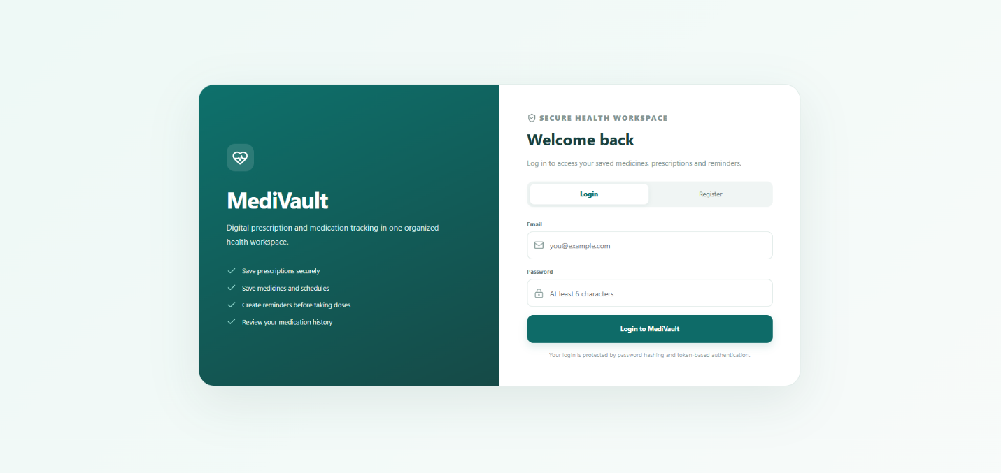

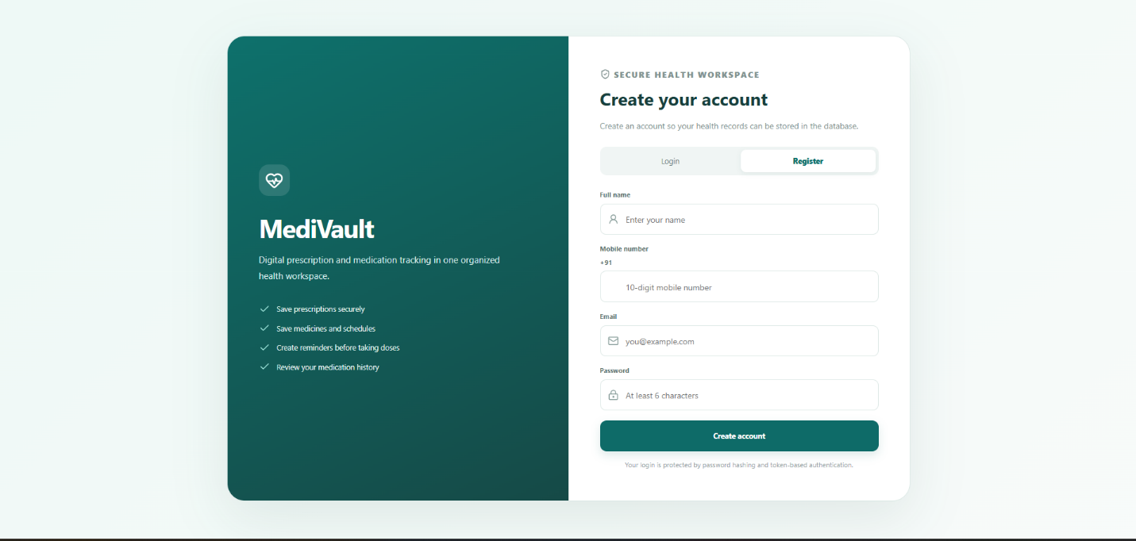

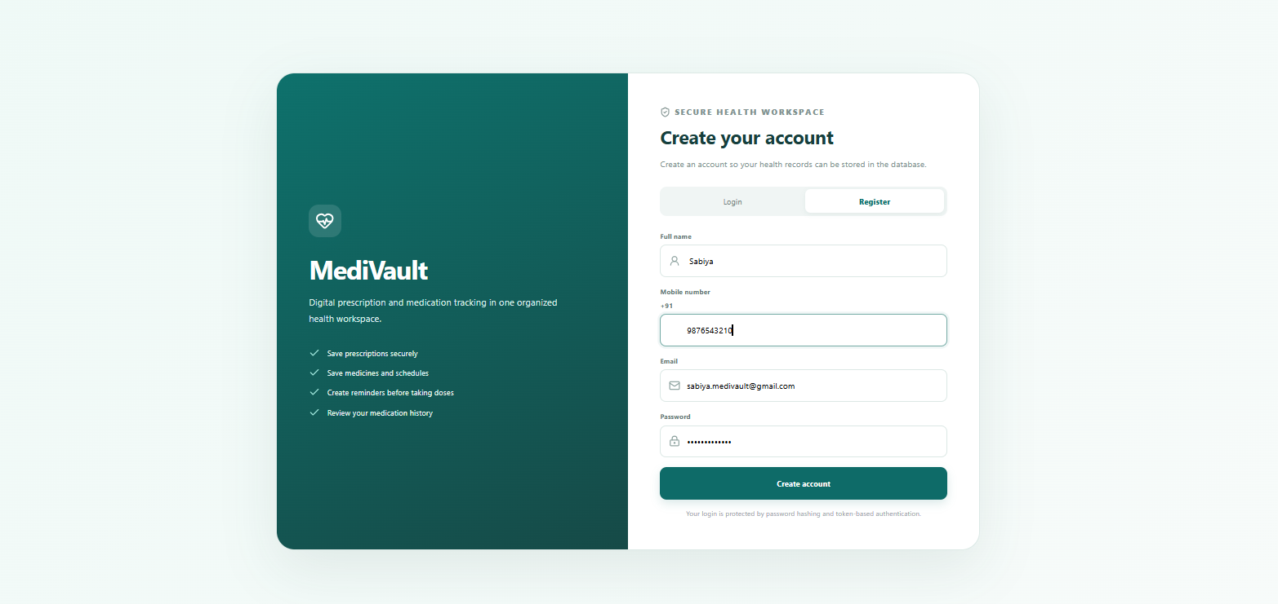

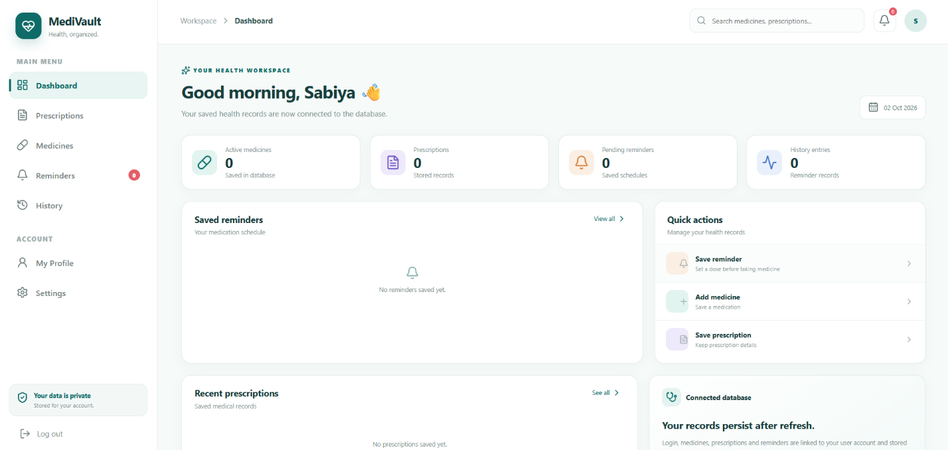

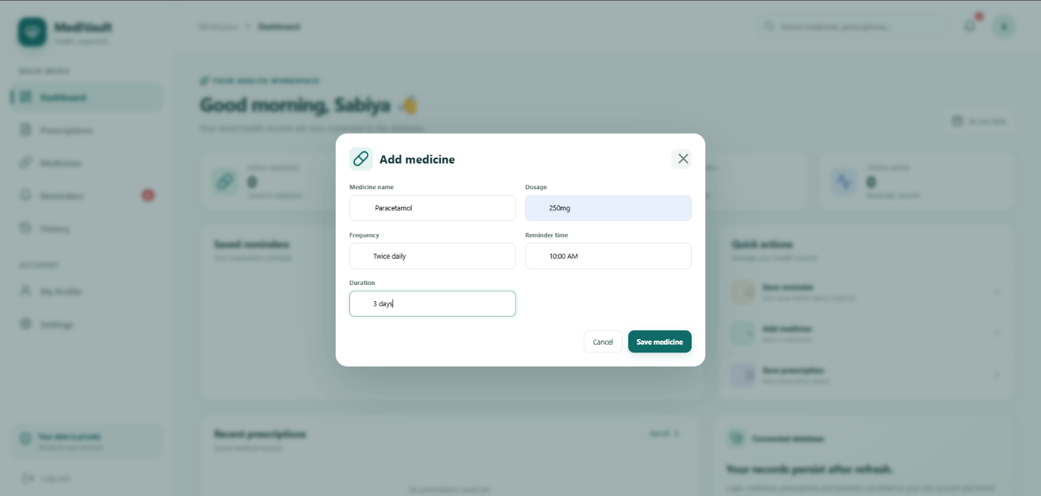

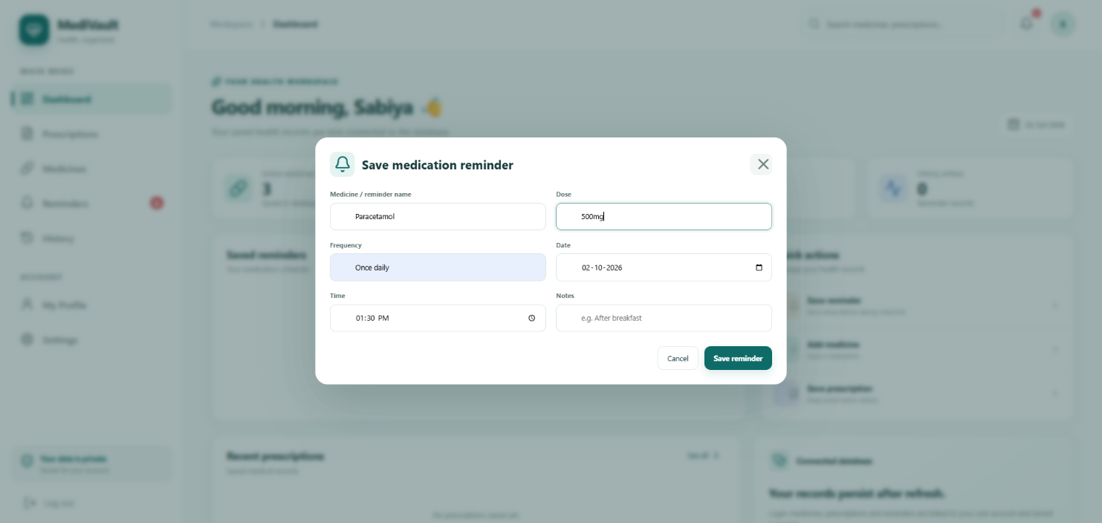

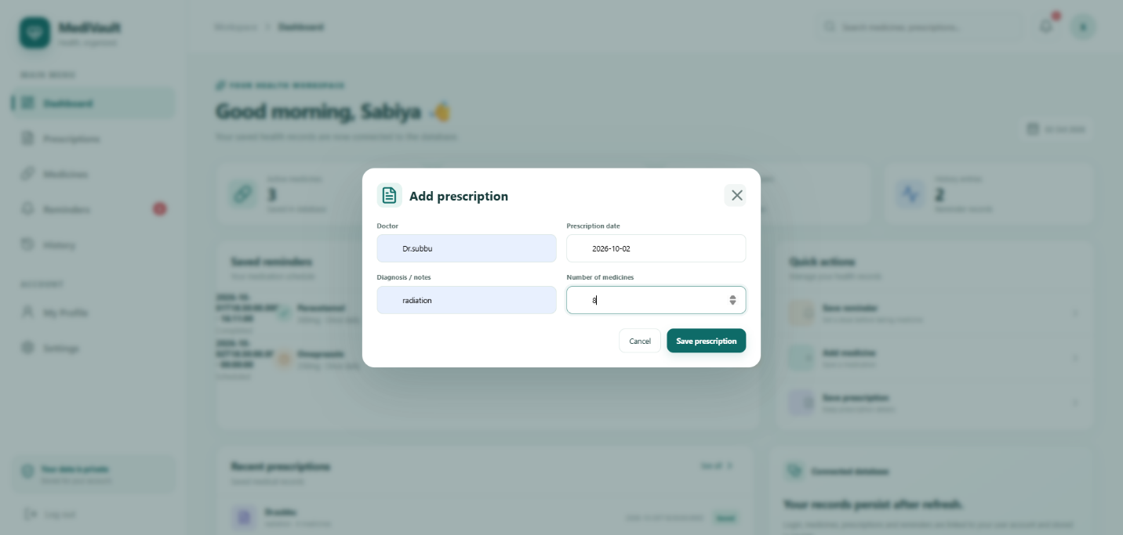

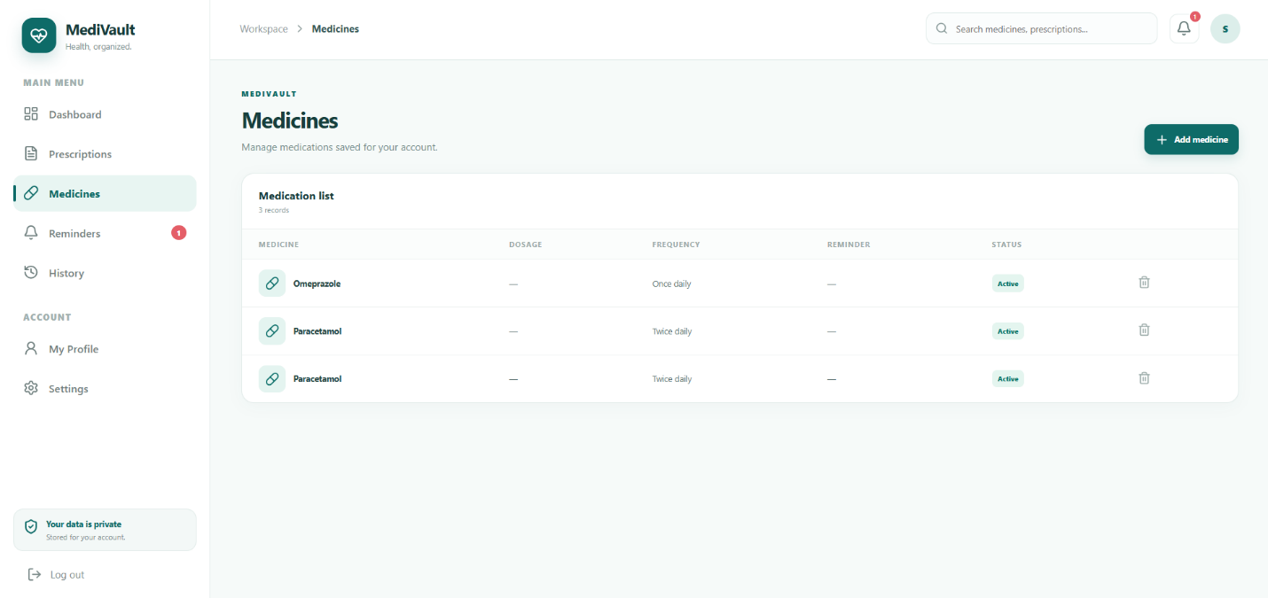

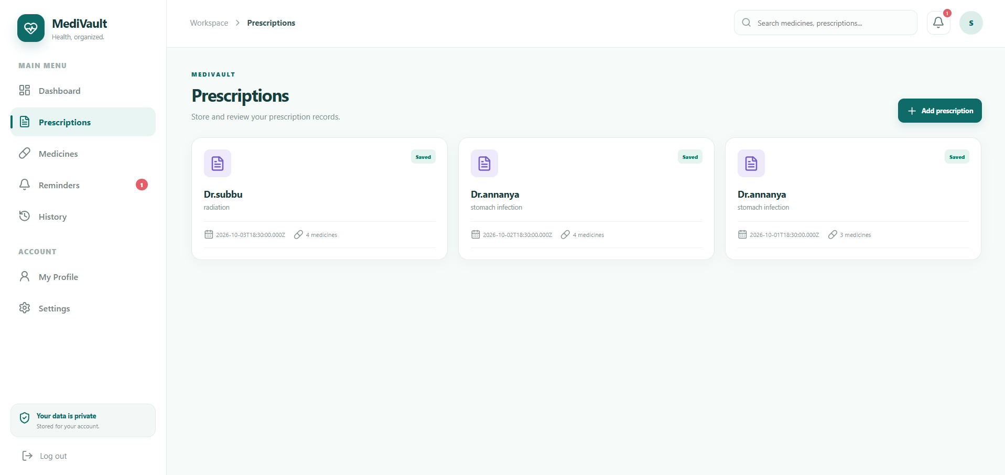

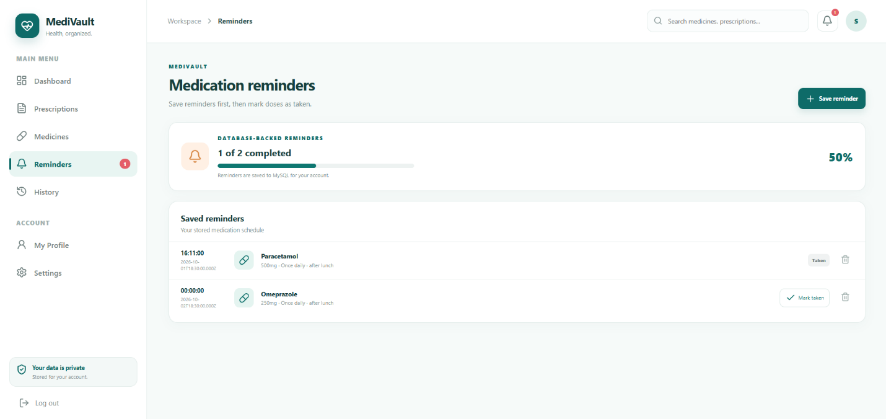

Smaple Code And Snippests
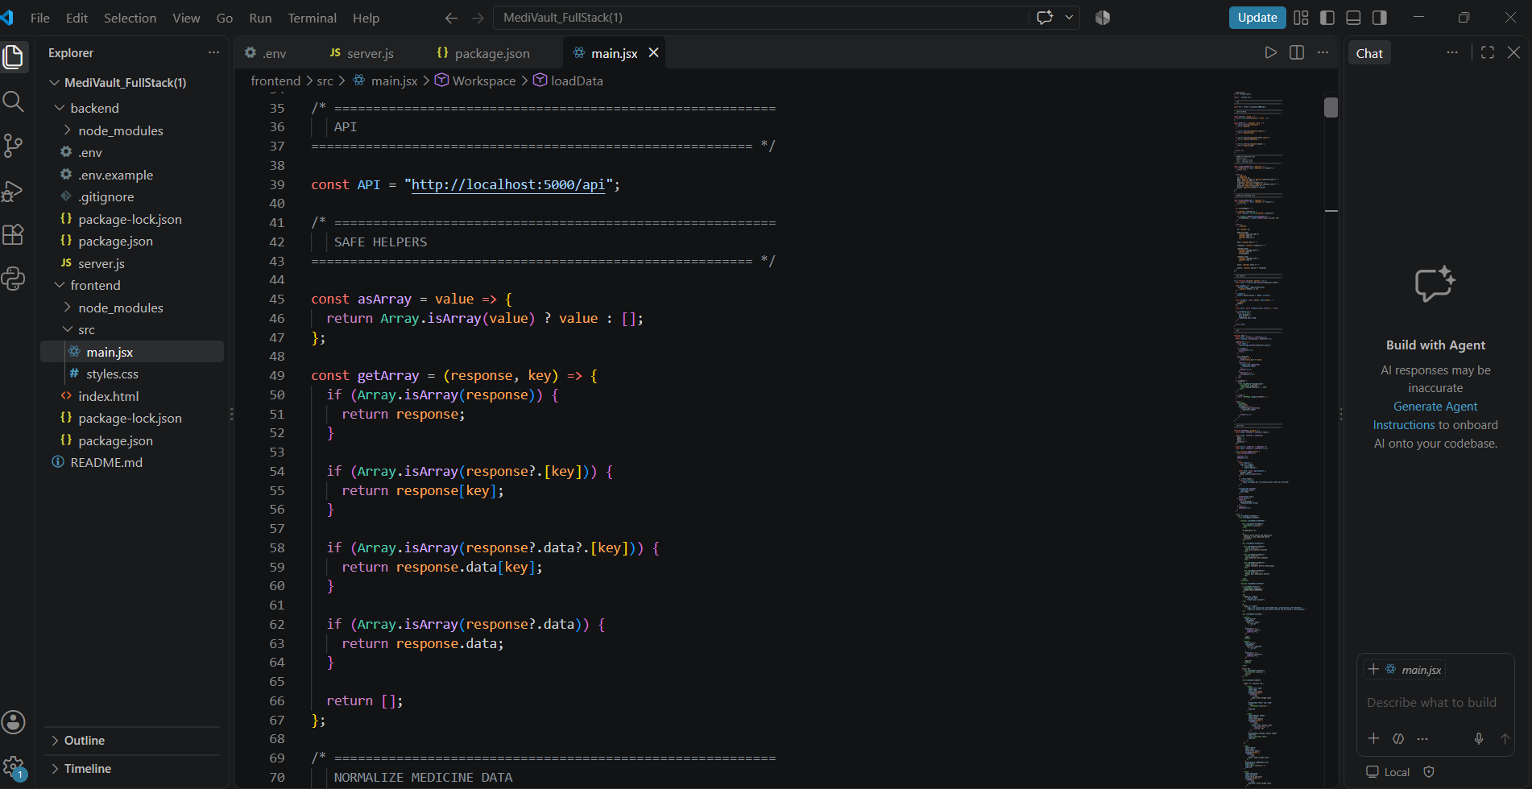

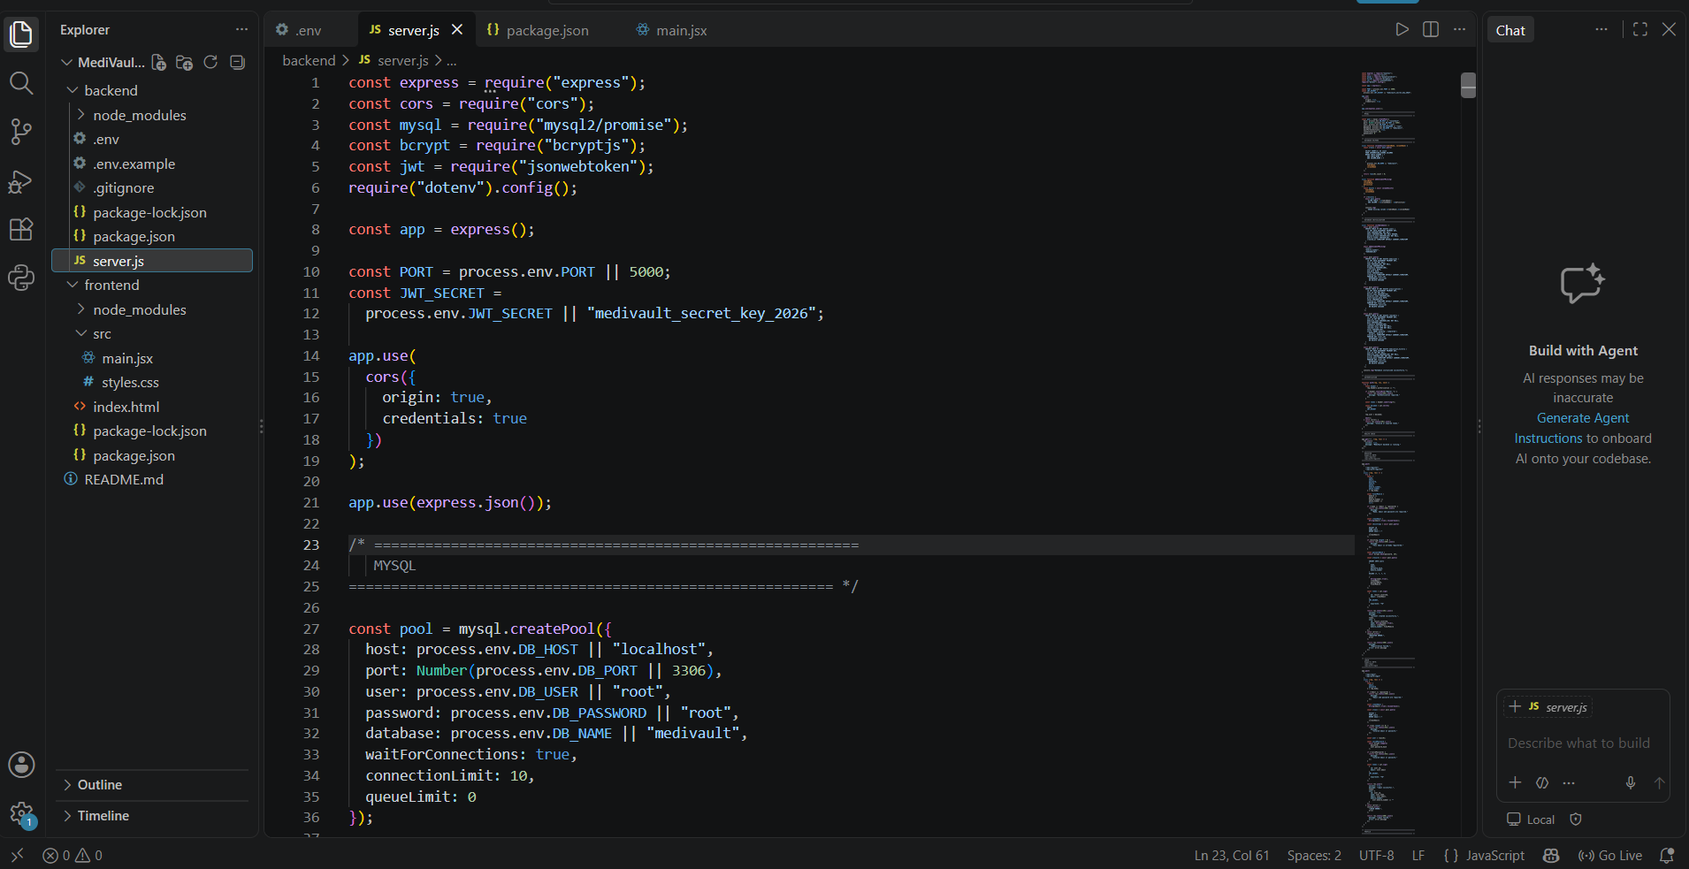

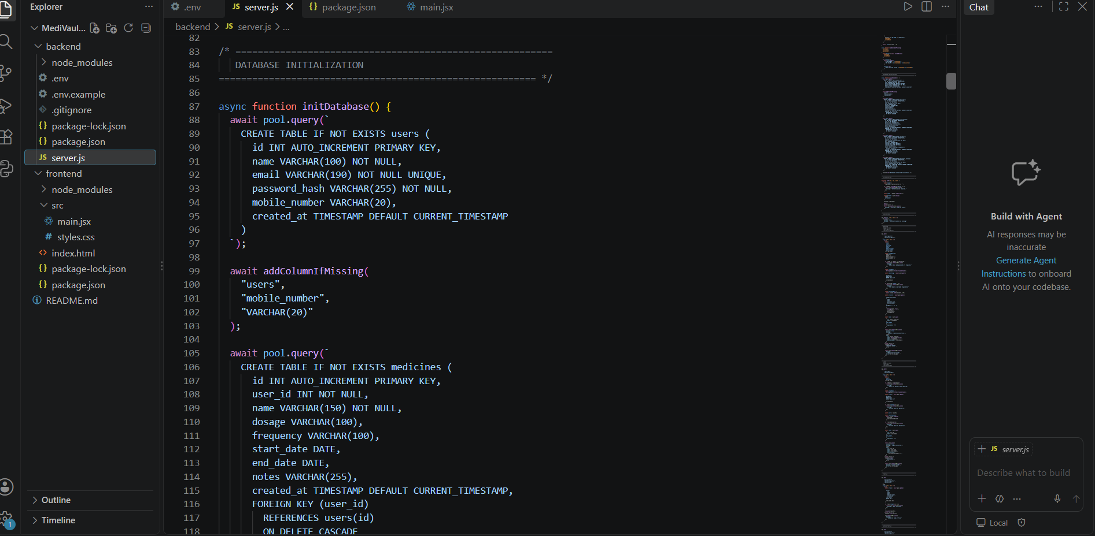

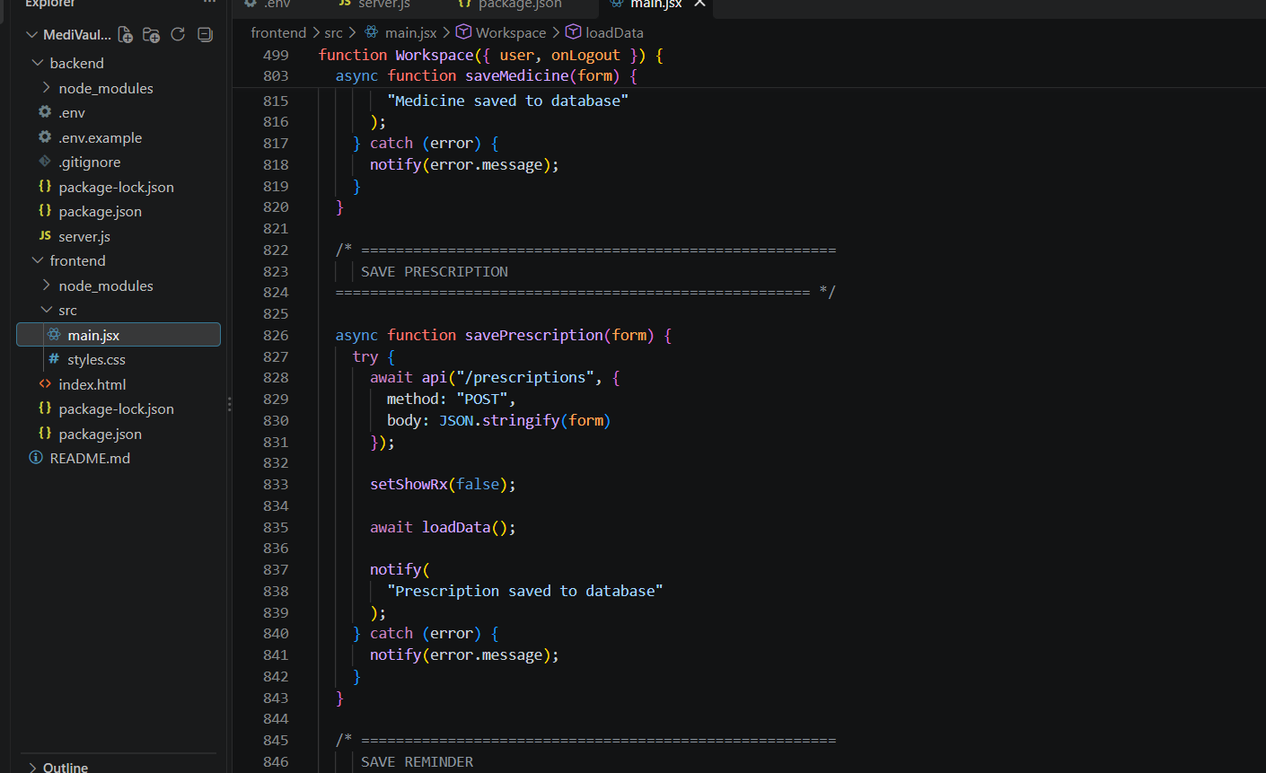

Geo Tag photos with guide





Review forms with guide signatures:

