Colorado State University SYSE 571, Professor Simske, Fall 2025
Analytics in Systems Engineering, Project #2, Assigned 5 November 2025, Due 10 December 2025 (100 points)

Please select a data-related project from one of the following:
- Module 10 classification problem re-done with a different f(z)
- System model for a data set (relevant to your work, for example)
- Image classification challenge from Module 11 on CANVAS (and to the Project 2 Assignment Page): The image classification training and testing XML ZIP files and results are posted on Module 11 Page on CANVAS
- Data mining of a work-relevant data set
- Unsupervised classification
- Classification model of Module 10 applied to your own data set (you could even apply this to the data set for Project 1, though you may not be happy with the classification accuracy!)
The final project will be a written document—WORD or PDF format preferred. Please run the topic past me first, if you have not already done so. Incorporate this page as the first page in your report, please.
Sections expected are:
- Problem Statement (10 points)
- Experimental Approach (20 points)
- Results (30 points)
- Discussion (30 points)
- Learning and Follow Up (10 points)

I am not expecting a lengthy report. The key element of the assignment is to apply data science techniques and processes you’ve learned in the course to a real-world problem. If you have no such problem, please use one of the two course-provided data sets (email logs or image classification).
Questions? Steve.Simske@Colostate.edu

Abstract
CIRRAS (Command Individual Risk and Resiliency Assesment System) is in dire need of a modernization of it’s internal algorithm. I work as the Systems Engineering Manager on this project and have identified several holes in its algorithm that could be suited to the implementation of AI. Due to the sensitive nature of the project I can not dive too deeply into the details of it or its shortcomings, but CIRRAS is an active web application used by the Marine Corps to assist commanding officers in analyzing a holistic view of each service member and determining when and how to intervene with high risk individuals. The goal of CIRRAS is to preserve the Marine Corps fighting force, but the outcome of that goal is better, data driven decision making and providing resources and guidance to service members who may be at risk for self harm or suicide.
CIRRAS ingests roughly 700+ fields of data about a service member from the Marine Corps Total Force System (MCTFS). The data provided to CIRRAS from MCTFS includes practically everything you can think of, from personal information such as ethnicity and gender to combat history to education to family members, you get the idea. It’s a massive pool of data about each and every enlisted service member. On top of this, CIRRAS offers some other important fields that can only be entered by a commanding officer, things like frequency of exercise, alcohol and drug use, and even financials. As CIRRAS is currently designed, All factors are weighted roughly the same, and contribute to a risk recommendation of None, Low, Medium or High risk. The commanding officer then manually goes through their subordinates and approves or corrects the risk determination, meets with service members, and offers resources that may help them with their straining situation. As you may guess, this is tedious and time consuming for the commanding officers, and because of the algorithm, results in many false recommendations.
Problem Statement
I propose that CIRRAS, as the wealth of data it is, is an excellent candidate for the implementation of AI. I believe that appropriately training an AI model will result in more accurate risk determinations and reduce both current algorithm error, human error, and the precious time between a critical stressor occurring and the delivery of a necessary relief resource. I am currently preparing to pitch this idea to my PMO and ultimately the data owner for our project. I plan to use this is as a backing for my dissertation, both to improve the project I’m on and thus usher in a new approach to high risk intervention in the Marine Corps and also to branch AI further into human psychology and hopefully set a path for a similar system in not only active duty, but veteran and retired service members as well.
Experimental Approach
According to a variety of recent research in the field of human psychology, and in part thanks to the Covid pandemic for prompting such a fresh turn of risk and resiliency analysis, major life events and daily stressors can be (relatively) easily quantified now. Using Mockaroo I created a data set of the following various risk and resiliency factors and generated 5000 entries. It’s important to note that as this was randomly generated, some entries were not realistic and ultimately skewed the models’ production predictions.

Age | Number | 18 – 85
Gender | String | Inclusive list to account for nonconformity
Income | USD (Salary) | 0 – 250,000
Education | String | High School, Bachelor’s, Master’s, PhD
Marital Status | String | Single, Married, Widowed, Divorced
Mental Health Condition | String | Small list of realistic mental illnesses (Depression, Anxiety, etc.)
Savings Amount | USD | 0 – 250,000
Employment Status | String | Employed, Unemployed, Self-Employed
Family Size | Number | Includes Direct family, not necessarily dependents
Debt Amount | USD | 0 – 250,000
Physical Activity Level | String | Sedentary, Lightly Active, Moderately Active, Very Active
Credit Score | Number | 300 – 850
Sleep Quality | String | Poor, Fair, Good, Excellent
Risk Tolerance | String | Low, Medium, High
Insurance Coverage | Boolean | Has access to Health Insurance
Social Support Network | Number | 0 – 10 Scale
Stress Level | Number | 0 – 10 Scale
Access to Healthcare | Boolean | Has Access to Healthcare
Financial Goals | String | Small list of financial goals, including no goal

The data generated was relatively straightforward and included opportunity for nuances. Research indicates that daily stressors can increase or decrease risk relatively close to major life event stressors, so this dataset was chosen with that in mind. Things like income, healthcare access, insurance, and social support network can change quickly. Other, more immovable characteristics, like age and income, also have impactful nuances that were considered. Age, for instance, according to Diehl, Hay, and Chui, indications of stability in self and as a result, stability in resilience can be found in age (Diehl, M., Hay, E. L., & Chui, H. (2012)). Not only does greater stability come with age, but the inverse was observed, where greater swings in attitude occurred in younger populations. This let’s us quantify the risk associated with age in a way that makes sense.
Another important consideration made in this dataset revolved around gender and gender-nonconformity. For the sake of this experiment, and in accordance with current research and relevance of the topic, gender was weighted with males having the least impact to risk, followed by females, and then all nonconforming gender identities were given the highest weighting. This helps account for both opportunity and career barriers for different genders as well as stigmas surrounding nonconformity.
Financials were relatively straight forward, risk was delegated based on a ration of income to savings to debt, and showed a priority risk weight to significant debt, while skewing a higher resilience weight to significant income and savings. Mental health conditions were considered in conjunction with insurance availability and access to healthcare. Credit Score was the most significantly weighted risk factor as a lower credit score is typically indicative of either a harder struggle or a more difficult uphill battle to return to credit stability.
Using these nuances, quantifiable scores were generated for each factor and compared as either risk or resiliency. The compared score was normalized against 100 and category determinations were made based on this score. The four ML algorithms that were selected for this experiment included Neural Network, Linear Regression, Random Forest, and XGBoost. These models were chosen for their robustness with large and complex datasets, efficiency in processing, and predictability. All models were trained with a subset of 1000 entries, validated with another 1000 entries, and used in a production like environment against the remaining 3000.
Results
Training results showed a relatively even split between high, medium, and low risk, which is shown in the below graph. This helps illustrate the balance of training data in a way that reflects the overall dataset.
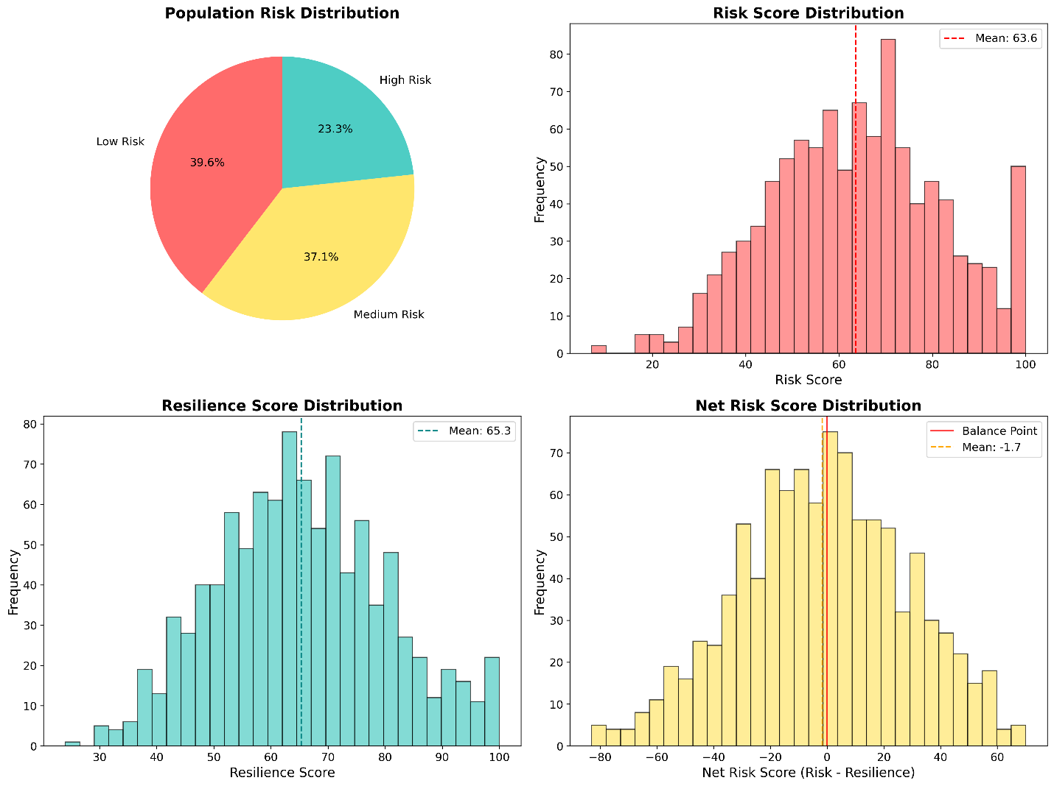
The Training data confirmed appropriate distributions and was then validated with another set of 1000 entries. As expected, coorelations were found in risk and credit score, resilience and income, and risk and age. Low risk groups when compared to high risk groups showed expected results as well. The average age, average income, and average credit score in high risk individuals were all lower than in low risk individuals. An interesting emergent behavior in the training data shows that age based risk was consistently overestimated when considering an older adult with a strong financial profile. This could be due to weighting expectation for age, however the results indicate that all models regularly categorized older, financially stable individuals higher than their actual observed risk levels. Another interesting financial behavior is that the debt to income ratio provided an important resilience prediction, but was not a strong predictor of risk.
In production, The XGBoost model proved to be the strongest prediction model out of all options. It predicted risk and resiliency scores at above 80% accuracy, and had above a 75% accuracy when categorizing risk level. As seen in the below comparison, the XGBoost model is clearly the strongest contendor. Also noted, interestingly, the linear regression model had significantly poor prediction accuracy.
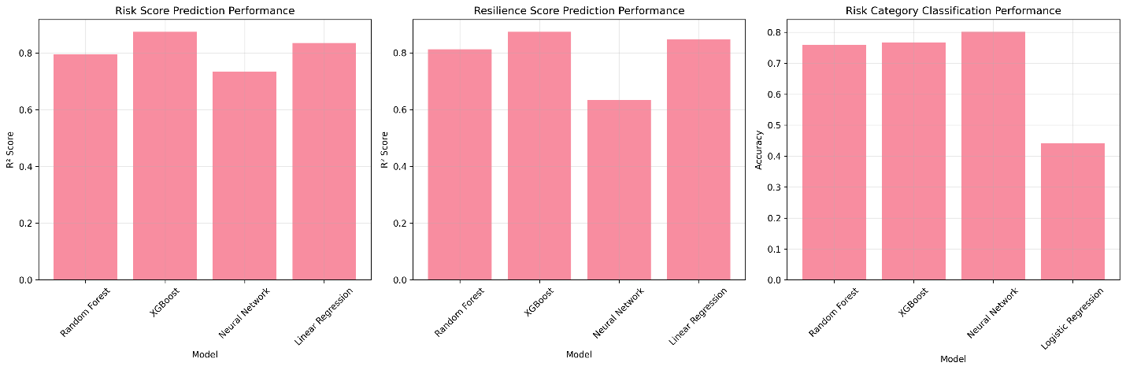
Discussion:
First and foremost, the dataset used in this experiment was completely fictional and could be attributed to the inaccuracy of the production models, specifically the linear regression model. The dataset was pseudo-randomly generated with man made constraints in an effort to expedite the experiment. It also reflects only a fraction of the real world risk and resiliency factors, but it does provide a strong overview of a wide demographic range for study. Using a real world data set with significantly more factors requires a much deeper understanding of human behavior and psychology to account for self considerations, socio-economic influences, political and cultural norms, and even the baseline resiliency versus risk comparison.
Nuances in human behavior are difficult to understand, even to us, and quantifying them is possibly the most difficult portion of this experiment. While not impossible, it does require a deep understanding of the above situations. This model shows a proof of concept in quantifying these relationships in a way that influences overall categorization. Using a bigger, more realistic dataset with better relationship nuances and a stronger quantification of risk and resiliency will likely yield closer accuracies across all models. The potential to implement this into a program like CIRRAS is clearly here.
Learning and Follow Up:
This experiment was impacted by the use of AI in code generation, data generation, and model implementation. While it was reviewed and validated by myself it is still prone to mistakes. Namely, mistakes in data generation and interpretation of human risk and resilience factors. Future recommendations are to spend time collecting real world data to interpret and review. The Linear Regression model will likely be more accurate when considering real data. This model comparison demonstrates the potential that CIRRAS has and will likely be used as a jumping board for future analysis.
The potential to implement a trained and proven ML algorithm into a project like CIRRAS shows strong positive trajectory. The real work comes from the research involved in defining relationships between factors and quantifying factors and their relationships. This experiment proves, at least on a conceptual level, that a data source like CIRRAS, with its goal of suicide and self harm prevention and just in time resource allocation, can benefit drastically from an ML implementation. This will reduce human error by using a data driven approach and offer back valuable time to commanding officers, as well as provide needed resources to at risk individuals in a quicker and more direct manor.

References:
- Diehl, M., Hay, E. L., & Chui, H. (2012). Personal Risk and Resilience Factors in the Context of Daily Stress. Annual review of gerontology & geriatrics, 32(1), 251–274. https://doi.org/10.1891/0198-8794.32.251
- Bockting, W., Barucco, R., LeBlanc, A., Singh, A., Mellman, W., Dolezal, C., & Ehrhardt, A. (2020). Sociopolitical change and transgender people's perceptions of vulnerability and resilience. Sexuality research & social policy : journal of NSRC : SR & SP, 17(1), 162–174. https://doi.org/10.1007/s13178-019-00381-5
- Schäfer, S.K., Fritz, J., Sopp, M.R. et al. Interrelations of resilience factors and their incremental impact for mental health: insights from network modeling using a prospective study across seven timepoints. Transl Psychiatry 13, 328 (2023). https://doi.org/10.1038/s41398-023-02603-2
- Rutten, B. P., Hammels, C., Geschwind, N., Menne-Lothmann, C., Pishva, E., Schruers, K., van den Hove, D., Kenis, G., van Os, J., & Wichers, M. (2013). Resilience in mental health: linking psychological and neurobiological perspectives. Acta psychiatrica Scandinavica, 128(1), 3–20. https://doi.org/10.1111/acps.12095

