Online Home Weather Station

Purpose and Scope
This project developed the critical communication infrastructure for a home weather station. The system consists of two controllers: The outdoor unit reads an array of sensors and sends information back to the indoor unit via a radio transceiver. The indoor unit monitors additional sensors and compiles all the data into a self-hosted website.

Materials and Resources
- Raspberry Pi computer
  - Raspbian OS
  - rpi.gpio library
  - Micro SD card

Background
Admittedly, there are multitudes of DIY weather station instructions posted online; however, this design achieves two advantages over most designs. First, the outdoor unit requires minimal infrastructure. The nRF24 radio transceivers have a claimed range of 100 meters. This allows for placement beyond what a standard home WiFi router can support without installing any wires. Most existing designs require one or the other. Second, the data from this weather station is available for free with an internet connection. Most designs restrict data access to within the home (which isn’t very useful) or use a cloud service (which isn’t very fun).
Two different controllers are used in this project. The outdoor unit is run off an Arduino Uno. The Arduino is a simple microcontroller that executes compiled C++ instructions. It has low power requirements and requires almost no input to operate once programmed. A Raspberry Pi is used for the indoor unit. The Pi is a single-board Linux machine capable of running interpreted Python code and hosting a web server. It is far more complex than the Arduino. Each is well-suited for its application.
A key component of this design is the nRF24L01+ radio transceiver. Two of these chips are used—one on each controller. Each chip is configurable as a transmitter (TX) or receiver (RX). They communicate in the 2.400 – 2.4835GHz band (also configurable). Communication is largely handled within the chips. Data is written to the TX chip via SPI. The TX chip broadcasts a radio signal addressed to the RX chip. When the RX chip decodes a signal, it broadcasts an acknowledgment back to the TX chip. The RX chip stores the received data in an SPI-accesable register and sets an interrupt (IQR) pin low. If the TX chip does not receive the RX acknowledgment, it will re-broadcast the message. The wait time and number of re-tries are configurable. The TX chip sets its IRQ low on a successful transmission.
This system would be quite boring without any sensors. Specifically, the BME280 measures ambient temperature, pressure, and humidity. These metrics are the core of any local meteorological observation. While the exact mechanism of sensing appears proprietary, it is clear that the pressure and humidity components are of higher quality than the temperature mode. The temperature component is sufficient to provide accurate pressure and humidity measurements, but ultimately temperature readings should utilize another sensor. The BME280 data is accessible via I2C.
Lastly, an AS3935 Franklin lightning detector was incorporated into the system. This chip is controlled by the indoor unit. While its performance would improve outside, indoor operation is sufficient and reduces current consumption in the outdoor unit. A Franklin lightning detector identifies radio signatures from lightning strikes on the 500 kHz band. The AS3935 relays lightning information to the controller with an interrupt signal and SPI communication.

Wiring
This program uses the circuits shown in Illustration 1. The LCD screen is on a 5V circuit from the Raspberry Pi and connects to the SDA & SCL communication lines. The ultrasonic sensor is a 5V device. The 3.3V signal is sufficient for the trigger input to read high, but resistors are required to drop the output voltage to a point that is safe for the Pi. Illustration 2 shows the actual board setup. This photograph should be used for reference only.
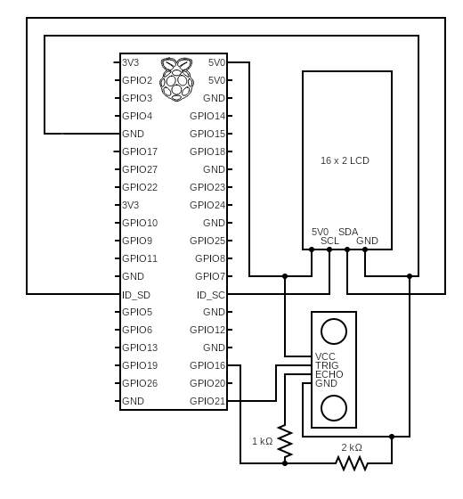Illustration 1: Wiring Schematic

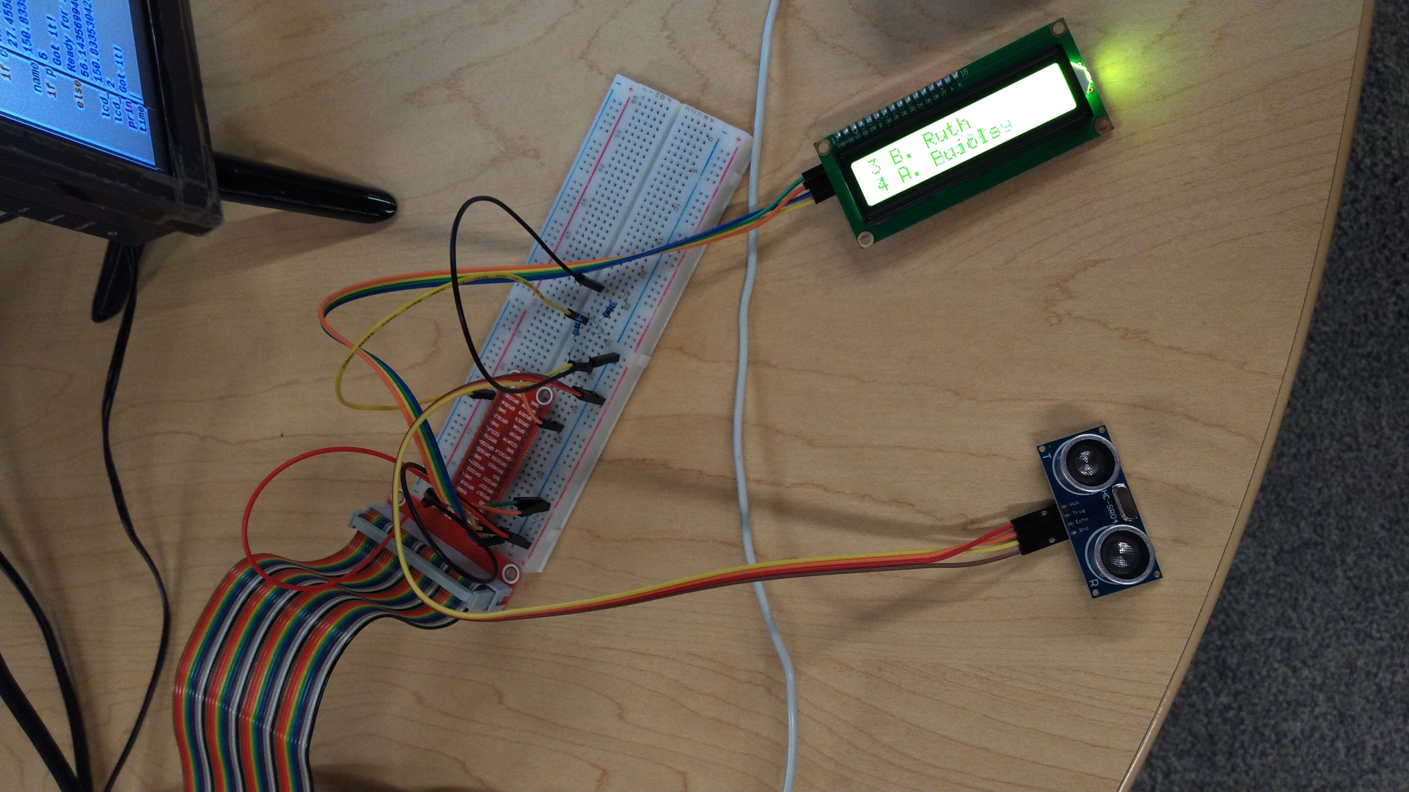Illustration 2: Assembly

Code
First, for the initialization, the relevant libraries are imported, the GPIO pins used are assigned to variables, I2C addresses are assigned as variables, display parameters are set, and the GPIO pins are configured.
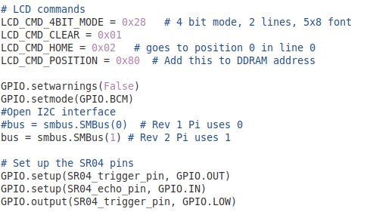
Several key functions for the operation of the LCD screen are built.
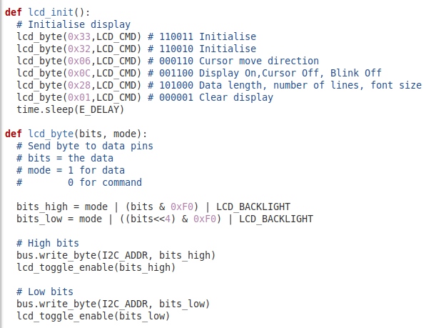

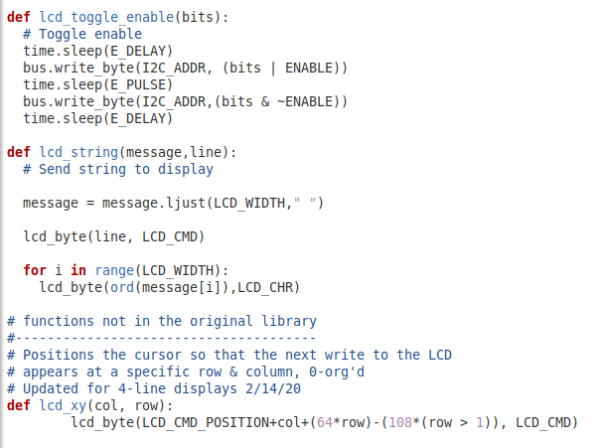
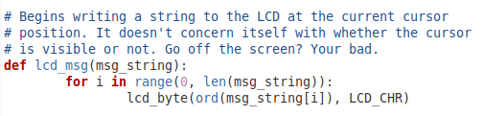
For testing, the local file of the web page will be used. The web page is assigned to a variable. A function is built to save the raw text of the web page into the code.
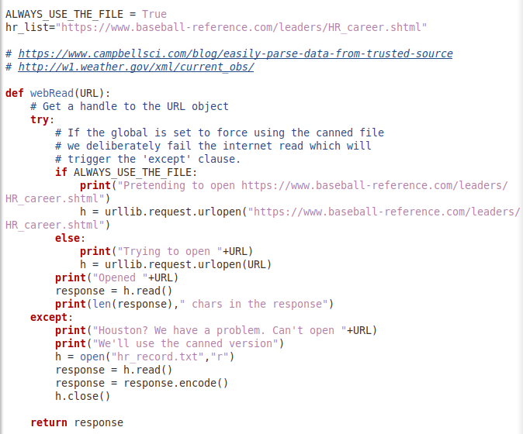
The next function will identify useful data within the web page by looking for key markers that are proximal to the desired information.
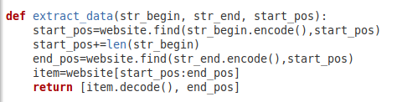
The distance() function is the fundamental operation of the ultrasonic sensor. It measures the time between a sonic wave being sent and its echo being heard. Using the speed of sound, the distance the sound travels is calculated.
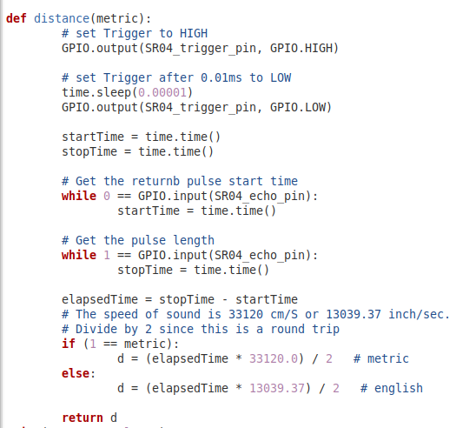
Along with some debugging information, the next block of code compiles a list of the top 100 all-time home run leaders in Major League Baseball History. Should the live website be used, this list will update every time the code is restarted.
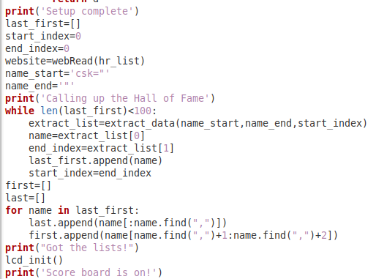
Lastly, the program checks for the distance registered on the ultrasonic sensor every three seconds. The closer the distance, the lower (fewer home runs) the rank is displayed on the LCD. It sets the farthest distance measured as the top home run hitter of all time and moves down the list as the distance gets proportionally closer to 0.
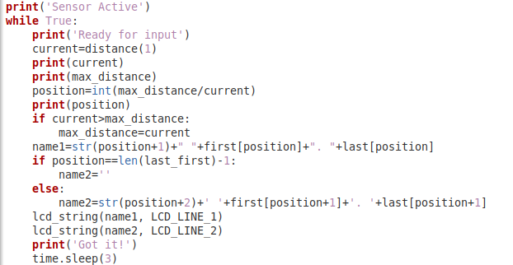
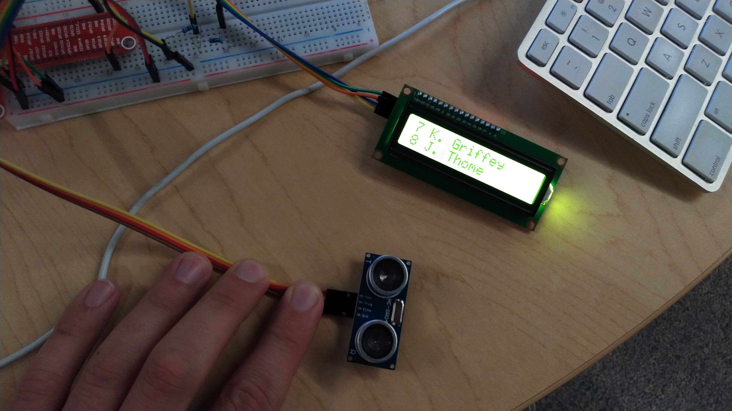
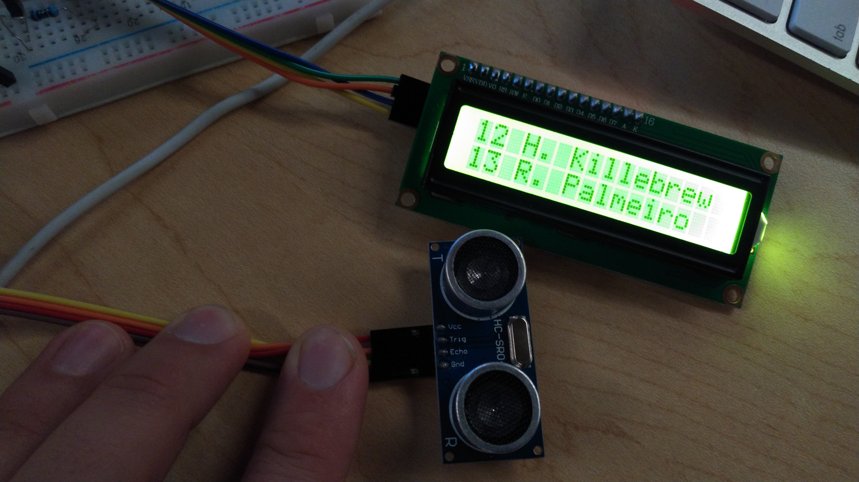

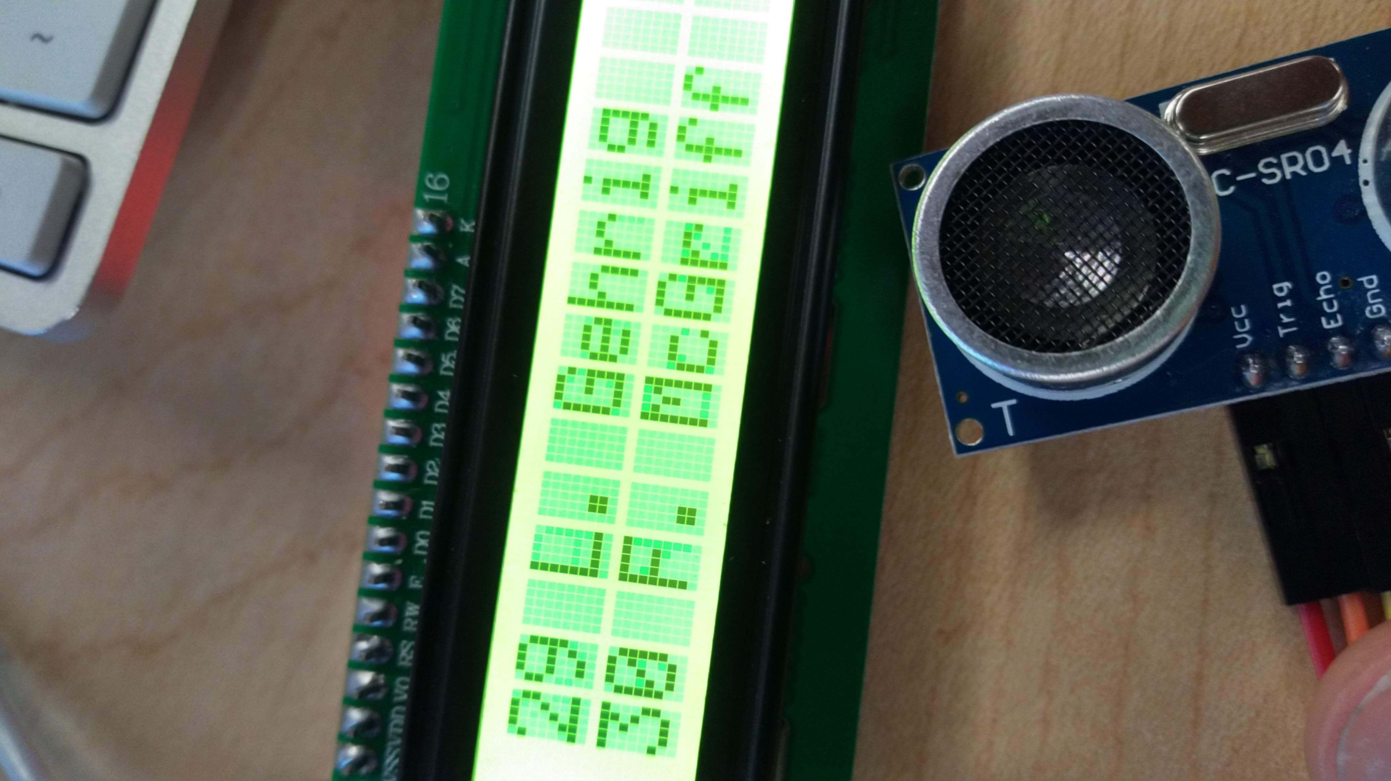

Problems & Next Steps
The program runs well given the limitations of the inexpensive proximity sensor. In advanced applications, a more interesting data set could be accessed. For example, this setup could be refined into an interactive museum exhibit or be adapted into a behavior modification tool (e.g. displaying real-time traffic mortality statistics to tailgaters).

