LCS PTO Presents......
Pocahontas’ Vision Quest Show
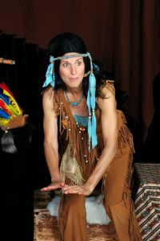
Virginia - 1616 Pocahontas’ Vision Quest unveils the lifestyle of Eastern Native American tribes. Their language, customs and traditions are explored. Before Pocahontas sets off on her vision quest, her father, Chief Powhatan insists she prepares properly. A Native American folktale is shared, as well as the friendship dance with John Smith (and the entire audience). Student participants harvest the planting mounds (corn, beans and squash), and Pocahontas’ “brothers and sisters” test their bravery in a bat-filled cave. She then plays a creative imagination game with her tribesmen before she departs on her quest. Pocahontas - is an historic Native American youth of the Powhatan tribe. Her attire is comprised of leather skins, complete with moccasins, beads, fur and feathers. Come along on the journey as the LCS PTO presents this free evening event! Kids - feel free to come dressed as a Native American brother or sister to Pocahontas!

Tuesday, November 19, 2013
Two Performances: 5:30 pm and 7:00 pm
______________________________________________________________________
Admission is free, Space is limited, pre-registration is required.

Family Name:____________________________________
Performance time (circle) 5:30 pm 7:00 pm
# Adults:_____________ # Children:_________________

Mail filled out response to Larissa Milligan via Backpack mail or email at:larissa_milligan@hotmail.com

