TITLE OF THE PAPER: CENTERED, UPPERCASE, 14 POINT TIMES NEW ROMAN, ON SECOND LINE FROM THE TOP MARGIN, NOT MORE THAN 3 LINES LONG

**Author A and Author B[1]**

Name of Institute

Corresponding Address

A@institute.gov; B@institute.gov

**Double space and list Author C**

Department of Nuclear Engineering

Name of University

Address

c@name.univ.edu

# INTRODUCTION

Paper starts here with two blank lines before first section title. Use 8.5 x 11 paper size, with 1" margins on all sides. Double-space before and after each subsequent section’s title. Section titles have style “Heading 1”, are 11 point font, must be all uppercase and centered, and must be numbered in Arabic numerals as shown above. Introduce the topic of your work in this section.

Do not indent the first line of a paragraph; rather double-space between paragraphs. There are four types of reference styles: journal paper [1], proceeding paper [2], book [3], and website [4]. References to websites are discouraged, but acceptable if absolutely necessary. It is the author’s responsibility to check links in the pdf file.

Since the paper will be included as a .pdf file for the proceedings, the author will get the best results from Word or WordPerfect by using the Acrobat Distiller or Acrobat PDFWriter as the default printer. When creating the PDF version, check the “Embed All Fonts” option. Note that it is the author’s responsibility to review the final PDF version of the paper to ensure proper translation into PDF. Final PDF file size should be no more than 10 MB. Recommended paper length is 2-3 pages (3-5 pages for best papers track).

# SUBSEQUENT MAJOR HEADING

A logical division of your paper into sections, etc., makes it so much easier to understand. The style for subsection titles and all text in this template is “Heading 2,” “Heading 3,” etc. All text in this template is “Body Text 3.” Make sure to ***avoid widow/orphan*** lines.

## Subsection Title: First Character of Each Non-trivial Word is Uppercase

Double-space before and after secondary titles. Secondary titles should start flush left, and are numbered as illustrated above.

Equations should be centered and sequentially numbered to the flush right of the formula.

 (1)

The continuation of a paragraph after an equation is not indented. All paragraphs, as well as section or subsection headings, are separated by just one single empty line.

### Sub-subsection level and lower: only first character uppercase

Figures and tables should appear as closely as possible to where they are first cited, e.g. Fig. 1, in the text. Figures are numbered in Arabic numerals, with the caption centered below the figure, in **boldface**. Double-space before the figure, and after the figure caption.

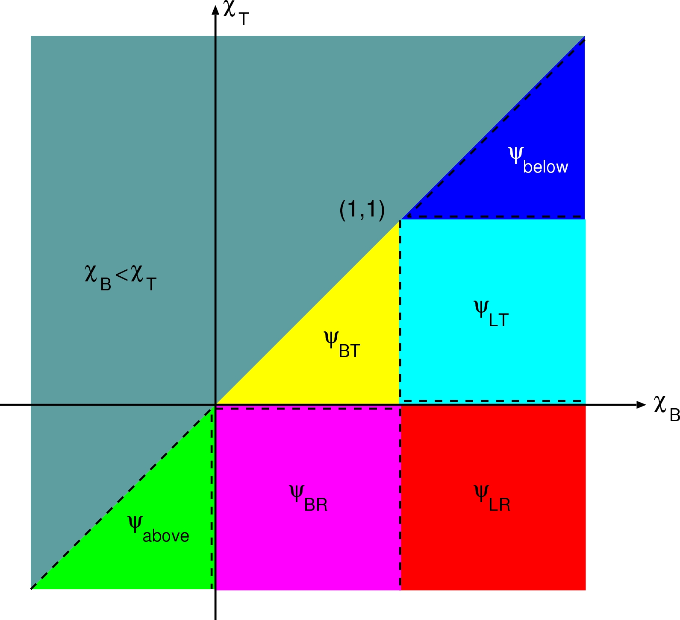

Figure 1. Sample figure

When importing figures or any graphical image please verify two things:

* Any number, text or symbol is in Times font and is not smaller than 8-point after reduction to the actual window in your paper;
* That it can be translated into PDF.

This is just fill in text. This is just fill in text. This is just fill in text. This is just fill in text. This is just fill in text. This is just fill in text. This is just fill in text. This is just fill in text. This is just fill in text. This is just fill in text. This is just fill in text. This is just fill in text. This is just fill in text. This is just fill in text. This is just fill in text. This is just fill in text. This is just fill in text. This is just fill in text. This is just fill in text. This is just fill in text. This is just fill in text. This is just fill in text. This is just fill in text. This is just fill in text.

Tables, like Table I, are numbered in Roman numerals, with the caption centered above the table, in **boldface**. Double-space before and after the table.

Table I. Sample table: accuracy of nodal and characteristic methods

|  |  |  |
| --- | --- | --- |
| **Mesh** | **8 x 8** | **16 x 16** |
| **Nodal** | 1.000 10-1 | 2.500 10-2 |
| **Characteristic** | 1.000 10-1 | 2.500 10-2 |

# CONCLUSIONS

Present your summary and conclusions here.

# ACKNOWLEDGMENTS

This template was adapted from the template for PHYSOR 2002 posted on the Internet. Acknowledge the help of colleagues, and sources of funding, if you wish.

# REFERENCES

1. B. AUTHOR, “Title of paper,” Nucl. Sci. Eng., **3**, 13 (2045).
2. J. E. HOOGENBOOM and W. R. MARTIN, “A Proposal for a Benchmark to Monitor the Performance of Detailed Monte Carlo Calculation of Power Densities in a Full Size Reactor Core,” *Proc. Int. Conf. Mathematics, Computational Methods, and Reactor Physics*, Saratoga Springs, New York, 2009.
3. G. I. BELL and S. GLASSTONE, *Nuclear Reactor Theory*, Van Nostrand, Princeton, NJ (1970).
4. X-5 Monte Carlo Team, “MCNP - A General Monte Carlo N-Particle Transport Code, Version 5,” LA-UR-03-1987, Los Alamos National Laboratory (2005).

1. Footnote, if necessary, in Times New Roman font and font size 9