- Results
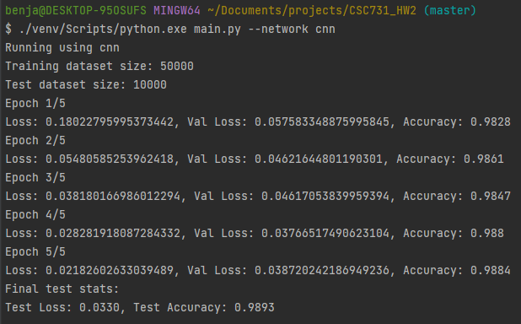
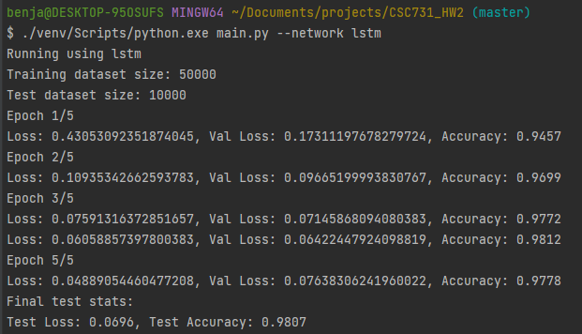
- Methods
  - Data Prep
Images were converted to tensors and normalized. I found the values used for std normalization were readily available. Data was split into training/validation/test datasets.
  - CNN
A fairly simple CNN was sufficient to get high accuracy. I started with a convolution layer that output 16 channels, kernel size 3 (1 padding to keep size). This was max pooled, and passed through a second convolution layer that output 32 channels (kernel and padding same as first). After pooling, I used two linear layers that ended with logits for the 10 classes.
  - LSTM
The LSTM was able to produce high accuracy almost immediately, with a hidden size of 128, and an input of 28 rows of 28 values.
  - Overfitting Prevention
I added early stopping based on validation loss. Patience defaults to 3, but can be adjusted with CLI.
  - Hyperparameter Adjustment
The default learning rate is 0.0001, for which the LSTM achieved Test Loss: 0.0733, Test Accuracy: 0.9800. By increasing this to 0.001, the metric improved, and training completed in 11 epochs (instead of 19): Test Loss: 0.0463, Test Accuracy: 0.9870. The results of the initial experiments were high enough that I felt there was no further need for adjustment.
- Replication
The command line interface is used as presented in the assignment: python.exe main.py --network {cnn or lstm}. Epoch, batch size, learning rate are optional, but can be overridden from the CLI The only requirements are numpy, torch, and torchvision (I did not specify a version).
- Observations
The biggest shock to me from this exercise was how the accuracy of the LSTM was very comparable to that of the CNN. My takeaway from this was that since we are working with grayscale images, there are only very specific dark pixel patterns on white pixels; this is essentially a numerical pattern that the LSTM learns to associate with a specific class. Another thing I did notice is that while both have near perfect accuracy on the test set, the LSTM has roughly twice the loss of the CNN.

