**How to capture video using v4l2 and streaming video using ffmpeg**

Reference:

Method adapted from boneCV:

boneCV: <https://github.com/derekmolloy/boneCV>

<http://derekmolloy.ie/beaglebone/beaglebone-video-capture-and-image-processing-on-embedded-linux-using-opencv/>

<http://derekmolloy.ie/udp-video-streaming-beaglebone-black/>

Useful previous cmpt433 how-to guides:

1. <http://www.cs.sfu.ca/CourseCentral/433/bfraser/other/2015-student-howtos/RecordingWebcamVideos.pdf>

2. <http://www.cs.sfu.ca/CourseCentral/433/bfraser/other/2014-student-howtos/WebCam.pdf>

3. <http://www.cs.sfu.ca/CourseCentral/433/bfraser/other/2016-student-howtos/WebCamVideoOpenCV.pdf>

**How to capture video**

1. BBG comes with v4l2, to check

# whereis v4l2-ctl

v4l2-ctl: /usr/bin/v4l2-ctl

Some v4l2 commands(after connect camera to BBG):

# v4l2-ctl –list-formats

...

# v4l2-ctl –list-device

UVC Camera (046d:0825) (usb-musb-hdrc.1.auto-1):

/dev/video0

# v4l2-ctl --list-formats

ioctl: VIDIOC_ENUM_FMT

Index : 0

Type : Video Capture

Pixel Format: 'YUYV'

Name : YUYV 4:2:2

Index : 1

Type : Video Capture

Pixel Format: 'MJPG' (compressed)

Name : Motion-JPEG

# v4l2-ctl --get-priority

Priority: 2

# v4l2-ctl -D

Driver Info (not using libv4l2):

Driver name : uvcvideo

Card type : UVC Camera (046d:0825)

Bus info : usb-musb-hdrc.1.auto-1

Driver version: 4.4.9

Capabilities : 0x84200001

Video Capture

Streaming

Extended Pix Format

Device Capabilities

Device Caps : 0x04200001

Video Capture

Streaming

Extended Pix Format

2. how to capture video

1. # apt-get install libv4l-dev

2. store revised capture.c to NFS server

3. enter the NFS directory

# cd /mnt/remote/...

compile capture.c on BBG

# make

or

# gcc capture.c -lv4l2 -o capture

capture video and store it in output.raw

# ./captureVideo

or

﻿# ./capture -F -c 300 -o > output.raw

-F force format to YUYV (after revision)

-c | --count Number of frames to grab [100] - use 0 for infinite

-o | --output Outputs stream to stdout

-h | --help

4. after capturing, a output.raw file will be produced. Convert raw file to mp4

#./raw2mpg4

or

# ffmpeg -f rawvideo -vcodec rawvideo -s 320x240 -r 25 -pix_fmt yuv420p -i output.raw -c:v libx264 -preset ultrafast -qp 0 output.mp4

**How to stream video using udp:**

1. install ffmpeg on BBG

First, we need to add backports to our sources.list because we are running debian 8.4 on BBG

# cd /etc/apt/sources.list.d/

modify sources.list and add the following line to the end of the file

deb http://ftp.debian.org/debian jessie-backports main

then ffmpeg can be installed using apt-get

# apt-get update

# apt-get install ffmpeg

2. install VLC media player on host

$ sudo apt update

$ sudo apt install vlc

3. on BBG

# ./streamVideoUDP

or

# ./capture -F -o -c0|ffmpeg -f rawvideo -vcodec rawvideo -s 640x480 -r 25 -pix_fmt yuv420p -i pipe:0 -f mjpeg udp://192.168.7.1:1234

Streaming is successful if the terminal output is like the following

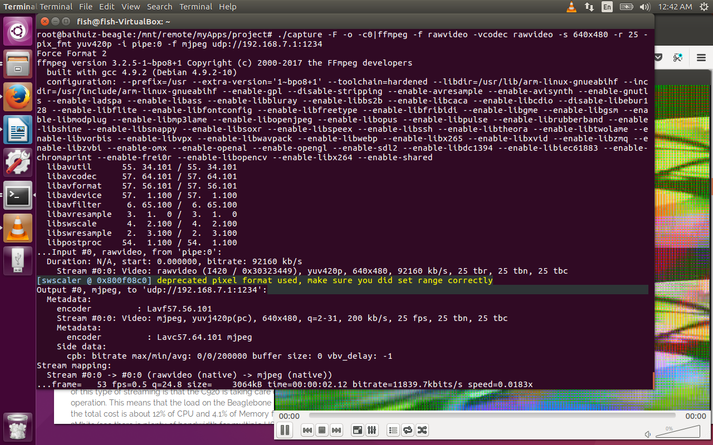

on host, open VLC, Media->open Network Stream-> Network-> Network Protocol->Please enter a network URL:

udp://@:1234

then click play

