wk3143.R

brittneyhannah

2024-01-18

# A plot from week 3  
x <- 1:50  
  
plot(x, sin(x))

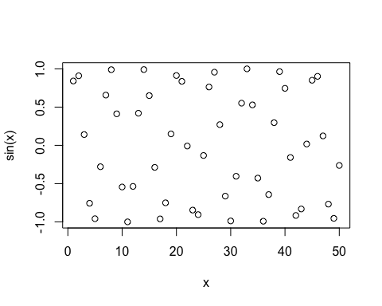

# make this a bit nicer  
plot (x, sin(x), type = "l", col = "blue", lwd = 2)

