Student’s Name: Bui Duc Hieu

Student ID: 20167174

Class: ICT.01-K61

**LAB WORK**

**CHAPTER1: INTRODUCTION**

**Question 1:** *What is the path of the HTML file that contains the content of the default website apache?*

the path of the HTML file that contains the content of the default website apache is “/var/www/html/index.html”

**Question 2:** *What is the default port that the webserver is listening?*

The default port that the webserver is listening is 80

**Question 3:** *Explain what permission 755 means*

Permission 755 means that everyone can read and execute access, but only root has the write access

**Question 4:** *What do you see after typing these 2 addresses? Explain it*

We can see the content of the 2 HTML files rendered on the browser because these 2 sites are enabled in the apache webserver.

**Question 5:** Try to make other machines in the same LAN access to these 2 addresses.

In order to make other machines in the same LAN access to these 2 websites, we need to add to that machine host file the IP of the webserver machine and the URL of the website.

Example:

192.168.1.2:80 example.com

**Question 6:** *What is the code of the while loop?*

Code of the while loop:

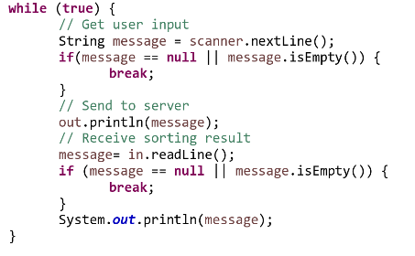

This while loop serves the purpose of listening to the message of the client and send it to the server and listen to server message until the client input nothing.

**Question 7:** *What is the role of method run? When is it called?*

The role of method run is to receive and to process client’s request. It is called whenever client send a line to server.