Earthquake Prediction Model:

Introduction:

Earthquake prediction model is a machine learning model which we develop to predict the occurrence of earthquake in places. As predicting the earthquake may be seems a little bit easy, because earthquake hit some places like Japan frequently. But we can’t predict when it would happen. Predicting the earthquake will be important one .By predicting the earthquake we can save many lives.

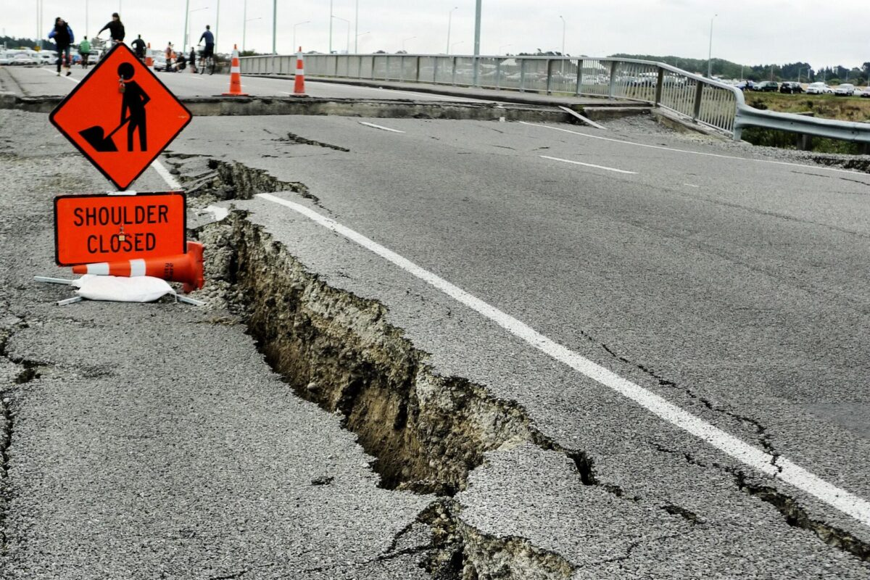

**Design:**

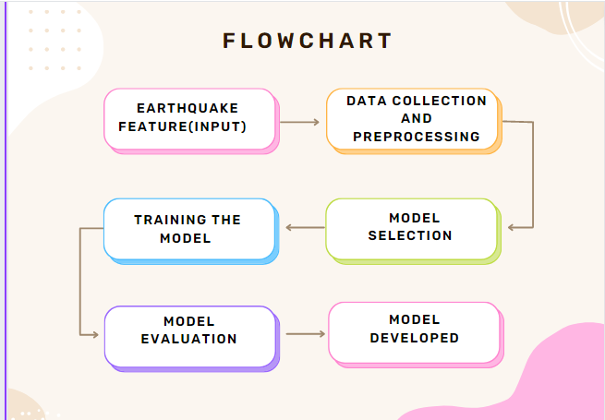

Data Collection and preprocessing:

**Data Cleaning:**

**Handling Missing Data**: Techniques include imputation (filling in missing values with a statistic like mean or median), deletion of rows or columns with missing values, or using advanced imputation methods like regression imputation.

**Encoding Categorical Variables:** Convert categorical variables (e.g., gender, color) into numerical representations using techniques like one-hot encoding or label encoding.

**Principal Component Analysis (PCA):** Reduce the dimensionality of data while retaining most of its variance. PCA is commonly used for high-dimensional datasets.

**Feature Selection:** Select the most important features to reduce the dimensionality and improve model efficiency. Techniques include filter methods, wrapper methods, and embedded methods. Here we use Filter method.

**Model Selection:**

* In this model we select **Artificial Neural Network(ANN).** an Artificial Neural Network (ANN) is a type of machine learning model. It's a mathematical model inspired by the structure and function of biological neural networks, like the human brain.
* ANNs consist of interconnected nodes (neurons) organized into layers, which process information and make predictions or classifications based on input data.
* In a neural network, data is passed through the layers, and the network learns to extract relevant features and patterns from the input data through a process of training.
* Training involves adjusting the weights and biases of the connections between neurons to minimize a defined error or loss function.Our neural network will consist of three dense layers each with 16, 16, 2 nodes and reread. **Relu** and **softmax** will be used as activation functions.

**Training the model:**

* Before training the model we will separate the data set into 4 parts.X_train,X_test,Y_train,Y_test.
* This is where the model learns from the training data. It tries to find patterns and relationships between the input data and the desired output.
* This involves adjusting the model's parameters using optimization techniques.
* Then we add hyperparameter tuning to train the model a little bit accurately.
* 'SGD', 'Adadelta' are the optimizers we used here.

**Model Evaluation:**

* Then we evaluate the model by giving the X_test model and check whether the given output is similar to y_test data.The accuracy can be tested by mean test score and standard deviation.
* Then we check the model with result and decide to train again or finalize it by the scores of mean test score.

**Model developed:**

* After checking the accuracy of the model, finally we will deploy the model with real time data. But we can’t expect it provide a 100% perfect prediction.
* Even if it provide a 80% accurate model, it will be a nice model.As japan build a model with 70% accuracy with 8 false warning anf 12 attacks are predicted with correct magnitude and intensity.Hope it will work better than that.