IntelliBroń Aman
SIEM Webhook Pipeline
Architecture Reference & Backend Setup Guide

Status: Proof-of-concept — translation engine verified against real data and live SIEM instances; production hardening not started
Prepared by: Brian Hikari Janna — Cyber Security Product Researcher, ITSEC Asia
Date: 2026-08-27
Source repo: ~/Documents/ChatGPT/Aman SIEM Pipeline/ (see PROGRESS.md, ARCHITECTURE.md)

1. Purpose & Audience
This document hands off the Aman SIEM webhook pipeline proof-of-concept to backend engineering. It exists so the system can be set up and taken toward production without re-deriving what's already been learned. It covers, in order: what the pipeline does and why it's built the way it is; what has been verified working against real data and real SIEM instances; what is demo scaffolding that must not be mistaken for production behavior; the operational gotchas found while hardening it (real bugs, hit for real, worth not repeating); and the concrete gaps — architectural and operational — that need engineering decisions before this can serve a real customer.
Audience: backend engineers picking this up to design and build the production version. Prior context on Aman or this specific POC is not assumed.

2. Product Context
Aman's DNS security product generates a continuous stream of DNS request logs for every subscriber (device or user) it protects. A customer running their own SOC wants the actionable subset of that stream — the DNS activity Aman actually blocked — delivered automatically into whatever SIEM they already operate, in that SIEM's own native format, without their team writing or maintaining a custom parser.
This pipeline is the translation and delivery layer that makes that true: normalize every event once into a single canonical shape (OCSF DNS Activity, class 4003), then translate that one shape into whatever wire format each destination SIEM product expects. Everything downstream of normalization — filtering, formatting, delivery — only ever looks at the canonical shape, which is what makes adding a new source or a new destination a contained change rather than a rewrite.
Scoping rule: The scoping rule this project was built against: pushing data to a customer's SIEM is our job. Getting that data to register as a native alert inside the SIEM's own alerting UI is the SIEM's own setting, or its own defect, unless we can push that configuration too. Section 6 shows where each target landed against that line.

3. Architecture Overview
The system is split into two planes with a hard separation of concerns:
- Control Plane — where a customer's SIEM webhook configuration is entered and stored. dashboard_app.py (a Streamlit UI) and mock_dashboard.py (a CLI) both write to the same tenant_configs.json.
- Data Plane — reads that configuration and processes the actual event stream: pulls raw DNS log rows, normalizes them, filters them, formats them per target, and delivers them, independently of the Control Plane's UI.
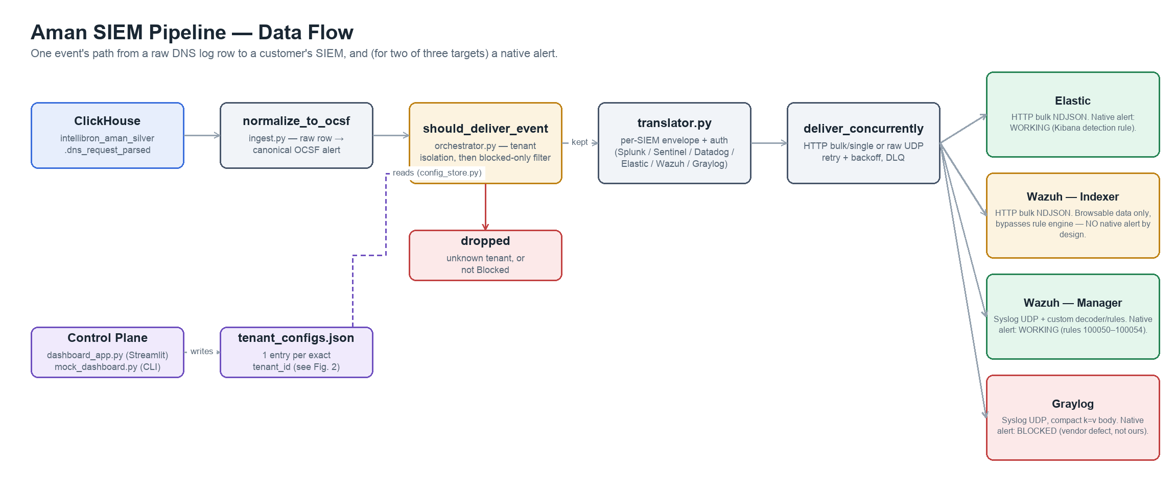
Figure 1 — end-to-end data flow, one event's path from ClickHouse to a customer's SIEM

4. Current Status — What's Proven vs. Not
"Working" needs to be split into two different claims. The translation engine — the hard, product-differentiating part — is demonstrably working end to end against real production data. A production-grade continuous pipeline is not built yet. Both are true at once; conflating them is the main risk of reading this table too quickly.
Capability | Status
OCSF normalization from real ClickHouse DNS data | Working — verified live
Per-SIEM translation (Splunk, Sentinel, Datadog, Elastic, Wazuh, Graylog) | Working, 55 passing unit tests (stdlib unittest, zero install)
Tenant isolation + blocked-only filtering (should_deliver_event) | Working in orchestrator.py's production path — NOT exercised by the live demo (§8)
Native alerting — Elastic | Working — Kibana Security detection rule verified producing real alerts
Native alerting — Wazuh | Working — custom decoder + rules 100050–100054 verified producing real alerts
Native alerting — Graylog | Blocked by a Graylog vendor defect (scheduler fires, job record never persists to MongoDB) — not fixable on our side
Continuous / live data feed | NOT built — ClickHouse source is one bounded, ~18-day-stale snapshot, no pagination, no checkpointing
Async delivery / durable queue / backpressure | NOT built — still a Phase 2 item
Multi-subscriber-per-customer routing | NOT built — critical gap, see §8
Secrets management | NOT built — webhook tokens stored plaintext in tenant_configs.json
Scoped credentials on every target | Partial — Elastic uses a scoped, write-only API key; Wazuh's bulk-indexer path still authenticates as admin (superuser)
Containerization / autoscaling / observability | NOT built — Phase 3, untouched

5. Data Flow Walkthrough
Per event, orchestrator.py runs four stages in order:
1. should_deliver_event — the isolation + filter gate
Tenant isolation first: alert.tenant.uid must have a matching entry in tenant_configs. Then the blocked-only filter: disposition must equal "Blocked". Anything that survives both checks is, by definition, something a SOC would want to see — no further judgment happens downstream. This is the single most consequential design decision in the system.
2. prepare_delivery_attempt — transport + format selection
Reads the tenant's webhook_url scheme to pick HTTP or raw syslog UDP, then hands off to translator.py for the actual per-target envelope and auth.
3. group_into_batches / build_batch — batching by product convention
Array-envelope SIEMs (Splunk, Sentinel, Datadog) batch as a JSON array. Elastic and Wazuh's NDJSON bulk batches too, but via concatenated bulk records rather than a JSON array — and always uses the bulk envelope even for a single alert, since the single-alert JSON shape is rejected by the _bulk endpoint. Syslog never batches: one UDP datagram is one record, by RFC 5426 convention, regardless of what the SIEM's other transport would allow.
4. deliver_concurrently / deliver_batch — delivery, retry, isolation
One worker per (tenant, SIEM) pair, so a slow or failing customer's delivery can never block another customer's. Retries with exponential backoff (0.5s → 1s → 2s); exhausted retries go to a dead-letter queue (dead_letter_queue.jsonl) rather than being silently dropped.

6. Per-SIEM Integration Reference
Target | Transport | Envelope | Auth | Native alerting
Splunk | HTTP | HEC — {"event": {...}} | Splunk <token> | Not exercised this session
Sentinel | HTTP | JSON array — [{...}] | Bearer <token> | Not exercised this session
Datadog | HTTP | JSON array — [{...}] | DD-API-KEY header | Not exercised this session
Elastic | HTTP bulk | NDJSON — {"index":{}}\n{...}\n | ApiKey <token> (scoped, write-only) | WORKING — Kibana detection rule
Wazuh (indexer) | HTTP bulk | NDJSON, same shape as Elastic | Basic <base64> — admin superuser, known gap | NONE by design — bypasses wazuh-manager
Wazuh (manager) | Syslog UDP | Compact JSON, custom decoder | None — network path is the access control | WORKING — decoder + rules 100050–100054
Graylog | Syslog UDP | Compact key=value | None | BLOCKED — Graylog vendor defect, not ours to fix
Wazuh has two configs, on purpose: test-annie-wazuh and test-annie-wazuh-syslog are two separate tenant entries pointed at the same physical Wazuh instance, over two different transports. Don't collapse them into one config — they exist for genuinely different reasons (browsable raw data vs. a real native alert) and a real customer likely wants both.

7. Operational Gotchas Found While Hardening This
These are not hypothetical edge cases — every one of them produced wrong or silently-dropped data during real testing. Worth reading before touching the code that already accounts for them.

7.1 — Dynamic field mapping locks on the first document written
Elasticsearch / OpenSearch infers a field's type from the first document that ever populates it in a given index, and locks it there for the index's lifetime. A later document with an incompatible type for that field is rejected outright, not coerced.
Hit for real this session: the Wazuh indexer's aman-live-test index had time locked to long by an old document (from before this pipeline's ISO-string normalization existed). Every new delivery — correctly formatted, ISO-8601 time strings — then failed with a mapper_parsing_exception, silently, because of the next gotcha below.
Fix applied: delete and recreate the index with an explicit mapping — time and @timestamp both set to type: date — at creation time, instead of leaving it to dynamic inference. This is more durable than code-side normalization alone: Elasticsearch's date type natively parses both ISO-8601 strings and epoch-millis integers, so whichever producer writes first can no longer lock the field to the wrong type.
PUT /aman-live-test
{"mappings":{"properties":{"time":{"type":"date"},"@timestamp":{"type":"date"}}}}
Rule for new indices: Set explicit mappings for every date-like field on any new index this pipeline writes to, at creation time, before the first write. Don't wait to hit this again.

7.2 — A 2xx from the Bulk API does not mean success
The Elasticsearch/OpenSearch Bulk API can return HTTP 200 while individual documents inside the batch were rejected — the per-item failure only appears in the response body's errors / items fields, never the status code. Code that checks only response.status_code will report a full delivery as a full success. orchestrator.py and live_dashboard.py both parse the bulk response body explicitly for this reason — keep doing that in any new bulk-writing code path.

7.3 — An unordered LIMIT against an immutable table is deterministic
A query with no ORDER BY against a table that isn't being written to (a fixed historical partition, in this case) returns the same rows in the same order every time it's re-run — verified directly by issuing the identical query twice. If a bounded sample needs to satisfy a condition (here: destination_blocked = true), filter for it server-side in the query. Don't pull an unfiltered LIMIT and hope client-side filtering finds what you need — it may never, deterministically, no matter how many times the process restarts.
What this actually broke: This was the root cause of the live demo appearing completely dead for an extended period: the query kept re-fetching the identical 10 rows, and none of them happened to be blocked, so the blocked-only filter dropped literally everything, forever, while looking like a live, healthy stream.

7.4 — Wazuh's wazuh-remoted only reads the first <remote> block
A second, separate <ossec_config> wrapper is valid XML and does merge for most Wazuh config sections — but wazuh-remoted specifically only picks up the first <remote> block it finds. Add any new remote/listener block as a sibling inside the existing wrapper, not as a new one — and update it in both the live container config and whatever host-side source file re-copies it on container restart, or the fix won't survive a restart.

7.5 — live_dashboard.py's tenant field is demo scaffolding, not a reference pattern
Do not reuse this pattern: live_dashboard.py force-overwrites every event's tenant.uid to one of its own demo tenant IDs before delivery, regardless of which real subscriber the event actually came from, and never calls should_deliver_event at all. This exists only so the visual demo has enough live volume to be worth watching. Do not copy this pattern into production code — it deliberately bypasses the exact tenant-isolation logic that keeps one customer's data from another. See §8.

8. Open Design Gap — Customer ↔ Subscriber Mapping
should_deliver_event only ever matches an event's tenant.uid against tenant_configs by an exact string. normalize_to_ocsf sets that field directly to the row's real subscriber_id from ClickHouse. tenant_configs itself (config_store.py) is a flat {tenant_id: config} map, one entry per exact ID — there is no concept anywhere in this schema of "a customer account owns many subscribers, route all of them to one SIEM."
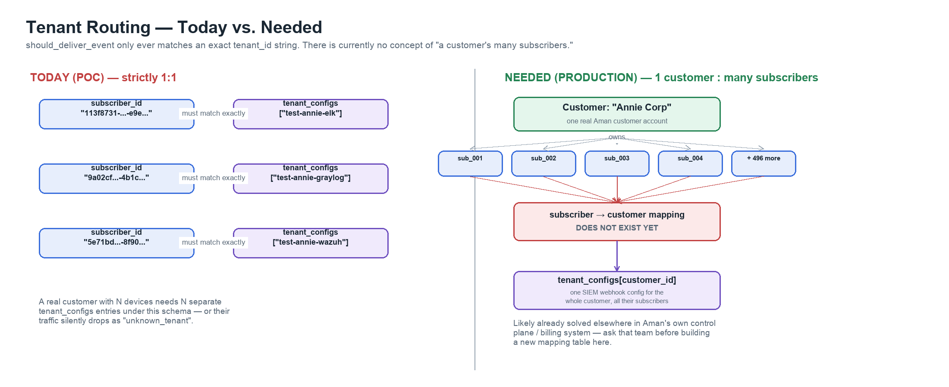
Figure 2 — today's 1:1 assumption vs. the 1-customer-to-many-subscribers shape production needs
Practical consequence: a real customer with more than one protected device cannot be routed correctly under the current schema. Either every one of their subscriber IDs needs its own tenant_configs entry (the same webhook duplicated N times, and N grows with every device the customer adds), or a mapping layer needs to exist that resolves a subscriber_id to the customer account it belongs to before the isolation check runs.
Before building anything here: This is very likely already solved somewhere in Aman's own control plane or billing system — a customer account already has to know which subscribers belong to it for billing and reporting to work at all. Check with that team before designing a new mapping table for this pipeline specifically; duplicating a source of truth that already exists is worse than the gap itself.

9. Backend Setup Guide

9.1 — Prerequisites
- Python 3 and the requests / urllib3 packages. The test suite itself is stdlib-only (unittest), zero extra installs required to run it.
- Real credentials for the ITSEC ClickHouse Data API (production feed source) and for whichever SIEM instances are being integrated — the ones used in this POC are lab/test instances and are not production credentials.

9.2 — Environment
ClickHouse Data API credentials are sourced from a file, never committed:
~/.config/clickhouse-api.env:
CLICKHOUSE_API_URL=...
CLICKHOUSE_API_KEY=...
set -a && source ~/.config/clickhouse-api.env && set +a

9.3 — tenant_configs.json
One entry per tenant_id (see §8 for why this is currently limiting). Required fields per entry:
Field | Notes
tenant_id | Must exactly match the value that will appear in an event's alert.tenant.uid
siem_type | One of: splunk, sentinel, datadog, elastic, wazuh, graylog, generic
webhook_url | Scheme decides transport — https://... for HTTP, syslog://host:port for raw UDP
auth_token | Plaintext today — see §4, flagged as needing a secrets manager before production
verify_ssl | Set false only for a known self-signed cert (e.g. a lab Wazuh indexer)

9.4 — Running it
cd "Aman SIEM Pipeline"
# Tests — expect all passing, stdlib only, zero install
python3 -m unittest discover -s tests
# CLI — real ClickHouse export snapshot, one-shot batch run
python3 orchestrator.py --source real --batch-size 10 --max-workers 8 --retries 2
# Live, continuous, real-time visual demo (proof-of-connectivity, not production)
set -a && source ~/.config/clickhouse-api.env && set +a
python3 live_dashboard.py # http://localhost:8901
# Control Plane — edit tenant_configs.json
python3 mock_dashboard.py # CLI
python3 -m streamlit run dashboard_app.py --server.port 8501 # browser UI

10. Recommended Next Steps, in Priority Order
1. Design & build the customer ↔ subscriber mapping (§8)
Blocks onboarding any real customer with more than one device. Check with Aman's control plane / billing team first — this data almost certainly already exists somewhere.
2. Move secrets out of plaintext JSON
Webhook auth tokens in tenant_configs.json need a real secrets manager before any real customer's credentials live in this system.
3. Scope the Wazuh bulk-indexer credential
Currently authenticates as admin (superuser) — a test-convenience shortcut, not a design choice. Should be a write-only role, matching what's already done for Elastic.
4. Build the real continuous ingestion path
iter_api_stream today is a single bounded, ~18-day-stale snapshot with no pagination or checkpointing. Needs coordination with the ClickHouse/backend data team, who also own the query performance and reliability issues (documented timeouts and 502s) this pipeline currently just retries around.
5. Async delivery + durable queue
Replace the ThreadPoolExecutor ceiling with async HTTP delivery and a real durable queue (Redis, per an earlier explicit decision) between ingest and delivery, with backpressure.
6. Observability
Structured logs, delivered/sec and latency metrics, DLQ depth monitoring — none of this exists yet.
7. Apply the explicit-mapping fix (§7.1) proactively elsewhere
The Elastic aman-live-test index has the identical dynamic-mapping exposure and simply hasn't been hit yet. Fix it before it fails, not after.

11. Appendix — File Map
File | Role
dashboard_app.py / mock_dashboard.py | Control Plane — tenant/SIEM/webhook config, writes tenant_configs.json
data_generator.py | Synthetic demo stream (superseded by real ClickHouse source for live demos)
ingest.py | Source-agnostic normalizer — normalize_to_ocsf, iter_export_csv, iter_api_stream
orchestrator.py | Production pipeline: filter → enrich → batch → deliver, with retry/DLQ
translator.py | Per-SIEM envelope, auth, and transport formatting
config_store.py | Validated tenant config load/save, stat-based cache
live_dashboard.py | Continuous real-time visual demo — proof-of-connectivity, not a reference implementation (§7.5)
queue_manager.py / sender.py | Legacy, unwired, candidates for removal
tests/ | 55 passing unit tests, stdlib unittest, zero install

Related documents in the project repo: PROGRESS.md (phase/roadmap status) and ARCHITECTURE.md (deep detail on the translation engine and per-SIEM integration, including the full incident log this document's §7 summarizes).

