**ACKNOWLEDGEMENT**

If words are considered as a symbol of approval and token of appreciation then let the words play the heralding role expressing my gratitude.

The satisfaction that accompanies that the successful completion of any task would be incomplete without the mention of people whose ceaseless co-operation made it possible, whose constant guidance and encouragement crown all efforts with success. We are grateful to our project guide Mr. Nainesh Gathiyavala for the guidance, inspiration and constructive suggestion that helpful us in the preparation of this project. We also thank our colleagues who have helped in successful completion of the project.

Chintan Bhimani

1. **Introduction**
   1. **Project description:**

Teleconferencing or Chatting, is a method of using technology to bring people and ideas “together” despite of the geographical barriers. The technology has been available for years but the acceptance it was quite recent. My project is an example of a chat server. It is made up of 2 application the client application, which runs on the user’s Pc and server application, which runs on any Pc on the network. To start chatting client should get connected to server where they can practice private (between any 2 users only) kind of chatting.

Broadcasting Chat Server Application is going to be a text communication software, it will be able to communicate between two computers using point communication.

The limitation of Chat Application is does not support audio and video conversations. To overcome this limitation, I am concurrently working on developing better technologies.

* 1. **Project Profile:**

|  |  |
| --- | --- |
| **Project Title:** | Real-Time MERN Chat Application |
| **Definition:** | Real-Time MERN Chat Application are web-based application program. Users are communicate each other using this application. |
| **Developed For:** | SDJ International College, Vesu, Surat |
| **Project Guide:** | Prof. Nainesh Gathiyavala |
| **Front End:** | React.js |
| **Scripting Language:** | Node.js |
| **Back End:** | Express.js |
| **Operating System:** | Microsoft Windows 10/11 |
| **Tools used for ERD & DFD:** | Microsoft Word |
| **Submitted By:** | Bhimani Chintan Ashvinbhai |

1. **Environment Description**

**2.1 Hardware and Software Requirements**:

* **Hardware Requirements:**

|  |  |  |
| --- | --- | --- |
| Processor | : | Intel(R) Pentium i3 CPU @ 2.30GHz |
| Memory | : | 6 GB |
| Hard Disk | : | 256 GB or Higher |

* **Software Requirements:**

|  |  |  |
| --- | --- | --- |
| Operating System | : | Microsoft Windows 10/11 |
| Front End | : | React.js, HTML |
| Backend | : | Node.js, Express.js |
| Input Device | : | Keyboard, Mouse |
| Output Device | : | Screen |
| Browser | : | All Browser Supported |

**2.2 Technologies Used:**

* + - **Server-side Technology:**
      * Node.js
      * Express.js
      * MongoDB
    - **Server-side Technology:**
      * HTML
      * React.js
      * CSS
      * JavaScript
      * Axios
    - **Other Technology:**
      * Visual Studio Code
      * Window 10
      * Chrome
      * MongoDB Compass
      * Hyper Terminal
      * Git

**3. System Analysis and Planning**

**3.1 Existing System and its Drawbacks:**

The customer service is now the most essential part of all service related companies or institutions. They have to give supports to save their business. However, in the high-priced world, it is now becoming more expensive for SME companies.

Current Situation of Live Chatting Software are expensive. Most of web based live chatting software companies charge additional money for different features such as chatting for long time with customers, user rent operators, voice, video etc. Current chatting software is not reliable as the manufacturer’s demands. Sometimes the buyers of these software become victim of hackers. For example, Facebook is created using PHP, and it is prove that it has lower security aspects than.

In some cases like online banking, access to personal data is only possible by secure identity check. This might require telephone contact.

**3.2** **Feasibility Study:**

The data collected during this survey showed that there is a high percentage of population who uses smartphones which support many mobile based on application. Also there is a high percentage of chat application users in the country and many uses these applications as a means of communication in a family even though some of these applications have security issues. Hence, these data indicate that there is a very good market share for a new chat application with good security feature and developed in our own country. For additional support to prove the feasibility of development of chat application of the country. Which indicates a high percentage of the population would use the chat application developed in our own country.

* + - **Technical Feasibility:**

The technical Feasibility work for the project is done with the present equipment, manual procedures, and existing software technology & available technology hardware. The necessary technology, front-end, backend database technology, and other tools namely reporting tool, installation tools, etc., (as mentioned in the project profile) for developing the system, are already available within the organization.

* + - **Economical Feasibility:**

Economic feasibility looks at the financial aspects of the project. Economic feasibility concerns with the returns from the investment in a project. It determines whether it is worthwhile to invest the money in the proposed system. It is not worth while spending a lot of money on a project for no returns. To carry out an economic feasibility for a system, it is necessary to place actual money value against any purchases or activities needed to implement the project.

* + - **Operational Feasibility:**

This phase is system operations performed by proposed system in this phase here testing is the important point is user will be operating the system. System will work under any condition .System will allow entering & retrieving of Data only to authorized user to operate the system. It will work any full efficiency & accuracy as used to work with particular computer. There is sufficient support to the project from the management and from the intended users of the system.

**3.3 Requirement Gathering and Analysis:**

The first concern is to ensure that the software is compatible to the various platforms and devices of your customers. The solution must run smoothly on all devices, catering to all operating systems. As a business owner, you cannot control what devices or on which OS your customer is using. It is better to choose a chat support solution that runs on all and if not the most popular platforms like different web browsers, android and iOS apps.

The next live chat requirement for your business should be automation. If you are investing in CRM integration, then might as well deploy a chat box for efficiency. This is highly recommended for e-commerce and finance-based businesses. Based on customer’s journey with the brand, the AI will make relevant recommendations to the customer.

For instance, I am revisiting my bank’s website with the intent of paying my credit card charges. Instead of looking further, I click on the chat option and after one or two questions the AI bot identifies me as an existing customer. Now, as my information already exists, the Chabot will scout that data and provide me with suggestions/prompts relevant to my account.  
In this case, the AI bot realises that I am closer to my payment date and offers me option to pay my credit card charges along with some benefits that can be extended to my credit card. It was a positive nudge and the entire ordeal is over within five minutes. It is extremely efficient, hassle-free and generates complete customer satisfaction.

At times, customers do not identify their problems correctly and end up in the wrong department. When this happens over chat, the agent on-task should be able to transfer the customer to the right department, without much hassle. The chat transfer feature will smoothen this process, while reserving the context for the next agent. Due to this, the customer does not have to repeat themselves and waste their times.

There will be instances when your agent may have to bring a subject matter expert / consultant in the chat. With Chat conference capability it will be great to do such conferences, smoothly. These conference over live chat could be text based or even video calls too. This is another must have Live chat requirements that you must consider.

**4. Proposed System**

**4.1 Scope:**

People can now chat and exchange messages via messaging apps but also pay their bills online, transfer money, shop online and do many more tasks. Some of the most common messaging Apps that are used in today’s world is Facebook messenger, WhatsApp, We Chat, Google and Yahoo messenger and Line messenger. WeChat in China is what all messaging platforms aspire to be: It accompanies the users throughout their daily life in every possible aspect — making it indispensable in people’s minds. Through Chat App we can do everything from chatting with friends, groups or strangers to conducting business or e-commerce, accessing fin tech applications, playing games, or even connecting to diverse IoT devices.  Beside there is a lot of new and upcoming messengers which can really change our messaging experience .Worldwide researches have shown that Over 2.5 billion people have at least one messenger apps install in their phone. A number of business strategies also support the power of messenger apps. Line and We chat has a wide assortment of stickers and messaging .Apps like Telegram **h**ave also been seen to launch their Bot APIs.

My Scope of creating the chat application in this generation is the Photo upload feature where people can upload their avatar image pictures in profile picture section. User can view their friends and family avatar in a separate section. Apart from photographs, users can also share funny messages and better time spend with his/her family and friends.

**4.2 Project modules:**

* + - **Login Module:**

A logging module is essential for system maintenance. Solving the issues and bugs without proper logging is a nightmare for every developer. The activities should be logged on multiple levels – debugging details, system event, warning, and error. If the log is preserved in a database, it is a good idea to write copies of logs to text files too.

* + - **Register Module:**

The register module provides a conceptual framework for entering data on those patients in a way that: eases data entry & accuracy by matching the entry to the data source, ties easily back to individual patient records to connect registers to patient data, and collects data elements to enable better supervision of treatment programs.

* + - **Chat Module:**

Real time messaging on chat page.

Search users in application for new conversations.

Contact list for recent conversation.

Unread message count each conversation.

Save all chat history with time in database.

**4.3 Module vise objectives/functionalities Constraints:**

* + - **Scope:**

Scope of creating the chat application in this generation is the Photo upload feature where people can upload their avatar image pictures in profile picture section. User can view their friends and family avatar in a separate section. Apart from photographs, users can also share funny messages and better time spend with his/her family and friends.

* + - **Budget/Cost:**

Live Box application are created in low budget. In this application no extra high machine requirements and no high requirements of software. It run and expand easily of any machine, such as pc, laptop, mobile phone etc.

Its light weight and easily accessible for any types of users.

**5. Detail Planning**

**5.1 Data Flow Diagram / UML:**

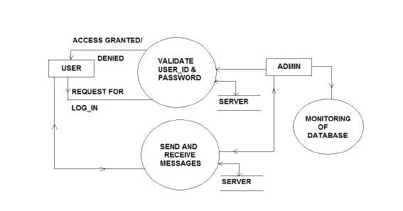

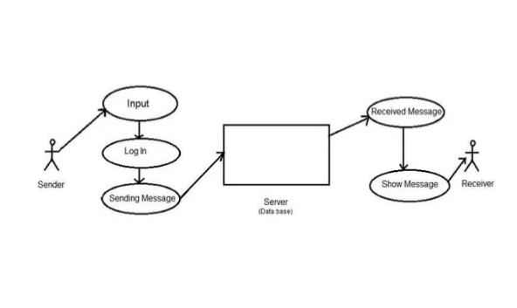

**5.2 Process Specification / Activity Flow Diagram:**

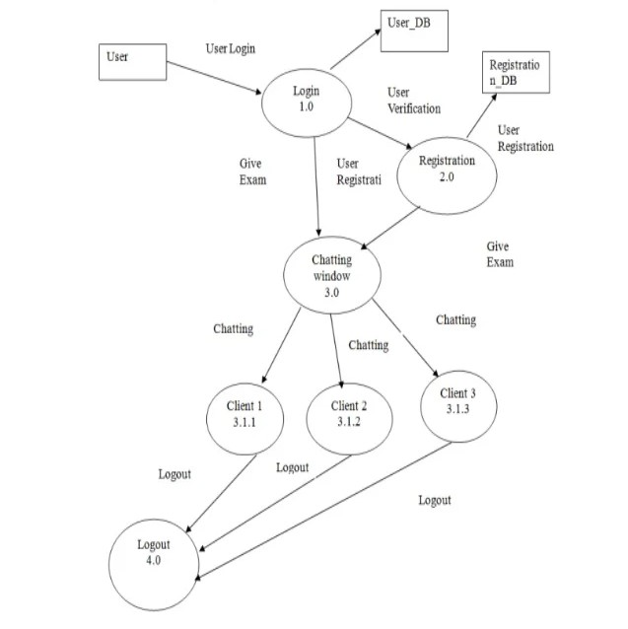

**5.3 Data Dictionary:**

|  |  |  |  |
| --- | --- | --- | --- |
| **Fields:** | **Data type:** | **Description:** | **Source table:** |
| _id | Object | Unique identifier | .Users |
| username | String | Name of user | Users |
| email | String | Email address of user | Users |
| password | String | User password | Users |
| isAvatarImageSet | Boolean | User profile pic set or not | Users |
| avatarImage | String | User profile pic | Users |
| _id | Object | Unique identifier | Messages |
| messages | Object | Object of data | Messages |
| text | String | Sanded text form user | Messages |
| users | Array | Sender and receiver | Messages |
| 0 | String | Sender id | Messages |
| 1 | String | Receiver id | Messages |
| sender | Object | Seder identifier | Messages |

**5.4 Entity-Relationship Diagram / Class Diagram:**

**6. System Design**

**6.1 Database Design:**

|  |
| --- |
| Users |
| _id |
| username |
| email |
| password |
| isavatarimageset |
| avatarimage |

|  |
| --- |
| Messages |
| _id |
| message |
| users |
| sender |
| createdAt |
| updatedat |

**6.2 Directory Structure:**

* + - **Frontend side:**

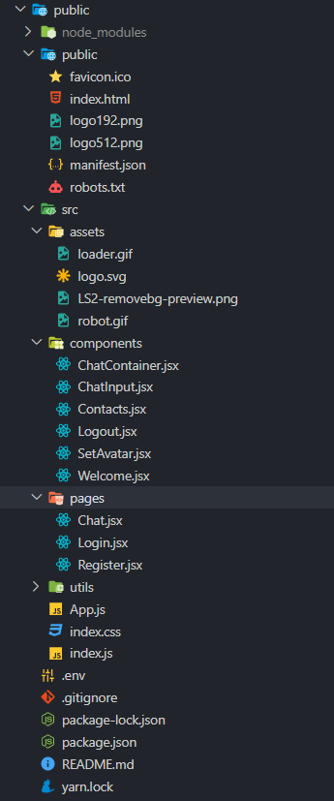

* + - **Server-side:**

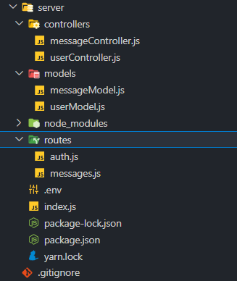

**6.3 Input Design:**

* + - **Login page:**

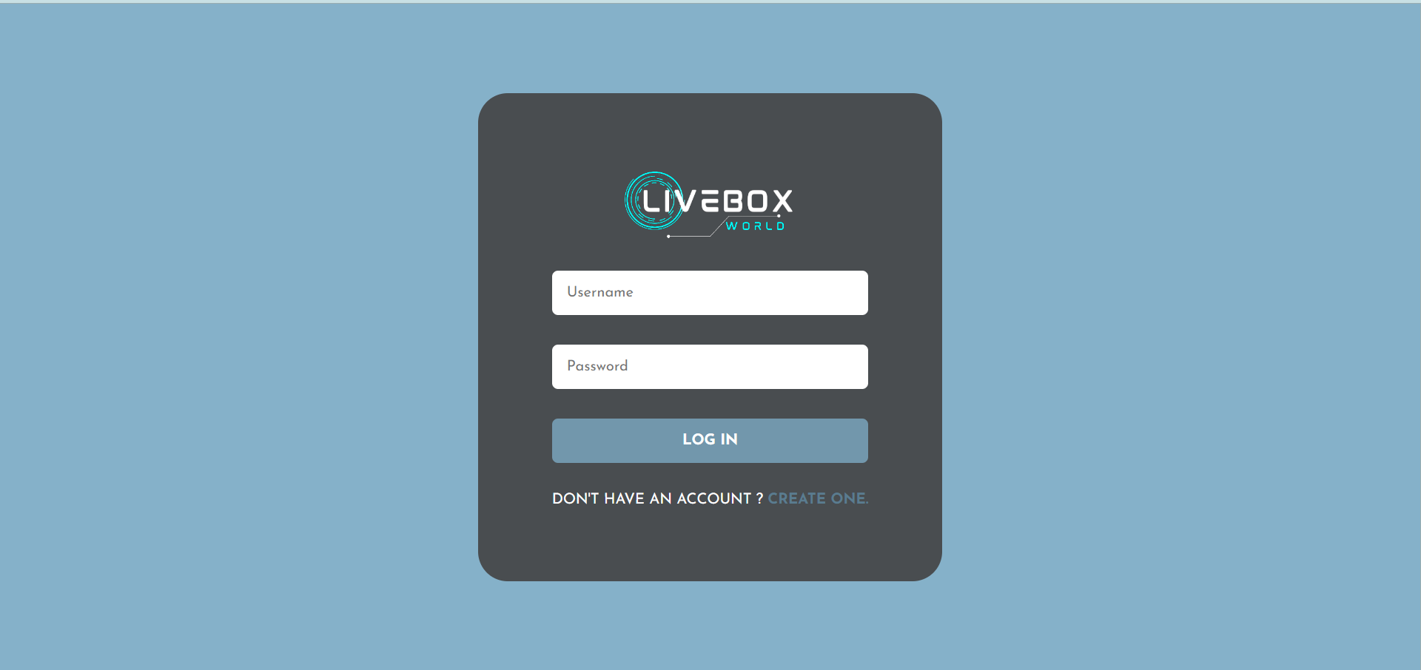

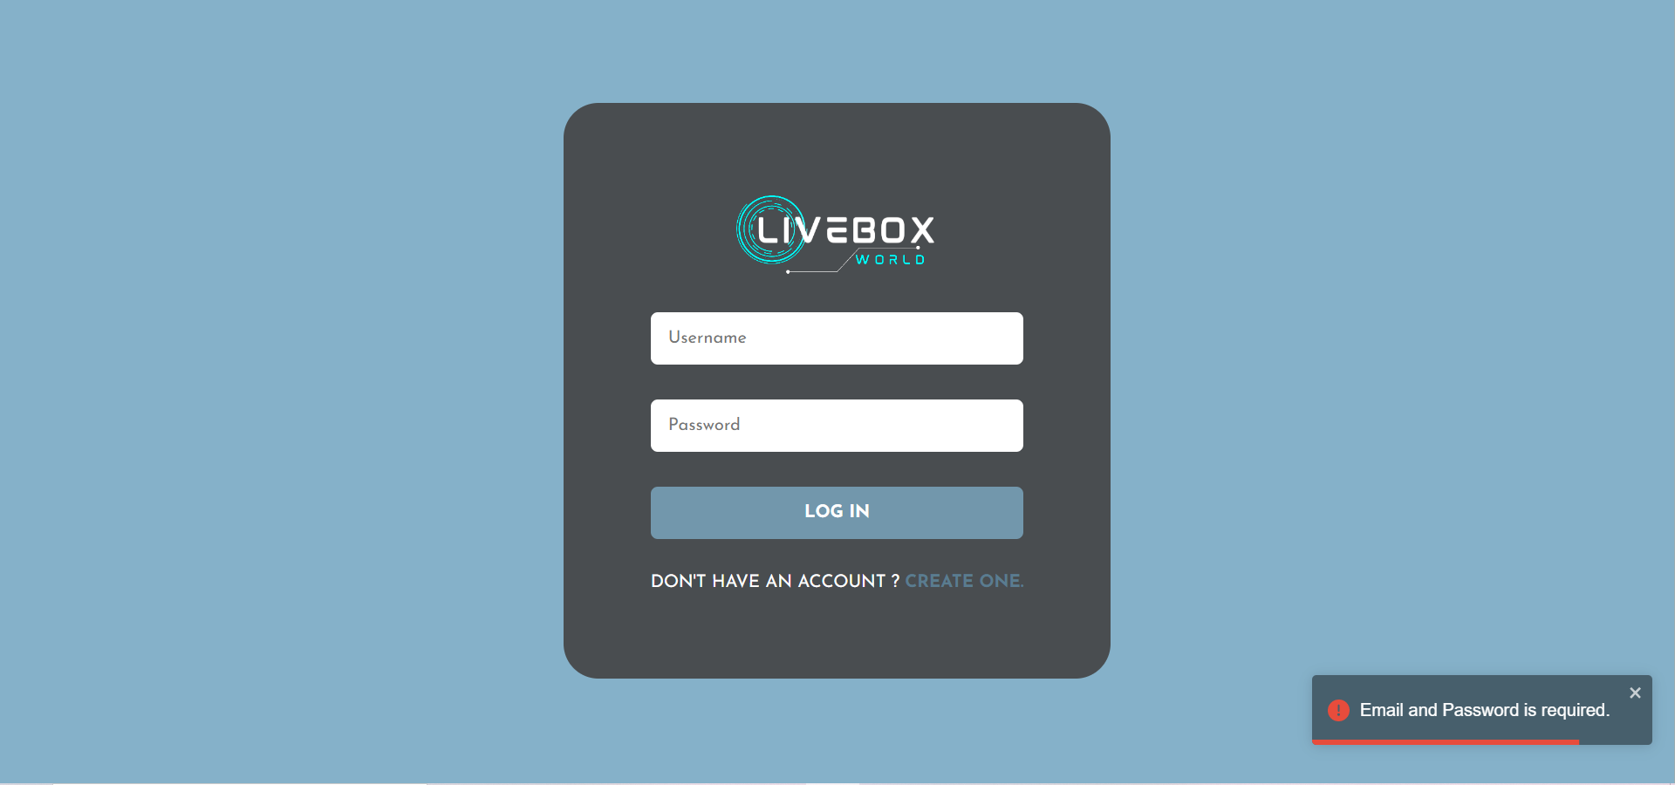

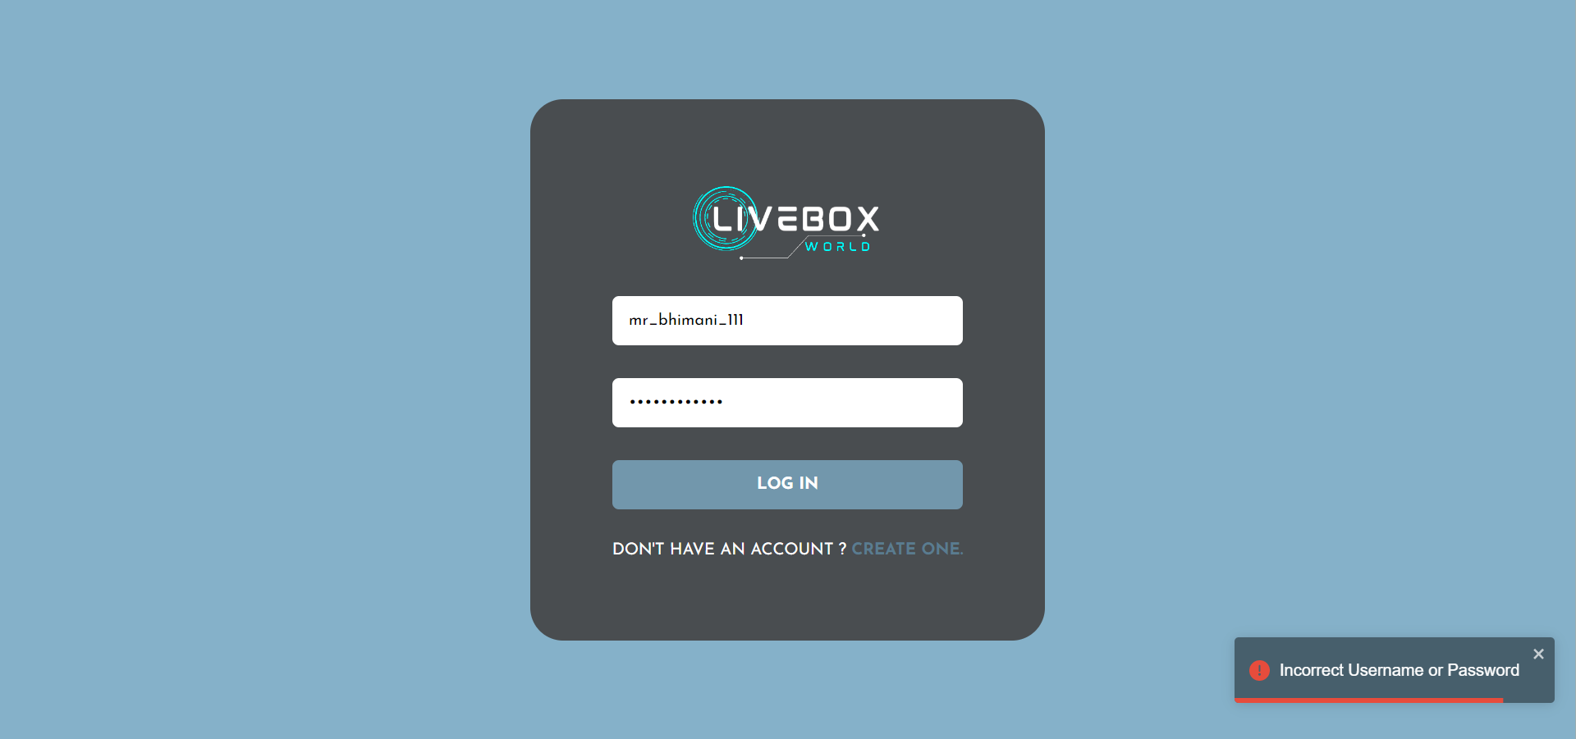

* + - **Signup page:**

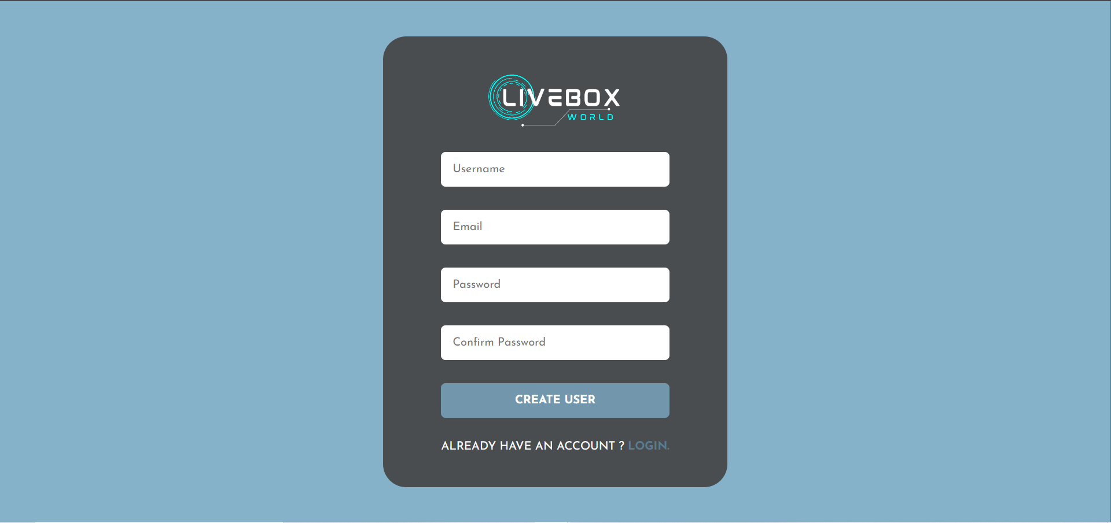

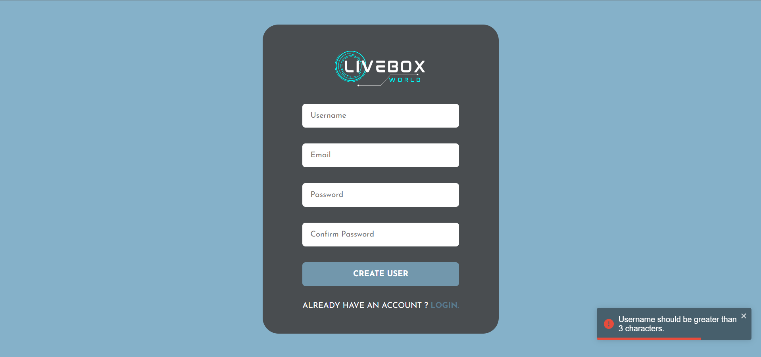

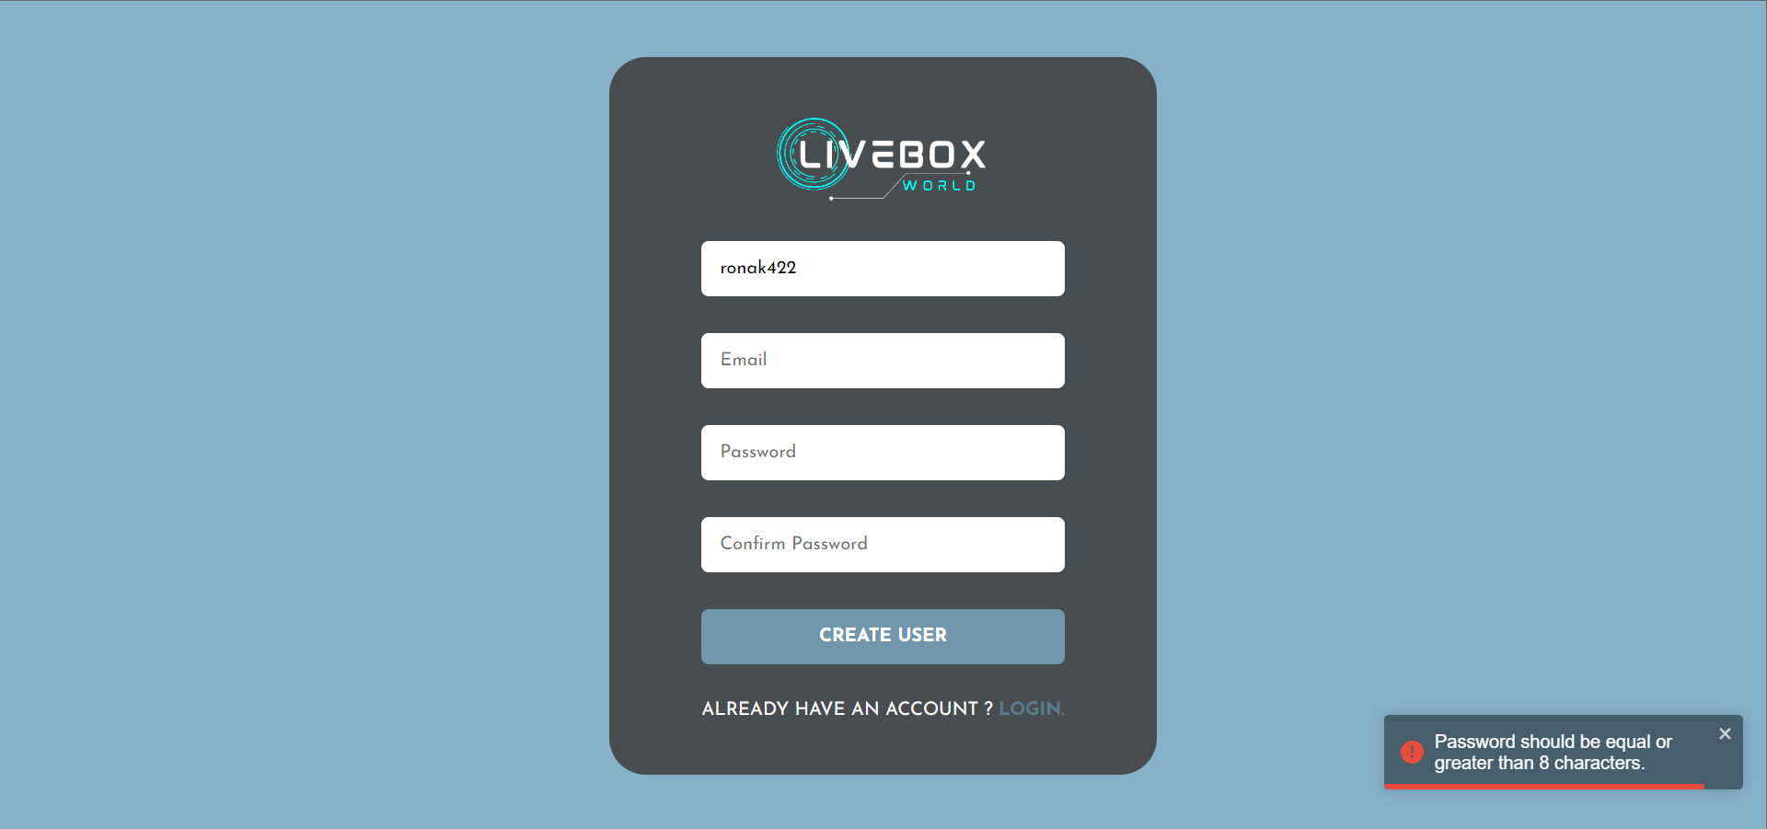

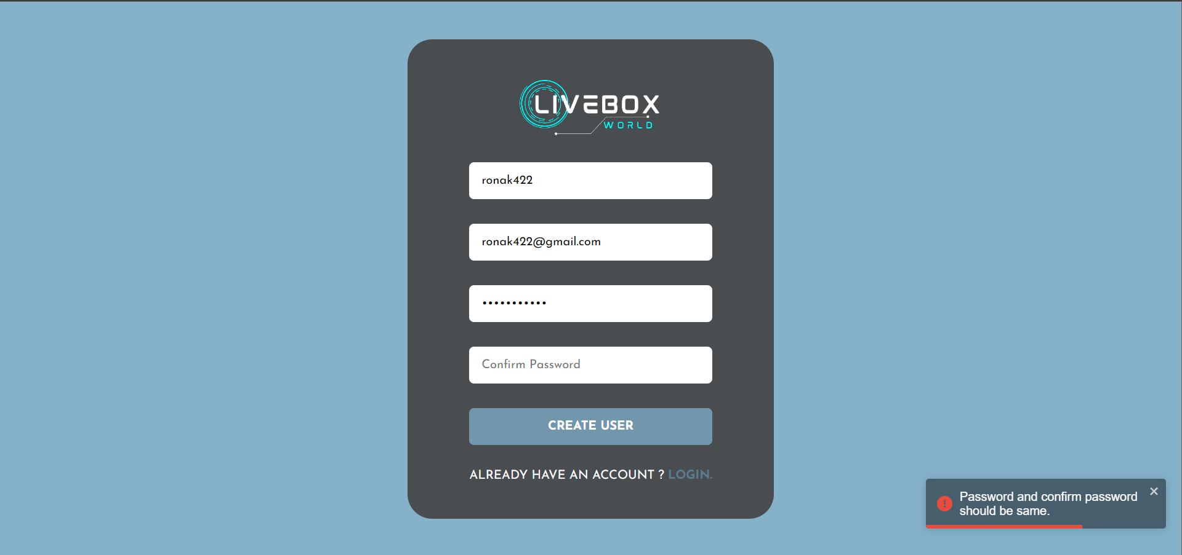

* + - **setAvatar Page:**

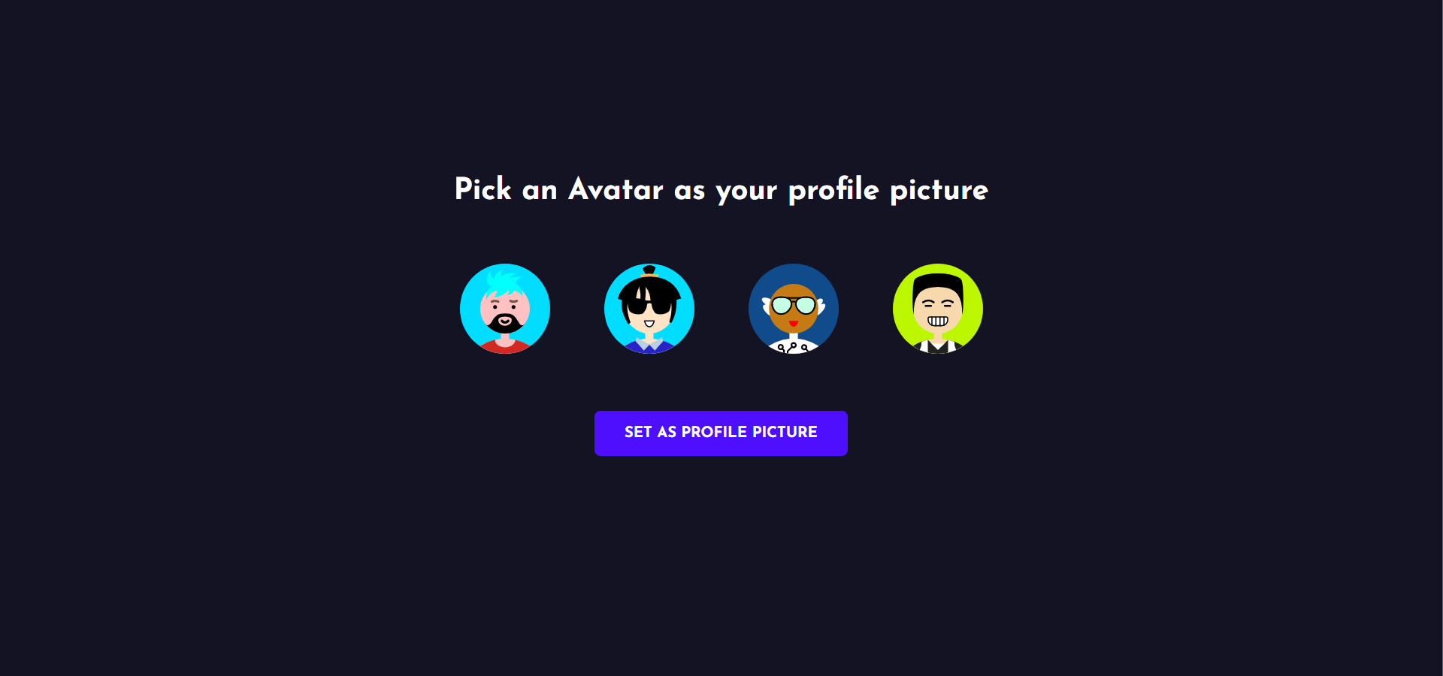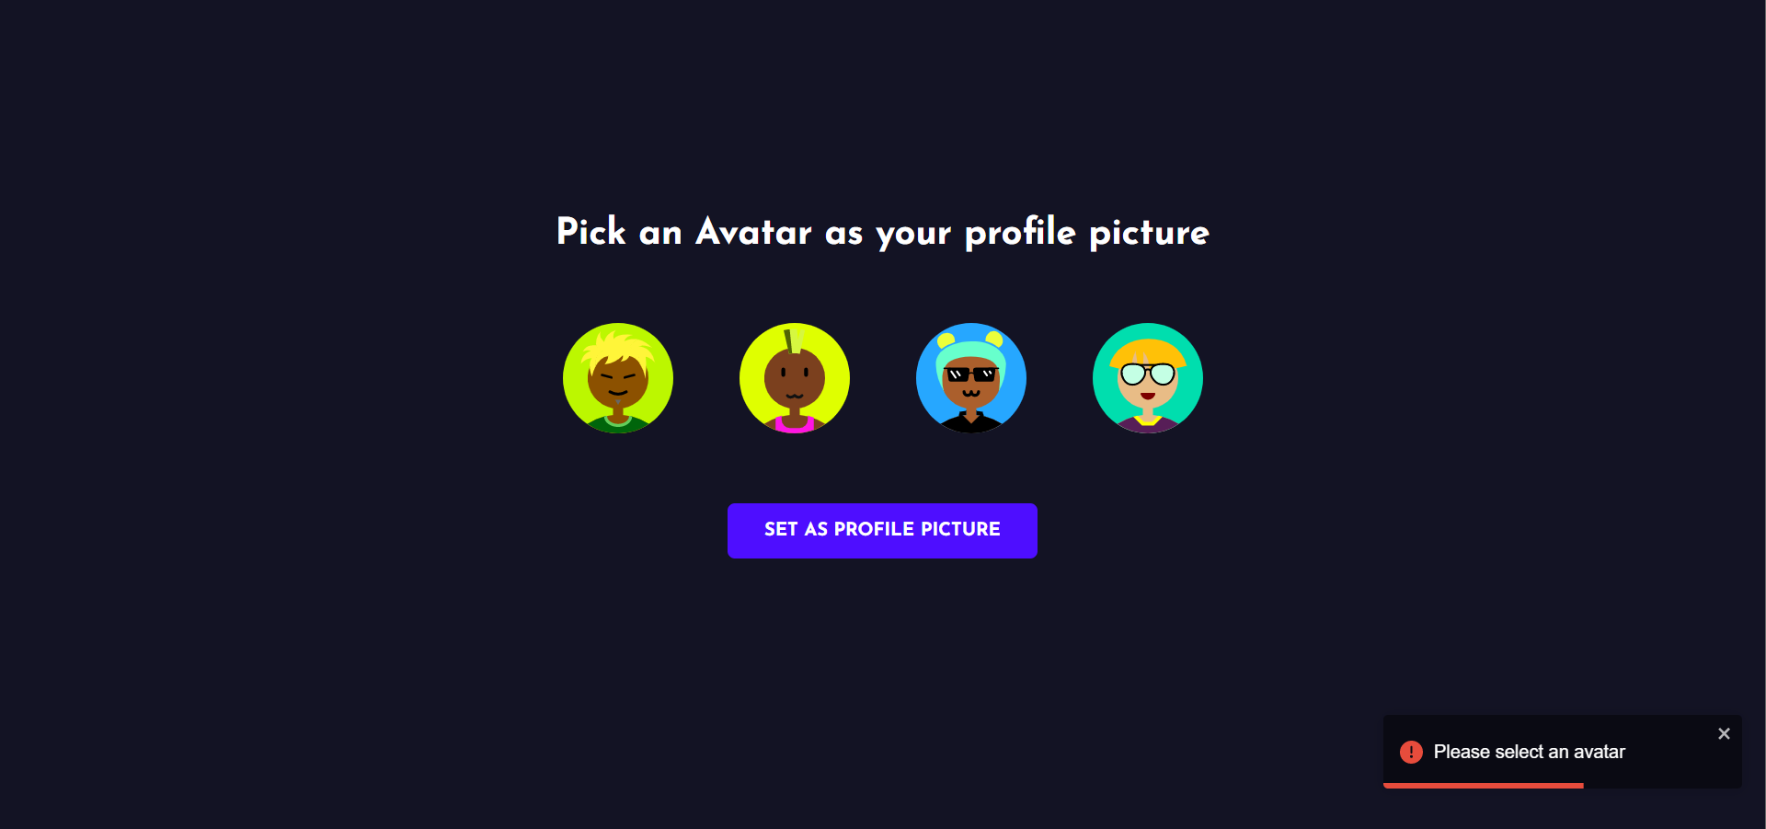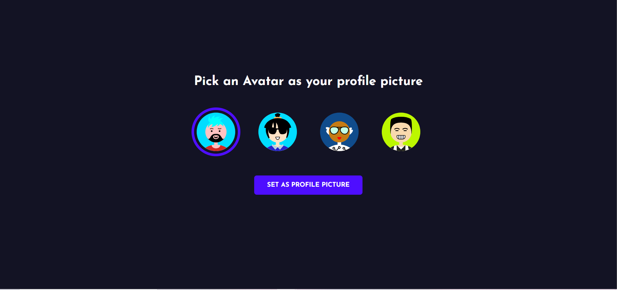

**6.3 Output Design:**

* + - **chat Page:**

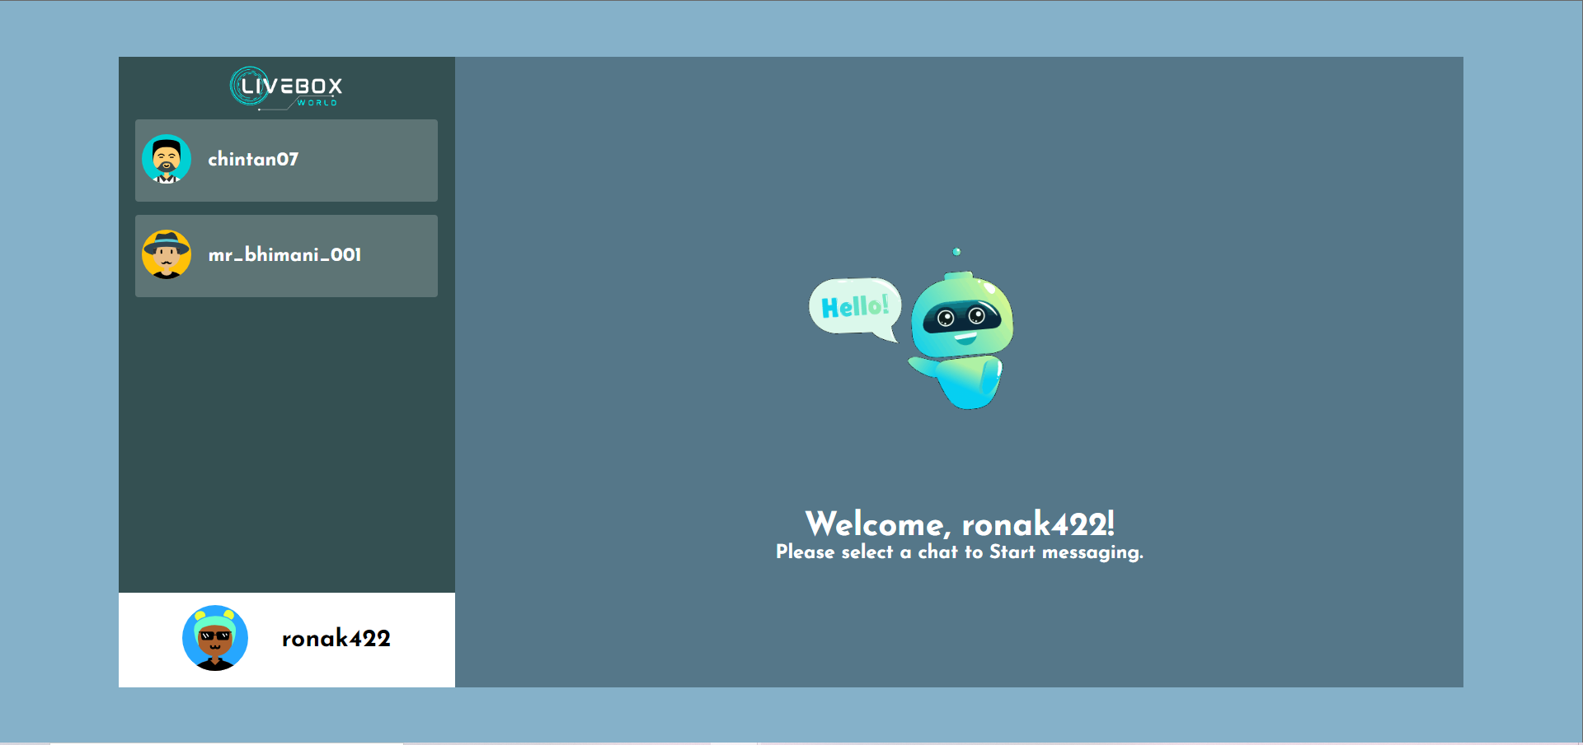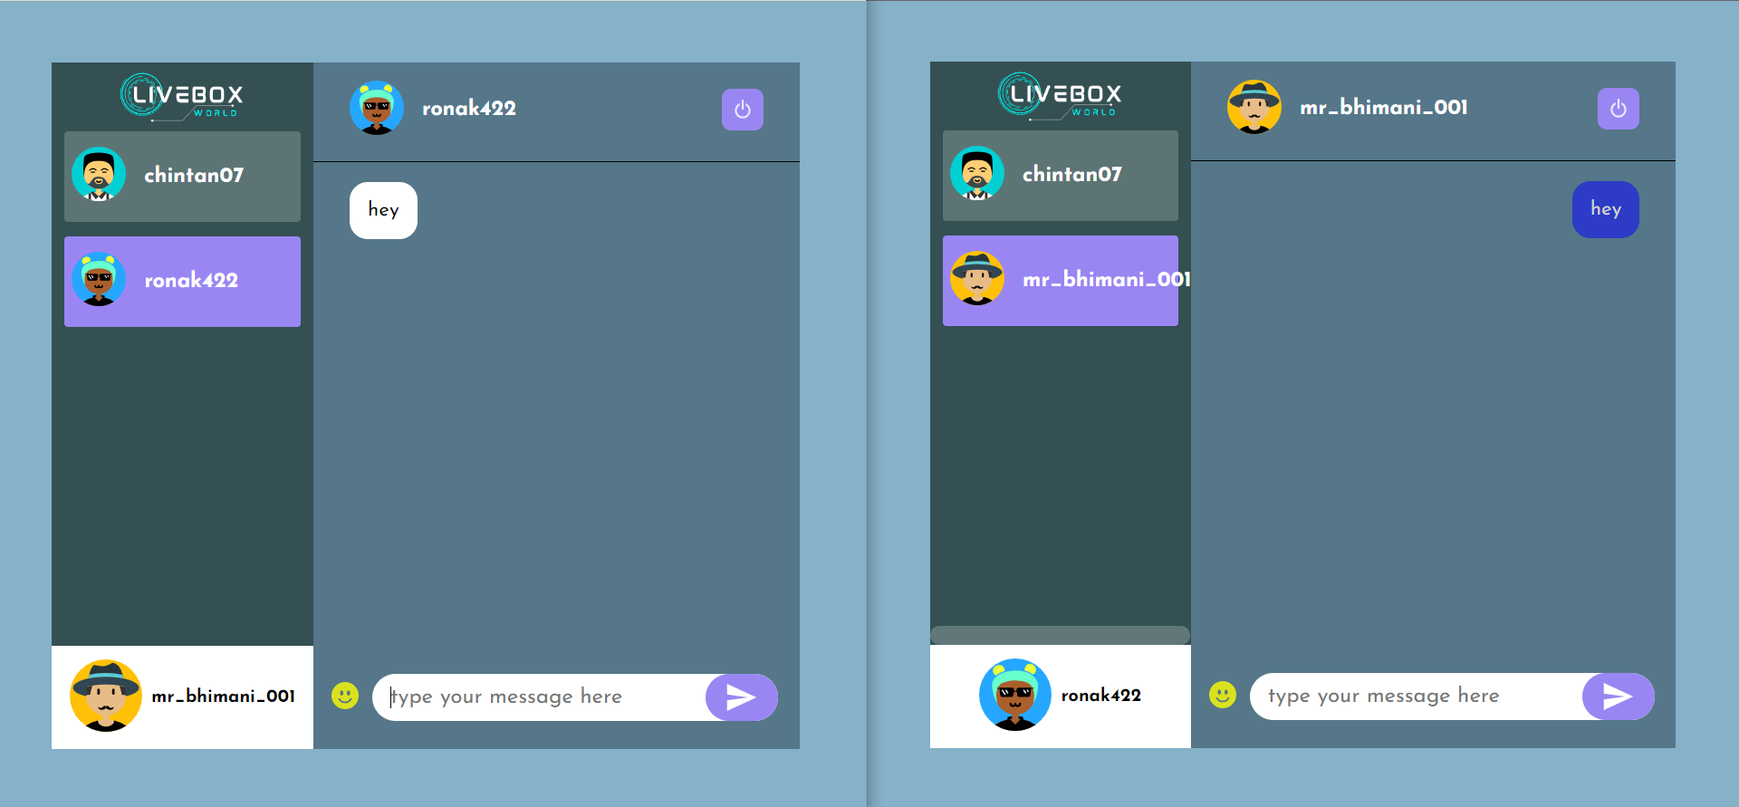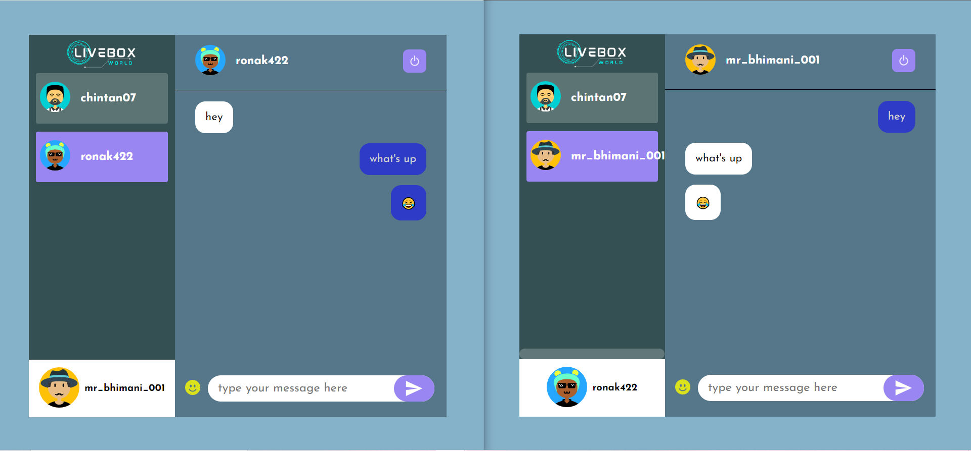

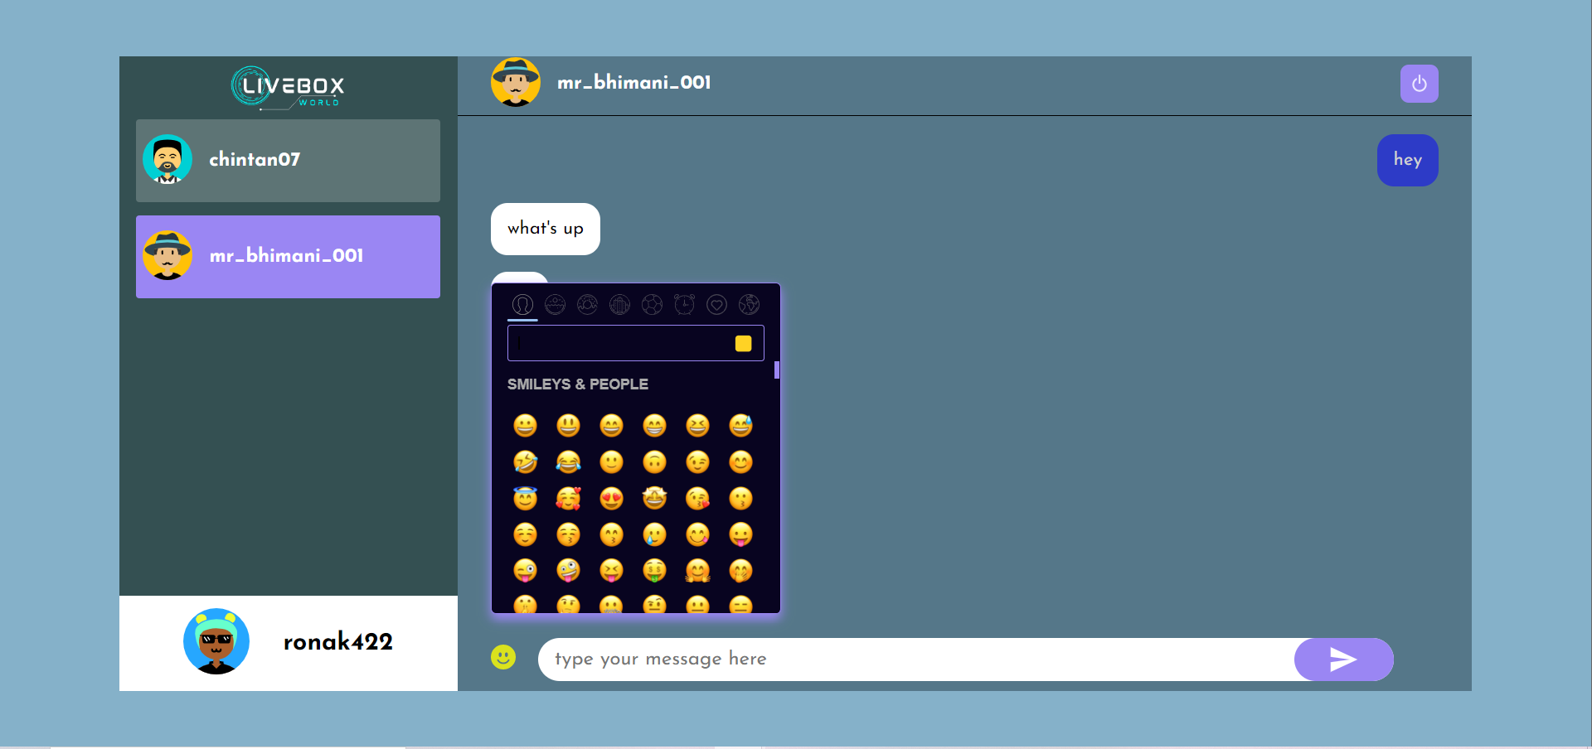

**7. Software Testing:**

**Software Testing is Important** because if there are any bugs or errors in the software, it can be identified early and can be solved before delivery of the software product. Properly tested software product ensures reliability, security and high performance which further results in time saving, cost effectiveness and customer satisfaction.

* + - **Integration Testing:**

In this type of process of testing the interface between two software units or modules. It focuses on determining the correctness of the interface. The purpose of integration testing is to expose faults in the interaction between integrated units. Once all the modules have been unit tested, integration testing is performed.

* + - **System Testing:**

System Testing includes testing of a fully integrated software system. Generally, a computer system is made with the integration of software (any software is only a single element of a Computer system). The software is developed in units and then interfaced with other software and hardware to create a complete computer system. In other words, a computer system consists of a group of software to perform the various tasks, but only software cannot perform the task; for that software must be interfaced with compatible hardware. System testing is a

Series of different type of tests with the purpose to exercise and examine the full working of an integrated software computer system against requirements.

**8. Limitations and Future Scope of Enhancements**

* + - **Limitations:**

There are mainly two limitations of project and that are:

* + - * The firewall is to be disabled for intra network.
      * It is dependent on the specific algorithm used.

* + - **Future Scope of Enhancements:**

There is always a room for improvements in any software package, however good and efficient it may be done. But the most important thing should be accept further modification. Right now we are just dealing with text communication. In future this software may be extended to include features such as:

* + - * + **File Transfer**: This will enable the user to send files of different formats to others via the chat application.
        + **Voice Chat**: This will enhance the application to higher level where communication will be possible via voice calling as in telephone.
        + **Video Chat:** This will further enhance the feature of calling into video communication.

**9. References**

[React – A JavaScript library for building user interfaces (reactjs.org)](https://reactjs.org/)

[Node.js (nodejs.org)](https://nodejs.org/en/)

[Express - Node.js web application framework (expressjs.com)](http://expressjs.com/)

[Bootstrap · The most popular HTML, CSS, and JS library in the world. (getbootstrap.com)](https://getbootstrap.com/)

[npm (npmjs.com)](https://www.npmjs.com/)

[Chakra UI - A simple, modular and accessible component library that gives you the building blocks you need to build your React applications. - Chakra UI (chakra-ui.com)](https://chakra-ui.com/)