class A{

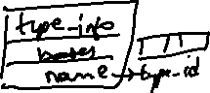

int dataA;

public:

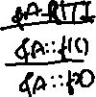

virtual int f1();



virtual int f2();

};

class B{



int dataB;

public:



virtual int f3();

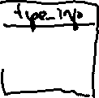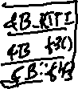

virtual int f4();



};



class C: public A, public B

{

int dataC;



public:

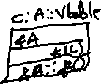

virtual int f2();



virtual int f4();

};

