Task Management System

0.2v

High Level Design & Low Level Design

| **Project Revision History** | | | | | | | | |
| --- | --- | --- | --- | --- | --- | --- | --- | --- |
|  |  |  | |  |  |  |  |  |
| **Date** | **Version** | **Author** | **Brief Description of Changes** | | | | **Approver Signature** | |
| 18/11/2022 | 0.1v | Group 1 | 0.1v | | | |  | |
| 21/11/2022 | 0.2v | Group 1 | 0.2v | | | |  | |

**Document Control :**

**1. Introduction**

1.1. Intended Audience 5

1.2. Acronyms/Abbreviations 5

1.3. Project Purpose 5

1.4. Key Project Objectives 5

1.5. Project Scope and Limitation 6

*1.5.1. In Scope 6*

*1.5.2. Out of scope 6*

1.6. Functional Overview 6

1.7. Assumptions, Dependencies & Constraints 7

1.8. Risks 7

**2. Design Overview 7**

2.1. Design Objectives 8

*2.1.1. Recommended Architecture 8*

2.2. Architectural Strategies 9

*2.2.1. Design Alternative 9*

*2.2.2. Reuse of Existing Common Services/Utilities 9*

*2.2.3. Creation of New Common Services/Utilities 9*

*2.2.4. User Interface Paradigms 9*

*2.2.5. System Interface Paradigms 9*

*2.2.6. Error Detection / Exceptional Handling 9*

*2.2.7. Memory Management 10*

*2.2.8. Performance 10*

*2.2.9. Security 10*

*2.2.10. Concurrency and Synchronization 10*

*2.2.11. Housekeeping and Maintenance 10*

**3. System Architecture 11**

3.1. System Architecture Diagram. (Not Necessary) 11

3.2. System Use-Cases 11

3.3. Subsystem Architecture 12

3.4. System Interfaces 12

*3.4.1. Internal Interfaces 12*

*3.4.2. External Interfaces 12*

**4. Detailed System Design.**

4.1. Key Entities 13

4.2. Detailed-Level Database Design 13

*4.2.1. Data Mapping Information 13*

*4.2.2. Data Conversion 13*

4.3. Archival and retention requirements 14

4.4. Disaster and Failure Recovery 14

4.5. Business Process workflow 15

4.6. Business Process Modeling and Management (as applicable) 15

4.7. Business Logic 15

4.8. Variables 15

4.9. Activity / Class Diagrams (as applicable) 16

4.10. Data Migration 16

*4.10.1. Architectural Representation 17*

*4.10.2. Architectural Goals and Constraints 18*

*4.10.3. Logical View 19*

*4.10.4. Architecturally Significant Design Packages 19*

*4.10.5. Data model 20*

*4.10.6. Deployment View 20*

**5. Environment Description 20**

5.1. Time Zone Support 20

5.2. Language Support 20

5.3. User Desktop Requirements 20

5.4. Server-Side Requirements 21

*5.4.1. Deployment Considerations 21*

*5.4.2. Application Server Disk Space 21*

*5.4.3. Database Server Disk Space 21*

*5.4.4. Integration Requirements 21*

*5.4.5. Jobs 21*

*5.4.6. Network 21*

*5.4.7. Others 22*

5.5. Configuration 22

*5.5.1. Operating System 22*

*5.5.2. Database 22*

*5.5.3. Network 22*

*5.5.4. Desktop 22*

6. References 22

7. Appendix 22

# 

1. **Introduction**

Task Management Software is planned in such a way that it can be used by an individual, team or organization to help complete tasks more efficiently by organizing, prioritizing and for maintaining the records of tasks. It is the primary foundation of any task management. It helps in creating and managing tasks throughout the working hours. The departments can rely on this software to collaborate and achieve group goals together

## 1.1Intended Audience

This document could be shared or view across the following members the CG Employees, BU SME’s, Internal SME’s

| CG Employees |  |
| --- | --- |
| BU SME’S |  |
| Internal SME’S |  |
|  |  |

## 1.2Acronyms/Abbreviations

| CSV | Comma Separated Values |
| --- | --- |
| SRS | Software Requirement Specifications |
| TMS | Task Management Software |
|  |  |

## 1.3. Project Purpose

The main purpose of this Task Management System is to manage the tasks among their employees. This task management includes accessing, reading, evaluating, updating, deletion and also provides report on particular tasks.

This Task Management can be used by individual, team or by an

organization to complete the projects efficiently by organizing and prioritizing

related tasks in time*.*

## 1.4 Key Project Objectives

* Manage everything from a single place.
* Make Task Prioritization Easier.
* Access Data from Anywhere Anytime.
* Keep an eye on all tasks and provide reports.
* Manage multiple tasks easily.
* Highly Configured workflow.

## 1.5. Project Scope and Limitation

Now-a-days this task management system is used by all the organizations to keep an eye on their employees and their task which are assigned to them. It is a centralized place to Manage the tasks and document sharing among the group.

### 1.5.1. In Scope

Task management software is an application that helps organize Streamline, and

Prioritize tasks required to achieve a goal or complete project. The ability to prioritize tasks for your employees is one of the most noteworthy benefits of a task management software. Your team members might find it challenging to switch between tasks. Prioritization enables team members to manage their time better and gives them a clearer idea of the order in which task assignments should be completed*.*

### 1.5.2. Out of scope

NA . It is not a real time project.

## 1.6. Functional Overview

The Task Management System is a web application that manage the tasks of each employee of an organization. In this we can perform all the operations like creating, reading, updating and deletion. Every project has some number of tasks and employees. All the Tasks under a project handled by the employees. Each employee is assigned by a task and deadline, the employee can attach their files and also can download the attached files.

This Task Management system consists of Project Planning, Document sharing, Strategy information, reminders and office & work management. This provides security to confidential information

## 1.7. Assumptions, Dependencies & Constraints

The Task Management Software is basically constructed using C language The Task Management Software is based on the concept of making tasks easier. The main actors in this system are users. The system will allow a single user ata time. The user can write the tasks. The system allows the user to view their upcoming tasks, user details, etc. The system also has an assigned section that allows the user to view the assigned tasks i.e., he can add/remove/update the tasks. For example, a project manager can create a task and assign the deadline of the task which will help the user to execute the tasks in an appropriate manner and also within the stipulated time. In this way it becomes easier for the user to keep a track of the pending tasks and its deadline.

The Task Management software should be user-friendly. The user has to sign up/login and should enter his details. The project manager has to input the task and deadline of the task. The task assigned can be viewed by the user. Assumptions of this software is to to reduce manual work and to provide a user-friendly interface. The system is built using the C language.

## 1.8. Risks

The TMS is designed as an independent system. As it is not connected to any other components or interfaces, application compatibility is not a concern.

# 2. Design Overview

The Task Management Software is based on the concept of scheduling which makes the tasks easier. The system helps to reduce the problems that occur when using a manual system and helps users to avoid the deadlines. Keeping track of the tasks and deadlines is difficult in already existing systems hence, the proposed system will overcome all these drawbacks of the existing system. The proposed system has many advantages in that it stores all the task information of the user, user profiles, deadlines, etc. Users can enter their details, update their profile and even view their assigned task along with their deadlines. Other than The system is user- friendly.

Project tasks and task lists make it easy to keep users' work items

Organized and manageable in one centralized, accessible location.

## 2.1. Design Objectives

The Task Management Software is basically constructed using C

language .

The Task Management Software is based on the concept of making tasks easier. The main actors in this system are users. The system will allow a single user at a time. The user can write the tasks. The system allows the user to view their upcoming tasks, user details, etc. The system also has an assigned section that allows the user to view the assigned tasks i.e.,he can add/remove/update the tasks. For example, a project manager can create a task and assign the deadline of the task which will help the user to execute the tasks in an appropriate manner and also within the stipulated time. In this way it becomes easier for the user to keep a track of the pending tasks and its deadline.

In this,the task record contains task_id,task_name,task_description

,task_deadline.

The user record contains user_id,user_name,User_designation.

### 

### 2.1.1. Recommended Architecture

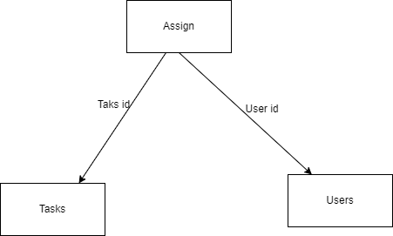

## 2.2. Architectural Strategies

### 2.2.1. Design Alternative

NA.There is no design alternative for this application.

### 2.2.2. Reuse of Existing Common Services/Utilities

In our Project Task Management Software, we are using CRUD (Create, Read, Update, Delete) operations which can be useful not only in Task Management Software but also in projects which need CRUD operations*.*

### 2.2.3. Creation of New Common Services/Utilities

The project does not create or use any new common services or utilities.

### 2.2.4. User Interface Paradigms

* Desktop or a Linux machine with internet connection.
* Command Line Interface (CLI).

### 2.2.5. System Interface Paradigms

* Operating system – Unix.
* Linux Kernel version - 4.4.0-19041-Microsoft.
* Bash shell: x86_64 GNU/Linux

### 2.2.6. Error Detection / Exceptional Handling

Should errors be encountered, an explanation will be displayed as to what went wrong. An error will be defined as anything that falls outside the normal and intended usage

### 2.2.7. Memory Management

The Tasks_csv and User_csv files should be loaded into the memory and the Tasks.csv and User.csv files look like this Once the file is loaded into the memory by using file handling , we can perform some CRUD operations like Create, Read ,Update the operations in that file and then the user commits the data once the operations are done with that file.

### 2.2.8. Performance

Performance is going to be very important for this project. For everything to run smoothly for this project, The system will work on the user’s terminal and the performance depends upon the hardware component of the user’s system*.*

### 2.2.9. Security

The Task Management Software works specifically for tracking task deadlines of the user. Security is not the major focus of this project. The Task Management software contains a set of basic functions for creating, updating, and deleting users and tasks.

### 2.2.10. Concurrency and Synchronization

NA

### 2.2.11. Housekeeping and Maintenance

Very little maintenance should be required for this setup. An initial configuration will be the only system required interaction after the system is put together. The only other user maintenance would be any changes to settings after setup, and any specified special cases where user settings or history need to be changed. Physical maintenance on the system’s parts may be required and would result in temporary loss of data or Internet. Upgrades of hardware and software should have little effect on this project but may result in downtime.

# 3.System Architecture

The design process of our Task Management Software is to arrange the task with the corresponding designated users so that the tasks could be completed within the required time.In order to make these designs easier to understand, the design has been illustrated in attached diagrams.

## 3.1. System Architecture Diagram

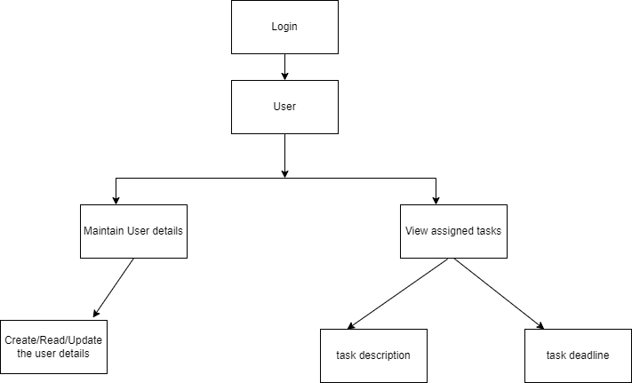

FIG-1

## 3.2. System Use-Cases

* On registration and Login, the project Admin can assign the daily tasks to the user and he can set certain deadlines for specific tasks.
* The system allows the user to create a profile and set his credential.
* The system authenticates user credentials to view the profile.
* Provides for the users to update the user information.
* User can add, update and delete .

## 3.3. Subsystem Architecture

NA

## 3.4. System Interfaces

The application runs in the Linux and Visual Studio Code also.

### 3.4.1. Internal Interfaces

The internal interfaces comprise interfaces through which the system interacts with the user through which it provides them services.

### 3.4.2. External Interfaces

The external interface comprises interfaces through which the users interact with the system.

* Desktop or Linux Machine
* Internet
* Software where the application is activated

# 4. Detailed System Design

Task management is the process of monitoring your project's tasks through their various stages from start to finish. From task planning to managing, task management software helps you log and track every piece of information related to your project. The ability to keep track of your tasks, deadlines, meetings, and team responsibilities makes task software is a crucial tool for your business needs.This effective task management requires which managing all aspects of a task, including its status, priority, time, human and financial resources assignments, recurrence, dependency, notifications and so on.

## 4.1. Key Entities

* Admin
* The project Manager can add tasks for the user and can

also add user info.

* The project manager can delete the information

of the tasks and the users.

* The project Manager can search for task information and user information.
* Users
* Users can login to the system
* User can add, update and delete
* Provides for the users to update the user information.
* Tasks

Here we used CRUD (Create/Read/Update/Delete) operations which is an acronym that refers to the four functions used to implement the applications.

## 4.2.Detailed-Level Database Design

NA

### 4.2.1. Data Mapping Information

After updating or modifying user or task details should be mapped into task.csv file and user.csv file.

### 4.2.2. Data Conversion

The Task Management Software (TMS) will use quite a number of files for saving data. It will store user data, user task data, and data about assignments.

There are a total of three files: .csv files: user.csv, task.csv, assignment.csv.

● user.csv: The user details such as user_login, user_data, user_designation will be included in this file.

● task.csv: The task details such as task_id, task_name, task_description, task _ deadline will be included in this file.

● assign.csv: The user and the task details such as user_id, task_id, task_deadline will be displayed by using assign.csv

## 4.3.Archival and retention requirements

TMS Should include debug log messages with at least 4 levels that is

FATA, INFO, WARNING, DEBUG.

## 4.4 Disaster and Failure Recovery

This system should have the ability that, once it is together, the entire system should be able to be physically moved to any location. Code and program portability should be possible between kernel-recompiled Linux distributions.If any record is not working properly or while storing the data in CSV format,if any format error occurs then the system will be able to load and process the other records. For everything to work properly, all components should be compiled from source.

## 4.5 Business Process workflow

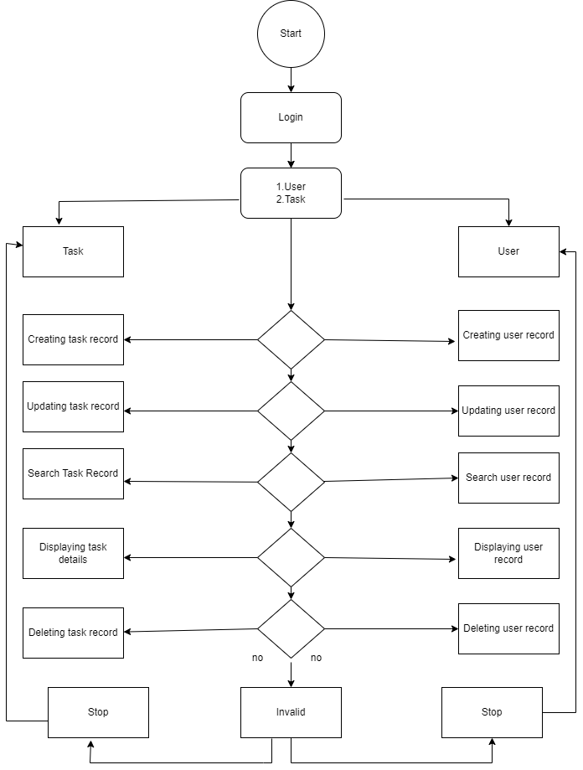

## 4.6. Business Process Modeling and Management (as applicable)

NA

## 4.7. Business Logic

NA

## 4.8 Variables

int ch, ret;

bool val=false;

char taskname[];

char taskdesc[];

char username[];

char userdesc[];

char filename[MAX_FILENAME_LENGTH];

task_t task;

user_u user;

int task_id;

int user_id;

## 4.9 Activity / Class Diagrams

# 

## 4.10 Data Migration

Data is migrated between the updated task and the user.

### 4.10.1. Architectural Representation

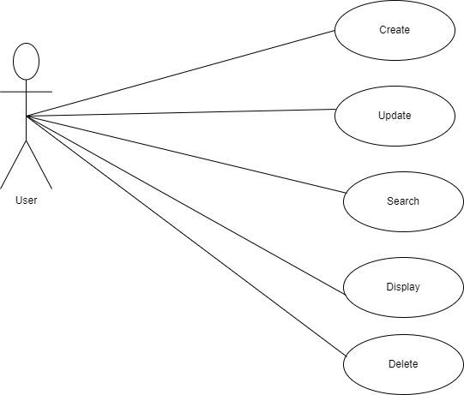

* User records can contain user_id,user_name,user_designation.
* Users can perform CRUD operations on tasks and assign tasks to particular users by using task_id.

### 4.10.2. Architectural Goals and Constraints

In this we use some software requirements such as functional requirements

**create_user () :** The create user is used to view the assigned tasks.

**create_task () :** The create task is used to create tasks by team manager.

**search_user():** Search will help in searching a particular user in the userlist.

**search_task():** This function searches the particular task in the list of tasks.

**update_user ():** The user can update their profile details.

**update_task ():** The manager can update the task for the

user if required

**delete_user ():** It can delete a specific user.

**delete_task ():** It can delete a specific task.

**display_task_data():** User should enter valid task_id.

**display_user_data():** User should enter valid task_id.

### 4.10.3 Logical View

NA

### 4.10.4. Architecturally Significant Design Packages

Here we use data flow diagram

  It evaluates all top-level designs.

It develops and documents top-level design for the external and internal interface

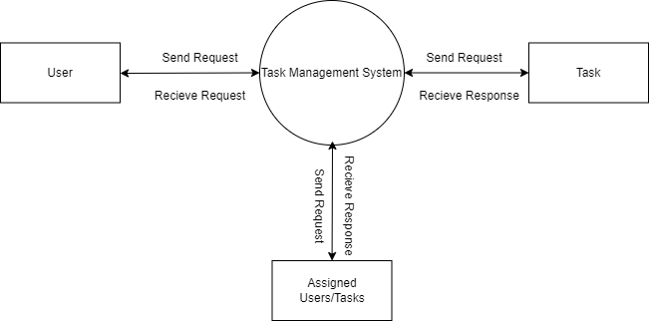

### 4.10.5. Data model

Legacy system data model Proposed system data model Interface data model

### 4.10.6. Deployment View

NA

# 5.Environment Description

Linux as a platform. It helps to arrange the file on the disk storage. It manages the file name,file size, creation date, and much more information about a file.C language is used.The Task Management software should be user-friendly. The user has to sign up/login and should enter his details. The project manager has to input the task and deadline of the task. The task assigned can be viewed by the user.

## 5.1.Time Zone Support

It will support time zone as per Indian standard time (IST) in (GMT +5:30) and UST standard.

## 5.2.Language Support

Here we use C Programming language and compilation using make file and gcc , Linux terminal for running the application.

## 5.3. User Desktop Requirements

User desktop requires a Linux environment, Operating system of Linux Debian or Terminal x86_64 GNU/Linux and kernel version 4.4.0-19041-Microsoft #1237Microsoft and reliable internet connectivity

## 5.4. Server-Side Requirements

NA

### 5.4.1. Deployment Considerations

The TMS is designed as an independent system. It is not connected to any other components or interfaces.This system should have the ability that, once it is together, the entire system should be able to be physically moved to any location. Code and program portability should be possible between kernel-recompiled Linux distributions. For everything to work properly, all components should be compiled from source.

### 5.4.2.Application Server Disk Space

Disk Space required to run the application is 10MB

### 5.4.3.Database Server Disk Space

NA

### 5.4.4. Integration Requirements

NA

### 5.4.5.Jobs

Task Management Software is an application from which we can see the required information of an employee like employee name, user ID, task name, task ID, and if required then other information like gender , D.O.B  etc and see the assigned project’s assigned date and deadline. We also track the current status of the work of each employee. Here we need to use CRUD (Create/Read/Update/Delete) operations which is an acronym that refers to the four functions used to implement the applications.

### 5.4.6.Network

NA

### 5.4.7. Others

NA

## 5.5.Configuration

A configuration management plan details how you will create ,update,delete and modify the tasks and user data in file.

### 5.5.1. Operating System

* OS Build : 19044.2251
* RAM : 4.00 GB (3.88 GB usable)
* Operating system –Linux.
* Processor - i3/i5.

### 5.5.2.Database

NA

### 5.5.3. Network

### NA

### 5.5.4.Desktop

Minimum Windows 10, 4 GB Ram with i3 configuration is required.

# 6.References

* <https://www.javatpoint.com/linux-commands> Linux Command
* <https://www.javatpoint.com/file-handling-in-c> File Handling Concept
* <https://stackoverflow.com/questions/2031163/when-to-use-the-different-log-levels>
* https://stackoverflow.com/questions/41798744/reading-csv-file-into-an-array-in-c

**7.Appendix**

**Change Log**

| **QMS Template Version Control (Maintained by QA)** | | | | | |
| --- | --- | --- | --- | --- | --- |
|  |  |  |  |  |  |
| **Date** | **Version** | **Author** | | **Description** | |
| 18-Nov-2022 | 0.1 | Group 1 | | Initial Version | |
| 21-Nov-2022 | 0.2 | Group 1 | | Final Version | |