

**Task Management Software**

**(TMS)**

**High Level Design and Low Level Design**

**Version 0.1**

**Document Control :**

|  |  |  |  |  |  |  |  |  |
| --- | --- | --- | --- | --- | --- | --- | --- | --- |
| **Project Revision History** | | | | | | | | |
|  |  |  | |  |  |  |  |  |
| **Date** | **Version** | **Author** | **Brief Description of Changes** | | | | **Approver Signature** | |
| 18/11/2022 | 0.1v | Group-1 | Initial Draft | | | |  | |

|  |
| --- |
| **Team Members** |

|  |  |
| --- | --- |
| **Employee ID:** | **Name** |
| 46281998 | Akshyarika Moharana |
| 46279704 | Nukala Charishma |
| 46281985 | Monalisa Mondal |
| 46279751 | Gollapudi Rujitha |
| 46279735 | Deepika Adireddi |

|  |
| --- |
| **Table of Contents** |

1. **High Level Design**

|  |  |  |  |  |
| --- | --- | --- | --- | --- |
| 1.Introduction | | |  |  |
| 1.1 | Purpose | | 1 |  |
| 1.2 | Scope | | 1 |  |
| 1.3 | Definitions | | 1 |  |
| 1.4 | Overview | | 2 | --- |
| 2.General Description | | |  |  |
| 2.1 | Product Perspective | | 2-3 |  |
| 2.2 | Tools used | | 3 | - |
| 2.3 | General Constraints | | 3 |  |
| 2.4 | Assumptions | | 3 |  |
| 2.5 | Special Design aspects | | 3 |  |
| 3.Design Details | | |  | 2 |
| 3.1 | Main Design Features | | 4 |  |
| 3.2 | Application Architecture | | 4-5 | 3 |
| 3.3 | Standards | | 5 |  |
| 3.4 | Data Flow Diagram | | 6 |  |
| 3.5 | Flow chart | | 7 |  |
| 3.6 | Files | | 8 |  |
| 3.7 | User Interface | | 8 |  |
| 3.8 | | Error Handling | 8 |  |
| 3.9 | | Help | 8 |  |
| 3.10 | | Performance | 8 |  |
| 3.11 | | Security | 8 | 3 |
| 3.12 | | Reliability | 9 | 3 |
| 3.13 | | Maintainability | 9 |  |
| 3.14 | | Portability | 9 |  |
| 3.15 | | Reusability | 9 |  |
| 3.16 | | Application compatibility | 9 |  |
| 3.17 | | Resource utilization | 10 |  |
| 3.18 | | Major Class | 10 |  |
| 3.19 | | Function used | 10 |  |
| 3.20 | | Roles of respective user | 11-12 |  |

1. **Low Level Design**

|  |
| --- |
| 4. Introduction |
| 4.1 Purpose 13 | Purpose |
| 4.2 Document Conventions 13 | Scope |
| 4.3 Intended Audience and Reading Suggestions 13 | Definitions |
| 4.4 Design Description 13  4.5 Use Case Diagram 14-15  4.6 Design and Implementation Constraints 15  4.7 References 15 | Overview |

|  |
| --- |
| **High Level Design** |

1. **Introduction**

The Task Management System is an application that allows the users to manage their tasks, projects and employees of an organization and provides reports on them.

**1.1 Purpose**

The main purpose of this Task Management System is to manage the tasks among their employees. This task management includes accessing, reading, evaluating, updating, deletion and also provides report on particular tasks. This Task Management can be used by individual, team or by an organization to complete the projects efficiently by organizing and prioritizing related tasks in time.

**1.2 Key Objectives:**

* Manage everything from a single place.
* Make Task Prioritization Easier.
* Access Data from Anywhere Anytime.
* Keep an eye on all tasks and provide reports.
* Manage multiple tasks easily.
* Highly Configured work flow.

**1.3 Scope**

Now-a-days this task management system is used by all the organizations to keep an eye on their employees and their task which are assigned to them. It is a centralized place to Manage the tasks and document sharing among the group.

**1.4Overview**

The Task Management System is a web application that manage the tasks of each employee of an organization. In this we can perform all the operations like creating, reading, updation and deletion. Every projects has some number of tasks and employees. All the Tasks under a project handled by the employees. Each employee is assigned by a task and deadline, the employee can attach their files and also can download the attached files.

This Task Management system consists of Project Planning, Document sharing, Strategy information, reminders and office & work management. This provides security to confidential information

**2. General Description**

**2.1 Product Perspective**

The Task Management Software is basically constructed using C language The Task Management Software is based on the concept of making tasks easier. The main actors in this system are users. The system will allow a single user at a time. The user can write the tasks. The system allows the user to view their upcoming tasks, user details, etc. The system also has an assigned section that allows the user to view the assigned tasks i.e., he can add/remove/update the tasks. For example, a project manager can create a task and assign the deadline of the task which will help the user to execute the tasks in an appropriate manner and also within the stipulated time. In this way it becomes easier for the user to keep a track of the pending tasks and its deadline.

**2.2** **Tools used**

1. Linux as a platform. It helps to arrange the file on the disk storage. It manages the file name,file size, creation date, and much more information about a file.
2. C language is used.
3. draw.io is used for pictorial representations. This software lets you choose from an automatic layout function or create a custom layout.
4. Makefile: Makefile is a way of automating software building procedure and other complex tasks with dependencies. Makefile contains dependency rules, macros and suffix (Or implicit) rules.
5. GCC is an optimizing compiler produced by the gnu project supporting various programming Languages.
6. Valgrind is a for building dynamic analysis tools. It helps in automatically detecting the memory leaks.

7 Splint : Secure Programming Lint, is a programming tool for statically checking C programs for security vulnerabilities and coding mistakes.

8 Gcov : It is test coverage program.It is used in concert with GCC to analyse your programa to help create more efficient, faster running code and to discover untested parts of your program.

**2.3 General Constraints**

The Task Management software should be user-friendly. The user has to sign up/login and should enter his details.

The project manager has to input the task and deadline of the task. The task assigned can be viewed by the user.

**2.4 Assumptions**

1. To reduce manual work.
2. To provide a user-friendly interface.

**2.5 Special Design aspects**

* One of the design aspects is that the system will work with a single user at a time.
* The user can focus on one task at a time.
* It will set time limits.

**3. Design Details**

**3.1 Main Design Features**

The main design features include four major parts: the architecture, the user interface design, the files, process relation.The design process of our Task Management Software is to arrange the task with the corresponding designated users so that the tasks could be completed within the required time.In order to make these designs easier to understand, the design has been illustrated in attached diagrams ( Use Case, Data flow diagrams).

**3.2 Application Architecture**

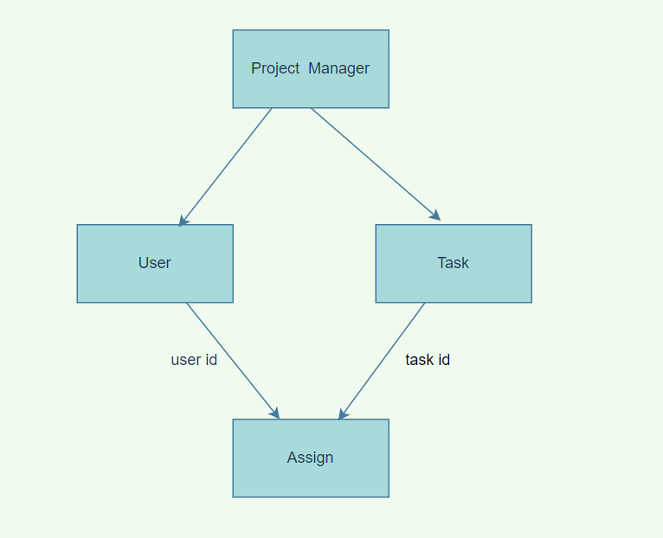

**Fig-1**

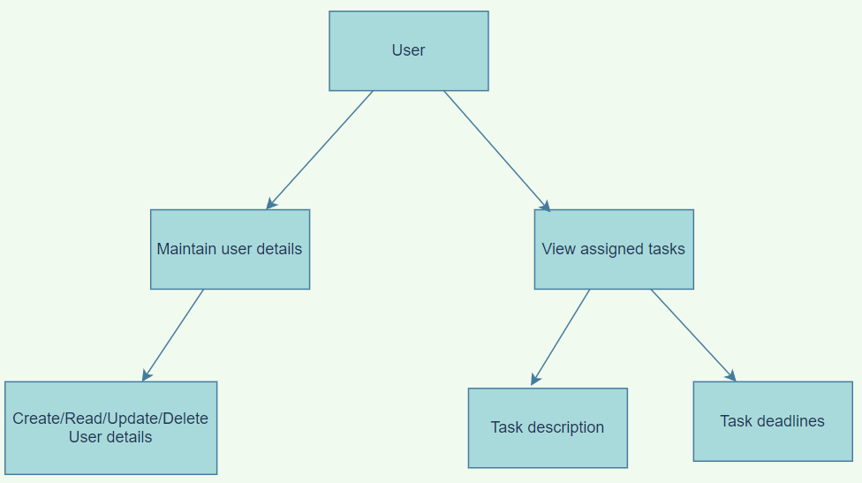

**Fig-2**

**3.3 Standards**

Security – username and password are required for access to the system. Quality – by keeping the interface simple and direct, quality should be kept at a maximum.

**3.4 Data Flow Diagram**

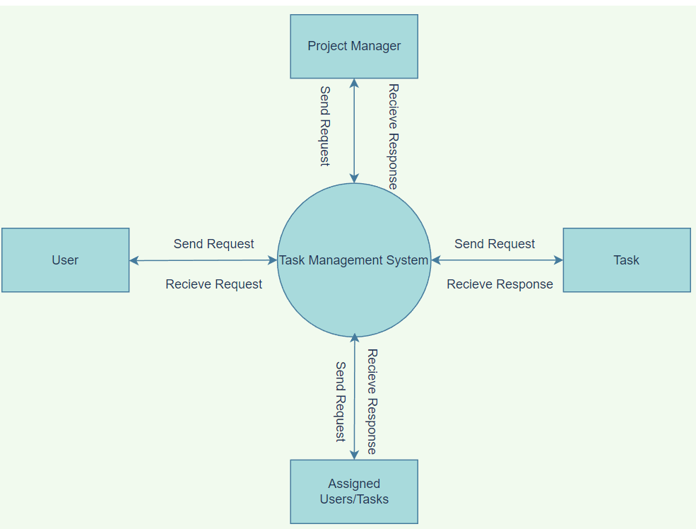

**Fig-3**

**3.5 Flow Chart**

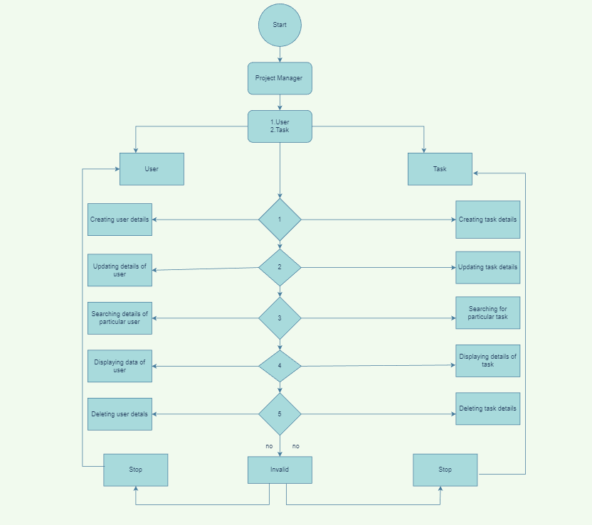**Fig-4**

**3.6 Files**

The Task Management Software (TMS) will use quite a number of files for saving data. It will store user data, task data and details regarding the tasks that is task description,task deadlines etc.

**3.7 User Interface**

The User Interface is basic and is built in a user-friendly manner.

**3.8 Error Handling**

Should errors be encountered, an explanation will be displayed as to what went wrong.

An error will be defined as anything that falls outside the normal and intended usage.

**3.9 Help**

Help will come in the form of all the documentation created prior to coding, which explain the intended uses. Should time allow, detailed instructions will be written on how to create and implement the system with the intentions of publishing as an Open Source solution.

**3.10** **Performance**

Performance is going to be very important for this project. For everything to run smoothly for this project, The system will work on the customer's terminal and the performance depends upon the hardware component of the customer’s system.

**3.11 Security**

The Task Management Software works specifically for tracking task deadlines of the user. Security is not the major focus of this project. The Task Management software contains a set of basic functions for creating, updating, and deleting users and tasks.

**3.12 Reliability**

The system is available when the user is requested for the service and it is available 24/7.The system has a very low failure rate.

**3.13 Maintainability**

Very little maintenance should be required for this setup. An initial configuration will be the only system required interaction after system is put together. The only other user maintenance would be any changes to settings after setup, and any specified special cases where user settings or history need to be changed. Physical maintenance on the system’s parts may be required, and would result in temporary loss of data or Internet. Upgrades of hardware and software should have little effect on this project, but may result in downtime.

**3.14 Portability**

This system should have the ability that, once it is together, the entire system should be able to be physically moved to any location. Code and program portability should be possible between kernel-recompiled Linux distributions. For everything to work properly, all components should be compiled from source.

**3.15 Reusability**

In our Project Task Management Software, we are using CRUD (Create, Read, Update, Delete) operations which can be useful not only in Task Management Software but also in projects which need CRUD operations.

**3.16 Application compatibility**

The TMS is designed as an independent system. As it is not connected to any other components or interfaces, application compatibility is not a concern.

**3.17 Resource utilization**

The TMS uses very limited resources.

**3.18 Major Classes**

There are a total 2 files: task_csv,user_csv

* user_csv: The user details such as user_data, user_designation will be included in this file.
* task_csv: The task details such as task_id, task_name, task_description, task _ deadline will be included in this file.

**3.19 Functions used** :

**3.19.1create_user () :** The create user is used to view the assigned tasks.

**3.19.2create_task () :** The create task is used to create tasks by

team manager.

**3.19.3 search_user():** Search will help in searching a particular user in the user list.

**3.19.4 search_task():** This function searches the particular task in

the list of tasks.

**3.19.5 update_user ():** The user can update their profile details.

**3.19.6 update_task ():** The manager can update the task for the

user if required

**3.19.7 delete_user ():** It can delete a specific user.

**3.19.8 delete_task ():** It can delete a specific task.

**3.19.9 display_task_data():** User should enter valid task_id.

**3.19.10 display_user_data():** User should enter valid task_id.

**3.20 Roles of respective user**

|  |  |
| --- | --- |
| **Actor** | **Description** |
| **Project Manager** | * The project Manager can add tasks for the user and can also add user info. * The project manager can delete the information of the tasks and the users. * The system allows the user to create a profile and set his credential. * The system authenticates user credentials to view the profile. * The project Manager can search for task information and user information. |

|  |  |
| --- | --- |
| **User** | * User can add, update and delete. * Provides for the users to update the user information. |

Low Level Design Document

**4.Introduction –**

**4.1 Purpose -** Task management is the process of monitoring your project's tasks through their various stages from start to finish. From task planning to managing, task management software helps you log and track every piece of information related to your project. The ability to keep track of your tasks, deadlines, meetings, and team responsibilities makes task management software a crucial tool for your business needs. This effective task management requires which managing all aspects of a task, including its status, priority, time, human and financial resources assignments, recurrence, dependency, notifications and so on.

### 4.2 Document Conventions

TBD (To be Continued).

### Intended Audience and Reading Suggestions

Document is primarily intended for members of **TMS** team which consists of trainees under **Capgemini** Training Program.

### 4.4 Design Descriptions

The Task Management Software is based on the concept of scheduling which makes the tasks easier. The system helps to reduce the problems that occur when using a manual system and helps users to avoid the deadlines. Keeping track of the tasks and deadlines is difficult in already existing systems hence, the proposed system will overcome all these drawbacks of the existing system. The proposed system has many advantages in that it stores all the task information of the user, user profiles, deadlines, etc. Users can enter their details, update their profile and even view their assigned task along with their deadlines. Other than that, the system is user- friendly.

Project tasks and task lists make it easy to keep users' work items organized and manageable in one centralized, accessible location.

**4.5 Use Case Diagram**

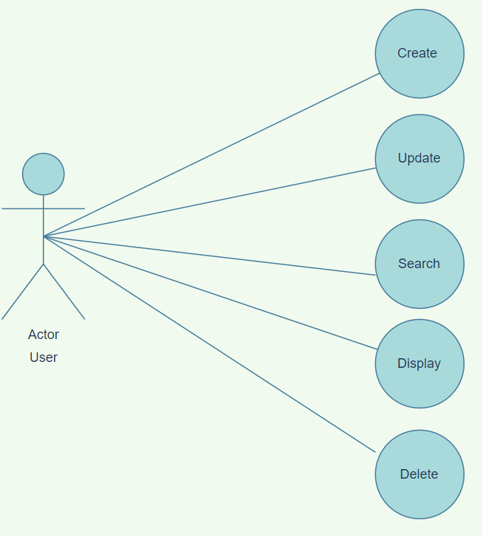

**Fig-5**

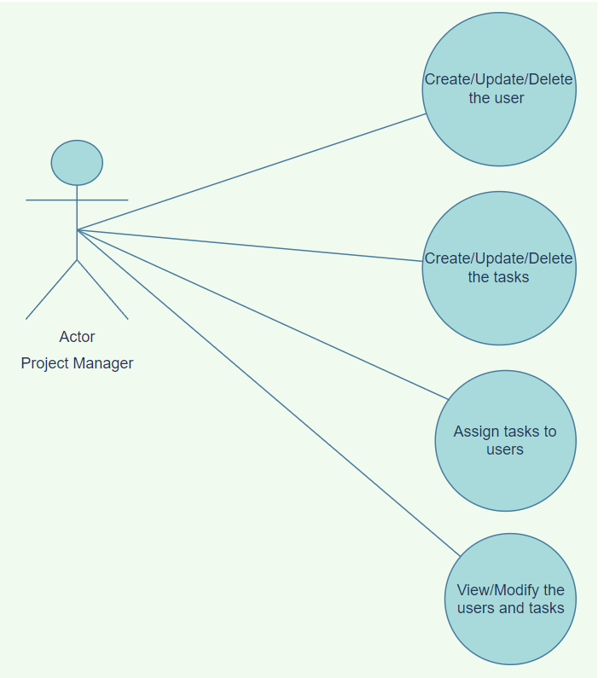

**Fig-6**

**4.6 Design and Implementation Constraints**

The system is built using the C language.

### 4.7 References

The References are as follows:

1. System Requirements Specification Document.
2. Project Proposal Document.
3. System Specification Requirement.
4. High Level Design Document for TMS.