QES

0.1v

QUIZ EVALUATION SOFTWARE(QES)

The purpose of this document is to provide with a template for documenting QES.

**Document Control:**

|  |  |  |  |  |  |  |  |  |
| --- | --- | --- | --- | --- | --- | --- | --- | --- |
| **Project Revision History** | | | | | | | | |
|  |  |  | |  |  |  |  |  |
| **Date** | **Version** | **Author** | **Brief Description of Changes** | | | | **Approver Signature** | |
| 12/11/2022 | 0.1v | Group08 | Initial Draft | | | |  | |
| 19/11/2022 | 0.2v | Group08 | Added Flowchart | | | |  | |

*1.**INTRODUCTION 5*

1.1. Intended Audience 5

1.2. Acronyms/Abbreviations 5

1.3. Project Purpose 5

1.4. Key Project Objectives 5

1.5. Project Scope and Limitation 6

1.7 Assumptions, Dependencies & Constraints 7

1.8 Risks 7

*2 Design Overview 7*

2.1 Design Objectives 7

*2.1.1 Recommended Architecture 7*

2.2Architectural Strategies 7

*2.2.1 Design Alternative* *8*

*2.2.2 Reuse of Existing Common Services/Utilities* *8*

*2.2.3 Creation of New Common Services/Utilities 8*

*2.2.4 User Interface Paradigms 8*

*2.2.5 System Interface Paradigms 8*

*2.2.6 Error Detection / Exceptional Handling 8*

*2.2.7 Memory Management 8*

*2.2.8 Performance 9*

*2.2.9 Security 9*

*2.2.10 Concurrency and Synchronization 9*

*2.2.11 Housekeeping and Maintenance 9*

*3. System Architecture 9*

3.1System Architecture Diagram. (Not Necessary) 9

3.2System Use-Cases 9

3.3 Subsystem Architecture 11

3.4 System Interfaces 11

*3.4.1 Internal Interfaces 11*

*3.4.2 External Interfaces 11*

*4.Detailed System Design 11*

4.1 Key Entities 11

4.2 Detailed-Level Database Design 13

*Level 2 1**3*

*4.2.1 Data Mapping Information 1**4*

*4.2.2 Data Conversion 1**4*

4.3 Archival and retention requirements 14

4.4 Disaster and Failure Recovery 14

4.5 Business Process workflow 15

4.6 Business Process Modeling and Management (as applicable) 16

4.7 Business Logic 16

4.8 Variables 16

4.9 Activity / Class Diagrams (as applicable) 16

4.10 Data Migration 16

*4.10.1 Architectural Representation 1**6*

*4.10.2 Architectural Goals and Constraints 1**6*

*4.10.3 Logical View 1**6*

*4.10.4 Architecturally Significant Design Packages 1**6*

*4.10.5 Data model 1**6*

*4.10.6 Deployment View 1**6*

*5 Environment Description 1**6*

*5.1Time Zone Support 1**6*

5.2 Language Support 17

5.3 User Desktop Requirements 17

5.4 Server-Side Requirements 17

*5.4.1 Deployment Considerations 1**7*

*5.4.2 Application Server Disk Space 1**7*

*5.4.3 Database Server Disk Space 1**7*

*5.4.4 Integration Requirements 1**7*

*5.4.5 Jobs 1**8*

*5.4.6 Network 1**8*

*5.4.7 Others 1**8*

5.5 Configuration 18

*5.5.1 Operating System 1**8*

*5.5.2 Database 1**8*

*5.5.3 Network 1**8*

*5.5.4 Desktop 1**8*

*6 .References 1**8*

*7.Appendix 1**8*

# 

### 1 Introduction

The ‘MCQ Quiz Evaluation’ project will develop to overcome the time-consuming problem of manual system. Apart from that in current system, checking the answer sheets after taking test, waste the examiners time, so this application will check the correct answer and save the examiner time and carry the examination in an effective manner. The users which are use this system don’t need to high computing knowledge and also system will inform them while entering invalid data.

## Intended Audience

This document could be shared or viewed across all the following CG employees, BUs, SME’s, internal SME’s. This is a technical document, and the terms should be understood by all of them.

|  |  |
| --- | --- |
| CG Employees |  |
| BU SME’s |  |
| Internal SME’s |  |

## Acronyms/Abbreviations

|  |  |
| --- | --- |
| QES | Quiz Evaluation Software |
| CSV | Comma Separated values |

## Project Purpose

# Quiz evaluation software using C and its various supporting tools. To computerized the manual system and help the examiners to save their valuable time and important data. Apart from this, data which are exist in this system, will exist for long period of time and will be easily accessible. This project helps the examiners to manage their services in a good way and provide a better service to their users.

## Key Project Objectives

## User will login with username and password.

## Then user will get into a test homepage.

## There will be set of questions with options below.

## User start attempting the quiz participant name.

## After completion of quiz they can view their score in csv format.

## Project Scope and Limitation

**1.5.1 In Scope**

The purpose of the application is to create a system which can be used to add questions and attempt quiz and analyze their performance. The end goal is to create an application that is easy to use, understand and respond to user queries in a fluid manner.

**1.5.2 Out Scope**

It is not a real-time project.

**1.6 Functional Overview**

 The Quiz Evaluation Software is developed using the C programming language. This Quiz evaluation Software allows the user to attempt ‘n’ Number of quizzes in online.

A Quiz Evaluation Software is a console application without graphics. File handling and data structure concepts have been used for almost all functions in this application.

This application is solved using several methods, like one can solve this program using command line arguments, user defined function concept, loop condition and conditional statements. The following steps are followed while implementing the given program:

* We have already embedded questions with their corresponding answers.
* Next user enters to a particular test window and need to enter participant name.
* And the test window also displays the questions with their question Id’s and the options within a range [1-5].
* After the completion of the quiz, it prints the scored marks out of total marks which is the output of the execution.
* In case anyone of the answer is format error then QES still able to print the records information.
* The inputs written can also be stored in a common file format for storage purposes.
* The stored data can be retrieved for future modification or display purposes. With the above-mentioned steps, we can insert, delete, retrieve or update a record in the Quiz Evaluation Software. Using file handling we can also store the data.

## 1.7 Assumptions, Dependencies & Constraints

## Organization has machine capable of running a UNIX based operating system.

## C source code can be compiled on the machine.

## The user has some storage space to store the data.

## 1.8 Risks

NA. There are no risk for Quiz Evaluation Software.

### 2 Design Overview

Operating Environment for the Quiz Evaluation Software is as follows:

* Client/Server system
* Operating System: Any UNIX Based OS
* Compiler: GCC or similar to compile source code written in C programming language.

## 2.1 Design Objectives

## User will login with username and password.

## Then user will get into a test homepage.

## There will be set of questions with options below.

## User start attempting the quiz participant name.

## After completion of quiz, they can view their score in csv format.

### 2.1.1 Recommended Architecture

NA

**2.2 Architectural Strategies**

* Question Id: This allows user to know their relevant question numbers in the question paper.
* Number of options: The user then selects relevant options from given options within a range mentioned.
* Correct answers: This display the select option is correct.
* Participant Name: This allows user to add their name who will participate in quiz.
* Total marks: This displays the total marks of the quiz we conducted.
* Scored marks: This displays the marks of the participant scored after the participation of the quiz.
* Invalid Answer: This displays “invalid response” for a particular question when participant select the option which is outside of the range.

### 2.2.1 Design Alternative

The project uses a database to establish a connection between user and server for evaluating the quiz and to generate scores.

### 2.2.2 Reuse of Existing Common Services/Utilities

The project does not reuse any new common services/utilities.

### 2.2.3 Creation of New Common Services/Utilities

The project does not create or use any new common services/utilities.

### 2.2.4 User Interface Paradigms

1. GUI: The application does not use Graphical User Interface.
2. CLI: The application uses Command Line Interface to accept console commands by users and perform the needful functions.

### 2.2.5 System Interface Paradigms

### 64bit Machine capable of running UNIX based operating system.

### Storage space to store the data.

### 2.2.6 Error Detection / Exceptional Handling

In this section we should encounter errors, and an explanation will be displayed to the participant and also can handle the exception handling by using file handling functions.

### 2.2.7 Memory Management

The question_pattern.csv and Evaluation_pattern.csv files should be loaded into the memory and the Question_pattern.csv and User.csv files look like this Once the file is loaded into the memory by using file handling, we can perform some CRUD operations like Create, Read, Update the operations in that file and then the user commits the data once the operations are done with that file.

### 2.2.8 Performance

The Application is developed to run through CLI on UNIX based system as the machine can run the operating system along with necessary dependencies without any flaws there are no additional requirements.

### 2.2.9 Security

# Some of the factors that are identified to protect the software from accidental or malicious access, use modification. Keep specific log or history data sets.

### 2.2.10 Concurrency and Synchronization

NA

### 2.2.11 Housekeeping and Maintenance

Clearing the memory buffer from the system.

### 3. System Architecture

Quiz evaluation software is a connection between user and server. This application evaluates the answer sheets of the participants and generate their score cards.

## 3.1 System Architecture Diagram. (Not Necessary)

NA

## 3.2 System Use-Cases

* In Quiz Evaluation Software, consists of login/registration page to check the credentials of the user.
* If the participant enter credentials are valid, he can take the quiz and evaluate their knowledge.
* If the participant credentials is not valid, system asks to enter valid credentials.

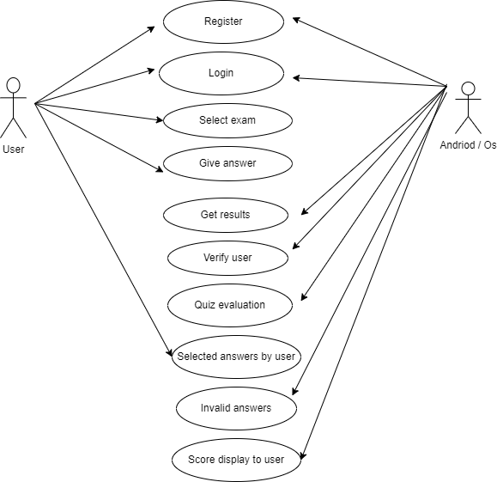

## 3.3 Subsystem Architecture

NA

## 3.4 System Interfaces

### 3.4.1 Internal Interfaces

GUI: The application does not use Graphical User Interface.

CLI: The application uses Command Line Interface to accept console commands by users and perform the needful functions

### 3.4.2 External Interfaces

Hardware Requirements are as follows:

* 64bit Machine capable of running UNIX based operating system.
* Storage space to store the data

### 4.Detailed System Design

## Key Entities

* Participant Name

In this section it consists of participant name, ques_ id, chosen option, Correct answer

## 4.2 Detailed-Level Database Design

**Level 0**

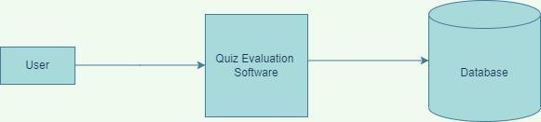

**Level 1**

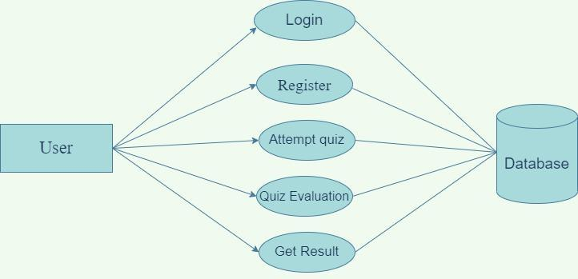

### 

### Level 2

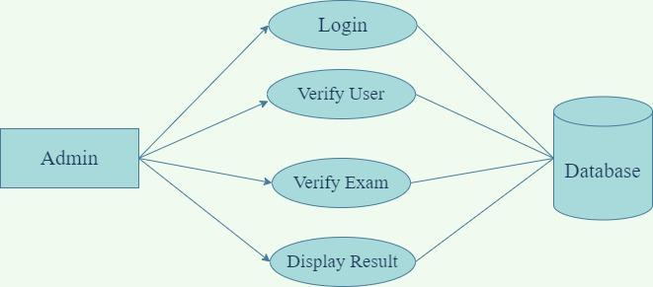

### 4.2.1 Data Mapping Information

The data can be viewed to the user after evaluation of quiz which he

was attempted and incorrect

### 4.2.2 Data Conversion

The Quiz Evaluation Software (QES) use number of files for saving data of quiz evaluation. It will evaluate the quiz of the participant, correct answers and invalid answers in csv format

## 4.3 Archival and retention requirements

QES should include debug log messages with at least 4 levels that is FATA, INFO, WARNING, DEBUG.

## 4.4 Disaster and Failure Recovery

This system should have the ability that, once it is together, the entire system should be able to be physically moved to any location. Code and program portability should be possible between kernel-recompiled Linux distributions. For everything to work properly, all components should be compiled from source.

## 4.5 Business Process workflow

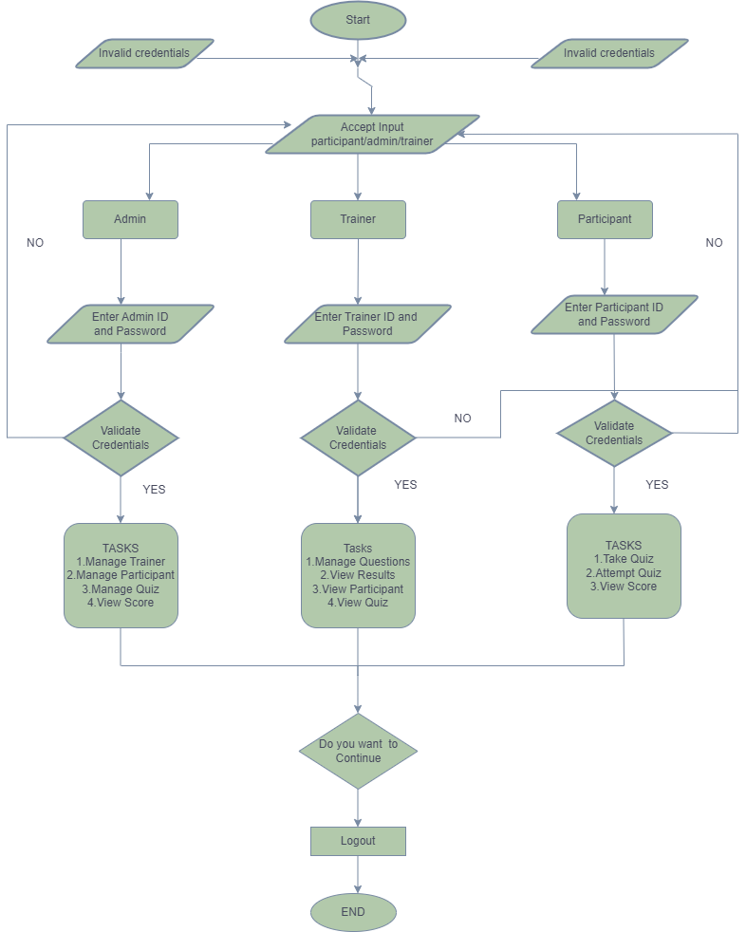

## 4.6 Business Process Modeling and Management (as applicable)

NA

## 4.7 Business Logic

NA

## 4.8 Variables

NA

## 4.9 Activity / Class Diagrams

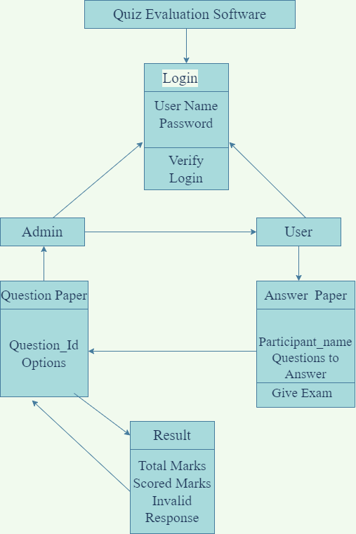

## 4.10 Data Migration

### 4.10.1 Architectural Representation

We used draw.io for implementation of use-case and logical view which are requirement for this application.

### 4.10.2 Architectural Goals and Constraints

We use C language to implement and design the Quiz and to run this we use Linux tool

### 4.10.3 Logical View

It should describe about the entities or attributes of Quiz Evaluation.

### 4.10.4 Architecturally Significant Design Packages

NA

### 4.10.5 Data model

NA

### 4.10.6 Deployment View

This describes the physical network (hardware) configurations on which the software is deployed and run*.*

### 5 Environment Description

### 5.1Time Zone Support

It will support time zone as per Indian standard time (IST) in (GMT +5:30) and UST standard.

## Language Support

C language in vi editor and compilation using make file and GCC. The Linux commands are used to do that task with specified commands.

**5.3 User Desktop Requirements**

User desktop requires a Linux environment, Operating system of Linux Debian or Terminal x86_64 GNU/Linux and kernel version 4.4.0-19041-Microsoft #1237Microsoft and reliable internet connectivity.

## 5.4 Server-Side Requirements

In server side,

● Disk space – Minimum 150GB

● Uninterrupted connectivity 24x7

● Monitor long running jobs, to reduce the server load

### 5.4.1 Deployment Considerations

Deployment considerations are,

● 500Mhz Processor

● 120GB HDD CPU

● minimum 4GB RAM

● Network connectivity

### 5.4.2 Application Server Disk Space

Disk space -Minimum 150GB

### 5.4.3 Database Server Disk Space

NA

### 5.4.4 Integration Requirements

Project integration management involves coordinating all the project elements.

### 5.4.5 Jobs

Quiz Evaluation Software is an application which evaluates the quiz taken by the participant, and give the results as per requirements.

### 5.4.6 Network

NA

### 5.4.7 Others

NA

## 5.5 Configuration

### 5.5.1 Operating System

* Operating system –Linux.
* RAM - 4GB or more.
* Processor - i3/i5.

### 5.5.2 Database

NA

### 5.5.3 Network

NA

### 5.5.4 Desktop

Minimum Windows 10, 8gb Ram with i5 configuration is required.

### 6 References

* [www.stackoverflow.com](http://www.stackoverflow.com)
* <https://www.javatpoint.com/file-handling-in-c> for file handling concept
* <https://www.javatpoint.com/linux-commands> Linux Command

### 7 Appendix

https://drive.google.com/drive/folders/1ygyZZc2rTtr4pEuRTjzxE6993bJVFZR_

**Change Log**

|  |  |  |  |  |  |
| --- | --- | --- | --- | --- | --- |
| **QES Template Version Control (Maintained by QA)** | | | | | |
|  |  |  |  |  |  |
| **Date** | **Version** | **Author** | | **Description** | |
| 18-Nov-2022 | 1.0 | Group 08 | | Initial Version | |