

**QUIZ EVALUATION SOFTWARE**



**QES**

**Software Requirements Specification Version 0.1**

**Document Control:**

|  |  |  |  |  |  |  |  |  |
| --- | --- | --- | --- | --- | --- | --- | --- | --- |
| **Project Revision History** | | | | | | | | |
|  |  |  | |  |  |  |  |  |
| **Date** | **Version** | **Author** | **Brief Description of Changes** | | | | **Approver Signature** | |
| 11/11/2022 | 0.1(Draft) | Group 08 | Basic design and documentation | | | |  | |
|  |  |  |  | | | |  | |

|  |
| --- |
| **Team Members** |

|  |  |
| --- | --- |
| **Employee ID:** | **Name** |
| 46281991 | Shivani Sinha |
| 46279750 | Shaik Saahera Banu |
| 46279757 | Nukala Vasanthi |
| 46279713 | Lavanya Anugu |

|  |  |  |  |  |
| --- | --- | --- | --- | --- |
|  |  |  |  |  |

**Table of Contents**

**1.Introduction……………………………………………………………………………………05**

* 1. Purpose
  2. Intended Audience
  3. Scope
  4. References
  5. Overview

**2. Overall Design…………………………………………………………06**

2.1 Product Perspective

2.2. Assumptions and Dependencies

2.3. Operating Environment

2.4. Product Features

**3. Working……………………………………………………………….07**

3.1 Use case Diagram

**4. System Features………………………………………………............08**

4.1Functional Requirements

**5. External Interface Requirements……………………………...........10**

5.1User Interfaces

5.2 Hardware Interfaces

**6. Non-Functional Requirements………………………………............11**

6.1. Performance Requirements

6.2. Software Quality Attributes

6.3. Safety Requirements

**7. Operational Scenario………………………………………………..12**

**Quiz Evaluation Software**

1. **Introduction**
   1. **Purpose**

The purpose of the project and this documentation is to build a Quiz evaluation software using C and its various supporting tools. To computerized the manual system and help the examiners to save their valuable time and important data. Apart from this, data which are exist in this system, will exist for long period of time and will be easy accessible. This project helps the examiners to manage their services in a good way and provide a better service to their users.

* 1. **Intended Audience**

The project is designed to provide users with a platform to organize their Quiz Exams in periodic manner and dynamically make changes to the questions as per the institutes criteria and requirements.

* 1. **Project Scope**

The purpose of the application is to create a system which can be used to add questions and attempt quiz and analyze their performance. The end goal is to create an Application that is easy to use, understand and respond to user queries in a fluid manner.

* 1. **Reference**
* [www.stackoverflow.com](http://www.stackoverflow.com)
* <https://www.javatpoint.com/file-handling-in-c>  for file handling concept
* <https://www.javatpoint.com/linux-commands> Linux Command

**1.5 Overview**

The ‘MCQ Quiz Evaluation’ project will developed to overcome the time consuming problem of manual system. Apart from that in current system, checking the answer sheets after taking test, waste the examiners time, so this application will check the correct answer and save the examiner time and carry the examination in an effective manner. The users which are use this system don’t need to high computing knowledge and also system will inform them while entering invalid data.

The objective of this project is to manage the details of students, examinations, marks, courses and papers in a good manner. The performance of the application will be fully control by administrator and administrator can guaranty any one to access. The project will reduce the manual process in managing examinations and all issues regarding that.

**2. Overall Description**

**2.1 Product Perspective**

QES is an on-line examination system. The objective of this app is to reach and connect candidate and examiner in remote communities and conduct exams in a virtual environment online. The various stages in the app are as follows:-

* System Overview:

This window can only be accessed by the administrator. It allows the administrator to add and edit exams.

* Test:

This window contains all the exams candidate can give. All these exams are organized according to the categories they fall in. The test window will be different for students and corporate employees.

* Result:

This window displays the result of exams the candidate has just appeared. This data will be saved and displayed in the user profile.

**2.2. Assumptions and Dependencies**

The following assumptions have been made in regards to the development of the Quiz Evaluation:

* The user or client organization has machines capable of running a UNIX based operating system.
* C source code can be compiled on the machines.
* The users have some storage space to store the data.

**2.3** **Operating Environment**

Operating Environment for the Quiz Evaluation is as follows:

* Operating System: Any UNIX Based OS
* Compiler: GCC or similar to compile source code written in C programming language.

**2.4. Product Features:**

The features are as follows:

* User can take the quiz either Desktop or Android.
* If user want any particular domain to analyse his/her knowledge they can access the quiz in the corresponding domain.
* Before starting their quiz they need to give their participant name.
* After completion of the quiz they can view their scores and also get an explanation of any incorrect answers.

**3.Working of Quiz Evaluation Software**

The Quiz Evaluation Software is developed using the C programming language. This Quiz evaluation Software allows the user to attempt ‘n’ Number of quizzes in online .

A Quiz Evaluation Software is a console application without graphics. File handling and data structure concepts have been used for almost all functions in this application.

This application is solved using several methods, like one can solve this program using command line arguments, user defined function concept, loop condition and conditional statements. The following steps are followed while implementing the given program :

* We have already embedded questions with their corresponding answers.
* Next user enter to a particular test window and need to enter participant name.
* And the test window also displays the questions with their question Id’s and the options within a range [1-5].
* After the completion of the quiz, it prints the scored marks out of total marks which is the output of the execution.
* In case anyone of the answer is format error then QES still able to print the records information.
* The inputs written can also be stored in a common file format for storage purposes.
* The stored data can be retrieved for future modification or display purposes.

With the above mentioned steps we can insert, delete, retrieve or update a record in the Quiz Evaluation Software. Using file handling we can also store the data.

**3.1** **Use case Diagram**

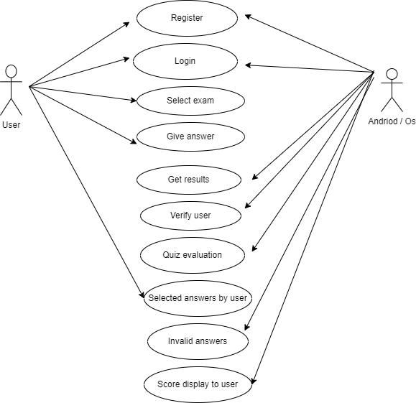

**Fig. 1.1**

**4.System Features**

The Quiz Evaluation is an application that gives users to attempt the quiz, view their score after completion of exam.

**4.1**. **Functional Requirements**

Following is a list of functionalities of the system:

1.Question Id

This allows user to know their relevant question numbers in the question paper.

2.Number of options

The user then select relevant option from given options within a range mentioned.

3.Correct answer

This displays the selected option is correct.

4.Participant name

This allows user to add their name who will participate in quiz.

5.Total marks

This displays the total marks of the quiz.

6.Scored marks

This displays the marks of the participant scored after the participation in the quiz.

7.Invalid answers

This displays "invalid response" for a particular question when participant select the outside the range provided.

**5.External Internal Requirements**

This application uses UNIX (CLI) to perform interaction between client and user.

Based on User choice the functions will perform tasks (Code reuse).

**5.1.** **User Interfaces**

* + GUL The application does not use Graphical User Interface
  + CLI: This application uses Command Line Interface to accept console commands by users choice and perform the needful functions.

**5.2. Hardware Interfaces**

Hardware Requirements are as follows:

* 32 bit and 64bit Machine capable of running UNIX based operating system
* Storage space to store the data.

**6. Non-Functional Requirements**

**6.1 Performance Requirements**

The Application is developed to run through CLI on UNIX based systems. As long as the machine can run the operating system along with the necessary dependencies without any flaws there are no additional requirements.

* 1. **Software Quality Attributes**

**Serviceability:**

* The system requires minimal amount of maintenance. The maintenance and upkeep can be performed by any person with a basic understanding and development experience in C.

**Reusability:**

* The application needs to be designed in a way such that the code can be easily reused and it can run in any UNIX like machine in the organization.

**Binary Compatibility**:

* This application should be compatible with any computer that has an UNIX based operating system.

**Portability:**

* The source code needs to be implemented in such a way that it is portable to any machine that can compile and run C programs.
  1. **Safety Attributes**
* Participants should be aware of instructions before attempting the quiz.
* Irrelevant contacts should not be displayed during searches to protect privacy.
* The implementation should not be susceptible to easy modification.

**7.Operational Scenarios**

1. Scenario A:

* Question Id: This allows user to know their relevant question numbers in the question paper.

1. Scenario B:

* Number of options: The user then select relevant option from given options within a range mentioned.

1. Scenario C:

* Correct answer: This displays the selected option is correct.

1. Scenario D:

* Participant name: This allows user to add their name who will participate in quiz.

1. Scenario E:

* Total marks: This displays the total marks of the quiz we conducted.

1. Scenario F:

* Scored marks: This displays the marks of the participant scored after the participation in quiz.

1. Scenario G:

* Invalid answers: This displays "invalid response" for a particular question when participant select the outside the range provided.

THANK YOU