|  |  |  |  |  |  |  |  |  |  |
| --- | --- | --- | --- | --- | --- | --- | --- | --- | --- |
|  |  |  |  |  |  |  |  |  |  |
|  |  |  |  |  |  |  |  |  |  |
|  |  |  |  |  |  |  |  |  |  |

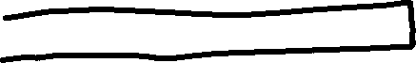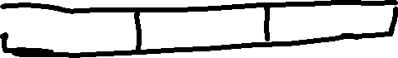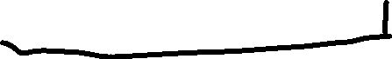

Books = (char ***)malloc(sizeof(char **)*noBooks);

for(i=0;i<noBooks;i++){

Books[i] = (char **)malloc(sizeof(char*)*row);

for(j=0;j<row;j++)

{

Books[i][j] = (char *)malloc(sizeof(char)*col);

}

}

