

Data structure - Graphs - BFS

In this session, we will learn: Traverse graph with BFS. Implement BFS.

Traversing a graph is visiting each and every vertex once.

Insert the start-vertex on to the queue.



1

2

Remove the vertex from the queue and visit it if not visited.

3 Insert all the unvisited adjacent vertices of the vertex obtained from step-2.

4 Repeat (2) & (3) until the queue is empty.

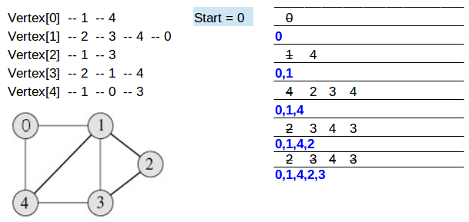

# Implementing functions

1 *void bfs(int vertex)*, performs BFS from

**vertex**.

# 2 Functions to build graph.

3 Functions implementing queue data structure.

Traverse the graph using BFS.

