

Data structure - Graphs - DFS

In this session, we will learn: Traverse graph with DFS. Implement DFS.

Traversing a graph is visiting each and every vertex once.

Push the start-vertex on to the stack.



1

2

3

Pop the vertex from the stack and visit it if not visited. Push all the unvisited adjacent vertices of the vertex obtained from step-2.

4 Repeat (2) & (3) until the stack is empty.

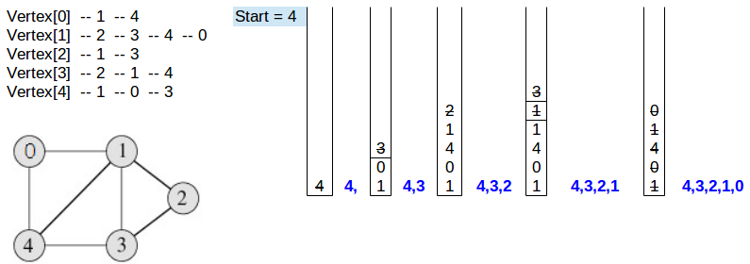

# Implementing functions

1 *void dfs(int vertex)*, performs DFS from

**vertex**.

# 2 Functions to build graph.

Traverse the graph using DFS.

