Change management important link

https://docs.bmc.com/docs/display/public/change80/Working+with+BMC+Change+Management+as+an+approver

**About floating licenses in a license pool**



A *license pool* consists of a number of floating licenses reserved for a group, subject to the number of floating licenses available in the database. When a member of a group logs in, a license from the license pool for that group is granted. When the user finishes using the license, it is released back into the pool.   
  
If no licenses are available in the pool, a check is made to see if the user is a member of any other group that has a license pool. If no licenses are available in any pool the user is a member of, a check is made for floating licenses not associated with any pool. A user is never granted a floating license from a pool of which the user is not a member.   
  
License pools enable you to give priority to a group that needs licenses more urgently. The group with the smallest group ID has the highest priority. When a non-reserved floating license becomes available, it is granted to the next user who needs it, regardless of the priority of that user's access to the system.

Groups in BMC Remedy AR System



Access control groups are collections of BMC Remedy AR System users. A user gains access to an object, a field, or a request if a group the user is in has access, or a role mapped to such a group has access. Notifications also can use groups. For example, you can designate an entire group to be notified in a filter action.   
  
BMC Remedy AR System includes a Public group and eight other special groups that are essential for access control within the system. You can define additional groups based on a common profile and assign access accordingly. For example, you might create a Sales group and allow members to view the status of a request but not to change it. A group can also be a general category, such as Browsers. For information about adding groups, see [Creating and managing groups](https://docs.bmc.com/docs/display/ars8000/Creating+and+managing+groups#Creatingandmanaginggroups-12179).

Special groups in BMC Remedy AR System



BMC Remedy AR System reserves the following group IDs for special group definitions. The following table describes the access privileges for each of these groups.

**Special groups in BMC Remedy AR System**

| **Group** | **ID** | **Type** | **Description** |
| --- | --- | --- | --- |
| **Group** | **ID** | **Type** | **Description** |
| Public | 0 | Implicit | Provides general access. Access granted to this group is granted to all users. Every user who logs in to BMC Remedy AR System is automatically a member of the Public group. This includes registered users (that is, listed in the User form) and guest users. |
| Administrator | 1 | Explicit | Defines users who have full and unlimited access to BMC Remedy AR System. Administrators, members of this group, can view any object or field in a browser and can create a request in any form. Administrators can view, create, modify, and delete any server object in Remedy Administrator. A user must have a fixed license or this group assignment is ignored. |
| Customize | 2 | Explicit | Grants users the ability to customize their form view layout in the mid tier. Use this group with caution. |
| Submitter | 3 | Implicit | Provides field access to the user whose login name is in the Submitter field (field ID 2) for a particular request. The user who creates a request is usually automatically belongs to the Submitter group for that requests. For more information, see [Submitter and Assignee access](https://docs.bmc.com/docs/display/ars8000/Submitter+and+Assignee+access#SubmitterandAssigneeaccess-25846). See [Enabling submitters to modify requests](https://docs.bmc.com/docs/display/ars8000/Enabling+submitters+to+modify+requests), to enable a special server Submitter mode that allows the user who submitted a request to modify it without having a write license. |
| Assignee | 4 | Implicit | Provides field access to the user whose name is in the Assignee field (field ID 4) for a particular request. The user whose name is in the Assignee field automatically belongs to the Assignee group. For more information, see [Submitter and Assignee access](https://docs.bmc.com/docs/display/ars8000/Submitter+and+Assignee+access). |
| Sub Administrator | 5 | Explicit | Provides administrative access to selected server objects. Subadministrators, members of this group, can be granted administrative access to objects that have the Subadministrator Permissions property. With administrative access, a subadministrator has the same access as an administrator for that object. See [Subadministrator security role](https://docs.bmc.com/docs/display/ars8000/Subadministrator+security+role). A user must have a fixed license or this group assignment is ignored. |
| Assignee Group | 7 | Implicit | Provides field access to the user who is a member of one of the groups listed in the Assignee Group field (field ID 112) for a request. A user automatically belongs to the Assignee Group group for requests in which the Assignee Group field exists and contains the name or ID of a group to which the user belongs, the name or ID of a role that maps to a group to which the user belongs, or the user's name. For more information, see [Assignee Group access](https://docs.bmc.com/docs/display/ars8000/Assignee+Group+access) and [Form, active link guide, and application permissions](https://docs.bmc.com/docs/display/ars8000/Form%2C+active+link+guide%2C+and+application+permissions).  Note  Do not confuse this group with the Assignee group, which gives permission to the individual user named in the Assignee field. |
| Struct Admin | 8 1 | Explicit | Struct Admin members can create, modify, and delete AR server objects, but have no access to data or to administrative functions unless provided by other groups in the user's group list.  Note  For more information about Struct Admin permissions, see [Struct Admin group permissions](https://docs.bmc.com/docs/display/ars8000/Struct+Admin+group+permissions).  The assigned user must have a fixed license or this group assignment is ignored. |
| Struct Subadmin | 9 1 | Explicit | Struct Subadmin members can modify AR server objects subject to the same rules that govern Sub Administrator group members. If the object's Administrator group list contains a group in which the Struct Subadmin user is a member, the user has access. Struct Subadmin members have no access to data or to administrative functions unless provided by other groups in the user's group list. The assigned user must have a fixed license or this group assignment is ignored. |

1. This Group ID assignment might present a conflict with custom type assignments.

In addition to the groups listed in the previous table, groups with IDs in the range of 60000 to 60999 are reserved for dynamic groups.

Struct Admin group permissions



When assigning Struct Admin permissions, you will need to create a group to provide access to the objects from the schema and assign it to Struct Admin. The following table lists all objects the Struct Admin permissions group must provide.   
  
For more information about structural administrators options, see:

* [Special groups in BMC Remedy AR System](https://docs.bmc.com/docs/display/ars8000/Special+groups+in+BMC+Remedy+AR+System)
* [Creating groups](https://docs.bmc.com/docs/display/ars8000/Creating+groups)
* [Access level options for administrators](https://docs.bmc.com/docs/display/ars8000/Access+level+options+for+administrators)

The **Access Type** field in the following table lists the access that BMC Remedy Developer Studio needs to the fields of the listed form.

* If the Access Type is Read, grant the Struct Admin Permissions group View permission to the form's fields.
* If the Access Type is Read/Write, grant the Struct Admin Permissions group Change permission to the form's fields (except field 1, which should always have View permission).   
    
  **StuctAdmin group permissions matrix**

| **Form Name** | **Access Type** | **Details** |
| --- | --- | --- |
| **Form Name** | **Access Type** | **Details** |
| Data Visualization Definition | Read/Write | This form is used for all Flashboard, Flashboard Variable and Flashboard Alarm. BMC Remedy Developer Studio needs read-write access for this form. |
| Data Visualization Module | Read | This form is used in Form Editor to populate the Module Type property of **Data Visualization** Field. |
| AR System Metadata: actlink | Read | All Metadata forms are used by Search, Analyzer and Workflow Viewer. |
| AR System Metadata: actlink_auto | Read | All Metadata forms are used by Search, Analyzer and Workflow Viewer. |
| AR System Metadata: actlink_call | Read | All Metadata forms are used by Search, Analyzer and Workflow Viewer. |
| AR System Metadata: actlink_dde | Read | All Metadata forms are used by Search, Analyzer and Workflow Viewer. |
| AR System Metadata: actlink_goto | Read | All Metadata forms are used by Search, Analyzer and Workflow Viewer. |
| AR System Metadata: actlink_group_ids | Read | All Metadata forms are used by Search, Analyzer and Workflow Viewer. |
| AR System Metadata: actlink_macro | Read | All Metadata forms are used by Search, Analyzer and Workflow Viewer. |
| AR System Metadata: actlink_macro_parm | Read | All Metadata forms are used by Search, Analyzer and Workflow Viewer. |
| AR System Metadata: actlink_mapping | Read | All Metadata forms are used by Search, Analyzer and Workflow Viewer. |
| AR System Metadata: actlink_message | Read | All Metadata forms are used by Search, Analyzer and Workflow Viewer. |
| AR System Metadata: actlink_open | Read | All Metadata forms are used by Search, Analyzer and Workflow Viewer. |
| AR System Metadata: actlink_process | Read | All Metadata forms are used by Search, Analyzer and Workflow Viewer. |
| AR System Metadata: actlink_push | Read | All Metadata forms are used by Search, Analyzer and Workflow Viewer. |
| AR System Metadata: actlink_serviceaction | Read | All Metadata forms are used by Search, Analyzer and Workflow Viewer. |
| AR System Metadata: actlink_set | Read | All Metadata forms are used by Search, Analyzer and Workflow Viewer. |
| AR System Metadata: actlink_set_char | Read | All Metadata forms are used by Search, Analyzer and Workflow Viewer. |
| AR System Metadata: actlink_sql | Read | All Metadata forms are used by Search, Analyzer and Workflow Viewer. |
| AR System Metadata: actlink_wait | Read | All Metadata forms are used by Search, Analyzer and Workflow Viewer. |
| AR System Metadata: arcontainer | Read | All Metadata forms are used by Search, Analyzer and Workflow Viewer. |
| AR System Metadata: arctr_group_ids | Read | All Metadata forms are used by Search, Analyzer and Workflow Viewer. |
| AR System Metadata: arctr_subadmin | Read | All Metadata forms are used by Search, Analyzer and Workflow Viewer. |
| AR System Metadata: arreference | Read | All Metadata forms are used by Search, Analyzer and Workflow Viewer. |
| AR System Metadata: arschema | Read | All Metadata forms are used by Search, Analyzer and Workflow Viewer. |
| AR System Metadata: char_menu | Read | All Metadata forms are used by Search, Analyzer and Workflow Viewer. |
| AR System Metadata: char_menu_dd | Read | All Metadata forms are used by Search, Analyzer and Workflow Viewer. |
| AR System Metadata: char_menu_file | Read | All Metadata forms are used by Search, Analyzer and Workflow Viewer. |
| AR System Metadata: char_menu_list | Read | All Metadata forms are used by Search, Analyzer and Workflow Viewer. |
| AR System Metadata: char_menu_query | Read | All Metadata forms are used by Search, Analyzer and Workflow Viewer. |
| AR System Metadata: char_menu_sql | Read | All Metadata forms are used by Search, Analyzer and Workflow Viewer. |
| AR System Metadata: cntnr_ownr_obj | Read | All Metadata forms are used by Search, Analyzer and Workflow Viewer. |
| AR System Metadata: escal_mapping | Read | All Metadata forms are used by Search, Analyzer and Workflow Viewer. |
| AR System Metadata: escalation | Read | All Metadata forms are used by Search, Analyzer and Workflow Viewer. |
| AR System Metadata: field | Read | All Metadata forms are used by Search, Analyzer and Workflow Viewer. |
| AR System Metadata: field_char | Read | All Metadata forms are used by Search, Analyzer and Workflow Viewer. |
| AR System Metadata: field_column | Read | All Metadata forms are used by Search, Analyzer and Workflow Viewer. |
| AR System Metadata: field_curr | Read | All Metadata forms are used by Search, Analyzer and Workflow Viewer. |
| AR System Metadata: field_dispprop | Read | All Metadata forms are used by Search, Analyzer and Workflow Viewer. |
| AR System Metadata: field_enum | Read | All Metadata forms are used by Search, Analyzer and Workflow Viewer. |
| AR System Metadata: field_enum_values | Read | All Metadata forms are used by Search, Analyzer and Workflow Viewer. |
| AR System Metadata: field_permissions | Read | All Metadata forms are used by Search, Analyzer and Workflow Viewer. |
| AR System Metadata: field_table | Read | All Metadata forms are used by Search, Analyzer and Workflow Viewer. |
| AR System Metadata: filter | Read | All Metadata forms are used by Search, Analyzer and Workflow Viewer. |
| AR System Metadata: filter_call | Read | All Metadata forms are used by Search, Analyzer and Workflow Viewer. |
| AR System Metadata: filter_goto | Read | All Metadata forms are used by Search, Analyzer and Workflow Viewer. |
| AR System Metadata: filter_log | Read | All Metadata forms are used by Search, Analyzer and Workflow Viewer. |
| AR System Metadata: filter_mapping | Read | All Metadata forms are used by Search, Analyzer and Workflow Viewer. |
| AR System Metadata: filter_message | Read | All Metadata forms are used by Search, Analyzer and Workflow Viewer. |
| AR System Metadata: filter_notify | Read | All Metadata forms are used by Search, Analyzer and Workflow Viewer. |
| AR System Metadata: filter_process | Read | All Metadata forms are used by Search, Analyzer and Workflow Viewer. |
| AR System Metadata: filter_push | Read | All Metadata forms are used by Search, Analyzer and Workflow Viewer. |
| AR System Metadata: filter_serviceaction | Read | All Metadata forms are used by Search, Analyzer and Workflow Viewer. |
| AR System Metadata: filter_set | Read | All Metadata forms are used by Search, Analyzer and Workflow Viewer. |
| AR System Metadata: filter_sql | Read | All Metadata forms are used by Search, Analyzer and Workflow Viewer. |
| AR System Metadata: image | Read | All Metadata forms are used by Search, Analyzer and Workflow Viewer. |
| AR System Metadata: schema_archive | Read | All Metadata forms are used by Search, Analyzer and Workflow Viewer. |
| AR System Metadata: schema_audit | Read | All Metadata forms are used by Search, Analyzer and Workflow Viewer. |
| AR System Metadata: schema_group_ids | Read | All Metadata forms are used by Search, Analyzer and Workflow Viewer. |
| AR System Metadata: schema_index | Read | All Metadata forms are used by Search, Analyzer and Workflow Viewer. |
| AR System Metadata: schema_join | Read | All Metadata forms are used by Search, Analyzer and Workflow Viewer. |
| AR System Metadata: schema_list_fields | Read | All Metadata forms are used by Search, Analyzer and Workflow Viewer. |
| AR System Metadata: subadmin_group | Read | All Metadata forms are used by Search, Analyzer and Workflow Viewer. |
| AR System Metadata: vendor_mapping | Read | All Metadata forms are used by Search, Analyzer and Workflow Viewer. |
| AR System Metadata: view_mapping | Read | All Metadata forms are used by Search, Analyzer and Workflow Viewer. |
| AR System Metadata: vui | Read | All Metadata forms are used by Search, Analyzer and Workflow Viewer. |
| AR System Administration: Server Information | Read | This form is used by the Analyzer to read configuration data. |
| AR System Ignored Analyzer Results | Read/Write | This form is used by the Analyzer to store results marked as Ignored. |
| User | Read | This form is by the Analyzer to read user permissions. |
| AR System Object Relationships | Read | This form is used to calculate related objects. It is used extensively in Search, Analyzer, Object List, Relationships and Workflow Viewer. |
| Groups | Read | This form is used in Group Object List, Search and Analyser. |
| Roles | Read | This form is used to read user roles. |
| AR System Administrator Preference | Read/Write | These forms are used to read and write administrator and user preferences. |
| AR System User Preference | Read/Write | These forms are used to read and write administrator and user preferences. |
| AR System Version Control: Object Reservation | Read/Write | These forms are used for Object Reservation feature. |
| AR System Version Control: Object Modification Log | Read | These forms are used for Label Management. |
| AR System Version Control: Label | Read/Write | These forms are used for Label Management. |
| AR System Version Control: Labeled Object | Read/Write | These forms are used for Label Management. |
| AR System Currency Codes | Read | This form is used to get currency types that are shown in the Currency Types property of a currency field. |
| AR System Orchestrator Configuration | Read | This form is used in Set Fields action when Data Source is set to Webservice. |
| ReportType | Read | This form is used by Open Window action when Window Type is set to Report. |
| Distributed Mapping | Read/Write | These forms are used in Distributed Mapping and Distributed Pool editors |
| Distributed Pool | Read/Write | These forms are used in Distributed Mapping and Distributed Pool editors. |
| DSO Distributed Logical Name | Read | Used by DSO Editors and DSO action to read logical names. |
| BMC Remedy Localization Toolkit: Items | Read/Write | This form is used by L10n Toolkit. |
| BMC Remedy Localization Toolkit: Location Package Join | Read | These forms are used by L10n Toolkit. |
| BMC Remedy Localization Toolkit: Location Package Link | Read | These forms are used by L10n Toolkit. |
| BMC Remedy Localization Toolkit: Locations | Read/Write | These forms are used by L10n Toolkit. |
| BMC Remedy Localization Toolkit: Translations | Read/Write | This form is used by L10n Toolkit. |
| BMC Remedy Localization Toolkit: Translations Audit | Read/Write | This form is used by L10n Toolkit. |
| AR System Resource Definitions | Read/Write | This form is used for localizing templates. |
| AR System Message Catalog | Read/Write | This form is used for localizing messages. |
| AR System Currency Label Catalog | Read | This form is used to read localized current code. |

Access level options for administrators



In your application development and production environments, you can provide different levels of access for administrators. The Overlay Group option on the Group Information Form, provides the following access options:

* **Overlay Group** field set to 1  
  When a group assigned to the user has the **Overlay Group** field is set to 1, the user is restricted to working on overlay and custom mode objects. In BMC Remedy Developer Studio, the user can work only in Best Practice Customization mode.
* **Overlay Group** field set to 0  
  When a group assigned to the user has the **Overlay Group** field is set to 0, the user is restricted to working on base mode objects. In BMC Remedy Developer Studio, the user can work only in Base Developer mode.
* Overlay Group set to (clear)  
  When the Overlay Group is set to (clear) the Group provides no restrictions on access to base, overlay, or custom objects. For more information about Overlay Groups, see [Creating groups](https://docs.bmc.com/docs/display/ars8000/Creating+groups).   
    
  When you assign a user to a group with Overlay Groups set to 1, you must also assign the user to the Struct Admin or Struct Subadmin group. For more information, see [Groups in BMC Remedy AR System](https://docs.bmc.com/docs/display/ars8000/Groups+in+BMC+Remedy+AR+System) and [Operations on objects restricted by development mode](https://docs.bmc.com/docs/display/ars8000/Operations+on+objects+restricted+by+development+mode).

To create a new group with the Overlay Group option set to 1

1. From the BMC Remedy AR System Administration Console, navigate to: **Application > Users/Groups/Roles > Groups**
2. Create the Group as desired and select **1** in the Overlay Group drop-down menu, to make it an Overlay Group.   
     
   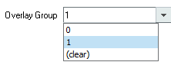

To create Struct Admin Permissions

1. From the BMC Remedy AR System Administration Console, navigate to **Application > Users/Groups/Roles > Groups**
2. Create a group named Struct Admin Permissions, to provide access to the objects.
3. Set the **Group Category** field to Regular.
4. Set the **Group Type** field to Change.

To assign group assignments to a user

1. From the BMC Remedy AR System Administration Console, navigate to **Application > Users/Groups/Roles > Users**
2. Make sure the user is assigned the following groups:
   * Struct Admin
   * Struct Admin Permissions

Approvals - Approving change requests



Within the lifecycle of the change request, approvals might be required. There are several approval phases possible, which vary depending on how your organization configures and implements the possible changes. Some changes bypass the approval process altogether. The application administrator determines which change requests require approval, what kind of approval process the change requests must undergo, and who the approvers are. Support staff and management can add more approvers to the list.

Tip

The SMPM process model specifies that the best practice is to include an approval after the risk and impact analysis of a change request.

For more information, see [Adding approvers](https://docs.bmc.com/docs/display/change80/Adding+approvers).   
  
**Approving changes**   
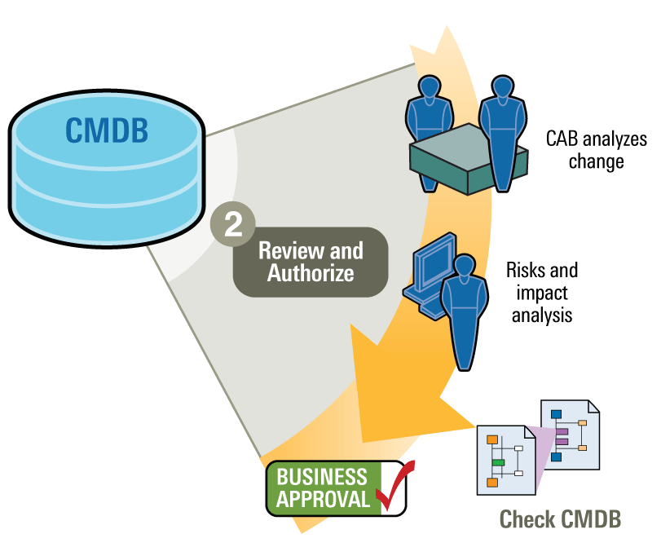  
  
Submit the change request for approval after you have completed planning the change request and provided all the information that the approvers require to review the change request.

When the change request requires an approval move to the next stage, the word **Approval** is displayed on the Process Status Flow bar. You must approve, cancel, put on hold, or reject the approval from the approval table. You can configure the approval settings to require one or all approvers. For more information on configuration options, see [Defining roles](https://docs.bmc.com/docs/display/ars8000/Defining+roles) in the BMC Remedy AR System Approval Server documentation.

It is important to understand that the change manager (or change coordinator) controls the overall progress of a change request. Change managers submit the requests for approval and monitor the approval process. As a manager, you might be required to review change requests for approval. You review change requests and provide approval through BMC Change Management.

| **When using the Best Practice view** | **When using the Classic view** |
| --- | --- |
| **When using the Best Practice view** | **When using the Classic view** |
| The approvers and the approval phase are viewable on the change form. | The approvers and the approval phase are viewable on the **Approvers** tab. |

Approvers are notified when a change request requires their approval. If an approval is reassigned, the new approver is notified. After reviewing the change request, approvers can approve it, reject it, or put it on hold if more information is required. When an approver approves the change request, the change request is refreshed and the updated approval status is displayed in the Approval table on the change form.

When the change request is in the Approval phase, the following fields cannot be modified:

* Services CI
* Impact
* Urgency
* Priority
* Risk Level
* Status
* Class
* Change Location
* Change Manager details
* Change Coordinator
* Relationships
* Operation Categorization
* Product Categorization
* Financial Information
* Any Date fields

An approver might not have have access to the BMC Change Management application to approve a change request. If the approver's access permission does not allow access the change request, he can use BMC Remedy AR System Approval Central to approve change requests. For more information on approving change requests from the Approval Central, see [Approving changes using Approval Central](https://docs.bmc.com/docs/display/change80/Approving+changes+using+Approval+Central).

Note

If no approvers are mapped to an approval phase, or the phase is configured for a self-approval, the change request is refreshed after the approval is complete.

If a technical error occurs when the request is sent for an approval, the change request moves to the Pending status with a status reason as Approval Error. The change user can restart the change request so that it can be sent for approval again.

The change request is refreshed when no approvers are found for an approval phase or when an approver approves the change request.

See the following procedures:

* For information about reviewing proposed change requests and providing or denying approval, see [Handling approvals for emergency change requests](https://docs.bmc.com/docs/display/change80/Handling+approvals+for+emergency+change+requests).
* For information about reviewing the approval process, see [Working with BMC Change Management as an approver](https://docs.bmc.com/docs/display/change80/Working+with+BMC+Change+Management+as+an+approver).
* For information about adding approvers, see [Adding approvers](https://docs.bmc.com/docs/display/change80/Adding+approvers).

Working with BMC Change Management as an approver



BMC Change Management integrates fully with the BMC Remedy Approval Server for business, technical, and financial approvals.

An approver must:

* Be defined in the ITSM Foundational People form
* Be assigned an appropriate application permissions. For example, Infrastructure Change Viewer is sufficient for a user who only needs to approve a request through the Approval Central.
* Have a BMC Remedy Action Request System Read license.
* Have the functional role of Infrastructure Change Approver

Additionally, the server must have the appropriate BMC Remedy ITSM application license.

Note

The BMC Change Management application ships with defined approval processes. Most companies should not have to define additional approval processes. However, you *can* use the Approval Process Configuration form to define additional approval processes for your company. For more information, see [change80:Approval processes provided out-of-the-box for Change Management].

In BMC Change Management application administrators can define an approval process in which a series of people must review and approve a proposed change request or release request. Only after all approvals are granted can the change request or release request be moved to the next status. A change request goes through several phases as it progresses through its lifecycle. Approvers are responsible for reviewing their assigned change requests, and for approving or rejecting them. Approvers are configured by the application administrator and are responsible for change requests with a specific categorization and location.The application administrator also determines which types of change requests need approval, and what type of approval process they require.As the change request moves from one status to another, the default workflow on the change request queries the approval server to find out which approval process to use, and then executes it.

For example, when a change request moves from the Draft status into the Review phase (shown in the following figure), the Approval Server checks the Review approval process. If the application administrator mapped an approver to the Review process, the change request must be approved before it moves to the next stage. Also, the Class and Timing Reason fields are locked by workflow. You cannot make modifications to the values set in these fields until the change request is approved and it moves to the next status in its lifecycle.

**Change request going through Review Approval in the Review & Authorize stage**  


The **Approve** option is enabled in the Process Flow bar when a change request is sent for Approval.

**Approval option enabled**  
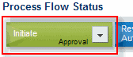

When the user clicks the approve option the change request is approved and it moves to the next status in its lifecycle. In case of an auto-approval (no approver is assigned), the change form is refreshed to show the updated Change status after approval.

Note

The Approve option is displayed to all users, even if the user is not an approver for that change request. If a user, who not an approver for that change request clicks the approve option the following error message is displayed:   
  
You are not currently defined as an alternate for any user and you are not on the Approvers list for this approval. (ARERR 45802).

The change manager or change coordinator controls the overall progression of a change request, and can perform approvals at several points in the change life cycle. For change requests in the Request for Change status with no approvers, the change manager and the change coordinator can move the change forward to Planning In Progress, cancel it, or send it back to the requester by assigning it a status of Draft. After a change is planned and built, the change request is set to a status of Scheduled for Review. Once again, the change manager or change coordinator has the opportunity to review change plans, schedules, and so on, before moving the change to the Implementation Approval phase.The following people perform the approval process:

| **Approver** | **Responsibility** |
| --- | --- |
| **Approver** | **Responsibility** |
| Application administrator | Selects the approval process, and if necessary, modifies the approval rules. Configures the approval mappings. For more information, see [Approval mappings](https://docs.bmc.com/docs/display/change80/Approval+mappings). |
| Change manager (or change coordinator) | Monitors the approval process to make sure that it proceeds as expected. The change manager also determines which types of change requests need approval, and in some cases, selects the approvers. |
| Change approvers | Reviews the change request and approve or reject it. If approvers need more information about a change request, they can request it. Their signature is put on hold while they are waiting for the information and the status is set to More Information. |
| Requester | Checks the status of the change request and follows the approval process throughout its cycle. |

Configuring approvals



BMC Remedy IT Service Management contains a set of approval process configuration records that are predefined and loaded with the application.

The approval process configuration records for managing change and release requests are tightly integrated with the Approval Server, which is shipped with BMC Remedy AR System. The Approval Server should be installed on the computer where BMC Remedy ITSM is installed.

To manage your change request approval process, you must understand at a high-level the different state transitions that a change request passes through. You must know how to map approval processes to approval phases, and how to define approvers for each phase.

The following topics contain information and instructions on configuring approvals:

* [Configuring approvals - Quick start](https://docs.bmc.com/docs/display/change80/Configuring+approvals+-+Quick+start)
* [Permissions and roles required to configure BMC Change Management approvals](https://docs.bmc.com/docs/display/change80/Permissions+and+roles+required+to+configure+BMC+Change+Management++approvals)
* [Approval states on the Status Flow tab](https://docs.bmc.com/docs/display/change80/Approval+states+on+the+Status+Flow+tab)
* [Viewing approval processes in the Approval Server (advanced information)](https://docs.bmc.com/docs/pages/viewpage.action?pageId=151454096)
* [BMC Change Management approval state transitions](https://docs.bmc.com/docs/display/change80/BMC+Change+Management+approval+state+transitions)
* [Understanding the relationship between company and global approval process configuration](https://docs.bmc.com/docs/display/change80/Understanding+the+relationship+between+company+and+global+approval+process+configuration)
* [Default global approval processes for Release Management](https://docs.bmc.com/docs/display/change80/Default+global+approval+processes+for+Release+Management)
* [Default global approval processes for BMC Change Management](https://docs.bmc.com/docs/display/change80/Default+global+approval+processes+for+BMC+Change+Management)
* [Approval process types](https://docs.bmc.com/docs/display/change80/Approval+process+types)
* [How approvals work with change requests](https://docs.bmc.com/docs/display/change80/How+approvals+work+with+change+requests)
* [Working requests through the approval phases](https://docs.bmc.com/docs/display/change80/Working+requests+through+the+approval+phases)

Configuring approvals - Quick start



To get approvals up and running quickly with BMC Change Management, the application administrator must perform the procedure described in this topic. You should review this material before you review the details of how the BMC Remedy Approval Server (Approval Server) works with BMC Change Management.

For more information on the updates that were incorporated as a part of this release for BMC Change Management approvals, see the section on BMC Change Management Approval process under [Enhancements in version 8.0.00].

Notes

* This section assumes you already know how to log on to the BMC Remedy AR System server, open the IT Home page, create a change request, and so on.
* This procedure is also applicable for Release Management.

**Quick start to approvals in BMC Change Management**

| **Step** | **Action** | **Menu item** | **Comments** |
| --- | --- | --- | --- |
| **Step** | **Action** | **Menu item** | **Comments** |
| [1](https://docs.bmc.com/docs/display/public/change80/Configuring+approvals+-+Quick+start#Configuringapprovals-Quickstart-step2) | Review the custom change management process defined for BMC Change Management, if any. | **Custom Configuration** > **Change Management** > **Advanced Options** > **Process Flow Configuration** | For more information, see [Configuring custom process flows](https://docs.bmc.com/docs/display/change80/Configuring+custom+process+flows). |
| [2](https://docs.bmc.com/docs/display/public/change80/Configuring+approvals+-+Quick+start#Configuringapprovals-Quickstart-step3) | Review the approval process configuration records that are installed by default. | **Custom Configuration** > **Foundation** > **Advanced Options** > **Approval Process Configuration** | For more information, see   * [Setting up approval process configuration records for your company](https://docs.bmc.com/docs/display/change80/Setting+up+approval+process+configuration+records+for+your+company) * [BMC Change Management approval state transitions](https://docs.bmc.com/docs/display/change80/BMC+Change+Management+approval+state+transitions) For detailed information about defining additional approval processes and rules in the BMC Remedy Approval Server, see [Setting up the approval process](https://docs.bmc.com/docs/display/ars8000/Setting+up+the+approval+process) in the BMC Remedy AR System documentation. |
| [3](https://docs.bmc.com/docs/display/public/change80/Configuring+approvals+-+Quick+start#Configuringapprovals-Quickstart-step4) | Review the states in the change request that drive the approval process. |  | For more information, see [Approval states on the Status Flow tab](https://docs.bmc.com/docs/display/change80/Approval+states+on+the+Status+Flow+tab). |
| [4](https://docs.bmc.com/docs/display/public/change80/Configuring+approvals+-+Quick+start#Configuringapprovals-Quickstart-step5) | Map approvers to the global approval process configuration records. | **Custom Configuration** > **Change Management** > **Approval** > **Approval Mappings** | For more information, see   * [Approval mappings](https://docs.bmc.com/docs/display/change80/Approval+mappings) * [BMC Change Management approval mappings](https://docs.bmc.com/docs/display/change80/BMC+Change+Management+approval+mappings) * [Release Management approval mappings](https://docs.bmc.com/docs/display/change80/Release+Management+approval+mappings) |
| [5](https://docs.bmc.com/docs/display/public/change80/Configuring+approvals+-+Quick+start#Configuringapprovals-Quickstart-step6) | Create a change or release request, and move it through its various approval phases. |  | For more information, see [Using BMC Change Management] or [Using Release Management](https://docs.bmc.com/docs/display/change80/Using+Release+Management). |
| [6](https://docs.bmc.com/docs/display/public/change80/Configuring+approvals+-+Quick+start#Configuringapprovals-Quickstart-step7) | Approve the change or release request. |  | For more information, see   * [Approvals - Approving change requests](https://docs.bmc.com/docs/display/change80/Approvals+-+Approving+change+requests) * [Managing release management approvals](https://docs.bmc.com/docs/display/change80/Managing+release+management+approvals) |
| [7](https://docs.bmc.com/docs/display/public/change80/Configuring+approvals+-+Quick+start#Configuringapprovals-Quickstart-step8) | Review the status of the change or release request after it is approved. |  |  |

To configure BMC Change Management approvals

1. Review the change management process flow. In the Application Administration Console, select **Custom Configuration** > **BMC Change Management** > **Advanced Options** > **Process Flow Configuration**.   
     
   **Custom Process Flow**  
   Click the following figure to expand it.  
   [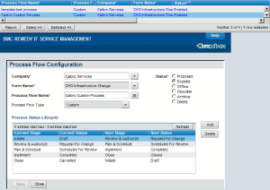](https://docs.bmc.com/docs/download/attachments/151453940/cm_custom_process.gif)
2. Review the approval process configuration records that are installed by default. In the Application Administration Console, select **Custom Configuration > Foundation > Advanced Options > Approval Process Configuration**.   
     
   **Reviewing the approval process configuration records**  
   Click the following figure to expand it.  
   [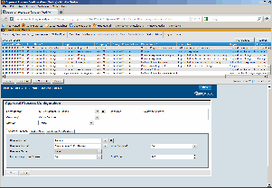](https://docs.bmc.com/docs/download/attachments/151453940/Global-Approval-Proc_62491_516.gif)

Note

BMC does not recommend that you modify the **Global** company record in this form. However, you can create company specific records for the approval process flow.

1. Click the **Status Flow** tab in the approval process configuration records to review the change states that drive the approval process.   
     
   **Reviewing the status flow of the approval process configuration record**  
   Click the following figure to expand it.  
   [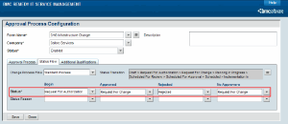](https://docs.bmc.com/docs/download/attachments/151453940/Quick-Start-Status-F_62493_516.gif)  
     
   The Change Process Flow drop-down displays the configured change process flows. It displays the standard process and custom processes created. The contents in the **Begin**, **Approved**, **Rejected**, and **No approvers** fields are displayed based on the Change process selected. This is a mandatory field.   
     
   **Approval and change request states**

| **Approval state field** | **Change request status** | **Approval Server action to the change request** |
| --- | --- | --- |
| **Approval state field** | **Change request status** | **Approval Server action to the change request** |
| **Begin** | Request For Authorization | When the Status of the change request is Request For Authorization, the approval process starts. |
| **Approved** | Request For Change | If the change request is approved, its Status becomes Request For Change. |
| **Rejected** | Rejected | If the change request is rejected, its Status changes to Rejected. |
| **No Approvers** | Request for Change | If there are no approvers defined for the change (that is, if no approvers are mapped to this phase), its Status changes to Request For Change. |

1. Map your approvers to the approval process configuration records. In the Application Administration Console, select **Custom Configuration** **> Change Management** **> Approval** **> Approval Mappings**.   
     
   **Mapping approvers**  
   Click the following figure to expand it.  
   [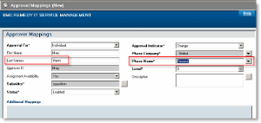](https://docs.bmc.com/docs/download/attachments/151453940/Quick-Start-approval.gif)

Note

Enter only the minimum values (shown in the red areas in the figure) that are needed to create the approver mappings. To enter values in the Additional Mappings area, *carefully* read [Approval mappings](https://docs.bmc.com/docs/display/change80/Approval+mappings) to understand the purposes of these fields and how they are used.

* 1. Enter Mann in the **Last Name** field and then press **Enter**.  
     Mary Mann is part of the Calbro Service sample data.
  2. Select **Global > Review** as the Phase Name.
  3. Ignore the remaining fields on the Approver Mappings form.
  4. Save your changes.
     + If you correctly mapped the approvers to the approval process configuration record, you will see the approver in the **Approvers** tab when the change request reaches the Request For Authorization status, as shown in the figure in step 6.
     + If you correctly mapped the approvers to the approval process configuration record, you will see the approver in the **Approvers** tab when the change request reaches the Request For Authorization status.

1. Create a change request, and then use the Process Flow Status wizard to work the change request through its approval phases.   
     
   **Viewing approval information in a change request**  
   Click the following figure to expand it.  
   [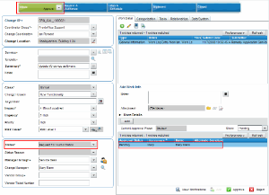](https://docs.bmc.com/docs/download/attachments/151453940/Quick-Start-change-r_62497_516.gif)
   1. Log on to BMC Change Management.
   2. Create a change request and assign it to a specific support group in your company.
   3. Use the Process Flow Status bar to move the change request to the Request For Authorization status.
2. As Mary Mann, log on to the BMC Remedy AR System server as the approver in a browser or user tool, open Approval Central from the IT Home page, and then approve the change request.   
     
   **Approving the change request in Approval Central**  
   Click the following figure to expand it.  
   [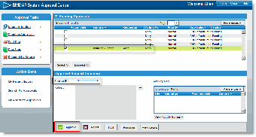](https://docs.bmc.com/docs/download/attachments/151453940/Quick-Start-approv-r_62499_516.gif)
3. Return to the change request, and then refresh it.   
     
   **Flow of change request after approval**  
   Click the following figure to expand it.  
   [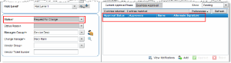](https://docs.bmc.com/docs/download/attachments/151453940/Quick-Start-next-app_62501_516.gif)

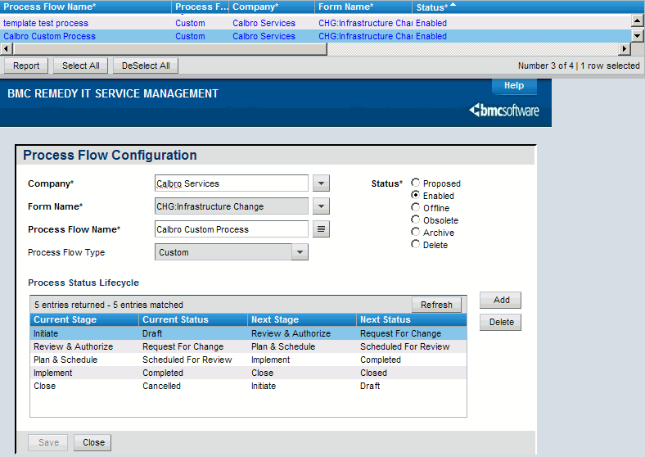

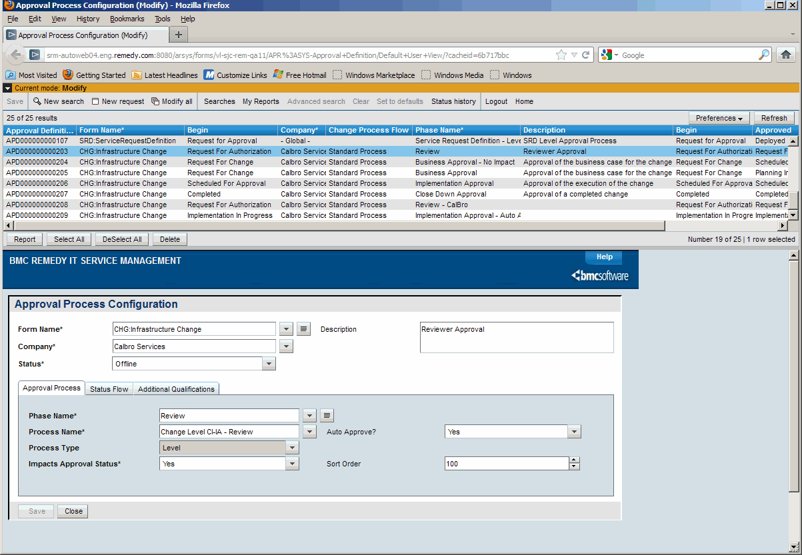

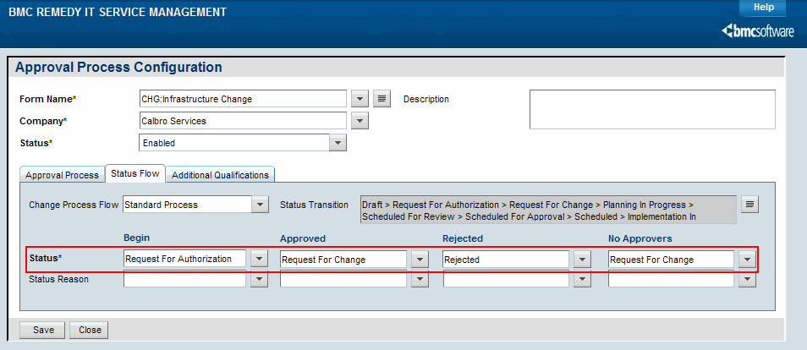

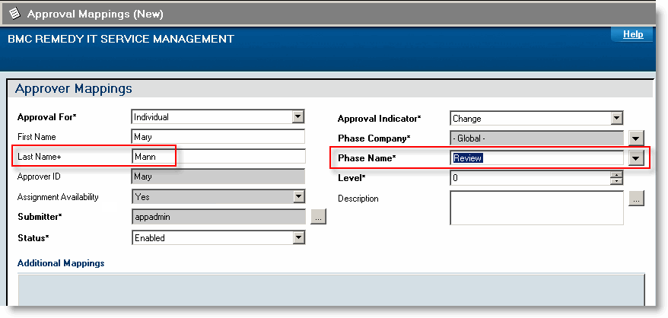

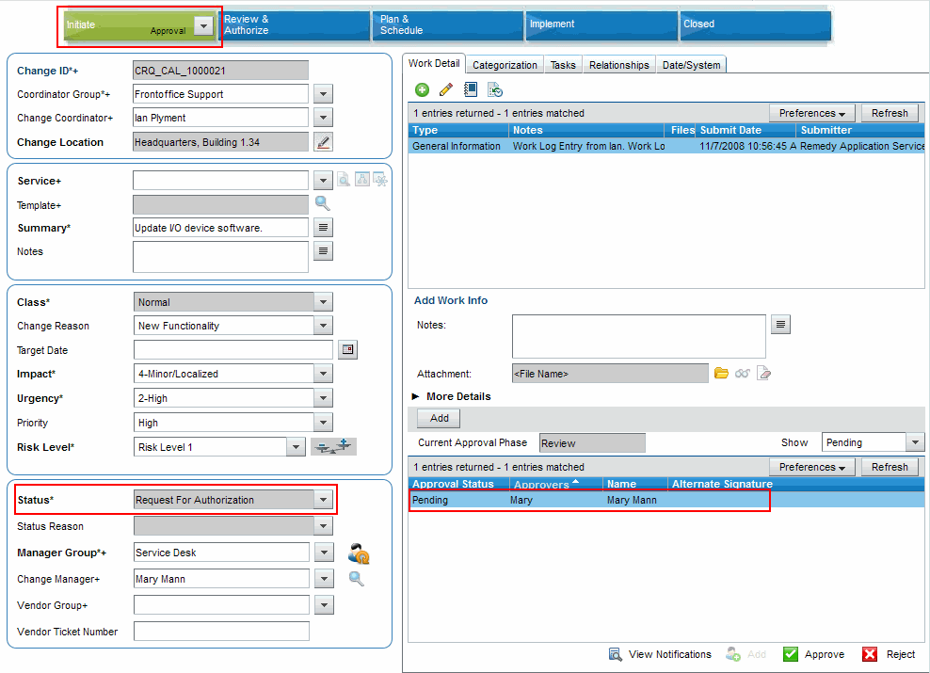

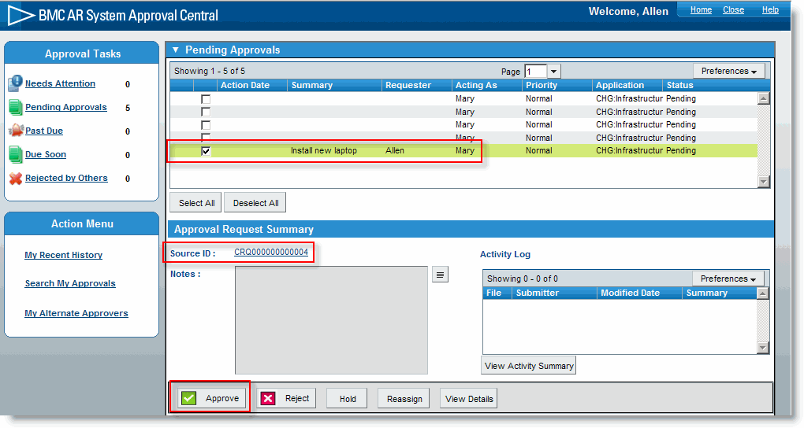

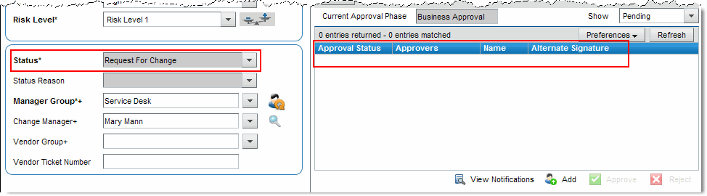

# Permissions and roles required to configure BMC Change Management approvals



Configuring approvals with BMC Change Management requires various permissions and roles. This topics explains what permissions are required for the various tasks.

**Configuring approvals**

| **Task** | **Description** | **Permissions required** |
| --- | --- | --- |
| **Task** | **Description** | **Permissions required** |
| Setting up approval process configuration records for your company | Use the Approval Process Configuration form (**Foundation > Advanced Options > Approval Process Configuration**) to connect the approval process configuration records to companies by phase. | * Infrastructure Change Config * Approval Admin is optional if you require administrative access to the Approval Server configuration forms (AP:Administration) |
| Creating people and mapping roles for approvals | Use the People form (**Foundation> People> People** ) to define people and support groups. | Contact Organization Admin |
| Setting up approval mappings | Use the Approval Mappings form (**Change Management> Approval> Approval Mappings**) to set up approval mappings for the different phases. Includes step-by-step instructions on creating individual and group approver mappings. | One of the following permissions is required to access this form:   * Infrastructure Change Config * Contact Organization Admin * Contact Support Admin * Requester Console Master * Approval Admin is optional if you require administrative access to the Approval Server configuration forms (AP:Administration) |

# Approval states on the Status Flow tab



The states (and lifecycle) of change requests are completely dependent on the settings defined in the **Status** and **Status Reason** fields on the **Status Flow** tab of the Approval Process Configuration form. This means that when the **Status** and **Status Reason** fields for the change requests match the value specified in the Begin column, the approval process starts.

Whenever there is a change in the **Status** and **Status Reason** fields for a change request, the workflow searches the Approval Process Configuration form to see if there are any approval configuration records for the current process combination. If a configuration record is found, then the process name is returned to the change request and the application command to the Approval Server to start the approval process is issued.

When the approval process starts, the **Status** and **Status Reason** fields are locked to prevent further changes to the change request record until there is a decision (approved or rejected) from the approvers.

Approval configuration records are defined for change requests by company, so you can configure several configuration records as needed.

The following table describes the approval states:

| **Approval state** | **Description** |
| --- | --- |
| **Approval state** | **Description** |
| Begin | This state is an indicator to the Approval Server for starting the approval process. By default, the Review phase does not begin until the change request reaches the status of Request for Authorization. |
| Approved | If one or all approvers have approved the change request, then the Approval Server changes the **Status** and **Status Reason** fields values on the change request to match the values configured here. By default, if the change is approved in the Review phase, it then moves to the status of Request For Change. At that time, the locked **Status** and **Status Reason** fields on those records are unlocked and the records go through the rest of their lifecycle.   **Note:** The Approved state is based on the rules set up in the Approval Server (in the AP:Rule Definition form). To access the AP:Rule Definition form from the AP:Administration Console, click the **Rule** tab, select a rule, and then click **View**. For more information about rules in the Approval Server, see [Approval rules](https://docs.bmc.com/docs/display/ars8000/Approval+rules) in the BMC Remedy Action Request System server documentation.   For auto-approvals, the change moves to the status selected in this field, and not to the status selected under No Approvers state. |
| Rejected | This state defines the values of the **Status** and **Status Reasons** fields for change requests if a record is rejected. |
| No Approvers | If the Approval Server does not find any of the mapped approvers, then the **Status** and **Status Reason** field values on the two forms are changed to the values specified.  **Note:** For Change Ad Hoc process and Change Management Chain process, the No Approval state transition is not applicable. If approvers are not found, the change moves to the Pending state with the status reason of Approval Error. For example, if for an Ad Hoc process, if the Change Manager is not defined, we get an error. |

# Viewing approval processes in the Approval Server (advanced information)



For a deeper understanding of how these approval processes are defined in the Approval Server, you can open the AP:Administration form and view them from the **Process** tab. For example, the following figure highlights the change management and asset management processes that are provided out-of-the-box. To access the AP:Process Definition form from the AP:Administration Console, click the **Process** tab, select a process, and then click **View**.

To access the AP:Process Definition form from the AP:Administration Console, click the **Process** tab, select a process, and then click **View**.

**AP:Administration Console – Process tab**  
[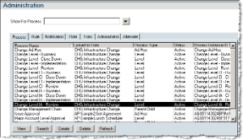](https://docs.bmc.com/docs/download/attachments/151454096/AP-Admin-Process_62537_516.gif)

Notes

* Avoid modifying processes, rules, and roles directly in the AP:Administration form, until you have exhausted all the configuring options in the ITSM Foundation forms.
* You can create additional approval process configuration records and adapt them to your business process instead of creating new ones from scratch. But if necessary, you can create new processes and rules. For detailed information about defining additional approval processes and rules in the BMC Remedy Approval Server, see [Creating new approval requests](https://docs.bmc.com/docs/display/ars8000/Creating+new+approval+requests) in the BMC Remedy AR System Approval Server documentation.

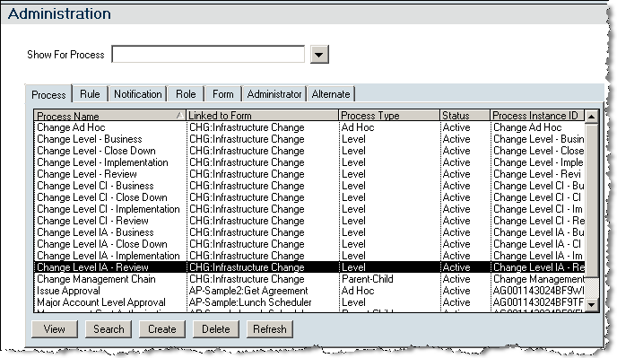

# BMC Change Management approval state transitions



When a change request moves from status to status, the default workflow on the change request queries the Approval Process Configuration form to find out which approval process to use, and then executes it.

If an approval process has been configured for the company, that approval process is used. Otherwise, the approval process configured for the Global company is used.

For example, when a change request moves from the Draft status into the Review phase, the Approval Server checks the Review approval process (Change Level CI-IA - Review) which is one of the five [approval processes](https://docs.bmc.com/docs/display/change80/Default+global+approval+processes+for+BMC+Change+Management) enabled by default to work with BMC Change Management. The Approval Server starts the approval process, and then executes the rules in the order of the approvers who are mapped to the approval phase.

**Change approval process**   
  
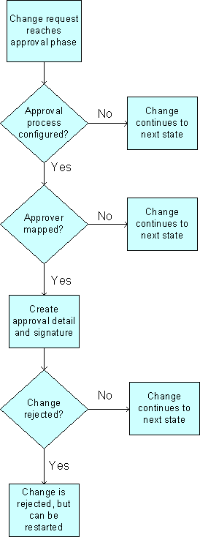

The rules contain the qualifications that set up approvers for each phase of that process, and create the approval detail and signature records for the change. If there are no approvers mapped to the Review process, the change request moves to the next phase (Business Approval).

You must set up the approvers by using the Approver Mappings form, as described in [Approval mappings](https://docs.bmc.com/docs/display/change80/Approval+mappings). The rules query this form using the appropriate criteria, then identify the appropriate approvers, and then add them to the change request record as the approvers. (You can view the approvers on the **Approvers** tab of the change request.)

When an approver approves or rejects the change request, the rules execute again and the next status in the Approval Process Configuration form is set. (See [Approval states on the Status Flow tab](https://docs.bmc.com/docs/display/change80/Approval+states+on+the+Status+Flow+tab).)

The Approval Server continues based on the Approval Server configuration and process type.

* In the Approval Server configuration, if **Approval Success** is set to No More Approvers the approval server continues until there are no approvers found for the process.
* In the Approval Server configuration, if **Approval Success** is set to Completion Rules, the approval server checks for any Completion Rules defined for the approval process. For more information on Completion Rule see, [Completion Check stage](https://docs.bmc.com/docs/display/ars8000/Completion+Check+stage) in the BMC Remedy AR System documentation.
* If the process is a level process type, then the Approval Server first sends the change request to the current level approvers. After the request or offering is approved, the Approval Server sends the request to the next level of approvers. On the **Approvers** tab, only the current level of approvers are displayed even if approvers are specified for several levels.

Note

You can configure additional processes for your company, as needed. For example, you could create a process specifying that change requests require approvals when they reach the Planning in Progress status.

# Approval process types



This topic describes the approval process types that are provided by BMC Change Management and the Release Management module.

For detailed information about defining the approval processes and rules, see [Defining an approval process](https://docs.bmc.com/docs/display/ars8000/Defining+an+approval+process) and [Defining approval rules](https://docs.bmc.com/docs/display/ars8000/Defining+approval+rules) in the BMC Remedy AR System documentation:

BMC Change Management and the Release Management module provide the following approval process types:

| **Type** | **Description** |
| --- | --- |
| **Type** | **Description** |
| Ad Hoc | Provides routing authority to each approver without requiring the administrator to create approver mappings for every individual or group. The Ad Hoc approval process is used in the No Impact Business Approval phase with the Change Manager as the approver. |
| Level | Associates individual approvers, or groups of approvers, with impacted areas or configuration items (CIs), or other additional qualifications. |
| Parent-Child | Uses the **Requested For** manager as the approver. If you configure an approval process that includes the Change Management Chain process, it uses the **Requested For** manager as the approver. If the **Requested For** fields are not filled in (on the Change form under the **Requester** tab), the approval server bypasses the Change Management Chain process.   If you configure an approval process that includes the Release Management Chain process, the approval process uses the manager of the Release Requester (on the **General** tab of the Release form) as the approver.   **Note:** Rule-based approvals are not included by default in BMC Change Management. |

For example, in the Change Management Chain process, if Joe Unser in HR wanted to upgrade the operating system on his computer and created a change request that required the Change Management Chain approval process, the change request would be sent to Joe's manager for approval. Joe's manager is not a member of the IT organization, and, therefore, might not be aware of additional issues surrounding Joe's request. This process is workflow-driven, triggered from the manager data that is stored in the People form.

**Change Management Chain approval process**  
Click the following figure to expand it.  
[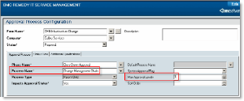](https://docs.bmc.com/docs/download/attachments/151454103/change-mgt-chain_62533_516.gif)

If you select the Change Management Chain process, the **Max Approval Levels** field appears in the Approval Process Configuration form, as shown in the preceding figure. You can specify how deep you want to go in the management chain. For example, if you enter 1, the chain extends only to Joe's manager. If you enter 2, the manager of Joe's manager must approve the upgrade, and so on. However, if you mention 3 levels, and only 2 levels of approvers are available, the approval chain is treated as completed.

Note

For BMC Change Management, you are allowed only one record per company with the process type of Parent-Child. If an administrator attempts to create a second approval phase with the Change Management Chain (Parent-Child) process type selected, the following error message is displayed: Only one 'Approval Phase' for '$Company$' can be set to use the 'Parent-Child' 'Process Type'.   
  
In addition, you should use a unique approval process for each phase. Otherwise your approvals do not work as expected.

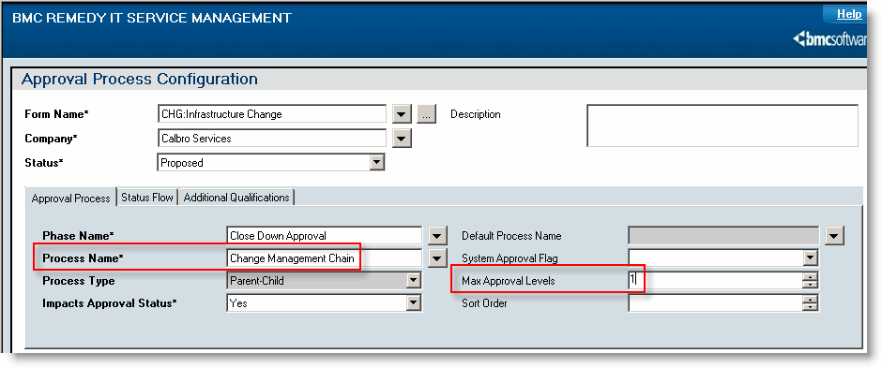

# How approvals work with change requests



The change manager or change coordinator controls the overall progression of a change request, and can perform approvals at several points in the change lifecycle.

For change requests that have a status of Request for Change with no approvers, the change manager or the change coordinator can move the change forward to Planning In Progress, cancel it, or send it back to the requester by assigning it a status of Draft.

After a change is planned and a change request is built, the change request is set to a status of Scheduled for Review. The change manager or change coordinator can again review change plans, schedules, and so on, before moving the change to the Implementation Approval phase.

The following figure shows the **Approvers** tab on the Change form:

**Change request — Approvers tab**  
Click the following figure to expand it.  
[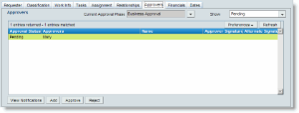](https://docs.bmc.com/docs/download/attachments/151454020/approvals-tab_62574_516.gif)

The following options are available to control the functions that involve approvers:

| **Option** | **Description** |
| --- | --- |
| **Option** | **Description** |
| **View Notifications** | Opens the APR:Non-ApprovalNotifications form so that you can view notifications in either Pending or Notified status. The APR:Non-ApprovalNotifications form enables you to specify a person or group to be notified when a change reaches a particular approval phase, even though that person or group does not need to approve the change. |
| **Add** | Allows you to assign a new individual or group to approve the change. |
| **Approve** | Allows defined approvers to approve the change. A change manager or change coordinator can approve the change on behalf of the selected approver, if they are defined as alternates.   This button is enabled only for users who are valid approvers for the change request. |
| **Reject** | Allows defined approvers to reject the change. A change manager or change coordinator can reject the change on behalf of the selected approver, if the change manager or change coordinator are defined as alternates.   This option is enabled only for users who are valid approvers for the change request. |

The read-only **Current Approval Phase** field displays what approval phase the change is in.

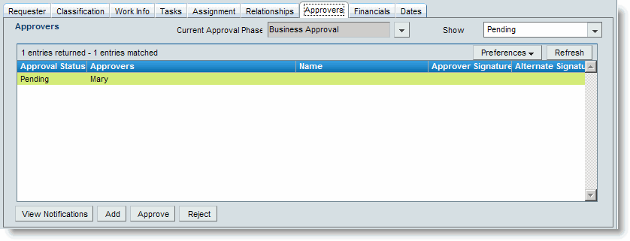

# Working requests through the approval phases



When an approval is required to move the request to the next status, the word Approval is displayed on the Process Status Flow bar. You need to approve or reject the approval, or cancel the request. When an approval is required, you cannot move the request to the next status unless you first receive an approval or rejection. When a request requires an approval, its approvers are notified. Notifications are sent according to the method specified in the approver's record in the User form.

Note

The Approval Process Configuration form is used to configure the sequence when a request is approved or rejected, or configure how the system should respond if no approvers are available.

When you have finished planning the request, and have supplied all the information that the approvers require to review the request, you can submit the request to the approval process.

To submit the request to the approval phase

1. Open the change request or release request.
2. Proceed through the states of your request.

Tip

When you reach a crucial state and perform an important action (for example, adding dates in the Scheduled status), refresh the request to make sure you are viewing the correct step in the workflow.

**Approving the request — Best Practice view**  
Click the following figure to expand it.  
[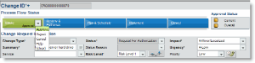](https://docs.bmc.com/docs/download/attachments/151454026/approving-CRs_62577_516.gif)

1. When you reach an approval phase, do one of the following tasks:

| **When using the Best Practice view** | **When using the Classic view** |
| --- | --- |
| **When using the Best Practice view** | **When using the Classic view** |
| In the Approvals section, click **Approve** or **Reject**. | Click the **Approvers** tab and then approve or reject the request. |

1. Note
2. The **Approve** and **Reject** options are enabled only if you are a valid approver or an alternate approver for the selected approval record.   
     
   As a change manager or a change coordinator (or a release coordinator or release assignee), you can perform these actions for standard approvals if you are the approver or an alternate approver.
   * If the change is configured for the change level approval process, all approvers on the first level are notified that they must review the request.
   * If the change is configured for the change management chain (parent-child) approval process, the manager of the **Requester For** user is notified.
   * If the change is configured for the ad hoc approval process, the change manager is notified.
   * The signature of the last approver completes the approval process, and automatically moves the change request to the next status.
3. Save your changes.

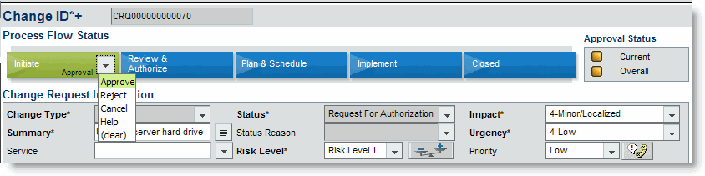

# Configuring phase and exit criteria milestones

* **https://docs.bmc.com/docs/s/en_GB/5983/f3e491afc761ac0a6981cfa3dcbc04fc7e88c149.36/_/download/resources/com.atlassian.confluence.plugins.confluence-page-banner:page-banner-resources/images/red_padlock.png**

You can enforce milestones that require all change requests and activities to be completed before the release can move to the next milestone. For example, you can configure Release Management so that all the Planning activities must be completed before the release can move to Build.

**Release Milestone Configuration form**  
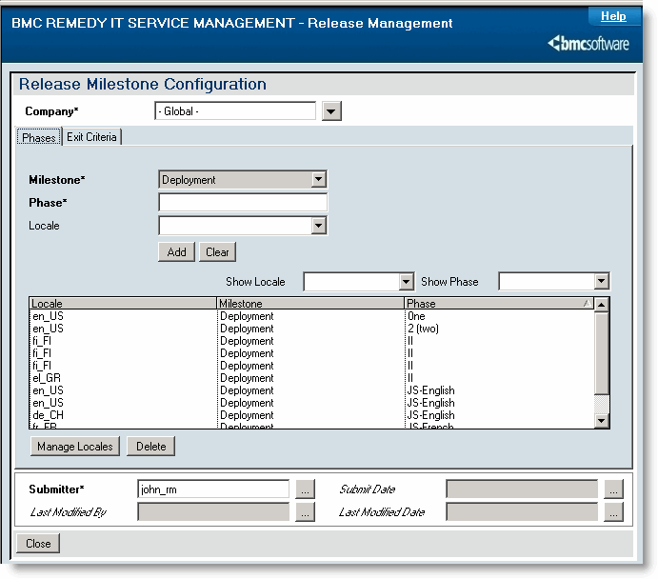

The Release Milestone Configuration form allows you to define phases, as well as the exit criteria, for each milestone.

Note

For the 7.5.00 and 7.6.00 releases, you can configure phases only for the Deployment milestone.

Finally, you can use this form to localize release milestones.

To configure phase milestones

1. In the Application Administration Console, click the Custom Configuration tab.
2. From the Application Settings list, choose **Release Management> Advanced Options> Milestone Configuration**, and then click **Open**.   
   You can filter table results by using the **Show Locale** and **Show Phase** menus. The **Show Phase** menu only shows phases defined for the locale you are in.
3. In the **Phase Name** field, define the Deployment phase that requires a milestone (for example, Phase 1, Phase 2, and so on).
4. Select a locale from the menu, and then click **Add** to create a new locale for the Deployment milestone (for example, en_AU for Australian English).
5. Define the localized text for each phase by performing the following actions.
   1. After adding a phase, select the phase from the table, and then click **Manage Locales**.  
      The Defined Locales dialog box appears, where you can add localized text for the selected phase.   
        
      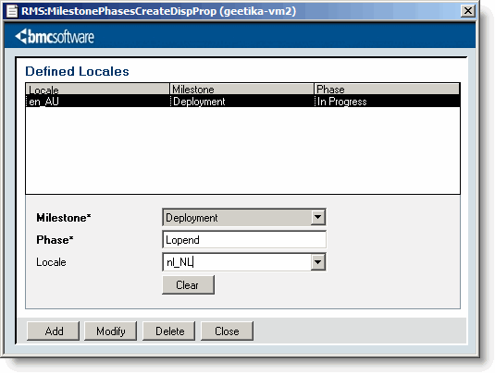
   2. Enter localized text into the **Phase** field.
   3. Select the locale.
   4. Click **Add**.   
      You can modify or delete localized text as needed.
   5. Close the Manage Locales dialog box when you are finished.   
      The localized text appears in the Release Milestone Configuration form.
   6. Close the Release Milestone Configuration form when you are finished.

# Configuring release priorities



In addition to the release priorities supplied out-of-the-box for you, the Release Management administrator can define new Priority maps with an Impact and Urgency combination. You can configure release prioritization data for each company, or create new global priorities. If you create and enable a new release priority, it overrides the default setting, unless you disable it.   
  
When creating priorities, the Priority field on the main Release form is calculated based on the Urgency and Impact specified.

Note

Impact + Urgency = Priority.

To configure release priorities

1. In the Application Administration Console, click the Custom Configuration tab.
2. From the Application Settings list, choose **Release Management> Advanced Options> Release Prioritization**, and then click **Open**.
3. Select a company to create the release prioritization for.   
   You can create a process flow for Calbro Financial Corporation and a completely different flow for a different corporation.   
   If you select **Global**, the approval process applies to all companies.
4. (Optional) Enter a description.
5. In the **Urgency** field, specify the importance assigned to the release (for example, 3-Medium).
6. In the **Impact** field, specify the extent to which the release affects the business (for example, 3-Moderate/Limited).
7. In the **Priority** field, specify the importance you (as support staff) assign to the release (for example, Low).
8. Save your changes.

As a result, when a release coordinator creates a release for Calbro Services and selects an Impact of 3-Moderate/Limited and Urgency 3-Medium, the Release form now is set to the new Priority of Low.

**Defining priorities in the Release form**  
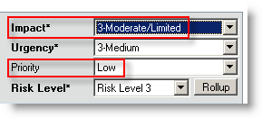

# Configuring release rules



You use the Release Configuration Rules form to configure the method of assignment used to automatically select a release coordinator to assign to a release request. Each company defined in the Company form can have its own assignment rules.

You can configure assignment for one company, or you can define it for all companies using the Global option. When Release Management uses assignment (for example, when assigning a release to a release coordinator), the Assignment Engine first checks the assignment rules for the requester's company. If no rules are found, it then uses the rules defined for Global.

By default, the Global assignment method follows the Round Robin assignment process.

To configure release rules

1. In the Application Administration Console, click the **Custom Configuration** tab.
2. From the **Application Settings** list, choose **Release Management > Advanced Options > Rules**, and then click **Open**.
3. From the **Company** list, select the company for which you want to configure assignment, or select the **Global** option.  
   Selecting Global configures assignment for all companies.
4. For **RMS Rule Status**, select **Enabled**.
5. Complete the following optional fields as required:

| **Field** | **Description** |
| --- | --- |
| **Field** | **Description** |
| **Assignment Engine Integration** | To enable assignment, select **Yes** (default). |
| **Assignment Process Name** | Select the default process for the release coordinator assignment. The options for assigning releases to release coordinators are as follows:   * + **Capacity** — Capacity in the assignment engine is a ratio-based assignment method.   + **Number** – Tracks the number of tickets assigned to the person. The number assignment process selects the release coordinator with the least number of tickets already assigned.   + **Round Robin** — Tracks the last time the release coordinator received an assignment. The round robin assignment process selects the person who was least recently assigned an incident. |
| **Require Service CI Related** | Select whether users must specify a Service CI (from the Service field) when creating a release request. The default is **No**.   If you specify **Yes** in the Require Service CI Related field, select the milestone by which the Service CI must be related. |
| **Require Scheduled Dates** | Select if users must specify the scheduled start dates (in the Dates tab) when creating a release request. The options are **No** (the default setting) and **Yes**.   If you specify **Yes** in the Require Scheduled Dates field, select the milestone by which the scheduled start date must be defined.   For example, you could configure the release rules so that users must enter the scheduled start date during the Initiate milestone. |
| **Auto-close** | Specify whether release requests are automatically closed. The options are No and Yes (the default setting).   If you specify that release requests are automatically closed, enter the number of days a release request remains in the Close Down milestone before its status is automatically set to Closed.   The default setting is 10. |
| **Action On Deployment Dates Change** | Specify the action to be taken when users modify the deployment start date and the release request is in the In Progress status during the Deployment milestone.   The options are Error Message, Warning Message, or No Action. No out-of-the-box settings are provided with this field. |
| **Business Hours Selection** | Specify whether to use company hours or assignee hours to calculate times associated with release requests.   **Note:** You must perform the Business Hours Workdays and Business Hours Holidays configuration tasks to set the company's daily hours and holidays. |

1. Click **Save**.

# Configuring activity rules



You use the **Activity Configuration Rules** form to configure the method of assignment used to automatically assign an activity. Each company defined in the **Company** form can have its own assignment rules.   
  
You can configure assignment for one company, or you can define it for all companies using the Global option. When the Activity System uses assignment (for example, when assigning an activity), the Assignment Engine first checks the assignment rules for the requester's company. If no rules are found, it then uses the rules defined for Global.

By default, the Global assignment method is according to Round Robin.

Note

The activity notifications process is identical to release notifications.

To configure activity rules

1. In the Application Administration Console, click the **Custom Configuration** tab.
2. From the Application Settings list, choose **Activity System > Configuration > Rules**, and then click **Open**.
3. From the **Company** list, select the company for which you want to configure assignment, or select the **Global** option.   
   Selecting Global configures assignment for all companies.
4. To enable assignment, select **Yes** for Assignment Engine Integration.
5. Select the default process for the assignment from **Assignment Process Name**. The options for assigning activities are as follows:
   * **Capacity** — Capacity in the assignment engine is a ratio-based assignment method.
   * **Number** — Tracks the number of tickets assigned to the activity user. The number assignment process selects the person with the least number of tickets already assigned.
   * **Round Robin** — Tracks the last time the activity user received an assignment. The round robin assignment process selects the person who was least recently assigned an incident.
6. For **Activity Rule Status**, select **Enabled**.
7. For **Activity Status for Task Activation**, define at which status of the activity request, the task associated with it should become active. For example, if you select the In Progress status in this field, the task associated with the activity request is activated when the request moves to the In Progress status.
8. Click **Save**.

# Enabling chat, Twitter notifications, and RSS feeds



To use the chat, Twitter notification and RSS feed functionality, you must enable it. Out of the box, these options are disabled by default.

To enable chat, Twitter notification, and RSS feed functionality

1. Select **Application Administration Console > Custom Configuration > Foundation > Advanced Options > System Configuration Settings - System Settings**.
2. Click **Open**.
3. Select the Social Collaboration features to enable:
   * Enable Notification via Twitter
   * Enable RSS Feed
   * Enable Chat
4. Click **Save**.
5. For your changes to take effect, log out and log back on.

# Setting time zone preferences for the Change Calendar



If your BMC Change Management application accesses a BMC Remedy Mid Tier server that is located in a different time zone, the time information that appears in your Change Calendar the time where the BMC Remedy Mid Tier server is located, not your local time.

For example, you work in the Pacific time zone and you are assigned a change that should start at 10:00 A.M. PT. However, your BMC Remedy Mid Tier server is in the Eastern time zone (which is three hours ahead of Pacific time), so your Change Calendar shows a scheduled start time of 1:00 P.M.

You can fix this discrepancy by indicating your local time zone in the BMC Remedy AR System user preference record that is associated with your BMC Remedy AR System login ID.

To set the time zone in your BMC Remedy AR System user preference record

1. Log on to the system as a AR System Administrator.
2. Select **Applications > AR System Administration > AR System Administration Console**.
3. On the BMC Remedy AR System Administration Console, click **User Preferences > Search User Preferences**.
4. Search for your user record, and then select it.
5. Click the Locale tab.
6. From the menu beside the **Time Zone** field, select your time zone.
7. Click **Save**.

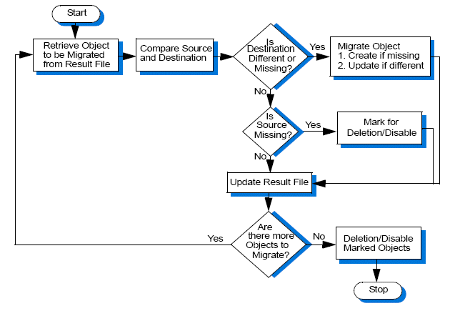

# Change Calendar preference settings



You can configure and customize the following preference values and filter choices in the Change Calendar:

* Default settings in the Quick Filter dialog box
* Duration, global, and level settings of business events that appear in the Change Calendar
* Amount of data that appears when a user scrolls through the Change Calendar

To configure the Change Calendar

1. From the Application Administration Console, click the **Custom Configuration** tab.
2. From the Application Settings list, choose **Change Management** **> Advanced Options** **> Change Calendar**, and then click **Open**.  
   The Calendar Administration form appears.
3. In the Business Events area, specify the default duration of events and change requests displayed in the Change Calendar.  
   This is the time period that users see the first time they open their calendar. You can display 5 or 7 days of business events and change requests. In the 1 day view, only change requests are displayed.
4. Specify whether global events are displayed.  
   This setting is helpful if your organization is acting as a service provider for multiple companies. The global setting shows all business events.
5. Specify the level of business events.  
   Enter a number to determine which level of business events are displayed. Each business event has a level attached to it.
   * If you enter a level number, only the business events with that level are displayed.
   * If you do not enter a level, all business events are displayed.   
     Business events are ordered in the display from top to bottom with the lower-level events first.
6. Specify the service CI levels.  
   Enter a number to determine the maximum level at which the service CIs are defined.   
   Service CIs are in a hierarchical structure as defined by the user's company. Users can specify the depth level to search. For example, depth level 2 means to search the specified CI, its children, and its grandchildren (in the hierarchy tree) for all the related change requests. Service CIs that are assigned lower numbers are processed before those that have higher numbers.
7. Specify any default print preferences for the calendar.   
   You can define page type and orientation for the calendar and provide a default title. Do not use single quotation marks (') in the title string (they cause JavaScript errors).
8. Click the **Change** tab, and then enter information as needed in the following fields in the Change Requests area:

| **Field name** | **Description** |
| --- | --- |
| **Field name** | **Description** |
| **Change Status** | State transition in the change request life cycle (for example, Draft) |
| **Approval Status** | State in change request life cycle that requires an approval to move forward (for example, Pending) |
| **Risk Level** | Relative risk associated with the change, from Risk Level 5 (highest risk) to Risk Level 1 (lowest risk) |
| **Priority** | Importance assigned to the change request |
| **Company** | Requests for a particular company. This field is especially useful in a multi-tenancy environment. For more information, see [Multitenancy](https://docs.bmc.com/docs/display/itsm80/Multi-tenancy) in the BMC Remedy ITSM Suite documentation. |
| **Region** | Particular area of a company (for example, North or South) |

1. Quick filtering is activated by default for any user logging on to the calendar for the first time. However, users can create their own customized search preferences as needed. The filter settings that then appear are the preferences that the user defined.
2. Click the **Release** tab, and then enter information as needed in the following fields:

| **Field name** | **Description** |
| --- | --- |
| **Field name** | **Description** |
| **Milestone** | Phase in the release request life cycle (for example, Initiate) |
| **Release Status** | Status transition in the release request life cycle (for example, Registered) |
| **Risk Level** | Relative risk associated with the release, from Risk Level 5 (highest risk) to Risk Level 1 (lowest risk) |
| **Impact** | Extent to which the release affects the business |
| **Priority** | Importance assigned to the release request (for example, High) |
| **Release Type** | Categorizes the release that is released into the IT infrastructure (for example, Delta or Package) |
| **Deployment Type** | Categorizes the deployment that is released into the IT infrastructure (for example, Phased) |
| **Company** | Requests for a particular company. This field is especially useful in a multi-tenancy environment. For more information, see [Multi-tenancy](https://docs.bmc.com/docs/display/itsm80/Multi-tenancy) in the BMC Remedy ITSM Suite documentation. |
| **Region** | Particular area of a company (for example, North or South) |

1. Click the **System** tab.
2. Specify whether to enable the **Monthly View Colors**.   
   This setting can impact performance. When a large set of data is pulled from the server and displayed, the Date-Picker must fetch all the data from the server, compute the risks for each day, and then display the month color-coded by risk level. As a result, you might see slower performance in the server.   
   Color coding applies to the date headers at the top of the Change Request chart and to the Date-Picker.   
   If you disable the Monthly View Colors, the Date-Picker redisplays all days with a white background. After users log out and log back on, they no longer see the days of the month color-coded by risk.
3. Click **Save**.Users must log out and back in to activate the new preference settings.