**Steps to view this project**

Sir I have also attached html file and deployed model in it. If you want to look into it following steps would required otherwise there is IPYNB and joblib file to directly view the model.

1. Open Anaconda prompt



2. Use cd command in prompt to reach to the folder where it has been saved.

Now type “python app.py”

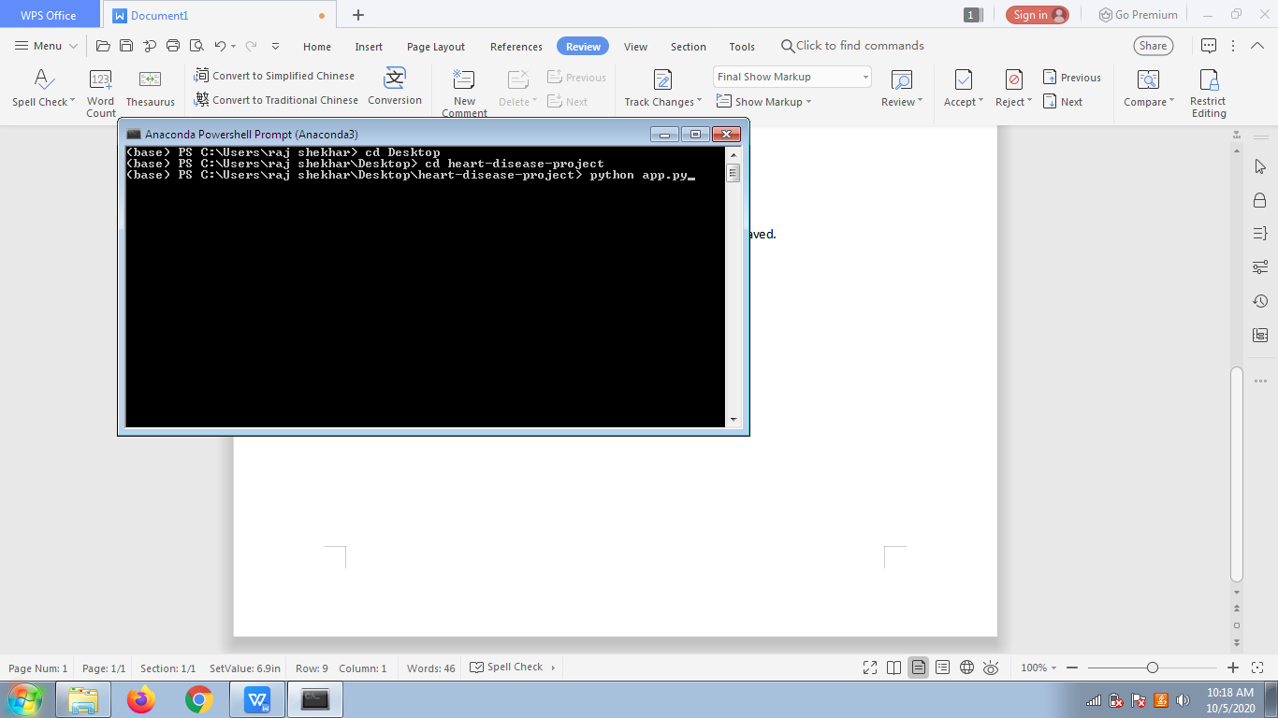

1. As soon as you press enter link will appear in last line.

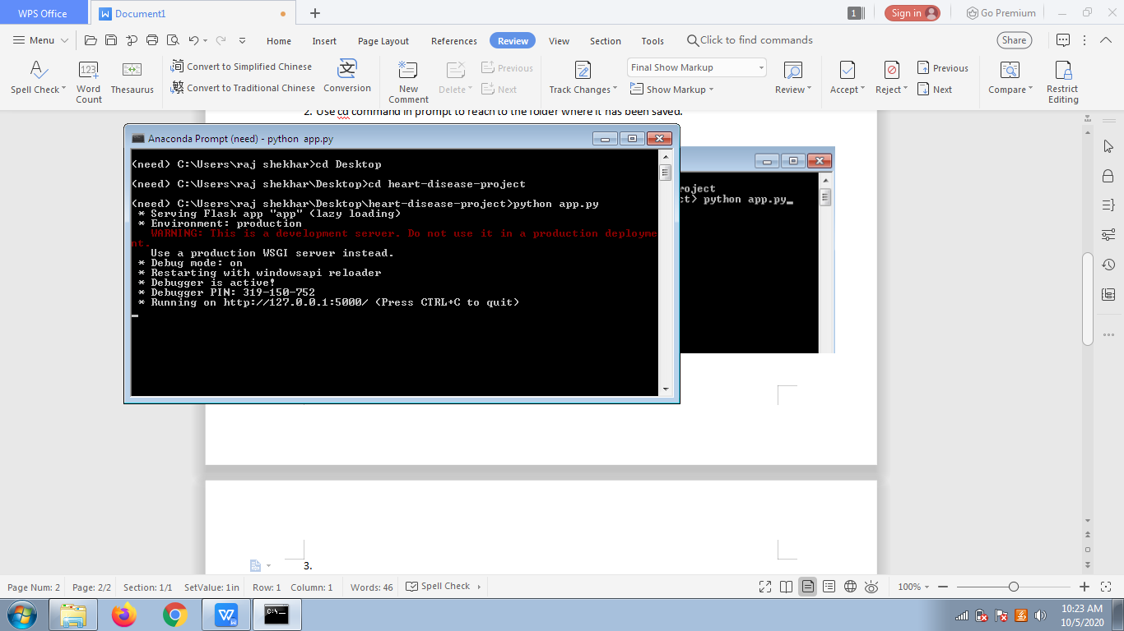(I have joblib to the model. It may cause some compatible issues.)

1. Copy this “http://127.0.0.1:5000/” now paste it in the browser. Following screen will appear. Fill the data and press Predict button

