Review of Introduction to Control and Scheduling Co-design

This paper introduces the concept of integrating control and scheduling models to achieve better control performance. The co-design of the system is required because of the limited computing resources availability. While designing control systems, it needs to know about the available computing resources (i.e. CPU time or communication bandwidth) so that it can improve control performance.

Real time scheduling of the task is done by two methods: EDF and RM. EDF (Earliest Deadline First Scheduling) schedule the task on-line based on which task has shortest remaining time to finish (deadline) whereas, RM (Rate monotonic Scheduling) priorities task off-line based on the shortest sampling time which is why it is fixed priority sampling.

In Control loop timing, three main parts are data collection (sampling), computing and output (response). Control delay (computing) and sampling period is most important part of the control loop which is directly influenced by the scheduler due to multiplexing or high priorities task. There can be sampling jitter or latency jitter which can make the control loop unstable that’s why understanding jitter introduces by scheduler, is important to understand so that controller should be designed to reduce the jitter.

Since (Timing Compensation) most of the controllers are made to compensate for the disturbance in the sampling period and control delay because of robustness of the controller. So even if the jitter or latency is produced by the scheduler which is non-deterministic, it will be handled properly by varying the controller parameters at each sample interval.

Q. Since, Varying the controller parameters could help make the controller robust to the jitter and latency caused by scheduler then why do we need co-design?
- If jitter or latency caused by scheduler keep pushing it for long time, then even if we recompute the controller parameters to compensate will not help stabilize the system.
- It will help design the control system so that it will consider the effect of scheduler behavior beforehand so that it will reduce the latency and jitter effect.

Suppose there are number of controller tasks and to improve the global performance of the tasks then scheduler needs to adjust the task attributes (i.e. sampling period, computing time, Task priority) of each controller task on-line. However, for on-line adjustment of the task attributes requires that scheduling algorithms and control algorithms are integrated off-line which should allow incorporation of computing resources availability to the control design.

Feedback Scheduling help optimize the control performance by adjusting the task attributes (like sampling period) on-line, but it requires right signals or control parameters and instructions made off-line. The goal of the scheduler is to minimize the CPU utilization which will be done by adjusting the sampling frequency of the controller task or changing the task modes (like switching to high precision trajectory tracking). Since cost does not depend monotonically on sampling period, it requires cost function that includes sampling period, input-output latency and jitter which will adjust the task attributes and optimize the control performance.

MPC controller can be used as anytime controller which can be used to reduce the workload by adjusting the task attributes, by decreasing the maximum allowed execution time for the task.

Review of Resource-Aware Automotive Control System Design
This thesis considers the limited computational resources available in automotive embedded systems and investigates how processor time and memory can be used more efficiently by vehicle control applications. As vehicles become increasingly automated, they rely on a growing number of complex control functions, which increases computational demand and makes efficient resource utilization more important. The thesis therefore examines several embedded-system-level factors that affect control performance, including task scheduling, cache and memory usage, processor workload, execution time, power consumption, thermal effects, and processor aging. Its overall goal is to improve the efficiency of automotive controllers while maintaining the required control performance.

Resource-aware design contributions
1. Memory-aware Automotive Control Systems Design:
The key idea over here is how to execute the control applications so that WCET (Worst Case Execution Time) will be reduced. For better results, this thesis presented that executing the same control application consecutively will save the cache memory which will reduce the information fetching time from flash memory thus reducing the total execution time.
Two sampling orders, S1 (Conventional memory-oblivious scheme) and S2 (memory-aware sampling order, are used to show the WCET results. They found that S1 has same WCET for all control applications. However, S2 have different execution times like E_wc(2) and E_wc(3) have shorter execution times compared to E_wc(1).

Co-design Levers | Function
Sampling period | Time interval at which control program will be executed which will affect the processor workload which is dependent on the WCET.
Memory-aware Sampling order | It changes the cache reuse and hence affects the execution time of the control application and overall control performance
Number of consecutive executions | It is important when the sampling order is non-uniform. Because idling time and settling deadlines need to meet so that overall control performance is improved.
Settling time | How fast it converges to the desired value which in turn get effected by the gains
WCET | execution time of each control application
Sensor-to-actuator delay | This parameter depends on the WCET
On-chip cache behavior | Direct-mapped cache and fully associative cache which will define how memory block will be placed to each cache line which in turn effect WCET
Controller Gain | It is obtained by finding the optimal poles given that we have optimal sampling order so that all the controller design constraint is met like settling time.

2. Computation-aware Automotive Control System Design:
The goal of computation-aware control design is to minimize the processor utilization of control applications sharing an ECU while satisfying all control-performance and system constraints.
The OSEK/VDX operating system is a commonly used automotive real-time operating system that supports fixed-priority scheduling. It provides a predefined set of allowable task periods, and each control application must operate using one of these periods or a feasible combination of them. Because the optimal sampling period for a controller may not be directly available, the main challenge is to design a controller that can operate under nonuniform sampling while maintaining good control performance and reducing processor workload.
1. Multirate controller design
The proposed multirate controller allows a control application to switch among multiple sampling periods defined by a cyclic schedule. A schedule contains a sequence of allowable sampling periods that is repeated continuously. For example, rather than operating with one fixed sampling period, the controller may follow a sequence containing both short and long sampling intervals.
A shorter fixed sampling period, such as 2 ms in the thesis, generally improves the settling time because the controller updates the control input more frequently. However, it also increases processor utilization because the control algorithm must execute more often. This high computational demand may prevent additional control applications from being integrated on the same ECU, which is undesirable in the cost-sensitive automotive domain.
To address this tradeoff, the thesis proposes a multirate scheduling approach in which different control applications use different cyclic sampling schedules while sharing the same ECU. In the four-application example, two control applications use one schedule containing shorter sampling periods, while the other two use another schedule containing longer sampling periods. The schedules are coordinated and repeated cyclically so that the applications can share the processor without exceeding its available computational capacity.
This approach allows more control applications to be integrated on a single ECU while satisfying their settling-time, stability, and actuator constraints. More precisely, the method aims to reduce the processor utilization of each control application and improve overall ECU resource utilization, rather than “maximize processor utilization.” By using the available processor capacity efficiently, the approach can reduce the number of required ECUs and therefore lower implementation cost.

Co-design Levers | Functions
ET and TT scheme | Task triggering process either by events or by time
Hyperperiod | Minimum common multiple of all periods
Multirate schedule | Switching the schedule between the controller in cyclic, like $S1=\left\{\text{2 ms},2\text{ ms},5\text{ ms, 5ms}\right\} and S2 = \{5ms, 5ms, 2ms, 2ms\}$
ECU | Single-core ECU (presented in this thesis) and Multi-core ECU
OSEK/VDX | OS which provides the sets of sampling periods which can be used to design the controller sampling period
MPC discretization | To match the sampling period with the MPC prediction horizon

3. Battery- and Aging-aware Automotive Control system Design
//TODO

Some Closes Priori work related to SDV:
Physical state aware | Physical-State-Aware Dynamic Slack Management for Mixed-Criticality Systems, 2018.
EDF-VD based | Yi-Wen Zhang, Ning Cai, Energy efficient EDF-VD-based mixed-criticality scheduling with shared resources, 2021

Questions:
1. Choosing the vehicle dynamic model for the MPC prediction:
Kong dynamic bicycle
$${\dot{v}}_{x}=rv_{y}+a_{x}$$
$${\dot{v}}_{y}=-rv_{x}+\frac{2}{m}\left(F_{y,f}{\cos{δ}}_{f}+F_{y,r}\right)$$
$$\dot{r}=\frac{2}{I_{z}}\left(l_{f}F_{y,f}-l_{r}F_{y,r}\right)$$
With global kinematics:
$$\dot{X}=v_{x}\cos{ψ}-v_{y}\sin{ψ}$$
$$\dot{Y}=v_{x}\sin{ψ}+v_{y}\cos{ψ}$$
$$\dot{ψ}=r$$
states and inputs:
$$x={\left[\begin{matrix}X & Y & ψ & v_{x} & v_{y} & r\end{matrix}\right]}^{T}$$
$$u={\left[\begin{matrix}a_{x} & δ_{f}\end{matrix}\right]}^{T}$$
What we need for the input:
$$u={\left[\begin{matrix}T_{df} & δ_{f}\end{matrix}\right]}^{T}$$
So, we need to convert $a_{x}$ into torque?

Simulink Testbed Design:
a) Open loop steady-state drive test:
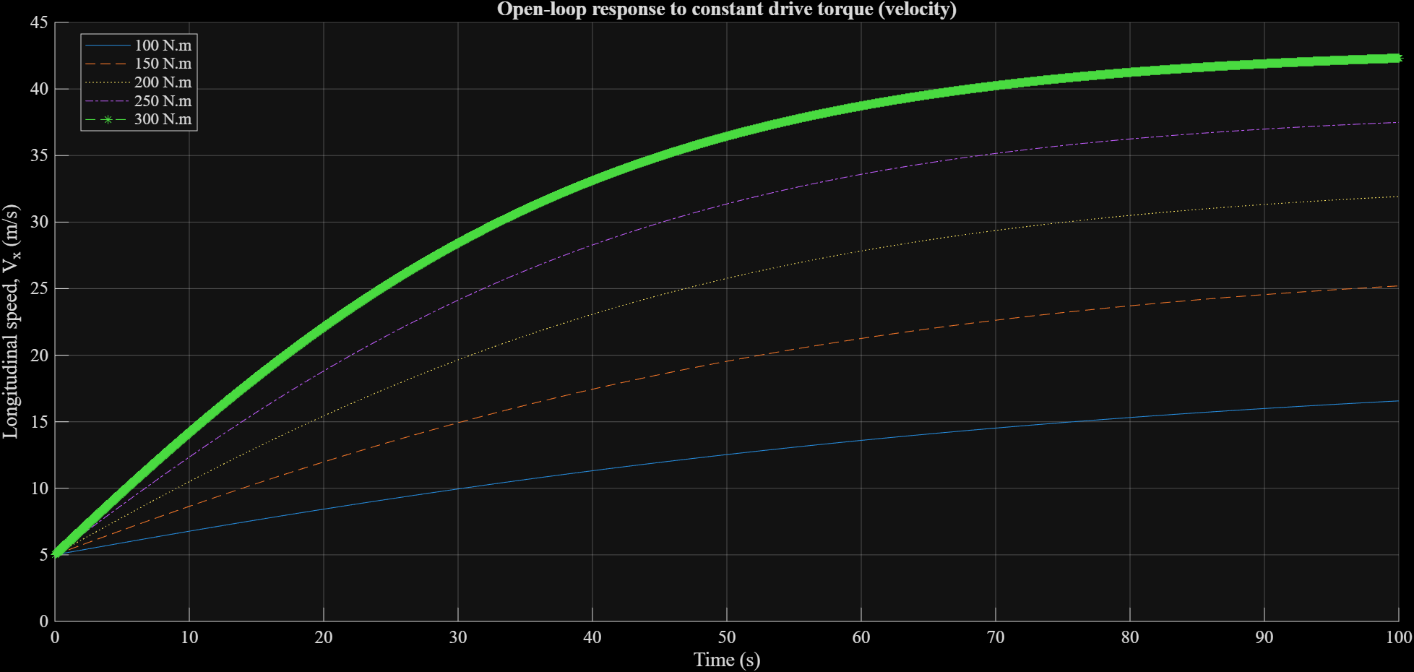
Figure 1 Open loop response to constant torque

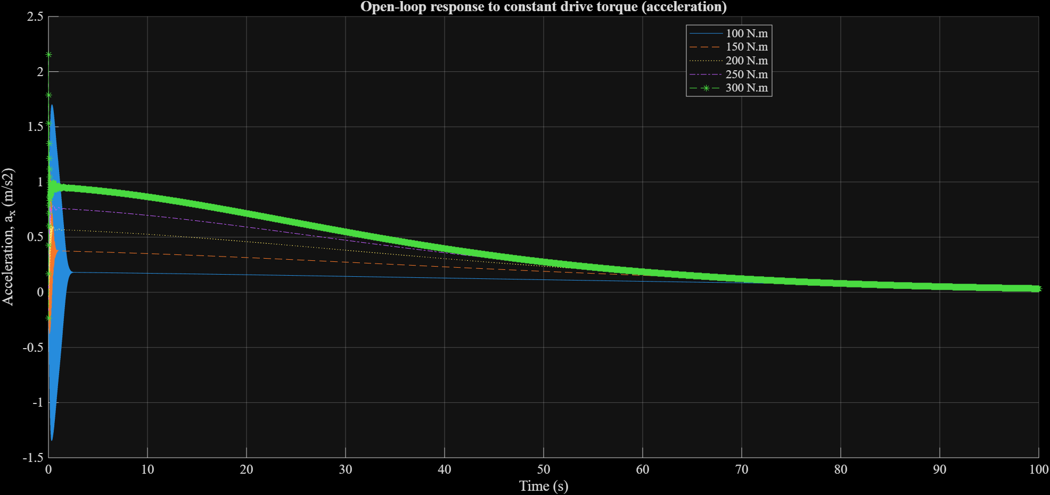
Figure 2 Open loop response to constant torque (acceleration)
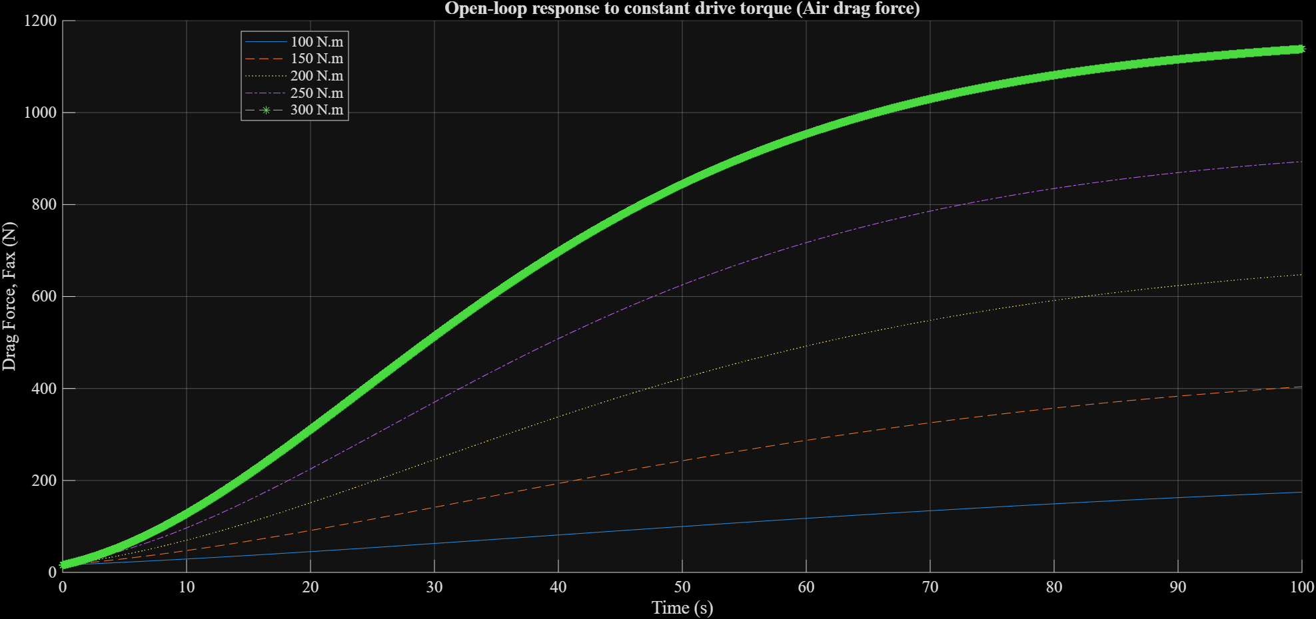
Figure 3 Open loop response to different constant torque (Drag force)

b) Open loop response to Steep-steer test:
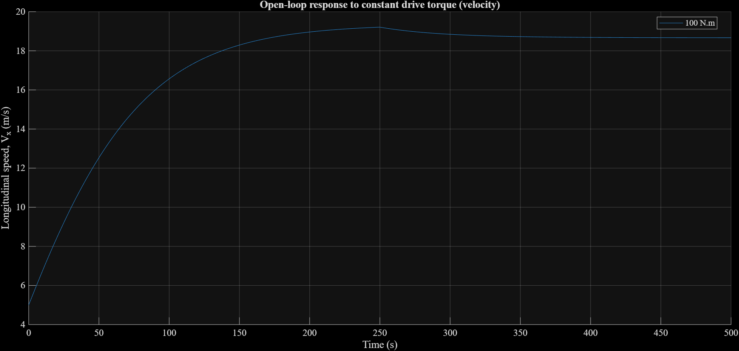
Figure 4 Open loop response to constant torque

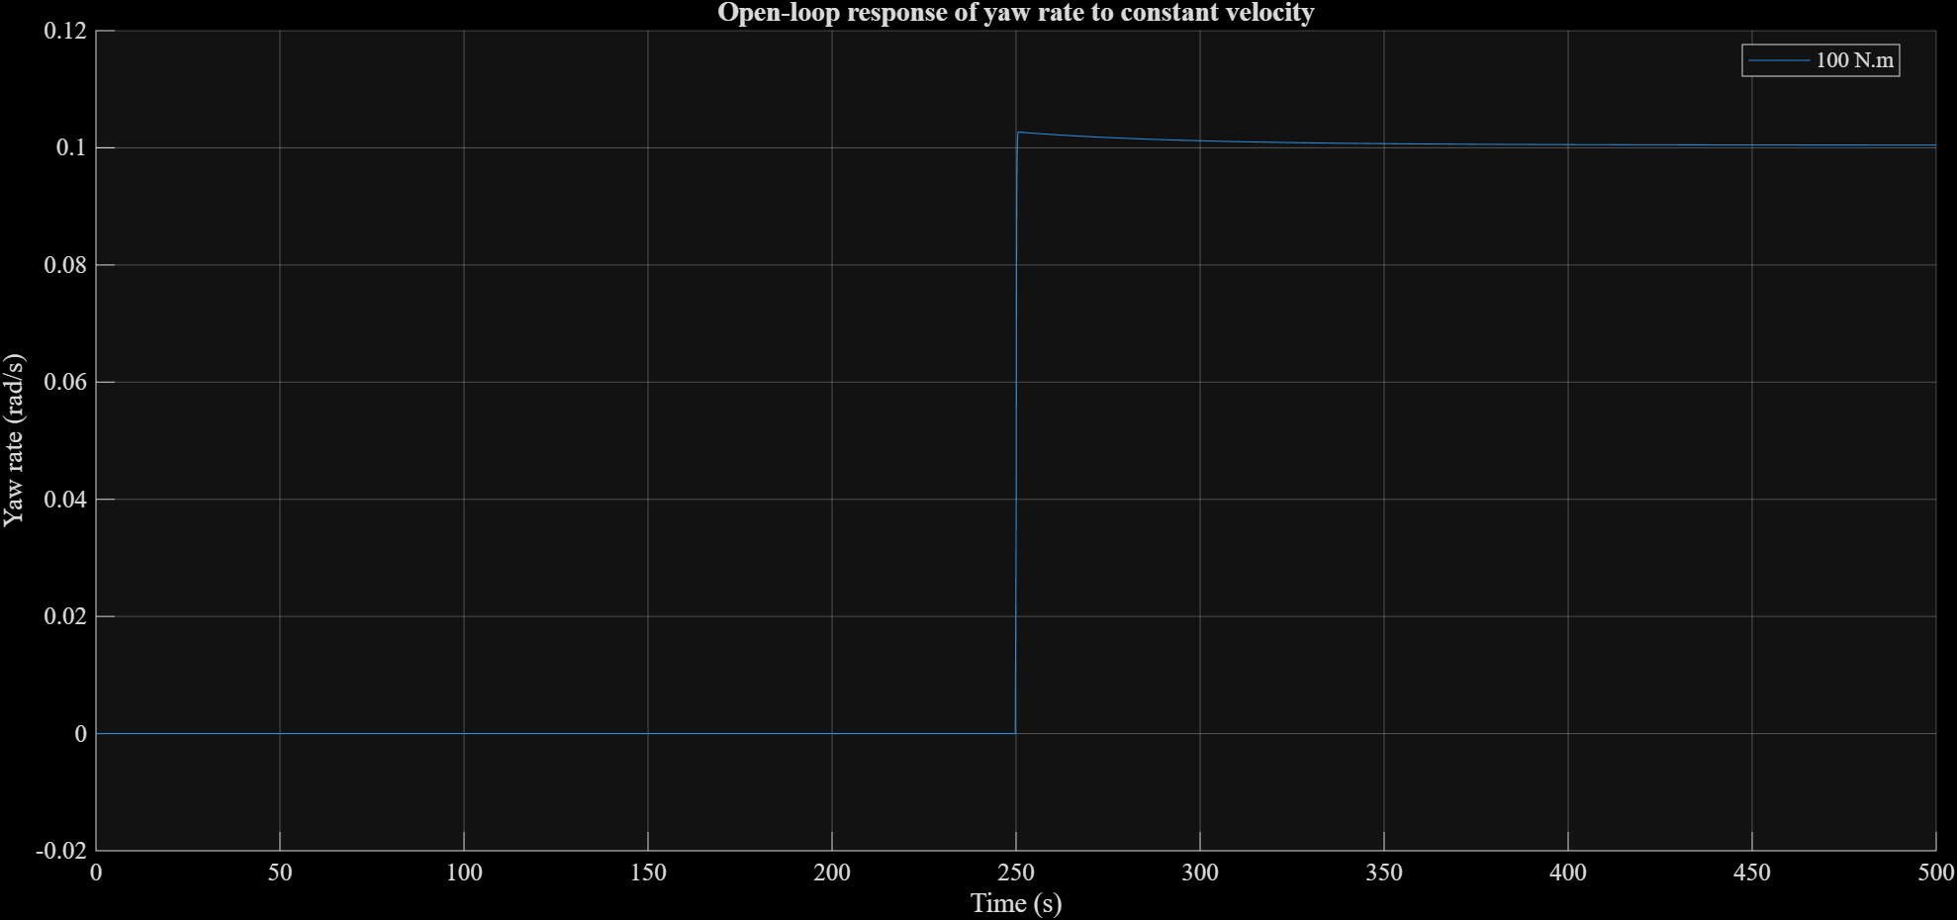
Figure 5 Open loop response test for steep steer test when velocity becomes constant

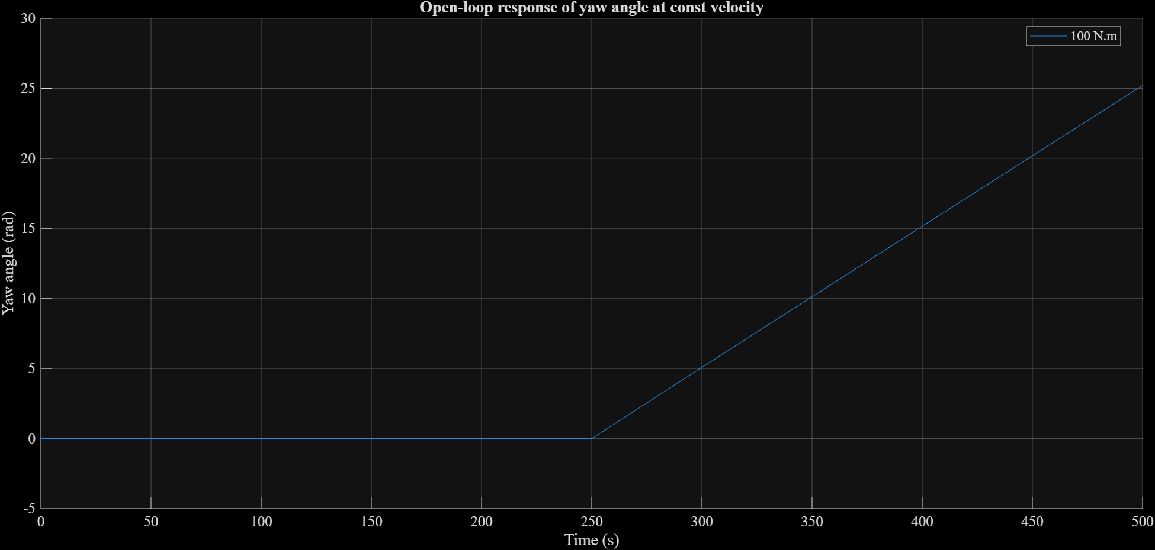
Figure 6 Yaw angle when step steer is applied at constant velocity

Optimization and Control: MATLAB MPC
The controller uses a low-order nonlinear dynamic bicycle model for prediction, while the existing mid-fidelity Simulink vehicle model remains the closed-loop plant. This separation allows the controller to use a computationally efficient model without modifying the supplied vehicle model.

States, control inputs, and disturbance
The prediction-model state vector is
$$x={\left[v_{x},v_{y},r,e_{y},e_{psi}\right]}^{T}$$
where:
- $v_{x}$ is longitudinal velocity in m/s
- $v_{y}$ is lateral velocity in m/s
- $r$ is yaw rate in rad/s
- $e_{y}$ is lateral path-tracking error in m
- $e_{psi}$ is heading error in rad
The manipulated-input vector is
$$u={\left[T_{f},delta_{f}\right]}^{T}$$
where $T_{f}$ is the signed total front-axle torque in $Nm$ and $delta_{f}$ is the equivalent front road-wheel steering angle in rad. Positive torque produces propulsion, while negative torque represents braking or deceleration. Positive steering produces positive lateral motion and yaw.
Reference-path curvature,
$$kappa_{ref}, \left[1/m\right]$$
is supplied to the MPC as a measured disturbance.

Tire slip angles and lateral forces
To avoid division by a very small longitudinal velocity, the slip-angle calculation uses a safeguarded longitudinal speed:
$$v_{x,safe}=max\left(v_{x},v_{x,min}\right)$$
The front and rear tire slip angles are
$$alpha_{f}=arctan\left(\left(v_{y}+l_{f}*r\right)/v_{x,safe}\right)-delta_{f}$$
$$alpha_{r}=arctan\left(\left(v_{y}-l_{r}*r\right)/v_{x,safe}\right)$$
The lateral tire forces are calculated using linear axle cornering stiffnesses:
$$F_{y,f}=-C_{f}*alpha_{f}, F_{y,r}=-C_{r}*alpha_{r}$$
Here, $F_{y,f}$ and $F_{y,r}$ represent the total lateral forces at the front and rear axles. Therefore, no additional factor of two is applied.

Longitudinal force and resistance
The total front-axle drive force is calculated from the signed torque command:
$$F_{drive}=\left(eta*T_{f}\right)/R_{w}$$
where eta is drivetrain efficiency, assumed as 1, and $R_{w}$ is the effective wheel radius. The prediction model includes rolling resistance and aerodynamic drag:
$$F_{res}=C_{rr}*m*g+\left(1/2\right)*rho*C_{d}*A_{f}*v_{x}*\left|v_{x}\right|$$

Vehicle equations of motion
The longitudinal dynamics are:
$$dv_{x}/dt=\left(F_{drive}*cos\left(delta_{f}\right)-F_{y,f}*sin\left(delta_{f}\right)-F_{res}\right)/m+v_{y}*r$$
The lateral dynamics are:
$$dv_{y}/dt=-v_{x}*r+\left(F_{y},f*cos\left(delta_{f}\right)+F_{y},r+F_{d}rive*sin\left(delta_{f}\right)\right)/m$$
The yaw dynamics are:
$$dr/dt=\left(l_{f}*F_{y},f*cos\left(delta_{f}\right)-l_{r}*F_{y},r+l_{f}*F_{d}rive*sin\left(delta_{f}\right)\right)/I_{z}$$
The path-error dynamics use the small-error road-coordinate approximation:
$$de_{y}/dt=v_{y}+v_{x}*e_{psi}$$
$$de_{psi}/dt=r-v_{x}*kappa_{ref}$$
The complete continuous-time prediction model is therefore:
$$x_{dot}=f\left(x,u,kappa_{ref}\right)$$

Modeling assumptions
The prediction model assumes:
- A single-track (bicycle) representation of the vehicle
- Front-wheel steering with zero rear steering
- Lumped front- and rear-axle lateral forces
- Linear tire cornering stiffness
- Moderate tire slip and normal road operation
- Forward vehicle motion above the configured minimum prediction speed (due to dynamic model used)
- Rolling resistance and quadratic aerodynamic drag
- No explicit suspension, wheel-rotation, load-transfer, or individual-tire dynamics
Those higher-order effects remain represented by the mid-fidelity Simulink plant. The resulting model is intentionally lower fidelity and is used only for MPC prediction and online linearization.

Discretization and Online Adaptive Linearization
The nonlinear prediction model is defined in continuous time as
$$x_{dot}=f\left(x,u,kappa_{ref}\right)$$
but the Adaptive MPC Controller requires a discrete-time linear prediction model. The nonlinear model is therefore first propagated over one controller sampling interval and then numerically linearized at the current operating point.
Nonlinear model discretization
The discrete nonlinear state-transition function is written as
$$x_{\left(k+1\right)}=F_{d}\left(x_{k},u_{k},kappa_{k}\right)$$
where $F_{d}$ represents propagation of the continuous nonlinear model over one controller interval $T_{s}$.
A fourth-order Runge–Kutta method is used for numerical integration. The controller interval is divided into $N_{int}$ internal integration substeps:
$$h=T_{s}/N_{int}$$
For every integration substep,
$$k_{1}=f\left(x_{i},u_{k},kappa_{k}\right)$$
$$k_{2}=f\left(x_{i}+\left(h/2\right)k_{1},u_{k},kappa_{k}\right)$$
$$k_{3}=f\left(x_{i}+\left(h/2\right)k_{2},u_{k},kappa_{k}\right)$$
$$k_{4}=f\left(x_{i}+hk_{3},u_{k},kappa_{k}\right)$$
and the state is updated according to
$$x_{\left(i+1\right)}=x_{i}+\left(h/6\right)\left(k_{1}+2k_{2}+2k_{3}+k_{4}\right)$$
The current implementation uses:
- Controller sampling interval: $T_{s}$ = 0.01 s
- Integration substeps: $N_{int}$ = 10
- Internal RK4 integration step: h = 0.001 s
These internal substeps improve numerical integration accuracy without introducing a second Simulink controller sampling rate.
Online operating point
At every controller interval, the prediction model is linearized around the current operating point defined by:
- The current five-state prediction vector $x_{k}$
- The previously applied manipulated input $u_{\left(k-1\right)}$
- The current reference-path curvature $kappa_{k}$
The manipulated input is
$$u={\left[T_{f},delta_{f}\right]}^{T}$$
and the combined prediction-model input is
$$w={\left[T_{f},delta_{f},kappa_{ref}\right]}^{T}$$
where curvature is treated as a measured disturbance.
Numerical state Jacobian
The discrete-time state-transition matrix is calculated using central finite differences:
$A\left(:,i\right)=[F_{d}\left(x+Delta_{x_{i}},u,kappa\right)$ $F_{d}\left(x-Delta_{x_{i}},u,kappa\right)]/\left(2Delta_{x_{i}}\right)$
The state perturbations are:
- Longitudinal velocity: $1e^{-4}m/s$
- Lateral velocity: $1e^{-5}m/s$
- Yaw rate: $1e^{-6}rad/s$
- Lateral error: $1e^{-5}m$
- Heading error: $1e^{-6}rad$
The resulting matrix A has dimensions 5 x 5.
Numerical manipulated-input Jacobian
The manipulated-input matrix is also calculated using central finite differences:
$$B_{u}\left(:,j\right)=\left[F_{d}\left(x,u+Delta_{u_{j}},kappa\right) F_{d}\left(x,u-Delta_{u_{j}},kappa\right)\right]/\left(2Delta_{u_{j}}\right)$$
The input perturbations are:
- Front-axle torque: $0.1N·m$
- Front road-wheel angle: $1e-5rad$
The resulting manipulated-input matrix $B_{u}$has dimensions 5 x 2.
Curvature-disturbance Jacobian
The curvature contribution is calculated as
$$B_{kappa}=\left[F_{d}\left(x,u,kappa+Delta_{kappa}\right)F_{d}\left(x,u,kappa-Delta_{kappa}\right)\right]/\left(2Delta_{kappa}\right)$$
using
$$Delta_{kappa}=1e^{-6} 1/m$$
The complete input matrix supplied to Adaptive MPC is
$$B=\left[B_{u},B_{kappa}\right]$$
and has dimensions 5 x 3.
Output model
All five prediction states are treated as model outputs. Therefore,
$$C=I_{\left(5x5\right)}$$
and, because there is no direct input-to-output feedthrough,
$$D=0_{\left(5x3\right)}$$
The output vector is
$$y={\left[v_{x},v_{y},r,e_{y},e_{psi}\right]}^{T}$$
Adaptive MPC nominal-condition data
In addition to A, B, C, and D, the Adaptive MPC block receives the current nominal operating conditions:
$$X=x_{k}$$
$$Y=x_{k}$$
$$U={\left[u_{\left(k-1\right)}, kappa_{k}\right]}^{T}$$
The nominal discrete state increment is
$$DX=F_{d}\left(X,u_{\left(k-1\right)},kappa_{k}\right)-X$$
This definition is appropriate for a discrete prediction model because DX represents the state change over one controller interval at the current operating point.
The local affine prediction model can therefore be interpreted as
$$x_{\left(k+1\right)}=X+DX+A\left(x_{k}-X\right)+B\left(w_{k}-U\right)$$
At every controller interval, the matrices and nominal-condition vectors are recalculated and supplied to the Adaptive MPC Controller through its model bus.
Adaptive model-bus dimensions
The model bus contains:
- $A:5x5$
- $B:5x3$
- $C:5x5$
- $D:5x3$
- $X:5x1$
- $Y:5x1$
- $U:3x1$
- $DX:5x1$
This approach updates the controller’s low-order prediction model at every simulation step. It does not linearize or modify the mid-fidelity Simulink plant itself.

Adaptive MPC Configuration and Backend Architecture
Controller execution settings
The controller and the mid-fidelity vehicle plant use the same sampling interval:
$$T_{s}=0.01s$$
The prediction horizon is configured in seconds and converted into discrete prediction steps:
$$Prediction horizon=1.0s=100steps$$
The control horizon is
$$Control horizon=0.10s=10steps$$
The controller therefore predicts vehicle behavior for one second while optimizing ten future control moves.
MPC prediction model
The initial discrete state-space model supplied when creating the MATLAB MPC object is
$$x_{k+1}=A_{d}x_{k}+B_{u}u_{k}+B_{kappa}kappa_{k}$$
$$y_{k}=C_{d}x_{k}+D_{d}w_{k}$$
Where,
$$C_{d}=I_{5x5}$$
$$D_{d}=0_{5x3}$$
The first two model inputs are declared as manipulated variables:
- Signed total front-axle torque
- Front road-wheel steering angle
Reference-path curvature is declared as a measured disturbance.
At runtime, the Adaptive MPC Controller replaces the initial A, B, C, and D matrices and nominal-condition data with the values produced by the online model-update block.
Nominal operating condition
The nominal state is
$$x_{nom}={\left[1,0,0,0,0\right]}^{T}$$
corresponding to:
- Longitudinal speed: $1 m/s$
- Lateral speed: $0 m/s$
- Yaw rate: $0 rad/s$
- Lateral error: $0 m$
- Heading error: $0 rad$
The nominal road-wheel angle and path curvature are both zero.
The nominal front-axle torque is calculated as the torque required to balance rolling resistance and aerodynamic drag at the initial speed:
$$T_{nom}=R_{w}\left(F_{roll}+F_{aero}\right)/eta$$
For the current vehicle parameters and an initial speed of $1m/s$, the nominal torque is approximately $149 N·m$.
MPC objective function
The MATLAB MPC controller minimizes a quadratic objective containing output-tracking error, manipulated-input magnitude, manipulated-input movement, and constraint-relaxation terms.
The objective can be represented conceptually as
J = $sum\left[{\left(y_{k}-y_{ref,k}\right)}^{T}Q\left(y_{k}-y_{ref,k}\right)+u_{k}^{T}R_{u}u_{k}+Delta_{u_{k}}^{T}R_{Delta_{u}}Delta_{u_{k}}\right]+$
$$rho_{epsilon} epsilon^{2}$$
where:
- $Q$ penalizes output-tracking error
- $R_{u}$ penalizes manipulated-input magnitude
- $R_{Delta_{u}}$ penalizes changes in manipulated inputs
- $epsilon$ is the constraint-relaxation variable
- $rho_{epsilon}$ is the slack-variable penalty
The output weights are assigned in the order
$$\left[v_{x},v_{y},r,e_{y},e_{psi}\right]$$
with values
$$\left[1,0.1,10,100,100\right]$$
The controller therefore gives the largest tracking priority to lateral error and heading error, followed by yaw rate and longitudinal speed. Lateral velocity receives a smaller penalty.
The manipulated-input magnitude weights, ordered as
$$\left[front_axle_{torque} ,road_wheel_{steeringangle}\right]$$
are
$$\left[1,1\right]$$
The manipulated-input rate weights are
$$\left[1,0.1\right]$$
All cost calculations use the MPC scale factors so signals with different physical units can be compared in dimensionless form.
Manipulated-variable constraints
The signed front-axle torque is constrained by
-$300 N·m<=T_{f}<=300 N·m$
The front road-wheel angle is constrained by
$$-0.30rad<=delta_{f}<=0.30rad$$
The physical torque-rate constraint is
$$-10 N·m/s<=dT_{f}/dt<=10 N·m/s$$
At $T_{s}=0.01s$, this corresponds to a maximum torque change of $\left|Delta_{T_{f}}\right|<=0.1 Nm/dt$. The road-wheel steering-rate constraint is
$$-20 deg/s<=d\left(delta_{f}\right)/dt<=20 deg/s$$
or equivalently
$$-0.3491 rad/s<=d\left(delta_{f}\right)/dt<=0.3491 rad/s$$
At $T_{s}=0.01s$, this corresponds to
$$\left|Delta_{delta_{f}}\right|<=0.00349 rad/dt$$
All manipulated-variable magnitude and rate constraints are configured as hard constraints by setting their ECR values to zero.
State and output constraints
The five prediction states are also exposed as MPC output variables. Their configured limits are:
- Longitudinal speed: 0 to 12 m/s
- Lateral speed: -1 to 1 m/s
- Yaw rate: -45 to 45 deg/s
- Lateral error: -0.5 to 0.5 m
- Heading error: -15 to 15 deg
Unlike the actuator constraints, the state constraints are soft. Each state constraint has an ECR value of 1, allowing the optimizer to relax a state limit if required to maintain feasibility.
Constraint violations are heavily penalized using
$$rho_{epsilon}=1e8$$
This arrangement keeps actuator limits physically enforceable while avoiding controller failure when temporary state-constraint violations occur.
Signal scale factors
The configured manipulated-variable scale factors are:
- Front-axle torque: $600 N·m$
- Road-wheel steering angle: $0.10 rad$
The output scale factors are:
- Longitudinal speed: $12m/s$
- Lateral speed: $2m/s$
- Yaw rate: $90 deg/s$
- Lateral error: $2m$
- Heading error: $30 deg$
These scale factors convert signals with different units and operating ranges into comparable dimensionless quantities for the MPC optimization problem.
Switchable controller backend
ControllerWrapper provides a common controller interface independent of the selected optimization backend.
The defined backend identifiers are:
- BACKEND_ACADOS = 1
- BACKEND_MATLAB = 2
- BACKEND_ADAPTIVE = 3
The current controller selection is
controller_backend = BACKEND_ADAPTIVE
The backend receives:
- Measured prediction-model state
- Prediction-state reference
- Reference-path curvature
The standardized controller outputs are:
- Signed front-axle torque in $N·m$
- Front road-wheel angle in $rad$
- Solver status
- Solver timing information when available
This interface is intended to allow MATLAB MPC and acados implementations to be exchanged without changing the plant-side controller interface.
Adaptive MPC backend
The adaptive backend contains:
- The Adaptive MPC Controller block
- The online nonlinear-model update block
- A unit-delay block storing the previously applied manipulated input
- A model-bus creator
- Output routing for torque, steering, and solver status
The online model-update block receives the current prediction state, previous manipulated input, and current path curvature. It calculates the local discrete model and supplies
A, B, C, D, X, Y, U, and DX
to the Adaptive MPC Controller at every controller interval.
The previous manipulated input is passed through a unit delay before being used by the model-update block. This avoids an algebraic loop between the optimizer output and the online linearization calculation.
Only numeric vehicle and integration parameters are passed into the MATLAB Function block through the adaptiveModelParams structure. Descriptive strings and other nonnumeric configuration fields are excluded to maintain compatibility with Simulink code generation.
Solver-status monitoring
The Adaptive MPC block exposes the QP solver status. A positive value indicates that the optimization was completed successfully and reports the number of QP iterations used. A zero value indicates that the maximum iteration count was reached, while a negative value indicates infeasibility or a numerical solver failure.
The solver-status signal is logged during closed-loop simulations so controller failures and periods of increased computational effort can be identified.

RESULT (more work to do):
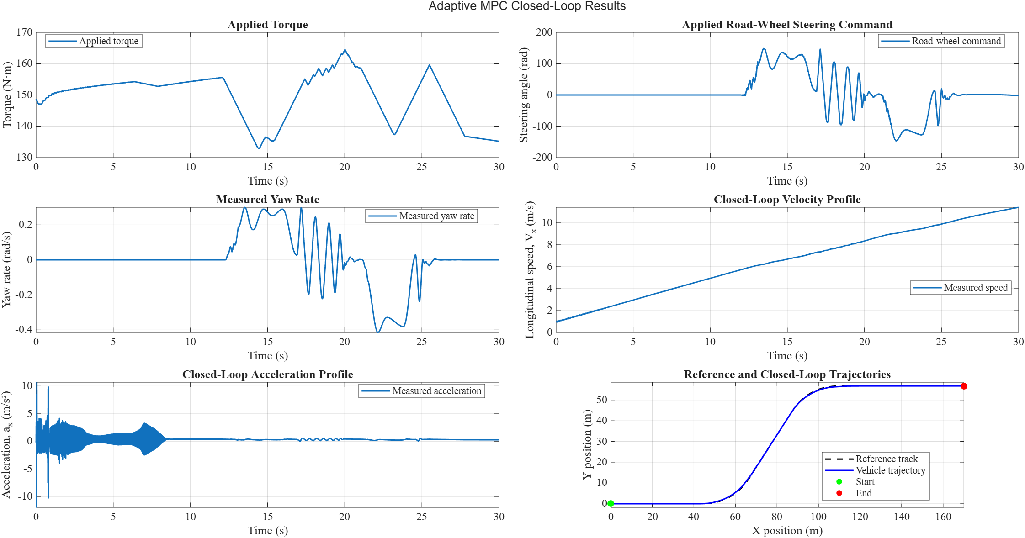
Steering-Command Interface and Conversion-Gain Issue
Initially, only a radians-to-degrees conversion was applied:
$$δ_{rw,rad}\frac{180}{π}$$
This conversion was insufficient because it did not account for the steering mechanism represented inside the plant. For example, when the controller requested approximately $\left(0.3 rad\right),$the actual ground-wheel angle observed inside the plant was only approximately $\left(0.0125 rad\right).$Consequently, the vehicle produced insufficient yaw rate and consistently understeered relative to the reference path.
Comparison of these signals indicated an effective steering conversion ratio of approximately
$$\frac{δ_{rw,requested}}{δ_{rw,actual}}≈24$$
The temporary interface conversion was therefore implemented as
$$G_{δ}*δ_{rw,rad}\frac{180}{π}, G_{δ}≈24$$

NEXT STEP (TODO):
Guideline | Status | Current evidence or remaining work
MPC baseline | Incomplete:  Functionally working; not frozen | Adaptive MPC works with discretized model, but ACADOS is not implemented yet
Scenario library | Incomplete:  Highway cruise and aggressive maneuver tested; urban profile not tested | Urban profile test and report RMS and peak errors per scenario yet to be done.
Solver-time telemetry | Incomplete:  MATLAB MPC does not provide solve time telemetry but solve-status | Solver status is logged, but per-step execution time, histograms, and statistical tables are missing.
Reading and Report | Incomplete | research-gap map, final baseline figure, and solve-time table need to be completed

Solve-time Telemetry:
Obtaining true per-step timing will require either:
- calling mpcmoveAdaptive from a custom MATLAB-based controller implementation and timing every call; or
- profiling generated controller code on a real-time target

