**Online Student Registration System**

*A Field project report submitted by*

**Bhindu madhuri(231FA04037)**

**Nanda gopika (231FA04081)**

**Harshini(231FA04120)**  
 **Uma mahesh(231FA04129)**

*in partial fulfillment for the award of the degree of*

**BACHELOR OF TECHNOLOGY**

in

**Computer Science Engineering**

*Under the Guidance of*

**K.Swathi**



**Department of Computer Science and Engineering**

*School of Computing and Informatics*

**Vignan’s Foundation for Science, Technology & Research**

(Deemed to be University)

Andhra Pradesh-522213, India



**Department of Computer Science and Engineering**

**School of Computing and Informatics**

**Vignan’s Foundation for Science, Technology & Research**

(

Deemed to be University

)

**AndhraPradesh,India-522213**

CERTIFICATE

This is to certify that the project entitled **“Tourism Website”**being submitted by in Bhindu madhuri(231FA04037),NandaGopika(231FA04081),

Harshini(231FA04120), Uma mahesh(231FA04120)

partial fulfilment of Bachelor of Technology in Computer Science and Business Systems, Department of Computer Science and Engineering, Vignan’s Foundation For Science Technology and Research (Deemed to be University), Vadlamudi, Guntur District, Andhra Pradesh, India, is a bonafide work carried out by them under my guidance and supervision.

**Project Co-ordinator**

**Ms. CH. Swarna Lalitha**



**Department of Computer Science and Engineering**

**School of Computing and Informatics**

**Vignan’s Foundation for Science, Technology&Research**

(

Deemed to be University

)

**Andhra Pradesh, India-522213**

# DECLARATION

We hereby declare that our project work described in the project titled **“Tourism Website”** which is being submitted by us for the partial fulfilment in the department of CSE, Vignan’s Foundation for Science, Technology and Research (Deemed to be University), Vadlamudi, Guntur, Andhra Pradesh, and the result of investigations are carried out by us under the guidance of Ms.CH. Swarna Lalitha

**Bhindu madhuri(231FA04037)**

**Nanda gopika (231FA04081)**

**Harshini(231FA04120)**  
 **Uma mahesh(231FA04129)**

Content

|  |  |  |
| --- | --- | --- |
| Chapter No. | Description | Page no. |
| 1 | Abstract | 05 |
| 2 | Introduction | 05 |
| 3 | Code function | 05-06 |
| 4 | Technologies used | 07-08 |
| 5 | Installation Instructions | 08 |
| 6 | Project Structure | 08 |
| 7 | Frontend Details | 08-09 |
| 8 | How to use the application | 09 |
| 9 | Screenshots | 09 |
| 10 | Logic | 10 |
| 11 | Future Enhancement | 10 |
| 12 | Acknowledgements | 11 |

### **Abstract:**

The World Tourism Website is an online platform designed to serve as a comprehensive solution for travelers looking to explore destinations worldwide. This website provides a seamless experience for users to search and book hotels, apply for visas, explore sports and recreational activities, and shop for local souvenirs. With a user-friendly interface, real-time availability checks, and secure booking options, the website empowers users to plan and manage their travel experiences efficiently. Through its innovative design and features, the World Tourism Website aims to make global travel easier, more enjoyable, and accessible to people of all backgrounds.

### **Introduction:**

The World Tourism Website is developed to facilitate the global travel experience by offering a one-stop solution for hotel bookings, visa applications, sports activities, shopping, and more. With the increasing demand for online travel services, this platform serves as a hub where users can find all necessary travel-related services in one place. The website is aimed at travelers who wish to simplify the process of booking accommodations, obtaining travel documents, and engaging in recreational activities during their travels.

**Key features of the website include:**

* **Hotel Booking**: Users can search for hotels based on location, price range, and preferences.
* **Visa Services**: A streamlined process for visa applications, document uploads, and status tracking.
* **Sports and Activities**: Information on available sports activities and recreational events.
* **Shopping**: A selection of local souvenirs and shopping options.

The World Tourism Website is designed to enhance the travel experience and ensure that users have access to all services they need in one place, making it easier to plan their trips.

### **Code Functionality:**

The World Tourism Website offers various functionalities to assist users throughout their travel journey. The key functions include:

#### 1. **Hotel Booking**:

* Users can search for hotels based on location, price, and availability.
* Real-time availability check and booking option.

#### **Example (Frontend - JavaScript):**

// Fetch hotels based on search criteria

function searchHotels() {

const location = document.getElementById('location').value;

const priceRange = document.getElementById('priceRange').value;

fetch(`/api/hotels?location=${location}&priceRange=${priceRange}`)

.then(response => response.json())

.then(data => displayHotels(data));

}

function displayHotels(hotels) {

const hotelList = document.getElementById('hotelList');

hotelList.innerHTML = '';

hotels.forEach(hotel => {

hotelList.innerHTML += `

<div class="hotel">

<h3>${hotel.name}</h3>

<p>Price: $${hotel.price}</p>

<button onclick="bookHotel('${hotel.id}')">Book Now</button>

</div>

`;

});

}

#### 2. **Visa Application**:

* Users can apply for a visa by submitting personal information and documents.
* The backend verifies and processes the application.

#### **Example (Backend - Node.js/Express):**

const express = require('express');

const app = express();

const multer = require('multer');

const upload = multer({ dest: 'uploads/' });

app.post('/apply-visa', upload.single('passport'), (req, res) => {

const { name, passportNumber } = req.body;

const passportCopy = req.file;

// Process visa application (simplified)

console.log(`Visa application received for ${name} with passport number ${passportNumber}`);

res.json({ message: 'Visa application submitted successfully' });

});

#### 3. **Sports Activities**:

* Users can explore available sports activities like snorkeling, hiking, etc., and book them directly.

#### **Example (Frontend - JavaScript):**

function fetchSports() {

fetch('/api/sports')

.then(response => response.json())

.then(data => displaySports(data));

}

function displaySports(sports) {

const sportsList = document.getElementById('sportsList');

sports.forEach(sport => {

sportsList.innerHTML += `

<div class="sport">

<h3>${sport.name}</h3>

<p>${sport.description}</p>

<button onclick="bookSport('${sport.name}')">Book Now</button>

</div>

`;

});

}

#### **4**. **Shopping**:

* A shopping section to buy souvenirs or local products from the destination.

#### **Example (Frontend - JavaScript):**

function fetchShoppingItems() {

fetch('/api/items')

.then(response => response.json())

.then(data => displayItems(data));

}

function displayItems(items) {

const itemList = document.getElementById('shoppingList');

items.forEach(item => {

itemList.innerHTML += `

<div class="item">

<h3>${item.name}</h3>

<p>Price: $${item.price}</p>

<button onclick="addToCart('${item.id}')">Add to Cart</button>

</div>

`;

});

}

### **Technologies Used:**

1. **Frontend Technologies**:
   * **HTML5**: To structure the web pages.
   * **CSS3**: For styling the website and ensuring it is visually appealing and responsive.
   * **JavaScript**: For dynamic behavior and interactivity, such as booking and searching functionalities.
   * **React.js**: For building a responsive, component-based user interface.
   * **Bootstrap**: A CSS framework to speed up the development of the responsive layout.
2. **Backend Technologies**:
   * **Node.js**: JavaScript runtime for building scalable backend applications.
   * **Express.js**: Web framework for Node.js to handle API routes.
   * **MongoDB**: NoSQL database for storing user data, property listings, and bookings.
   * **Mongoose**: ODM (Object Data Modeling) library for MongoDB, used to interact with the database.
   * **JWT (JSON Web Tokens)**: For user authentication and secure API access.
   * **Multer**: For handling file uploads, such as passport copies during the visa application process.
3. **Development Tools**:
   * **Visual Studio Code**: Code editor used for development.
   * **Git**: Version control for managing the source code.
   * **Postman**: API testing tool used to check the backend API functionality.

### **Project Structure:**

/world-tourism-website

│

├── /frontend

│ ├── index.html

│ ├── app.js

│ ├── styles.css

│ └── components/

│

├── /backend

│ ├── server.js

│ ├── models/

│ │ ├── hotelModel.js

│ │ ├── sportsModel.js

│ │ ├── itemModel.js

│ │ └── userModel.js

│ ├── routes/

│ │ ├── hotelRoutes.js

│ │ ├── sportsRoutes.js

│ │ ├── shoppingRoutes.js

│ │ └── visaRoutes.js

│ └── controllers/

│ ├── hotelController.js

│ ├── sportsController.js

│ ├── shoppingController.js

│ └── visaController.js

│

├── package.json

└── README.md

### **Frontend Details:**

The frontend of the World Tourism Website is designed to be engaging and intuitive. It features:

* **Home Page**: Displays an overview of services with quick links to book hotels, apply for a visa, and browse activities and shopping.
* **Property Listings Page**: Allows users to search for hotels by location and price range.
* **Visa Application Page**: Users can fill out a form to apply for a visa and upload necessary documents.
* **Sports Activities Page**: Displays available sports activities and allows users to book them.
* **Shopping Page**: Shows a list of local souvenirs and products for users to purchase.

### **How to Use the Application:**

1. **Search Hotels**: Enter a location and price range, and click "Search" to view a list of available hotels.
2. **Book Hotels**: Once you find a hotel, click "Book Now" to proceed with the booking process.
3. **Apply for a Visa**: Go to the Visa section, fill in the necessary details, and upload your documents to apply.
4. **Explore Sports**: Browse through the available sports and activities, and click "Book Now" to reserve your spot.
5. **Shopping**: Browse through the shopping list, and add items to your cart for purchase.

Screenshots:

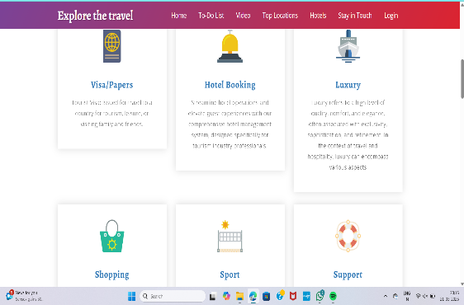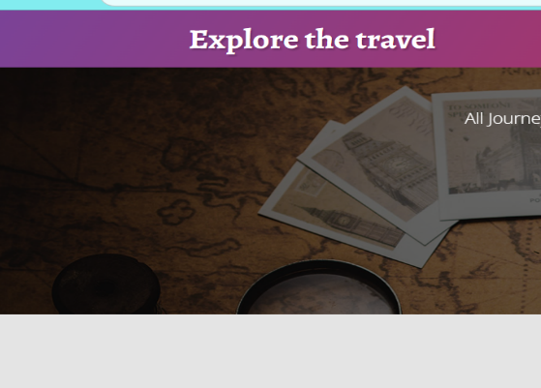

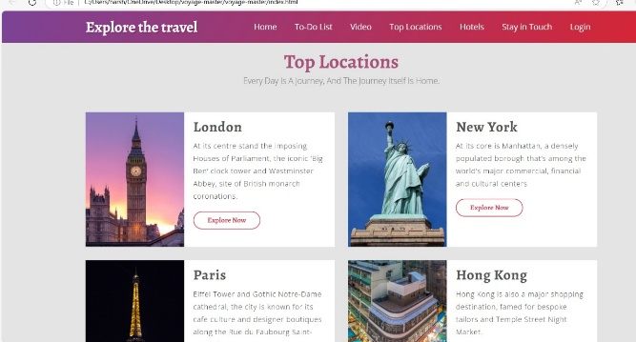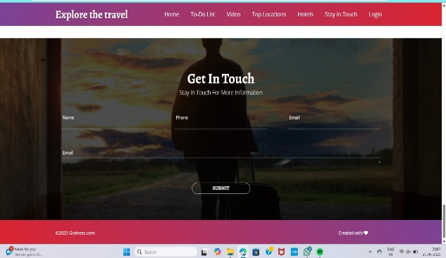

Logic:

Matter in the scientific sense? (e.g., states of matter, atomic structure, chemical reactions)

Matter related to a specific topic? (e.g., matter related to climate change, the human body, or a particular industry)

Matter for a creative project? (e.g., story ideas, descriptive passages, or factual information for a script)

Matter related to a current news event?

General information on the concept of matter?

In the meantime, here's some basic information about matter in the scientific sense:

What is Matter?

In physics, matter is any substance that has mass and takes up space (volume). It's what makes up everything we can touch and see in the universe.

States of Matter:

Matter commonly exists in four states:

Solid: Has a fixed shape and volume. Particles are tightly packed.

Liquid: Has a fixed volume but takes the shape of its container. Particles are less tightly packed than in solids.

Gas: Has no fixed shape or volume. Particles are widely spaced and move freely.

Plasma: An ionized gas, often found in high-temperature environments like stars.

Atomic Structure:

Matter is made up of atoms, which are the basic building blocks of all substances.

Atoms consist of a nucleus (containing protons and neutrons) surrounded by electrons.

The arrangement and interactions of atoms determine the properties of matter.

Chemical Reactions:

Chemical reactions involve the rearrangement of atoms and molecules.

These reactions can change the properties of matter, creating new substances.

Examples: combustion, rusting, and photosynthesis.

Examples of Matter:

A rock (solid)

Water (liquid)

Air (gas)

The sun (plasma)

I hope this general information is helpful. Please let me know what specific kind of "matter" you are looking for, so I can provide a more tailored response.

### **Future Enhancements:**

1. **Integration with External APIs**: Integrate third-party services like Expedia, Booking.com, or other tourism platforms for real-time data.
2. **Mobile Application**: Develop a mobile app version for a more seamless and accessible user experience.
3. **User Reviews and Ratings**: Allow users to leave feedback and rate hotels, activities, and agents.
4. **Payment Gateway Integration**: Integrate secure payment options for hotel bookings and shopping transactions.
5. **Multi-Language Support**: Add support for multiple languages to cater to global users.
6. **Real-Time Availability for Sports and Events**: Implement real-time availability tracking for sports activities and events.

### **Acknowledgements:**

* **Mentors and Advisors**: Thanks to all mentors and guides who provided continuous support during the development of the project.
* **Third-Party Libraries and APIs**: Acknowledgment for the libraries and APIs used, including React.js, Node.js, MongoDB, and external APIs for booking and sports data.
* **Team Members**: Appreciation to the team for their collaboration and contribution to different aspects of the website's development.