Names and NSIDs: Corey Hickson (crh208), Benj Hingston (bvh895), Evan Salter (evs162)
Project: jEdit
Change Number: 4
Date: 03/19/2018

Add timestamps to log

- Change Request:
“Locate where the activity.log is. Currently there are no timestamps in the log file. Add timestamps to all kinds of messages.”

- Concept Location:
I searched for Log in the main file (jEdit) and came across a Log class. I went to the Log class and discovered where it was writing the log messages.

Table 1. The list of all the classes visited during concept location.
# | File name | Tool used | Located? | Comments
1 | jEdit.java | Given in the spec | Propagating | Uses the Log class
2 | Log.java | Find Class | Changed | Contains the code we need to change

- Impact Analysis:
I searched for usages of the Log class and came up with a large list of package, each with their own set of classes that had uses of Log within them.
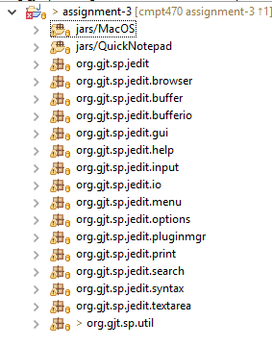
Figure 2 List of packages found with the Log class

This makes sense because pretty much every event is logged so almost every spot would need it. I’ve just included a few of those spots in the table below, since all of them will be impacted, but in the same way (they will not include the Timestamp in the log).

Table 2. The list of all the classes visited during impact analysis.
# | Class name | Tool used | Impacted? | Comments
1 | jEdit | Find usages in Workspace | Yes | This is where a lot of the init is setup so if there’s any problems, they’ll likely come up in here
2 | BrowserIORequest | Find usages in Workspace | Yes | This is an example of a spot which will do the Log.Log() and have the Timestamp

- Learning process:
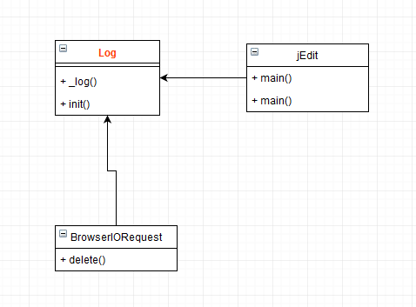
Figure 1 Example of the class diagram

- Description of the implementation:
In the private _log method, each time it’s called, it now creates a Timestamp and adds it to the fullMessage that is printed out when logging happens.

- Sources: None

- Highlighted Source Code:
