CyberSathy FiberNet

Complete System Design &
Implementation Documentation
ISP Fiber Mapping, ODN Documentation, Optical Engineering, Field Operations and Network Change Management

Prepared for | CyberSathy IT and Technology
Product | CyberSathy FiberNet
Version | 1.0
Date | 30 September 2026
Default timezone | Asia/Kathmandu
Initial currency | NPR (configurable)

Implementation principle: The connectivity database is authoritative. The map, topology, closure drawing and path cache are synchronized views over persisted physical terminations, optical transfers and connections.

Executive Summary
CyberSathy FiberNet is designed as a production-oriented ISP fiber mapping and Optical Distribution Network management platform. Its defining architectural choice is an explicit core-and-port connectivity graph rather than a GIS-only map. The system models each cable segment, individual fiber, fiber end, splice, continuity, splitter/coupler port, patch path, OLT PON port and ONU optical endpoint so every customer path can be traced and validated.
The application combines five synchronized operational views: geographic Network Map, Network Topology, PON View, Closure/Splice View and ordered Path View. These UI surfaces never become the authoritative source themselves. Engineers make topology changes through draft change sets, review customer and optical impact, perform field work, verify evidence, and commission an immutable new topology revision atomically.
The recommended implementation is a React + TypeScript frontend, Django REST Framework modular-monolith backend, PostgreSQL/PostGIS authoritative database, private object storage and background workers for expensive analysis/import/export/integration jobs. The design supports one ISP initially while including tenant isolation in all domain ownership and authorization boundaries.
This report and accompanying developer documentation package define the product menu, screen behaviors, frontend/backend modules, canonical database model, API behavior, optical mathematics, revisions/concurrency, incidents/work orders, offline field operation, security, testing, deployment and staged implementation plan.

Documentation Contents
- 1. Product and Scope
- 2. Complete Feature Catalog
- 3. UI/UX Screenbook
- 4. Frontend Architecture
- 5. Backend Architecture
- 6. Data Model and Canonical Topology
- 7. API Contract
- 8. Optical Engineering and Loss Ledger
- 9. Change Management, Reservations and Revisions
- 10. Faults, Work Orders and Field Operations
- 11. Security and Multitenancy
- 12. Import, Export and Integrations
- 13. Testing and Quality Strategy
- 14. Deployment and Operations
- 15. Demonstration Dataset
- 16. Implementation Roadmap
- 17. Recommended Repository Structure
- 18. Nonfunctional Requirements
- 19. Glossary
- Appendix A. UI Visual Reference
- Appendix B. Acceptance A01-A30 Traceability
- Appendix C. AI Repository Instructions (CLAUDE.md)

UI Visual Reference
The following mockups establish the current design direction. They are conceptual UI references; the implementation must connect each view to persisted domain data, permissions, validation and revision context.
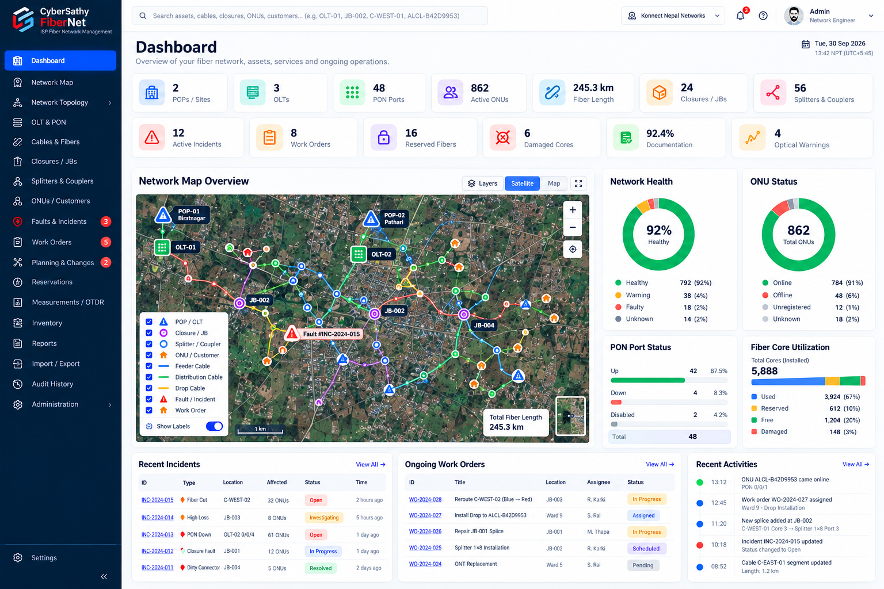
Dashboard - network KPIs, overview map, health/utilization, incidents, work orders and recent activities.

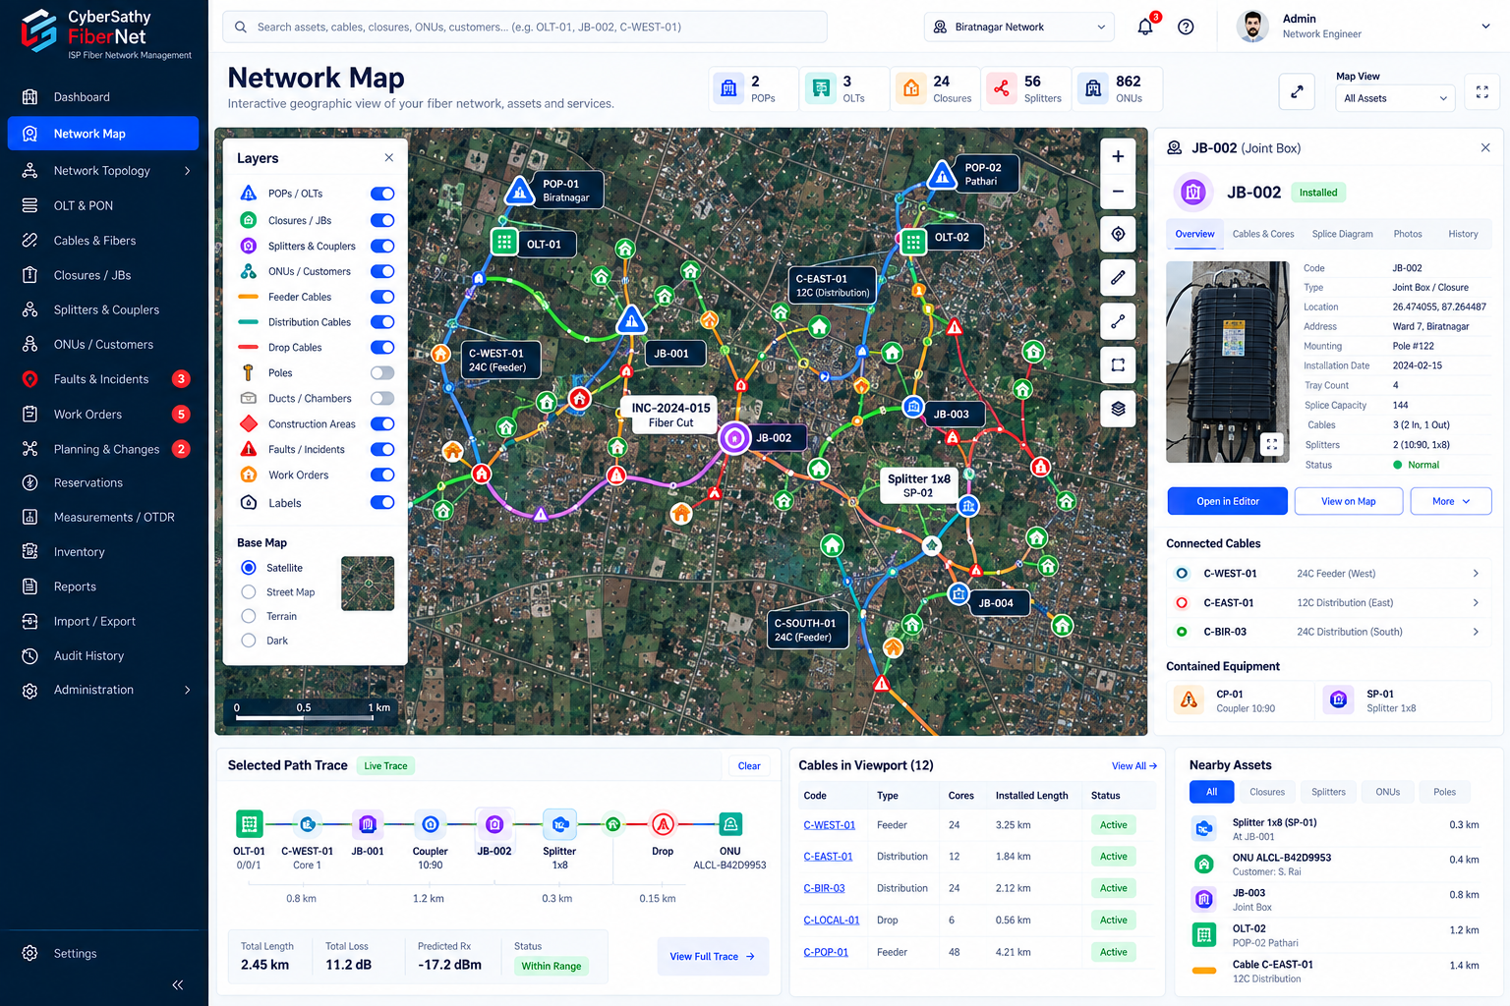
Network Map - GIS layers, routes, selected asset inspector, selected path trace, viewport cables and nearby assets.

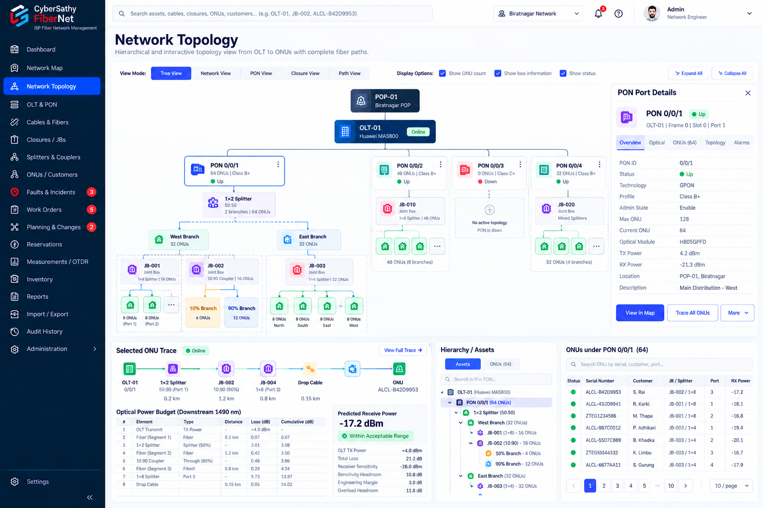
Network Topology Tree View - POP/OLT/PON hierarchy, splitter/coupler branches, selected ONU trace and optical ledger.

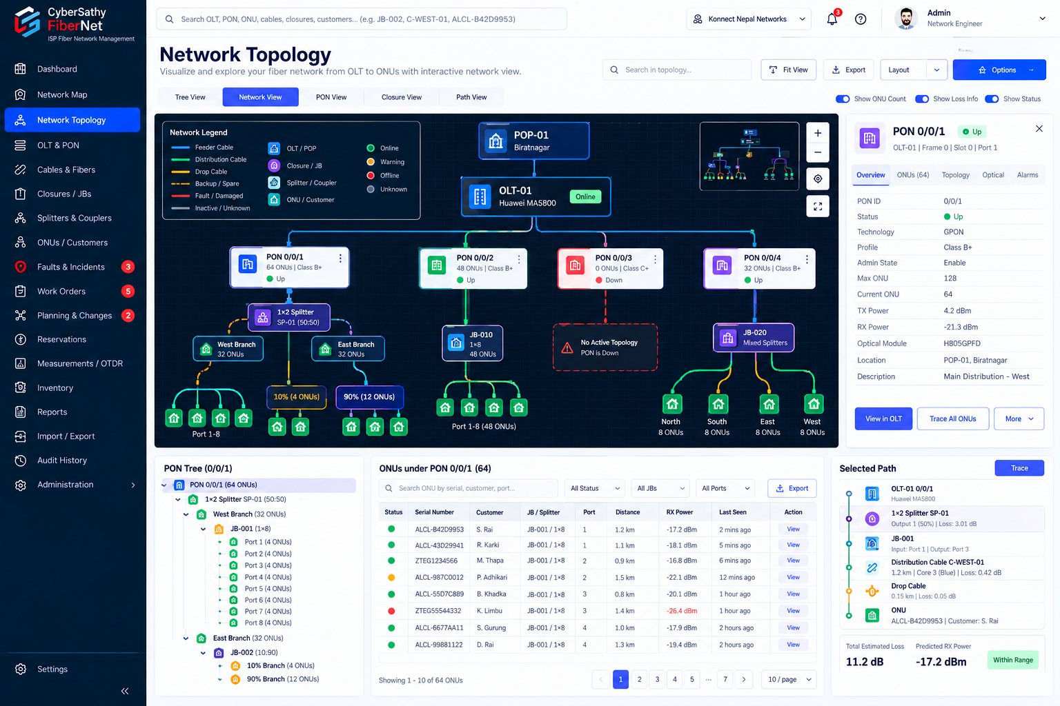
Network Topology Network View - interactive graph canvas, PON details, PON tree, ONU table and selected path.

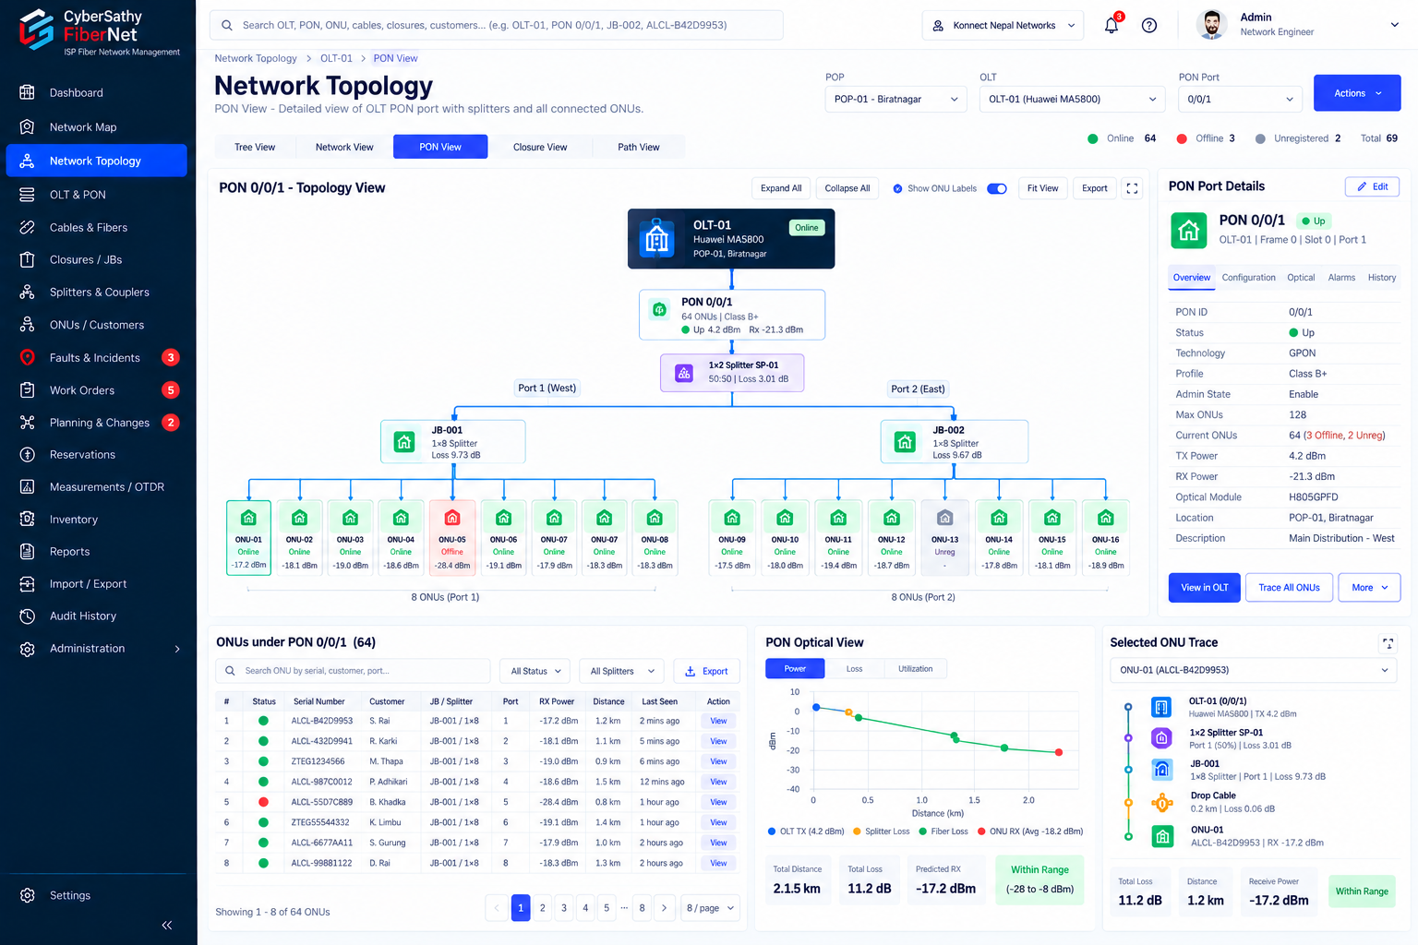
Network Topology PON View - selected OLT/PON topology, ONU status, optical view and per-ONU trace.

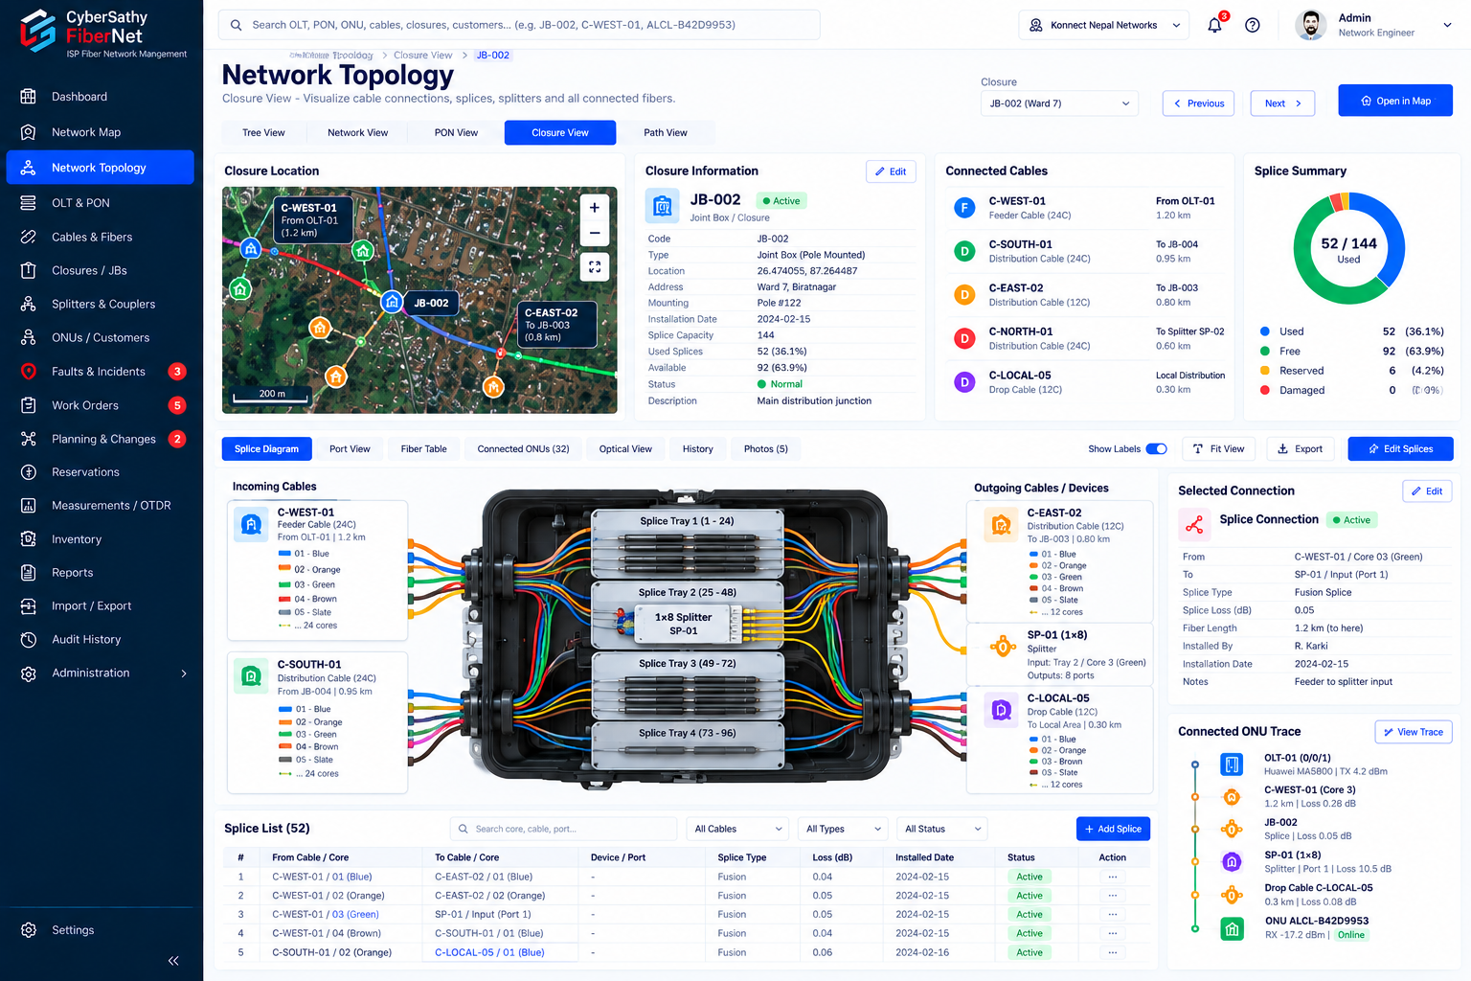
Network Topology Closure View - closure summary, connected cables, splice diagram, selected connection and splice schedule.

01 - Product and Scope

1. Product purpose
CyberSathy FiberNet is an ISP engineering and operations system for designing, documenting, tracing, maintaining, and troubleshooting passive optical distribution networks from OLT PON port to ONU/ONT. The product combines geographic mapping with an explicit physical connectivity graph.
A GIS-only application is insufficient because physical continuity depends on exact cable segments, individual fibers, fiber ends, splice relationships, splitter/coupler ports, patching, and customer drops. Conversely, a topology-only application is insufficient for field work because technicians need routes, closure locations, distance, GPS evidence, and map context. The product therefore maintains synchronized geographic, topology, closure/splice, tabular, and historical views.

2. Product objectives
- Know exactly how each ONU is physically connected back to its root PON port.
- Know which fiber, tube, closure, splice, splitter output, ODF/adapter/cord, and cable segment each path traverses.
- Calculate wavelength-aware downstream/upstream optical budgets with provenance and uncertainty.
- Identify affected services for fiber, cable, splitter, closure, splice, or PON failures.
- Plan and safely commission reroutes, repairs, extensions, and splitter replacements.
- Preserve immutable historical path revisions.
- Support field technicians through a responsive PWA with QR/GPS/photo/measurement workflows.
- Reconcile documented topology with read-only operational observations without making telemetry authoritative over undocumented passive structure.

3. Target users
- Organization administrator - tenant/users/templates/settings/commissioning authority.
- Network engineer - design, splice editing, validation, optical engineering, change review.
- NOC operator - trace, incidents, impact, operational status, reconciliation.
- Field technician - assigned work, splice instructions, GPS/photos/measurements, draft edits.
- Support agent - restricted customer path/outage status.
- Viewer/auditor - authorized read-only topology and history.

4. Architectural principles
- PostgreSQL/PostGIS is authoritative for physical topology and geography.
- Use one canonical connectivity model for coupler, trunk, mixed, equal-splitter, and repair scenarios.
- Graph traversal and optical math are deterministic domain services independent of UI.
- Tenant isolation, authorization, audit, and revisions are foundational rather than later add-ons.
- Planned, as-built, and observed layers are separate.
- Large map and fiber datasets are loaded selectively.
- Offline field edits are drafts until server validation and commissioning.

5. Terminology
- PON root: persistent OLT PON port identity.
- Optical module: replaceable module associated with a PON port, with replacement history.
- Core/fiber: individually identifiable strand within a cable segment.
- JB/closure: enclosure containing cable entries, trays, splices, passive components, and optional patching.
- Coupler: unequal/equal optical power divider represented by explicit input-to-output transfers.
- Trunk: feeder architecture/multi-core cable usage; not an Ethernet VLAN trunk.
- Core switching: physical re-splicing/patching, never automatic electronic switching.
- Continuity: explicit uncut/pass-through strand connection with no splice loss.

6. Explicit physical rules
- Single-fiber PON carries upstream and downstream on one physical strand using different wavelengths/technology timing.
- One PON feeding two fibers uses an explicit 1x2 component or another documented physical architecture.
- A fusion splice cannot create four outputs.
- Splitter outputs share the PON source/capacity; they do not create new independent PON bandwidth.
- 10:90 ratios are fractions of incoming linear optical power and attach to physical output labels.
- A high-count cable may repeat the same color across different tubes. Color alone is never an identifier.
- Geographic poles/vertices do not create cable segments or connections unless the cable model explicitly defines a segment boundary there.

7. Scope boundaries
Included: inventory, geography, connectivity, traces, optical engineering, planning/revisions, incidents/impact, field work, measurements, reporting, import/export, read-only integration, reconciliation, security/audit.
Deferred/separate engineering projects: automatic device configuration/provisioning, protection switching models, active wavelength coexistence/WDM engineering beyond explicit supported profiles, and arbitrary active multi-source behavior.

02 - Complete Feature Catalog
This catalog is the implementation checklist for the product. Every feature must be backed by persistence, API behavior, authorization, validation, and relevant tests.

A. Dashboard
- Tenant/network selector and global search.
- KPI cards: POPs/sites, OLTs, PON ports, active ONUs, route length, closures/JBs, splitters/couplers, active incidents, work orders, reserved fibers, damaged cores, documentation completeness, optical warnings.
- Network overview map with route/asset/fault/work-order layers.
- Network health donut: healthy/warning/faulty/unknown.
- ONU status: online/offline/unregistered/unknown/stale.
- PON port status: up/down/disabled/unknown.
- Fiber core utilization: occupied/reserved/free/damaged/unknown.
- Recent incidents, ongoing work orders, recent topology changes, recent activities, optical exceptions.
- Click-through filters from every metric.

B. Network Map
- Street/satellite/terrain/dark basemap choices where licensing permits.
- Viewport-based spatial loading.
- Layers: POP/OLT/ODF, closures, splitters/couplers, ONU/customer, feeder/distribution/drop/backbone cable, pole, duct, chamber, cabinet, construction, fault/incident, work order, planned routes.
- Route draw/edit, vertex edit, snap endpoint to chosen asset, measure distance, GPS capture with accuracy/timestamp, nearby asset search.
- Asset labels, clustering/simplification at zoom levels, cable role/status styling.
- Path trace highlighting synchronized with selected table/asset.
- Crossing lines do not create a connection.
- Nearby endpoints may suggest a connection but require explicit user action/change set.
- Asset right panel with overview, connected assets, contained equipment, photos/history, open-in-editor actions.

C. Network Topology
Five synchronized modes:
- Tree View - hierarchical POP > OLT > PON > components > branches > ONUs.
- Network View - free-layout graph for physical topology exploration.
- PON View - one selected PON and complete descendant topology with counts/status/loss information.
- Closure View - one selected closure with exact incoming/outgoing fibers, trays, components, splices, continuities, and local paths.
- Path View - ordered OLT-to-ONU or ONU-to-OLT trace with loss ledger and map highlight.
Common functions: search, expand/collapse, fit, zoom, minimap, filters, show/hide ONU count/status/loss, export diagram, open selected node detail. Graph layout changes never alter connectivity.

D. OLT and PON inventory
- POP/site, room/rack/chassis context.
- OLT manufacturer/model/chassis ID/management reference.
- Board inventory and slot/state/history.
- PON frame/slot/port IDs, technology, profile, admin state, observed state, planned ONU limit, reach constraints.
- Optical module serial/model/replacement history without changing PON UUID.
- PON tabs: Overview, Topology, ONUs, Optical, Measurements, Alarms/Observations, History.
- Observed polling values include timestamp/freshness/source and never overwrite documented topology.

E. Cable and fiber inventory
- Cable asset: UUID/code/name/role/manufacturer/model/core count/tube layout/color template/installation method/ownership/install date/lifecycle/attachments/cost.
- Cable segment: endpoints, polyline, route length, installed length, slack, surveyed length, chosen calculation length, provenance, uncertainty.
- Fiber: segment, number, tube number/color, within-tube number/color, marker, lineage, condition, notes.
- Arbitrary positive core count; presets 6/12/24/48/96/144; preserve 122 exactly.
- Virtualized large-core table.
- Separate physical condition, lifecycle, allocation, reservation state, and observed signal state.
- Cable detail tabs: Overview, Segments, Fibers, Route, Splices, Usage, History, Attachments.
- Root PONs and downstream destinations derived from traces, not assumed from sheath membership.

F. Closures / JBs and splice editor
- Closure type/code/GPS/mount/capacity/cable entries/trays/splice slots/environment/access/install photos/maintenance history.
- Multiple splitters/couplers in one closure; closure may have none.
- Incoming/outgoing cable endpoint groups by tube and fiber.
- Tray and tray-position assignment.
- Drag-to-connect plus accessible form alternative.
- Fusion/mechanical splice, explicit uncut continuity, patch/termination, component port connection.
- Blue-to-red and different core-number splicing while preserving each fiber identity.
- Bulk range connect with exact preview, occupied/damaged/invalid skip list.
- Disconnect, reserve, measured loss, move tray position.
- Mid-span closure insertion without fictitious splices for uncut fibers.
- Technician splice schedule/diagram export.
- Diagram layout persistence is distinct from connectivity persistence.
- Editing live connectivity creates a change set and shows impact before commissioning.

G. Splitters, couplers, passive components
- Templates: 1x2, 1x4, 1x8, 1x16, 1x32, 1x64, plus configurable templates.
- Coupler examples: 10:90, 20:80, 30:70, 50:50.
- Explicit input/output physical labels, nominal branch fraction, wavelengths, rated per-path insertion loss, optional measured loss, datasheet attachment.
- Output fractions >0 and sum to 1 within documented tolerance for power-divider templates.
- ODF, patch panel, adapter, pigtail, patch cord, attenuator support.
- Adapter has distinct front/rear terminations and one internal transfer path.

H. ONU / Customer mapping
- ONU serial/model/customer service reference/location/optical port/drop cable/activation/documented PON/latest observed association.
- One customer reference may own multiple ONUs/services.
- Documented source and observed source shown side-by-side; mismatch warning/reconciliation workflow.
- ONU tabs: Overview, Fiber Trace, Service, Optical, Measurements, Incidents, History.
- Trace-to-OLT button with map/topology highlighting and ordered path details.
- Optional VLAN/service/billing identifiers live in service layer and never define passive continuity.

I. Trace and impact engine
- ONU-to-OLT, OLT-to-all-ONUs, core both directions, splitter output descendants, closure-contained paths.
- Result states: complete, incomplete, ambiguous, invalid loop, blocked known damage, incompatible component, unknown optical budget, conflicting source.
- Ordered steps with IDs, cable/core/tube, length, loss, cumulative loss, warnings.
- Bounded traversal/visited-state by node+direction+wavelength/service context.
- Revision/profile/calculation-version aware cache and invalidation after commissioning.
- Failure scopes: fiber, segment, entire cable asset/sheath, splitter output, splitter body, splice, PON, closure.
- Unique ONU and customer-service counts separately.
- Correlated alarm common-upstream hypotheses with confidence/supporting paths but never auto-damage classification.

J. Optical engineering
- Direction/wavelength aware downstream and upstream calculations.
- Parameter provenance: manufacturer rated, measured, project default, ideal estimate.
- Nominal/min/max transmit and receive limits where supported.
- Fiber attenuation, splice, connector-pair, transfer, attenuator/other explicit loss.
- Ideal branch loss and datasheet total-insertion-loss handling without double counting.
- Predicted RX, weakest RX, strongest RX, sensitivity headroom, engineering margin remaining, overload headroom.
- ODN attenuation/reach/profile checks.
- Unknown input => unknown result.
- What-if: splitter ratio/stage, alternate core, drop length, source profile; compare all affected existing customers.
- Separate indicators: available output, PON ONU count/capacity, measured health, optical design, documentation completeness.

K. Planning, reservations, revisions, audit
- Change set states: draft, submitted, approved, work in progress, verified, commissioned, rejected, cancelled.
- Base revision and stale draft detection.
- Before/after topology, affected assets/services, optical differences, warnings, evidence/work order, executor, approver.
- Port/fiber reservations with purpose/holder/expiry/change/customer reference.
- Atomic commissioning with endpoint locks and optimistic revision checks.
- Immutable as-built revisions and time-based path inspection.
- Rollback as new verified change/revision.
- Audit of before/after values and reason.

L. Faults and incidents
- Types: suspected/confirmed cable cut, high loss, damaged core, splitter fault, dirty connector, closure damage, power outage, PON issue, unknown.
- Multiple incidents per asset and no duplicate impact count.
- Suspected vs confirmed asset/scope.
- Incident map, timeline, affected service list, related work orders, measurements/photos/evidence.
- Cable break repair workflow and alternate-fiber analysis.

M. Work orders and field operations
- Work order: location, exact fiber/tube/color, current/proposed splice list, affected customers, materials, test checklist, assignee, schedule/timestamps/evidence.
- States: draft, assigned, scheduled, in progress, awaiting verification, completed, cancelled.
- PWA: QR/barcode lookup, GPS+accuracy, cached work package, photos, measurement entry, route overlay, stale data indicator.
- Offline queue uses idempotency keys/base revision and never last-write-wins fiber occupancy.
- Completion requires topology/evidence requirements, not only checkbox completion.

N. Measurements / OTDR
- Receive power dBm, insertion loss dB, OTDR event distance m.
- Asset/port/path reference, reference plane, direction, wavelength, instrument, timestamp, technician, units, attachment, quality.
- Do not substitute measurements from incompatible reference planes.
- OTDR distance-to-map helper follows selected installed-length model and uncertainty/slack/launch offset; after splitters return candidates rather than false certainty.

O. Inventory/materials
- Stock categories: cable, closure, splitter/coupler, ODF/adapters, patch cords/pigtails, modules, ONU, sleeves/connectors, tools/consumables.
- Stock lifecycle: in stock, reserved, issued, installed, returned, damaged, lost, retired.
- Material estimates distinguish installed/planned/stock quantities.
- Costs/rates configurable; estimated reports clearly labeled.

P. Reports
- OLT/PON inventory; PON-to-ONU tree; ONU path sheet.
- Cable/core utilization; closure splice schedule; free/reserved/damaged fibers.
- Splitter output allocation; low/unknown optical margin; overload; documentation gaps.
- Commissioning exceptions; fault impact; repair history; work orders/technician activity.
- Materials/cost estimates.
- CSV, GeoJSON, printable reports, versioned topology JSON.

Q. Import / Export / Integrations
- CSV/XLSX inventory and GeoJSON/KML route import with preview, mapping, identifier resolution, validation.
- CRS preservation/conversion, dry-run, duplicate detection, stable external IDs, idempotent retries, all-or-nothing or explicitly reported partial batches.
- Do not infer splices from geometry crossing.
- Versioned topology JSON export/import with relationship validation and trace-equivalence report.
- Read-only OLT adapters for inventory, PON state, ONU registration, readings, alarms, timestamps/freshness/errors.
- Reconciliation screen for observed vs documented source.
- Billing/CRM customer links do not become topology authority.

R. Administration / Security
- Organization, branding, timezone, currency, locale.
- Users, memberships, teams/regions, roles/permissions.
- Network templates, color/tube templates, component templates, optical profiles.
- Integration settings/secrets references.
- MFA/session/security policy.
- Backup/restore/retention configuration and consistency checks.
- Authentication/export/connection/commissioning audit.

Phase allocation
Phase 1: A-H core inventory/connectivity/topology, trace, optical, revision/audit, basic security/map.
Phase 2: incidents/impact, repair, reservations/work orders, measurements, imports/exports/reports/what-if.
Phase 3: offline sync, read-only OLT adapters, customer links/reconciliation, OTDR candidate mapping.
Phase 4: scale optimization, advanced reporting/engineering/procurement/route alternatives.

03 - UI/UX Screenbook

1. Design language
Desktop mockup language:
- Dark navy left navigation with CyberSathy FiberNet identity.
- Light main canvas with white cards, subtle borders, rounded corners, compact shadows.
- Blue is the primary action/highlight; semantic states use green/red/orange/gray/purple plus text/icon labels.
- Dense operational tables use sticky headers, filters, pagination/virtualization, and row actions.
- A right-side context inspector appears for selected map/topology assets.
- Search and tenant/network switcher remain globally available.
- Do not rely on color alone for fiber/status differentiation; include core number, tube, labels, markers/patterns.
Mobile PWA:
- Map-first layout with bottom sheet.
- Bottom navigation: Map, Assets, Work, Scan, More.
- Large touch targets, offline/stale/sync state always visible during field workflows.

2. Global shell

Left navigation
Dashboard
Network Map
Network Topology
OLT & PON
Cables & Fibers
Closures / JBs
Splitters & Couplers
ONUs / Customers
Faults & Incidents
Work Orders
Planning & Changes
Reservations
Measurements / OTDR
Inventory
Reports
Import / Export
Audit History
Administration
Settings
Badges may show active incidents, assigned work orders, pending changes, or conflicts.

Top bar
- Global search: asset code/name, cable, closure, OLT frame/slot/port, ONU serial, authorized customer reference, work order, incident, QR code.
- Tenant/network/site selector.
- Notifications.
- Help/documentation.
- User profile/role/session controls.

3. Dashboard page
Top KPI grid with drill-down. Center-left map overview. Right analytics cards. Bottom operational tables.
Required states:
- No inventory yet: onboarding call-to-action.
- Telemetry unavailable: operational cards show stale/unknown, not zero/offline.
- Permission-limited user: hide restricted customer/export details while retaining allowed network status.

4. Network Map page

Layout
- Full-height GIS canvas.
- Floating layer manager on left.
- Vertical edit/navigation toolbar on right edge of map.
- Context inspector on right side of application.
- Bottom row: selected path trace, cables in viewport, nearby assets.

Layer panel
Asset toggles and base-map choice. Persist user preferences per account where appropriate.

Context inspector
For closure example: image, code/type/location/mount/install date/tray/splice capacity/cable count/splitter count/status; tabs Overview, Cables & Cores, Splice Diagram, Photos, History; actions Open in Editor, View/center on Map, More.

Drawing/editing
- Explicit edit mode prevents accidental route edits.
- Snapping presents target name and requires confirmation.
- Adding a geographic vertex changes geometry only.
- Connection suggestions are clearly advisory.
- Planned geometry has distinct planned-state styling.

5. Network Topology page
Top tabs: Tree View, Network View, PON View, Closure View, Path View.

Tree View
Expandable cards/branches from POP to OLT/PON and descendants. Useful for inventory hierarchy and ONU counts.

Network View
Dark grid graph canvas. Topology nodes are movable for layout only. Provide fit, zoom, minimap, automatic layout selector, export, display toggles. Right inspector shows selected PON/component/asset. Bottom area can display selected PON tree, ONU table, selected path.

PON View
Header selectors: POP, OLT, PON. Status summary: online/offline/unregistered/total.
Central topology begins at OLT/PON, displays explicit splitter outputs/branch names, closures/splitters, and child ONUs. Do not visually imply that every ONU is direct if intermediary components exist; collapsed groups must state they are summarized.
Right PON inspector tabs: Overview, Configuration/Profile, Optical, Alarms/Observations, History.
Bottom: ONU table, optical power/loss/utilization view, selected ONU trace.

Closure View
Header closure selector, Previous/Next, Open in Map. Summary cards: location map, closure information, connected cables, splice utilization.
Tabs: Splice Diagram, Port View, Fiber Table, Connected ONUs, Optical View, History, Photos.
Splice Diagram shows incoming cables at left, physical tray/component workspace center, outgoing cables/devices right, selected connection inspector, connected ONU trace, and searchable splice list.

Path View
Ordered trace visualization and table. Toggle downstream/upstream. Synchronized map mini-view and optical ledger. Display exact first blocking location for incomplete paths.

6. OLT & PON pages

OLT list
Filters by POP/model/state/vendor. Table + optional rack visualization.

OLT detail
Overview, Boards, PON Ports, Optical Modules, Observations, History, Attachments. Chassis illustration is informative, not an authoritative port relationship unless generated from persisted inventory.

PON detail
Overview, Topology, ONUs, Optical, Measurements, Alarms, History. Include planned limit and current derived installed count separately.

7. Cables & Fibers

Cable list
Code, role, nominal cores, length, utilization, condition, lifecycle, root PON count, endpoints. Filters by role/core count/condition/lifecycle/allocation/area/PON.

Cable detail
Overview, Segments, Fibers, Route, Splices, Usage, History, Attachments.

Fiber/core table
Virtualized; supports 122+ rows without rendering all cells. Fixed identity columns and optional derived trace columns. Exact label example: C-WEST-01 / Segment S3 / Tube 2 Orange / Fiber 13 Blue.
Status chips remain separate: condition, allocation, lifecycle, observed signal.

8. Closure editor behavior

Endpoint cards
Each endpoint shows cable, segment, fiber number, tube/color, core color/marker, condition, allocation, existing connection, reservation, trace root if resolvable.

Connection creation
Accessible form:
- Select source termination.
- Select connection type.
- Select destination termination/component port.
- Optional tray/slot/measured loss/notes.
- Preview exact old/new state and impact.
- Save to draft change set.
Drag-to-connect triggers the same backend validation and produces the same draft operation.

Bulk connect
Range mapping UI has source/destination ranges, increment policy, preview table, skip reasons. No silent row dropping.

Live topology editing
If base revision is commissioned, UI automatically creates/uses a draft change set. Context header clearly shows Editing Draft CHG-... based on Revision ....

9. Splitter/coupler pages
Component list, template/model, enclosure/tray, input, outputs, allocation, branch fraction, insertion loss source, descendant ONU count, root PON.
Editor always displays physical output IDs and their ratio/loss. Reversing 10%/90% requires explicit reassignment and impact recalculation.

10. ONU/Customer pages
List includes serial, service reference, documented PON, observed PON, splitter/output, status, RX power, freshness. Source mismatch filter.
ONU detail trace timeline supports click-to-open every physical asset. Customer-sensitive fields obey role/region policy.

11. Faults / Incidents
Incident board/list/map. Detail contains scope, suspected/confirmed status, affected sets, shared-fault candidates, evidence, related measurements/work orders, timeline.
Impact views distinguish one core, one segment, whole cable/sheath, splitter output/body, splice, PON, closure.

12. Work Orders
Desktop work-order editor plus field view. Exact splice instructions are generated from proposed change set and cannot be free-form only. Completion screen validates required topology changes/evidence/test readings.

13. Planning & Changes
List by lifecycle/status. Detail contains base revision, proposed operations, topology diff, affected ONUs/services, optical diff, conflicts, evidence, approval, field status. Commission button is disabled until backend validation is current and authorization is satisfied.

14. Reservations
Calendar/list/table; shows resource, holder, purpose, related change/customer/work, expiration, conflicts. Availability is rechecked server-side at create/commission.

15. Measurements / OTDR
Measurement list and detail, with reference plane/direction/wavelength always visible. OTDR helper lets user pick origin/path and shows distance candidates with uncertainty.

16. Inventory
Stock overview, categories, receipts/issues/reservations/install associations, low-stock thresholds, cost estimates. Installed network asset lifecycle and warehouse stock remain related but distinct.

17. Reports
Report center cards grouped by Network, Fiber, Optical, Operations, Planning, Materials, Audit. Each report has filters, generation state, revision/time basis, export format, and permission checks.

18. Import / Export
Wizard stages: Upload, Format, Mapping, Identifier Resolution, Validation, Preview, Commit, Result. Row-level errors are downloadable. Import never implies topology connection from line crossing.

19. Audit / Administration
Audit offers filtered immutable event timeline. Administration contains Organization, Users, Teams/Regions, Roles, Templates, Optical Profiles, Integrations, Security, Data/Backup, Localization.

20. Common UI states
Every data view should intentionally handle:
- Loading/skeleton.
- Empty/no data.
- Filtered empty.
- Partial/incomplete documentation.
- Unknown domain state.
- Stale telemetry.
- Permission denied.
- API/server error.
- Offline (field app).
- Revision conflict.
- Endpoint occupancy conflict.
- Validation blocked.
Avoid green success styling for unknown/incomplete states.

04 - Frontend Architecture

1. Stack
Recommended: React + TypeScript, a supported bundler such as Vite, React Router (or equivalent), TanStack Query for server state, a small client-state store for UI/session preferences, MapLibre GL JS for GIS, and React Flow/XYFlow or an equivalent maintained graph editor for topology. Verify current versions and licenses before installation.
Use a component library/design-token layer but keep domain-specific fiber/topology components first-class rather than forcing them into generic form widgets.

2. Frontend responsibilities
Frontend is responsible for interaction, visualization, optimistic draft UX where safe, filtering, accessibility, and synchronizing map/topology/table selection. It is not authoritative for topology validation, optical math, tenant authorization, commissioning, or concurrency decisions.

3. Recommended source tree
frontend/
src/
app/
router/
providers/
layouts/
guards/
auth/
dashboard/
map/
components/
layers/
drawing/
queries/
state/
topology/
tree/
network/
pon/
closure/
path/
common/
olt/
cables/
closures/
passive/
onus/
customers/
optical/
incidents/
work-orders/
changes/
reservations/
measurements/
inventory/
reports/
import-export/
audit/
administration/
field/
shared/
api/
components/
forms/
tables/
charts/
status/
permissions/
errors/
hooks/
utils/
types/
design-tokens/

4. Route model
/dashboard
/map
/topology/tree
/topology/network
/topology/pon/:ponId?
/topology/closure/:closureId?
/topology/path?endpoint=...
/olts
/olts/:id
/pon-ports/:id
/cables
/cables/:id
/segments/:id
/closures
/closures/:id
/components
/components/:id
/onus
/onus/:id
/customers/:id
/incidents
/incidents/:id
/work-orders
/work-orders/:id
/changes
/changes/:id
/reservations
/measurements
/inventory
/reports
/import-export
/audit
/admin/*
/field/*
Routes should preserve selected revision/change-set context in a deliberate route/query/session model so deep links reproduce the same view.

5. Server-state strategy
Use query keys that include tenant, revision/change-set, relevant filters, and resource ID. Examples:
- `['mapFeatures', tenantId, viewport, layers, revision]`
- `['closureConnectivity', tenantId, closureId, revisionOrChangeSet]`
- `['trace', tenantId, endpointId, direction, revision, profile]`
- `['optical', tenantId, traceKey, profile, calculationVersion]`
Mutations invalidate only affected scoped keys where possible.

6. UI state strategy
Local/UI state: selected map asset, open inspector tab, topology layout positions, active layer controls, table column preferences, unsaved diagram layout, mobile bottom sheet state.
Server/domain state must not be duplicated into a global client store if query cache is sufficient.

7. Core reusable components
- `GlobalSearch`
- `TenantNetworkSelector`
- `PermissionGate`
- `AssetStatusBadge`
- `FreshnessBadge`
- `RevisionBadge`
- `ValidationSummary`
- `ConflictPanel`
- `VirtualizedCoreTable`
- `MapCanvas`, `MapLayerControl`, `MapAssetPopup`, `RouteEditor`
- `TopologyCanvas`, `TopologyNode`, `TopologyEdge`, `TopologyMiniMap`
- Domain nodes: `OLTNode`, `PONNode`, `ClosureNode`, `SplitterNode`, `CouplerNode`, `FiberNode`, `ONUNode`
- `FiberEndpointCard`
- `SpliceTrayView`
- `ConnectionEditor`
- `BulkConnectionPreview`
- `TraceTimeline`
- `PathStepTable`
- `LossLedger`
- `OpticalResultCard`
- `ImpactSummary`
- `TopologyDiff`
- `WorkOrderChecklist`
- `MeasurementForm`
- `OfflineSyncStatus`
- `AuditTimeline`

8. Map rendering
Load clustered/simplified asset/route features by viewport and zoom. Detailed cable cores are never individual map lines at the opening network overview. Core details are loaded after cable selection or trace request.
Geometry editing uses server-provided entity/version IDs and returns a draft/planned geometry operation as appropriate. Geometry and connectivity APIs remain distinct.

9. Topology rendering
The frontend receives normalized nodes/edges already derived from authoritative connectivity. A topology edge includes a domain edge type and IDs; the UI may hide/collapse intermediate edges but cannot invent connections.
Layout coordinates may be persisted in a separate layout table keyed by view/entity/revision/user or shared layout context. Layout save must never call a connection mutation.

10. Closure editor
Source/destination termination selection uses stable UUIDs. Display strings contain cable/segment/tube/core/color for technicians. Drag-and-drop is translated into the same typed mutation payload used by the accessible form.
After each draft edit, show structural validation; full commissioning validation remains server-side. Impact and optical preview should be recomputed asynchronously when potentially expensive.

11. Tables and large core counts
Use row virtualization for 96/122/144+ core tables and large ONU lists. Server-side pagination/filtering for tenant-wide searches. Do not instantiate thousands of interactive topology/DOM elements when a summary/collapse representation is adequate.

12. Accessibility
- Keyboard-accessible connection form equivalent to drag/drop.
- Focus states and screen-reader labels.
- Color + text/icon/pattern redundancy.
- Minimum touch target size on mobile.
- Table header association and logical reading order.
- Charts accompanied by textual/tabular summaries.

13. PWA/offline
Cache app shell and explicitly assigned work packages only. Store offline mutations in a structured queue with idempotency key, base revision, object IDs, payload, attachments/evidence references, local timestamp, and sync state. On conflict, stop and display server conflict details; never auto-overwrite occupancy.

14. Error model
Frontend maps stable API error codes to specific UX:
- `REVISION_STALE` -> topology diff/conflict screen.
- `ENDPOINT_OCCUPIED` -> show exact competing connection/reservation if authorized.
- `MULTIPLE_PON_ROOTS` -> block commissioning and highlight competing source steps.
- `ACTIVE_LOOP` -> highlight loop endpoints.
- `OPTICAL_INPUT_UNKNOWN` -> unknown budget badge and missing parameter list.
- `PERMISSION_DENIED` -> restricted state without leaking protected object details.

05 - Backend Architecture

1. Style
Use a modular Django + Django REST Framework monolith with PostgreSQL/PostGIS. Keep business logic in domain/application services rather than serializers/views. Use a background worker for expensive trace subtrees, impact analysis, report generation, import/export, attachment processing, and integrations.
Redis may be used for queue/cache/locks where appropriate, but correctness must remain enforceable at the database transaction layer.

2. Recommended Django apps
backend/
config/
identity/
tenancy/
locations/
olt/
cables/
connectivity/
passive/
topology/
optical/
customers/
observations/
changes/
reservations/
incidents/
workorders/
measurements/
inventory/
imports/
exports/
reports/
integrations/
attachments/
audit/
common/

3. Layering
- Models: persistence and low-level invariants/constraints.
- Repositories/query services: efficient domain queries and PostGIS access.
- Domain services: traversal, validation, loss ledger, impact, reservation rules.
- Application services: use cases such as create draft connection, validate change, commission, create work order, import commit.
- API serializers/controllers: schema/transport only.
- Jobs: call application/domain services and store structured progress/error state.

4. Connectivity service responsibilities
- Create/retire revisioned external connections.
- Validate endpoint type compatibility, tenant, lifecycle, occupancy, reservation conflicts, tray position, duplicate reverse-order pairs.
- Generate explicit continuities for mid-span cases.
- Support component port terminations without allowing illegal fanout.

5. Topology service responsibilities
- Build revision-aware graph from termination nodes, fiber spans, external connections, and component transfers.
- Trace with direction/wavelength/service context.
- Detect source conflicts, active cycles, dangling/incomplete paths, known damage, incompatible components.
- Generate descendant service sets and common-upstream candidates.
- Produce normalized graph DTOs for tree/network/PON/closure/path views.

6. Optical service responsibilities
- Convert trace edges to unique physical loss elements.
- Resolve parameter values/provenance by wavelength/direction/profile.
- Compute downstream/upstream ledger and headroom checks.
- Return missing inputs rather than fabricated defaults unless a configured project default is explicitly selected and labeled.

7. Change/commissioning service
Pseudocode:
BEGIN TRANSACTION
lock change set row
verify status and authorization
verify base revision == current commissioned revision
determine affected terminations/resources
lock affected endpoint/resource rows
re-check occupancy/reservations/lifecycle
apply proposed operations to transaction-visible candidate graph
run structural validation
run source/cycle validation
run service trace/impact validation
run optical validation/exception policy
create immutable topology revision
materialize connection/asset revision changes
create audit events
mark change set commissioned
COMMIT
Any failure rolls back the entire commit.

8. Observations/integrations
Observed OLT inventory/state and ONU association live in timestamped observation tables. Polling failure updates connector job/freshness error state; it does not rewrite all observed ONUs as offline. Reconciliation compares observed association to documented derived root.

9. Background jobs
- Large OLT-to-all-ONU trace.
- Failure impact on very large subtrees.
- Imports/exports.
- Printable reports.
- Topology JSON validation/re-import simulation.
- OLT polling.
- Cache invalidation/prewarming.
- Backup consistency checks if automated by application tooling.
Every job is tenant-scoped, authorized at creation, records progress/retry/error, and avoids leaking cross-tenant IDs/data.

10. Attachments
Store metadata in PostgreSQL and bytes in private S3-compatible/object storage. Validate MIME/size, use random storage keys, scan if required, and issue time-limited authorized URLs. Photos/OTDR files/datasheets/work evidence link to typed domain records.

11. Audit
Audit events include tenant, actor, event type, object references, request/correlation ID, timestamp, reason, change set/revision, and structured before/after values where appropriate. Never store passwords/tokens/customer secrets in logs.

06 - Data Model and Canonical Topology

1. Source of truth
PostgreSQL/PostGIS stores both geographic and physical network information. The physical graph uses one unified Termination identity so connection endpoints are real foreign-key owned records, not unchecked generic IDs.

2. Core entity groups

Tenant / identity
Tenant, User, Membership, Role, TeamRegionScope.

Geography / enclosure
Location - point/area/address/geolocation provenance.
Enclosure - POP, closure, cabinet, chamber, rack/enclosure context.

Active source equipment
OLT, OLTBoard, PONPort, OpticalModule, OpticalModuleAssignment.

Cable / strand inventory
CableAsset, CableSegment, Fiber, FiberEnd, StrandLineage.

Passive components
Component, ComponentPort, OpticalTransfer, Tray, TrayPosition.

Connectivity
Termination, FiberSpan, Connection, optional PatchCord/Adapter specialized metadata.

Customer endpoint
ONU, CustomerReference, ServiceAssignment.

Optical engineering
OpticalProfile, LossParameter, Measurement, CalculationVersion.

Operational control
Reservation, ChangeSet, ChangeOperation, TopologyRevision, AuditEvent.

Fault/field
Incident, WorkOrder, WorkTask, Attachment.

Observations / caching
ObservationSource, PONObservation, ONUObservation, TraceCache.

3. Universal fields
Use UUID primary keys for domain objects. Every tenant-owned record has tenant_id. Common timestamps are UTC. Display timezone defaults to Asia/Kathmandu. Soft retirement/lifecycle is preferred to destructive deletion where history references the object.

4. Cable model

CableAsset
- UUID, tenant, readable code/name.
- role: backbone/feeder/distribution/drop/other.
- manufacturer/model.
- nominal core count (positive integer, arbitrary; 122 remains 122).
- tube/color template reference plus captured installed labeling.
- ownership/install method/install date/lifecycle/cost/attachments.

CableSegment
- parent cable.
- endpoint location/enclosure references.
- PostGIS LineString/polyline.
- route length (derived), installed length, slack, surveyed length.
- selected calculation length + provenance + uncertainty.

Fiber
Unique (tenant_id, segment_id, fiber_number).
Fields: fiber number, tube number/color, within-tube number/color, stripe/marker, lineage ID, physical condition, notes.

FiberEnd
Each fiber has exactly two ends (A/B), each backed by one Termination node.

FiberSpan
Internal traversable edge between those two terminations. It references the fiber and contributes length/attenuation loss.

5. Termination model
Termination fields conceptually include:
- UUID, tenant.
- `kind`: fiber_end, component_port, pon_port, onu_port, patch_cord_end, etc.
- typed one-to-one relation to the owning domain record/port through enforceable database relations/application invariants.
- lifecycle/status metadata where needed.
Do not use unrestricted content_type/object_id generic foreign keys for authoritative endpoint ownership unless database constraints preserve type/tenant integrity; prefer explicit ownership tables/one-to-one relations.

6. Component model
Component: splitter, coupler, adapter, attenuator, ODF panel/other supported passive device.
ComponentPort: physical identifier, role (input/output/common/front/rear/etc.), enclosure/tray context, one termination.
OpticalTransfer: internal directional relation between component ports with wavelength applicability, branch fraction, insertion-loss parameter source, and transfer type.
For a 10:90 coupler:
- `INPUT -> TAP-10`, fraction 0.10.
- `INPUT -> THROUGH-90`, fraction 0.90.
These labels must be explicit physical labels.

7. Connection model
Connection is an external physical relationship between two Termination UUIDs.
Fields include:
- tenant.
- endpoint A/B.
- type: fusion_splice, mechanical_splice, continuity, patch_termination, supported other.
- tray/position.
- nominal/measured loss reference where applicable.
- state/lifecycle.
- created revision and retired revision.
- notes/evidence/work/change references.
Canonicalize endpoint ordering for uniqueness or enforce duplicate reverse-order prevention through a database expression/constraint/service.
A commissioned termination has at most one incompatible external connection. Component internal transfers do not count as external occupancy.

8. Mid-span/lineage model
A physical parent cable can be represented by segments split at a closure while strand lineage indicates they are the same continuous installed strand. For uncut fiber, create explicit continuity between appropriate segment fiber ends with type=continuity, contributing zero splice loss. Cut/spliced fibers use fusion/mechanical splice records separately.

9. Revision model
Recommended approach: immutable TopologyRevision sequence plus revision-valid domain relationships.
For revisioned connectivity, store created_revision_id and optional retired_revision_id. A connection is visible at revision R if it was created at/before R and not retired before/equal R according to the chosen sequence semantics.
Assets that change historically may use version rows or audited snapshots for fields requiring time-based reconstruction. At minimum, topology path reconstruction must be exact for historical connection/fiber/component relationships.
ChangeSet points to base_revision, stores draft operations rather than mutating commissioned records. Draft graph projection applies base revision plus ordered draft operations.

10. Invariants
- Tenant of both endpoints/component/connection matches.
- Fiber has exactly two ends.
- Splitter input/output relationships follow supported template/port semantics.
- Branch fractions >0; power-divider outputs sum to one within configured tolerance.
- One external occupancy per commissioned termination unless a specifically modeled endpoint type allows otherwise.
- Ordinary splice/continuity cannot fan out.
- Retired assets cannot be newly commissioned.
- Tray position must exist/capacity must be respected.
- No duplicate reverse-order connection.
- Reservation conflicts prevent incompatible allocation.
- Active service graph cannot contain closed passive loop or conflicting upstream roots.

11. Indexing
- Tenant + readable code indexes.
- GIST/SP-GIST on map geometries.
- Tenant/segment/fiber-number unique index.
- Endpoint A/B connection indexes.
- Revision visibility indexes.
- PON/ONU serial/customer reference search indexes.
- Observation source + collected timestamp indexes.
- Reservation resource/status/expiry indexes.
- Audit event object/time indexes.

12. Derived data
Derived, not manually authoritative:
- ONU root PON.
- Cable/core occupied state from commissioned connections and service paths.
- Descendant ONU count.
- Root PON set carried by a cable/sheath.
- Path optical loss/result.
Explicitly stored separately:
- reservation.
- physical condition.
- lifecycle.
- observed association/status.
- planned/design intent.

07 - API Contract

1. General conventions
Base: /api/v1/.
Every request runs in authenticated tenant context. IDs are UUIDs. Times are ISO-8601 UTC; clients display tenant/user timezone. Paginate list endpoints. Use explicit revision/change-set query/body context.
Responses should include machine-readable error codes, human-readable explanation, affected IDs if authorized, and remediation hints.

2. Error semantics
- `400` malformed request/schema.
- `401` unauthenticated.
- `403` unauthorized without object detail leakage.
- `404` not found or intentionally hidden protected resource.
- `409` revision/occupancy/reservation/concurrency conflict.
- `422` structurally impossible/engineering validation failure where the API design distinguishes semantic validation.
- `429` rate limit.
- `5xx` server/integration failure with correlation ID.
Example stable codes: REVISION_STALE, ENDPOINT_OCCUPIED, RESERVATION_CONFLICT, MULTIPLE_PON_ROOTS, ACTIVE_LOOP, INVALID_ENDPOINT_PAIR, RETIRED_ASSET, TRAY_CAPACITY_EXCEEDED, OPTICAL_INPUT_UNKNOWN, KNOWN_DAMAGED_PATH, TENANT_SCOPE_DENIED.

3. Search/map
GET /assets
- filters: type, q, status, area, lifecycle, tenant-authorized scopes.
GET /map/features
- bbox/viewport, zoom, layers, revision/planned context.
- returns generalized GeoJSON-like features and minimal properties.
PATCH /locations/{id} or planned geometry operation endpoint
- geometry update with version/base revision semantics.

4. OLT/PON
GET /olts, GET /olts/{id}
GET /olts/{id}/boards
GET /pon-ports, GET /pon-ports/{id}
GET /pon-ports/{id}/onus
GET /pon-ports/{id}/observations
GET /optical-modules, GET /optical-modules/{id}

5. Cables/fibers
GET/POST /cables
GET/PATCH /cables/{id}
GET /cables/{id}/segments
GET /segments/{id}
GET /segments/{id}/fibers - server pagination/filter, exact inventory.
GET /fibers/{id}
GET /fibers/{id}/trace-summary
Bulk fiber generation is an explicit operation that validates requested positive core count and template mapping and creates exactly the requested number.

6. Closure/component
GET /closures/{id}
GET /closures/{id}/connectivity?revision=...|change_set=...
- returns cable entries, fiber terminations, trays, ports, internal transfers, external connections, layout data, validation annotations.
GET/POST /components
GET /components/{id}
GET /components/{id}/ports

7. Change sets
POST /change-sets
Body: purpose, base_revision, idempotency_key, scope/assets optional.
POST /change-sets/{id}/connections
Body: endpoint_a_id, endpoint_b_id, connection_type, tray/position/loss/notes.
DELETE /change-sets/{id}/connections/{operation_id} or explicit disconnect operation.
POST /change-sets/{id}/bulk-connections/preview
POST /change-sets/{id}/bulk-connections
POST /change-sets/{id}/validate
Returns structural errors, trace/source/cycle errors, affected services, optical exceptions, missing data, warnings, validation token/version.
POST /change-sets/{id}/submit
POST /change-sets/{id}/approve
POST /change-sets/{id}/verify
POST /change-sets/{id}/commission
Commission body may include latest validation token, idempotency key, managed-exception acknowledgements if policy permits.

8. Trace
GET /traces
Parameters: endpoint, direction, revision or change_set, wavelength/profile/service context, max work bounds if exposed by policy.
Result:
- state.
- root PON(s) if resolved.
- ordered step list.
- first blocking location/missing edge.
- warnings.
- calculation/cache revision metadata.
GET /pon-ports/{id}/topology
GET /closures/{id}/topology
- normalized graph/tree representations for UI.

9. Optical
POST /optical-calculations
Input: trace/endpoint, revision/change set, optical profile, optional what-if overrides.
Returns downstream and upstream independently: ledger elements, provenance, nominal/min/max loss and RX, sensitivity/overload/margin checks, missing parameters, warnings, calculation version.

10. Impact/fault
POST /impact-analyses
Input explicit failure type/scope/object. For expensive cases returns job ID/status URL.
GET/POST /incidents
GET/PATCH /incidents/{id}
POST /incidents/{id}/confirm-scope

11. Reservations
POST /reservations
- resource type/UUID, purpose, holder/change/customer, expiry, idempotency.
- server rechecks availability.
DELETE/PATCH /reservations/{id} for release/extend subject to policy.

12. Measurements
POST /measurements
Requires measurement type, target/path/reference plane, direction, wavelength where applicable, instrument, timestamp, unit/value, evidence metadata.
GET /measurements filters by asset/path/technician/type/date.

13. Work orders / field sync
GET/POST /work-orders
GET/PATCH /work-orders/{id}
POST /work-orders/{id}/evidence
POST /work-orders/{id}/measurements
POST /field-sync
Batch: idempotency keys, base revision, local operation IDs, payloads, attachment references. Response returns per-operation accepted/conflict/rejected state; commissioning remains a separate authorized server workflow.

14. Import/export/report jobs
POST /imports upload/register source.
POST /imports/{id}/dry-run
POST /imports/{id}/commit
GET /imports/{id}/errors
POST /exports
POST /reports
GET /jobs/{id} common structured job status.

15. Idempotency
Store tenant-scoped idempotency key + operation + request digest + outcome for retry-sensitive writes. Replayed identical request returns original result; same key with materially different request is a conflict.

08 - Optical Engineering and Loss Ledger

1. Purpose
The optical engine evaluates a documented or proposed physical path. It is an engineering aid, not a substitute for vendor specifications or field measurements.

2. Provenance
Every parameter includes value/range, unit, wavelength/direction applicability, source type, source reference, and date/quality where measured.
Source types: manufacturer-rated, measured, project default, ideal estimate.
Missing required input returns unknown/incomplete status.

3. Ideal splitter/coupler loss
For linear branch fraction r:
L_ideal_dB = -10 * log10(r)
For equal split N:
L_ideal_dB = 10 * log10(N)
Fixtures:
- 50%: 3.0103 dB
- 10%: 10.0000 dB
- 90%: 0.4576 dB
- 1x4: 6.0206 dB
- 1x8: 9.0309 dB
- 1x16: 12.0412 dB
If a datasheet supplies total insertion loss for the branch path, that total is used directly. Do not add ideal split loss again. If only ideal fraction and separate excess loss are known, add each exactly once and label estimate provenance.

4. Path loss
L_path = sum(length_km * attenuation_dB_per_km) + sum(splice losses) + sum(connector-pair losses) + sum(component transfer losses) + sum(other explicit losses)
Stable loss-element identity prevents double charging the same physical connector/splice through multiple graph representations.

5. Receive power and headroom
P_rx_nominal = P_tx_nominal - L_path_nominal
P_rx_weakest = P_tx_min - L_path_max
P_rx_strongest = P_tx_max - L_path_min
Sensitivity headroom = P_rx_weakest - receiver_sensitivity
Design margin remaining = sensitivity_headroom - configured_engineering_margin
Overload headroom = receiver_overload_limit - P_rx_strongest
Engineering margin is a reserve and is not subtracted from displayed predicted receive power a second time.

6. Directionality
Calculate OLT-to-ONU downstream and ONU-to-OLT upstream independently with appropriate wavelength, transmitter, receiver, attenuation, and component data. Reverse traversal of a reciprocal splitter follows the same selected branch-to-common transfer path; never sum all ONUs for an individual scheduled burst budget.

7. Engineering checks
- Receiver sensitivity.
- Receiver overload.
- Engineering margin.
- Profile min/max ODN attenuation where defined.
- Reach constraints.
- ONU count/device limits.
- Component wavelength compatibility.
- Missing/uncertain parameter flags.
- Known damaged element block/exception policy.

8. Synthetic fixture
OLT Tx +4 dBm; 2 km at 0.35 dB/km; 4 splices at 0.1 dB; 2 connector pairs at 0.3 dB; 90% ideal branch; 1x4 ideal output:
0.70 + 0.40 + 0.60 + 0.4576 + 6.0206 = 8.1782 dB
P_rx = +4 - 8.1782 = -4.1782 dBm
10% branch fixture: 17.7206 dB path loss and -13.7206 dBm receive power with other fixture values unchanged.

9. API/UI result
The result must show:
- direction/wavelength.
- calculation/revision/profile versions.
- ordered loss ledger.
- nominal/min/max totals.
- predicted/weakest/strongest receive powers.
- sensitivity and overload limits.
- headrooms and configured margin.
- provenance for each parameter.
- missing inputs and warnings.
- status separately for sensitivity, overload, margin, reach, profile attenuation, documentation completeness.
Do not collapse all engineering information into a single green/red badge.

09 - Change Management, Reservations and Revisions

1. Why changes are first-class
Editing commissioned fiber connectivity represents real field work. The application must not silently mutate as-built topology because technicians may still need to perform splicing/patching and customer services may be disrupted.

2. Change lifecycle
Draft -> Submitted -> Approved -> Work in Progress -> Verified -> Commissioned.
Alternate terminal states: Rejected, Cancelled.
Smaller ISPs may authorize one administrator/engineer to perform several transitions while retaining the same event history.

3. Change contents
- ID/title/purpose/reason.
- author and responsible team.
- base topology revision.
- affected area/assets/services.
- ordered operations: add/retire connection, create component/port, reassign component output, route change, reservation, etc.
- work order link.
- impact preview.
- optical before/after.
- validation results/warnings/exceptions.
- field evidence/measurements.
- reviewer/approver/executor/verification/commission timestamps.

4. Damaged-core bypass workflow
Example: C-02 blue damaged between JB-02 and JB-03.
The bypass preview determines whether both ends require changes. A draft changing only JB-02 to red remains incomplete if red does not continue to the intended downstream path at JB-03. The UI identifies the first missing downstream connection. Completion of both necessary end changes yields a proposed trace over red while retaining damaged blue history.
Never repair by changing the stored fiber color.

5. Coupler orientation change
Changing physical 10% and 90% output assignment is an explicit component-port/transfer mapping change. The preview recalculates all affected downstream paths and includes physical output labels in work instructions.

6. Splitter replacement
Map old physical output assignments to new output IDs. Detect missing/duplicate mappings. Show affected customers and optical changes. Do not match outputs by screen position or color.

7. Reservations
A reservation records resource UUID/type, purpose, holder, related customer/change/work order, created/expiry timestamps, and status. Reservation is not occupancy. Commissioning rechecks both occupancy and reservation compatibility under lock.
Expiry behavior is policy-controlled and audited. A field work order may extend a reservation explicitly.

8. Concurrency
Two engineers attempting to use the same free output may both see it as free initially. Commission/create-reservation must serialize the resource. One succeeds and one receives 409 ENDPOINT_OCCUPIED or RESERVATION_CONFLICT with current authorized state.

9. Historical inspection
UI offers Current, a specific revision/time, or draft projection. Historical trace uses historical component/connection relationships and does not blend current connectivity into the old path.

10. Rollback
A software rollback does not undo physical splicing. To revert, create a new change set describing the intended physical restoration, execute/verify it, and commission a new revision.

10 - Faults, Work Orders and Field Operations

1. Incident model
Incident records represent suspected or confirmed operational problems without rewriting asset physical condition automatically.
Fields: ID, type, severity, state, reported/detected time, location, suspected scope, confirmed scope, notes, affected set snapshots/analysis references, related work orders, evidence, timeline.

2. Failure scope
Supported scopes include one fiber, cable segment, entire cable asset/sheath, splitter output, splitter body, splice, PON port, closure/equipment-inside assumption.
Impact engine computes the union of actual commissioned descendant service paths intersecting the failed scope and counts unique ONUs and customer services separately.

3. Shared fault hypotheses
For an ONU alarm cluster, intersect/score common upstream objects. Display supporting paths and data freshness. Label candidates as hypotheses. Never automatically set component/cable condition to damaged based only on correlation.

4. Repair workflow
- Record incident/scope/location.
- Compute affected customers.
- Inspect alternate healthy/reserved/free fibers.
- Create repair change set.
- Preview all endpoint edits and before/after traces.
- Generate exact splice instructions/work order.
- Field technician performs work and records evidence/measurements.
- Engineer verifies and commissions atomically.
- Damaged strand remains in history/current condition as appropriate.
- Close incident after service/path verification.

5. Work order content
- Exact site/map coordinate/asset.
- Current and proposed fiber tube/core/color at each end.
- Current/proposed splice/component ports.
- Affected customers count/list subject to technician permissions.
- Required materials.
- Safety/test checklist.
- Assigned technician/team/schedule.
- Photos, GPS, measured optical readings.
- Required change-set operations and commissioning dependency.

6. Mobile PWA
Bottom tabs: Map, Assets, Work, Scan, More.
Features: QR/barcode asset lookup; GPS capture with accuracy/timestamp; assigned work package; cached closure/cable/component data; route overlay; photo capture; measurement entry; splice checklist; proposed edits; offline queue; last sync/stale indicators.

7. Offline conflict behavior
Every queued write contains idempotency key and base revision. On synchronization, endpoint occupancy and revision are rechecked. Conflicts are surfaced for review and are never resolved by last-write-wins.

8. Data minimization
Offline package contains only assets/customer references needed for assigned work. Cached customer data has expiration/cleanup policy. Attachments remain protected during upload and local storage should use platform-appropriate secure storage where possible.

9. OTDR helper
User selects test origin and fiber path. System walks installed/calculation lengths and displays estimated event location with uncertainty due to slack/calibration/launch cable. If the distance extends beyond a splitter with multiple possible descendants, return candidate branches and corresponding estimated positions.

11 - Security and Multitenancy

1. Tenant isolation
Every domain read/write/job/export must be tenant-scoped. Do not trust tenant IDs supplied by clients without resolving them against authenticated membership/context. Use ORM managers/repositories/middleware and, where suitable, PostgreSQL row-level security as defense-in-depth.
Automated tests must attempt cross-tenant UUID access for detail endpoints, nested resources, exports, attachments, jobs, trace/impact queries, and background processing.

2. RBAC and scopes
Roles: organization administrator, network engineer, NOC operator, field technician, support agent, viewer/auditor. Permissions are capability-based; region/team scopes further restrict objects/customer detail.
Backend enforces permissions; UI hiding is only convenience.

3. Authentication
Use standard secure authentication, secure cookies/token handling, session expiry, optional/tenant-configurable MFA, CSRF protection appropriate to auth mode, password policy/integration where applicable, and rate limiting.

4. Secrets
OLT/API/object-store credentials are references to a secret store/environment-managed secret, not ordinary asset fields. Never return secrets to frontend after creation. Do not log them.

5. Attachments
Private object storage; authorization check before time-limited download URL; file type/size validation; optional malware scanning; metadata scrub where required for sensitive exports/photos.

6. Customer privacy
Shared maps never expose customer names/addresses by default. Support role receives only authorized path/outage/service-reference details. Exports require explicit permission and are audited.

7. Audit
Record authentication events, export generation/download, connection edits, change transitions, commissioning, reservation changes, measurements, admin/security changes, integration credential references, and backup/restore actions.

8. Security testing
- IDOR/cross-tenant object access.
- Unauthorized nested relationship enumeration.
- Tenant leakage through search, errors, reports, jobs, websocket/progress channels, attachments.
- CSRF/session fixation/session expiry.
- Rate limit abuse.
- File upload validation.
- Injection and unsafe import formulas/content.
- Permission bypass on commissioning/export/admin APIs.
- Secret leakage in logs/errors.

12 - Import, Export and Integrations

1. Import goals
Support imperfect legacy inventories without pretending contradictory data is validated topology.

2. Import pipeline
Upload -> detect format -> mapping -> identifier resolution -> validation/dry-run -> preview -> commit -> result/review queue.
CSV/XLSX: inventory and tabular connectivity where explicitly identified.
GeoJSON/KML: geographic assets/routes with CRS preservation/conversion.
Never infer a splice from intersecting/crossing geometry.

3. Import correctness
- Stable external ID per source system.
- Tenant-scoped duplicate detection.
- Idempotent retry.
- Parent-before-child dependency validation.
- Exact core count validation; do not silently change 122 to 12/144.
- Reject/queue contradictory endpoint occupancy.
- Avoid partially importing half of a cable's generated core inventory unless the import mode explicitly supports partial batches and reports that outcome.

4. Export formats
CSV - inventory/reports.
GeoJSON - geographic data only.
Printable PDF/HTML/office report - path/splice/work sheets.
Versioned topology JSON - authoritative portable graph representation including IDs/mappings, fibers, terminations, component ports/transfers, connections, revision metadata, optical/profile references as needed.
Topology JSON re-import performs validation and produces ID mapping and trace-equivalence report.

5. Read-only OLT adapters
Adapter interface can provide:
- OLT/board/PON inventory.
- PON admin/operational state.
- ONU registrations and current association.
- Optical readings.
- alarms/events.
- collection time/freshness/error.
Adapters never mutate passive topology and failed poll means stale/unknown rather than mass outage.

6. Reconciliation
Screen compares each observed ONU association with documented derived root. Categories: match, mismatch, observed-only, documented-only, stale/unknown. User may investigate and create a documentation change; integration does not auto-create undocumented splices.

7. Billing/CRM
Link by external customer/service identifiers with explicit sync provenance. Billing status/service profile does not define fiber continuity. Customer data access remains permission-scoped.

13 - Testing and Quality Strategy

1. Test pyramid
- Pure domain unit tests: graph rules, optical math, validation, impact set operations.
- PostgreSQL integration tests: constraints, revision visibility, locking/concurrency, PostGIS, tenant isolation.
- API tests: auth/permissions/errors/idempotency/pagination.
- Job/integration tests: imports, exports, polling freshness, retry.
- Browser tests: key workflows and UI states.
- Performance/benchmark tests on realistic scale dataset.
Mocked diagrams are not substitutes for graph-service tests.

2. Acceptance A01-A30
See acceptance/acceptance-matrix.md. Every acceptance ID maps to at least one automated domain/integration test and relevant UI/API test.

3. Additional mandatory tests
- Unique physical loss-element counting.
- Engineering margin applied exactly once.
- Reservation expiration and race.
- Import idempotent retry and duplicate handling.
- Source mismatch reconciliation does not overwrite topology.
- Backup restore plus topology consistency/trace equivalence.
- Stale polling preserves prior observation and marks freshness.
- Large-core table virtualization.
- Accessible non-drag connection form.
- Offline stale revision conflict.

4. Property/invariant testing candidates
- No commissioned ordinary splice endpoint degree >1 externally.
- Splitter sibling output is unreachable from another output without traversing common/input in the context-invalid direction.
- Every complete ONU trace has exactly one root PON.
- Trace terminates under arbitrary draft graphs/work limits.
- Reversing a connection endpoint order yields same physical relationship and cannot duplicate.
- Export/import preserves trace-equivalent graph.

5. UI quality gates
- Keyboard navigation for primary forms.
- Mobile closure lookup/work order flow.
- Desktop map trace highlighting.
- Topology selection synchronized with inspector.
- Conflict and unknown/stale states visually distinct.
- 122-core table remains responsive.

6. Performance targets
Benchmark dataset: 10,000 cable segments averaging 24 fibers, 5,000 closures, 50,000 ONUs in one tenant.
Targets on documented benchmark environment:
- common scoped API/map queries within ~2 seconds.
- ordinary single-ONU trace within ~1 second.
- large subtree/impact handled asynchronously when necessary.
Targets are measured goals, not unsupported guarantees.

14 - Deployment and Operations

1. Environments
Local development, test/CI, staging, production. Keep production secrets/data isolated and never seed demo customers into production automatically.

2. Services
Recommended production deployment units:
- Web/API application.
- Background worker(s).
- Scheduler for polling/maintenance jobs.
- PostgreSQL + PostGIS.
- Redis/queue if selected.
- Private S3-compatible object storage.
- Reverse proxy/TLS ingress.
- Observability stack/integrations.

3. Local startup
Provide Docker Compose (or documented equivalent) containing database/PostGIS, API, worker, frontend, object-store emulator where useful, and queue. Migrations/seed commands must be repeatable.

4. Database migrations
Migrations are reviewed as production changes. Avoid destructive rewrites of topology identifiers. Data migrations must be idempotent/restartable where practical and include validation reports for topology-affecting changes.

5. Backups
Back up PostgreSQL and attachments/object storage. Define retention and restore runbook. Periodically restore to isolated environment and run topology consistency checks and sample trace equivalence.

6. Observability
- Structured logs with tenant-safe context and correlation IDs.
- Metrics: request latency/errors, trace/calculation timing, job queue depth, polling success/freshness, import failures, conflict rates.
- Distributed tracing/OpenTelemetry where practical.
- Error reporting with secret/customer-data scrubbing.

7. Health checks
Separate liveness/readiness. Readiness verifies critical dependencies. Integration vendor outage must not necessarily make the core topology application unavailable.

8. Deployment safety
- Run migrations before/with compatible application release.
- Feature flags for deferred integrations.
- Backward-compatible API changes inside a version where possible; breaking changes require version transition.
- No application deploy should automatically commission network topology changes.

9. Disaster recovery
Document RPO/RTO goals when deployment owner confirms them. Restore procedure: infrastructure -> database -> attachments -> application -> consistency validation -> tenant smoke tests -> re-enable scheduled integrations.

15 - Demonstration Dataset
All data is synthetic/demo and must be labeled as such.

PON-A west scenario
OLT-DEMO-01 / PON-A -> feeder west core -> JB-WEST-01 -> CP-01 10:90.
- TAP-10 -> local 1x8 -> multiple demo ONUs.
- THROUGH-90 -> onward fiber -> `JB-WEST-02` -> 1x4 -> arbitrary branch labels North/South/East/Far-West.
- At least one further unequal tap on a descendant branch.

PON-B 50:50 scenario
OLT-DEMO-01 / PON-B -> initial 1x2 50:50 -> two different cores/cables -> independent descendant branches sharing PON identity/capacity.

24-core trunk box
- Core 1 -> North splitter.
- Core 2 -> South splitter.
- Core 3 -> continuity/pass-through.
- Core 4 -> another cable core 7.
- Spare, reserved, damaged, unverified cores included.
- Some cores root to different PONs; one shared cable carries fibers from different PONs.

Special fixtures
- Blue-to-red splice.
- Mid-span uncut continuity.
- Two-ended repair draft and incomplete one-end bypass draft.
- Known damaged connected path.
- Incomplete/dangling path.
- Unknown optical profile path.
- Overloaded short-path calculation fixture.
- 122-core cable generated exactly as entered.
- Repeated blue colors in different tubes.
- Rejected active loop fixture and rejected conflicting-source fixture only in tests/drafts.

Seed trace assertions
Seed script should print IDs for at least:
- one local 10% ONU.
- one 90% + 1x4 distant ONU.
- one PON-B west/east ONU.
- damaged/incomplete ONU.
- blue-to-red repair target.
These IDs are used in smoke tests and demo operator documentation.

16 - Implementation Roadmap

Phase 0 - Engineering foundation
- Monorepo/repository layout.
- Local containers, PostgreSQL/PostGIS, CI.
- Authentication/tenant context scaffolding.
- Coding standards, migrations, API error format, test framework.
- Design tokens/application shell.
Do not build a fake map-only prototype that later replaces the topology model.

Phase 1 - Correct connected network
Build order:
- Tenant/auth/RBAC base.
- Location/enclosure/POP.
- OLT/board/PON/module inventory.
- Cable asset/segment/fiber/fiber-end generation.
- Unified termination and span model.
- Passive components/ports/transfers.
- External connections and invariants.
- Topology revision/change-set draft projection.
- Trace engine/source/cycle validation.
- Optical ledger/calculation.
- Closure editor connected to real API.
- Network Topology Tree/Network/PON/Closure/Path views.
- GIS map/routes/selection/path highlight.
- ONU/customer reference and source mismatch display.
- Commissioning transaction and audit.
- Synthetic demo seed and acceptance tests.
Exit: required A01-A14, A17-A22, A24-A25, A28-A29 pass; persistence survives restart; sample trace/loss ledger inspectable.

Phase 2 - Operational use
- Failure scope/impact.
- Incident lifecycle.
- Repair/bypass workflow.
- Reservations.
- Work orders/evidence.
- Measurement history.
- Import/export/reporting.
- Actual-vs-planned and basic what-if engineering.
- Inventory/material estimates.
Exit: technician can document a complete repair; applicable tests pass; topology JSON round-trip validated.

Phase 3 - Field sync and integrations
- PWA installability/offline assigned packages.
- Field sync queue/conflict UX.
- Read-only OLT adapter interface/first supported adapter(s).
- Observation freshness/reconciliation.
- Customer-system links.
- OTDR distance candidate mapping.
Exit: offline/polling isolation tests pass; credentials protected; field writes never bypass commissioning.

Phase 4 - Scale and advanced engineering
- Measured query/index optimization.
- Large topology async analysis/cache tuning.
- Advanced reports/procurement/route alternatives.
- Additional vendor optical profiles/components.
Protection switching/WDM coexistence require separate modeled projects and tests.

Definition of done for a feature
A feature is done when persistence, migration, domain validation, permission, API, frontend integration, error/empty/loading states, automated tests, documentation, and audit implications are complete. A rendered screen alone is not done.

17 - Recommended Repository Structure
cybersathy-fibernet/
CLAUDE.md
README.md
.env.example
docker-compose.yml
Makefile
docs/
... product and engineering docs ...
frontend/
package.json
src/
app/
auth/
dashboard/
map/
topology/
olt/
cables/
closures/
passive/
onus/
customers/
optical/
incidents/
work-orders/
changes/
reservations/
measurements/
inventory/
reports/
import-export/
audit/
administration/
field/
shared/
tests/
backend/
manage.py
config/
identity/
tenancy/
locations/
olt/
cables/
connectivity/
passive/
topology/
optical/
customers/
observations/
changes/
reservations/
incidents/
workorders/
measurements/
inventory/
imports/
exports/
reports/
integrations/
attachments/
audit/
common/
tests/
deploy/
docker/
nginx-or-ingress/
k8s-or-compose/
backup/
monitoring/
scripts/
seed_demo/
benchmark/
backup_restore_test/

Module ownership rule
Do not create circular domain ownership. Connectivity/topology references domain objects but does not allow presentation modules to mutate graph internals. Optical consumes trace/loss-element interfaces. Incidents/impact consume topology traces. Integrations write observations/reconciliation records, not passive connections.

Shared contracts
Generate typed frontend API clients from OpenAPI when practical. Keep stable error codes and shared enums documented. Avoid sharing database model assumptions directly into UI code.

18 - Nonfunctional Requirements

Performance
- Viewport/spatial map queries and geometry simplification.
- Selective fiber loading.
- Server-side pagination/filtering.
- Virtualized high-core tables.
- Trace cache keyed by tenant/revision/endpoint/profile/calculation version.
- Invalidate only affected cache scopes after commissioning.
- Large subtree impact/report jobs asynchronous.

Reliability
- Transactional commissioning.
- Idempotent retry-sensitive APIs.
- Structured background jobs.
- Backup/restore validation.
- Telemetry failures produce stale/unknown, not destructive inferred outages.

Accessibility
Target WCAG-aligned interaction practices: keyboard forms, visible focus, semantic labels, chart/table alternatives, non-color status encoding, touch sizing.

Localization
English first. All display strings externalized for localization; Nepali support planned. Unicode-safe search/display. Dates/times rendered with locale/timezone preferences while database timestamps remain UTC.

Currency
Configurable tenant currency; default NPR. Costs/rates labeled estimates and kept separate from network engineering values.

Data quality
Every imported/calculated/observed value stores provenance or source. Unknown is a valid state. Documentation completeness is measured separately from operational health.

Browser/mobile
Support current mainstream desktop browsers and responsive mobile PWA. Define an explicit support matrix before production release.

Privacy
Collect only necessary customer references, permission-restrict customer details, minimize offline data, audit exports, use private attachments.

Maintainability
Domain services have deterministic tests, migrations are reviewable, API schemas generated/documented, no hidden frontend-only business rules, architecture decisions recorded when model assumptions change.

19 - Glossary
- **As-built**: commissioned documented physical network state.
- **Cable asset**: physical cable/sheath identity spanning one or more modeled segments.
- **Cable segment**: routed section between modeled endpoints/closure boundaries.
- **Closure/JB**: enclosure for cable entries, trays, splices and optional passive components.
- **Connection**: external physical relation between two termination nodes, such as splice/continuity/patch termination.
- **Continuity**: explicit uncut strand pass-through between modeled cable segments; no splice loss.
- **Core/Fiber**: individual optical strand in a cable segment.
- **Coupler**: passive optical divider with explicit branch fractions such as 10:90.
- **Documented source**: root PON derived from commissioned topology.
- **Observed source**: OLT/telemetry association captured with timestamp/freshness.
- **ODN**: Optical Distribution Network between active endpoints.
- **OLT**: Optical Line Terminal.
- **ONU/ONT**: subscriber optical network endpoint.
- **Optical transfer**: internal component path between ports, such as splitter input to output.
- **PON port/root**: persistent active source termination from which a service path is derived.
- **Planned**: proposed design/work not yet commissioned as-built.
- **Reservation**: temporary resource allocation intent, distinct from physical occupancy.
- **Splice**: physical joining of two fiber ends; ordinary splice cannot branch.
- **Termination**: canonical endpoint node used by the connectivity graph.
- **Topology revision**: immutable commissioned version boundary for reconstructing paths/history.
- **Trunk**: feeder/multi-core optical architecture in this application; not Ethernet VLAN trunk.

Appendix A - Acceptance Test Traceability

Acceptance A01-A30 Matrix
ID | Behavior | Primary service | Phase
A01 | PON -> west core -> 10:90 gives labeled 10/90 branches same root | topology/trace | 1
A02 | 90% branch -> 1x4 yields exactly four optical branches | topology | 1
A03 | ordinary splice to four cores rejected | connectivity validation | 1
A04 | PON -> 50:50 -> two cables shares source/PON limits | topology | 1
A05 | blue -> red splice traces without identity mutation | connectivity/trace | 1
A06 | one-ended bypass identified incomplete | draft projection/trace | 1
A07 | both bypass ends restore trace and history | changes/trace | 2
A08 | two PON roots in one active tree rejected | topology validation | 1
A09 | map crossing creates no connection | map/connectivity separation | 1
A10 | closed active optical loop rejected and traversal terminates | topology validation | 1
A11 | mid-span uncut continuity, no splice loss | connectivity/optical | 1
A12 | concurrent reservation/connection conflict | transaction/concurrency | 2
A13 | repeated blue colors remain unique by fiber identity | inventory | 1
A14 | 122-core cable creates exactly 122 fibers | inventory | 1
A15 | fiber vs sheath failure produces distinct impact sets | impact | 2
A16 | splitter output failure does not affect sibling outputs | impact | 2
A17 | dangling/missing optical data => incomplete/unknown, never pass | trace/optical | 1
A18 | ideal loss fixtures within 0.001 dB | optical | 1
A19 | synthetic path 8.1782 dB/-4.1782 dBm | optical | 1
A20 | datasheet total insertion loss not double-counted | optical | 1
A21 | short path may fail overload while sensitivity passes | optical | 1
A22 | upstream/downstream differing profiles use proper data | optical | 1
A23 | stale offline edit conflicts; no last-write-wins | field sync | 3
A24 | cross-tenant object/export denied without data leak | security | 1
A25 | historical reroute revisions yield respective paths | revisions/trace | 1
A26 | topology JSON round-trip preserves/matches relationships/traces | import/export | 2
A27 | polling failure marks previous data stale, not outage | observations | 3
A28 | two PON trees share cable: core vs sheath impact differs | trace/impact | 1/2
A29 | 10:90 orientation change updates affected budgets and labels | changes/optical | 1
A30 | measurement reference-plane mismatch not silently substituted | measurements/optical | 2

Additional gates: unique loss element counting; margin exactly once; reservation expiry; import retry; source reconciliation; backup restore consistency; UI mobile lookup; desktop trace highlight; accessible connection form; large-core virtualization.

Appendix B - AI Repository Instructions
The following instructions are also supplied as repository-level CLAUDE.md in the developer package. They are intended to keep AI-assisted implementation aligned with the physical network model, commissioning rules and acceptance tests.

CLAUDE.md
This repository implements CyberSathy FiberNet, an ISP fiber mapping and optical distribution network management application. Read this file and the linked documentation before changing the domain model.

Required reading order
- `docs/01-product-and-scope.md`
- `docs/06-data-model-and-topology.md`
- `docs/03-ui-ux-screenbook.md`
- `docs/08-optical-engineering.md`
- `docs/09-change-management.md`
- `docs/13-testing-and-quality.md`
- The phase-specific implementation section in `docs/16-implementation-roadmap.md`

Primary invariant
Accurate core-and-port connectivity is the source of truth. The map, topology graph, closure drawing, cable core table, cached trace, and ONU tree are views over persisted domain data. Never make a visual edge authoritative by itself.

Physical-model rules
- A `Fiber` belongs to a `CableSegment` and owns exactly two termination nodes through its two fiber ends.
- A fusion splice is one external `Connection` between exactly two eligible termination nodes.
- A normal splice cannot fan out.
- A splitter/coupler owns an input port, explicit physical output ports, and internal `OpticalTransfer` paths.
- Unequal branch ratios are attached to physical output identifiers, never left/right screen position.
- An uncut mid-span strand uses continuity semantics and must not add splice loss.
- Patch cords, adapters, ODF ports, pigtails, and attenuators are explicit components/ports where required for correct path accounting.
- Crossing geographic polylines never create a connection.
- A closure is an enclosure; it does not split power by itself.
- The persistent root is an OLT PON port. Replaceable optical modules have their own inventory/history.

Topology rules
- Physical fiber spans and ordinary splices are bidirectionally traversable.
- Splitter/coupler transfer is input-to-output downstream and reversed only for upstream trace. Never traverse output-to-sibling-output.
- A commissioned active service path must resolve to one upstream PON root.
- Reject conflicting roots and closed active passive optical loops.
- Never manufacture a source for a dangling fiber.
- A damaged connected fiber may remain documented in as-built topology; the path becomes failed/blocked rather than being deleted.

Optical rules
- Optical calculations belong in deterministic backend domain services.
- Every path result must include wavelength/direction, source power, receiver limits, fiber loss, connection loss, component transfer losses, engineering margin, and parameter provenance.
- For branch fraction `r`, ideal loss is `-10*log10(r)`.
- If manufacturer total insertion loss is supplied for a transfer path, use it directly; do not add ideal split loss again.
- Calculate upstream and downstream independently.
- Check sensitivity and overload separately.
- Engineering margin is reserve, not a physical loss to subtract twice.
- Missing optical parameters produce unknown/incomplete status, not a pass.
- Count each physical loss element once using stable loss-element identity.

Revision and concurrency rules
- User edits occur in `ChangeSet` drafts against a `base_revision`.
- Commissioning runs final validation inside the same database transaction as the topology commit.
- Lock or serialize affected termination endpoints and use optimistic revision checks.
- Return HTTP 409 for stale base revision or endpoint occupancy conflicts.
- Never partially commission a set of topology edits.
- As-built topology revisions are immutable.
- Rollback means a new verified change/revision, not pretending field work was undone.

Planned / as-built / observed
Keep these layers separate:
- Planned: proposed route/equipment/connectivity.
- As-built: commissioned documented physical state.
- Observed: telemetry/OLT association/power/alarm state with collection timestamp and freshness.
Observed data never silently overwrites documented passive connectivity.

Frontend rules
- Preserve the CyberSathy FiberNet visual language in `docs/03-ui-ux-screenbook.md`.
- Desktop: dark navy sidebar, light work area, contextual right panel, data-dense but readable tables.
- Mobile: PWA, bottom navigation, large touch targets, offline/stale indicators.
- Every significant page has loading, empty, error, permission-denied, stale, unknown, and conflict states where applicable.
- Color is never the only signal; use labels/icons/patterns.
- Saving diagram layout is separate from saving topology connectivity.
- Moving a map point does not reconnect fibers.
- Moving a topology node changes layout only.

Backend rules
Use a modular monolith initially. Recommended modules are identity/tenancy, locations, inventory, olt, cables, connectivity, topology, optical, customers, observations, changes, reservations, incidents, work orders, measurements, imports/exports, reports, integrations, attachments, and audit.
PostgreSQL/PostGIS is authoritative. Do not add a second authoritative graph database in the initial implementation.
All tenant domain tables must contain tenant ownership or be reachable through an enforced tenant-owned relation. Apply backend authorization to object reads, writes, exports, jobs, and attachment access.

API rules
- Base path: `/api/v1/`.
- Authenticated tenant context is required.
- Write connections using endpoint UUIDs and typed connection semantics, not cable names/colors.
- Use stable machine-readable error codes plus human-readable explanations, affected IDs, and remediation hints.
- Idempotency keys are required for change creation, import commits, field synchronization, and other retry-sensitive operations.
- Paginate large lists. Use viewport/spatial map queries. Do not load every fiber/ONU on first map render.

No-placeholder policy
Do not claim a feature is implemented because a screen exists. A feature is implemented only when:
- the domain model persists it,
- backend validation enforces relevant rules,
- API behavior is functional,
- the UI is connected to the API,
- the applicable tests pass.
Unavailable integrations must be visibly marked unavailable or disabled.

Phase policy
Implement in the order documented in docs/16-implementation-roadmap.md. Preserve the complete domain model from Phase 1 so later operational workflows do not require replacing the topology model.

Acceptance gates
A01-A30 in acceptance/acceptance-matrix.md are contractual behavior. Add tests for unique loss counting, reservation expiry, restoration, import retries, source mismatch reconciliation, permissions, and offline conflict behavior.
Before reporting a phase complete:
- run domain/unit tests,
- run PostgreSQL transactional tests,
- run API tests,
- run relevant browser/UI tests,
- run tenant isolation tests,
- demonstrate scenario seed traces,
- verify persistence across restart,
- report exact implemented/deferred requirements and known limitations.

Demo-data rule
Use synthetic records and fictional/demo coordinates. Never imply demonstration coordinates, power readings, customer references, or serial numbers are actual surveyed production data.

Scope boundary
The application documents, plans, validates, traces, calculates, reconciles, and manages work. Initial scope does not execute device configuration writes or automatic ONU provisioning.

Implementation Handoff Checklist
- Repository created using the documented frontend/backend module boundaries.
- PostgreSQL/PostGIS topology schema and migrations implemented before visual-only editors.
- Unified termination/endpoints and component optical transfer model implemented.
- Demo dataset seeded and clearly labeled synthetic.
- A01-A30 acceptance tests mapped and automated by phase.
- Dashboard, Network Map, Topology Tree/Network/PON/Closure/Path views connected to real APIs.
- Closure editor creates draft operations using endpoint UUIDs and backend validation.
- Trace and optical services are backend-authoritative and revision-aware.
- Commissioning is atomic, locked, audited and conflict-safe.
- Tenant security, export/attachment authorization and object-ID isolation tests pass.
- Operational features expose stale/unknown states rather than fabricating health.
- Deferred integrations are visibly disabled/unavailable until functional.

