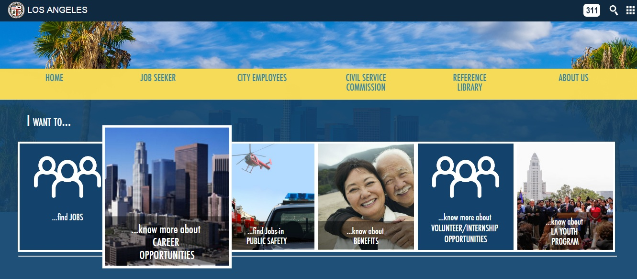

**Los Angeles City Payroll Data Analysis using Tableau**

Bhagyashree Arvind Jadhav

California State University, Los Angeles

1. **URL’s of data sets**

<https://controllerdata.lacity.org/Payroll/PAYROLL_DATA/pazn-qyym>

This URL contain the entire data regarding Payroll of Los Angeles City from 2013-2016. The Los Angeles City Controller Office releases payroll information for all city employees on a quarterly basis since 2013. It has a total of 34 columns with each column giving meaningful details related to the topic. The dataset has total 2, 33,585 records showing data of past four years for different departments and job titles. The data is based on Departments, Employee’s Job Title, Employment Type, Total Payments, Bonus, Base Pay, Overtime Pay and other benefits. The dataset also provides employee benefits in the form of Average Health Cost, Average Dental Cost, Average Basic Life and Average Benefit Cost. The benefit plans are divided into City, DWP, Fire and Police. All the departments in the LA City and job titles under each department are clearly mentioned in the data.

1. **Data Cleaning**

|  |  |  |
| --- | --- | --- |
| **Scope/Issue** | **Dirty Data** | **Cleaned Data** |
| 1. **Missing Values** | Contained dummy values/null in the State column. | Removed the values having Null values. |
| 1. **Negative Values** | Base Pay had negative values which is not possible. | Removed negative values |
| 1. **Abbreviations** | Contained Abbreviations for the “Memorandum of Understanding” field | MOU: Memorandum of Understanding  FMS Department: Department number in City Financial Management System |
| 1. **Wrong Date Format** | Tableau was not taking this field as date and was changing it automatically to 1905 | Changed the format of the year so that tableau can identify it’s format |
| 1. **Wrong format** | Hourly or Event rate had commas instead of “.” | Replaced comma with decimal notation |

1. **Data Visualization**
2. **How payments are changing quarterly from 2013-2016 across departments?**

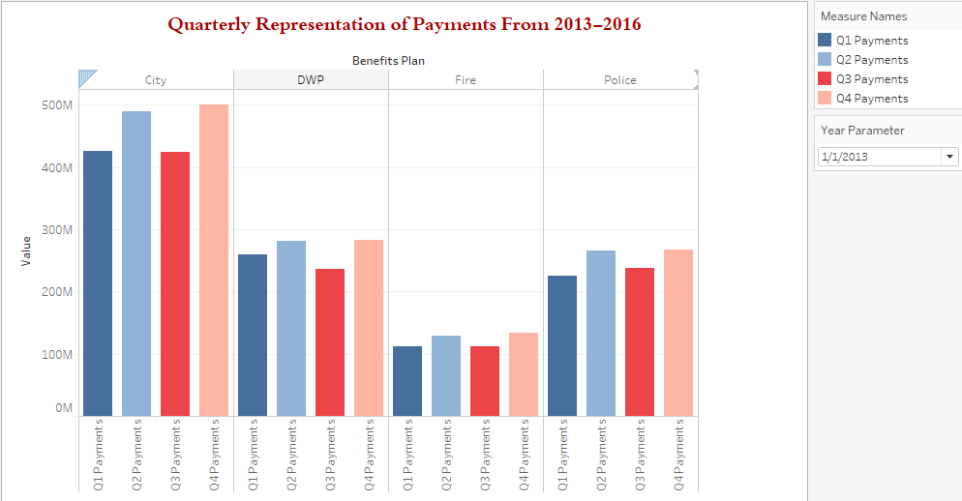

[Tools used: Parameters and Side by side bars]

The above bar chart provides quarterly payments across the departments of LA City from 2013-2016. New candidates or existing employees will get information about quarterly variation of payments in the departments of LA City. Year is being used to create parameter in this graph and to represent yearly data in the easier manner. By using parameter control, data of every year can be seen. In second and fourth quarter of 2013, all the departments have more payments. This trend almost continues in upcoming quarters but in 2016 first and third quarters have more payments.

1. **What are the top 10 highest paid titles among all the departments of LA City?**

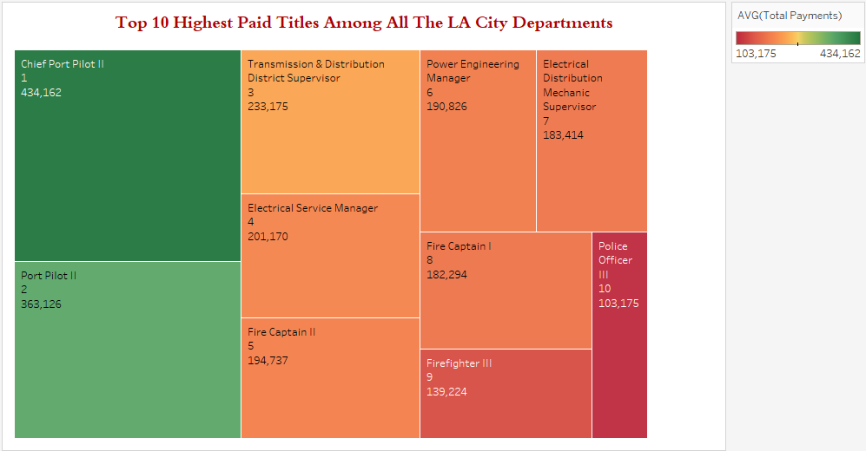

[Tools used: Rank and Treemap]

The Treemap tells us top 10 highest paid job titles among all the LA City Departments. Chief Port Pilot II is the highest paid position. Graph shows all the 10 positions along with their ranks and total payment. Candidates can focus on these job titles to target highest paid jobs in the city. The job titles include Chief Port Pilot II, Port Pilot II, Transmission and Distribution District Supervisor, Electrical Service Manager, Fire Captain I, Firefighter III, Police Officer III as per the ranks. Rank makes it easier to read the above Treemap.

1. **How have salaries changed over the past four years? Does Projected Annual Salaries are approximately same as Actual Annual Salary?**

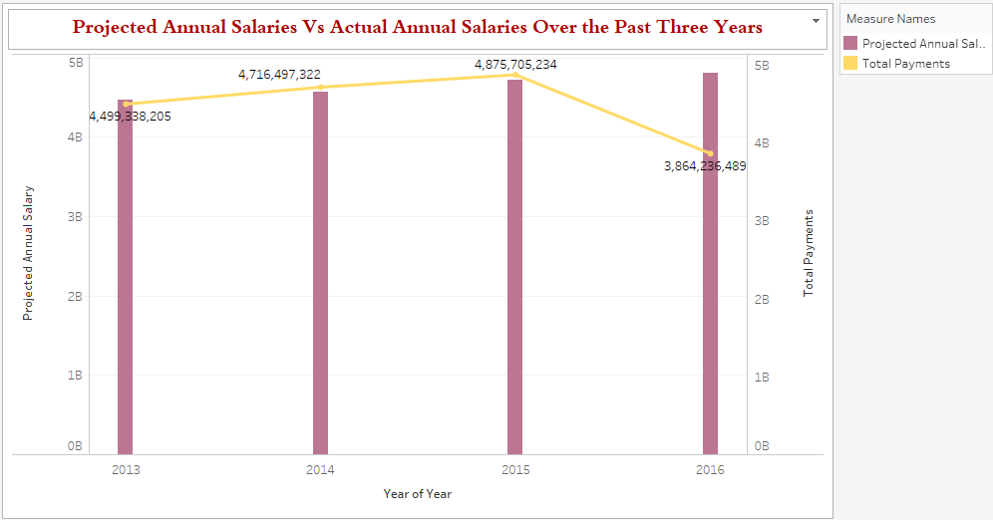

[Tools used: Dual Axis Chart, Trend Line]

Data provides information about Projected Annual Salary and Actual Annual Salary. This dual axis graph compares both the values to see the difference between the projected payments and the payments actually given to employees of LA City. From the graph it can be seen that till 2015 payments were made almost as per the projections but in 2016 payments are not made as per the projected payments. Salaries of LA City Employees have been increasing from 2013 to 2015 but in 2016 salaries are decreasing. Highest total payments have been made in 2015 which is 4.8 billion.

1. **Does Payment Over base pay affect the total salaries significantly?**

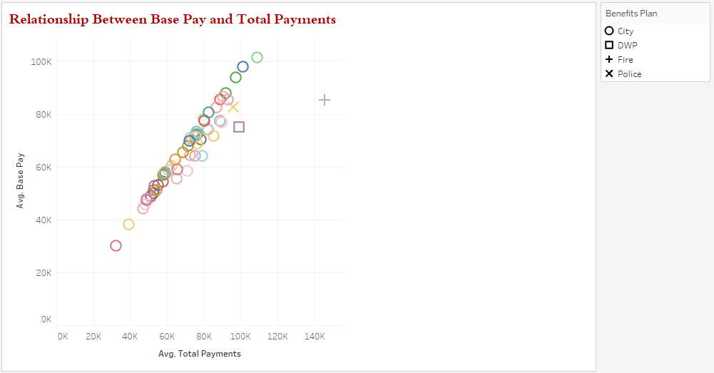

[Tools used: Scatter Plot]

The above scatter plot shows positive and strong relationship between Average Total Payment and Average Base Pay for all the departments. Even though LA city employees are getting permanent bonus, longevity bonus, temporary bonus and overtime pay, it does not increase the total payment significantly. Minimum average base payment is in ‘Recreation and Parks’ Department and an employee can get around $2000 as a payment over base pay. Employees of City Attorney Department are getting maximum total and base pay. The average difference between their base pay and total pay is around $8000. This shows that LA City employees can get up to $8000 as an extra pay over their base pay.

1. **Which departments in the LA City get highest average bonus pay?**

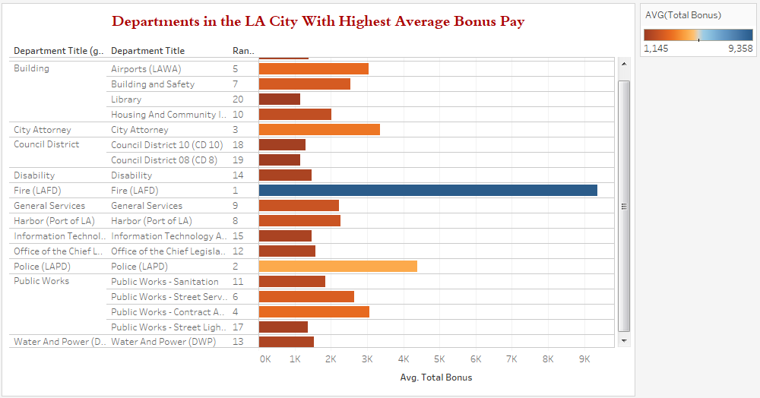

[Tools Used: Calculated Field, Groups and Rank]

While applying for LA City jobs if a candidate wants to consider bonus in the departments, this chart can best help. In this chart average total bonus has been calculated to show top 20 departments providing highest bonus pay. Total Bonus is calculated from Permanent Bonus Pay, Longevity Bonus Pay, and Temporary Bonus Pay. The chart also shows the rank of all the 20 departments which makes the entire graph easily readable. Graph shows that highest bonus is being given in Fire department. Applicants can use this chart to make decisions if in case they get offers from more than one department. Some Department Titles have been grouped under Building, Public Works and Council District for better representation of the data.

1. **How Many part time or full time positions are available in LA City departments?**

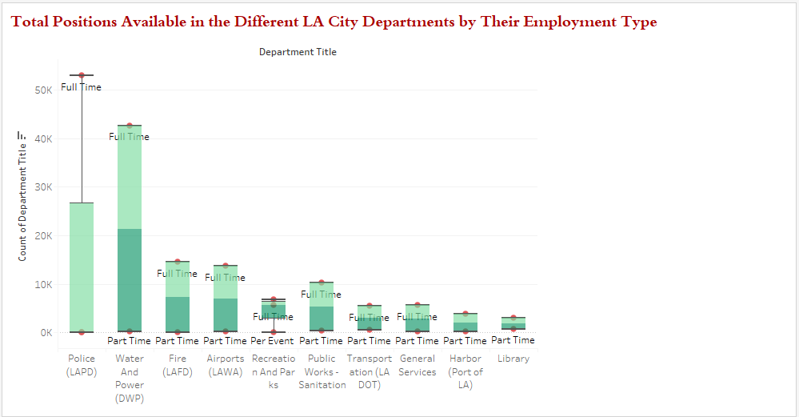

[Tools Used: Box and whisker plot]

From the above Box and whisker plot we can find total positions available in the different LA City departments by their employment type. Taking top 50% of the group which represent 53,030 Full Time positions at upper whisker in the Police(LAPD) department and 39 Per Event positions at the lower whisker. Also, in Water and Power Department(DWP) department upper quartile 42,654 shows the highest number of full time positions available in this department. Lower quartile shows 162 part time positions are available in DWP department.

1. **What are the most common salary ranges for Full Time and Part Time positions?**

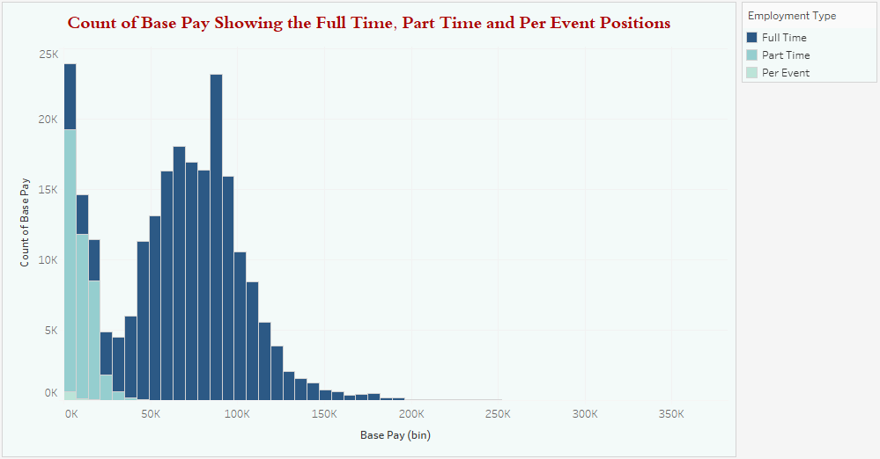

[Tools Used: Histogram, Bins]

The histogram chart denotes the count of base pay showing the Full Time, Part Time and Per Event positions. Maximum number of jobs is available in the range of $0 to $7000 base pay. Bin with the range from $77,000 to $84,000 have 23,140 jobs available. Per event positions have salaries in the range of $0 to $14,000 whereas part time positions have salaries in the range of $0 to $50,000. 18,660 part time employees get $0 to $7000 as a base pay. Full time employees can have base pay up to $300k depending on the job title. Majority of the full time employees get base pay in the range of $35k to $100K.

1. **Dashboard**

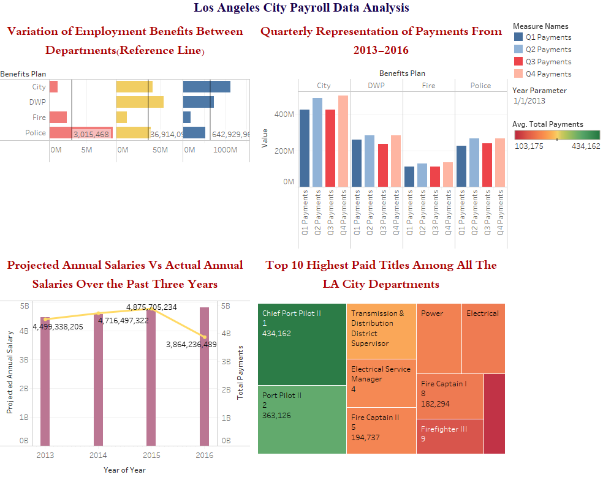

1. **Story Telling**

Los Angeles is the nation's second largest city. Employees of the City feel particular pride in serving the community and enhancing the lives of those within its boundaries. As a large employer with such a diverse workforce, the City of Los Angeles offers its employees many opportunities for advancement. Employees are encouraged to develop their skills and seek to improve their level within the organization. The City provides a variety of health and dental plans for the employee, spouses, domestic partners, and eligible children. The programs available include both managed care and preferred provider options. (City)

The Los Angeles City Controller Office releases payroll information for all city employees on a quarterly basis since 2013. (Controller) For most positions, the City has a five-step salary range. Other annual salary adjustments are determined by collective bargaining between employee organizations and the City. Employees with specific language abilities may earn a salary bonus for working in positions which require the use of bilingual skills. Employees get two weeks paid vacation after one year and three weeks paid vacation after five years. (City)

With 46% of the City's workforce eligible to retire by next year, the City of Los Angeles has been presented with a unique challenge and that is to create a workforce that serves locally, thinks globally, and acts boldly. (LA-City) As per the analyzed dataset there are 1644 job titles across all the 84 departments of LA City. Los Angeles County employs 103,338 people with a cumulative wage of $7.2 billion in annual salary and $2.76 billion in health and retirement benefits (HRABE)

Even though LA City has so many opportunities and employee benefits, applicants should consider different factors or facts while applying to these job titles. There are many other facts which need to be known to target the best jobs as per salary, employment benefits and bonus.

As per the LA DT News, Mayor of the city (Eric Garcetti) is in the top 1% of annual wage earners in Los Angeles, but barely. In fact, the guy who runs the city, who could be Hillary Clinton’s running mate isn’t the highest-paid municipal employee or the second highest. He’s not even in the top 100. (Regardie) By looking at the treemap of highest paid job titles we come to know that the top 10 job titles as per hourly pay rate are Commission Hearing Examiner, Member Employee Relations Board, General Manager Airports, Chief of Police, General Manager and Chief Engineer Water and Power, General Manager harbor Department, Fire Chief, Chief Legislative Analyst, City Administrative Officer and Chief Product Pilot respectively. Approximately 521 employees made more that Mayor in the year 2015. In total, about 58,000 people got a check for work they did for the city. Hence, considering these facts is important to make better decisions about career.

For instance, when the database says “Police Chief,” we know that means Charlie Beck. In 2015 his total pay was $351,692, which is a lot of money for a dude who probably didn’t arrest even one bad guy that year. Candidates should look for such positions to get best benefits out of the LA City jobs. (Regardie)

The packed bubbles chart clearly shows that Police (LAPD), Water and Power (DWP), Fire (LAFD) and Airports (LAWA) are major 4 departments getting more payments and having more available positions. Police (LAPD) department has been paid around $4.9 billion from 2013-2016 having 199 job titles.

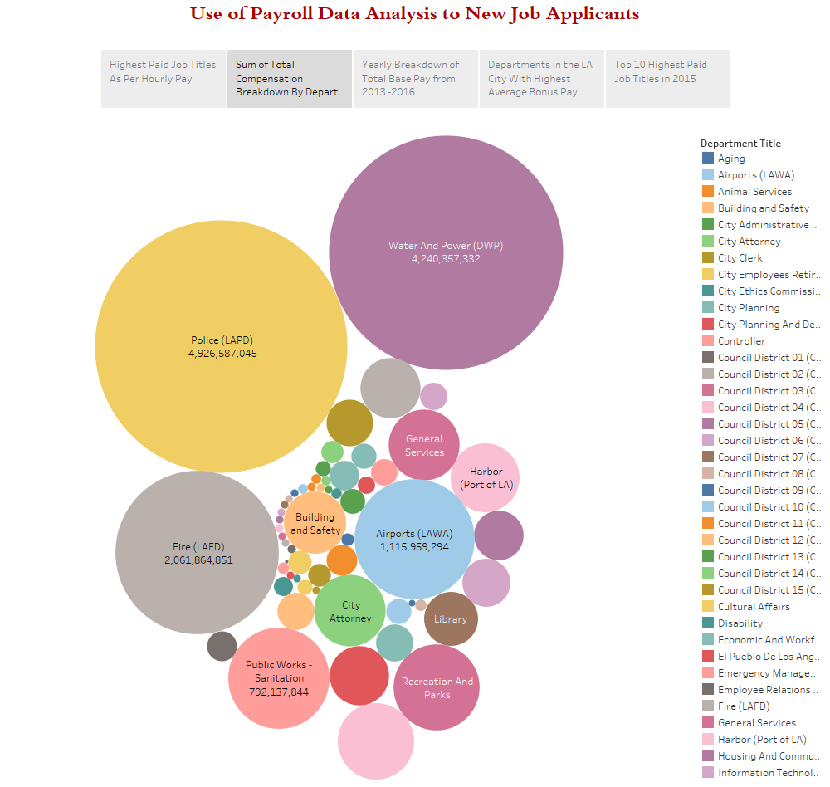

In 2015, the city of Los Angeles paid 58,244 people a total of $4.88 billion. By way of comparison, the entire country of Fiji had a gross domestic product of $4.53 billion that year, according to the World Bank (there’s a branch in South Park. Not really). For those who don’t speak money, annual GDP is essentially the value of all of a country’s goods and services produced in a year. So, instead of paying these workers, the city could have just bought everything made in Fiji in 2015, and then used the leftovers for a massive ice cream party. (Regardie)

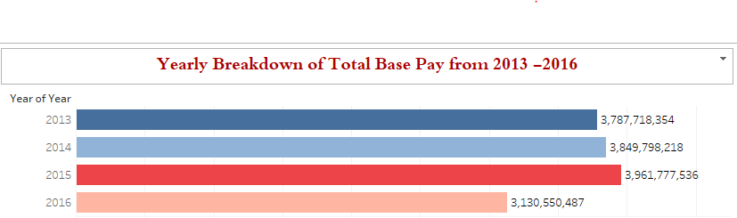

It can be seen from the graphical representation that the base pay for city employees in the year 2015 was $3.96 billion. It gets tricked up thanks to a whopping $553 million in overtime, and then another $365 million in what is dubbed “other pay,” which includes lump-sum payouts and bonuses for taking on unpleasant tasks such as dealing with City Councilman Mitch Englander in the week after he finished fifth in the County Supervisor’s race. As shown in the graph Fire(LAFD) department has got highest bonus in the past four years getting average total bonus of $9,358.

This prompts a key question: How has the system been so mismanaged that overtime chomps such a sizable portion of the city’s general fund? Some OT specifics are mindboggling: One Fire Captain got $311,000 in overtime on top of his $121,000 base pay last year. Presumably so he wouldn’t be lonely during all those extra hours, another Fire Captain made $273,000 in overtime. The list goes on and on and on. (Regardie)

As per the analysis of past years if someone wants their son or daughter to be financially secure, there is no better gig than Chief Port Pilot II. Someone with this boat-y job title was the highest-paid employee in the city in 2015, earning an incredible $499,382, with a base pay of about $298,000 and the mysterious “other pay” of $201,000. Even, more amazing, nine of the 11 highest-paid city employees in 2015 had the title of either Chief Port Pilot II or Port Pilot II.

On comparing past data, it is understood that a job seeker in the City of Los Angeles should consider all the factors affecting total payments and focus on certain jobs providing best facilities and payments. As mentioned earlier candidates should look for the opportunities from the top job titles to get highest pays and one should also look for the jobs in the departments like LAPD, DWP, LAFD.

# Works Cited

City Benefits Information. 17 02 2017 <http://personnel.lacity.org/index.cfm?content=careerbenefits>.

City, LA. City Benefits Information. 10 February 2017 <http://personnel.lacity.org/index.cfm?content=careerbenefits>.

Controller. PAYROLL_DATA. 26 January 2017. 11 February 2017 <https://controllerdata.lacity.org/Payroll/PAYROLL_DATA/pazn-qyym>.

HRABE, JOHN. LA City, County Own Fattest Payrolls … Here’s Salary Data. 23 December 2015. 29 March 2017 <.( http://www.citywatchla.com/index.php/the-la-beat/10161-la-city-county-own-fattest-payrolls-here-s-salary-data>.

LA-City. I want to... 12 February 2017 <http://personnel.lacity.org/index.cfm>.

PAYROLL_DATA. 26 01 2017. 17 02 2017 <https://controllerdata.lacity.org/Payroll/PAYROLL_DATA/pazn-qyym>.

Regardie, Jon. Soaring Salaries, Skyrocketing Overtime and More City Payroll Fun! 27 June 2016. 25 March 2017 <http://www.ladowntownnews.com/news/soaring-salaries-skyrocketing-overtime-and-more-city-payroll-fun/article_56ed28b4-3a58-11e6-a841-77e4c781aa36.html>.