Solution of Flow in a Lid Driven Cavity
by Anna Garrison
April 20, 2001

Introduction
An object-oriented Java-based computer program was created to solve flow in a lid driven cavity. The GUI driven code allows the user to create a block structured mesh, solve for temperature and diffusion-dominated flow, and post-process the solver results in the form of vector and color contour plots.

The pressure-velocity coupling approach implemented in this work is the SIMPLEC algorithm applied to non-staggered structured grids. The structured grid is treated as an unstructured grid; each cell has north, south, east, and west neighbors (unless it lies on a boundary) rather than indices (i, j), (i, j+1), (i, j-1), (i+1, j), and (i-1, j). Each cell is comprised of four faces which are referenced similarly. This avoids the confusion associated with using indices incremented by ½, and simplifies the implementation of multi-block grids. Cell P is shown with its neighbor cells in Figure 1.

P
W
S
N
E
e
w
n
s

Figure 1. Definition of cell neighbors and faces in non-staggered grid.

Implementation of the SIMPLEC Algorithm for Non-Staggered Grids
Step 1. Solve for cell center velocity.
Assuming that the faces lie halfway between the cell centers, the diffusion coefficients are defined as:

a_{P} * u_{P} = a_{E} *u_{E} + a_{W} *u_{W} + a_{N} *u_{N} + a_{S} * u_{S} + source_{X}
a_{P} * v_{P} = a_{E} *v_{E} + a_{W} *v_{W} + a_{N} *v_{N} + a_{S} * v_{S} + source_{y}

where:
a_{E} = 2.0*μ*dy_{P} / (dx_{E} + dx_{P})
a_{W} = 2.0*μ*dy_{P} / (dx_{W} + dx_{P})
a_{N} = 2.0*μ*dx_{P} / (dy_{N} + dy_{P})
a_{S} = 2.0*μ*dx_{P} / (dy_{S} + dy_{P})
a_{P} = a_{E} + a_{W} + a_{N} + a_{S}
source_{X} = dy * (P_{p} – P_{e})
source_{y} = dx * (P_{p} – P_{s})

P is the face pressure (interpolated from adjacent cells), dx and dy are the cell width and height respectively, and μ is the fluid viscosity. The subscripts E, W, N, and S refer to the east, west, north, and south neighboring cells of cell P. The source term, since it is a pressure gradient, is direction dependent hence the X and Y subscripts.

The boundary conditions are applied as an addition to the source term in boundary cells. If no tangential wall velocity is specified, then the additional source is zero. Otherwise the following modification is applied to the source term:

source_{X} = source_{X} + a_{N or S} * u_{wall}
source_{y} = source_{y} + a_{E or W} * v_{wall}

The coefficient multiplying the wall velocity is chosen based on the location of the wall relative to the cell. For example, if the wall lies on the east boundary of a cell, then a_{E} is used to calculate source_{y}.

Once the coefficients are defined, Gauss-Seidel is used to iteratively solve for the velocity at the cell centers. Gauss-Seidel iterations in this step (and others) will be referenced as “sweeps”. Residual reduction by four orders of magnitude or 200 sweeps, whichever occurs first, are applied to u and v in this problem.

Note that after the pressure is corrected in Step 4, the source term coefficients need to be updated, with regard to the applied boundary condition, so that the latest pressure values are accounted for.

Step 2. Solve for face velocity.
Velocity at the faces is solved for using only known values therfore iterative solution is not required. Presently, the cells are considered to be rectangular with their faces aligned with the x and y coordinate axes. This assumption allows for the division of the solution of face velocity into two steps; solve for u velocity on vertical faces, and solve for v on horizontal faces. Face velocity is used in Step 3 to compute the mass source.

The u velocity at face e is computed using:

u_{e} = [ f⁺ *h_{E} + (1- f⁺)*h_{P}] + α*dy*(P_{P} – P_{E}) / A_{P}
+ (1-α)*[ u’_{e} - f⁺ * u’_{E} – (1- f⁺)*u’_{P} ]
where
f⁺ = Pe / (Pe + eE)
1 / Â_{P} = f⁺ / A_{P(E)} + (1- f⁺) / A_{P(P)}
h_{P} = u’_{P} *(1-α) + α*( a_{E}*u_{E} + a_{W} *u_{W} + a_{N}*u_{N} + a_{S}*u_{S} ) / Â_{P}

The geometric interpolation factor f⁺ is exactly 0.5 for uniform meshes. Â_{P} is an interpolated value for face e using the a_{P} coefficients from the adjacent cells E and P. The prime ‘ in the h_{U} equation denotes the old value of velocity u_{P}, before the cell velocity sweeps in Step 1 (the old value is stored before Gauss-Seidel begins its sweeps). An equation similar to h_{U} is applied to calculate coefficients h_{V}.

Step 3. Evaluate mass source and calculate pressure correction.
The mass source is a measure of the error of the flow solution and is used to calculate a correction to the pressure field. The mass source b is calculated for each cell using known values of velocity at the faces:

b = (ρuA)_{w} - (ρuA)_{e} + (ρuA)_{s} - (ρuA)_{n}

where A is the area of the face and ρ is the fluid density. The pressure correction is iteratively solved using:

a_{P} * P’_{P} = a_{E} *P’_{E} + a_{W} *P’_{W} + a_{N} *P’_{N} + a_{S} * P’_{S} + b

where:
a_{E} = (ρAd)_{e}
a_{W} = (ρAd)_{w}
a_{N} = (ρAd)_{n}
a_{S} = (ρAd)_{s}
a_{P} = a_{E} + a_{W} + a_{N} + a_{S}
d_{e} = α*dy / Â_{P} (similarly for d_{w}, d_{n}, and d_{s})
α = the same value for under-relaxation that was used in velocity
calculations

The iterative process here is again referred to as a “sweep”. Here the prime ‘ tells us that we are solving for pressure correction using the most recent values (implicit solution). The pressure correction quantities are initialized to zero before the solution begins to prevent using the values applied in the previous iteration. One hundred pressure correction sweeps (per visit to this step) are performed by in this study.

Step 4. Correct the pressure and velocity fields.
Correct the pressure in each cell using:

P = P^{old} + α*P’

where α is an under-relaxation parameter that may need to be applied.

The cell velocity is corrected using:

u_{E} = u_{E}^{old} + α*dy*(P_{w} - P_{e}) / A_{P}

The value u_{E}^{old} is the u velocity value obtained after the cell velocity sweep in Step 1. The under-relaxation parameter α is equal to that set previously for velocity under-relaxation. As in Step 1, the pressure at the faces, P_{w} and P_{e}, are determined via interpolation from adjacent cell values. A_{P} is the sum of the diffusion coefficients as detailed in Step 1. Note that when accounting for convection, A_{P} changes with each loop of Steps 1 - 4 and must be updated accordingly.

Step 5. Update scalar quantities, then return to step 1.
A single loop over Steps 1 - 4 is referred to as an “iteration”, while the iterative processes in steps 1 and 3 are referred to as “sweeps”. Repeat Steps 1 through 4 until the flow solution changes minimally.

Results
Flow in a lid driven cavity was applied to a 20 by 20 cell structured uniform mesh (Figure 2). Viscosity and density were set to unity. The top wall velocity was set to 1m/s in the x direction, while all other walls were stationary. These quantities equate to a Reynolds number of unity.

All flow variables were initialized to zero. A relaxation factor of 0.5 was applied to all quantities named “alpha” in steps 1 – 4. A value of 0.8 caused divergence.

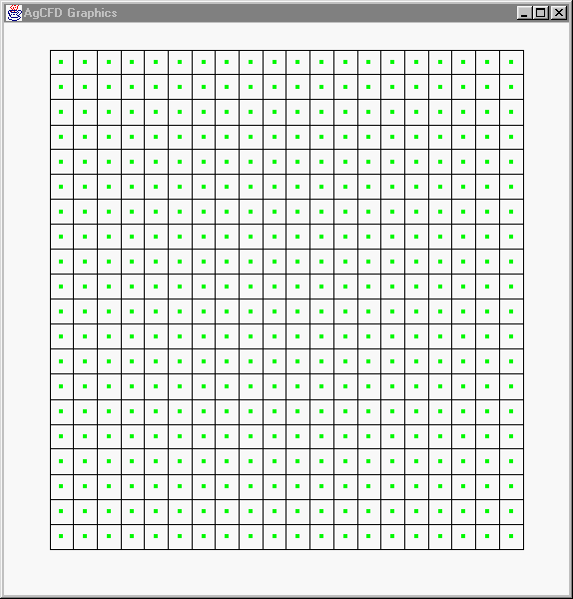

Figure 2. Uniform, structured mesh used in study. Green dots show cell center locations.

After the first velocity sweep (Step 1), the velocity solution is as shown in Figure 3. The u velocity field is similar in shape to that of a scalar field with similar boundary conditions; there are no areas of negative u velocity, indicating that there is no recirculation. The entire v velocity field is zero, also showing the lack of recirculation. Before correcting the pressure field and applying it, x and y direction flows are decoupled.

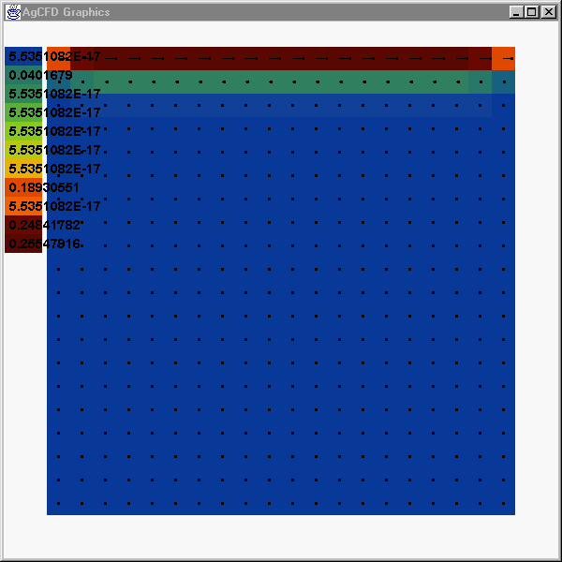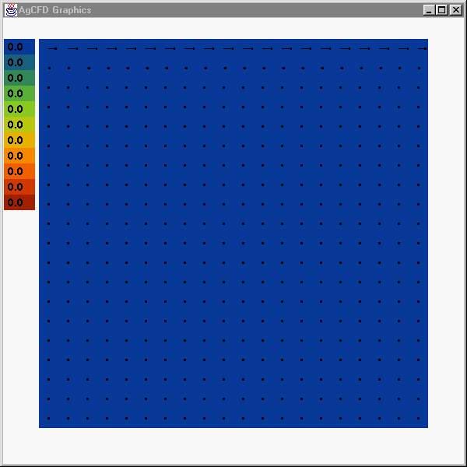

(a) (b)
Figure 3. Cell-center velocity solution after the first sweep. Image (a) shows u velocity and (b) shows v velocity.

After one complete iteration, where one iteration is defined as a single loop through steps 1 through 4, the velocity field is updated via pressure correction. The mass imbalance is computed and used in Step 3 to calculate a pressure correction field, which is then used to correct cell pressure, cell velocity, and face velocity (pressure at the faces is interpolated from cell values as needed). The x and y direction momentum equations are now coupled.

As the top wall moves from left to right, the fluid is pulled up on the left, translated along the wall, then pushed down on the right. The rise in pressure in the top right corner is caused by the impingement of the fluid in this region. This region, in the early stages of the solution, experiences an increase of mass in each cell. The top left wall experiences an opposite (symmetric in magnitude) effect. Figure 4 shows the u velocity, v velocity, pressure, and mass source fields after one iteration.

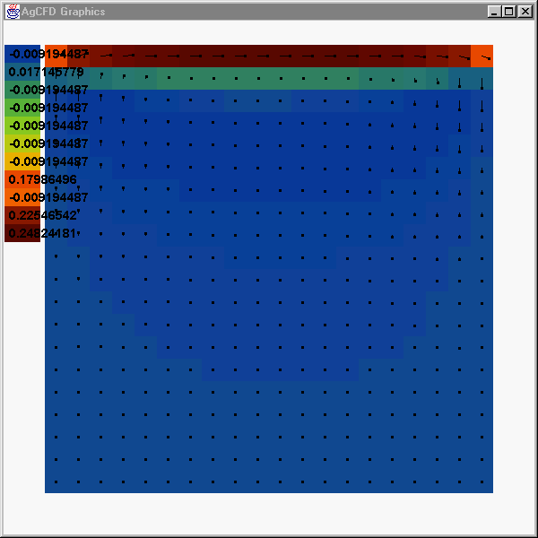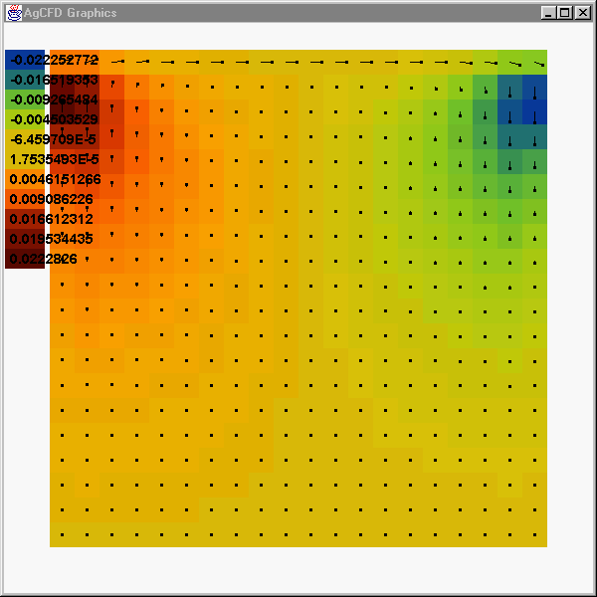
(a) (b)

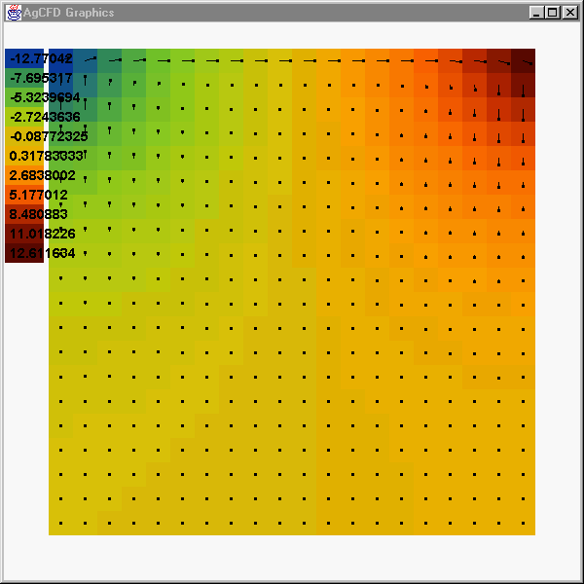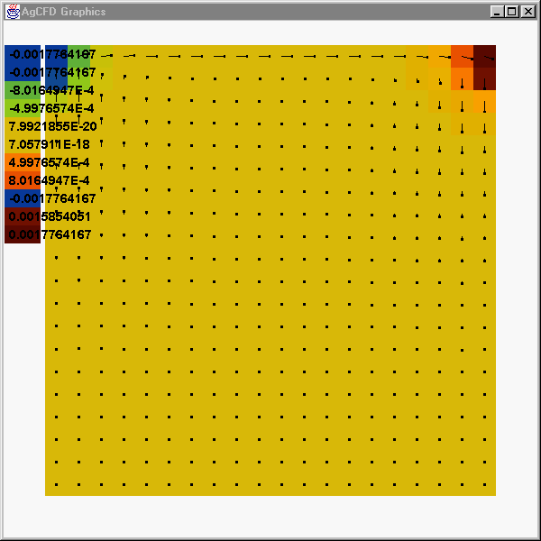
(c) (d)
Figure 4. Velocity vectors superimposed on contours of (a) U velocity, (b) V velocity, (c) pressure, and (d) mass imbalance after one iteration.

The mass balance is not negligible after one iteration, therefore more iterations are required. Figure 5 shows the quantities in the lid driven cavity after 200 iterations. The qualitative and quantitative results of 200 iterations are nearly identical to those after 100 iterations, therefore the solution is considered converged.
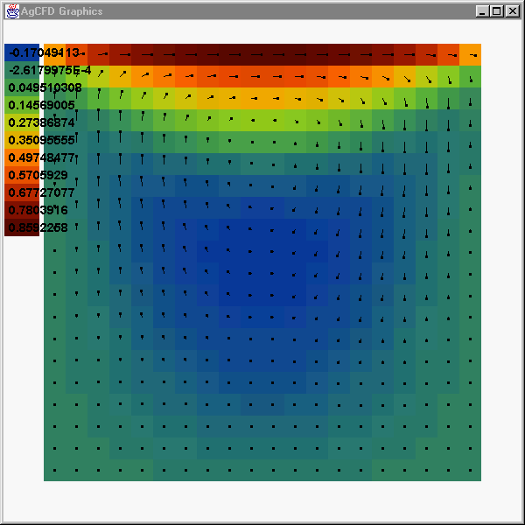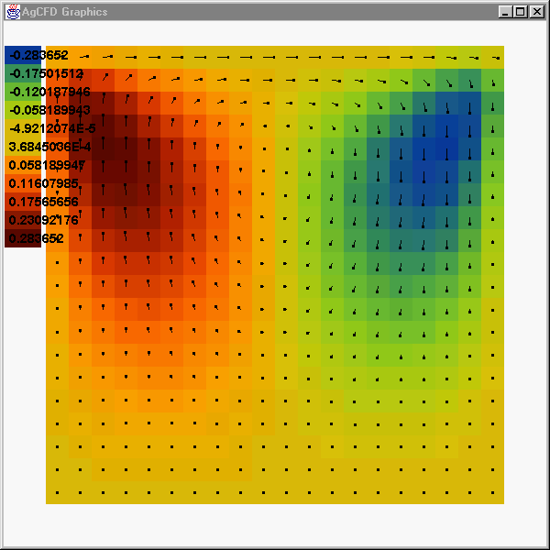
(a) (b)

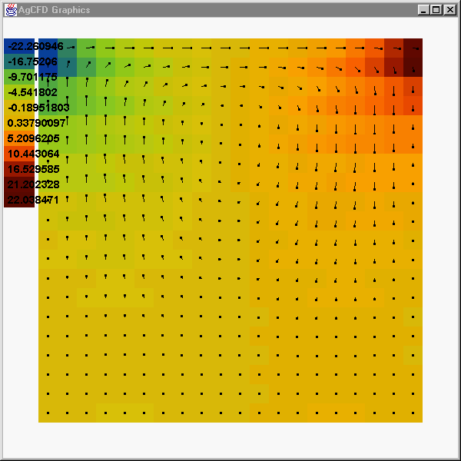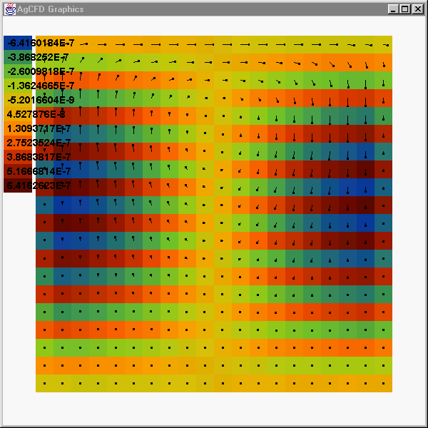
(c) (d)
Figure 5. Velocity vectors superimposed on (a) U velocity and (b) V velocity contours. (c) Pressure contours after 200 iterations. (d) Values of mass source after 200 iterations are very small, which implies that the flow solution is converged.

The introduction section of this document stated that the solver applied for this study is coded such that it can handle block structured grids. To demonstrate this capability, a lid driven cavity problem was solved on a modified geometry. Figure 6 shows results obtained from considering an upside-down U-shaped cavity with a moving top wall. The total dimensions of this geometry are (0, 0) by (1.5, 1.0).

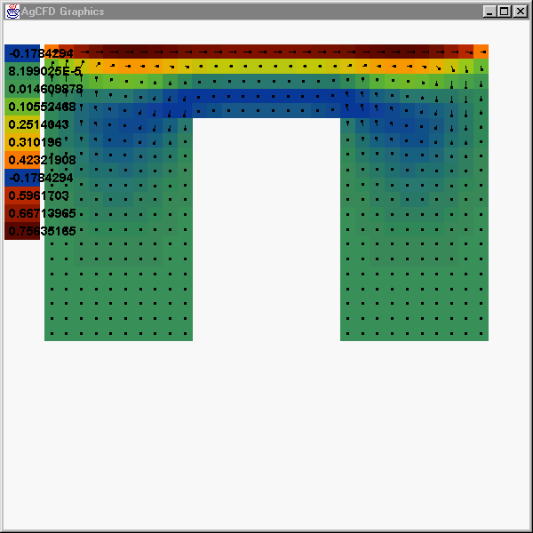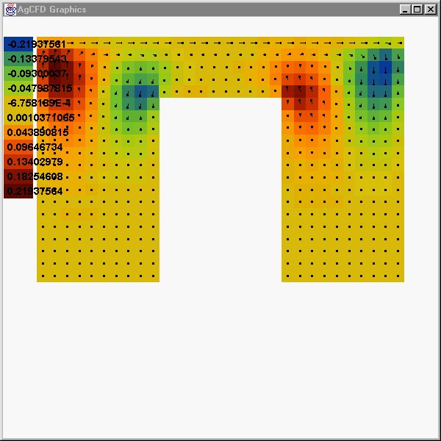
(a) (b)

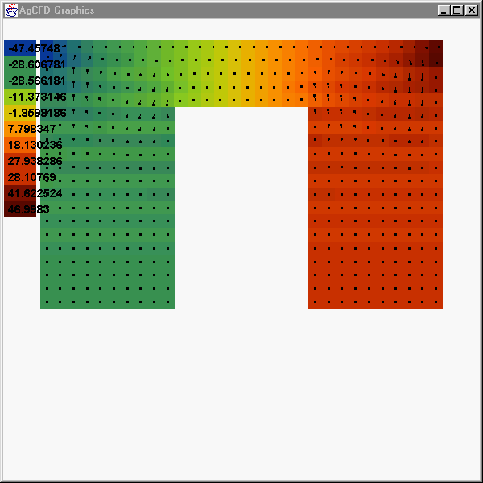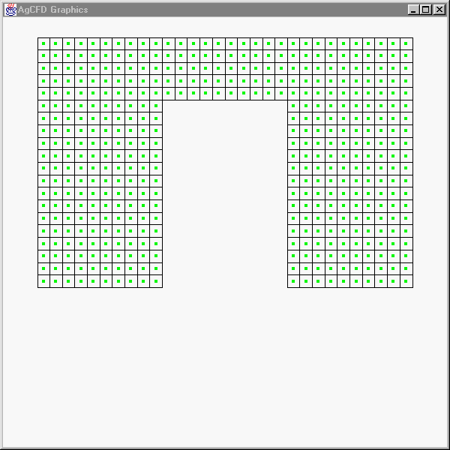

(c) (d)
Figure 6. Flow in a lid driven cavity with modified geometry. Velocity vectors are superimposed on (a) u velocity, (b) v velocity, and (c) pressure contours. The computational mesh is shown in (d).

Conclusions
The SIMPLEC velocity-pressure correction algorithm was implemented for solution of diffusion dominated flow in a lid driven cavity on a non-staggered grid. This GUI-driven computer code can be applied to any two-dimensional, block structured geometry with any combination of tangentially moving wall boundary conditions.

Future Work
- Account for upwinded convection
- Add velocity inlet and pressure outlet boundary conditions
- Increase speed and efficiency of code (use solver algorithms such as Conjugate Gradient, Algebraic Multigrid acceleration of Gauss-Seidel, and make code improvements to reduce the memory used by minimizing the number of objects, arrays, etc.)

References
Majumdar, S., “Role of Underrelaxation in Momentum Interpolation for Calculation of Flow with Nonstaggered Grids”, Numerical Heat Transfer, vol. 13, pp. 125-132, 1988.

Van Doormal, J.P., Raithby, G.D., “Enhancements of the SIMPLE Method for Predicting Incompressible Fluid Flows”, Numerical Heat Transfer, vol. 7, pp 147-163, 1984.

