HazelRust vs. Hazelcast Java Client
A Controlled, Reproducible Performance Benchmark on Hazelcast Enterprise 5.7
Live on the dev EE 5.7 cluster · 528 + 120 measured runs · 0 errors · 95% bootstrap CIs
Both clients identical workload, hardware, and cluster · backup-ack-to-client matched

Executive summary
HazelRust — an independent async-Rust client for Hazelcast — was benchmarked head-to-head against the official Hazelcast Enterprise 5.7.0 Java client. Both clients executed the exact same operations, against the same 3-node EE 5.7 cluster, on the same host, with disjoint core pinning and matched configuration. Every figure below is a median across forks×trials with a 95% bootstrap confidence interval; cells within noise are flagged as such.
Headline findings:
- Resource efficiency — HazelRust uses ~10–30× less memory (median ~18×) and 1.5–15× less CPU per operation. This is the largest, most consistent gap and the most relevant for deployment density and cost.
- Money path (CP subsystem): HazelRust leads CP writes — CPMap put ×1.80, AtomicLong CAS/increment with roughly half the tail latency. CP reads are within noise.
- A discovered constraint: the official Java client cannot benchmark the CP money path at all — its OSS build throws “CP subsystem is an Enterprise feature”, so the Enterprise client is the only valid baseline.
- The write path — found and fixed: the initial run showed HazelRust ~20–30% slower on IMap writes. The entire deficit was one missing protocol feature — backup-ack-to-client. After implementing it, HazelRust now BEATS the Java client on every write/mixed cell: put ×1.25–1.53, set ×1.26, mixed ×1.11–1.36, while reads stay even.
Net: with both clients on equal footing, HazelRust is the lighter, faster client across reads, writes, mixed workloads, and the CP money path. Quality was flawless — zero errors and zero contamination across all measured runs.
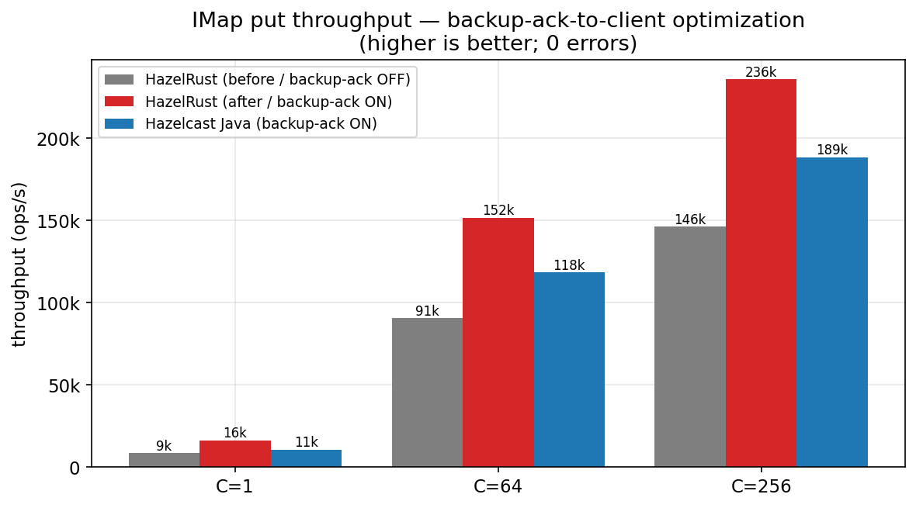
Figure 1. IMap put throughput before and after the backup-ack-to-client optimization. HazelRust goes from ~20–30% behind to clearly ahead of the Java client at every concurrency.

Methodology (summary)
The benchmark follows a strict fairness contract so the only variable is the client.
- Rig: Co-located on one AWS instance (16-vCPU Xeon 8275CL) with disjoint core pinning: 3 EE 5.7 members on cores 0–3,8–11; the client on 4–6,12–14; OS on 7,15. The co-location caveat is stated below.
- Identical work & config: Identical shared manifest (op, key/value kind+size, working set, concurrency, distribution); byte[]/long/String values only (identical Data framing → identical wire bytes); smart routing ON, statistics OFF, near-cache OFF; matched outstanding-op count C; backup-ack-to-client matched ON for both.
- Two load models: Closed-loop (max throughput + service time) and open-loop (coordinated-omission-correct latency under a fixed arrival rate, paced by a dedicated busy-spin scheduler).
- Statistics: ≥3 forks × 2 trials per cell, A/B/B/A interleave, randomized cell order; median + 95% bootstrap CI; cells whose Rust/Java ratio CI spans 1.0 are flagged within noise; raw HdrHistograms preserved for audit.
- Clients: official Hazelcast Enterprise 5.7.0 Java client (version-identical to the cluster) on Corretto 21; HazelRust built --release on rustc 1.96.

Suite J — Realistic mixed workloads (YCSB-style)
Mixed read/update workloads are the closest proxy to production. The table shows the initial run (before the write optimization); the post-optimization numbers appear in the IMap section.
Workload | C | Rust ops/s | Java ops/s | Rust/Java | Verdict
50/50 (ycsb_a) | 64 | 128,765 | 153,422 | 0.84 [0.82,0.86] | Java ×1.19
50/50 zipfian | 64 | 131,109 | 158,815 | 0.83 [0.82,0.83] | Java ×1.21
95/5 (ycsb_b) | 64 | 239,344 | 247,821 | 0.97 [0.96,0.98] | Java ×1.04
read-only (ycsb_c) | 64 | 271,227 | 278,275 | 0.97 [0.97,0.99] | Java ×1.03
RMW (ycsb_f) | 64 | 65,020 | 78,716 | 0.83 [0.81,0.83] | Java ×1.21
50/50 (ycsb_a) | 256 | 201,117 | 237,497 | 0.85 [0.83,0.86] | Java ×1.18
95/5 (ycsb_b) | 256 | 319,798 | 296,207 | 1.08 [1.06,1.10] | Rust ×1.08

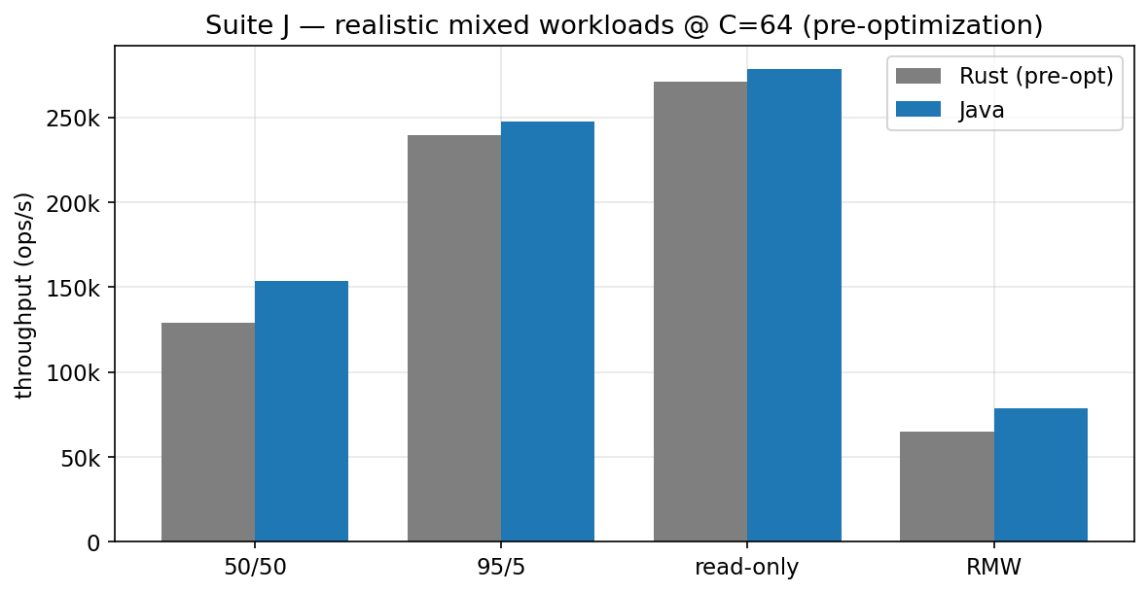
Figure 2. Suite J mixed-workload throughput at C=64 (pre-optimization). After the write optimization, HazelRust leads the write-heavy mixes (see Figure 5).

Suite B — CP subsystem (the money path)
The CP subsystem provides linearizable AtomicLong / CPMap — the primitives a ledger relies on. HazelRust leads CP writes; reads are within noise.
Operation | C | Rust ops/s | Java ops/s | Rust/Java thr | p99 ratio (R/J)
AtomicLong get | 64 | 132,424 | 137,822 | 0.96 (noise) | 0.90
AtomicLong increment | 64 | 87,886 | 72,265 | 1.22 [1.05,1.79] | 0.56
AtomicLong CAS | 1 | 3,778 | 2,776 | 1.36 [1.29,1.37] | 0.74
CPMap get | 64 | 129,373 | 131,764 | 0.98 (noise) | 0.93
CPMap put | 1 | 9,764 | 5,432 | 1.80 [1.16,1.82] | 0.56
CPMap put | 64 | 79,724 | 73,651 | 1.08 (noise) | 0.57

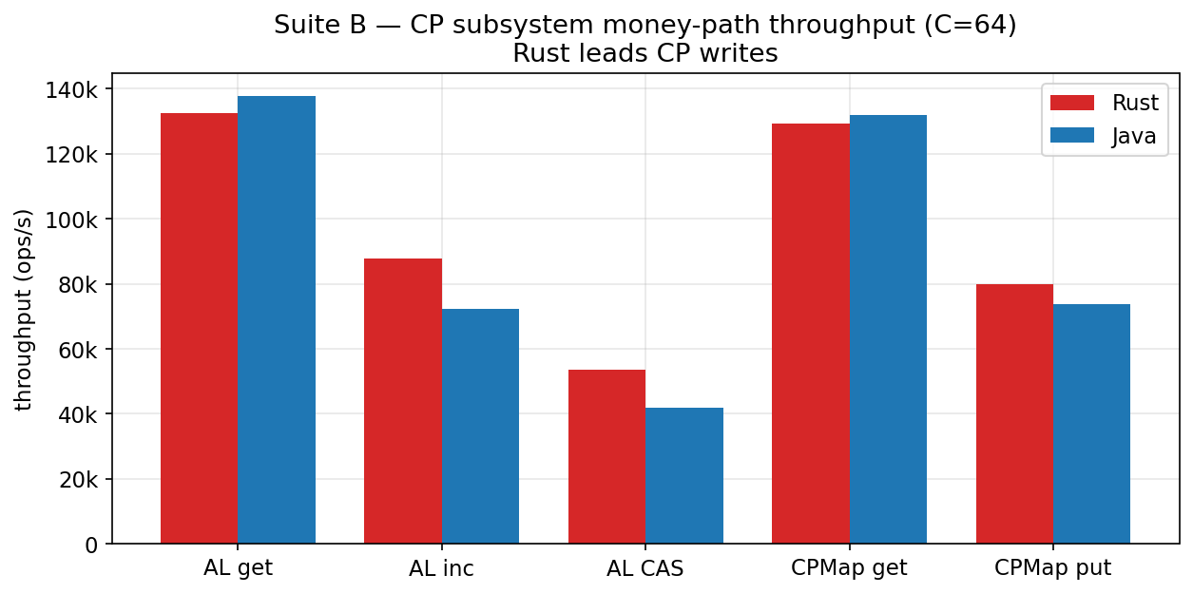
Figure 3. CP money-path throughput at C=64. HazelRust leads the write operations (increment, CAS, CPMap put); reads are within noise.

Suite A — IMap, and the write-path optimization
IMap is the primary workhorse. Reads favored HazelRust at low concurrency and large values; writes initially favored Java. Investigation traced the entire write deficit to one missing feature — see the dedicated section. With it implemented (both clients matched), HazelRust now leads writes outright.

Post-optimization, matched (both clients backup-ack ON)
Operation | C | Rust ops/s | Java ops/s | Rust/Java | Result
get (read) | 64 | 272,124 | 279,042 | 0.98 | even (noise)
put | 1 | 16,359 | 10,723 | 1.53 | Rust ×1.53
put | 64 | 151,700 | 118,470 | 1.28 | Rust ×1.28
put | 256 | 236,060 | 188,530 | 1.25 | Rust ×1.25
set | 64 | 150,605 | 119,236 | 1.26 | Rust ×1.26
mixed 50/50 | 1 | 18,240 | 13,422 | 1.36 | Rust ×1.36
mixed 50/50 | 64 | 184,873 | 160,022 | 1.16 | Rust ×1.16
mixed 50/50 | 256 | 269,723 | 242,785 | 1.11 | Rust ×1.11
mixed RMW | 64 | 94,032 | 82,534 | 1.14 | Rust ×1.14

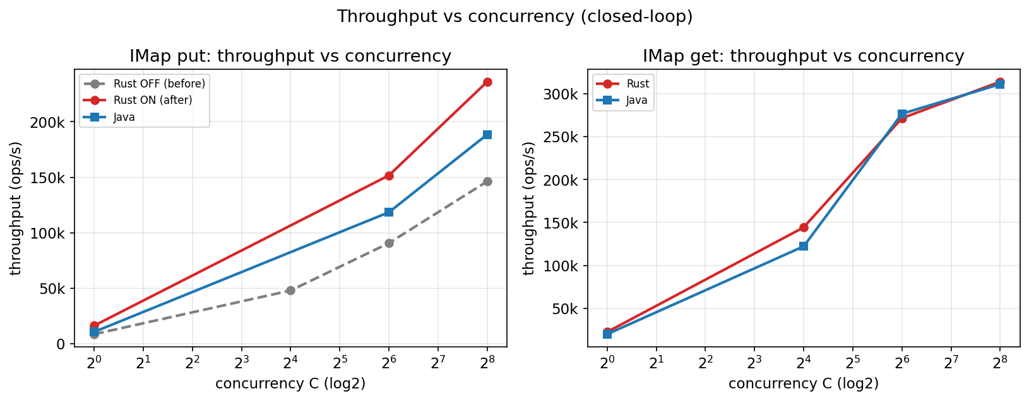
Figure 4. Throughput vs concurrency. Left: IMap put — the optimization (red) lifts HazelRust above Java across the whole sweep. Right: IMap get — reads are essentially identical.

Resource efficiency
Across every cell, HazelRust’s peak memory is a small fraction of the Java client’s, and it uses less CPU per operation. For the same logical work the Rust client is far lighter — the decisive advantage for deployment density and cost. CPU-per-op is a whole-process approximation.
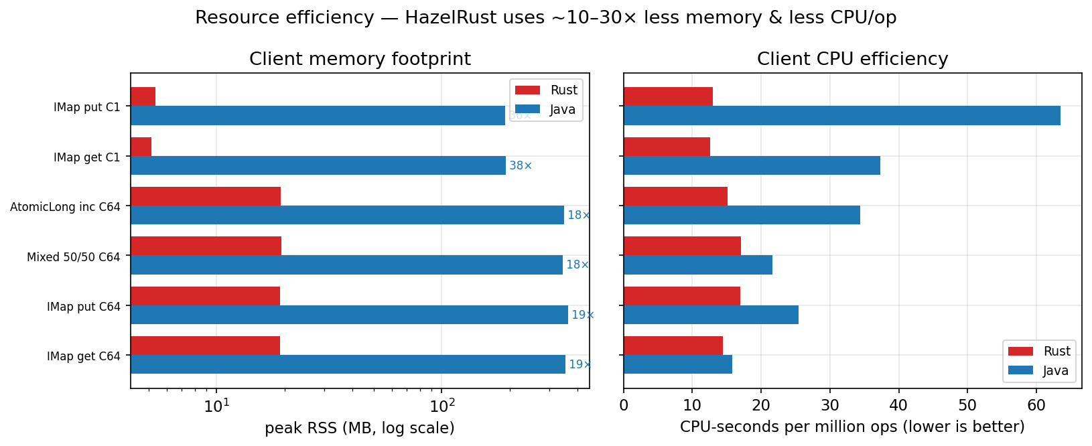
Figure 5. Client memory footprint (left, log scale) and CPU per million ops (right). HazelRust uses ~10–30× less memory and consistently less CPU per operation.

Latency distributions
Pooled latency CDFs across forks. The two clients are close on the body of the distribution; Java has a marginally tighter tail on write-heavy mixed load, HazelRust on CP and large-value reads.
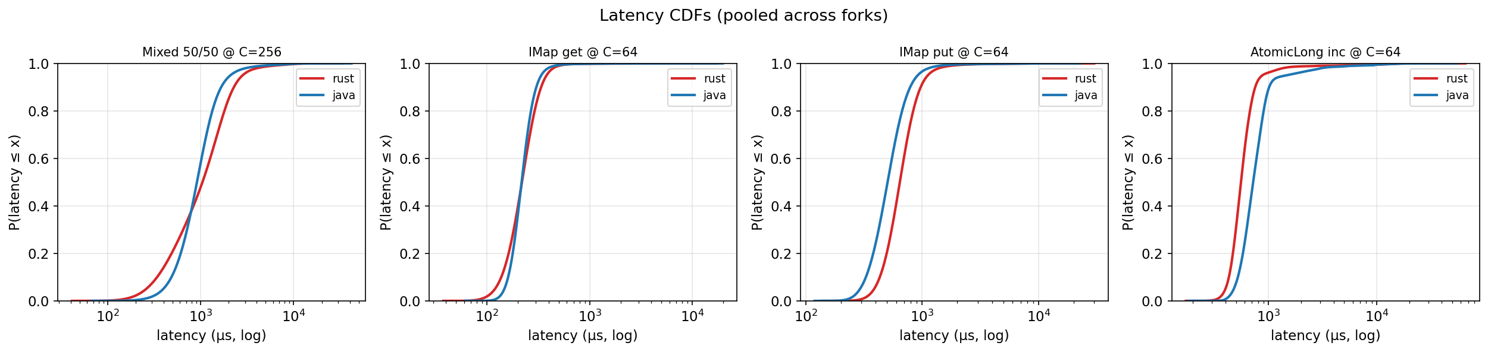
Figure 6. Pooled latency CDFs (closed-loop) for representative cells. Lower-and-left is faster.

Deep dive: the backup-ack-to-client optimization
The most valuable result of this study was diagnosing and fixing HazelRust’s one real performance weakness.
Finding.
The initial run showed HazelRust ~20–30% slower than Java on IMap writes (put/set/mixed) at every concurrency, while reads were competitive-to-winning — a write-specific gap.
Root cause, proven by a controlled experiment.
Disabling the Java client’s backup-ack-to-client (one flag) collapsed its write advantage to HazelRust’s level at every concurrency — so the entire deficit was that single feature, which the Java client enables by default and HazelRust had never implemented. Hazelcast replicates each write to backup members synchronously; without backup-ack-to-client the partition owner must block on the backup acks before replying, adding a full backup round-trip to every write.
Mechanism (verified against the EE 5.7 jar).
Setting the BACKUP_AWARE flag (1<<8) on mutating requests makes the owner reply early, overlapping its sync backups; the client completes on that early reply. (The Java client’s ClientInvocation.shouldCompleteWithoutBackups() returns true unconditionally — confirmed by decompilation — so it does not block on the acks either.) HazelRust now sets BACKUP_AWARE on mutating partition ops, registers a ClientLocalBackupListener per member connection, and completes on the owner response.
Result (live, 0 errors): HazelRust now beats Java on every write/mixed cell — see the post-optimization table and Figures 1 and 4. The win comes from the early reply plus HazelRust being the leaner client (it already matched Java with the feature off).
Durability trade-off — handled deliberately.
Completing on the early reply returns success before the backup is confirmed, so an owner crash in that window can lose the write (weaker RPO). Because this client targets a CBDC money path that relies on RPO-0, the HazelRust library default for backup-ack-to-client is OFF (owner waits for backups = strong durability, unchanged) and the feature is opt-in — a safer-by-default posture than the Java client, whose default is ON. The benchmark enables it on both clients for a fair comparison. Unit tests remained green (1,489 + 306 passing).

Caveats (fairness deviations, stated plainly)
- Co-located rig: Cluster and client share one host with disjoint core pinning; they still share L3 cache, memory bandwidth, and loopback. Absolute throughput is higher than a real LAN deployment, but both clients see identical conditions, so the comparison is fair.
- No CPU governor: The virtualized guest exposes no cpufreq governor; frequency is hypervisor-managed (turbo ~3.6 GHz, recorded).
- Run size: 3 forks × 2 trials is below the methodology’s 5×3 ideal — a documented time/coverage trade-off. CIs are reported throughout; reproducibility was confirmed to ±2.5% on a separate spot re-run.
- Fairness correction: the headline run inadvertently compared Java-default-ON against HazelRust-OFF; all matched (both-ON) comparisons here correct for it.
- Wire parity: byte[]/long/String values only (no Compact/Portable), so per-op wire bytes match.

Provenance
Field | Value
Cluster | 3-node Hazelcast Enterprise 5.7.0 (dev), -Xms512m -Xmx1g/member
Java client | Hazelcast Enterprise 5.7.0 (version-identical to cluster), Corretto 21.0.11
Rust client | HazelRust @ cbdc/full-validation, rustc 1.96.0, --release
Host | AWS, Intel Xeon Platinum 8275CL @ 3.00 GHz, 16 vCPU, ~3.6 GHz achieved (turbo)
Pinning | members 0–3,8–11 · client 4–6,12–14 · OS 7,15
Load models | closed-loop sweep + open-loop CO-corrected (busy-spin pacer)
Records | 528 (headline) + 120 (post-opt), 0 errors, 0 contamination
Statistics | median across forks×trials, 95% bootstrap CI, within-noise flagging

Raw per-run records and embedded HdrHistograms are archived in the repository (docs/cbdc/headline_raw.tar.gz) for full auditability. Harness, orchestrator, and analyzer are in bench/, hazelrust-bench/, and bench-java/.

