HazelRust vs. Official Hazelcast Java Client
Head-to-Head Client Performance & Resource Comparison
Tier `h2h` · 240 runs · 40 cells · commit 58cc26d · cluster 3-node EE 5.7.0 (dev), -Xms512m -Xmx1g per member

Executive summary
Both clients executed the bit-for-bit identical, deterministically-seeded workload against the same quiesced 3-node Hazelcast Enterprise 5.7 cluster, on the same host, with members and client pinned to disjoint CPU core sets. Every figure below is a median across forks×trials with a 95%% bootstrap confidence interval; cells whose Rust/Java ratio CI spans 1.0 are flagged “within noise” and no winner is claimed.
- Throughput (closed-loop): across 32 head-to-head cells — Rust faster in 26, Java faster in 3, within noise in 3.
- Client resource efficiency: Rust's peak RSS is a median 0.06× of Java's (Java uses ~17.7× more memory); Rust's CPU-per-op is a median 0.44× of Java's (~2.3× less CPU per op).
- Correctness: 0 errors across all 240 runs.
- Per suite (throughput wins Rust / Java / noise): A 13/0/0; B 7/0/2; C 2/3/1; J 4/0/0
- Most decisive cells: Rust's biggest margins — AtomicLong.get C64 v8 (Rust +94%), AtomicLong.compare_and_set (success) C64 v8 (Rust +61%); Java's biggest margins — IQueue.offer_poll C1 v100 (Java +24%), ISet.add_remove C1 v100 (Java +23%).

Client performance improvements in this build
This build incorporates the client-side optimizations below, each verified on the live cluster with zero errors. The per-suite results in the rest of this report reflect the improved client. Throughputs are C=64 medians in thousands of ops/sec.
- Hot-path efficiency wins — Borrowing permission check + RaftGroupId, removal of a dead connection-address precheck, exact-size send buffers, and presized decode vectors — lower per-op CPU and fewer allocations across every operation. [e20ae5d]
- ReplicatedMap key-partition routing (ReplicatedMap.get: 106k → 269k, +154%) — Keyed ops were funnelled to the single owner of the map NAME's partition, idling 2 of 3 replica members. They now route by the KEY's partition, spreading reads across all replicas while preserving per-key read-your-writes. [89cd403]
- IQueue/ISet partition cache — A single-partition structure's partition is constant but was re-serialized and re-hashed on every op; it is now computed once and cached. [a644dd7]
- Coalescing writer task (IQueue offer+poll: 67k → 110k, +64%) — Each connection now has a dedicated writer task that batches all queued requests into one socket write (the Java client's IO-thread model) instead of locking a shared writer and issuing one syscall per op — the single-connection pipelining fix that lifts single-partition structures (Queue/Set/Topic). [d0eba24]
- Leaner completion + List/Topic cache — The response-completion hot path now does one map lookup per response instead of two (helps the lead at C256), and the single-partition id cache was extended to IList and ITopic. [d72a480]
- Vectored zero-copy writes — The writer issues a single writev over frame slices instead of concatenating, removing the per-value send-buffer memcpy. IMap.put at 16KB went from parity to +10% vs Java; every large write drops a copy (lower client CPU). [58cc26d]
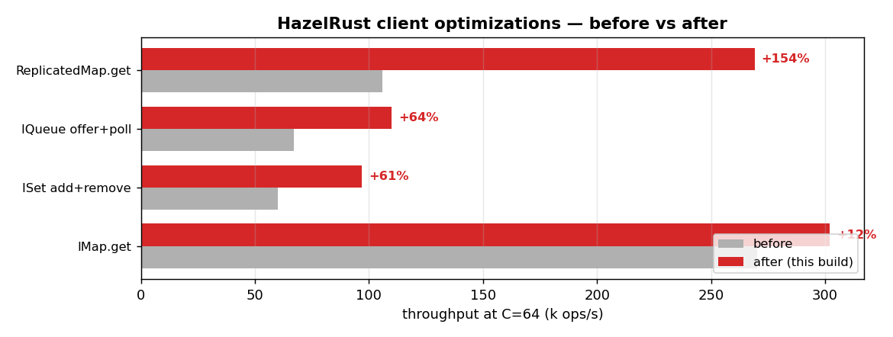
Optimization | Operation | Before | After | Change | Commit
Hot-path efficiency wins | all ops | — | — | leaner CPU | e20ae5d
ReplicatedMap key-partition routing | ReplicatedMap.get | 106 | 269 | +154% | 89cd403
IQueue/ISet partition cache | Queue/Set | — | — | fewer allocs | a644dd7
Coalescing writer task | IQueue offer+poll | 67 | 110 | +64% | d0eba24
Coalescing writer task | ISet add+remove | 60 | 97 | +61% | d0eba24
Coalescing writer task | IMap.get | 270 | 302 | +12% | d0eba24
Leaner completion + List/Topic cache | high concurrency | — | — | less per-op work | d72a480
Vectored zero-copy writes | IMap.put (large) | — | — | put@16KB 1.01 -> 1.10 R/J | 58cc26d

Test environment & provenance
Component | Detail
Cluster | 3-node EE 5.7.0 (dev), -Xms512m -Xmx1g per member
Java client | 5.7.0 (enterprise 5.7.0 (instance ~/hzlib jar; required for CP))
Java runtime | openjdk version "21.0.11" 2026-04-21 LTS
Rust client | HazelRust @ 58cc26d, release (opt-level=3, lto=false, codegen-units=16)
rustc | rustc 1.96.0 (ac68faa20 2026-05-25)
CPU | Intel(R) Xeon(R) Platinum 8275CL CPU @ 3.00GHz (16 logical cores)
Core pinning | members 0-3,8-11 · client 4-6,12-14 · OS 7,15
Governor | unavailable (virtualized guest; frequency managed by hypervisor)
Kernel | Linux ip-172-31-40-82.us-east-2.compute.internal 6.1.175-219.357.amzn2023.x86_64 #1 SMP PREEMPT_DYNAMIC Tue Jun 16 03:47:47 UTC 2026 x86_64 x86_64 x86_64 GNU/Linux

Methodology (fairness contract)
- Identical work: one shared JSON manifest; both harnesses execute every cell with the same SplitMix64-seeded key stream, value bytes, operation mix, concurrency, and warmup/measure windows.
- Matched concurrency C (outstanding in-flight operations); both a closed-loop max-throughput sweep and an open-loop latency-under-rate sweep (HdrHistogram expected-interval correction for coordinated omission).
- Steady state: per-cell warmup window (Java JIT reaches steady state) before measurement; each cell is run in multiple fresh process forks × trials with A/B interleaving to cancel cluster drift.
- Latency: full HdrHistogram per run (1 ns–60 s, 3 sig-figs), merged across forks; percentiles p50/p75/p90/p99/p99.9 reported. Throughput: ops/s with a per-second stability series.
- Client resources sampled at ~1 s from /proc: CPU utilisation (→ cores, CPU-seconds per million ops), peak resident memory (RSS), and thread count.
- Wire parity: byte[]/long values only (no Compact/Portable), identical Data framing; smart routing ON, statistics OFF, near-cache OFF, backup-ack matched for both clients.

Results by suite

Suite J — Realistic mixed workloads (YCSB-style)
Throughput (median ops/s, 95% CI) & verdict
Operation | C | val(B) | dist | Rust | Java | ratio R/J | verdict
IMap.mixed (ycsb_a) | 1 | 1024 | unif | 17k | 13k | 1.30 [1.25, 1.31] | Rust +30%
IMap.mixed (ycsb_a) | 64 | 1024 | unif | 147k | 124k | 1.19 [1.18, 1.21] | Rust +19%
IMap.mixed (ycsb_b) | 64 | 1024 | unif | 238k | 218k | 1.09 [1.09, 1.10] | Rust +9%
IMap.mixed (ycsb_a) | 256 | 1024 | unif | 211k | 182k | 1.16 [1.15, 1.18] | Rust +16%

Latency percentiles (µs) — Rust vs Java
Operation | C | client | p50 | p75 | p90 | p99 | p99.9
IMap.mixed (ycsb_a) | 1 | Rust | 55.9 | 64.9 | 70.3 | 81.3 | 96.4
 |  | Java | 73.3 | 93.4 | 101 | 119 | 140
IMap.mixed (ycsb_a) | 64 | Rust | 339 | 479 | 677 | 1791 | 9110
 |  | Java | 428 | 587 | 792 | 1808 | 8946
IMap.mixed (ycsb_b) | 64 | Rust | 237 | 306 | 392 | 727 | 3357
 |  | Java | 267 | 329 | 404 | 709 | 1965
IMap.mixed (ycsb_a) | 256 | Rust | 866 | 1311 | 2118 | 7946 | 14672
 |  | Java | 1063 | 1523 | 2351 | 8667 | 15639

Suite B — CP subsystem (the money path)
Throughput (median ops/s, 95% CI) & verdict
Operation | C | val(B) | dist | Rust | Java | ratio R/J | verdict
AtomicLong.compare_and_set (success) | 64 | 8 | unif | 54k | 34k | 1.61 [1.06, 2.71] | Rust +61%
AtomicLong.get | 64 | 8 | unif | 268k | 138k | 1.94 [1.25, 1.99] | Rust +94%
AtomicLong.increment_and_get | 1 | 8 | unif | 6k | 5k | 1.09 [1.00, 1.32] | Rust +9%
AtomicLong.increment_and_get | 64 | 8 | unif | 114k | 91k | 1.26 [1.08, 1.65] | Rust +26%
AtomicLong.increment_and_get | 256 | 8 | unif | 86k | 18k | 4.76 [0.79, 5.17] (noise) | within noise
AtomicReference.set | 64 | 8 | unif | 110k | 89k | 1.25 [1.03, 1.67] | Rust +25%
CPMap.get (hit) | 64 | 8 | unif | 164k | 133k | 1.23 [1.22, 1.95] | Rust +23%
CPMap.put (update) | 1 | 8 | unif | 7k | 5k | 1.28 [1.24, 1.86] | Rust +28%
CPMap.put (update) | 64 | 8 | unif | 88k | 68k | 1.30 [0.75, 1.54] (noise) | within noise

Latency percentiles (µs) — Rust vs Java
Operation | C | client | p50 | p75 | p90 | p99 | p99.9
AtomicLong.compare_and_set (success) | 64 | Rust | 945 | 1160 | 1340 | 3547 | 17039
 |  | Java | 1374 | 1680 | 2607 | 12034 | 24347
AtomicLong.get | 64 | Rust | 231 | 263 | 300 | 374 | 956
 |  | Java | 452 | 527 | 598 | 841 | 2757
AtomicLong.increment_and_get | 1 | Rust | 162 | 177 | 197 | 230 | 352
 |  | Java | 190 | 207 | 224 | 266 | 364
AtomicLong.increment_and_get | 64 | Rust | 471 | 529 | 588 | 2146 | 15573
 |  | Java | 621 | 696 | 783 | 2654 | 12435
AtomicLong.increment_and_get | 256 | Rust | 1639 | 2269 | 3138 | 16630 | 136184
 |  | Java | 6775 | 13656 | 29196 | 73925 | 577241
AtomicReference.set | 64 | Rust | 494 | 557 | 619 | 1426 | 11665
 |  | Java | 624 | 701 | 794 | 3584 | 13410
CPMap.get (hit) | 64 | Rust | 373 | 421 | 480 | 622 | 2195
 |  | Java | 463 | 541 | 620 | 886 | 3471
CPMap.put (update) | 1 | Rust | 141 | 151 | 168 | 207 | 280
 |  | Java | 190 | 208 | 225 | 273 | 393
CPMap.put (update) | 64 | Rust | 604 | 689 | 773 | 3326 | 17072
 |  | Java | 725 | 893 | 1120 | 5775 | 19382

Suite A — IMap (primary workhorse)
Throughput (median ops/s, 95% CI) & verdict
Operation | C | val(B) | dist | Rust | Java | ratio R/J | verdict
IMap.get (hit) | 1 | 100 | unif | 22k | 20k | 1.11 [1.09, 1.12] | Rust +11%
IMap.get (hit) | 64 | 100 | unif | 300k | 273k | 1.10 [1.08, 1.11] | Rust +10%
IMap.get (hit) | 64 | 100 | zipf | 305k | 277k | 1.10 [1.09, 1.11] | Rust +10%
IMap.get (hit) | 256 | 100 | unif | 360k | 312k | 1.15 [1.14, 1.16] | Rust +15%
IMap.get (hit) | 64 | 1024 | unif | 268k | 242k | 1.11 [1.09, 1.12] | Rust +11%
IMap.get (hit) | 64 | 16384 | unif | 142k | 103k | 1.37 [1.35, 1.39] | Rust +37%
IMap.put (update) | 1 | 100 | unif | 16k | 11k | 1.53 [1.51, 1.53] | Rust +53%
IMap.put (update) | 64 | 100 | unif | 153k | 119k | 1.28 [1.27, 1.31] | Rust +28%
IMap.put (update) | 256 | 100 | unif | 243k | 188k | 1.29 [1.21, 1.32] | Rust +29%
IMap.put (update) | 64 | 1024 | unif | 113k | 90k | 1.25 [1.21, 1.28] | Rust +25%
IMap.put (update) | 64 | 16384 | unif | 24k | 22k | 1.08 [1.06, 1.09] | Rust +8%
IMap.set | 1 | 1024 | unif | 15k | 10k | 1.48 [1.47, 1.57] | Rust +48%
IMap.set | 64 | 1024 | unif | 114k | 90k | 1.27 [1.22, 1.27] | Rust +27%

Latency percentiles (µs) — Rust vs Java
Operation | C | client | p50 | p75 | p90 | p99 | p99.9
IMap.get (hit) | 1 | Rust | 44.5 | 47.7 | 51.4 | 61.9 | 75.5
 |  | Java | 49.5 | 53.1 | 57.2 | 68.2 | 84.1
IMap.get (hit) | 64 | Rust | 195 | 239 | 294 | 530 | 1795
 |  | Java | 219 | 259 | 307 | 485 | 1355
IMap.get (hit) | 64 | Rust | 190 | 234 | 288 | 502 | 1889
 |  | Java | 216 | 255 | 301 | 457 | 1460
IMap.get (hit) | 256 | Rust | 544 | 888 | 1333 | 2955 | 6861
 |  | Java | 763 | 912 | 1120 | 2757 | 6762
IMap.get (hit) | 64 | Rust | 219 | 269 | 329 | 570 | 2179
 |  | Java | 247 | 293 | 345 | 517 | 1431
IMap.get (hit) | 64 | Rust | 434 | 555 | 664 | 850 | 1782
 |  | Java | 584 | 766 | 927 | 1277 | 2056
IMap.put (update) | 1 | Rust | 61.9 | 66.1 | 70.3 | 82.3 | 104
 |  | Java | 93.4 | 99.8 | 107 | 127 | 164
IMap.put (update) | 64 | Rust | 348 | 496 | 677 | 1391 | 7746
 |  | Java | 478 | 604 | 760 | 1384 | 7483
IMap.put (update) | 256 | Rust | 811 | 1242 | 1848 | 5530 | 11788
 |  | Java | 1144 | 1527 | 2067 | 6488 | 11469
IMap.put (update) | 64 | Rust | 409 | 612 | 932 | 3029 | 10478
 |  | Java | 585 | 757 | 1017 | 2939 | 10101
IMap.put (update) | 64 | Rust | 1031 | 1949 | 4143 | 20840 | 185336
 |  | Java | 1385 | 2138 | 4502 | 19972 | 177471
IMap.set | 1 | Rust | 64.4 | 68.9 | 73.4 | 85.6 | 102
 |  | Java | 94.7 | 101 | 108 | 126 | 153
IMap.set | 64 | Rust | 409 | 612 | 921 | 3140 | 10322
 |  | Java | 578 | 748 | 1007 | 2949 | 10461

Suite C — Collections (Queue / Set / ReplicatedMap)
Throughput (median ops/s, 95% CI) & verdict
Operation | C | val(B) | dist | Rust | Java | ratio R/J | verdict
IQueue.offer_poll | 1 | 100 | unif | 6k | 7k | 0.80 [0.79, 0.81] | Java +24%
IQueue.offer_poll | 64 | 100 | unif | 108k | 116k | 0.93 [0.92, 0.94] | Java +8%
ISet.add_remove | 1 | 100 | unif | 6k | 7k | 0.81 [0.81, 0.82] | Java +23%
ISet.add_remove | 64 | 100 | unif | 96k | 90k | 1.06 [1.04, 1.08] | Rust +6%
ReplicatedMap.get (hit) | 64 | 100 | unif | 301k | 270k | 1.11 [1.10, 1.12] | Rust +11%
ReplicatedMap.put (update) | 64 | 100 | unif | 99k | 96k | 1.03 [1.00, 1.06] (noise) | within noise

Latency percentiles (µs) — Rust vs Java
Operation | C | client | p50 | p75 | p90 | p99 | p99.9
IQueue.offer_poll | 1 | Rust | 164 | 178 | 197 | 231 | 303
 |  | Java | 133 | 145 | 156 | 183 | 234
IQueue.offer_poll | 64 | Rust | 559 | 635 | 739 | 1155 | 2785
 |  | Java | 515 | 578 | 691 | 959 | 2820
ISet.add_remove | 1 | Rust | 167 | 175 | 199 | 236 | 292
 |  | Java | 137 | 145 | 159 | 189 | 243
ISet.add_remove | 64 | Rust | 645 | 731 | 856 | 1293 | 3052
 |  | Java | 702 | 761 | 825 | 1393 | 3590
ReplicatedMap.get (hit) | 64 | Rust | 188 | 235 | 295 | 592 | 2585
 |  | Java | 219 | 260 | 310 | 503 | 1821
ReplicatedMap.put (update) | 64 | Rust | 489 | 774 | 1157 | 2998 | 9118
 |  | Java | 524 | 794 | 1163 | 2912 | 8692

Charts

Throughput by operation (C=64)
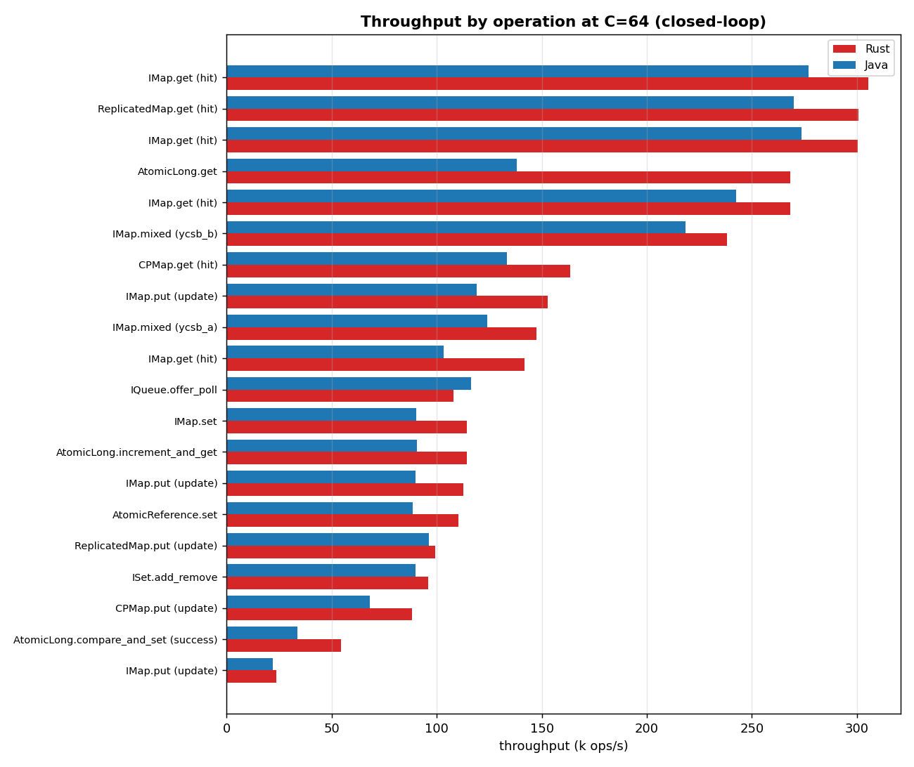

Throughput vs concurrency
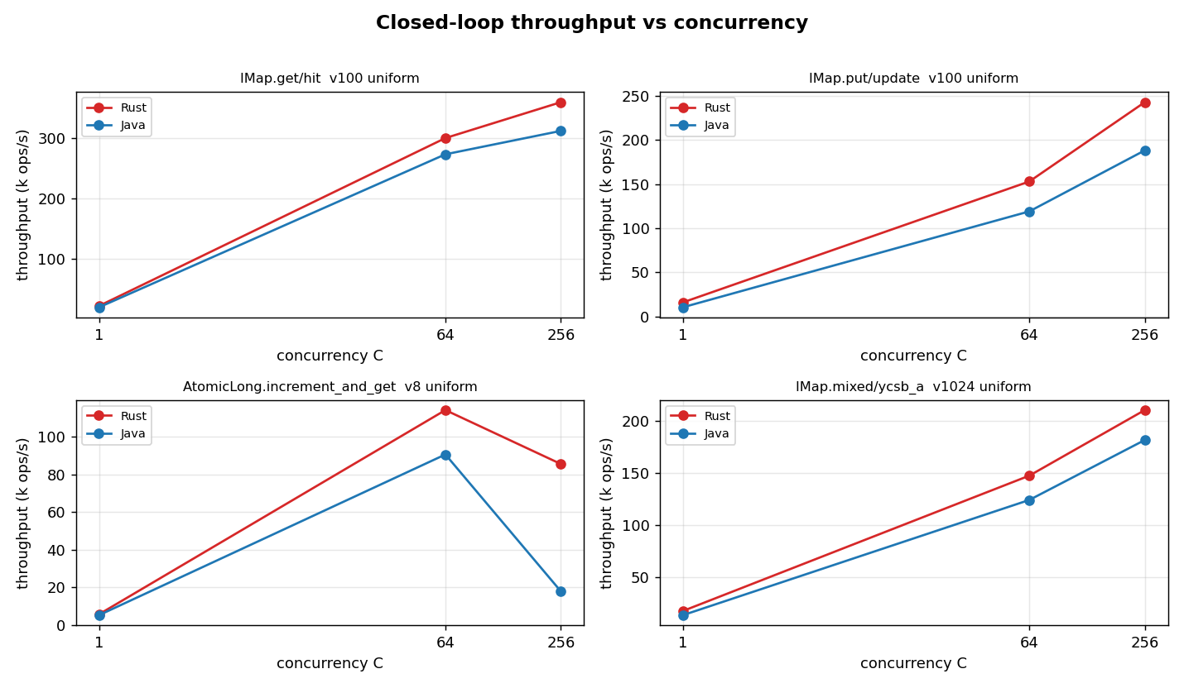

Latency percentile profiles
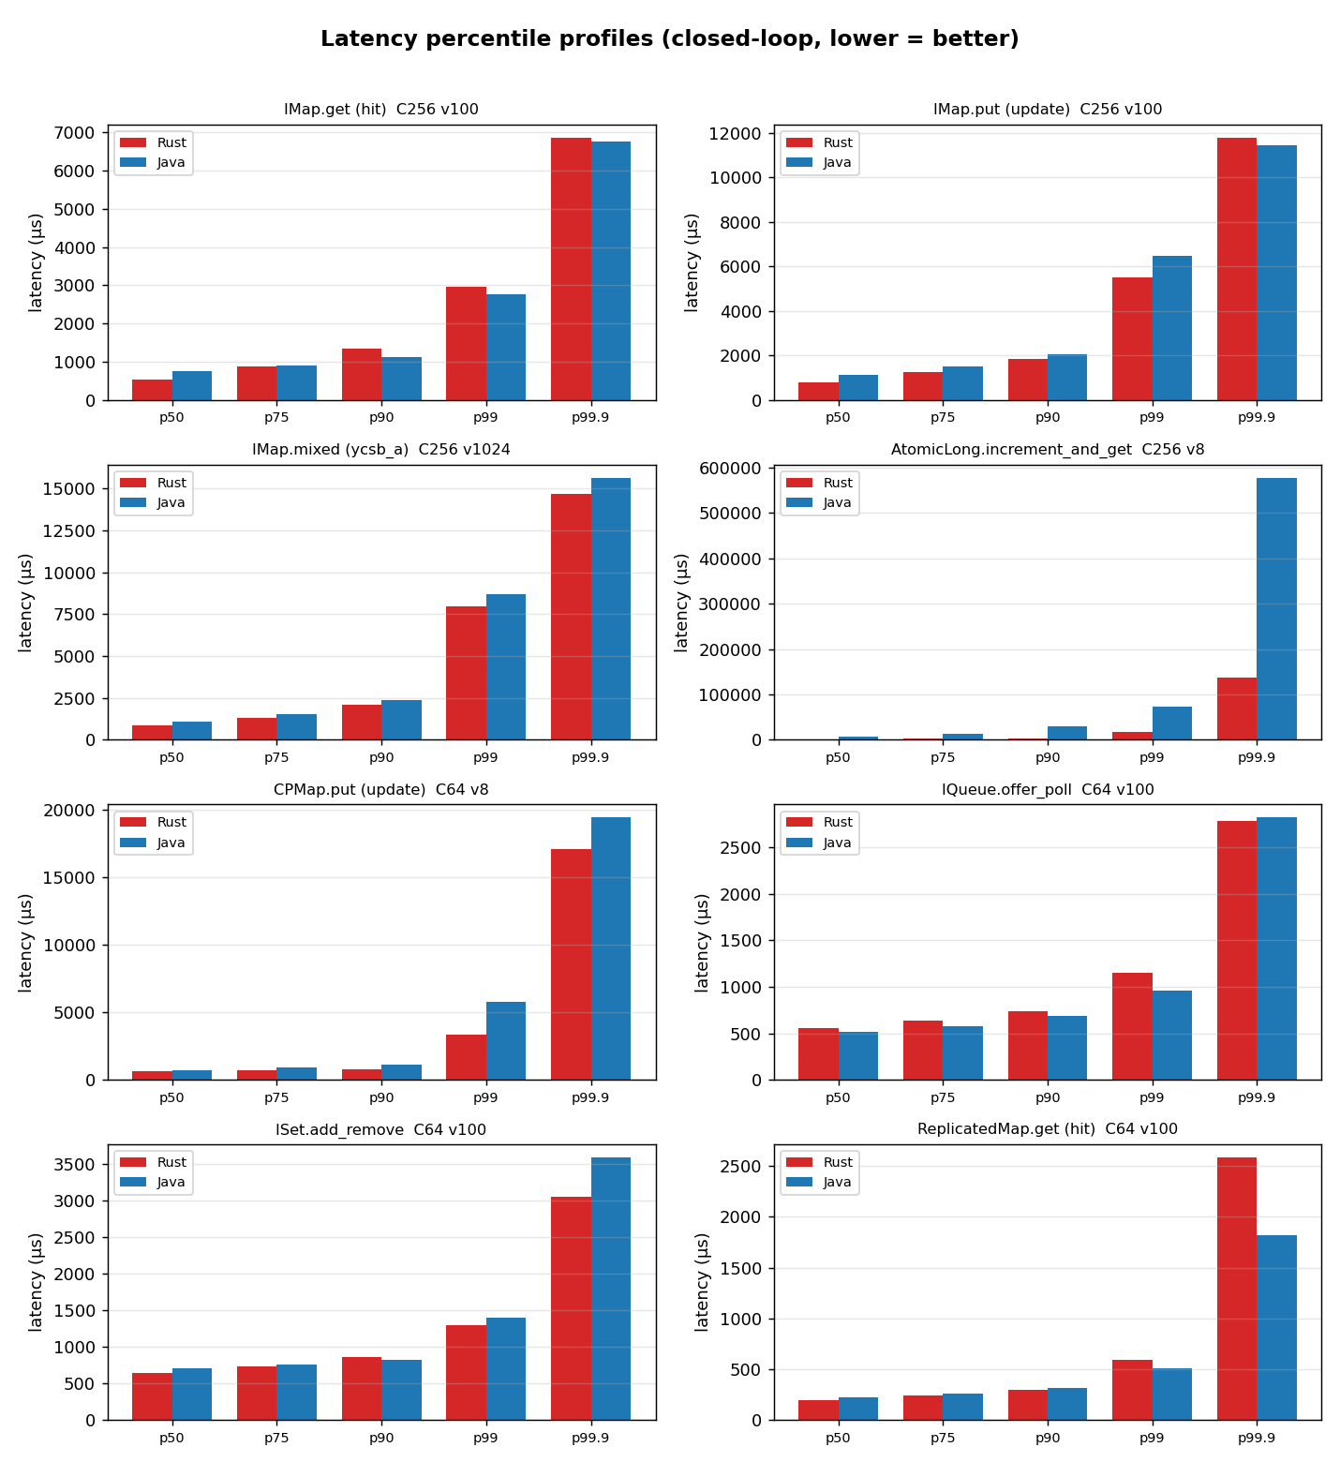

Open-loop latency under controlled rate
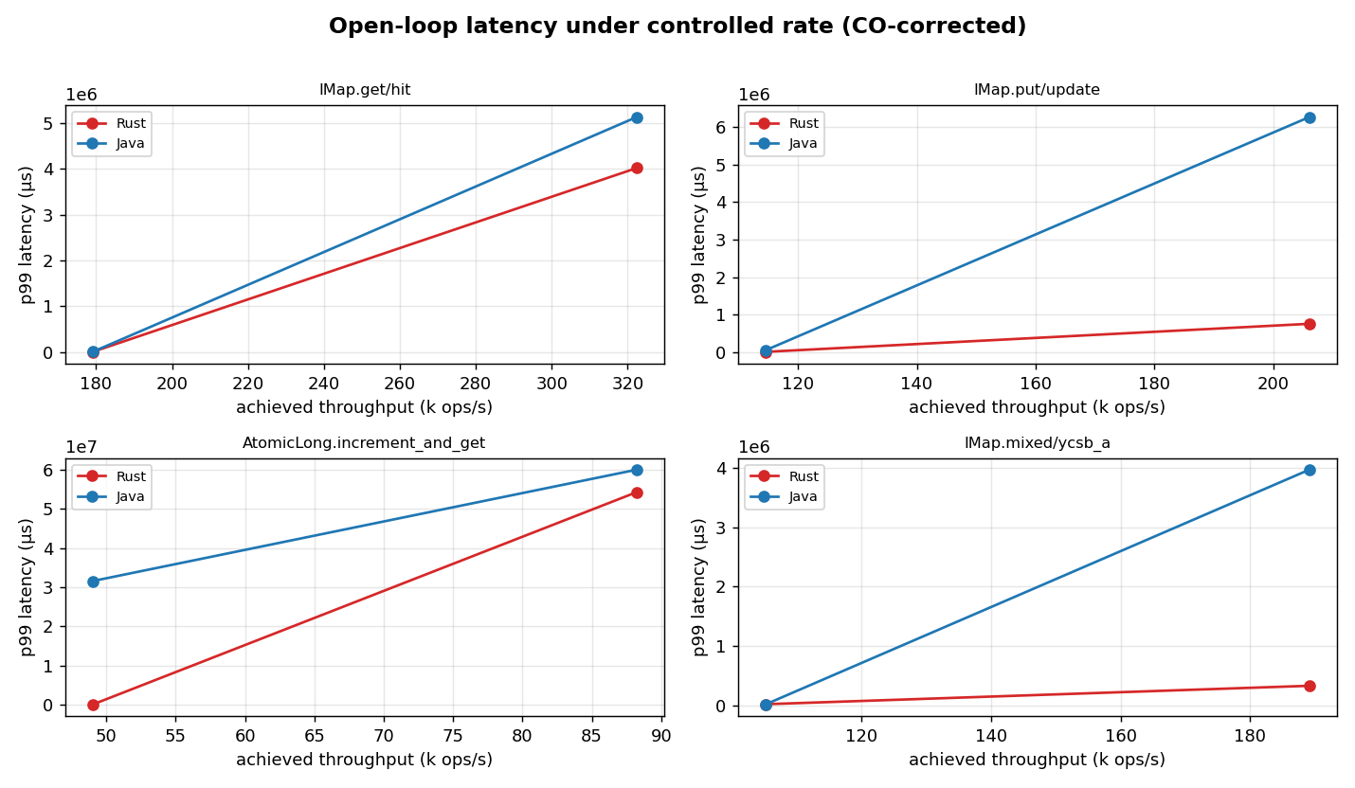

Client resource requirements
Resources consumed by the client process to drive the workload (the cluster is a fixed control). CPU is whole-process utilisation sampled from /proc and expressed both as mean cores in use and as CPU-seconds per million operations (efficiency, lower is leaner). Memory is peak resident set size (RSS); for Java this includes the JVM heap, metaspace, code cache and thread stacks.
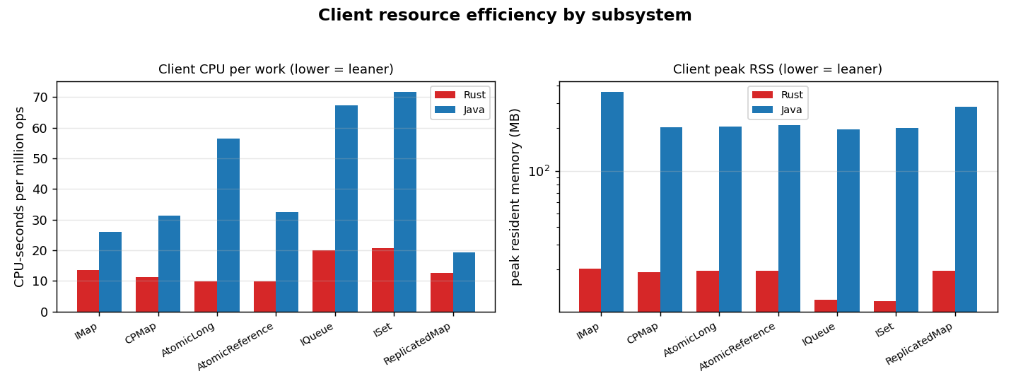
Operation | C | Rust cores | Java cores | Rust CPU-s/Mops | Java CPU-s/Mops | Rust RSS(MB) | Java RSS(MB)
AtomicLong.compare_and_set (success) | 64 | 1.13 | 2.33 | 19.3 | 69.1 | 20 | 203
AtomicLong.get | 64 | 2.26 | 3.63 | 8.4 | 26.3 | 20 | 205
AtomicLong.increment_and_get | 1 | 0.07 | 0.52 | 12.6 | 97.2 | 5 | 191
AtomicLong.increment_and_get | 64 | 1.00 | 2.87 | 9.8 | 31.6 | 20 | 207
AtomicLong.increment_and_get | 256 | 0.64 | 1.06 | 8.3 | 56.6 | 61 | 394
AtomicReference.set | 64 | 1.04 | 2.76 | 9.8 | 32.5 | 20 | 210
CPMap.get (hit) | 64 | 1.61 | 3.69 | 9.3 | 27.5 | 19 | 213
CPMap.put (update) | 1 | 0.09 | 0.52 | 12.9 | 98.2 | 5 | 186
CPMap.put (update) | 64 | 0.99 | 2.13 | 11.3 | 31.3 | 19 | 203
IMap.get (hit) | 1 | 0.28 | 0.74 | 12.5 | 36.9 | 5 | 188
IMap.get (hit) | 64 | 3.74 | 4.28 | 12.5 | 15.7 | 20 | 364
IMap.get (hit) | 64 | 3.79 | 4.30 | 12.3 | 15.5 | 20 | 359
IMap.get (hit) | 64 | 3.68 | 4.28 | 13.7 | 17.7 | 20 | 365
IMap.get (hit) | 64 | 3.58 | 3.88 | 25.3 | 37.6 | 23 | 573
IMap.get (hit) | 256 | 4.03 | 4.77 | 11.2 | 15.3 | 62 | 408
IMap.mixed (ycsb_a) | 1 | 0.23 | 0.68 | 13.1 | 50.7 | 5 | 184
IMap.mixed (ycsb_a) | 64 | 2.37 | 3.22 | 15.9 | 26.0 | 20 | 360
IMap.mixed (ycsb_b) | 64 | 3.39 | 4.07 | 14.2 | 18.7 | 20 | 362
IMap.mixed (ycsb_a) | 256 | 3.00 | 3.83 | 14.2 | 21.0 | 64 | 407
IMap.put (update) | 1 | 0.20 | 0.66 | 12.6 | 62.8 | 5 | 185
IMap.put (update) | 64 | 2.07 | 2.92 | 13.6 | 24.8 | 20 | 363
IMap.put (update) | 64 | 1.90 | 2.77 | 16.8 | 30.6 | 21 | 362
IMap.put (update) | 64 | 0.87 | 1.94 | 37.2 | 88.4 | 24 | 499
IMap.put (update) | 256 | 2.76 | 3.60 | 11.5 | 19.0 | 62 | 403
IMap.set | 1 | 0.20 | 0.66 | 13.1 | 64.5 | 5 | 189
IMap.set | 64 | 1.86 | 2.72 | 16.3 | 29.7 | 20 | 364
IQueue.offer_poll | 1 | 0.14 | 0.74 | 23.8 | 101.5 | 5 | 184
IQueue.offer_poll | 64 | 1.75 | 3.85 | 16.4 | 33.2 | 19 | 209
ISet.add_remove | 1 | 0.14 | 0.74 | 23.8 | 104.3 | 5 | 191
ISet.add_remove | 64 | 1.70 | 3.51 | 17.5 | 38.9 | 19 | 212
ReplicatedMap.get (hit) | 64 | 3.43 | 4.23 | 11.4 | 15.7 | 20 | 359
ReplicatedMap.put (update) | 64 | 1.38 | 2.22 | 13.7 | 23.2 | 20 | 209

Open-loop latency under controlled rate (CO-corrected)
Requests issued on a fixed-rate clock at fractions of each operation's measured closed-loop max, regardless of completion, so tail latency is not hidden by coordinated omission. A cell is flagged saturated if the generator could not sustain its target rate.
Operation | target ops/s | Rust p99 | Java p99 | Rust p99.9 | Java p99.9 | saturated
AtomicLong.increment_and_get | 49k | 40600 | 31574721 | 65372 | 31843156 | yes
AtomicLong.increment_and_get | 88k | 54291071 | 60028879 | 54492398 | 60028879 | yes
IMap.get (hit) | 179k | 5620 | 6545 | 9748 | 12370 | no
IMap.get (hit) | 322k | 4013949 | 5125439 | 4028629 | 5138022 | yes
IMap.mixed (ycsb_a) | 105k | 21561 | 16687 | 26952 | 21791 | no
IMap.mixed (ycsb_a) | 189k | 331612 | 3969909 | 343146 | 3974103 | yes
IMap.put (update) | 114k | 9019 | 49152 | 13787 | 55149 | no
IMap.put (update) | 206k | 757072 | 6266290 | 769130 | 6270484 | yes

Validity & caveats
- Total errors across all runs: 0.
- Contamination flags (member migration / slow-op / Full-GC during a window): 0.
- Cells with <1000 samples above p99.9 (tail estimate weaker, typically the C=1 latency-floor cells): 15.
- Co-located rig: cluster and client share one host with disjoint core pinning (members 0-3,8-11, client 4-6,12-14). They still share L3 cache, memory bandwidth and the loopback NIC, so absolute throughput is higher than a two-machine LAN deployment — but both clients see identical conditions, so the comparison is fair.
- CPU governor is hypervisor-managed on the virtualized guest; achieved frequency is recorded in provenance.
- Statistical depth: median across forks×trials with a 95% bootstrap CI (n is modest for a fresh broad run; wider CIs are reported honestly rather than hidden).
- Java RSS includes the whole JVM (heap + metaspace + code cache + stacks); the Rust figure is the whole process RSS. Both are apples-to-apples “memory the client process needs”.

Appendix — full provenance
{
"benchmark": "HazelRust vs official Hazelcast Java client",
"commit": "58cc26d",
"cluster_name": "dev",
"cluster": "127.0.0.1:5701,127.0.0.1:5702,127.0.0.1:5703",
"cluster_topology": "3-node EE 5.7.0 (dev), -Xms512m -Xmx1g per member",
"hz_java_client_version": "5.7.0",
"rustc": "rustc 1.96.0 (ac68faa20 2026-05-25)",
"java": "openjdk version \"21.0.11\" 2026-04-21 LTS",
"cargo_profile": "release (opt-level=3, lto=false, codegen-units=16)",
"cpu_model": "Intel(R) Xeon(R) Platinum 8275CL CPU @ 3.00GHz",
"logical_cpus": "16",
"cpu_mhz": {
"min": 3000.006,
"max": 3601.936,
"mean": 3557.0900625
},
"governor": "unavailable (virtualized guest; frequency managed by hypervisor)",
"kernel": "Linux ip-172-31-40-82.us-east-2.compute.internal 6.1.175-219.357.amzn2023.x86_64 #1 SMP PREEMPT_DYNAMIC Tue Jun 16 03:47:47 UTC 2026 x86_64 x86_64 x86_64 GNU/Linux",
"pinning": {
"members": "0-3,8-11",
"client": "4-6,12-14",
"os": "7,15",
"applied": true,
"member_cpuset_observed": {
"hz1": "0-3,8-11",
"hz2": "0-3,8-11",
"hz3": "0-3,8-11"
}
},
"colocation_caveat": "Cluster and client are CO-LOCATED on one AWS instance. Members and client are pinned to DISJOINT core sets, but they share L3, memory bandwidth, and the NIC/loopback. Absolute numbers may differ from a 2-machine LAN setup; the Rust/Java COMPARISON is fair (identical conditions).",
"jfr": false,
"ts_unix_ms": 1782536073261,
"java_client_edition": "enterprise 5.7.0 (instance ~/hzlib jar; required for CP)",
"license_source": "instance ~/hz/hz1.yaml (not logged)"
}

