HazelRust vs. Official Hazelcast Java Client
Head-to-Head Client Performance & Resource Comparison
Tier `h2h` · 240 runs · 40 cells · commit d0eba24 · cluster 3-node EE 5.7.0 (dev), -Xms512m -Xmx1g per member

Executive summary
Both clients executed the bit-for-bit identical, deterministically-seeded workload against the same quiesced 3-node Hazelcast Enterprise 5.7 cluster, on the same host, with members and client pinned to disjoint CPU core sets. Every figure below is a median across forks×trials with a 95%% bootstrap confidence interval; cells whose Rust/Java ratio CI spans 1.0 are flagged “within noise” and no winner is claimed.
- Throughput (closed-loop): across 32 head-to-head cells — Rust faster in 26, Java faster in 3, within noise in 3.
- Client resource efficiency: Rust's peak RSS is a median 0.06× of Java's (Java uses ~17.8× more memory); Rust's CPU-per-op is a median 0.47× of Java's (~2.1× less CPU per op).
- Correctness: 0 errors across all 240 runs.
- Per suite (throughput wins Rust / Java / noise): A 12/0/1; B 8/0/1; C 2/3/1; J 4/0/0
- Most decisive cells: Rust's biggest margins — AtomicLong.compare_and_set (success) C64 v8 (Rust +74%), IMap.put (update) C1 v100 (Rust +52%); Java's biggest margins — IQueue.offer_poll C1 v100 (Java +24%), ISet.add_remove C1 v100 (Java +24%).

Client performance improvements in this build
This build incorporates the client-side optimizations below, each verified on the live cluster with zero errors. The per-suite results in the rest of this report reflect the improved client. Throughputs are C=64 medians in thousands of ops/sec.
- Hot-path efficiency wins — Borrowing permission check + RaftGroupId, removal of a dead connection-address precheck, exact-size send buffers, and presized decode vectors — lower per-op CPU and fewer allocations across every operation. [e20ae5d]
- ReplicatedMap key-partition routing (ReplicatedMap.get: 106k → 269k, +154%) — Keyed ops were funnelled to the single owner of the map NAME's partition, idling 2 of 3 replica members. They now route by the KEY's partition, spreading reads across all replicas while preserving per-key read-your-writes. [89cd403]
- IQueue/ISet partition cache — A single-partition structure's partition is constant but was re-serialized and re-hashed on every op; it is now computed once and cached. [a644dd7]
- Coalescing writer task (IQueue offer+poll: 67k → 110k, +64%) — Each connection now has a dedicated writer task that batches all queued requests into one socket write (the Java client's IO-thread model) instead of locking a shared writer and issuing one syscall per op — the single-connection pipelining fix that lifts single-partition structures (Queue/Set/Topic). [d0eba24]
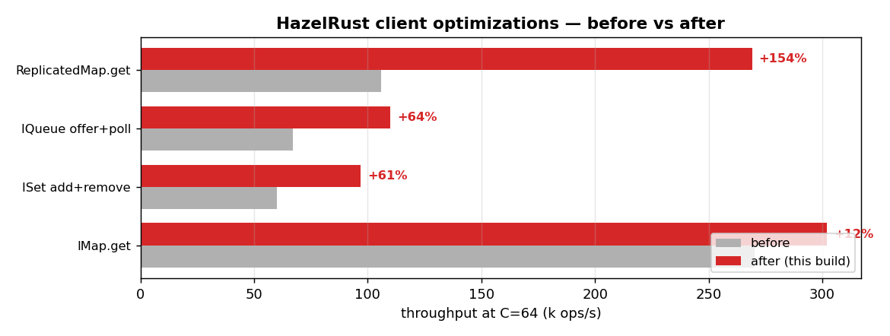
Optimization | Operation | Before | After | Change | Commit
Hot-path efficiency wins | all ops | — | — | leaner CPU | e20ae5d
ReplicatedMap key-partition routing | ReplicatedMap.get | 106 | 269 | +154% | 89cd403
IQueue/ISet partition cache | Queue/Set | — | — | fewer allocs | a644dd7
Coalescing writer task | IQueue offer+poll | 67 | 110 | +64% | d0eba24
Coalescing writer task | ISet add+remove | 60 | 97 | +61% | d0eba24
Coalescing writer task | IMap.get | 270 | 302 | +12% | d0eba24

Test environment & provenance
Component | Detail
Cluster | 3-node EE 5.7.0 (dev), -Xms512m -Xmx1g per member
Java client | 5.7.0 (enterprise 5.7.0 (instance ~/hzlib jar; required for CP))
Java runtime | openjdk version "21.0.11" 2026-04-21 LTS
Rust client | HazelRust @ d0eba24, release (opt-level=3, lto=false, codegen-units=16)
rustc | rustc 1.96.0 (ac68faa20 2026-05-25)
CPU | Intel(R) Xeon(R) Platinum 8275CL CPU @ 3.00GHz (16 logical cores)
Core pinning | members 0-3,8-11 · client 4-6,12-14 · OS 7,15
Governor | unavailable (virtualized guest; frequency managed by hypervisor)
Kernel | Linux ip-172-31-40-82.us-east-2.compute.internal 6.1.175-219.357.amzn2023.x86_64 #1 SMP PREEMPT_DYNAMIC Tue Jun 16 03:47:47 UTC 2026 x86_64 x86_64 x86_64 GNU/Linux

Methodology (fairness contract)
- Identical work: one shared JSON manifest; both harnesses execute every cell with the same SplitMix64-seeded key stream, value bytes, operation mix, concurrency, and warmup/measure windows.
- Matched concurrency C (outstanding in-flight operations); both a closed-loop max-throughput sweep and an open-loop latency-under-rate sweep (HdrHistogram expected-interval correction for coordinated omission).
- Steady state: per-cell warmup window (Java JIT reaches steady state) before measurement; each cell is run in multiple fresh process forks × trials with A/B interleaving to cancel cluster drift.
- Latency: full HdrHistogram per run (1 ns–60 s, 3 sig-figs), merged across forks; percentiles p50/p75/p90/p99/p99.9 reported. Throughput: ops/s with a per-second stability series.
- Client resources sampled at ~1 s from /proc: CPU utilisation (→ cores, CPU-seconds per million ops), peak resident memory (RSS), and thread count.
- Wire parity: byte[]/long values only (no Compact/Portable), identical Data framing; smart routing ON, statistics OFF, near-cache OFF, backup-ack matched for both clients.

Results by suite

Suite J — Realistic mixed workloads (YCSB-style)
Throughput (median ops/s, 95% CI) & verdict
Operation | C | val(B) | dist | Rust | Java | ratio R/J | verdict
IMap.mixed (ycsb_a) | 1 | 1024 | unif | 17k | 13k | 1.32 [1.30, 1.33] | Rust +32%
IMap.mixed (ycsb_a) | 64 | 1024 | unif | 154k | 129k | 1.19 [1.19, 1.20] | Rust +19%
IMap.mixed (ycsb_b) | 64 | 1024 | unif | 242k | 220k | 1.10 [1.09, 1.10] | Rust +10%
IMap.mixed (ycsb_a) | 256 | 1024 | unif | 215k | 188k | 1.14 [1.14, 1.16] | Rust +14%

Latency percentiles (µs) — Rust vs Java
Operation | C | client | p50 | p75 | p90 | p99 | p99.9
IMap.mixed (ycsb_a) | 1 | Rust | 55.5 | 64.2 | 69.5 | 81.3 | 97.5
 |  | Java | 74.3 | 94.3 | 102 | 120 | 142
IMap.mixed (ycsb_a) | 64 | Rust | 333 | 468 | 643 | 1572 | 8446
 |  | Java | 419 | 569 | 750 | 1662 | 8684
IMap.mixed (ycsb_b) | 64 | Rust | 235 | 305 | 389 | 686 | 2710
 |  | Java | 265 | 326 | 400 | 666 | 2169
IMap.mixed (ycsb_a) | 256 | Rust | 877 | 1312 | 2068 | 7078 | 14148
 |  | Java | 1042 | 1480 | 2238 | 8413 | 14287

Suite B — CP subsystem (the money path)
Throughput (median ops/s, 95% CI) & verdict
Operation | C | val(B) | dist | Rust | Java | ratio R/J | verdict
AtomicLong.compare_and_set (success) | 64 | 8 | unif | 76k | 44k | 1.74 [1.06, 1.80] | Rust +74%
AtomicLong.get | 64 | 8 | unif | 175k | 138k | 1.27 [1.25, 1.98] | Rust +27%
AtomicLong.increment_and_get | 1 | 8 | unif | 6k | 6k | 1.16 [1.07, 1.20] | Rust +16%
AtomicLong.increment_and_get | 64 | 8 | unif | 119k | 92k | 1.30 [1.29, 1.65] | Rust +30%
AtomicLong.increment_and_get | 256 | 8 | unif | 24k | 21k | 1.14 [0.72, 4.33] (noise) | within noise
AtomicReference.set | 64 | 8 | unif | 116k | 90k | 1.29 [1.09, 1.50] | Rust +29%
CPMap.get (hit) | 64 | 8 | unif | 171k | 134k | 1.28 [1.26, 1.94] | Rust +28%
CPMap.put (update) | 1 | 8 | unif | 7k | 5k | 1.26 [1.08, 1.70] | Rust +26%
CPMap.put (update) | 64 | 8 | unif | 86k | 68k | 1.27 [1.21, 2.22] | Rust +27%

Latency percentiles (µs) — Rust vs Java
Operation | C | client | p50 | p75 | p90 | p99 | p99.9
AtomicLong.compare_and_set (success) | 64 | Rust | 737 | 827 | 928 | 3273 | 16474
 |  | Java | 1279 | 1530 | 1778 | 7123 | 16908
AtomicLong.get | 64 | Rust | 354 | 388 | 433 | 540 | 1117
 |  | Java | 449 | 524 | 592 | 786 | 2845
AtomicLong.increment_and_get | 1 | Rust | 142 | 161 | 191 | 243 | 357
 |  | Java | 186 | 204 | 215 | 242 | 351
AtomicLong.increment_and_get | 64 | Rust | 454 | 505 | 560 | 1318 | 11616
 |  | Java | 617 | 691 | 773 | 1964 | 11117
AtomicLong.increment_and_get | 256 | Rust | 7578 | 10912 | 19202 | 49152 | 293863
 |  | Java | 6902 | 10797 | 21971 | 57836 | 543162
AtomicReference.set | 64 | Rust | 462 | 517 | 582 | 1576 | 11510
 |  | Java | 621 | 696 | 780 | 3052 | 12362
CPMap.get (hit) | 64 | Rust | 361 | 398 | 449 | 566 | 1501
 |  | Java | 463 | 538 | 609 | 828 | 2798
CPMap.put (update) | 1 | Rust | 142 | 156 | 177 | 214 | 326
 |  | Java | 195 | 209 | 222 | 261 | 389
CPMap.put (update) | 64 | Rust | 616 | 691 | 771 | 2900 | 16318
 |  | Java | 816 | 944 | 1067 | 5419 | 16703

Suite A — IMap (primary workhorse)
Throughput (median ops/s, 95% CI) & verdict
Operation | C | val(B) | dist | Rust | Java | ratio R/J | verdict
IMap.get (hit) | 1 | 100 | unif | 22k | 20k | 1.11 [1.10, 1.12] | Rust +11%
IMap.get (hit) | 64 | 100 | unif | 306k | 278k | 1.10 [1.10, 1.11] | Rust +10%
IMap.get (hit) | 64 | 100 | zipf | 313k | 281k | 1.11 [1.10, 1.14] | Rust +11%
IMap.get (hit) | 256 | 100 | unif | 363k | 314k | 1.16 [1.14, 1.20] | Rust +16%
IMap.get (hit) | 64 | 1024 | unif | 275k | 244k | 1.12 [1.12, 1.14] | Rust +12%
IMap.get (hit) | 64 | 16384 | unif | 150k | 101k | 1.48 [1.45, 1.51] | Rust +48%
IMap.put (update) | 1 | 100 | unif | 16k | 11k | 1.52 [1.50, 1.54] | Rust +52%
IMap.put (update) | 64 | 100 | unif | 155k | 120k | 1.30 [1.29, 1.32] | Rust +30%
IMap.put (update) | 256 | 100 | unif | 250k | 192k | 1.30 [1.24, 1.38] | Rust +30%
IMap.put (update) | 64 | 1024 | unif | 118k | 93k | 1.27 [1.26, 1.30] | Rust +27%
IMap.put (update) | 64 | 16384 | unif | 25k | 25k | 1.01 [0.99, 1.12] (noise) | within noise
IMap.set | 1 | 1024 | unif | 15k | 10k | 1.50 [1.48, 1.55] | Rust +50%
IMap.set | 64 | 1024 | unif | 118k | 93k | 1.27 [1.26, 1.28] | Rust +27%

Latency percentiles (µs) — Rust vs Java
Operation | C | client | p50 | p75 | p90 | p99 | p99.9
IMap.get (hit) | 1 | Rust | 44.5 | 47.7 | 51.7 | 62.4 | 76.4
 |  | Java | 49.4 | 52.9 | 57.0 | 67.9 | 84.0
IMap.get (hit) | 64 | Rust | 191 | 236 | 290 | 503 | 1506
 |  | Java | 216 | 256 | 302 | 458 | 1199
IMap.get (hit) | 64 | Rust | 188 | 231 | 283 | 481 | 1320
 |  | Java | 215 | 254 | 299 | 452 | 1227
IMap.get (hit) | 256 | Rust | 508 | 930 | 1380 | 2884 | 7385
 |  | Java | 760 | 902 | 1094 | 2824 | 7438
IMap.get (hit) | 64 | Rust | 215 | 264 | 324 | 558 | 1389
 |  | Java | 247 | 292 | 346 | 540 | 1365
IMap.get (hit) | 64 | Rust | 403 | 522 | 636 | 830 | 1658
 |  | Java | 592 | 778 | 950 | 1377 | 2080
IMap.put (update) | 1 | Rust | 61.2 | 65.4 | 69.4 | 80.1 | 97.2
 |  | Java | 92.6 | 98.6 | 105 | 119 | 142
IMap.put (update) | 64 | Rust | 347 | 493 | 667 | 1306 | 7033
 |  | Java | 480 | 606 | 759 | 1330 | 6894
IMap.put (update) | 256 | Rust | 794 | 1209 | 1779 | 5272 | 10830
 |  | Java | 1140 | 1507 | 2053 | 6132 | 11280
IMap.put (update) | 64 | Rust | 409 | 599 | 874 | 2677 | 10338
 |  | Java | 573 | 739 | 985 | 2677 | 10101
IMap.put (update) | 64 | Rust | 1030 | 1929 | 4194 | 19038 | 154403
 |  | Java | 1361 | 2099 | 4125 | 16859 | 161350
IMap.set | 1 | Rust | 63.8 | 68.1 | 72.2 | 83.3 | 100
 |  | Java | 94.8 | 102 | 109 | 126 | 155
IMap.set | 64 | Rust | 403 | 596 | 879 | 2630 | 10060
 |  | Java | 574 | 739 | 981 | 2449 | 10174

Suite C — Collections (Queue / Set / ReplicatedMap)
Throughput (median ops/s, 95% CI) & verdict
Operation | C | val(B) | dist | Rust | Java | ratio R/J | verdict
IQueue.offer_poll | 1 | 100 | unif | 6k | 7k | 0.81 [0.79, 0.81] | Java +24%
IQueue.offer_poll | 64 | 100 | unif | 110k | 116k | 0.95 [0.94, 0.95] | Java +6%
ISet.add_remove | 1 | 100 | unif | 6k | 7k | 0.81 [0.81, 0.82] | Java +24%
ISet.add_remove | 64 | 100 | unif | 97k | 91k | 1.06 [1.05, 1.08] | Rust +6%
ReplicatedMap.get (hit) | 64 | 100 | unif | 305k | 272k | 1.12 [1.10, 1.13] | Rust +12%
ReplicatedMap.put (update) | 64 | 100 | unif | 102k | 100k | 1.02 [0.95, 1.09] (noise) | within noise

Latency percentiles (µs) — Rust vs Java
Operation | C | client | p50 | p75 | p90 | p99 | p99.9
IQueue.offer_poll | 1 | Rust | 164 | 174 | 196 | 227 | 294
 |  | Java | 132 | 141 | 156 | 187 | 238
IQueue.offer_poll | 64 | Rust | 553 | 621 | 718 | 943 | 2748
 |  | Java | 515 | 563 | 657 | 1276 | 2839
ISet.add_remove | 1 | Rust | 166 | 175 | 197 | 248 | 313
 |  | Java | 135 | 144 | 160 | 201 | 254
ISet.add_remove | 64 | Rust | 638 | 722 | 839 | 1159 | 2851
 |  | Java | 697 | 757 | 826 | 1087 | 2830
ReplicatedMap.get (hit) | 64 | Rust | 189 | 235 | 292 | 540 | 2564
 |  | Java | 219 | 259 | 308 | 487 | 1508
ReplicatedMap.put (update) | 64 | Rust | 487 | 768 | 1147 | 2757 | 7967
 |  | Java | 510 | 762 | 1109 | 2677 | 7844

Charts

Throughput by operation (C=64)
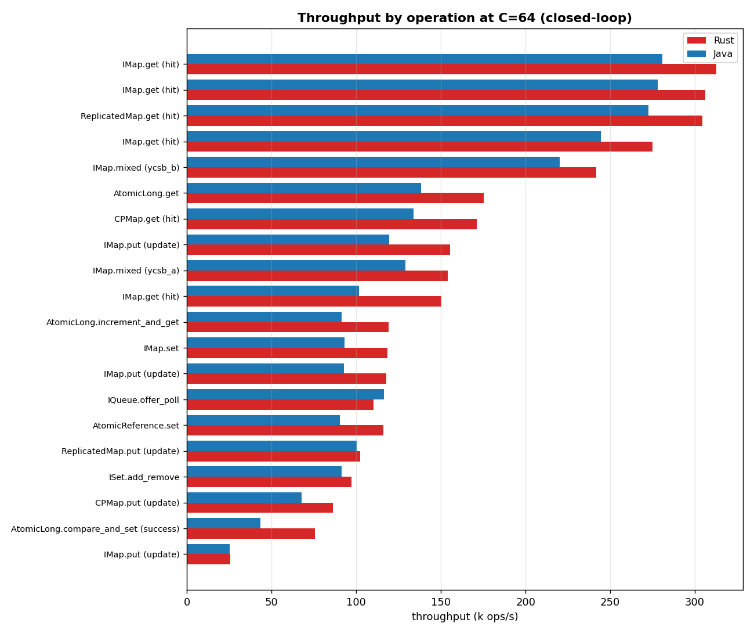

Throughput vs concurrency
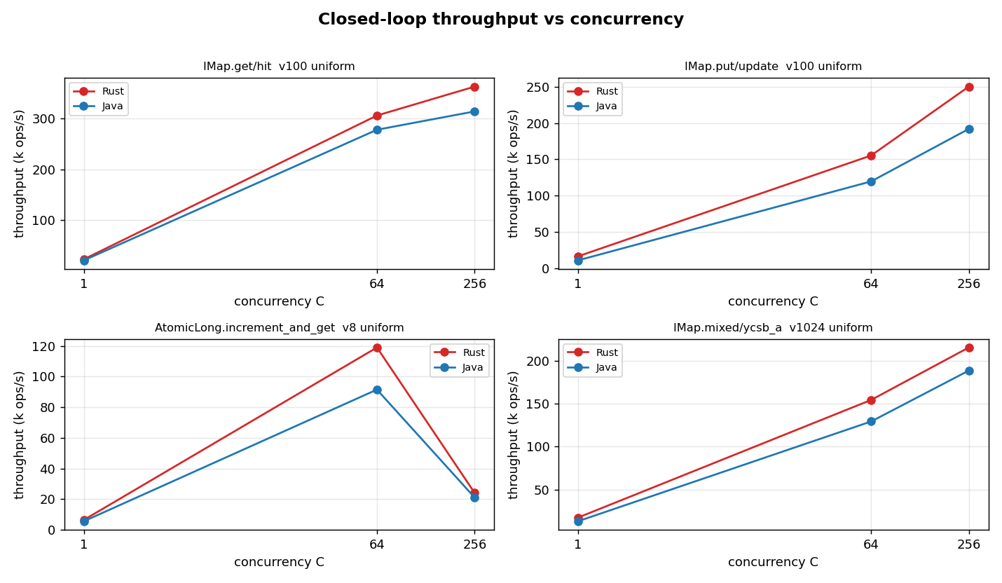

Latency percentile profiles
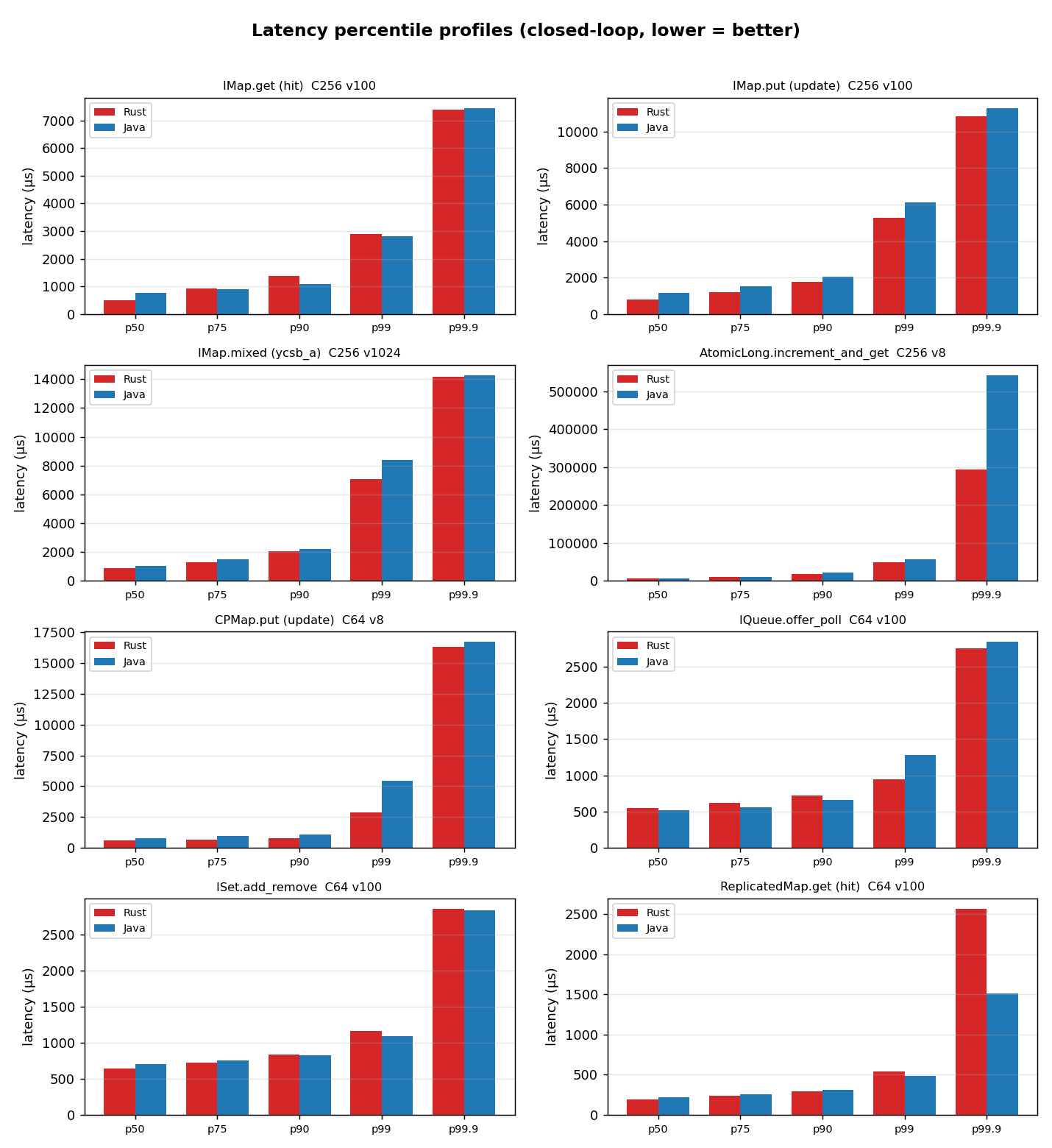

Open-loop latency under controlled rate
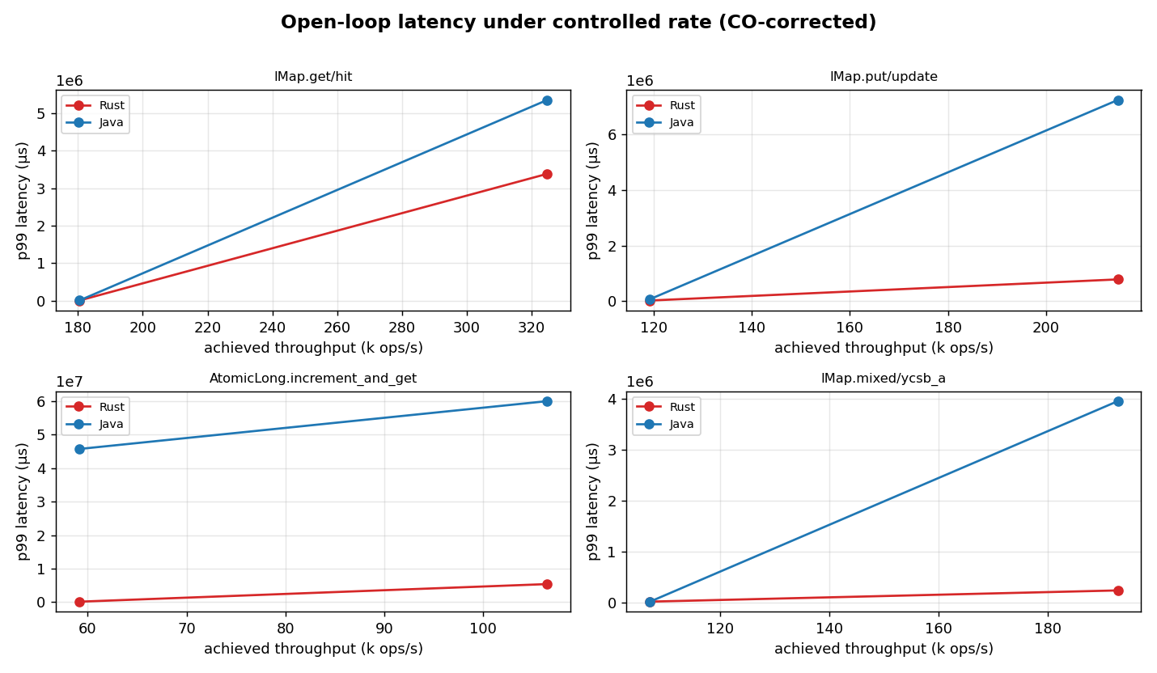

Client resource requirements
Resources consumed by the client process to drive the workload (the cluster is a fixed control). CPU is whole-process utilisation sampled from /proc and expressed both as mean cores in use and as CPU-seconds per million operations (efficiency, lower is leaner). Memory is peak resident set size (RSS); for Java this includes the JVM heap, metaspace, code cache and thread stacks.
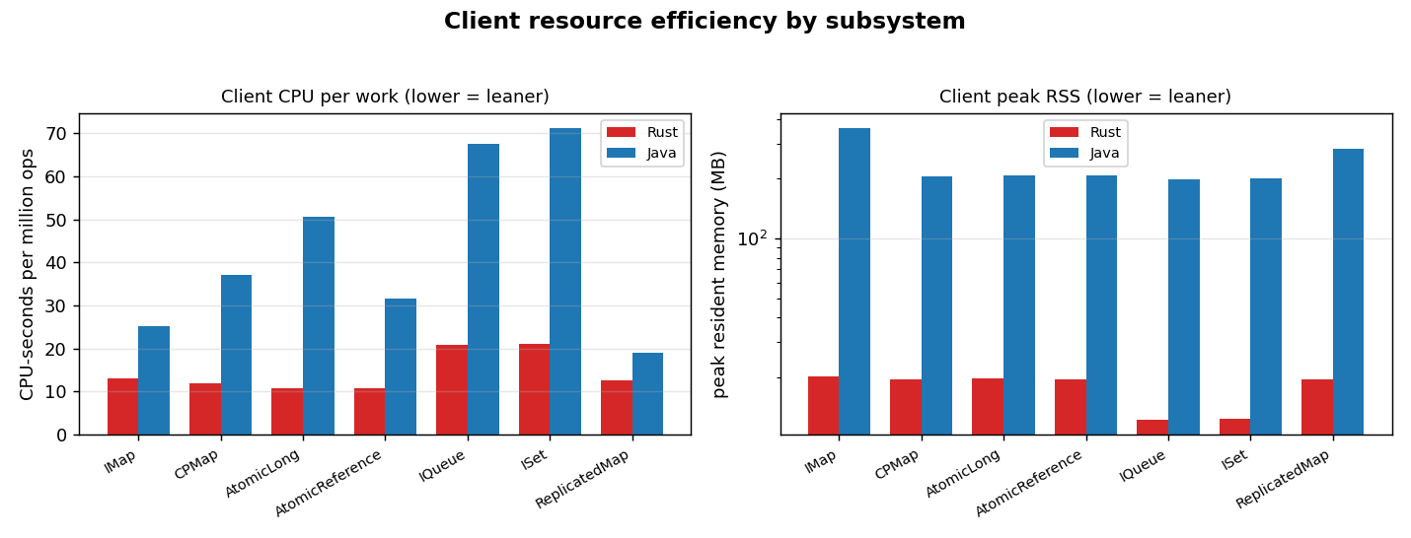
Operation | C | Rust cores | Java cores | Rust CPU-s/Mops | Java CPU-s/Mops | Rust RSS(MB) | Java RSS(MB)
AtomicLong.compare_and_set (success) | 64 | 1.57 | 2.81 | 22.2 | 64.6 | 20 | 209
AtomicLong.get | 64 | 1.66 | 3.64 | 9.4 | 26.3 | 20 | 208
AtomicLong.increment_and_get | 1 | 0.08 | 0.52 | 12.6 | 94.4 | 5 | 183
AtomicLong.increment_and_get | 64 | 1.28 | 2.87 | 10.8 | 31.4 | 19 | 200
AtomicLong.increment_and_get | 256 | 0.23 | 1.12 | 9.6 | 50.7 | 61 | 388
AtomicReference.set | 64 | 1.24 | 2.83 | 10.8 | 31.6 | 19 | 209
CPMap.get (hit) | 64 | 1.63 | 3.64 | 9.5 | 27.2 | 19 | 206
CPMap.put (update) | 1 | 0.08 | 0.53 | 12.3 | 98.2 | 5 | 188
CPMap.put (update) | 64 | 1.01 | 2.52 | 11.8 | 37.2 | 19 | 205
IMap.get (hit) | 1 | 0.27 | 0.73 | 12.2 | 36.4 | 5 | 185
IMap.get (hit) | 64 | 3.62 | 4.25 | 11.8 | 15.3 | 19 | 361
IMap.get (hit) | 64 | 3.68 | 4.32 | 11.8 | 15.4 | 20 | 359
IMap.get (hit) | 64 | 3.54 | 4.30 | 12.9 | 17.6 | 20 | 362
IMap.get (hit) | 64 | 3.56 | 3.88 | 23.8 | 38.3 | 23 | 573
IMap.get (hit) | 256 | 3.94 | 4.73 | 10.8 | 15.1 | 62 | 413
IMap.mixed (ycsb_a) | 1 | 0.22 | 0.67 | 12.7 | 50.5 | 5 | 187
IMap.mixed (ycsb_a) | 64 | 2.46 | 3.24 | 16.0 | 25.1 | 21 | 362
IMap.mixed (ycsb_b) | 64 | 3.30 | 4.10 | 13.7 | 18.6 | 20 | 362
IMap.mixed (ycsb_a) | 256 | 3.07 | 3.91 | 14.3 | 21.0 | 64 | 408
IMap.put (update) | 1 | 0.20 | 0.64 | 12.2 | 59.9 | 5 | 184
IMap.put (update) | 64 | 2.03 | 2.96 | 13.1 | 24.7 | 19 | 359
IMap.put (update) | 64 | 2.04 | 2.82 | 17.3 | 30.7 | 20 | 363
IMap.put (update) | 64 | 1.00 | 2.13 | 39.0 | 84.4 | 27 | 503
IMap.put (update) | 256 | 2.79 | 3.73 | 11.2 | 19.6 | 62 | 358
IMap.set | 1 | 0.20 | 0.67 | 13.0 | 64.2 | 5 | 189
IMap.set | 64 | 2.05 | 2.73 | 17.4 | 29.3 | 21 | 364
IQueue.offer_poll | 1 | 0.14 | 0.75 | 23.5 | 102.5 | 5 | 184
IQueue.offer_poll | 64 | 1.96 | 3.81 | 18.0 | 32.8 | 19 | 212
ISet.add_remove | 1 | 0.14 | 0.74 | 23.8 | 103.4 | 5 | 189
ISet.add_remove | 64 | 1.76 | 3.55 | 18.3 | 38.9 | 19 | 216
ReplicatedMap.get (hit) | 64 | 3.40 | 4.25 | 11.3 | 15.6 | 20 | 360
ReplicatedMap.put (update) | 64 | 1.40 | 2.25 | 13.7 | 22.5 | 19 | 206

Open-loop latency under controlled rate (CO-corrected)
Requests issued on a fixed-rate clock at fractions of each operation's measured closed-loop max, regardless of completion, so tail latency is not hidden by coordinated omission. A cell is flagged saturated if the generator could not sustain its target rate.
Operation | target ops/s | Rust p99 | Java p99 | Rust p99.9 | Java p99.9 | saturated
AtomicLong.increment_and_get | 59k | 95420 | 45734691 | 119079 | 46036681 | yes
AtomicLong.increment_and_get | 106k | 5356126 | 60028879 | 5372903 | 60028879 | yes
IMap.get (hit) | 180k | 5452 | 6562 | 10084 | 11559 | no
IMap.get (hit) | 325k | 3382706 | 5351932 | 3395289 | 5372903 | yes
IMap.mixed (ycsb_a) | 107k | 20120 | 19104 | 27771 | 37618 | no
IMap.mixed (ycsb_a) | 193k | 240255 | 3953132 | 244842 | 3959423 | yes
IMap.put (update) | 119k | 16376 | 64127 | 28492 | 68420 | no
IMap.put (update) | 215k | 778568 | 7251952 | 781713 | 7340032 | yes

Validity & caveats
- Total errors across all runs: 0.
- Contamination flags (member migration / slow-op / Full-GC during a window): 0.
- Cells with <1000 samples above p99.9 (tail estimate weaker, typically the C=1 latency-floor cells): 15.
- Co-located rig: cluster and client share one host with disjoint core pinning (members 0-3,8-11, client 4-6,12-14). They still share L3 cache, memory bandwidth and the loopback NIC, so absolute throughput is higher than a two-machine LAN deployment — but both clients see identical conditions, so the comparison is fair.
- CPU governor is hypervisor-managed on the virtualized guest; achieved frequency is recorded in provenance.
- Statistical depth: median across forks×trials with a 95% bootstrap CI (n is modest for a fresh broad run; wider CIs are reported honestly rather than hidden).
- Java RSS includes the whole JVM (heap + metaspace + code cache + stacks); the Rust figure is the whole process RSS. Both are apples-to-apples “memory the client process needs”.

Appendix — full provenance
{
"benchmark": "HazelRust vs official Hazelcast Java client",
"commit": "d0eba24",
"cluster_name": "dev",
"cluster": "127.0.0.1:5701,127.0.0.1:5702,127.0.0.1:5703",
"cluster_topology": "3-node EE 5.7.0 (dev), -Xms512m -Xmx1g per member",
"hz_java_client_version": "5.7.0",
"rustc": "rustc 1.96.0 (ac68faa20 2026-05-25)",
"java": "openjdk version \"21.0.11\" 2026-04-21 LTS",
"cargo_profile": "release (opt-level=3, lto=false, codegen-units=16)",
"cpu_model": "Intel(R) Xeon(R) Platinum 8275CL CPU @ 3.00GHz",
"logical_cpus": "16",
"cpu_mhz": {
"min": 3591.849,
"max": 3610.263,
"mean": 3600.865
},
"governor": "unavailable (virtualized guest; frequency managed by hypervisor)",
"kernel": "Linux ip-172-31-40-82.us-east-2.compute.internal 6.1.175-219.357.amzn2023.x86_64 #1 SMP PREEMPT_DYNAMIC Tue Jun 16 03:47:47 UTC 2026 x86_64 x86_64 x86_64 GNU/Linux",
"pinning": {
"members": "0-3,8-11",
"client": "4-6,12-14",
"os": "7,15",
"applied": true,
"member_cpuset_observed": {
"hz1": "0-3,8-11",
"hz2": "0-3,8-11",
"hz3": "0-3,8-11"
}
},
"colocation_caveat": "Cluster and client are CO-LOCATED on one AWS instance. Members and client are pinned to DISJOINT core sets, but they share L3, memory bandwidth, and the NIC/loopback. Absolute numbers may differ from a 2-machine LAN setup; the Rust/Java COMPARISON is fair (identical conditions).",
"jfr": false,
"ts_unix_ms": 1782511360527,
"java_client_edition": "enterprise 5.7.0 (instance ~/hzlib jar; required for CP)",
"license_source": "instance ~/hz/hz1.yaml (not logged)"
}

