HazelRust vs. Official Hazelcast Java Client
Head-to-Head Client Performance & Resource Comparison
Tier `h2h` · 480 runs · 40 cells · commit e20ae5d · cluster 3-node EE 5.7.0 (dev), -Xms512m -Xmx1g per member

Executive summary
Both clients executed the bit-for-bit identical, deterministically-seeded workload against the same quiesced 3-node Hazelcast Enterprise 5.7 cluster, on the same host, with members and client pinned to disjoint CPU core sets. Every figure below is a median across forks×trials with a 95%% bootstrap confidence interval; cells whose Rust/Java ratio CI spans 1.0 are flagged “within noise” and no winner is claimed.
- Throughput (closed-loop): across 32 head-to-head cells — Rust faster in 23, Java faster in 7, within noise in 2.
- Client resource efficiency: Rust's peak RSS is a median 0.06× of Java's (Java uses ~17.9× more memory); Rust's CPU-per-op is a median 0.55× of Java's (~1.8× less CPU per op).
- Correctness: 0 errors across all 480 runs.
- Per suite (throughput wins Rust / Java / noise): A 11/2/0; B 7/0/2; C 1/5/0; J 4/0/0
- Most decisive cells: Rust's biggest margins — IMap.put (update) C1 v100 (Rust +51%), AtomicLong.compare_and_set (success) C64 v8 (Rust +51%); Java's biggest margins — ReplicatedMap.get (hit) C64 v100 (Java +162%), IQueue.offer_poll C64 v100 (Java +86%).

Test environment & provenance
Component | Detail
Cluster | 3-node EE 5.7.0 (dev), -Xms512m -Xmx1g per member
Java client | 5.7.0 (enterprise 5.7.0 (instance ~/hzlib jar; required for CP))
Java runtime | openjdk version "21.0.11" 2026-04-21 LTS
Rust client | HazelRust @ e20ae5d, release (opt-level=3, lto=false, codegen-units=16)
rustc | rustc 1.96.0 (ac68faa20 2026-05-25)
CPU | Intel(R) Xeon(R) Platinum 8275CL CPU @ 3.00GHz (16 logical cores)
Core pinning | members 0-3,8-11 · client 4-6,12-14 · OS 7,15
Governor | unavailable (virtualized guest; frequency managed by hypervisor)
Kernel | Linux ip-172-31-40-82.us-east-2.compute.internal 6.1.175-219.357.amzn2023.x86_64 #1 SMP PREEMPT_DYNAMIC Tue Jun 16 03:47:47 UTC 2026 x86_64 x86_64 x86_64 GNU/Linux

Methodology (fairness contract)
- Identical work: one shared JSON manifest; both harnesses execute every cell with the same SplitMix64-seeded key stream, value bytes, operation mix, concurrency, and warmup/measure windows.
- Matched concurrency C (outstanding in-flight operations); both a closed-loop max-throughput sweep and an open-loop latency-under-rate sweep (HdrHistogram expected-interval correction for coordinated omission).
- Steady state: per-cell warmup window (Java JIT reaches steady state) before measurement; each cell is run in multiple fresh process forks × trials with A/B interleaving to cancel cluster drift.
- Latency: full HdrHistogram per run (1 ns–60 s, 3 sig-figs), merged across forks; percentiles p50/p75/p90/p99/p99.9 reported. Throughput: ops/s with a per-second stability series.
- Client resources sampled at ~1 s from /proc: CPU utilisation (→ cores, CPU-seconds per million ops), peak resident memory (RSS), and thread count.
- Wire parity: byte[]/long values only (no Compact/Portable), identical Data framing; smart routing ON, statistics OFF, near-cache OFF, backup-ack matched for both clients.

Results by suite

Suite J — Realistic mixed workloads (YCSB-style)
Throughput (median ops/s, 95% CI) & verdict
Operation | C | val(B) | dist | Rust | Java | ratio R/J | verdict
IMap.mixed (ycsb_a) | 1 | 1024 | unif | 18k | 13k | 1.32 [1.31, 1.34] | Rust +32%
IMap.mixed (ycsb_a) | 64 | 1024 | unif | 152k | 130k | 1.17 [1.16, 1.18] | Rust +17%
IMap.mixed (ycsb_b) | 64 | 1024 | unif | 227k | 219k | 1.04 [1.02, 1.05] | Rust +4%
IMap.mixed (ycsb_a) | 256 | 1024 | unif | 209k | 192k | 1.09 [1.07, 1.10] | Rust +9%

Latency percentiles (µs) — Rust vs Java
Operation | C | client | p50 | p75 | p90 | p99 | p99.9
IMap.mixed (ycsb_a) | 1 | Rust | 54.9 | 63.6 | 68.9 | 80.2 | 96.5
 |  | Java | 73.3 | 92.8 | 101 | 117 | 137
IMap.mixed (ycsb_a) | 64 | Rust | 342 | 474 | 648 | 1513 | 8557
 |  | Java | 418 | 569 | 753 | 1607 | 8536
IMap.mixed (ycsb_b) | 64 | Rust | 257 | 326 | 405 | 679 | 2205
 |  | Java | 265 | 327 | 403 | 697 | 2320
IMap.mixed (ycsb_a) | 256 | Rust | 944 | 1323 | 1992 | 6887 | 13693
 |  | Java | 1035 | 1455 | 2156 | 8141 | 13771

Suite B — CP subsystem (the money path)
Throughput (median ops/s, 95% CI) & verdict
Operation | C | val(B) | dist | Rust | Java | ratio R/J | verdict
AtomicLong.compare_and_set (success) | 64 | 8 | unif | 53k | 35k | 1.51 [1.10, 1.76] | Rust +51%
AtomicLong.get | 64 | 8 | unif | 143k | 139k | 1.03 [1.02, 1.04] | Rust +3%
AtomicLong.increment_and_get | 1 | 8 | unif | 6k | 5k | 1.15 [1.08, 1.27] | Rust +15%
AtomicLong.increment_and_get | 64 | 8 | unif | 102k | 92k | 1.11 [1.09, 1.17] | Rust +11%
AtomicLong.increment_and_get | 256 | 8 | unif | 26k | 20k | 1.28 [0.98, 3.19] (noise) | within noise
AtomicReference.set | 64 | 8 | unif | 109k | 78k | 1.39 [1.17, 1.55] | Rust +39%
CPMap.get (hit) | 64 | 8 | unif | 135k | 135k | 1.00 [0.97, 1.02] (noise) | within noise
CPMap.put (update) | 1 | 8 | unif | 7k | 5k | 1.23 [1.20, 1.80] | Rust +23%
CPMap.put (update) | 64 | 8 | unif | 98k | 68k | 1.44 [1.18, 2.51] | Rust +44%

Latency percentiles (µs) — Rust vs Java
Operation | C | client | p50 | p75 | p90 | p99 | p99.9
AtomicLong.compare_and_set (success) | 64 | Rust | 1099 | 1207 | 1444 | 4578 | 18637
 |  | Java | 1340 | 1671 | 2633 | 11370 | 22979
AtomicLong.get | 64 | Rust | 449 | 495 | 540 | 627 | 1070
 |  | Java | 450 | 522 | 590 | 774 | 2608
AtomicLong.increment_and_get | 1 | Rust | 151 | 163 | 191 | 217 | 316
 |  | Java | 190 | 206 | 217 | 252 | 377
AtomicLong.increment_and_get | 64 | Rust | 551 | 609 | 674 | 1482 | 11436
 |  | Java | 614 | 687 | 769 | 2161 | 11117
AtomicLong.increment_and_get | 256 | Rust | 6689 | 11035 | 22118 | 50823 | 178913
 |  | Java | 6676 | 11657 | 24601 | 63259 | 554697
AtomicReference.set | 64 | Rust | 482 | 534 | 595 | 1591 | 15114
 |  | Java | 690 | 823 | 952 | 4835 | 15364
CPMap.get (hit) | 64 | Rust | 465 | 525 | 586 | 712 | 1494
 |  | Java | 459 | 534 | 607 | 825 | 2874
CPMap.put (update) | 1 | Rust | 142 | 156 | 170 | 195 | 270
 |  | Java | 189 | 206 | 217 | 249 | 365
CPMap.put (update) | 64 | Rust | 573 | 637 | 712 | 2108 | 14279
 |  | Java | 800 | 936 | 1063 | 5825 | 16454

Suite A — IMap (primary workhorse)
Throughput (median ops/s, 95% CI) & verdict
Operation | C | val(B) | dist | Rust | Java | ratio R/J | verdict
IMap.get (hit) | 1 | 100 | unif | 22k | 20k | 1.12 [1.11, 1.13] | Rust +12%
IMap.get (hit) | 64 | 100 | unif | 270k | 275k | 0.98 [0.97, 0.99] | Java +2%
IMap.get (hit) | 64 | 100 | zipf | 266k | 281k | 0.95 [0.94, 0.97] | Java +5%
IMap.get (hit) | 256 | 100 | unif | 320k | 315k | 1.02 [1.00, 1.03] | Rust +2%
IMap.get (hit) | 64 | 1024 | unif | 248k | 243k | 1.02 [1.01, 1.03] | Rust +2%
IMap.get (hit) | 64 | 16384 | unif | 135k | 103k | 1.31 [1.30, 1.32] | Rust +31%
IMap.put (update) | 1 | 100 | unif | 16k | 11k | 1.51 [1.51, 1.53] | Rust +51%
IMap.put (update) | 64 | 100 | unif | 153k | 119k | 1.28 [1.25, 1.31] | Rust +28%
IMap.put (update) | 256 | 100 | unif | 239k | 195k | 1.23 [1.20, 1.27] | Rust +23%
IMap.put (update) | 64 | 1024 | unif | 118k | 92k | 1.28 [1.24, 1.30] | Rust +28%
IMap.put (update) | 64 | 16384 | unif | 27k | 26k | 1.03 [1.01, 1.08] | Rust +3%
IMap.set | 1 | 1024 | unif | 16k | 10k | 1.49 [1.48, 1.53] | Rust +49%
IMap.set | 64 | 1024 | unif | 119k | 94k | 1.26 [1.24, 1.28] | Rust +26%

Latency percentiles (µs) — Rust vs Java
Operation | C | client | p50 | p75 | p90 | p99 | p99.9
IMap.get (hit) | 1 | Rust | 44.1 | 47.4 | 51.3 | 62.2 | 76.8
 |  | Java | 49.5 | 52.8 | 56.4 | 67.6 | 82.3
IMap.get (hit) | 64 | Rust | 219 | 278 | 342 | 517 | 1832
 |  | Java | 218 | 257 | 303 | 459 | 1416
IMap.get (hit) | 64 | Rust | 220 | 287 | 358 | 524 | 1954
 |  | Java | 214 | 253 | 297 | 446 | 1371
IMap.get (hit) | 256 | Rust | 727 | 962 | 1219 | 2684 | 6760
 |  | Java | 759 | 904 | 1102 | 2718 | 6822
IMap.get (hit) | 64 | Rust | 241 | 300 | 365 | 547 | 1648
 |  | Java | 248 | 293 | 345 | 513 | 1361
IMap.get (hit) | 64 | Rust | 431 | 626 | 807 | 1049 | 1588
 |  | Java | 586 | 769 | 933 | 1277 | 2018
IMap.put (update) | 1 | Rust | 61.4 | 65.6 | 69.7 | 81.0 | 98.0
 |  | Java | 92.2 | 98.3 | 105 | 122 | 148
IMap.put (update) | 64 | Rust | 352 | 501 | 677 | 1315 | 7172
 |  | Java | 482 | 605 | 753 | 1338 | 6926
IMap.put (update) | 256 | Rust | 844 | 1251 | 1804 | 5216 | 11559
 |  | Java | 1123 | 1485 | 1983 | 5585 | 11670
IMap.put (update) | 64 | Rust | 410 | 596 | 874 | 2547 | 10015
 |  | Java | 578 | 743 | 985 | 2487 | 10211
IMap.put (update) | 64 | Rust | 1022 | 1877 | 3786 | 17850 | 149684
 |  | Java | 1347 | 2078 | 3998 | 15241 | 162726
IMap.set | 1 | Rust | 63.2 | 67.7 | 72.1 | 84.4 | 104
 |  | Java | 94.2 | 101 | 108 | 125 | 156
IMap.set | 64 | Rust | 410 | 597 | 862 | 2584 | 9884
 |  | Java | 567 | 732 | 966 | 2466 | 9929

Suite C — Collections (Queue / Set / ReplicatedMap)
Throughput (median ops/s, 95% CI) & verdict
Operation | C | val(B) | dist | Rust | Java | ratio R/J | verdict
IQueue.offer_poll | 1 | 100 | unif | 6k | 7k | 0.82 [0.81, 0.82] | Java +23%
IQueue.offer_poll | 64 | 100 | unif | 63k | 118k | 0.54 [0.53, 0.54] | Java +86%
ISet.add_remove | 1 | 100 | unif | 6k | 7k | 0.81 [0.81, 0.83] | Java +23%
ISet.add_remove | 64 | 100 | unif | 61k | 92k | 0.66 [0.63, 0.67] | Java +52%
ReplicatedMap.get (hit) | 64 | 100 | unif | 106k | 277k | 0.38 [0.38, 0.39] | Java +162%
ReplicatedMap.put (update) | 64 | 100 | unif | 106k | 100k | 1.06 [1.04, 1.08] | Rust +6%

Latency percentiles (µs) — Rust vs Java
Operation | C | client | p50 | p75 | p90 | p99 | p99.9
IQueue.offer_poll | 1 | Rust | 163 | 172 | 199 | 234 | 288
 |  | Java | 134 | 144 | 157 | 186 | 248
IQueue.offer_poll | 64 | Rust | 1003 | 1059 | 1111 | 1247 | 3213
 |  | Java | 514 | 562 | 649 | 902 | 2728
ISet.add_remove | 1 | Rust | 165 | 175 | 193 | 231 | 299
 |  | Java | 134 | 143 | 159 | 184 | 259
ISet.add_remove | 64 | Rust | 1058 | 1121 | 1180 | 1376 | 3253
 |  | Java | 686 | 739 | 809 | 1125 | 2873
ReplicatedMap.get (hit) | 64 | Rust | 603 | 640 | 673 | 735 | 860
 |  | Java | 217 | 256 | 301 | 451 | 1254
ReplicatedMap.put (update) | 64 | Rust | 590 | 669 | 775 | 1129 | 3399
 |  | Java | 510 | 766 | 1106 | 2716 | 8163

Charts

Throughput by operation (C=64)
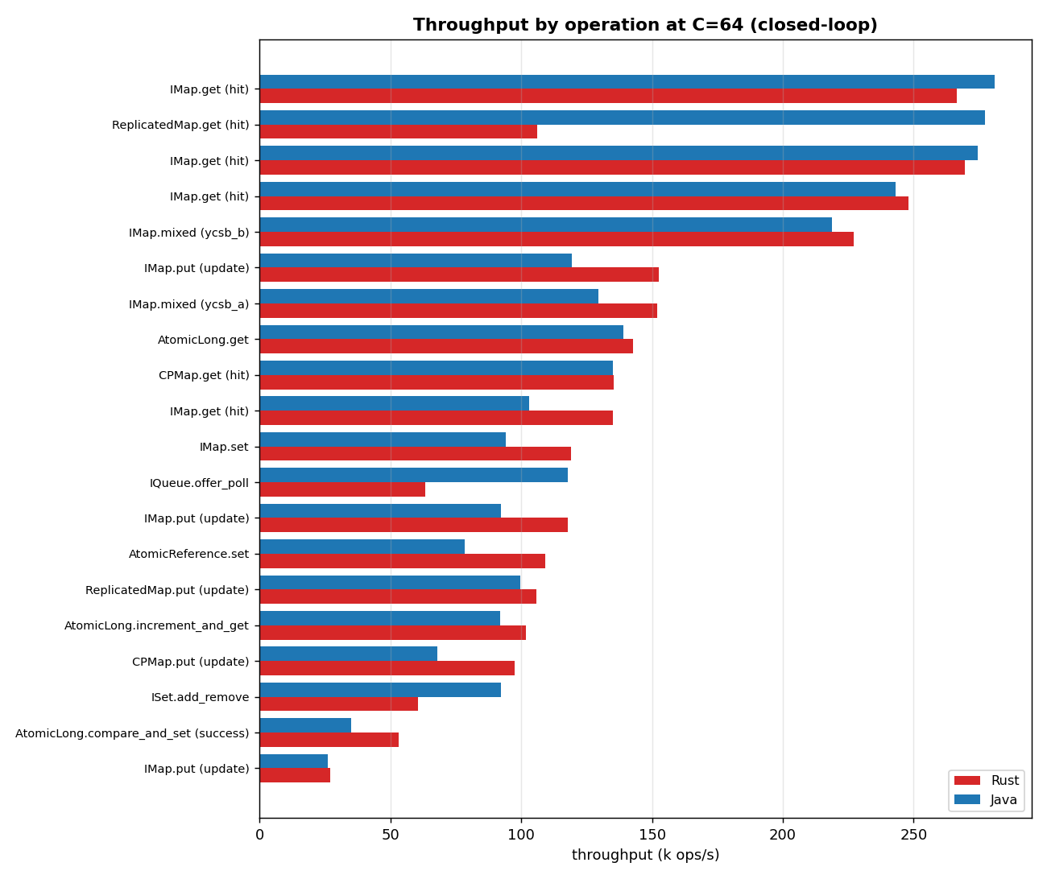

Throughput vs concurrency
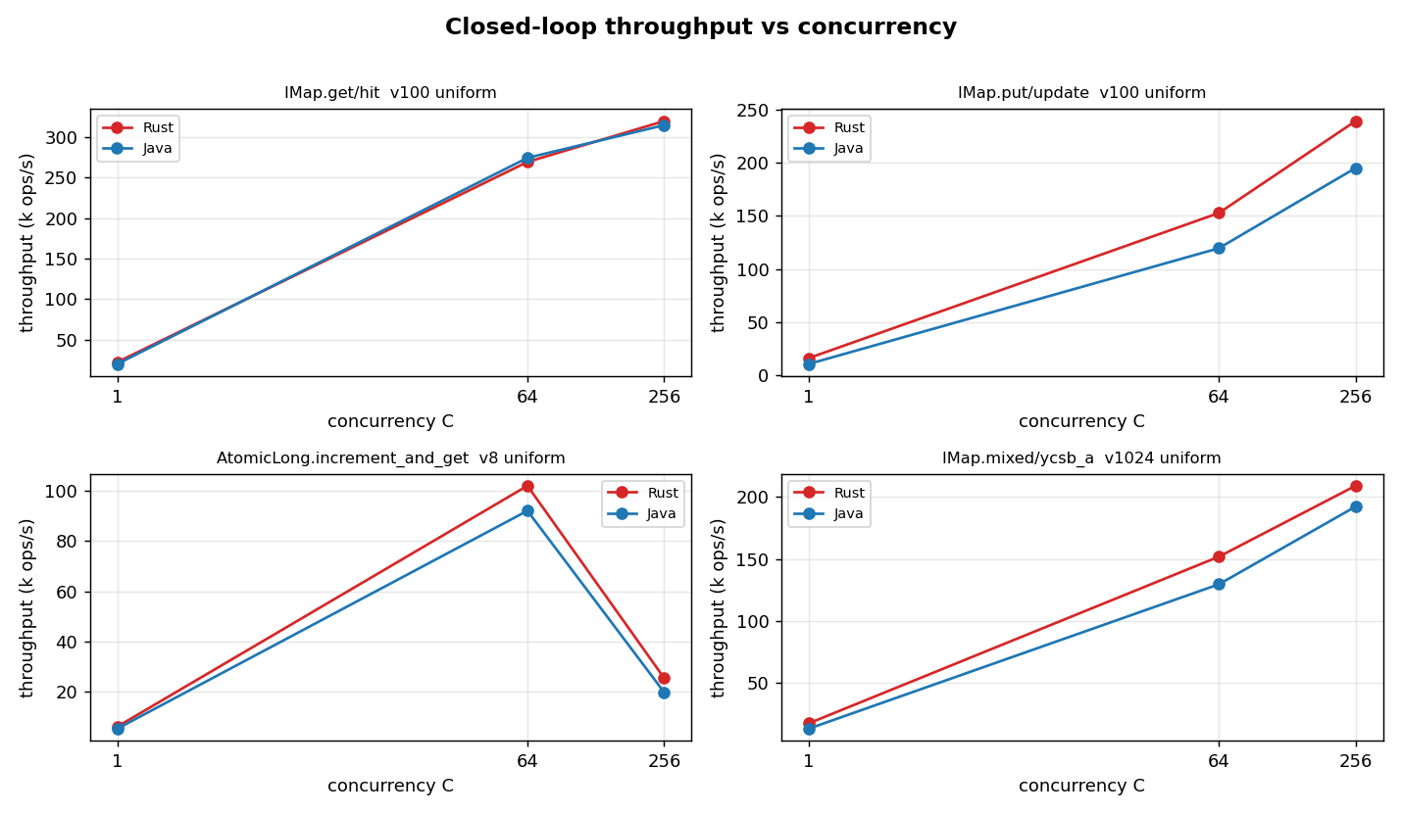

Latency percentile profiles
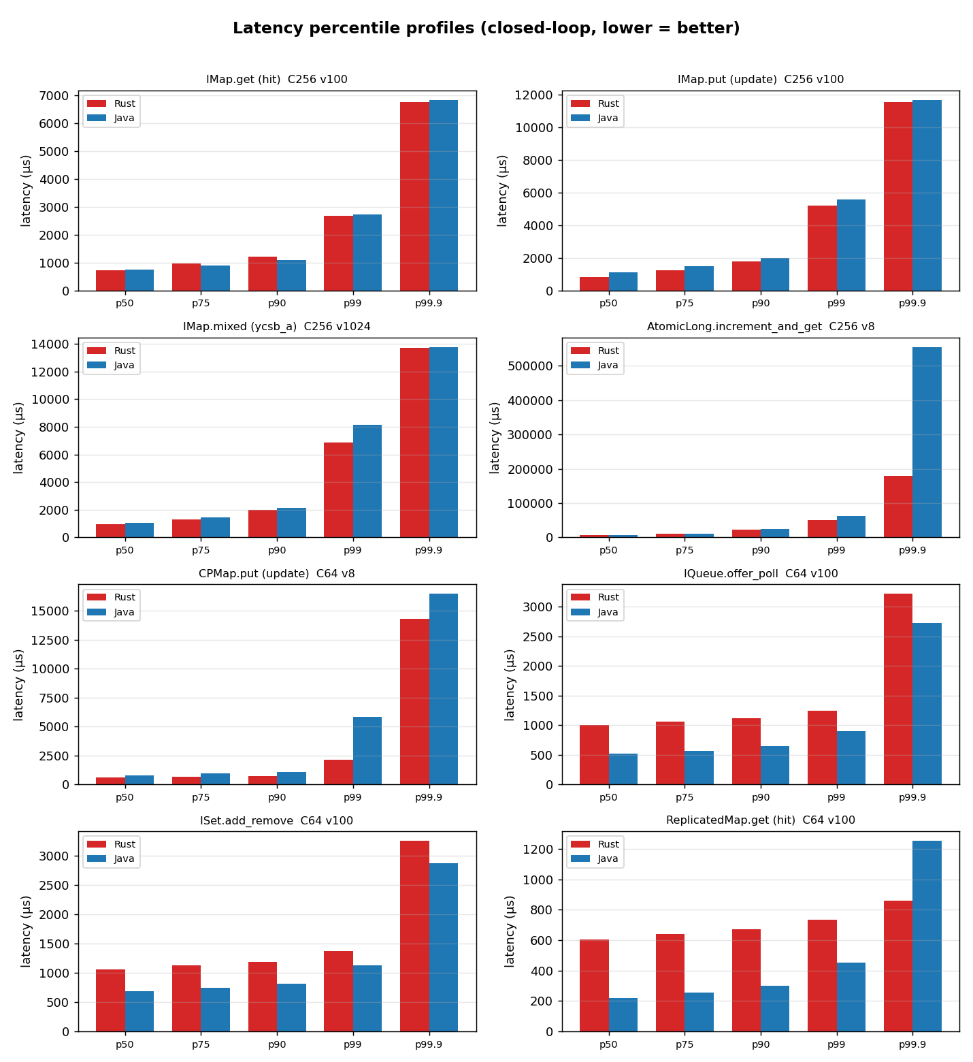

Open-loop latency under controlled rate
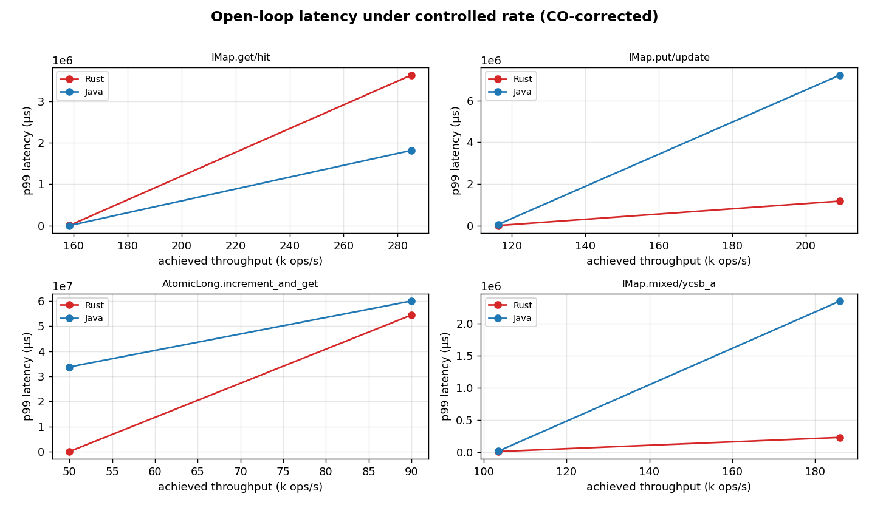

Client resource requirements
Resources consumed by the client process to drive the workload (the cluster is a fixed control). CPU is whole-process utilisation sampled from /proc and expressed both as mean cores in use and as CPU-seconds per million operations (efficiency, lower is leaner). Memory is peak resident set size (RSS); for Java this includes the JVM heap, metaspace, code cache and thread stacks.
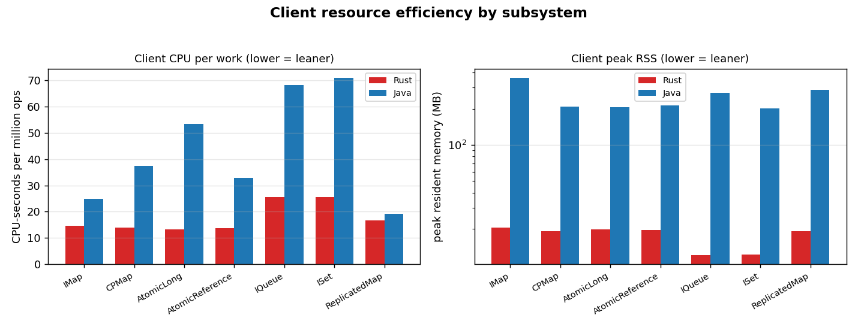
Operation | C | Rust cores | Java cores | Rust CPU-s/Mops | Java CPU-s/Mops | Rust RSS(MB) | Java RSS(MB)
AtomicLong.compare_and_set (success) | 64 | 1.30 | 2.59 | 26.6 | 73.2 | 20 | 206
AtomicLong.get | 64 | 1.85 | 3.63 | 13.0 | 26.2 | 20 | 205
AtomicLong.increment_and_get | 1 | 0.08 | 0.52 | 12.0 | 95.1 | 5 | 184
AtomicLong.increment_and_get | 64 | 1.35 | 2.88 | 13.2 | 31.1 | 19 | 209
AtomicLong.increment_and_get | 256 | 0.38 | 1.07 | 14.8 | 53.3 | 62 | 383
AtomicReference.set | 64 | 1.52 | 2.59 | 13.7 | 32.8 | 20 | 214
CPMap.get (hit) | 64 | 1.84 | 3.68 | 13.8 | 27.1 | 19 | 210
CPMap.put (update) | 1 | 0.08 | 0.52 | 12.4 | 95.0 | 5 | 187
CPMap.put (update) | 64 | 1.37 | 2.53 | 14.0 | 37.5 | 19 | 208
IMap.get (hit) | 1 | 0.27 | 0.73 | 12.1 | 36.7 | 5 | 193
IMap.get (hit) | 64 | 3.65 | 4.28 | 13.6 | 15.5 | 20 | 363
IMap.get (hit) | 64 | 3.65 | 4.32 | 13.7 | 15.4 | 20 | 364
IMap.get (hit) | 64 | 3.61 | 4.31 | 14.6 | 17.7 | 20 | 361
IMap.get (hit) | 64 | 3.44 | 3.86 | 25.5 | 37.5 | 23 | 577
IMap.get (hit) | 256 | 3.78 | 4.76 | 11.8 | 15.1 | 62 | 406
IMap.mixed (ycsb_a) | 1 | 0.22 | 0.69 | 12.5 | 51.4 | 5 | 189
IMap.mixed (ycsb_a) | 64 | 2.62 | 3.25 | 17.3 | 25.0 | 20 | 366
IMap.mixed (ycsb_b) | 64 | 3.44 | 4.11 | 15.1 | 18.8 | 20 | 359
IMap.mixed (ycsb_a) | 256 | 3.20 | 3.96 | 15.3 | 20.6 | 64 | 400
IMap.put (update) | 1 | 0.19 | 0.65 | 12.1 | 60.9 | 5 | 186
IMap.put (update) | 64 | 2.21 | 2.95 | 14.6 | 24.6 | 20 | 356
IMap.put (update) | 64 | 2.23 | 2.85 | 18.8 | 30.6 | 21 | 370
IMap.put (update) | 64 | 1.05 | 2.19 | 38.8 | 84.0 | 26 | 592
IMap.put (update) | 256 | 3.03 | 3.73 | 12.6 | 19.3 | 62 | 404
IMap.set | 1 | 0.20 | 0.66 | 12.5 | 63.1 | 5 | 188
IMap.set | 64 | 2.16 | 2.74 | 18.2 | 29.2 | 20 | 363
IQueue.offer_poll | 1 | 0.14 | 0.75 | 23.3 | 103.9 | 5 | 184
IQueue.offer_poll | 64 | 1.76 | 3.89 | 27.9 | 32.9 | 19 | 360
ISet.add_remove | 1 | 0.14 | 0.74 | 23.3 | 103.4 | 5 | 192
ISet.add_remove | 64 | 1.68 | 3.55 | 27.8 | 38.5 | 19 | 211
ReplicatedMap.get (hit) | 64 | 1.78 | 4.27 | 16.8 | 15.4 | 19 | 363
ReplicatedMap.put (update) | 64 | 1.72 | 2.28 | 16.3 | 22.8 | 19 | 209

Open-loop latency under controlled rate (CO-corrected)
Requests issued on a fixed-rate clock at fractions of each operation's measured closed-loop max, regardless of completion, so tail latency is not hidden by coordinated omission. A cell is flagged saturated if the generator could not sustain its target rate.
Operation | target ops/s | Rust p99 | Java p99 | Rust p99.9 | Java p99.9 | saturated
AtomicLong.increment_and_get | 50k | 24732 | 33747370 | 46973 | 34024194 | yes
AtomicLong.increment_and_get | 90k | 54442066 | 60028879 | 54744056 | 60028879 | yes
IMap.get (hit) | 158k | 4897 | 2010 | 8573 | 7379 | no
IMap.get (hit) | 285k | 3632267 | 1814561 | 3649044 | 1815609 | yes
IMap.mixed (ycsb_a) | 103k | 8704 | 12349 | 15675 | 21938 | no
IMap.mixed (ycsb_a) | 186k | 228131 | 2353005 | 236061 | 2358247 | yes
IMap.put (update) | 116k | 9189 | 56517 | 16069 | 62816 | no
IMap.put (update) | 209k | 1179648 | 7222591 | 1186464 | 7239369 | yes

Validity & caveats
- Total errors across all runs: 0.
- Contamination flags (member migration / slow-op / Full-GC during a window): 0.
- Cells with <1000 samples above p99.9 (tail estimate weaker, typically the C=1 latency-floor cells): 16.
- Co-located rig: cluster and client share one host with disjoint core pinning (members 0-3,8-11, client 4-6,12-14). They still share L3 cache, memory bandwidth and the loopback NIC, so absolute throughput is higher than a two-machine LAN deployment — but both clients see identical conditions, so the comparison is fair.
- CPU governor is hypervisor-managed on the virtualized guest; achieved frequency is recorded in provenance.
- Statistical depth: median across forks×trials with a 95% bootstrap CI (n is modest for a fresh broad run; wider CIs are reported honestly rather than hidden).
- Java RSS includes the whole JVM (heap + metaspace + code cache + stacks); the Rust figure is the whole process RSS. Both are apples-to-apples “memory the client process needs”.

Appendix — full provenance
{
"benchmark": "HazelRust vs official Hazelcast Java client",
"commit": "e20ae5d",
"cluster_name": "dev",
"cluster": "127.0.0.1:5701,127.0.0.1:5702,127.0.0.1:5703",
"cluster_topology": "3-node EE 5.7.0 (dev), -Xms512m -Xmx1g per member",
"hz_java_client_version": "5.7.0",
"rustc": "rustc 1.96.0 (ac68faa20 2026-05-25)",
"java": "openjdk version \"21.0.11\" 2026-04-21 LTS",
"cargo_profile": "release (opt-level=3, lto=false, codegen-units=16)",
"cpu_model": "Intel(R) Xeon(R) Platinum 8275CL CPU @ 3.00GHz",
"logical_cpus": "16",
"cpu_mhz": {
"min": 3000.006,
"max": 3612.909,
"mean": 3452.437625
},
"governor": "unavailable (virtualized guest; frequency managed by hypervisor)",
"kernel": "Linux ip-172-31-40-82.us-east-2.compute.internal 6.1.175-219.357.amzn2023.x86_64 #1 SMP PREEMPT_DYNAMIC Tue Jun 16 03:47:47 UTC 2026 x86_64 x86_64 x86_64 GNU/Linux",
"pinning": {
"members": "0-3,8-11",
"client": "4-6,12-14",
"os": "7,15",
"applied": true,
"member_cpuset_observed": {
"hz1": "0-3,8-11",
"hz2": "0-3,8-11",
"hz3": "0-3,8-11"
}
},
"colocation_caveat": "Cluster and client are CO-LOCATED on one AWS instance. Members and client are pinned to DISJOINT core sets, but they share L3, memory bandwidth, and the NIC/loopback. Absolute numbers may differ from a 2-machine LAN setup; the Rust/Java COMPARISON is fair (identical conditions).",
"jfr": false,
"ts_unix_ms": 1782485265029,
"java_client_edition": "enterprise 5.7.0 (instance ~/hzlib jar; required for CP)",
"license_source": "instance ~/hz/hz1.yaml (not logged)"
}

