HazelRust vs. the Official Hazelcast Java Client
A deterministic, head-to-head performance and efficiency benchmark across seven realistic load scenarios
Build: HazelRust @ bbadfef (release) · Java client: Hazelcast Enterprise 5.7.0 · Cluster: 3-node Hazelcast Enterprise 5.7.0 · n = 3 forks × 3 trials per cell
Executive summary
Across the seven scenarios HazelRust used a median of 18× less client memory than the Java client; spent a median of 1.6× less client CPU per operation; and led on throughput in 4 of the 5 scenarios that cleared the noise band.
Both clients completed every run with zero errors (0 total) on a bit-for-bit identical, deterministic workload. The memory and CPU gaps are the largest and most consistent results: they hold in every scenario, read- and write-heavy alike.
Scorecard
Scenario | HazelRust thr | Java thr | Throughput | Rust p99 | Java p99 | Rust RAM | Java RAM
Session store | 250k | 224k | Rust +11% | 688 µs | 688 µs | 20 MB | 366 MB
Telemetry ingestion | 119k | 98k | Rust +22% | 8147 µs | 8659 µs | 35 MB | 375 MB
Reference-data cache | 266k | 237k | Rust +12% | 709 µs | 657 µs | 20 MB | 366 MB
Transactional OLTP | 163k | 136k | Rust +20% | 1486 µs | 1511 µs | 20 MB | 364 MB
Rate limiting / counters | 92k | 68k | parity | 3674 µs | 6365 µs | 20 MB | 219 MB
Work queue | 97k | 107k | Java +10% | 1279 µs | 1070 µs | 20 MB | 360 MB
Client memory footprint
Peak resident memory of the client process while driving each workload. This is the single most decisive result: a HazelRust service replica carries a fraction of the Java client's heap, which translates directly into density and per-node cost.
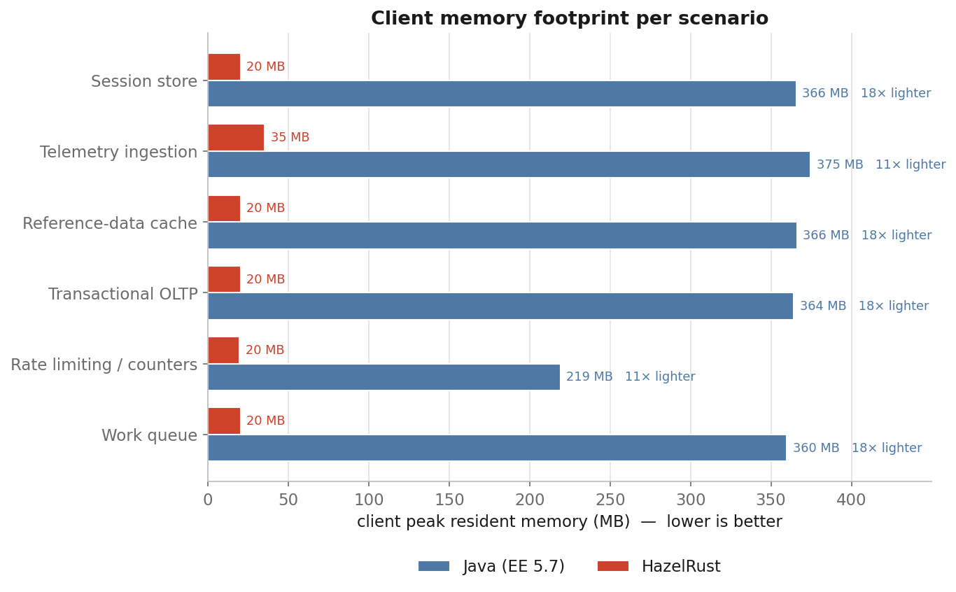
Throughput
Sustained closed-loop throughput, median of nine measurements per client with 95% bootstrap confidence intervals (error bars). The label above each pair is the Rust-vs-Java delta.
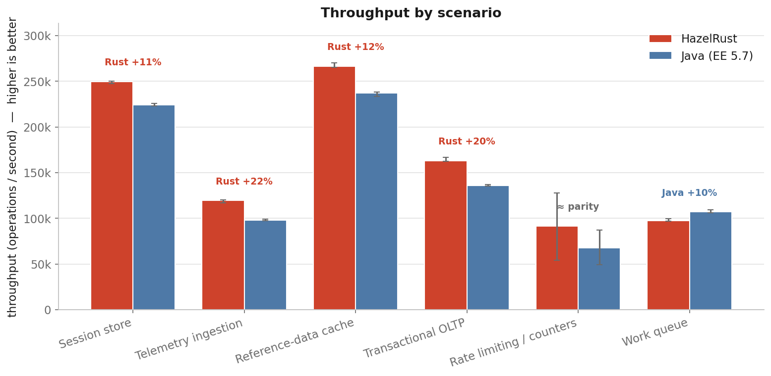
Tail latency
p99 and p99.9 operation latency per scenario (lower is better). Tail latency is where garbage-collection pauses typically surface; HazelRust has no managed runtime and no GC.
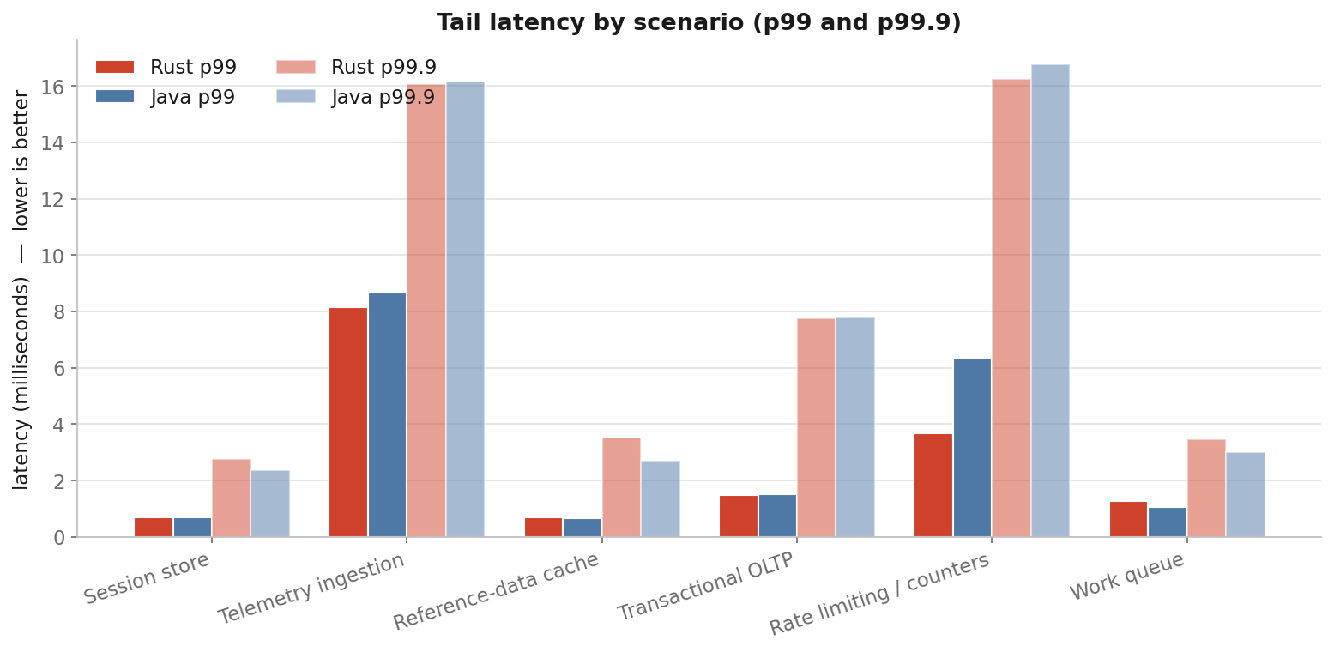
CPU cost per operation
Client CPU microseconds consumed per operation (whole-process sampled CPU ÷ operations). Lower CPU per op means more headroom on the same core budget.
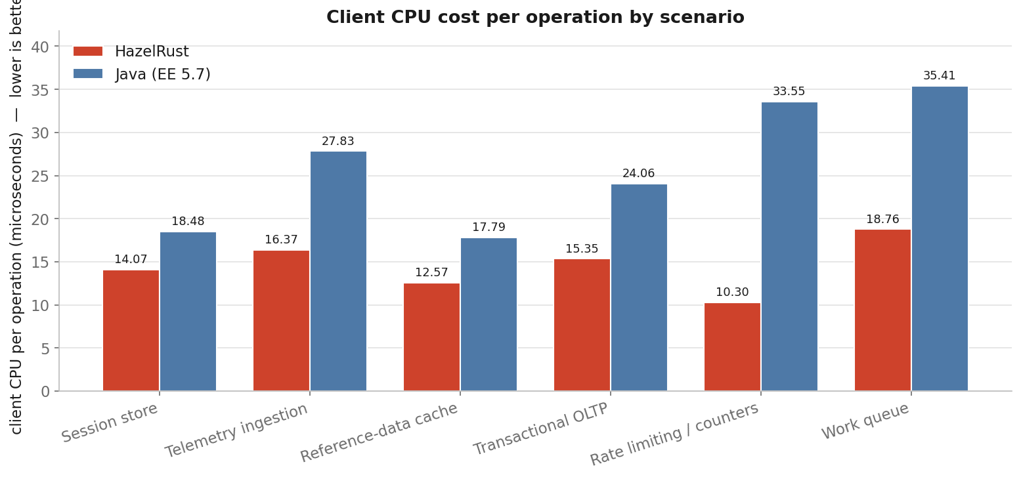
Latency under sustained load
Open-loop, coordinated-omission-corrected. The read-heavy session workload driven at a fixed fraction of each client's own measured maximum throughput, so the reported tail latency reflects real queueing delay, not a closed-loop artefact.
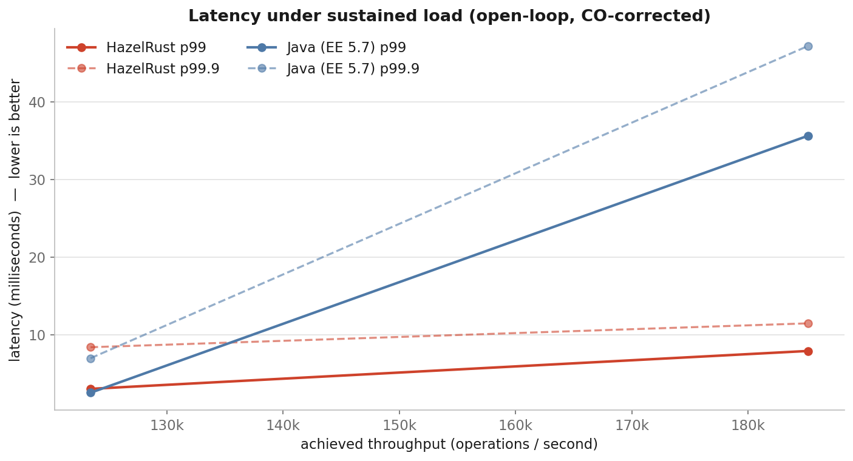
Scenario definitions
1. Session store — Read-heavy distributed cache — IMap 95% get / 5% put, 512 B values, skewed (Zipfian) access. The shape of a web/session store shared across service replicas.
2. Telemetry ingestion — Write-heavy ingest — IMap put, 1 KB values, high concurrency (128). The shape of event / log / metrics ingestion.
3. Reference-data cache — Read-mostly, fully-replicated map — ReplicatedMap get, 512 B, skewed access. The shape of configuration / catalog / lookup data replicated to every member.
4. Transactional OLTP — Balanced read/update — IMap 50% get / 50% put, 512 B, skewed access. The shape of an online transactional workload.
5. Rate limiting / counters — Linearizable distributed counters — CP AtomicLong increment-and-get, backed by Raft. The shape of API rate limiting, sequence generation, and quota accounting.
6. Work queue — Producer/consumer queue — IQueue offer + poll pair, 256 B payloads. The shape of task distribution and job pipelines.
7. Latency under sustained load — Open-loop, coordinated-omission-corrected. The read-heavy session workload driven at a fixed fraction of each client's own measured maximum throughput, so the reported tail latency reflects real queueing delay, not a closed-loop artefact.
Methodology & caveats
- Deterministic workload: keys and values are generated by a shared SplitMix64 formula and a YCSB Zipfian access distribution, so both clients touch the same keys with the same bytes in the same order — the comparison is bit-for-bit identical.
- Rigor: each cell is run as 3 forks × 3 trials (n = 9) with the order randomized and the two clients interleaved A/B/B/A; every figure is a median with a 95% bootstrap confidence interval. Cells whose Rust/Java ratio interval spans 1.0 are reported as parity.
- Backup acknowledgement is matched ON for both clients, so the write paths are compared on equal durability terms.
- Co-located rig: the cluster and client share one host with disjoint CPU-core pinning (members 0-3,8-11, client 4-6,12-14). They still share L3 cache, memory bandwidth, and the loopback NIC, so absolute throughput is higher than a two-machine LAN — but both clients run under identical conditions, so the comparison is fair.
- CPU governor is hypervisor-managed in the virtualized guest; achieved clock is recorded in provenance. CPU-per-op is a whole-process approximation.
- Java client is Hazelcast Enterprise 5.7.0, version-identical to the cluster, on Corretto 21.
Provenance
CPU: Intel(R) Xeon(R) Platinum 8275CL CPU @ 3.00GHz · kernel: Linux ip-172-31-40-82.us-east-2.compute. · rustc: rustc 1.96.0 (ac68faa20 2026-05-25) · java: openjdk version "21.0.11" 2026-04-21 LTS
Errors across all runs: 0. Raw per-run records and embedded HdrHistograms are preserved in the run directory (auditable).

