Module 1 Critical Thinking Option #2

Benjamin Mossberg
Colorado State University Global
CSC320: Programming I
Dr. Terrell Brandes
22 March 2026

Module 1 Critical Thinking Option #2
In week one we discussed basics of Java, Integrated Development Environments (IDEs), GitHub, and pseudocode. This paper presents a basic application solidifying these concepts that will print information for a restaurant in my city.
Requirements and Pseudocode Philosophy
The application will ultimately be written in Java code using the Eclipse IDE, compiled, executed, and pushed to GitHub. This program will display the following restaurant information with no user input:
- Restaurant name
- Business address
- City, State, and Zip code
To write the pseudocode, a sequence control structure with the basic display output operation will be used with no need for loops, variables, or decisions. It will be written in clear English with programming-appropriate whitespace to delineate processes, as discussed by Shrestha (2017).
Pseudocode
BEGIN
DISPLAY "Casa Bonita"
DISPLAY "6715 W Colfax Ave"
DISPLAY "Lakewood, CO 80214"
END
Java Source Code
public class RestaurantInfo {
public static void main(String[] args) {
System.out.println("Casa Bonita");
System.out.println("6715 W Colfax Ave");
System.out.println("Lakewood, CO 80214");
}
}

Git Repository
https://github.com/bhmossberg/CSC320-Mod-1-CT-Option-2
Conclusion
This assignment resulted in numerous lessons learned in both coding and professional utility familiarization. While writing this pseudocode was simple and in line with previous class work, exploring the syntax of Java in the Eclipse IDE presented numerous points of confusion to work through. After reviewing the course material, I still had some issues working with eclipse and questions regarding the interoperability between versions of the JDK and JRE and their use in Eclipse that required follow up research. Additionally, starting a new Java coding project in Eclipse was more cumbersome than what I had become accustomed to in Visual Studio Code. I am certain I still have a lot to learn in this IDE to maximize usage of its capabilities. For the presentation of executing the completed code, I was used to being able to launch Python programs straight from the file explorer and so it was valuable to learn the different ways that a Java program can compile and run whether from the IDE console, command line (after compiling and creating a .class file), or by generating a .jar file.
Learning how to interact with GitHub was also a new experience for me that produced valuable insight into its Distributed Version Control System (DVCS). After installing Git, this was the first time I created a repository using my account. This module also allowed me to learn the version control process and command line interface utilized in Git where tracked files are put through the Stage-Commit-Push process with the capacity to pull for long term collaborative works. I initially tried to just create a repository by uploading files on the website but then familiarized myself with the command line to push the final files to the repository. The process of cloning a repository on the command line to interact with its contents was straightforward once I read through the first chapter of ProGit (Chacon & Straub, 2022).
Figure 1
Console output in Eclipse IDE after successful compile and execution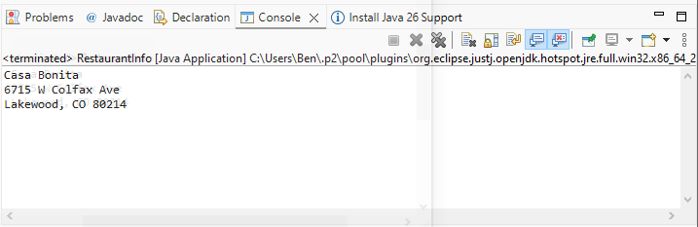
Figure 2
Compiling and running of program from command line
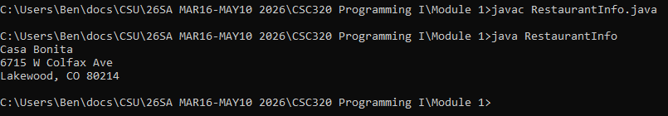

Figure 3
Committing and pushing files to GitHub via command line
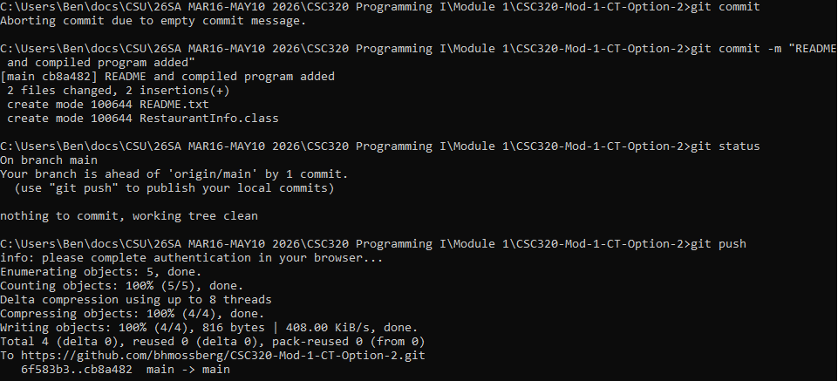
References
Shrestha, S. (2017). Pseudocode: Examples of Pseudocode, How to write Pseudocode. Computersciencementor. https://computersciencementor.com/pseudocode/
Chacon, S., & Straub, B. (2022). Pro Git (2nd ed.). Apress. https://git-scm.com/book/en/v2

